Extended Data
Extended Figures
Extended data Fig. 1. Evaluation of the tet-inducible CRISPRi system and CcdB-counter selection for sgRNA cloning. a. The designed tet-inducible system for P. aeruginosa. It includes a constitutive promoter (P_{con}) driving a codon-optimized TetR and a tet-inducible promoter (P_{tet}) initiating reporter gene expression. Dox presence inhibits TetR binding to tetO on P_{tet}, enabling reporter gene transcription. b. Impact of doxycycline on growth of P. aeruginosa PA14 with tet-inducible system. c. Impact of CRISPRi system on growth of P. aeruginosa. The P. aeruginosa strains PAO1 and PA14 were engineered to express a CRISPRi system including dCas9 to repress transcription of the luciferase reporter gene lucff. As lucff is absent in the PAO1 and PA14 genomes, this allows quantification of any growth defects resulting specifically from dcas9 expression. d, e. Enhanced sgRNA cloning efficiency via ccdB replacement in bacteria. The successful replacement of ccdB by sgRNAs in bacteria allows for their survival on LB agar plates (d). 100% positive sgRNA cloning efficiency was achieved as validated by colony PCR (e).

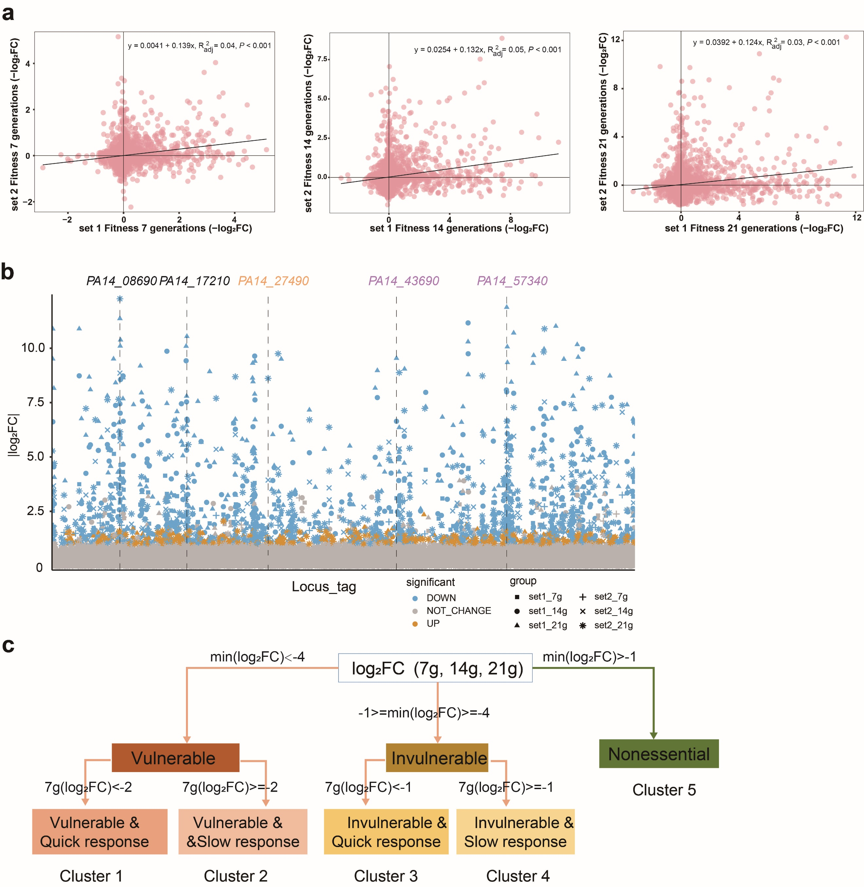
Extended data Fig. 2. Assessment of the gene essentiality in P. aeruginosa via CRISPRi-seq. a. Correlation of gene fitness evaluated by set 1 and set 2 libraries, across 7, 14 and 21 generations of Dox induction. b. Comparative analysis of essential gene targets from set1 and set 2 libraries. Locus-tags in black (e.g. PA14_08690 and PA14_17210) were screened in both libraries. Those in purple (PA14_43690 and PA14_57340) were unique to set 1 library, while the one in yellow (PA14_27490) was only screened by set 2 library. c. The workflow for categorizing genes into five clusters based on response time and maximum log₂FC in PA14 utilizing CRISPRi-seq.

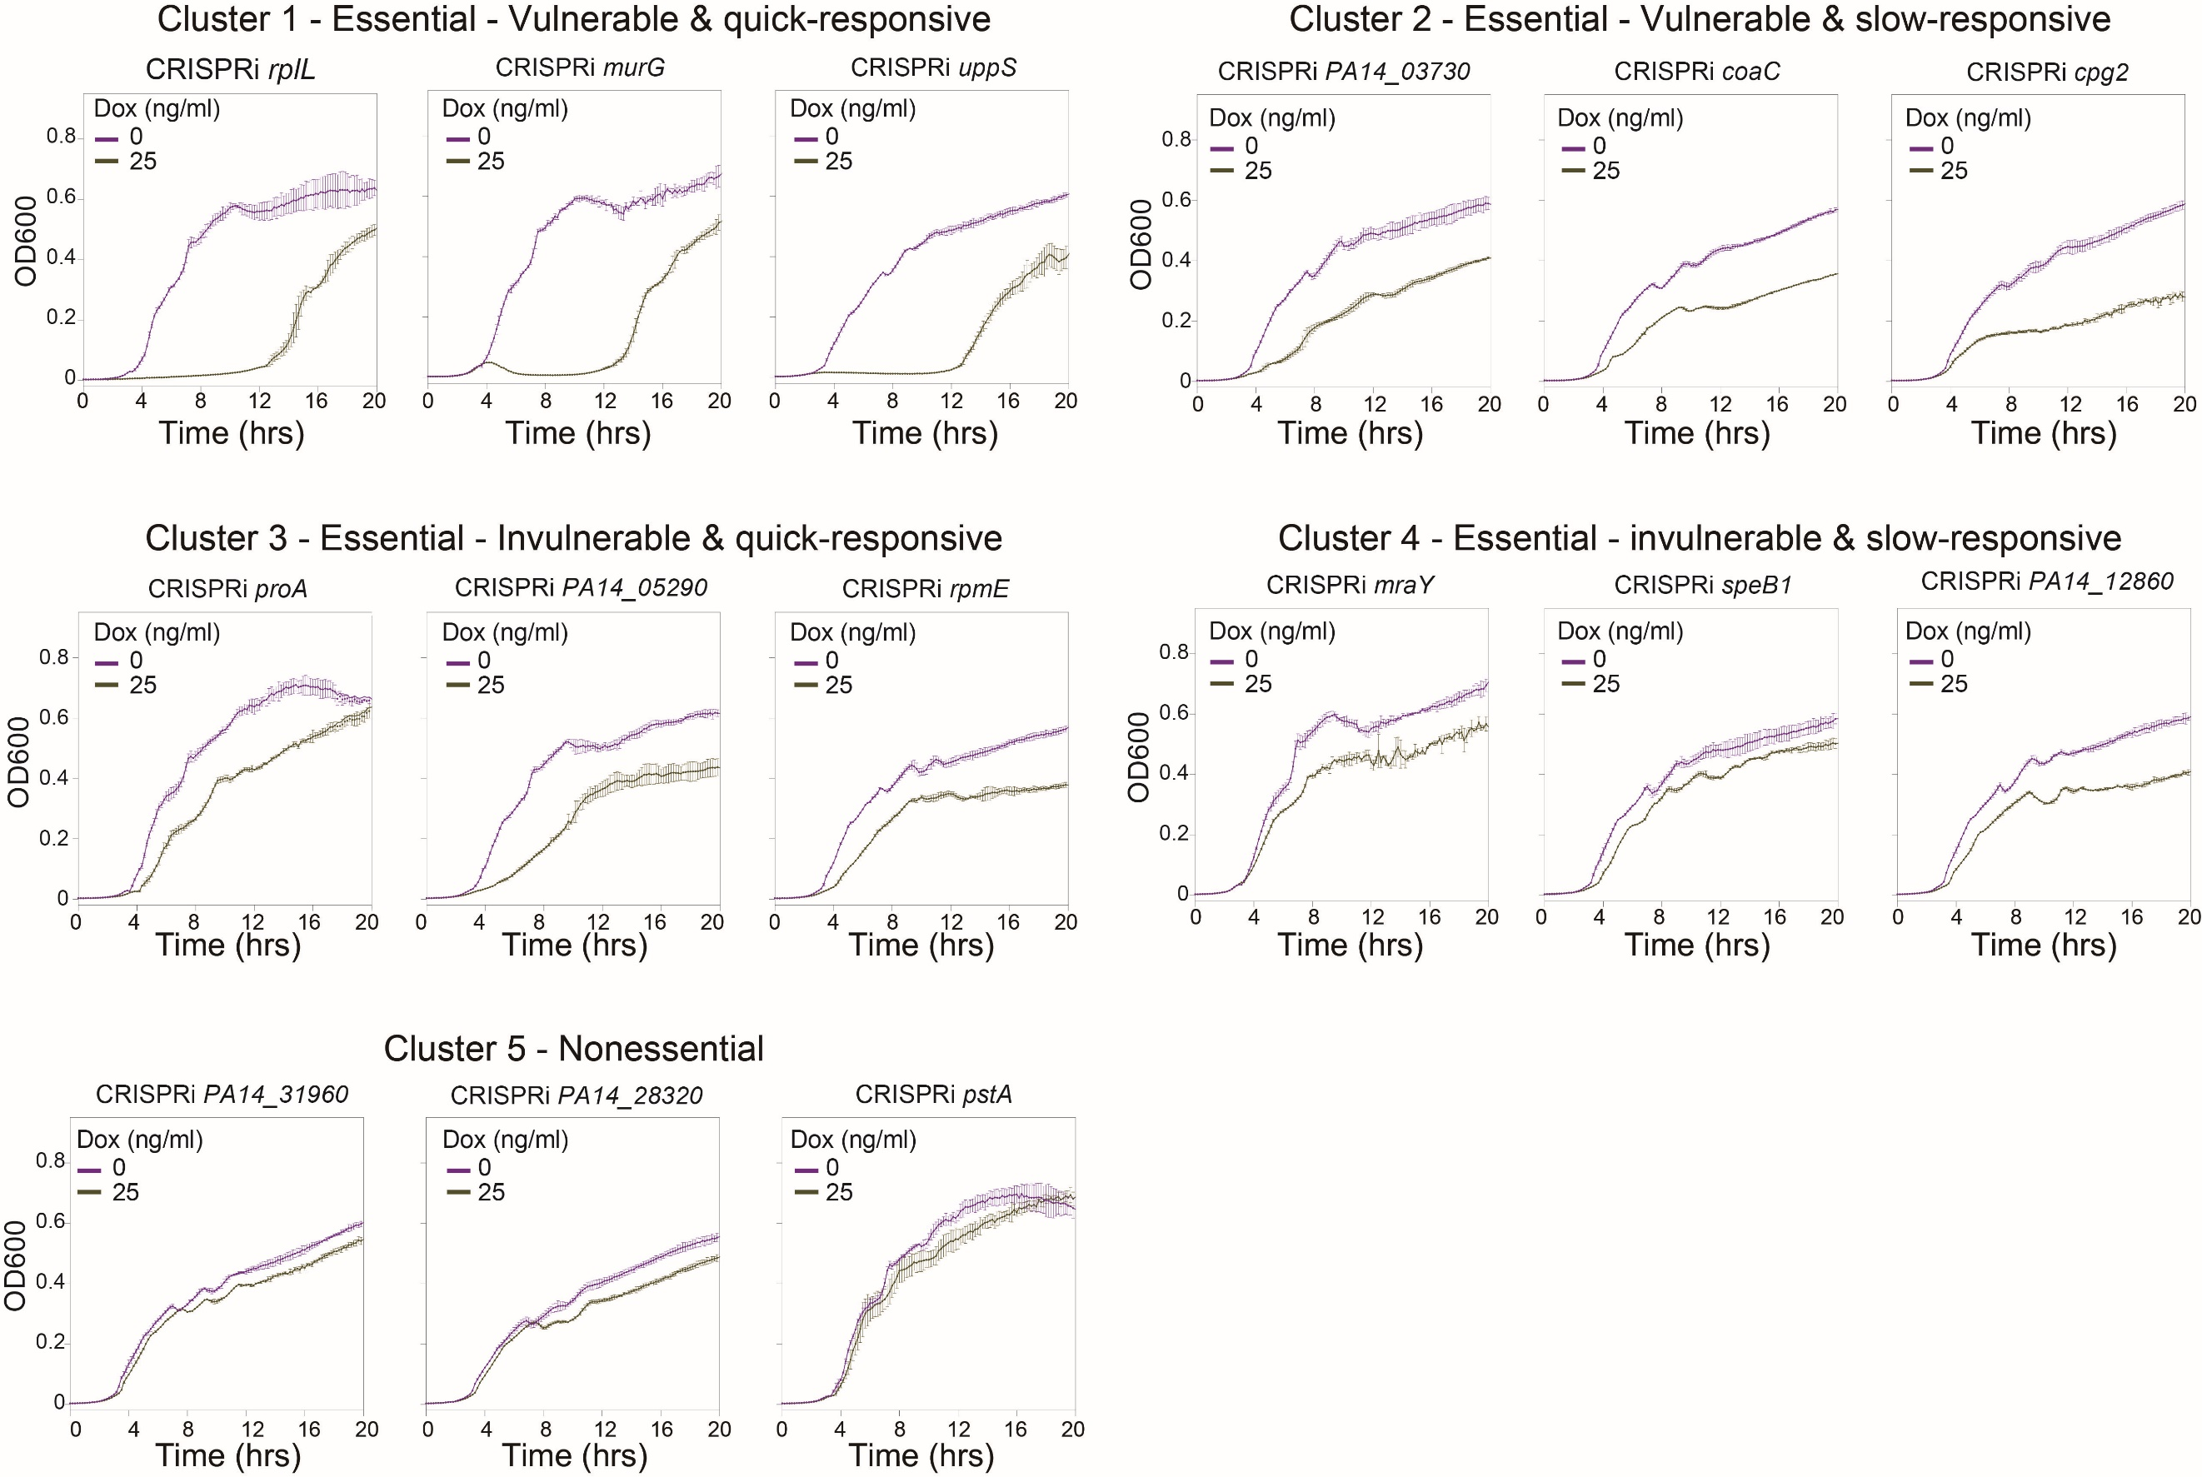
Extended data Fig. 3. Validation of growth for genes from the 5 clusters identified in Extended data Fig. 2c. All strains were initially adjusted to an OD600 of 0.003. Experiments were performed in triplicate and data are presented as mean ± SD.

Extended data Fig. 4. Impact of Ga(NO₃)₃ on P. aeruginosa growth. a. GO enrichment analysis of the genes with differential fitness in Ga(NO₃)₃-treated and untreated P. aeruginosa, identified by CRISPRi-seq. b. Deletion of PA3237 (ortholog of PA14_22320) and PA0287 (ortholog of PA14_03760) shows no growth difference under gallium treatment compared to wild-type PAO1. In contrast, deletion of hitA increases PAO1 resistance to gallium.

Extended data Fig. 5. Functional analysis of FprB. a. MIC determination of Ga(NO₃)₃ for P. aeruginosa. Bacteria were cultured in 96-well plates for 24 hours at 37°C with 4 replicates per strain. b. AlphaFold3 prediction showing FprB binding to FAD. c. Dose-response curves for the FprB 2,6-dichlorophenolindophenol (DCPIP)-diaphorase activity in the absence or presence of Ga(NO₃)₃. Experiments performed at 25°C in a mixture containing 800 nM FprB, 800 µM DCPIP and 400 µM NADPH in 50 mM Tris/HCl pH 8.0 (n = 3, mean ± SD). Negative control contains all reactants but no FprB. d. Intracellular gallium concentration of P. aeruginosa under Ga(NO₃)₃ treatment. P. aeruginosa were cultured from an initial OD600 of 0.003 at 37°C for 16 hours in the absence or presence of Ga(NO₃)₃. The intracellular gallium concentration was determined by an ICP-MS analyzer. Data are presented as mean ± SD. The asterisks represent a significant difference from indicated groups with **P < 0.01, ***P < 0.001 and ****P < 0.0001 by two-way ANOVA and Tukey’s multiple-comparison test.

Extended data Fig. 6. Role of NADP⁺ and NADPH in P. aeruginosa growth under Ga(NO₃)₃ treatment. a. Intracellular NADP⁺ and NADPH accumulation. Bacteria (initial OD600 of 0.01) were cultured for 4 hours in LB broth with or without Ga(NO₃)₃. Luminescence value measured by a microplate reader were normalized to final OD600. b. Drop plate assay of the ΔfprB strain treated with Ga(NO₃)₃ and NADPH. Bacterial cultures were adjusted to an initial OD600 of 0.003. Assays were conducted with 6.25 μM Ga(NO₃)₃ and/or 1 mM NADPH. Data are presented as mean ± SD. The asterisks represent a significant difference from indicated groups with **P < 0.01, ***P < 0.001 and ****P < 0.0001 by two-way ANOVA and Tukey’s multiple-comparison test.

Extended data Fig. 7. The evolutionary conservation of FprB in P. aeruginosa. Analysis of FprB across P. aeruginosa strains reveal high conservation at both gene and protein levels. a. Neighbor-Joining phylogenetic tree of FprB proteins in representative P. aeruginosa strains. In total, 71 phylogenetic sub-clusters were detected from the 981 surveyed P. aeruginosa strains. The FprB proteins were collected from the representative strains of each sub-cluster, and used for phylogenetic tree building. The strains for which the genome accessions were highlighted in red were used for further comparative genomic analysis. b. Collinearity analysis between P. aeruginosa strains representing different FprB sequence clusters for the fprB loci (indicated) and their 10k flanking sequences. c. Multiple sequence alignment results for the FprB proteins from representative P. aeruginosa strains. d. CRISPRi-seq screen under Ga(NO₃)₃ stress did not identify FprA and its substrate Fdx1 as a contributor to gallium resistance. e. Suppression of fprA did not significantly increase sensitivity to Ga(NO₃)₃. f, g. Sequence alignment showing FprA exhibits approximately 42% amino acid sequence identity with FprB in P. aeruginosa. h. Complementation of fprA in the ΔfprB mutant did not enhance gallium tolerance.

Supplementary Tables
Supplementary Table S1. Strains and plasmids used in this work
Supplementary Table S2. Primers used in this work
Supplementary Table S3. gBlocks used in this work
Supplementary Table S4. List of sgRNA and targets in PA14
Supplementary Table S5. PA14 essential genes by CRISPRi-seq
Supplementary Table S6. Classification of genes into five categories by response time and essentiality
Supplementary Table S7. Fitness evaluated by CRISPRi-seq screening under gallium stress
Supplementary Table S8. GO enrichment analysis of CRISPRi-Seq screening for Gallium-treated vs. untreated groups
Supplementary Table S9. Analysis of differentially expressed genes in fprB knockout strain vs PAO1 wild type

