Figure S1. Kaplan-Meier curves showing distant recurrence-free survival and relapse-free survival according to the molecular subtype of the disease
- For all patients (n = 298)
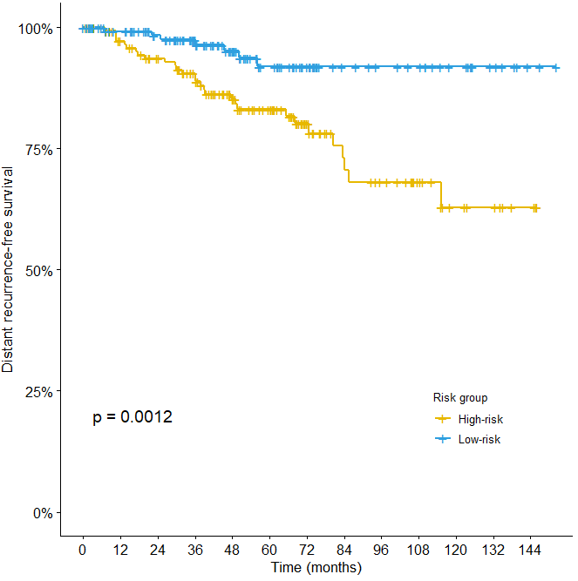 | 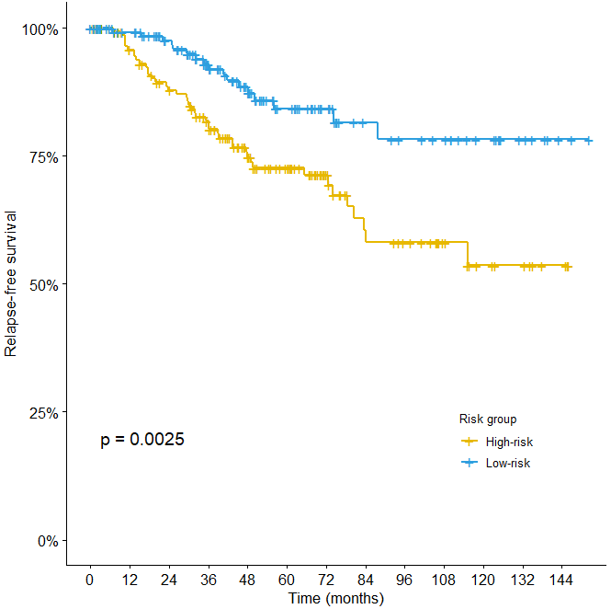

- For luminal-like patients (n = 255)
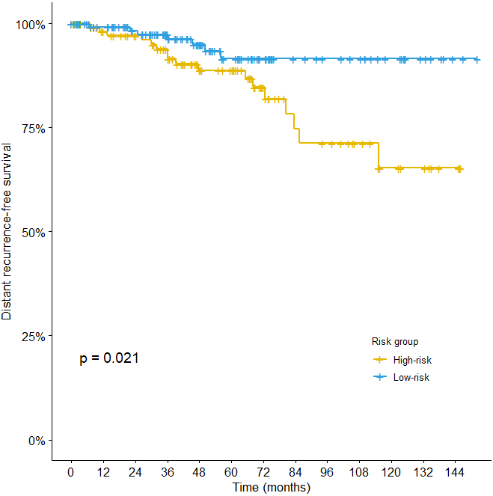 | 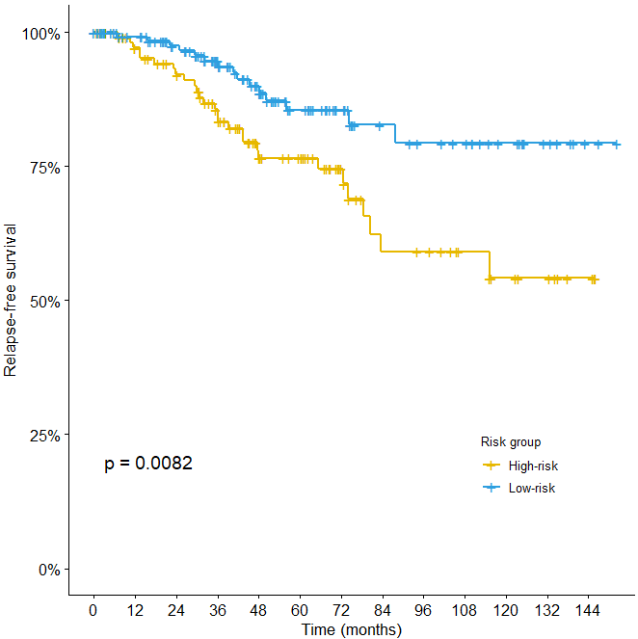

- For HER2/ TNBC patients (n =43)
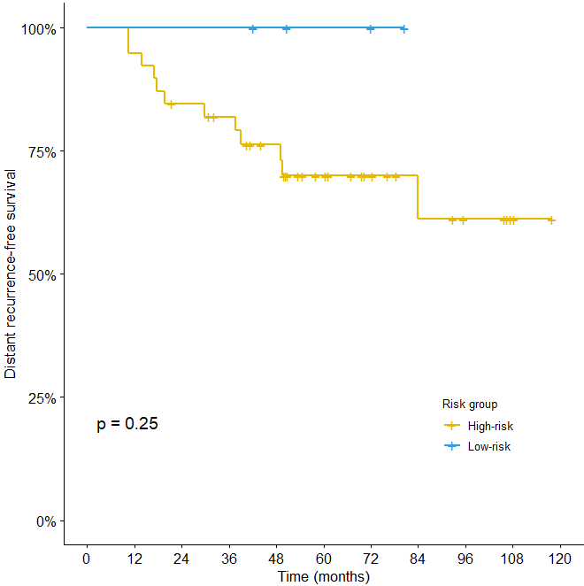 | 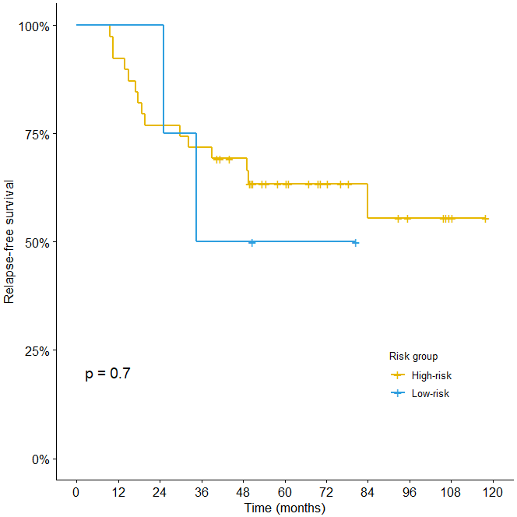

Figure S2. Forest plot of hazard ratios and 95% CIs by patient’s subgroup based on univariate analysis (n=298)
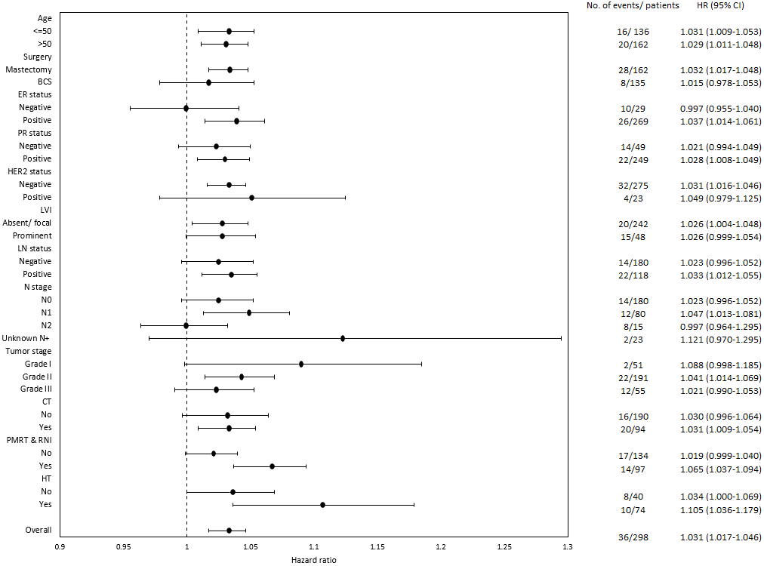
Abbreviations: HR hazard ratio, CI confidence interval

