Supplementary Materials
Corrosion inhibition threshold effect of 1,2,4-triazole in alkaline chemical mechanical polishing of copper: Investigations using synchrotron radiation microinfrared
Lei Dai ª, Zixuan Yan ª, Daquan Zhang ^{a,b*}, Chunping Liª, Cheng Shi ª, Lixin Gao^{b}, Zhiling Xin ª
ª Shanghai Key Laboratory of Materials Protection and Advanced Materials in Electric Power, Shanghai University of Electric Power, P. R. China
^{b} Shanghai Engineering Research Centre of Energy-Saving in Heat Exchange Systems, Shanghai 2001306, P. R. China
*Corresponding author, E-mail: zhangdaquan@shiep.edu.cn

S1 Experimental

S1.1 FT-IR analysis
The SR-FTIR was obtained by the infrared micro-spectroscopy and the imaging instrument (in the BL01B beamline of the Shanghai National Institute of Protein Science [NFPS] at the SSRF) [14]. Thermo Scientific OMNIC Atlms software was used to operate the instrument and performed data collection, and the SR-FTIR spectra were transmitted in the 4000 cm⁻¹- 650 cm⁻¹ in the mid-infrared range.

S1.2 Three-dimensional Fluorescence test
The slurry after the polishing test was analyzed by three-dimensional fluorescence spectroscopy. Spectral measurements were performed using a 3D spectrometer, (HORIBA, Ltd, Japan) equipped with a dual grating excitation and emission monochromator.
The fluorescence spectroscopy uses a fluorescent quartz cell (inner thickness of 2 mm and inner width of 10 mm). The incident light was irradiated on the sample surface at an angle of 60°, and the emitted fluorescence (fluorescence in the 90° direction with respect to the incident light) was collected at an angle of 150°. The excitation wavelengths (Ex.) were 250 nm ~ 800 nm (excitation slit: 5 nm bandpass), and the emission wavelengths (Em.) were 300 nm ~ 850 nm (emission slit: 5 nm bandpass). Signal accumulation time was 0.1 s at 5 nm intervals.

S2 Results and discussion

S2.1 XPS analysis
Representative XPS survey spectra of bare copper sample is depicted in Fig. S1. Prominent core-level lines are evident in the XPS spectra of these copper samples, specifically the Cu 2p doublet (consisting of Cu 2p_{1/2} and Cu 2p_{3/2}) located within the 925-960 eV range, the O 1S peak at 531.6 eV, and the C 1S peak at 284.8 eV. The spontaneous oxidation of copper in alkaline slurry gives rise to distinct peaks for Cu(II) at 931.1 eV and Cu(I) around 931.8 eV, which can be identified by fitting the Cu 2p3/2 spectrum.
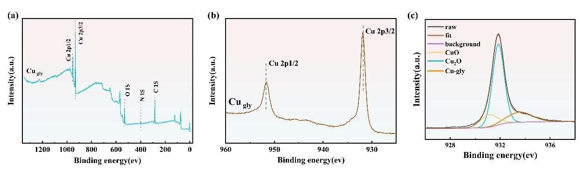
Fig. S1 XPS spectra of copper surfaces after being immersed in slurry.

S2.2 Three-dimensional fluorescence analysis
Corrosion inhibitor molecules essentially bind to copper by means of coordination, forming a film of insoluble coordination products on the copper surface, which provides corrosion inhibition by blocking the contact of copper with the corrosive medium. The fluorescence of the solution was determined by three-dimensional fluorescence spectroscopy to reflect the products in the solution and thus to study the copper complexes in the solution.
Fig. S3 shows that the slurry shows a strong fluorescence signal corresponding to the Cu-TAZ complex at 453 nm under the excitation of the excitation light source with wavelengths of about 290 nm and 365 nm. Meanwhile, the fluorescence signal corresponding to the Cu-TAZ complex has the lowest fluorescence intensity in the solution when the TAZ concentration is 15 mM. At this concentration, TAZ prefers to complex with the copper substrate rather than free in solution. The oblique linear spot in the figure is mainly due to the interference of Raman scattering from water molecules and does not affect the test results.
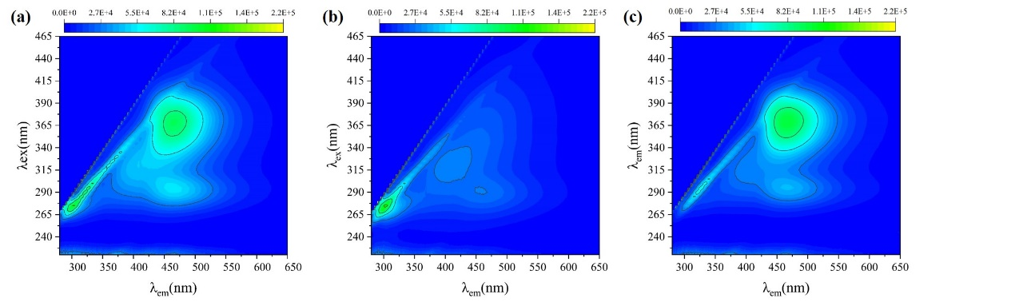
Fig. S3 Three-dimensional fluorescence images obtained after immersing copper specimens in with different concentrations of TAZ:10 mM (a), 15 mM (b), 20 mM(c).

S2.3 Theoretical calculation
Fig. S4 shows the model of the equilibrium adsorption of TAZ molecules on Cu(1 1 1)(a1-a5) and CuO(1 1 1) (b1-b5) surfaces.
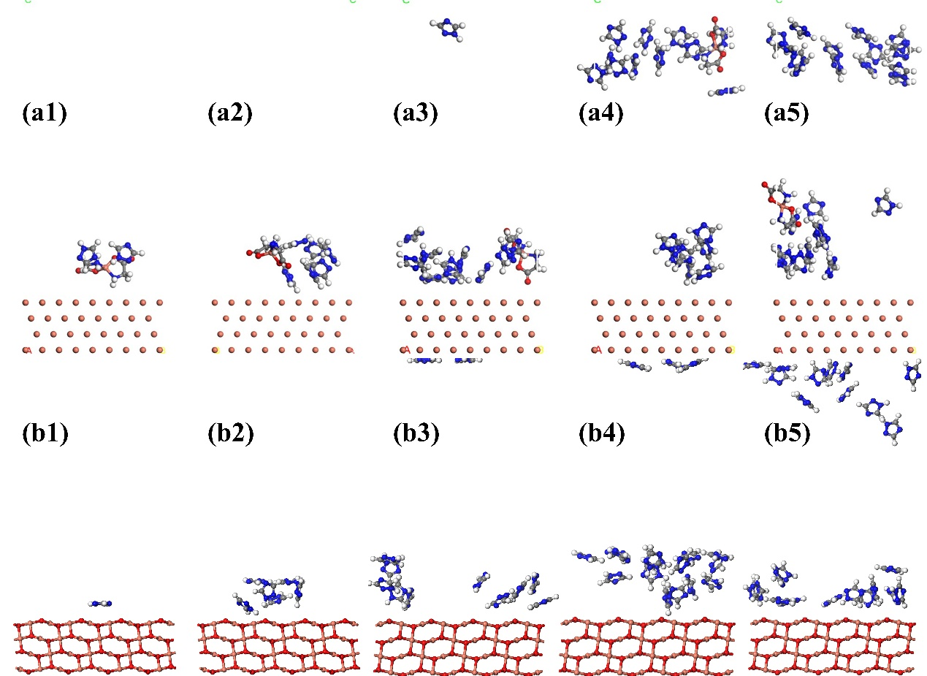
Fig. S4 model of the equilibrium adsorption of TAZ molecules on Cu(1 1 1) surfaces (a1-a5) and CuO(1 1 1)(b1-b5).

