Supplementary materials:
Title: Global, Regional, and National Burden of Benign Prostatic Hyperplasia: A Comprehensive Analysis from 1990 to 2021
Authors’ names: Xin Chen^{1, 2, *}, Siyuan Yang^{3, *}, Zihao Chen², Haodong Xu¹, Xinling Tang¹, Yuxin Lin¹, Yuhua Huang^{1, #}, Jianquan Hou^{1, 2, #}, Xuedong Wei^{1, #}
Authors’ affiliations:
¹ Department of Urology, The First Affiliated Hospital of Soochow University, Suzhou, 215031, People’s Republic of China;
² Department of Urology, The Fourth Affiliated Hospital of Soochow University, Suzhou Dushu Lake Hospital, Suzhou, 215125, People’s Republic of China;
³ Department of Neurosurgery, The First Affiliated Hospital of Soochow University, Suzhou, 215031, People’s Republic of China;
* These authors contributed equally to this work.
# These authors are co-authors of communication.
Corresponding author:
Xuedong Wei, Department of Urology, The First Affiliated Hospital of Soochow University, No. 899 Pinghai Road, Suzhou, 215006, People’s Republic of China, Tel/Fax +86 0512-67972184, Email wxd0422@suda.edu.cn / wxd0422@163.com
Jianquan Hou, Department of Urology, The First Affiliated Hospital of Soochow University, No. 899 Pinghai Road, Suzhou, 215006, People’s Republic of China, Tel/Fax +86 0512-67972184, Email xf192@163.com
Yuhua Huang, Department of Urology, The First Affiliated Hospital of Soochow University, No. 899 Pinghai Road, Suzhou, 215006, People’s Republic of China, Tel/Fax +86 0512-67972184, Email sdfyyhyh@163.com

Figure S1. Temporal trend of benign prostatic hyperplasia burden in global and 5 SDI regions: the rates of incidence from 1990 to 2021.
Figure S2. Temporal trend of benign prostatic hyperplasia burden in global and 5 SDI regions: the rates of DALYs from 1990 to 2021.
Figure S3. Temporal trend of benign prostatic hyperplasia burden in regions: incidence rate per 100,000 population in 1990 and 2021.
Figure S4. Temporal trend of benign prostatic hyperplasia burden in regions: DALYs rate per 100,000 population in 1990 and 2021.
Figure S5. Temporal trend of benign prostatic hyperplasia burden in countries level: incidence cases across 204 countries in 1990 and 2021.
Figure S6. Temporal trend of benign prostatic hyperplasia burden in countries level: DALYs cases across 204 countries in 1990 and 2021.
Figure S7. Temporal trend of benign prostatic hyperplasia burden in countries level: EAPC in incidence rates across 204 countries from 1990 to 2021.
Figure S8. Temporal trend of benign prostatic hyperplasia burden in countries level: EAPC in DALYs rates across 204 countries from 1990 to 2021.
Figure S9. Temporal trend of benign prostatic hyperplasia burden by age pattern in global and 5 SDI regions: Global age-specific distribution of benign prostatic hyperplasia incidence cases.
Figure S10. Temporal trend of benign prostatic hyperplasia burden by age pattern in global and 5 SDI regions: Global age-specific distribution of benign prostatic hyperplasia DALYs cases.
Figure S11. The associations between the SDI and incidence rates per 100,000 population of benign prostatic hyperplasia across 21 GBD regions. SDI = Socio-Demographic Index, GBD = Global Burden of Disease
Figure S12. The associations between the SDI and DALYs rates per 100,000 population of benign prostatic hyperplasia across 21 GBD regions. SDI = Socio-Demographic Index, GBD = Global Burden of Disease
Figure S13. The associations between the SDI and prevalent rates per 100,000 population of benign prostatic hyperplasia across 21 GBD regions without global. SDI = Socio-Demographic Index, GBD = Global Burden of Disease
Figure S14. The associations between the SDI and incidence rates per 100,000 population of benign prostatic hyperplasia across 21 GBD regions without global. SDI = Socio-Demographic Index, GBD = Global Burden of Disease
Figure S15. The associations between the SDI and DALYs rates per 100,000 population of benign prostatic hyperplasia across 21 GBD regions without global. SDI = Socio-Demographic Index, GBD = Global Burden of Disease
Figure S16. The associations between the SDI and prevalent rates per 100,000 population of benign prostatic hyperplasia across 204 countries. SDI = Socio-Demographic Index, GBD = Global Burden of Disease
Figure S17. The associations between the SDI and incidence rates per 100,000 population of benign prostatic hyperplasia across 204 countries. SDI = Socio-Demographic Index, GBD = Global Burden of Disease
Figure S18. The associations between the SDI and DALYs rates per 100,000 population of benign prostatic hyperplasia across 204 countries. SDI = Socio-Demographic Index, GBD = Global Burden of Disease
Figure S19. The trends ASIR of benign prostatic hyperplasia in global and 5 SDI regions from 1990 to 2021. ASIR = Age-standardized incidence rate (*: p<0.05).
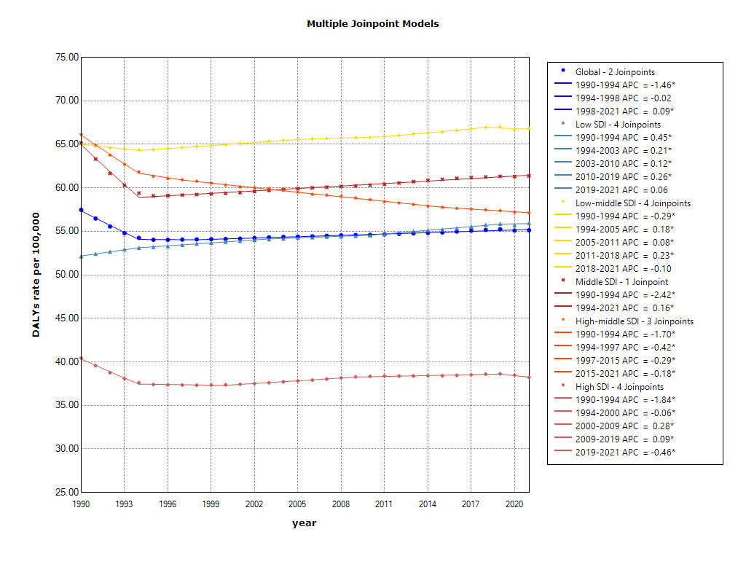
Figure S20. The trends of ASDR of benign prostatic hyperplasia in global and 5 SDI regions from 1990 to 2021. ASDR = Age-standardized DALYs rate (*: p<0.05).

