New Tetrahydroisoquinolines Bearing Nitrophenyl Group Targeting HSP90 and RET Enzymes: Synthesis, Characterization and Biological Evaluation.
Etify A. Bakhite^{*1}, Reda Hassanien², Nasser Farhan², Eman M. Sayed^{*2, 3}, Marwa Sharaky ⁴
¹Chemistry Department, Faculty of Science, Assuit University, 71516 Assiut, Egypt.
²Chemistry Department, Faculty of Science, New Valley University, 72511 El-Kharja, Egypt
.³ South Egypt cancer institute- Assuit university- 71516 Assiut - Egypt.
⁴ Pharmacology Unit - Cancer Biology Department - National Cancer Institute - Cairo University-12613 EL- Gize, EGYPT.
Figure S1: FT-IR spectrum of the start 7-acetyl-6-hydroxy-1,6-dimethyl-8-(3-nitrophenyl)-3-thioxo-2,3,5,6,7,8-hexahydroisoquinoline-4-carbonitrile (2a)
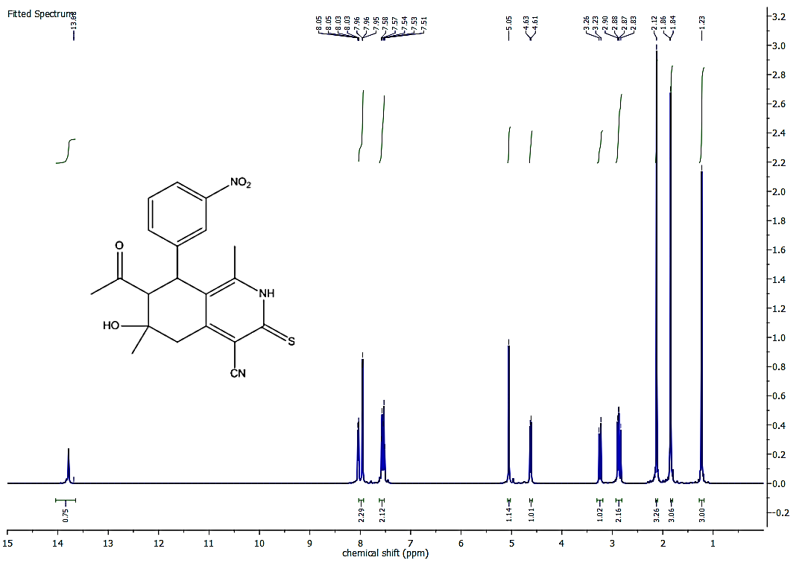
Figure S 2: ¹H NMR spectrum of the start 7-acetyl-6-hydroxy-1,6-dimethyl-8-(3-nitrophenyl)-3-thioxo-2,3,5,6,7,8-hexahydroisoquinoline-4-carbonitrile (2a)

Figure S3: FT-IR spectrum of the start 7-acetyl-6-hydroxy-1,6-dimethyl-8-(4-nitrophenyl)-3-thioxo-2,3,5,6,7,8-hexahydroisoquinoline-4-carbonitrile (2b)

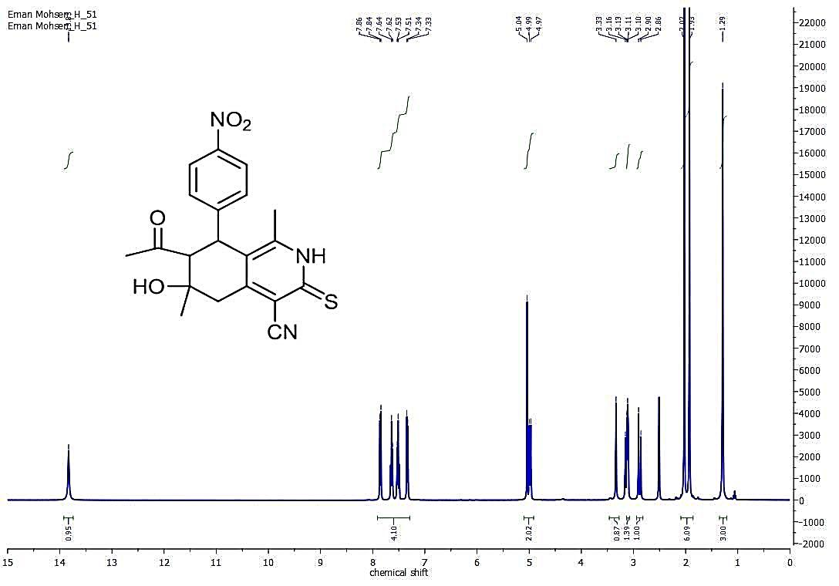
Figure S4: ¹HNMR spectrum of the start 7-acetyl-6-hydroxy-1,6-dimethyl-8-(4-nitrophenyl)-3-thioxo-2,3,5,6,7,8-hexahydroisoquinoline-4-carbonitrile (2b)

Figure S5: FT-IR spectrum of the start 7-acetyl-3-(ethylthio)-6-hydroxy-1,6-dimethyl-8-(3-nitrophenyl)-5,6,7,8-tetrahydroisoquinoline-4-carbonitrile (3).

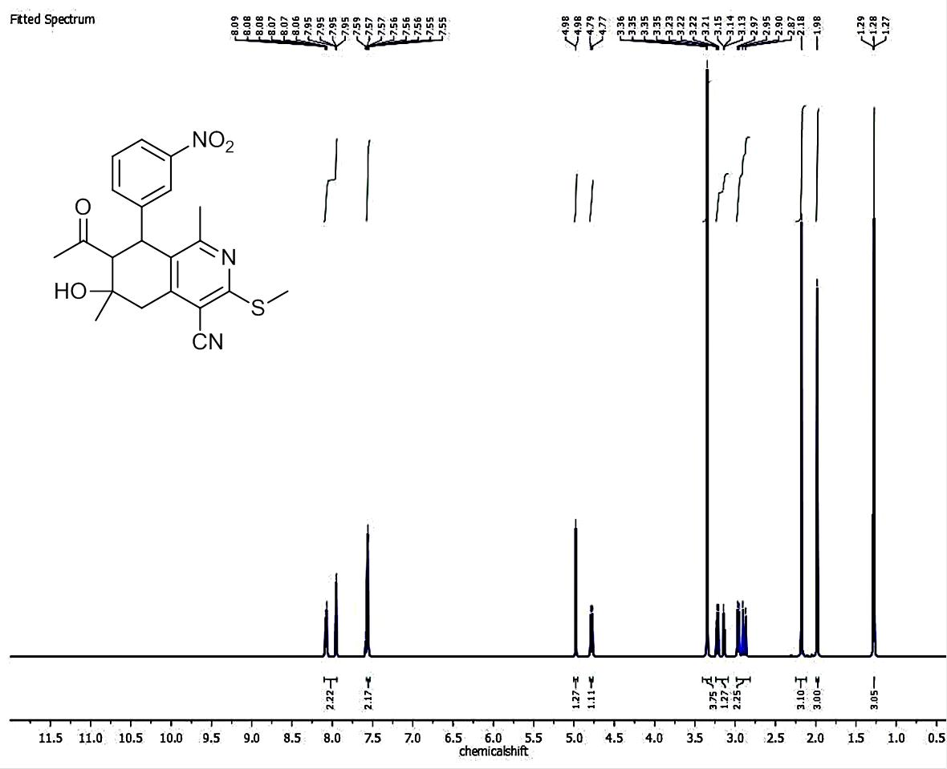

Figure S 6: ¹H NMR spectrum of the start 7-acetyl-3-(ethylthio)-6-hydroxy-1,6-dimethyl-8-(3-nitrophenyl)-5,6,7,8-tetrahydroisoquinoline-4-carbonitrile (3).
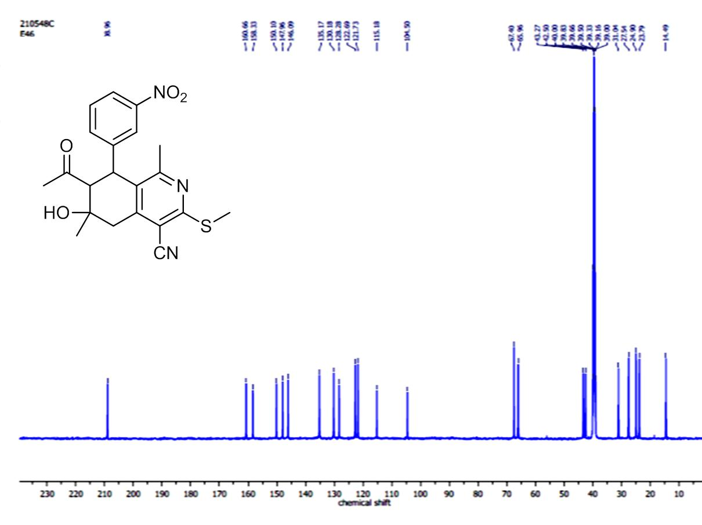

Figure S7: C13 spectrum of the start 7-acetyl-3-(ethylthio)-6-hydroxy-1,6-dimethyl-8-(3-nitrophenyl)-5,6,7,8-tetrahydroisoquinoline-4-carbonitrile (3).

Figure S8: FT-IR spectrum of the ethyl 2-((7-acetyl-4-cyano-6-hydroxy-1,6-dimethyl-8-(3-nitrophenyl)-5,6,7,8-tetrahydroisoquinolin-3-yl)thio)acetate (4).
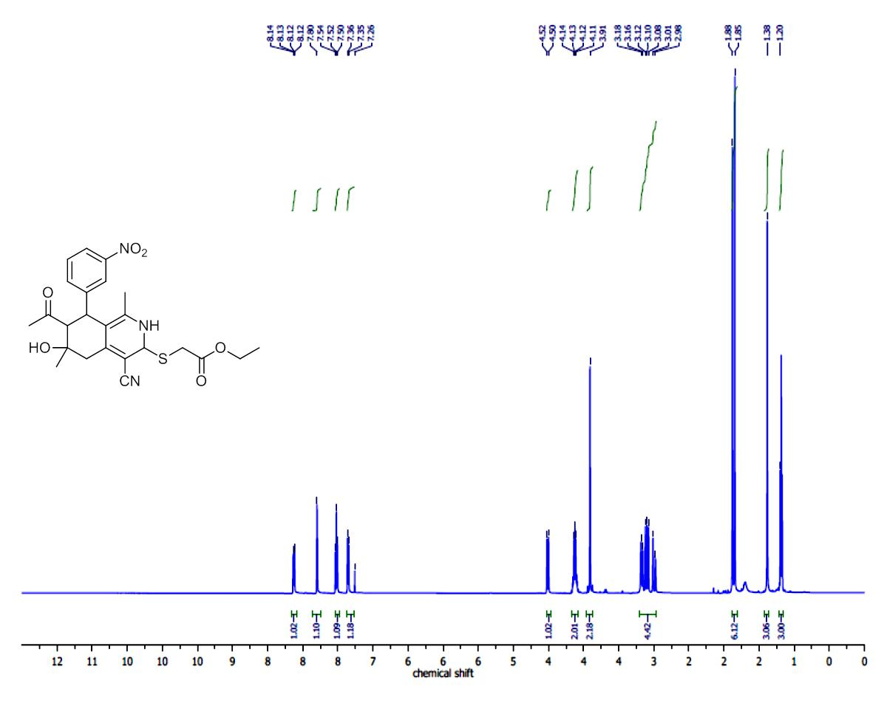
Figure S9: ¹H NMR spectrum of the ethyl 2-((7-acetyl-4-cyano-6-hydroxy-1,
6-dimethyl-8-(3-nitrophenyl)-5,6,7,8-tetrahydroisoquinolin-3-yl)thio)acetate (4).

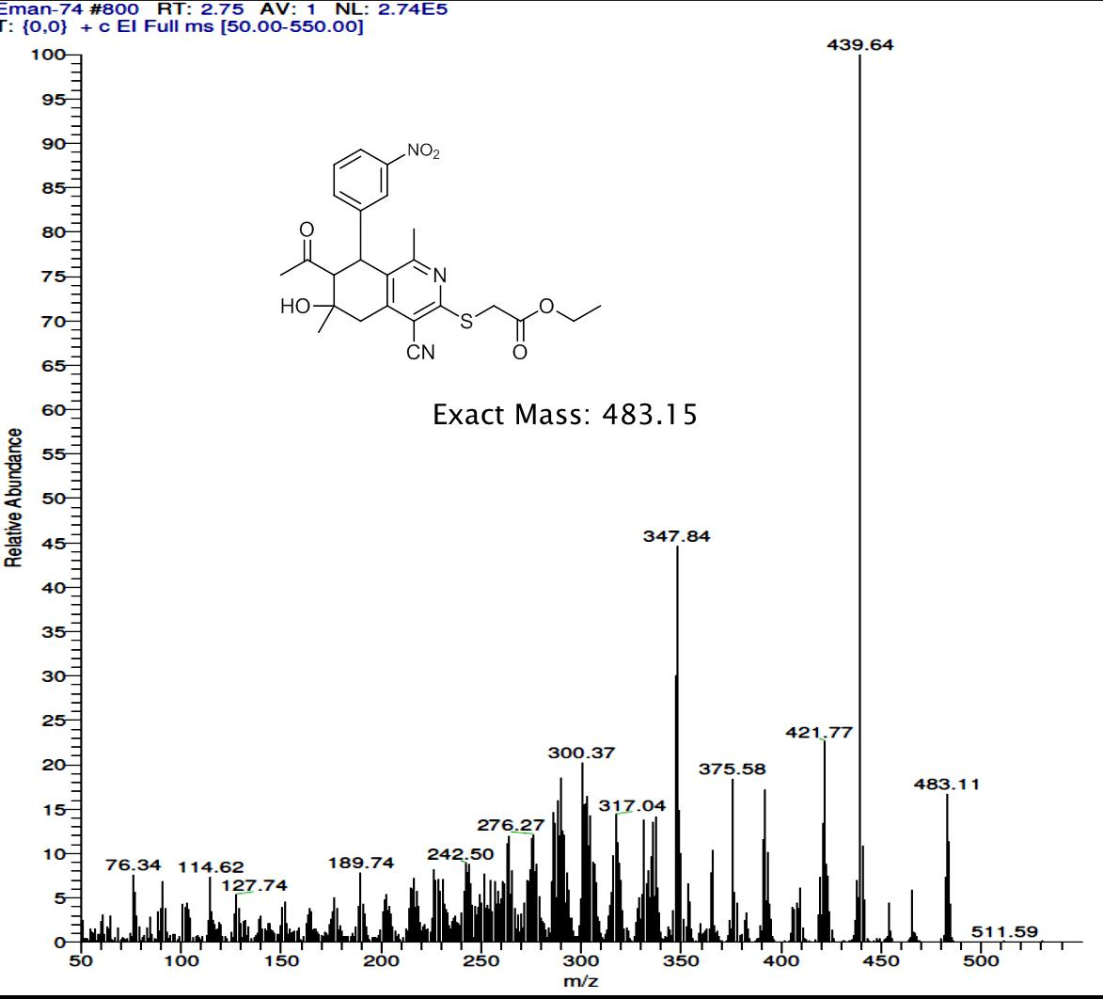
Figure S10: Mass spectrum of the ethyl 2-((7-acetyl-4-cyano-6-hydroxy-1,6-
dimethyl-8-(3-nitrophenyl)-5,6,7,8-tetrahydroisoquinolin-3-yl)thio)acetate (4).

Figure S11: FT-IR Spectrum of the 7-acetyl-3-((cyanomethyl)thio)-6-hydroxy-6-methyl-8-(4-nitrophenyl)-5,6,7,8-tetrahydroisoquinoline-4-carbonitrile (5).

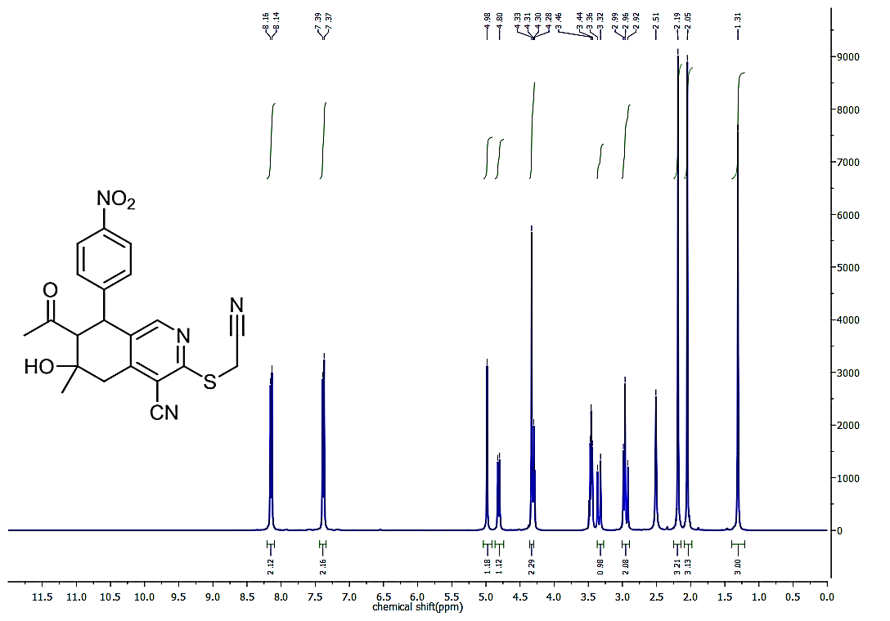
Figure S12: ¹H NMR Spectrum of the 7-acetyl-3-((cyanomethyl)thio)-6-hydroxy-6-methyl-8-(4-nitrophenyl)-5,6,7,8-tetrahydroisoquinoline-4-carbonitrile (5).
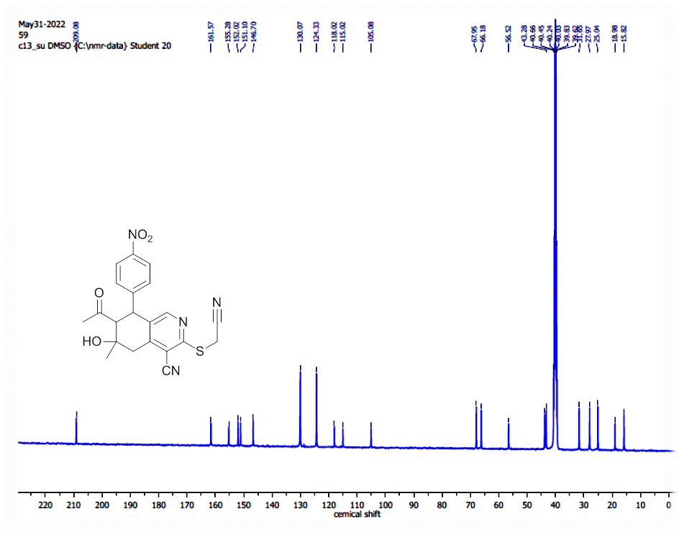
Figure S13: ¹³ CNMR Spectrum of the 7-acetyl-3-((cyanomethyl)thio)-6-hydroxy-6-methyl-8-(4-nitrophenyl)-5,6,7,8-tetrahydroisoquinoline-4-carbonitrile (5)

Figure S14: FT-IR spectrum of the 2-((7-acetyl-4-cyano-6-hydroxy-1,6-dimethyl-8-(3-nitrophenyl)-5,6,7,8-tetrahydroisoquinolin-3-yl)thio)-N-(4-acetylphenyl)acetamide (6a).

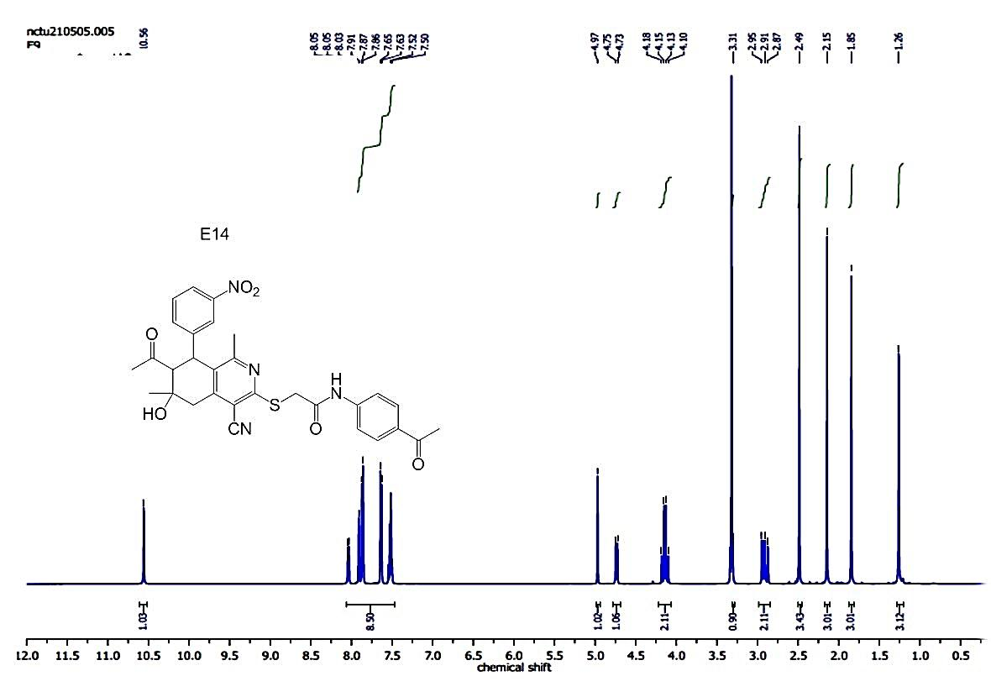
Figure S15: ¹H NMR spectrum of the 2-((7-acetyl-4-cyano-6-hydroxy-1,6-dimethyl-8-(2-nitrophenyl)-5,6,7,8-tetrahydroisoquinolin-3-yl)thio)-N-(4-acetylphenyl)acetamide(6a).
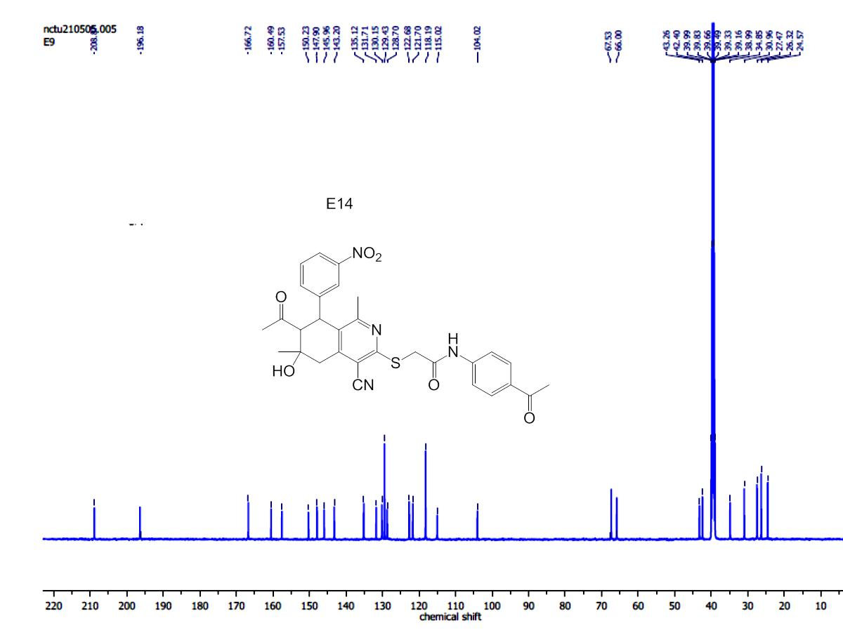
Figure S16: C¹³ spectrum of the 2-((7-acetyl-4-cyano-6-hydroxy-1,6-dimethyl-8-(3-nitrophenyl)-5,6,7,8-tetrahydroisoquinolin-3-yl)thio)-N-(4-acetylphenyl)acetamide (6a).
Figure S17: FT-IR spectrum of the 2-((7-acetyl-4-cyano-6-hydroxy-1,6-dimethyl-8-(3-nitrophenyl)-5,6,7,8-tetrahydroisoquinolin-3-yl)thio)-N-(4-acetylphenyl)acetamide (6b).

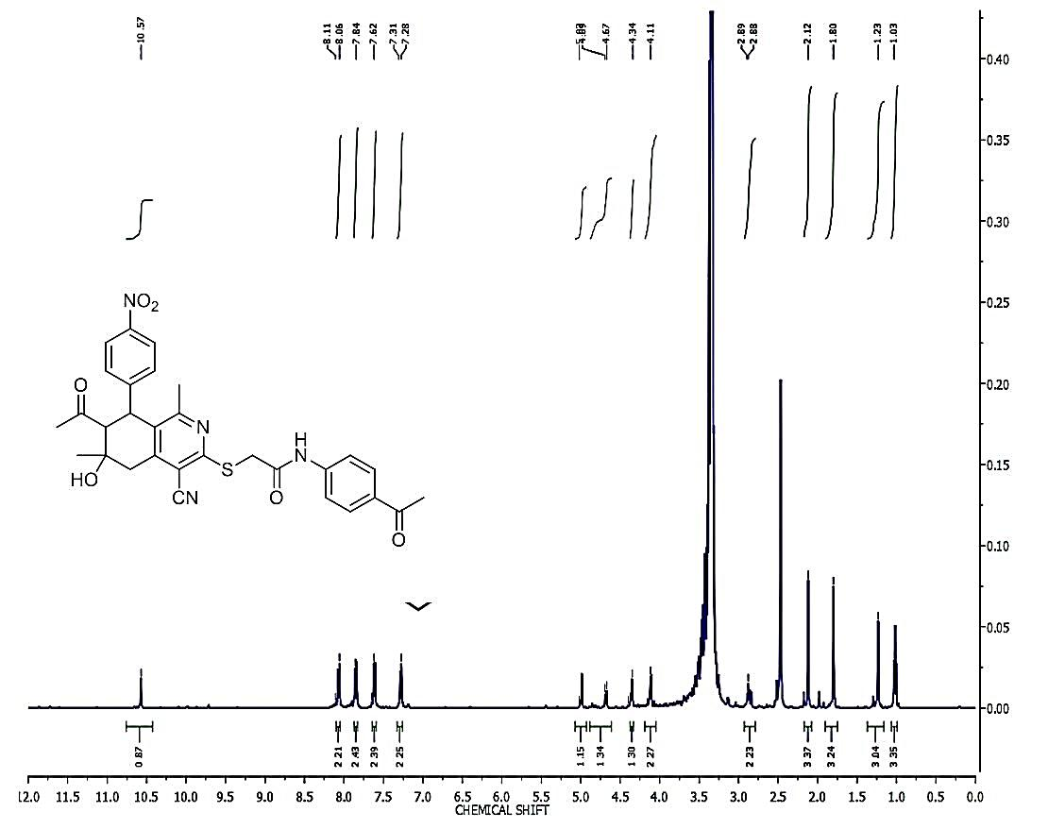
Figure S18: ¹H NMR spectrum of the 2-((7-acetyl-4-cyano-6-hydroxy-1,6-dimethyl-8-(3-nitrophenyl)-5,6,7,8-tetrahydroisoquinolin-3-yl)thio)-N-(4-acetylphenyl)acetamide (6b).

Figure S19: FT-IR spectrum of 2-((7-acetyl-4-cyano-6-hydroxy-1,6-dimethyl-8-(4-nitrophenyl)-5,6,7,8-tetrahydroisoquinolin-3-yl)thio)-N-(4-chlorophenyl)acetamide (6c).
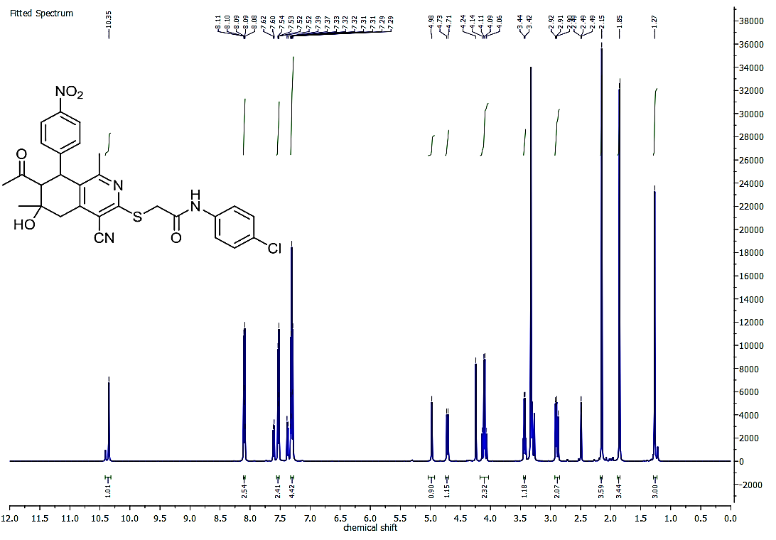
Figure S20: ¹H NMR spectrum of 2-((7-acetyl-4-cyano-6-hydroxy-1,6-dimethyl-8-(4-nitrophenyl)-5,6,7,8-tetrahydroisoquinolin-3-yl)thio)-N-(4-chlorophenyl)acetamide (6c).

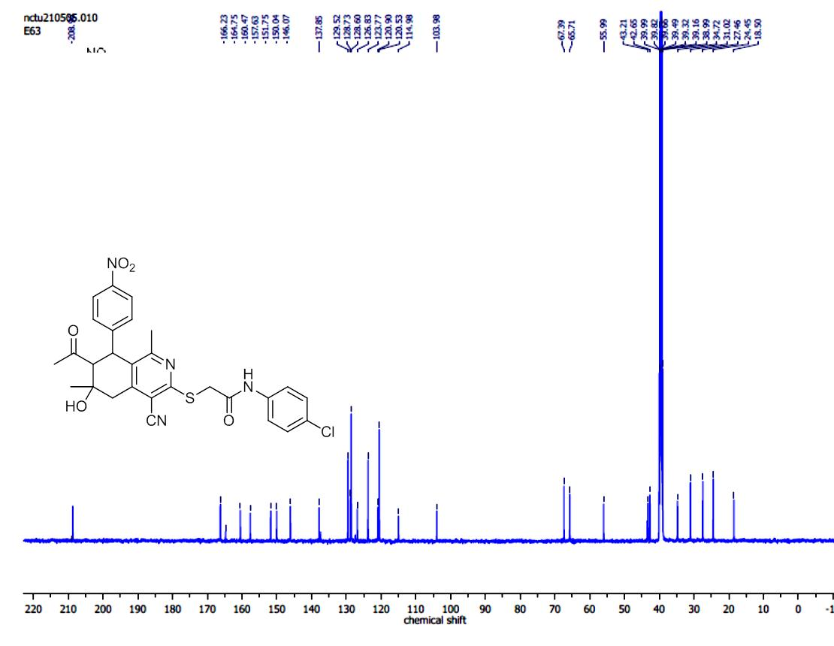
Figure S21: ¹³C spectrum of 2-((7-acetyl-4-cyano-6-hydroxy-1,6-dimethyl-8-(4-nitrophenyl)-5,6,7,8-tetrahydroisoquinolin-3-yl)thio)-N-(4-chlorophenyl)acetamide (6c).

Figure S22: FT-IR spectrum of the 7-acetyl-N-(4-acetylphenyl)-1-amino-8-hydroxy-5,8-dimethyl-6-(3-nitrophenyl)-6,7,8,9-tetrahydrothieno[2,3-c]isoquinoline-2-carboxamide (7a).

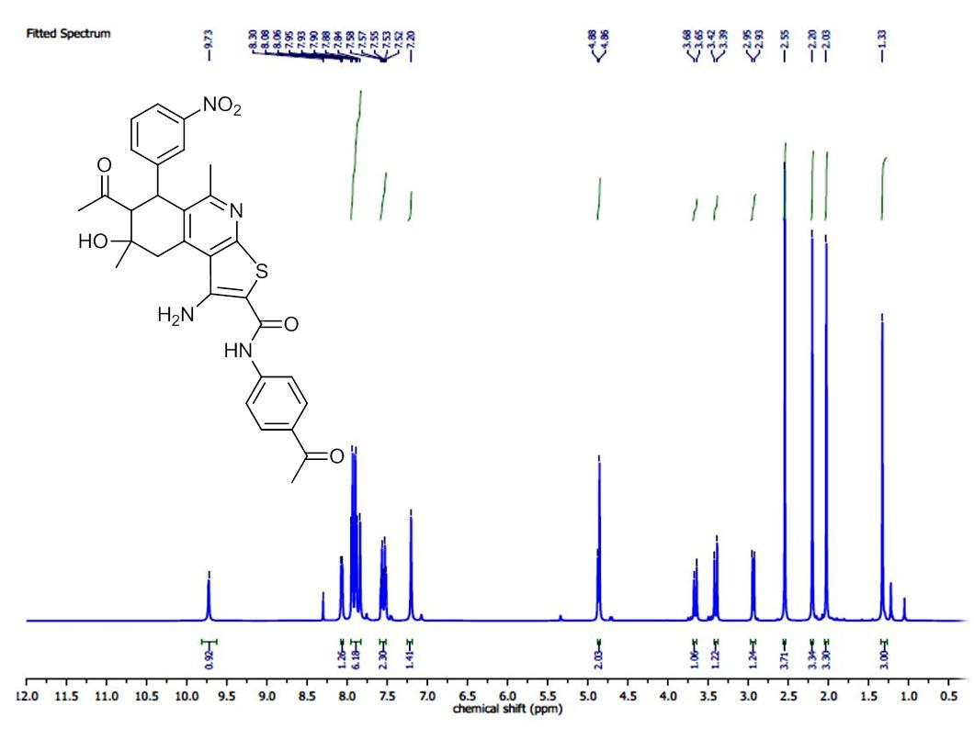

Figure S23: ¹H NMR spectrum of the 7-acetyl-N-(4-acetylphenyl)-1-amino-8-hydroxy-5,8-dimethyl-6-(3-nitrophenyl)-6,7,8,9-tetrahydrothieno[2,3-c]isoquinoline-2-carboxamide (7a).

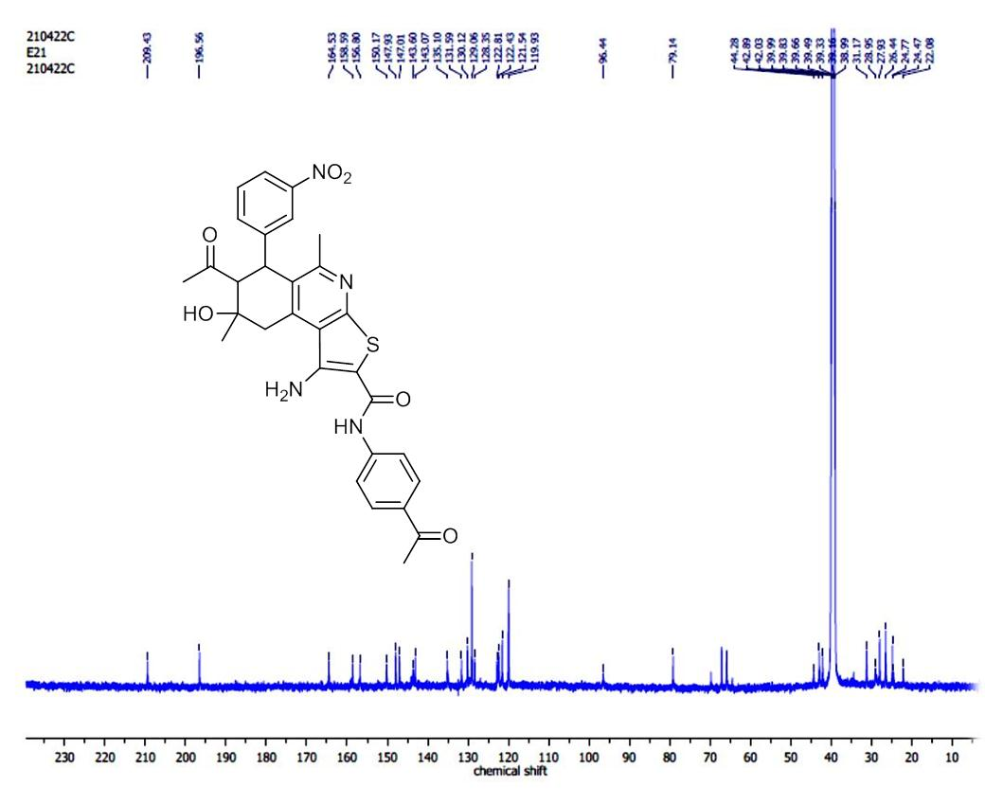
Figure 24: ¹³C NMR Spectrum of the 7-acetyl-N-(4-acetylphenyl)-1-amino-8-hydroxy-5,8-dimethyl-6-(3-nitrophenyl)-6,7,8,9-tetrahydrothieno[2,3-c]isoquinoline-2-carboxamide (7a).

Figure S25: FT-IR spectrum of the 7-acetyl-N-(4-acetylphenyl)-1-amino-8-hydroxy-5,8-dimethyl-6-(4-nitrophenyl)-6,7,8,9-tetrahydrothieno[2,3-c]isoquinoline-2-carboxamide (7b).

Figure S26: ¹HNMR spectrum of the 7-acetyl-N-(4-acetylphenyl)-1-amino-8-hydroxy-5,8-dimethyl-6-(4-nitrophenyl)-6,7,8,9-tetrahydrothieno[2,3-c]isoquinoline-2-carboxamide (7b).

Figure S27: ¹³CNMR spectrum of the 7-acetyl-N-(4-acetylphenyl)-1-amino-8-hydroxy-5,8-dimethyl-6-(4-nitrophenyl)-6,7,8,9-tetrahydrothieno[2,3-c]isoquinoline-2-carboxamide (7b).

Figure S28: FT-IR Spectrum of 7-Acetyl-1-amino-N-(4-chlorophenyl)-5,8-dimethyl-8-hydroxy-6-(3-nitrophenyl)-6,7,8,9-tetrahydrothieno[2,3-c]isoquinoline-2-carboxamide (7C).
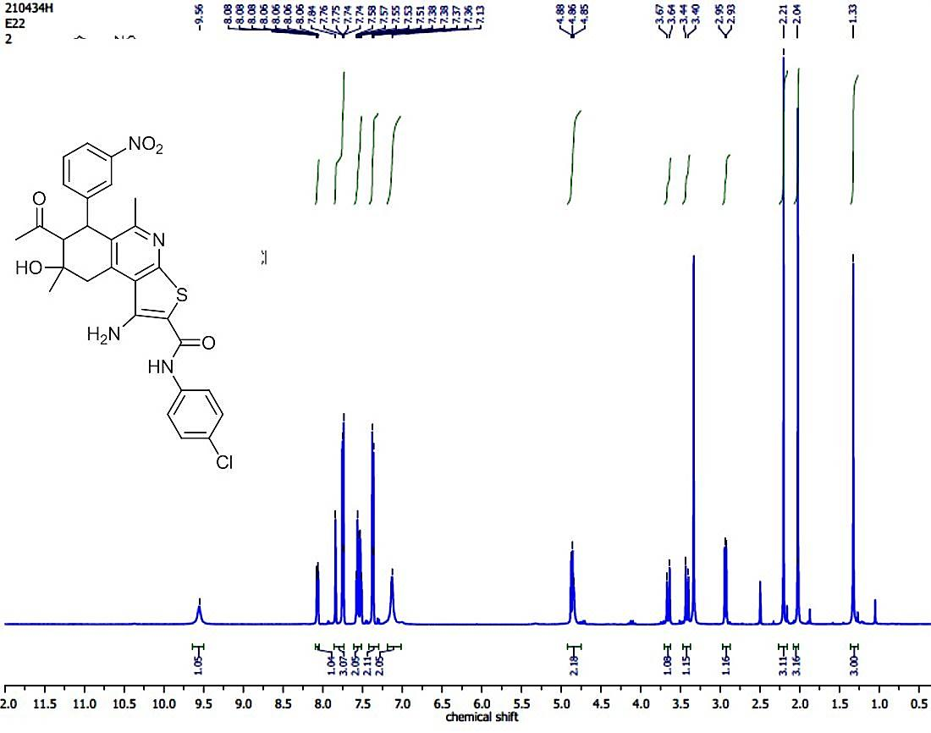
Figure S29:¹H NMR Spectrum of 7-Acetyl-1-amino-N-(4-chlorophenyl)-5,8-dimethyl-8-hydroxy-6-(3-nitrophenyl)-6,7,8,9-tetrahydrothieno[2,3-c]isoquinoline-2-carboxamide (7C) in DMSO-d₆.
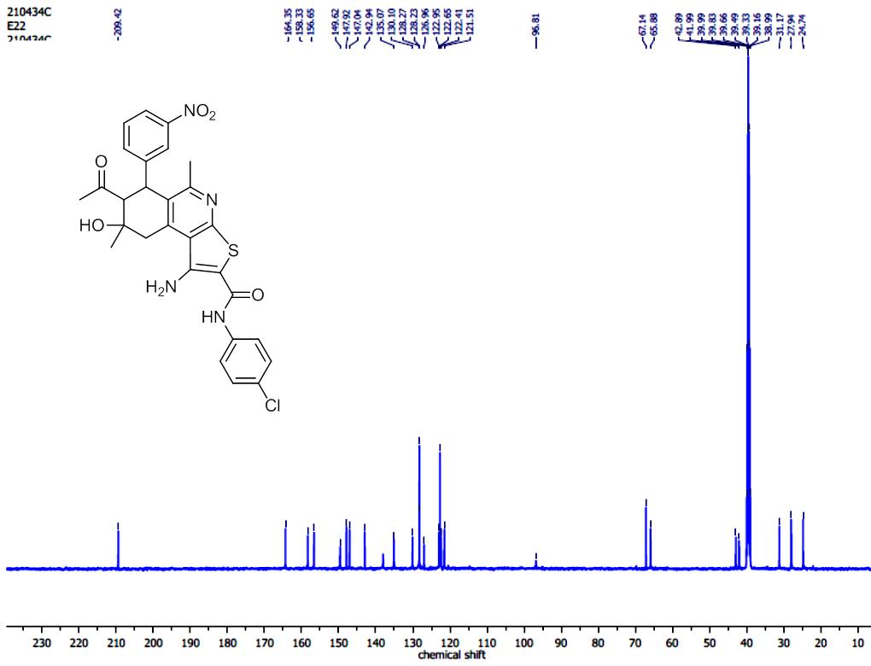
Figure S30: ¹³ C NMR Spectrum of 7-Acetyl-1-amino-N-(4-chlorophenyl)-5,8-dimethyl-8-hydroxy-6-(3-nitrophenyl)-6,7,8,9-tetrahydrothieno[2,3-c]isoquinoline-2-carboxamide (7C) in DMSO-d₆.
Figure S31: FT-IR spectrum of the 2-((7-acetyl-4-cyano-6-hydroxy-1,6-dimethyl-8-(3-nitrophenyl)-5,6,7,8-tetrahydroisoquinolin-3-yl)thio)-N-(naphthalen-1-yl)acetamide (9a).
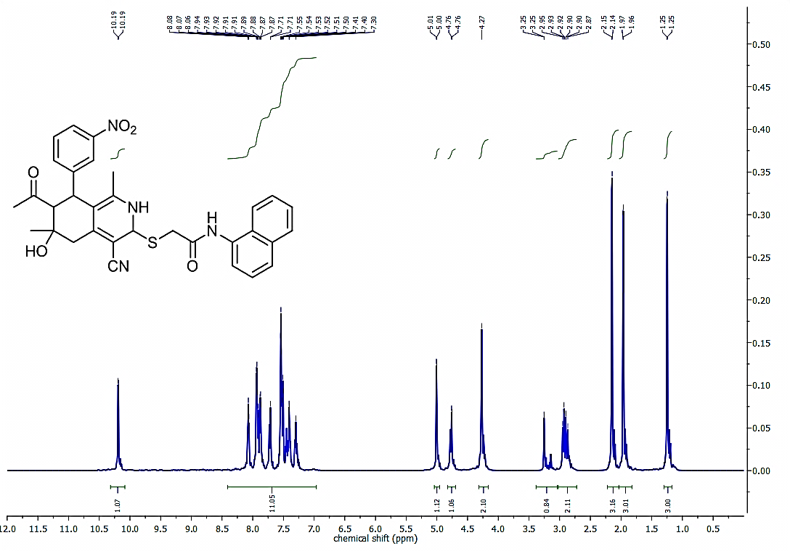
Figure S32: ¹H NMR spectrum of the 2-((7-acetyl-4-cyano-6-hydroxy-1,6-dimethyl-8-(3-nitrophenyl)-5,6,7,8-tetrahydroisoquinolin-3-yl)thio)-N-(naphthalen-1-yl)acetamide (9a).

Figure S33: FT-IR spectrum of the 2-((7-acetyl-4-cyano-6-hydroxy-1,6-dimethyl-8-(4-nitrophenyl)-5,6,7,8-tetrahydroisoquinolin-3-yl)thio)-N-(naphthalen-1-yl)acetamide (9b).

Figure S34: ¹H NMR spectrum of the 2-((7-acetyl-4-cyano-6-hydroxy-1,6-dimethyl-8-(4-nitrophenyl)-5,6,7,8-tetrahydroisoquinolin-3-yl)thio)-N-(naphthalen-1-yl)acetamide (9b).

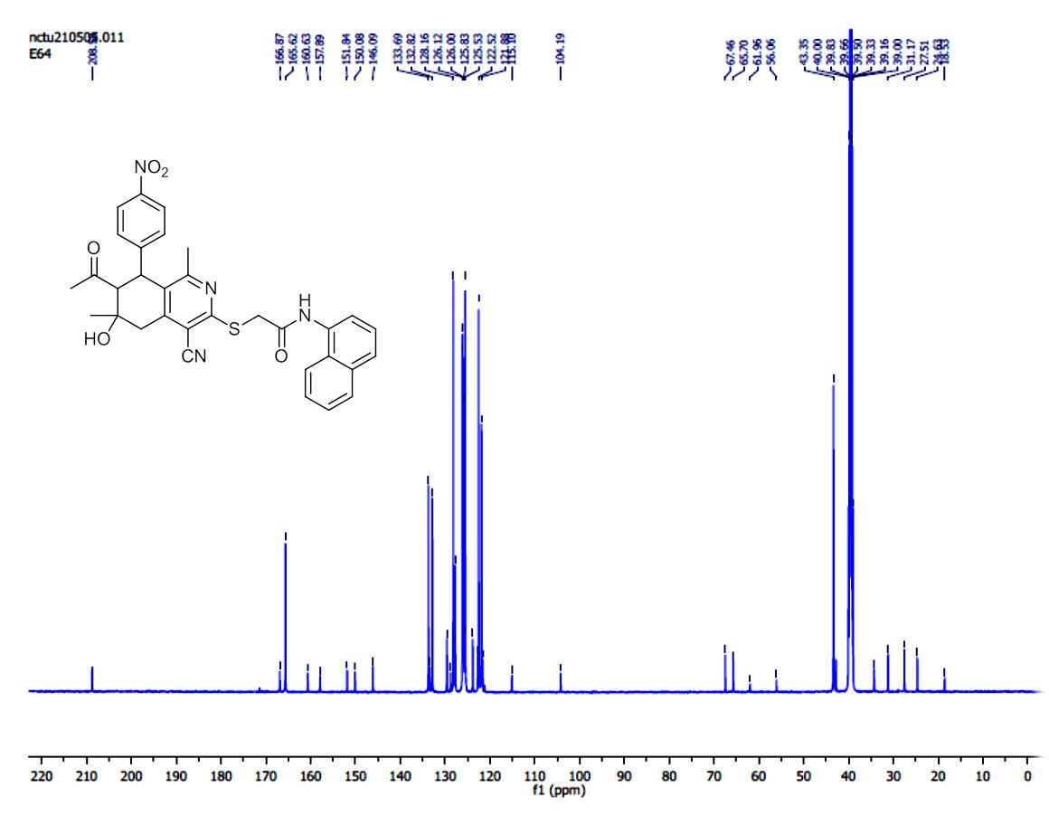
Figure S35: ¹³C spectrum of the 2-((7-acetyl-4-cyano-6-hydroxy-1,6-dimethyl-8-(4-nitrophenyl)-5,6,7,8-tetrahydroisoquinolin-3-yl)thio)-N-(naphthalen-1-yl)acetamide (9b).

Figure S 36: FT-IR Spectrum of 7-Acetyl-1-amino-N (naphthalen-1-yl)-5,8-dimethyl-8-hydroxy-6-(3-nitro- phenyl)-6,7,8,9-tetrahydrothieno[2,3-c]isoquinoline-2-carboxamide (10a).

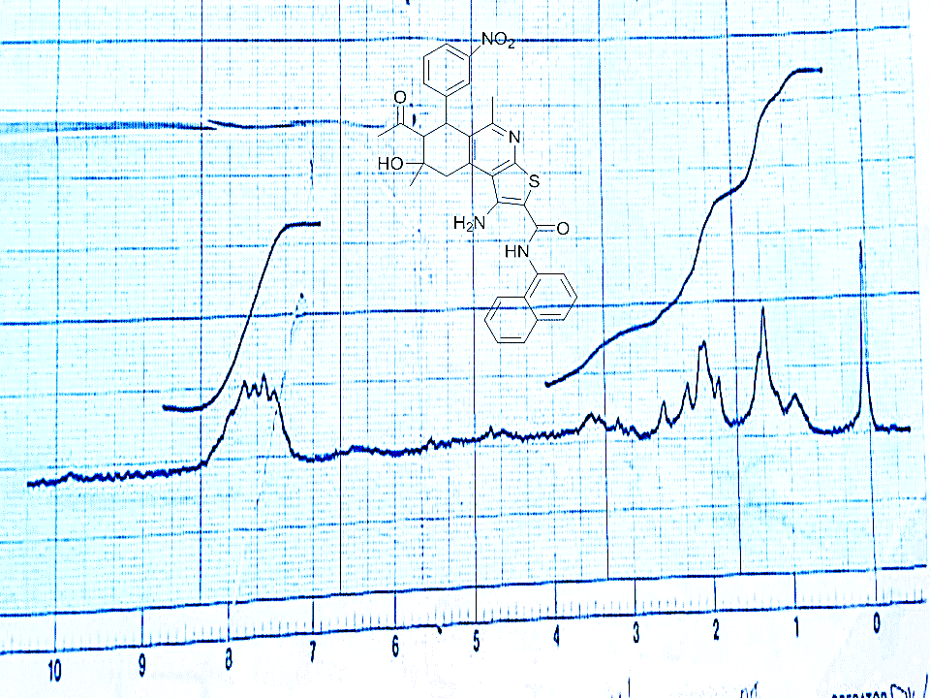

Figure S 37: ¹ HNMR Spectrum of 7-Acetyl-1-amino-N (naphthalen-1-yl)-5,8-dimethyl-8-hydroxy-6-(3-nitro- phenyl)-6,7,8,9-tetrahydrothieno[2,3-c]isoquinoline-2-carboxamide (10a) in CDCl₃.

Figure S38: FT-IR Spectrum of 7-Acetyl-1-amino-N (naphthalen-1-yl)-5,8-dimethyl-8-hydroxy-6-(4-nitro- phenyl)-6,7,8,9-tetrahydrothieno[2,3-c]isoquinoline-2-carboxamide (10b).

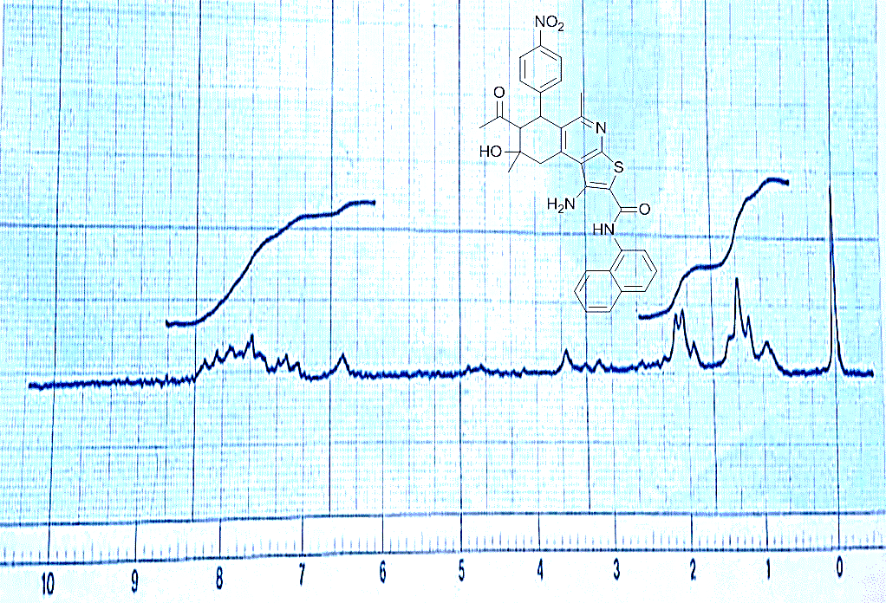

Figure S39: ¹H NMR Spectrum of 7-Acetyl-1-amino-N (naphthalen-1-yl)-5,8-dimethyl-8-hydroxy-6-(4-nitro- phenyl)-6,7,8,9-tetrahydrothieno[2,3-c]isoquinoline-2-carboxamide (10b) in CDCl_{3.}

Figure S40: FT-IR spectrum of the 2-((7-acetyl-4-cyano-6-hydroxy-1,6-dimethyl-8-(3-nitrophenyl)-2,3,5,6,7,8-hexahydroisoquinolin-3-yl)thio)-N-phenylacetamide (13).

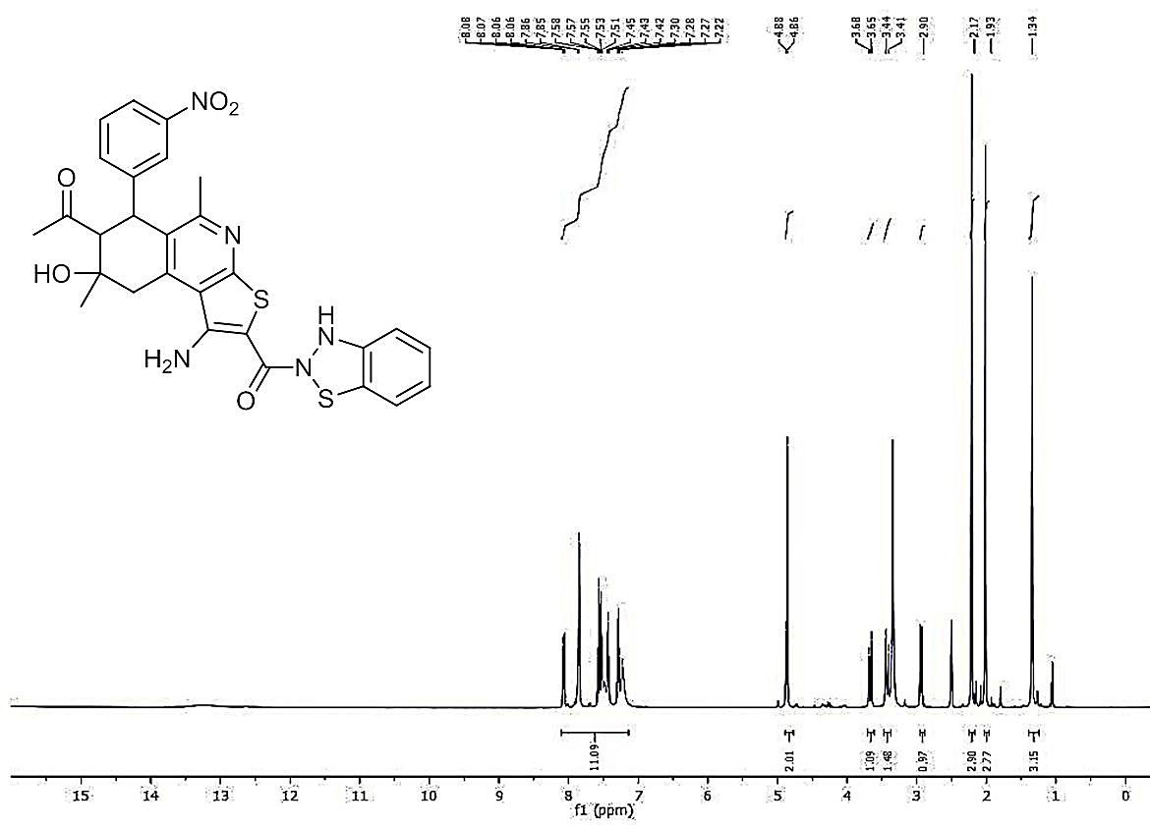
Figure S41: ¹H NMR spectrum of the 2-((7-acetyl-4-cyano-6-hydroxy-1,6-dimethyl-8-(3-nitrophenyl)-2,3,5,6,7,8-hexahydroisoquinolin-3-yl)thio)-N-phenylacetamide (13).
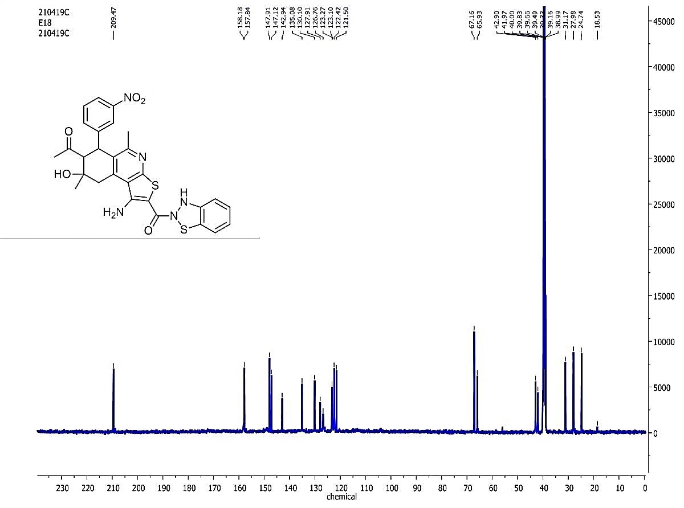
Figure S42: ¹³C spectrum of the 2-((7-acetyl-4-cyano-6-hydroxy-1,6-dimethyl-8-(3-nitrophenyl)-2,3,5,6,7,8-hexahydroisoquinolin-3-yl)thio)-N-phenylacetamide (13).

Table S1: one spot concentration of all synthesized compounds against eight cell lines.

COMPD.NO. | MG-63 | S.D. | HCT116 | S.D. | CACO2 | S.D. | A549 | S.D.
3 | 44.257467 | 5.0615101 | 67.072323 | 1.5623534 | 59.170306 | 2.9743363 | 50.552251 | 1.2551645
4 | 53.76525 | 1.0201393 | 56.815021 | 2.7360661 | 64.379289 | 1.2773297 | 47.196262 | 2.1565064
5 | 55.742533 | 4.3010107 | 58.936022 | 2.1638884 | 61.540861 | 2.316797 | 55.225149 | 2.5307342
13 | 46.739588 | 2.7157049 | 59.179416 | 4.3827403 | 60.636307 | 4.2070406 | 47.408666 | 2.6924302
2a | 41.901557 | 4.5335982 | 62.308762 | 2.7545622 | 55.1466 | 2.4425168 | 42.438403 | 3.4204367
6a | 45.814051 | 2.9228698 | 58.10153 | 1.2531865 | 54.834685 | 2.7286783 | 20.305862 | 5.7353913
7a | 50.441733 | 2.051956 | 59.700974 | 1.6700709 | 58.203369 | 3.2862301 | 46.813934 | 3.3265543
9a | 38.4939 | 2.012768 | 56.05007 | 3.3139785 | 53.181535 | 0.8893685 | 46.17672 | 0.9899049
9b | 57.509466 | 2.1467986 | 67.524339 | 1.0705705 | 41.671865 | 1.9479095 | 15.208156 | 7.4587528
10b | 30.164072 | 4.0570681 | 55.632823 | 3.4945665 | 51.746725 | 3.607579 | 44.987256 | 1.0987695
DOX | 63.819941 | 1.9278821 | 70.862309 | 5.1487372 | 74.828447 | 4.2398668 | 32.030586 | 1.9467186

Table S1 Continued:

COMPD.NO. | H460 | S.D. | HUH7 | S.D. | HEPG2 | S.D. | MCF7 | S.D. | HSF | S.D.
3 | 62.004326 | 1.6105485 | 32.940847 | 4.2172522 | 67.742789 | 0.6657711 | 71.531792 | 1.7520745 | 50.605971 | 3.7508045
4 | 66.762797 | 0.903386 | 27.474068 | 3.5025507 | 62.132839 | 2.33886 | 76.32948 | 1.4194253 | 49.423589 | 6.20265
5 | 66.594569 | 2.5320004 | 35.49201 | 4.2678266 | 68.245568 | 4.2007166 | 67.630058 | 3.0449866 | 66.834171 | 1.365191
13 | 63.326124 | 1.3398087 | 21.754976 | 3.7142623 | 55.22625 | 1.6404323 | 75.433526 | 0.9024564 | 54.655631 | 1.5994974
2a | 55.299207 | 1.9075352 | 27.389964 | 3.9746136 | 61.286055 | 0.4372244 | 73.988439 | 2.6011561 | 46.201596 | 1.3545893
6a | 63.47032 | 3.4072211 | 38.631904 | 3.0791054 | 59.486637 | 2.4906658 | 66.358382 | 3.908472 | 53.502808 | 1.8943506
7a | 59.865417 | 2.7295882 | 32.352117 | 6.2692024 | 58.666314 | 2.1098385 | 57.919075 | 6.4450219 | 51.847473 | 2.384451
9a | 59.552992 | 3.0951821 | 25.876086 | 8.4713243 | 59.962953 | 1.1236239 | 72.369942 | 2.4298092 | 56.902158 | 3.2071785
9b | 62.028359 | 2.2026319 | 30.165405 | 5.2187598 | 66.631384 | 3.8116343 | 57.225434 | 2.6488877 | 48.152527 | 5.917157
10b | 58.038933 | 4.0886653 | 35.688253 | 1.7847821 | 69.965599 | 1.0719571 | 55.202312 | 1.8049127 | 56.222288 | 1.4197824
DPX | 72.891132 | 1.806772 | 52.761424 | 1.2874643 | 58.904472 | 0.5958365 | 73.959538 | 0.1324444 | 58.912208 | 4.1907913

Table2: cytotoxicity of the sythnsizedcompounds.
compound number | Concentration 0 | Concentration 12.5 | Concentration 25 | Concentration 50 | Concentration 100
3 | 1.0276 | 0.7687 | 0.6657 | 0.63227 | 0.4568
 | 0.9103 | 0.6287 | 0.6563 | 0.62339 | 0.3317
 | 1.0266 | 0.72896 | 0.5889 | 0.61914 | 0.3526
AVERGE | 0.9881667 | 0.7087867 | 0.6369667 | 0.6249333 | 0.3803667
4 | 0 | 12.5 | 25 | 50 | 100
 | 1.0276 | 0.7104 | 0.7231 | 0.53934 | 0.479
 | 0.9103 | 0.76882 | 0.7277 | 0.49132 | 0.4559
 | 1.0266 | 0.86413 | 0.7515 | 0.53432 | 0.53984
AVERGE | 0.9881667 | 0.7811167 | 0.7341 | 0.52166 | 0.49158
13 | 0 | 12.5 | 25 | 50 | 100
 | 1.0276 | 0.997437 | 1.0244 | 0.8607 | 0.73312
 | 0.9103 | 0.986 | 0.92 | 0.85914 | 0.64231
 | 1.0266 | 1.1 | 0.9654 | 0.9302 | 0.64832
AVERGE | 0.9881667 | 1.0278123 | 0.9699333 | 0.8833467 | 0.6745833
2A | 0 | 12.5 | 25 | 50 | 100
 | 1.0276 | 0.96577 | 0.74688 | 0.64552 | 0.4277
 | 0.9103 | 0.96412 | 0.74415 | 0.64778 | 0.42184
 | 1.0266 | 1.1486 | 0.8787 | 0.7304 | 0.3671
AVERGE | 0.9881667 | 1.0261633 | 0.78991 | 0.6745667 | 0.4055467
6A | 0 | 12.5 | 25 | 50 | 100
 | 1.0276 | 0.8094 | 0.7265 | 0.65253 | 0.4895
 | 0.9103 | 0.9004 | 0.7856 | 0.6182 | 0.4568
 | 1.0266 | 0.8971 | 0.8697 | 0.7192 | 0.5797
AVERGE | 0.9881667 | 0.8689667 | 0.7939333 | 0.66331 | 0.5086667
7A | 0 | 12.5 | 25 | 50 | 100
 | 1.0276 | 0.9779 | 0.8015 | 0.7673 | 0.4356
 | 0.9103 | 0.9423 | 0.8177 | 0.6711 | 0.5604
 | 1.0266 | 1.0361 | 0.9059994 | 0.7619 | 0.4229
AVERGE | 0.9881667 | 0.9854333 | 0.8417332 | 0.7334333 | 0.4729667
 | 0 | 12.5 | 25 | 50 | 100
9A | 1.3043 | 1.1856 | 0.8324 | 0.76209 | 0.5543
 | 1.3043 | 1.1645 | 0.9594 | 0.8064 | 0.6353
 | 1.3043 | 1.0852 | 0.9527 | 0.7671 | 0.6449
AVERGE | 1.3043 | 1.1451 | 0.9148333 | 0.77853 | 0.6115
9B | 0 | 12.5 | 25 | 50 | 100
 | 0.9063 | 0.9329 | 0.8067 | 0.68007 | 0.4501
 | 0.8542 | 0.98791 | 0.8494 | 0.636 | 0.3823
 | 0.9211 | 0.8723 | 0.8704 | 0.5876 | 0.417
AVERGE | 0.8938667 | 0.9310367 | 0.8421667 | 0.6345567 | 0.4164667
10B | 0 | 12.5 | 25 | 50 | 100
 | 0.9063 | 0.9726 | 0.7934 | 0.6021 | 0.3938
 | 0.8542 | 0.9995728 | 0.7536 | 0.667 | 0.371
 | 0.9211 | 0.899 | 0.7874 | 0.6503 | 0.4041
AVERGE | 0.8938667 | 0.9570576 | 0.7781333 | 0.6398 | 0.3896333

Table S3: Cytotoxicity of DOX against HEPG2.

Figure 43: Cytotoxicity of DOX against HEPG2.

Table S4: Cytotoxicity of DOX against MCF7.

Figure 44: Cytotoxicity of DOX against MCF7.

Table S5: interactions of 9b compound with RET enzyme.
Interaction | Distance | category | Type
LYS893 | 2.71327 | Hydrogen Bond | Conventional Hydrogen Bond
PRO892 | 3.4556666 | Hydrogen Bond | Carbon Hydrogen Bond
VAL892 | 3.75965 | Hydrophobic | Pi-Sigma
ARG889 | 5.4818 | Hydrophobic | Pi-Alkyl
PRO931 | 4.48016 | Hydrophobic | Pi-Alkyl

Table S6: interactions of Standard compound with RET enzyme
interactions
Interaction | Distance | category | Type
A:GLU935:CA - :UNL1:O | 3.21679 | Hydrogen Bond | Carbon Hydrogen Bond
A:ILE890:CD1 - :UNL1 | 3.38069 | Hydrophobic | Pi-Sigma
A:HIS903 - :UNL1:C | 4.53641 | Hydrophobic | Pi-Alkyl

Table S7: interactions of compound 3 with HSP90 enzyme.
Interaction | distance | Category | Type
A:TYR305:HH - :UNK1:O | 2.4645 | Hydrogen Bond | Conventional Hydrogen Bond
A:ARG378:HE - :UNK1:O | 2.41396 | Hydrogen Bond | Conventional Hydrogen Bond
A:ARG378:HH22 - :UNK1:O | 2.71189 | Hydrogen Bond | Conventional Hydrogen Bond
A:ASP311:OD2 - :UNK1 | 4.04436 | Electrostatic | Pi-Anion
:UNK1:S - A:PHE341 | 5.27227 | Other | Pi-Sulfur
A:PHE341 - :UNK1 | 5.2244 | Hydrophobic | Pi-Pi T-shaped
A:PHE341 - :UNK1:C | 4.96597 | Hydrophobic | Pi-Alkyl

Table S8: interactions of standered compound with HSP90 enzyme.
Interaction | distance | Category | Type
:UNL1:C - A:ASP364:OD2 | 3.37557 | Hydrogen Bond | Carbon Hydrogen Bond
A:ARG378:NH1 - :UNL1 | 4.42611 | Electrostatic | Pi-Cation

