Nitrophenyl-group-containing Heterocycles. 3. New Isoquinolines, as antiprolifative agents against MCF7and HEGP2 Cell lines. Synthesis, characterization and biological Evaluation.
Etify A. Bakhite, Reda Hassanien², Naseer Farhan², Eman M. Sayed^{2, 3*}, Marwa Sharaky ⁴
¹Chemistry Department, Faculty of Science, Assuit University, Assiut 71516, Egypt.
²Chemistry Department, Faculty of Science, New Valley University, 72511 El-Kharja, Egypt.³ South Egypt cancer institute- Assuit university- Egypt.
⁴ Pharmacology Unit - Cancer Biology Department - National Cancer Institute - Cairo University.

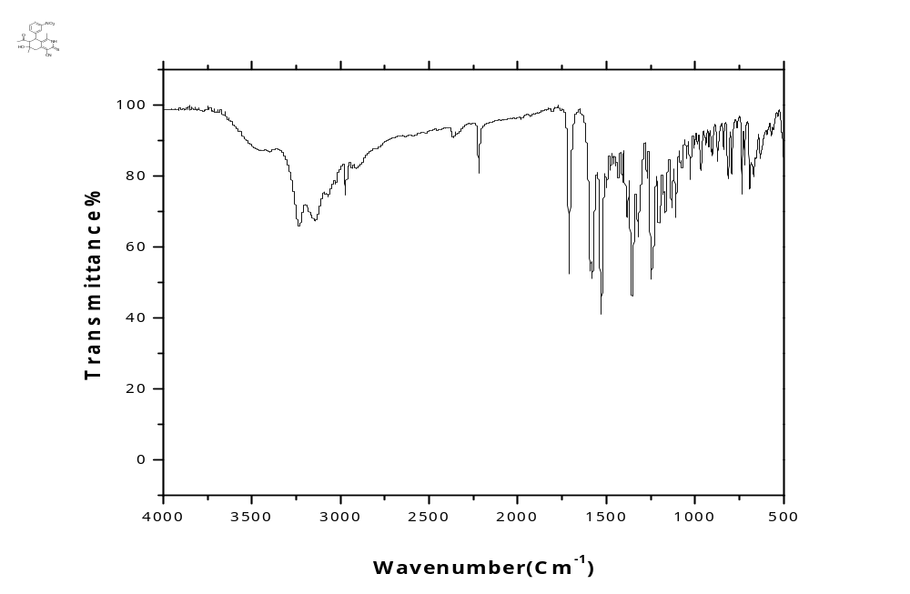
Figure S1: FT-IR spectrum of the start 7-acetyl-6-hydroxy-1,6-dimethyl-8-(3-nitrophenyl)-3-thioxo-2,3,5,6,7,8-hexahydroisoquinoline-4-carbonitrile (2a).
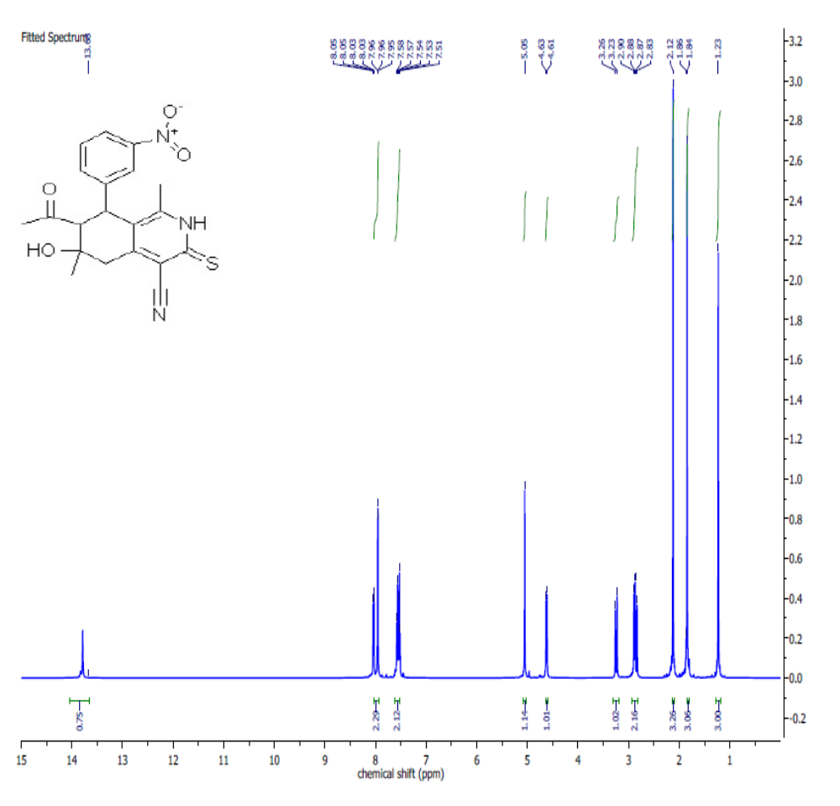
Figure S 2: ¹H NMR spectrum of the start 7-acetyl-6-hydroxy-1,6-dimethyl-8-(3-nitrophenyl)-3-thioxo-2,3,5,6,7,8-hexahydroisoquinoline-4-carbonitrile (2a)

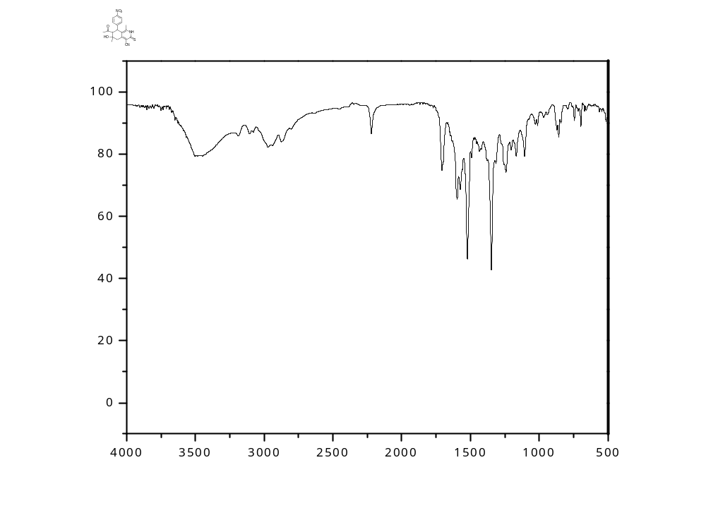
Figure S3: FT-IR spectrum of the start 7-acetyl-6-hydroxy-1,6-dimethyl-8-(4-nitrophenyl)-3-thioxo-2,3,5,6,7,8-hexahydroisoquinoline-4-carbonitrile (2b)

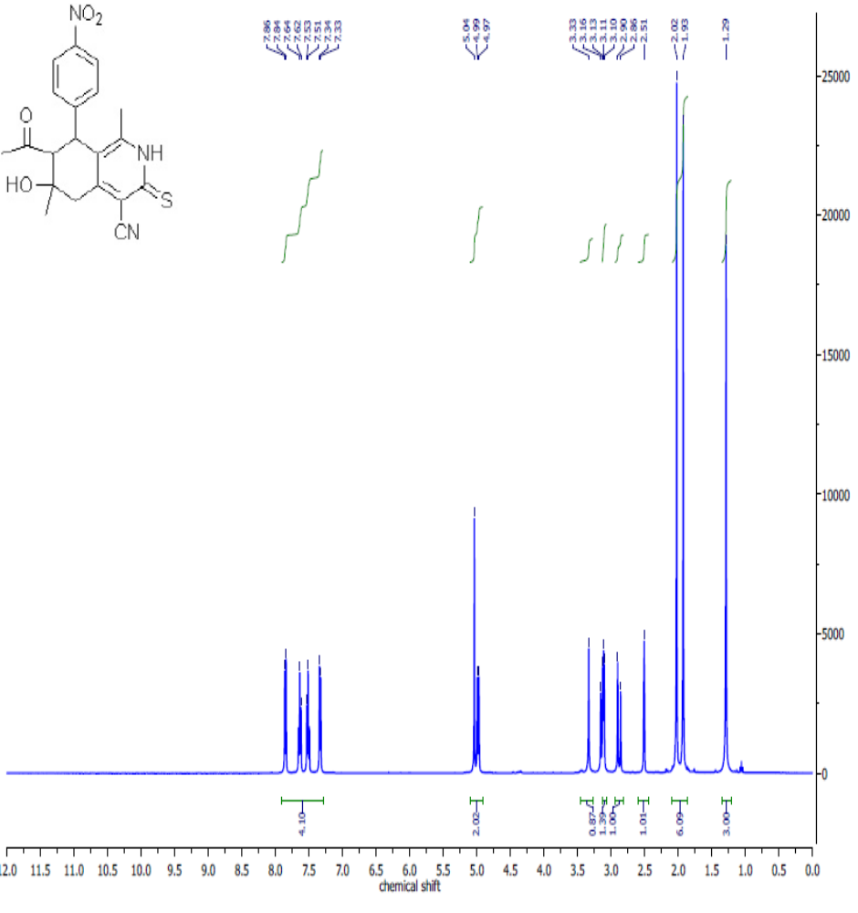
Figure S4: ¹H NMR spectrum of the start 7-acetyl-6-hydroxy-1,6-dimethyl-8-(4-nitrophenyl)-3-thioxo-2,3,5,6,7,8-hexahydroisoquinoline-4-carbonitrile (2b).
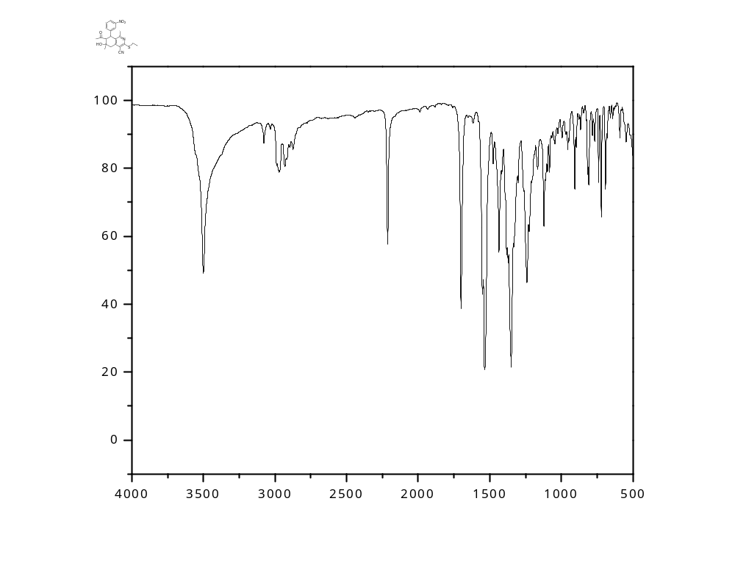
Figure S5: FT-IR spectrum of the start 7-acetyl-3-(ethylthio)-6-hydroxy-1,6-dimethyl-8-(3-nitrophenyl)-5,6,7,8-tetrahydroisoquinoline-4-carbonitrile (3).

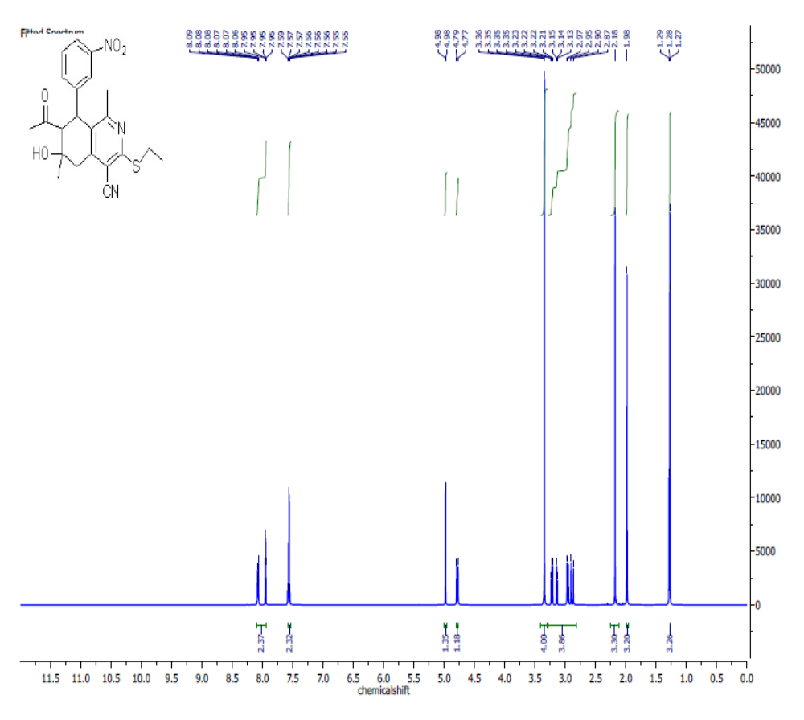

Figure S 6: ¹H NMR spectrum of the start 7-acetyl-3-(ethylthio)-6-hydroxy-1,6-dimethyl-8-(3-nitrophenyl)-5,6,7,8-tetrahydroisoquinoline-4-carbonitrile (3).
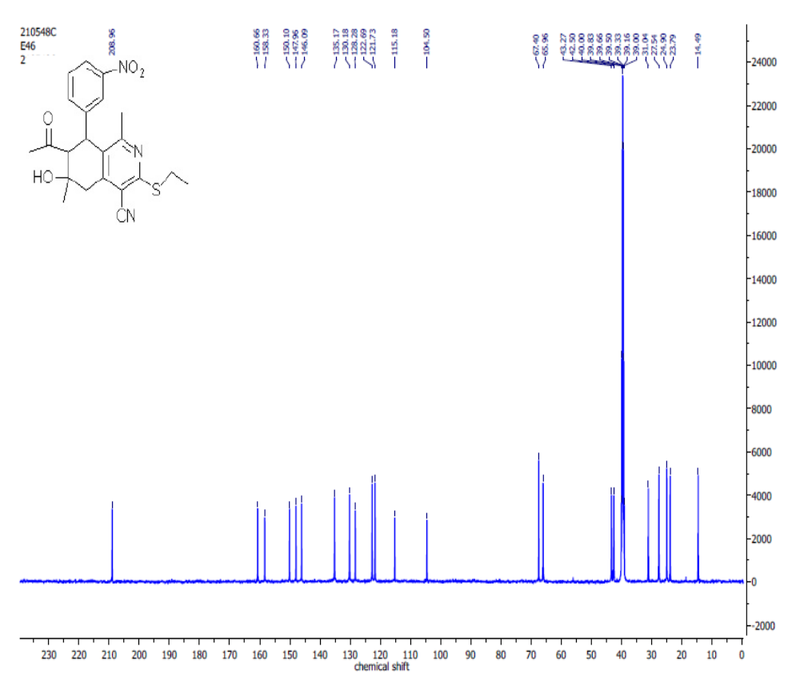

Figure S7: C13 spectrum of the start 7-acetyl-3-(ethylthio)-6-hydroxy-1,6-dimethyl-8-(3-nitrophenyl)-5,6,7,8-tetrahydroisoquinoline-4-carbonitrile (3).

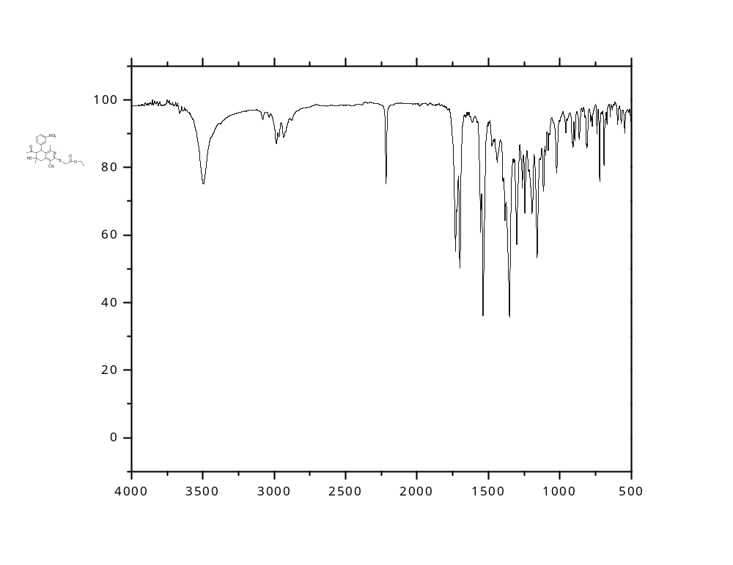

Figure S8: FT-IR spectrum of the ethyl 2-((7-acetyl-4-cyano-6-hydroxy-1,6-dimethyl-8-(3-nitrophenyl)-5,6,7,8-tetrahydroisoquinolin-3-yl)thio)acetate (4).
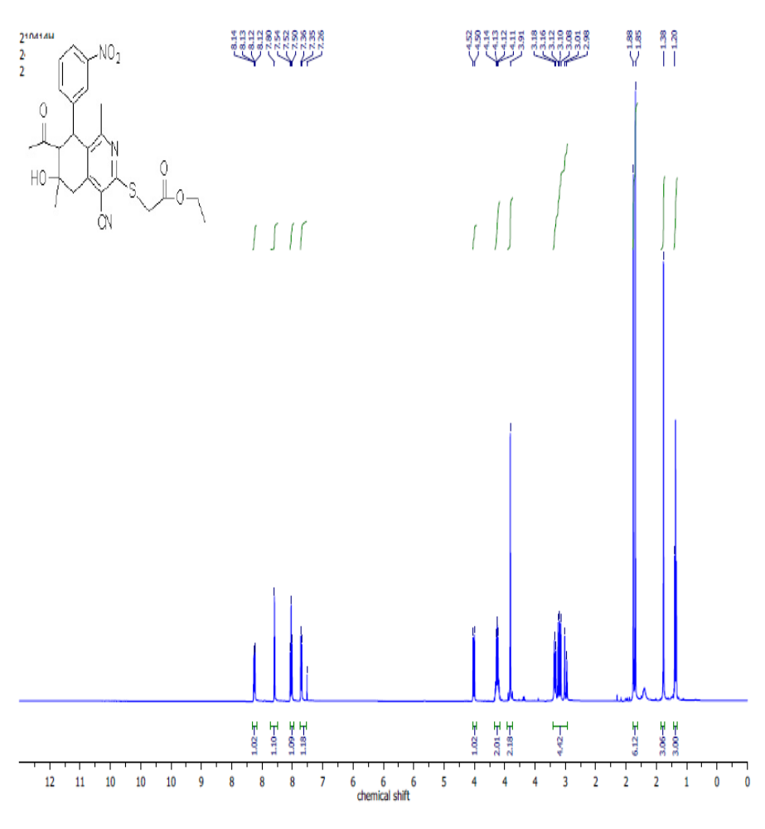
Figure S9: ¹H NMR spectrum of the ethyl 2-((7-acetyl-4-cyano-6-hydroxy-1,6-dimethyl-8-(3-nitrophenyl)-5,6,7,8-tetrahydroisoquinolin-3-yl)thio)acetate (4).

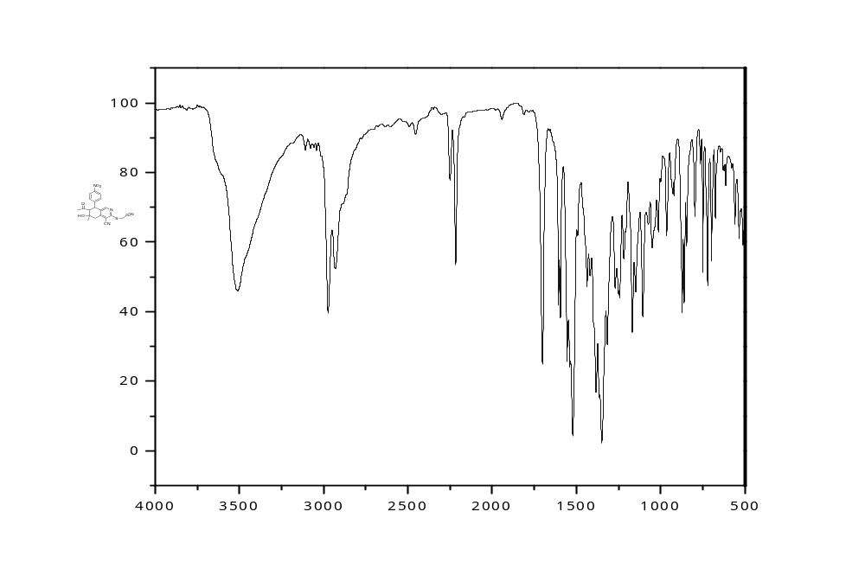

Figure S10: FT-IR Spectrum of the 7-acetyl-3-((cyanomethyl)thio)-6-hydroxy-6-methyl-8-(4-nitrophenyl)-5,6,7,8-tetrahydroisoquinoline-4-carbonitrile (5).

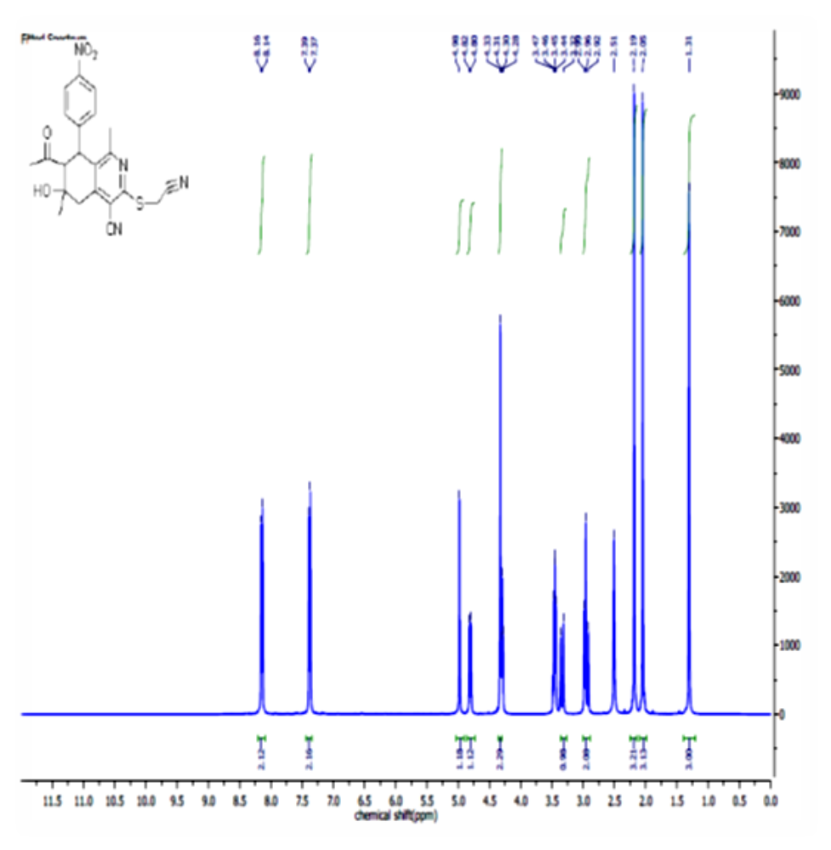 Figure S11: ¹H NMR Spectrum of the 7-acetyl-3-((cyanomethyl)thio)-6-hydroxy-6-methyl-8-(4-nitrophenyl)-5,6,7,8-tetrahydroisoquinoline-4-carbonitrile (5).
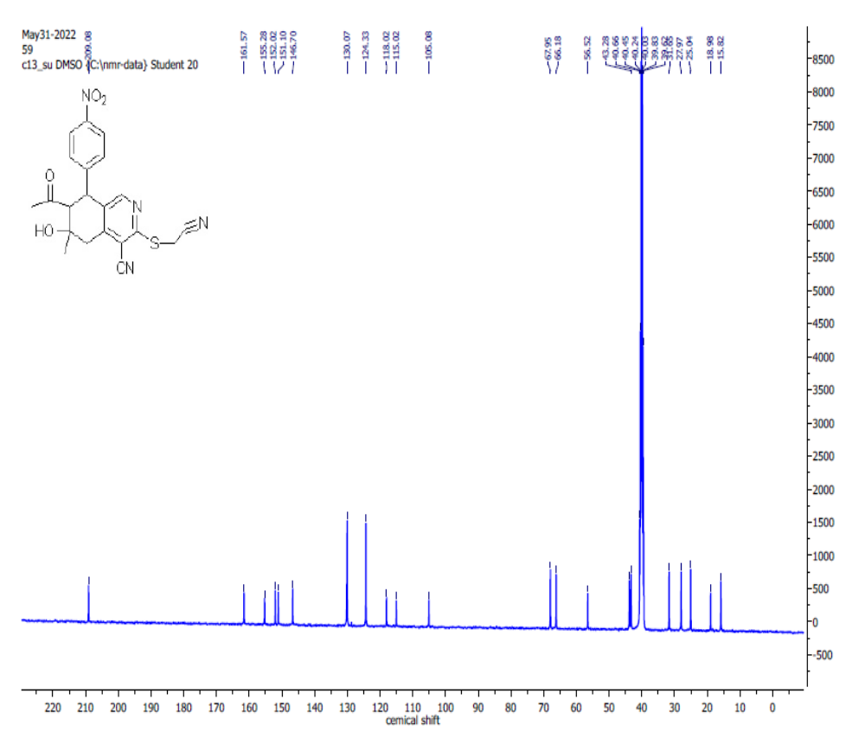
Figure S12: ¹³ CNMR Spectrum of the 7-acetyl-3-((cyanomethyl)thio)-6-hydroxy-6-methyl-8-(4-nitrophenyl)-5,6,7,8-tetrahydroisoquinoline-4-carbonitrile (5)

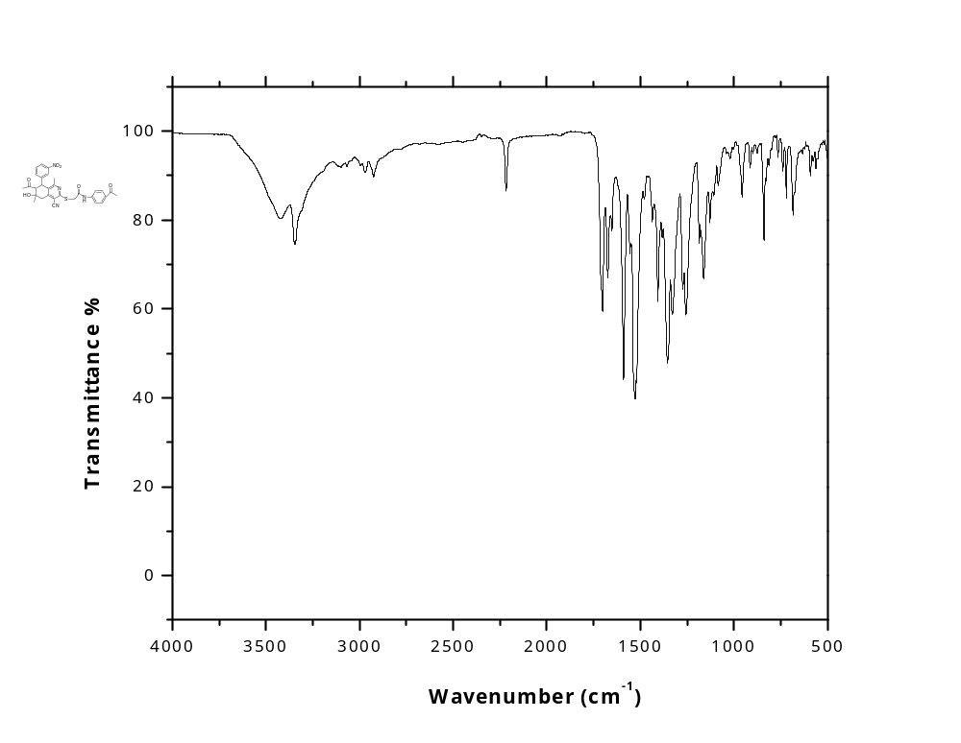
Figure S13: FT-IR spectrum of the 2-((7-acetyl-4-cyano-6-hydroxy-1,6-dimethyl-8-(3-nitrophenyl)-5,6,7,8-tetrahydroisoquinolin-3-yl)thio)-N-(4-acetylphenyl)acetamide (6a).

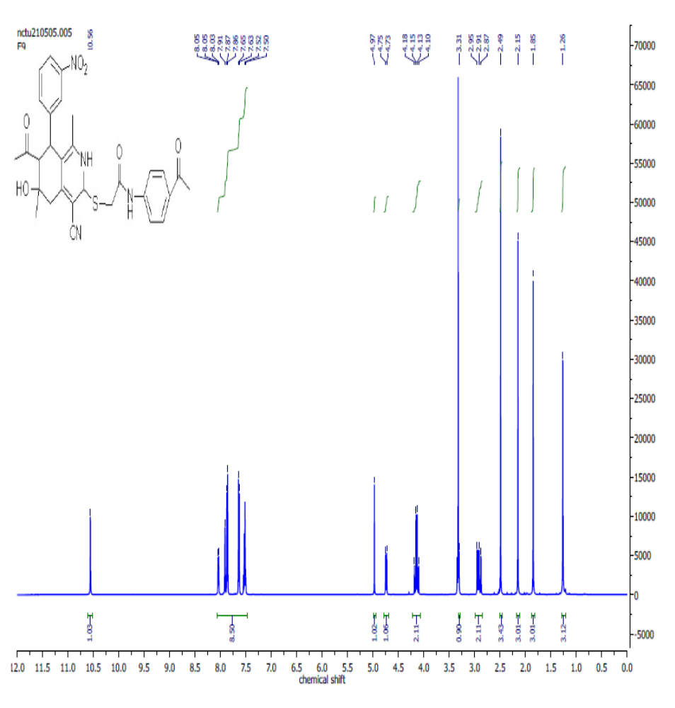Figure S14: ¹H NMR spectrum of the 2-((7-acetyl-4-cyano-6-hydroxy-1,6-dimethyl-8-(2-nitrophenyl)-5,6,7,8-tetrahydroisoquinolin-3-yl)thio)-N-(4-acetylphenyl)acetamide(6a).
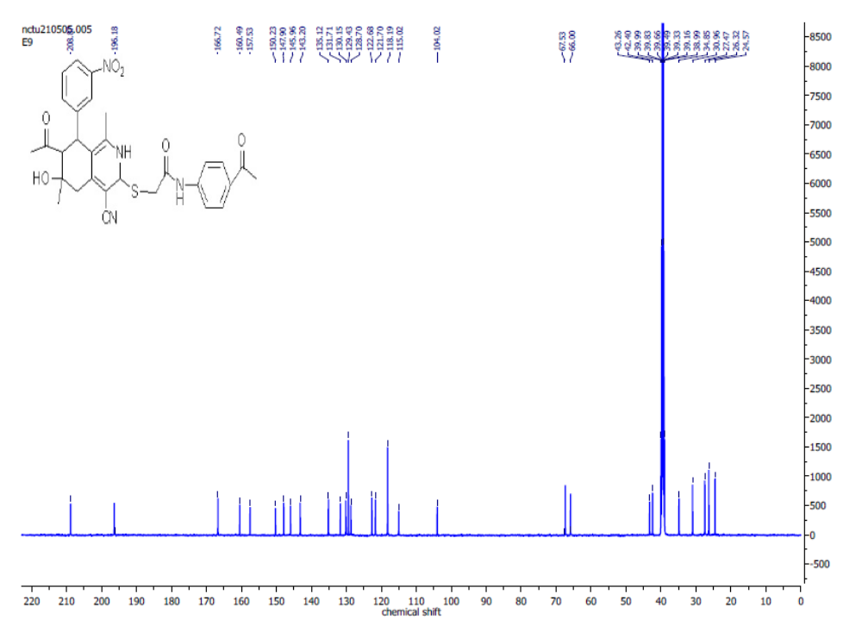
Figure S15: C¹³ spectrum of the 2-((7-acetyl-4-cyano-6-hydroxy-1,6-dimethyl-8-(2-nitrophenyl)-5,6,7,8-tetrahydroisoquinolin-3-yl)thio)-N-(4-acetylphenyl)acetamide (6a).
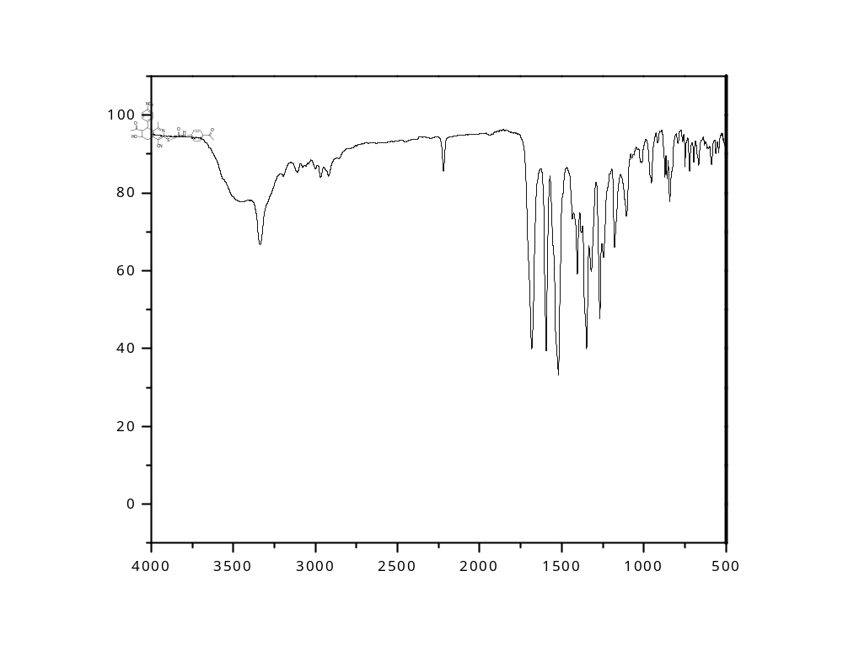
Figure S16: FT-IR spectrum of the 2-((7-acetyl-4-cyano-6-hydroxy-1,6-dimethyl-8-(3-nitrophenyl)-5,6,7,8-tetrahydroisoquinolin-3-yl)thio)-N-(4-acetylphenyl)acetamide (6b).

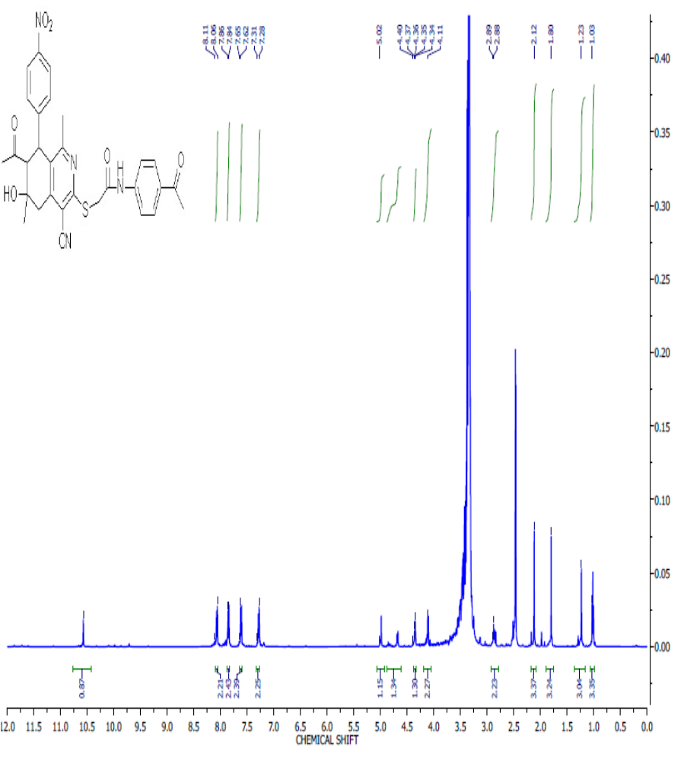
Figure S17: ¹H NMR spectrum of the 2-((7-acetyl-4-cyano-6-hydroxy-1,6-dimethyl-8-(3-nitrophenyl)-5,6,7,8-tetrahydroisoquinolin-3-yl)thio)-N-(4-acetylphenyl)acetamide (6b

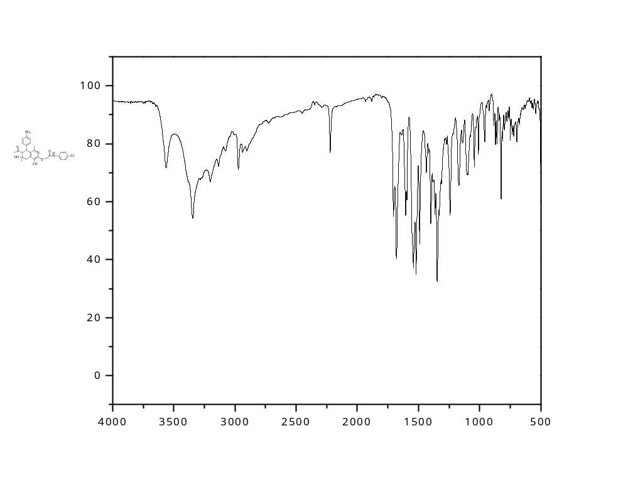
Figure S18: FT-IR spectrum of 2-((7-acetyl-4-cyano-6-hydroxy-1,6-dimethyl-8-(4-nitrophenyl)-5,6,7,8-tetrahydroisoquinolin-3-yl)thio)-N-(4-chlorophenyl)acetamide (6c).
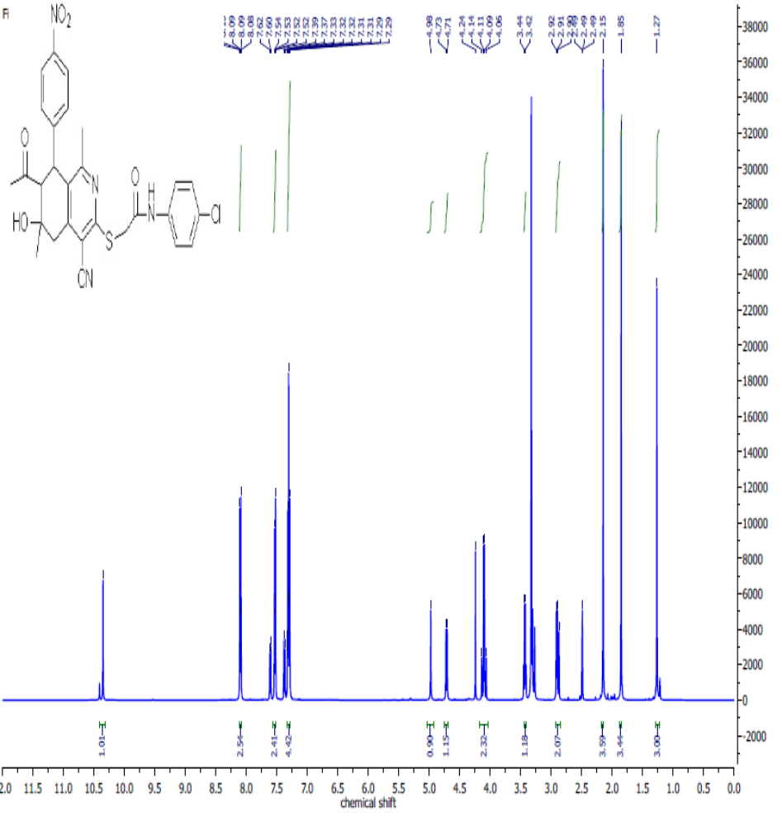
Figure S19: ¹H NMR spectrum of 2-((7-acetyl-4-cyano-6-hydroxy-1,6-dimethyl-8-(4-nitrophenyl)-5,6,7,8-tetrahydroisoquinolin-3-yl)thio)-N-(4-chlorophenyl)acetamide (6c).

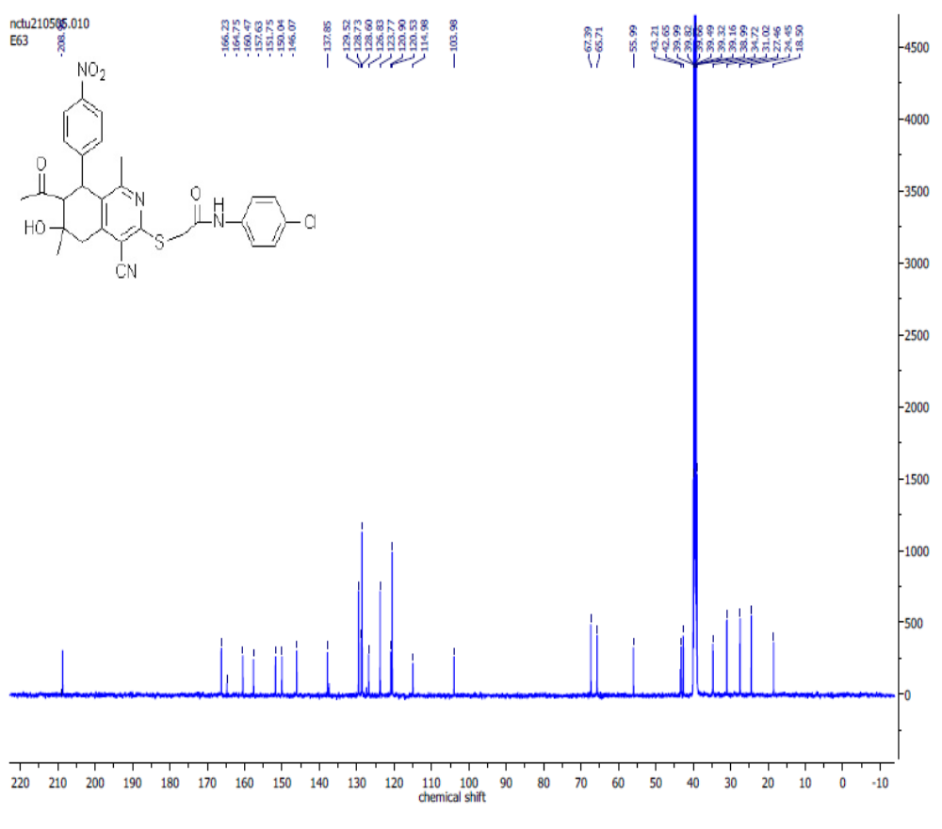
Figure S20: ¹³C spectrum of 2-((7-acetyl-4-cyano-6-hydroxy-1,6-dimethyl-8-(4-nitrophenyl)-5,6,7,8-tetrahydroisoquinolin-3-yl)thio)-N-(4-chlorophenyl)acetamide (6c).
).

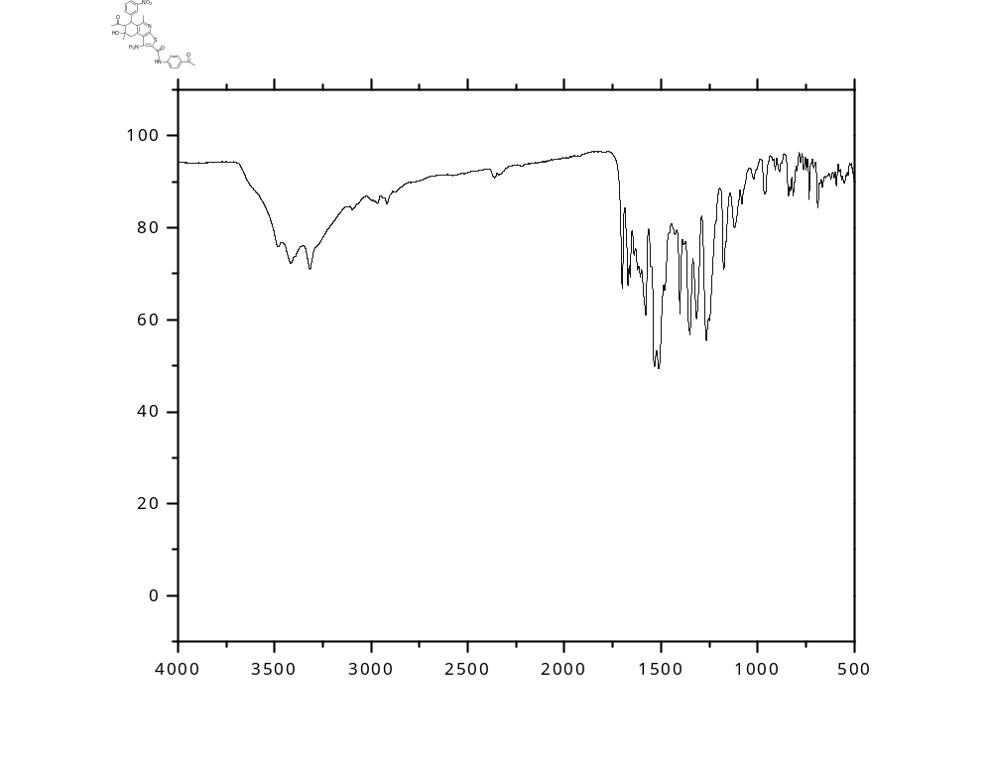
Figure S21: FT-IR spectrum of the 7-acetyl-N-(4-acetylphenyl)-1-amino-8-hydroxy-5,8-dimethyl-6-(3-nitrophenyl)-6,7,8,9-tetrahydrothieno[2,3-c]isoquinoline-2-carboxamide (7a).

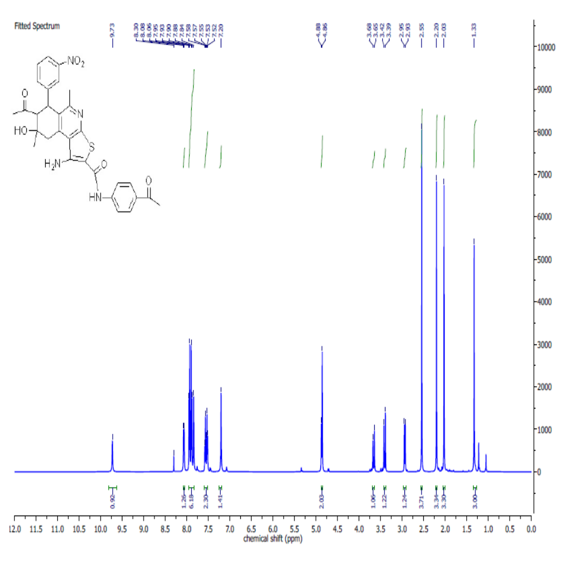

Figure S22: ¹H NMR spectrum of the 7-acetyl-N-(4-acetylphenyl)-1-amino-8-hydroxy-5,8-dimethyl-6-(3-nitrophenyl)-6,7,8,9-tetrahydrothieno[2,3-c]isoquinoline-2-carboxamide (7a).

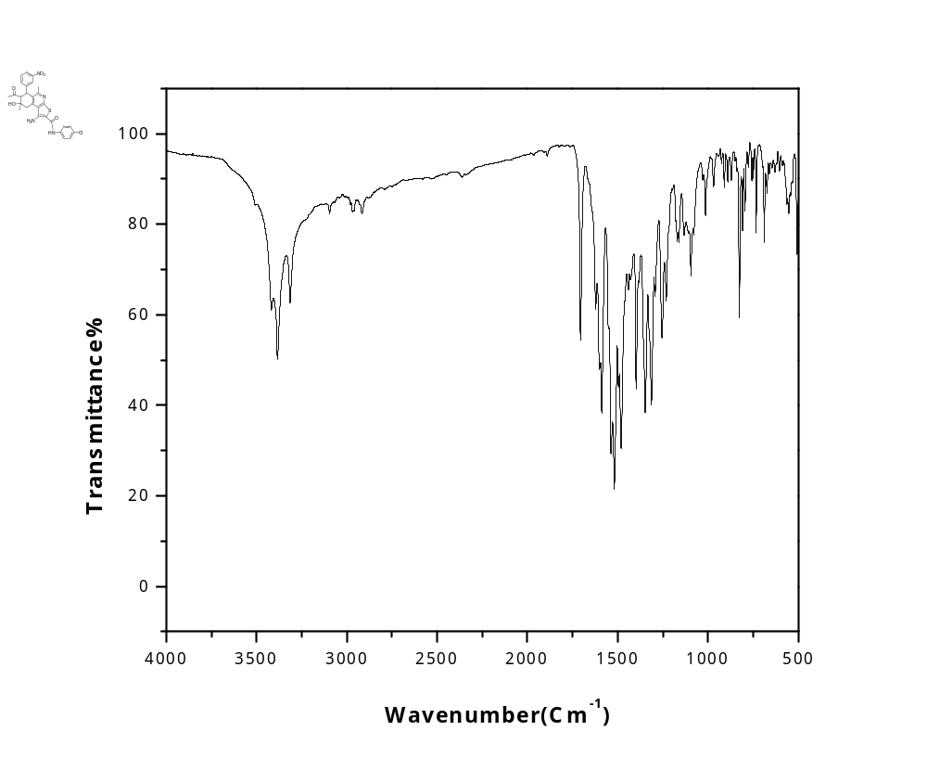
Figure S23: FT-IR Spectrum of 7-Acetyl-1-amino-N-(4-chlorophenyl)-5,8-dimethyl-8-hydroxy-6-(3-nitrophenyl)-6,7,8,9-tetrahydrothieno[2,3-c]isoquinoline-2-carboxamide (7C).
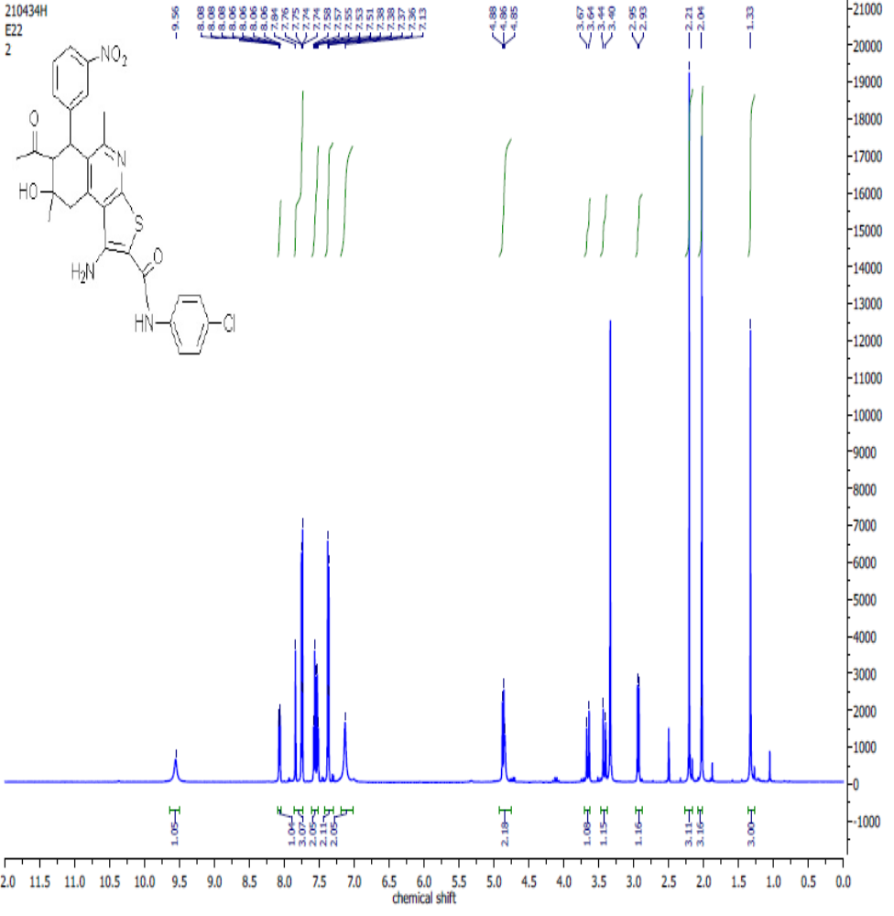
Figure S24:¹H NMR Spectrum of 7-Acetyl-1-amino-N-(4-chlorophenyl)-5,8-dimethyl-8-hydroxy-6-(3-nitrophenyl)-6,7,8,9-tetrahydrothieno[2,3-c]isoquinoline-2-carboxamide (7C) in DMSO-d₆.
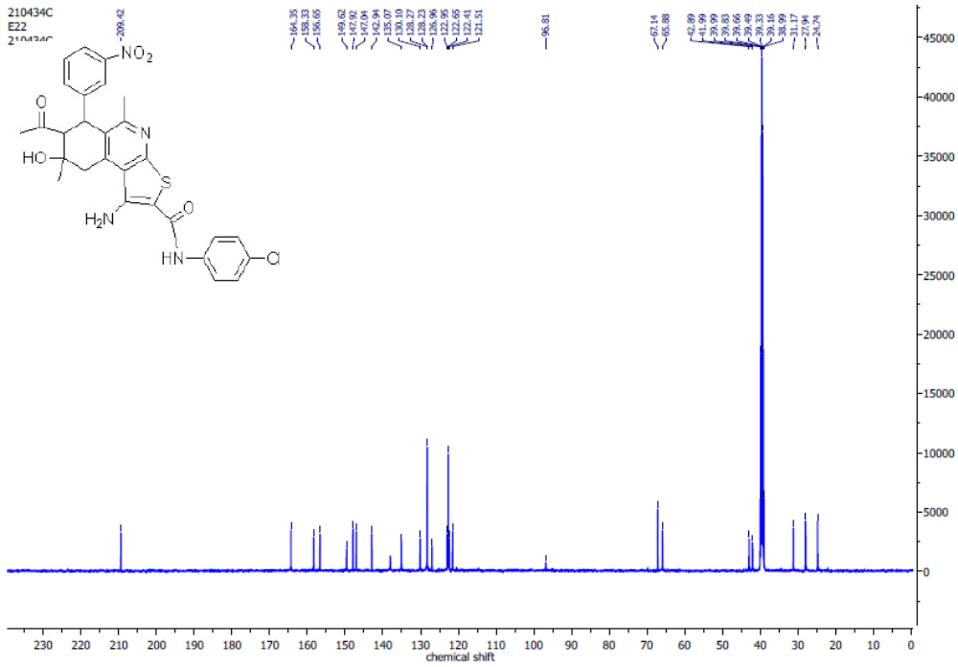
Figure S25: ¹³ C NMR Spectrum of 7-Acetyl-1-amino-N-(4-chlorophenyl)-5,8-dimethyl-8-hydroxy-6-(3-nitrophenyl)-6,7,8,9-tetrahydrothieno[2,3-c]isoquinoline-2-carboxamide (7C) in DMSO-d₆.
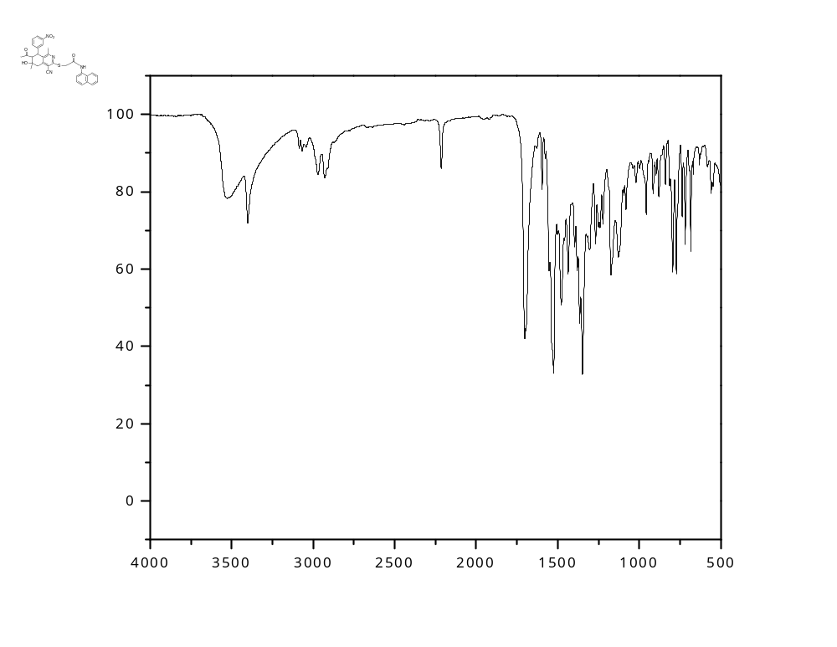
Figure S26: FT-IR spectrum of the 2-((7-acetyl-4-cyano-6-hydroxy-1,6-dimethyl-8-(3-nitrophenyl)-5,6,7,8-tetrahydroisoquinolin-3-yl)thio)-N-(naphthalen-1-yl)acetamide (9a).
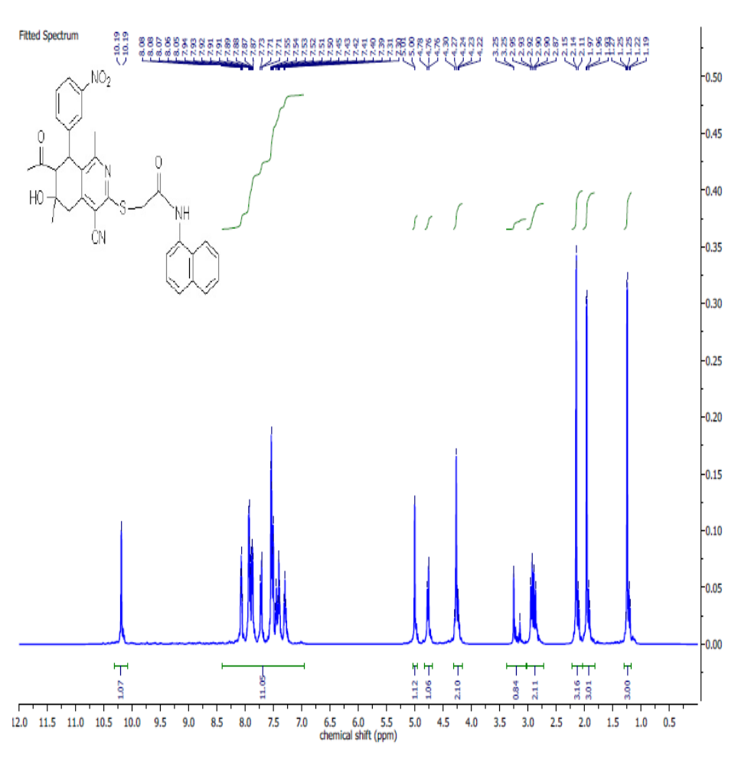
Figure S27: ¹H NMR spectrum of the 2-((7-acetyl-4-cyano-6-hydroxy-1,6-dimethyl-8-(3-nitrophenyl)-5,6,7,8-tetrahydroisoquinolin-3-yl)thio)-N-(naphthalen-1-yl)acetamide (9a).

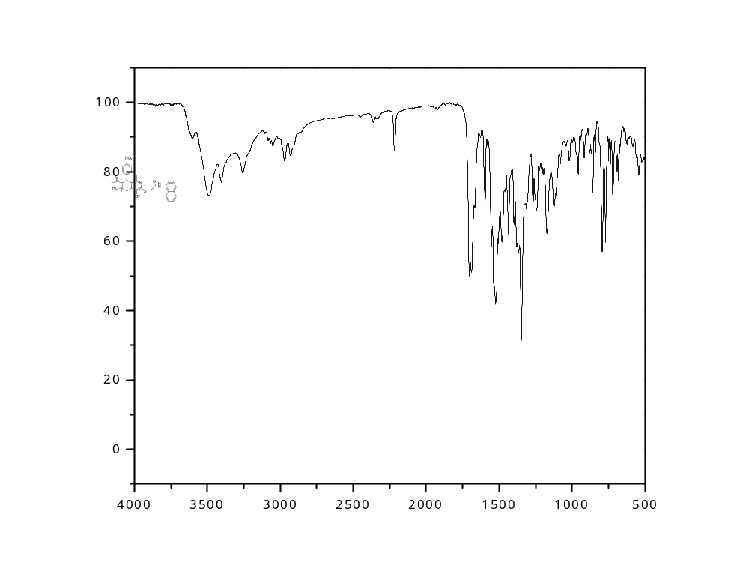

Figure S28: FT-IR spectrum of the 2-((7-acetyl-4-cyano-6-hydroxy-1,6-dimethyl-8-(4-nitrophenyl)-5,6,7,8-tetrahydroisoquinolin-3-yl)thio)-N-(naphthalen-1-yl)acetamide (9b).

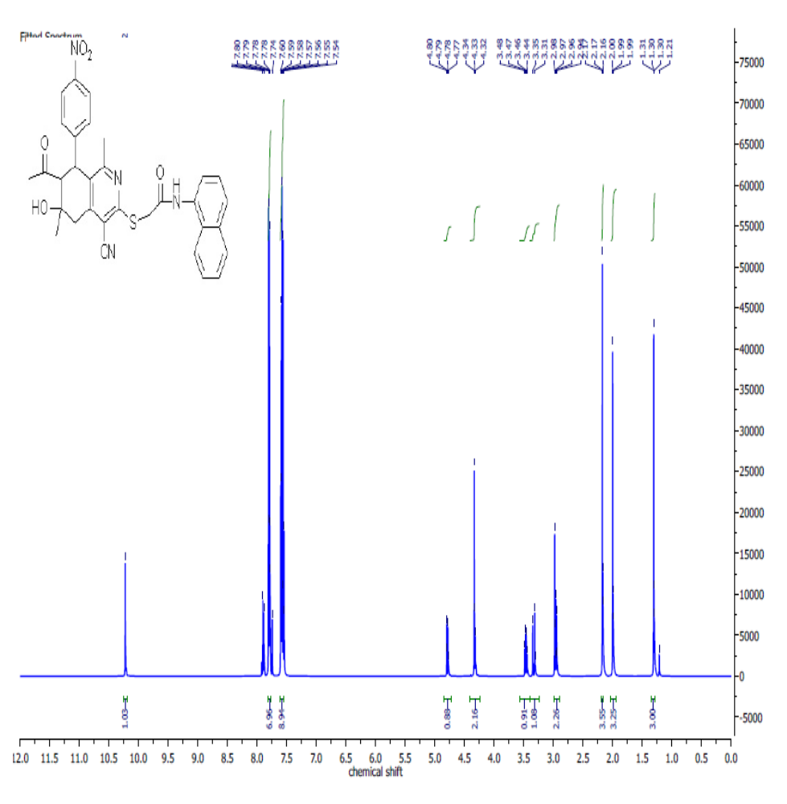
Figure S29: ¹H NMR spectrum of the 2-((7-acetyl-4-cyano-6-hydroxy-1,6-dimethyl-8-(4-nitrophenyl)-5,6,7,8-tetrahydroisoquinolin-3-yl)thio)-N-(naphthalen-1-yl)acetamide (9b).

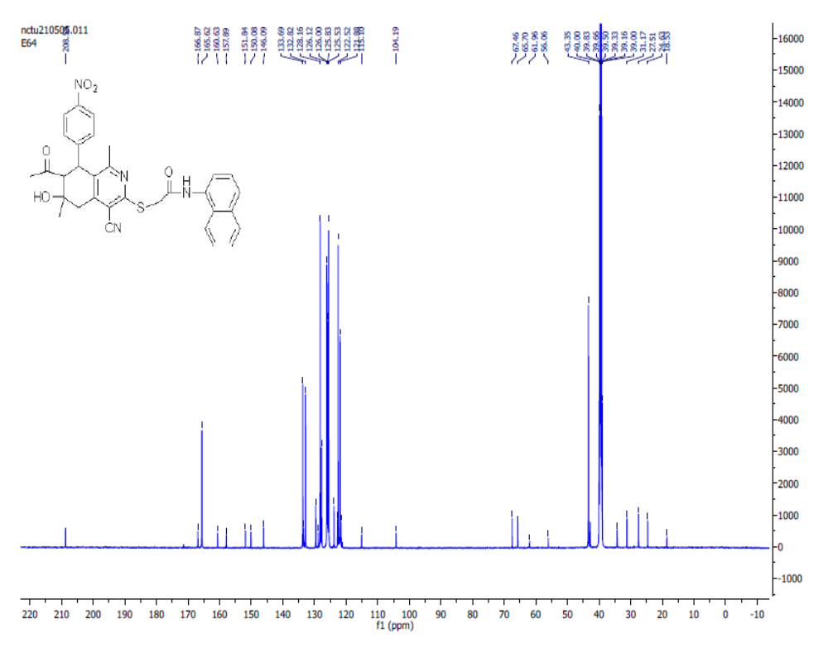
Figure S30: ¹³C spectrum of the 2-((7-acetyl-4-cyano-6-hydroxy-1,6-dimethyl-8-(4-nitrophenyl)-5,6,7,8-tetrahydroisoquinolin-3-yl)thio)-N-(naphthalen-1-yl)acetamide (9b).

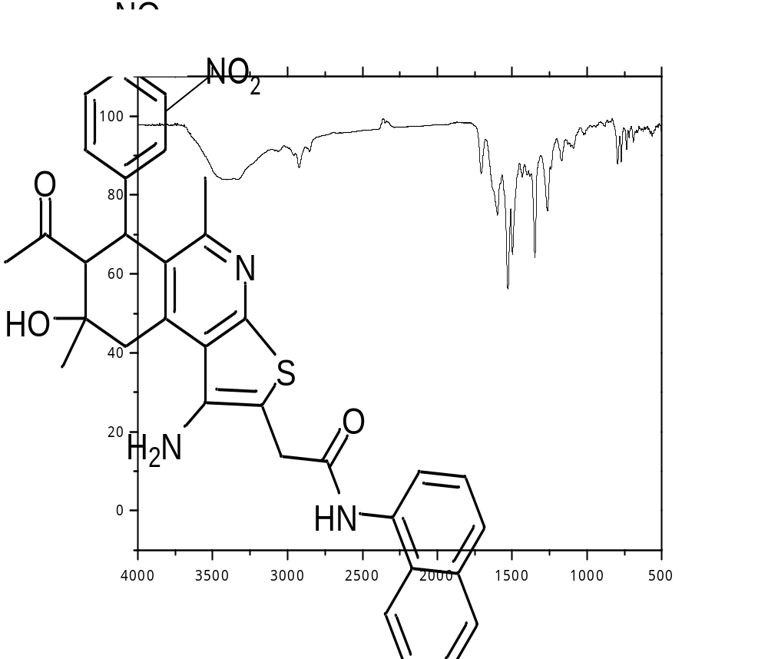
Figure S 31: FT-IR Spectrum of 7-Acetyl-1-amino-N (naphthalen-1-yl)-5,8-dimethyl-8-hydroxy-6-(3-nitro- phenyl)-6,7,8,9-tetrahydrothieno[2,3-c]isoquinoline-2-carboxamide (10a).

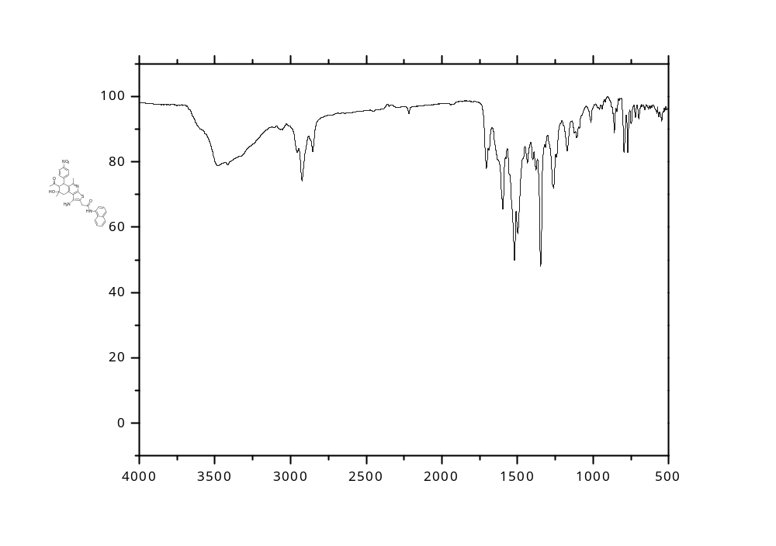
Figure S32: FT-IR Spectrum of 7-Acetyl-1-amino-N (naphthalen-1-yl)-5,8-dimethyl-8-hydroxy-6-(4-nitro- phenyl)-6,7,8,9-tetrahydrothieno[2,3-c]isoquinoline-2-carboxamide (10b).

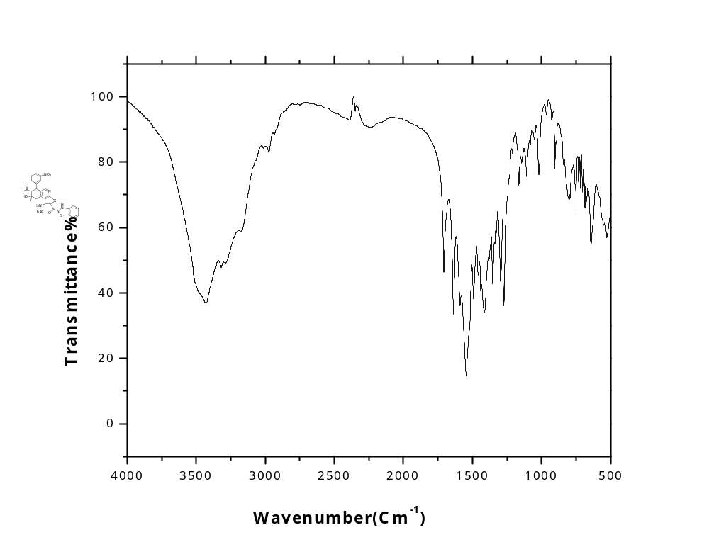
Figure S33: FT-IR spectrum of the 2-((7-acetyl-4-cyano-6-hydroxy-1,6-dimethyl-8-(3-nitrophenyl)-2,3,5,6,7,8-hexahydroisoquinolin-3-yl)thio)-N-phenylacetamide (13).

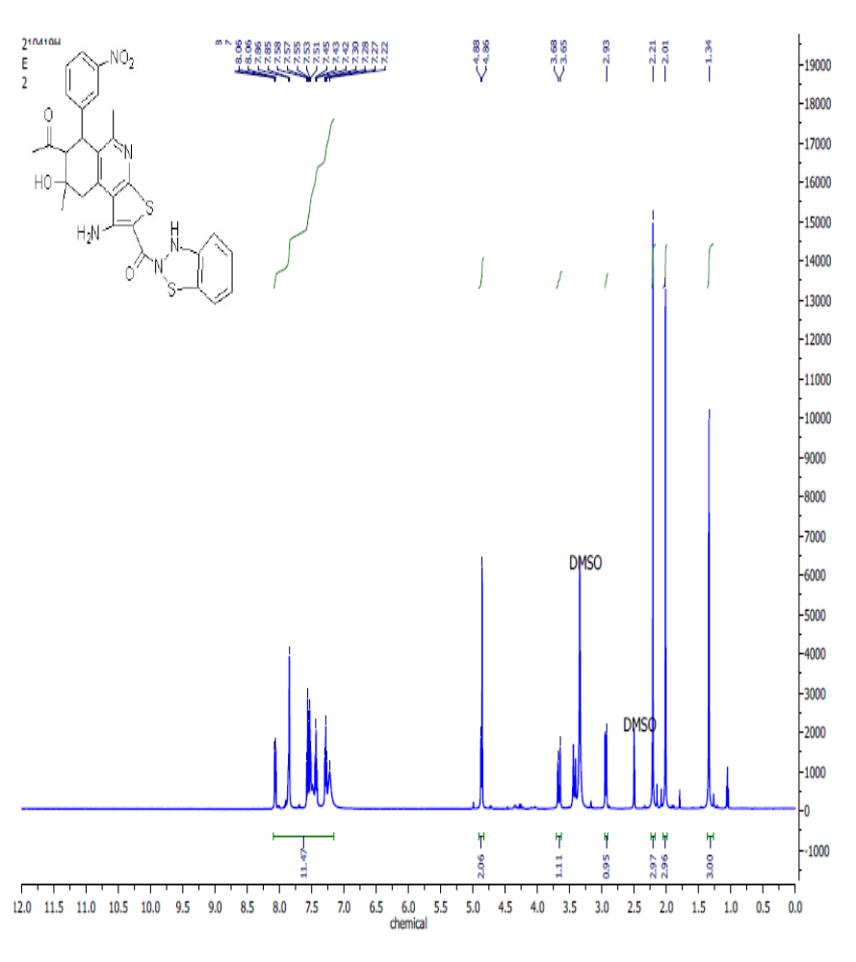
Figure S34: ¹H NMR spectrum of the 2-((7-acetyl-4-cyano-6-hydroxy-1,6-dimethyl-8-(3-nitrophenyl)-2,3,5,6,7,8-hexahydroisoquinolin-3-yl)thio)-N-phenylacetamide (13).
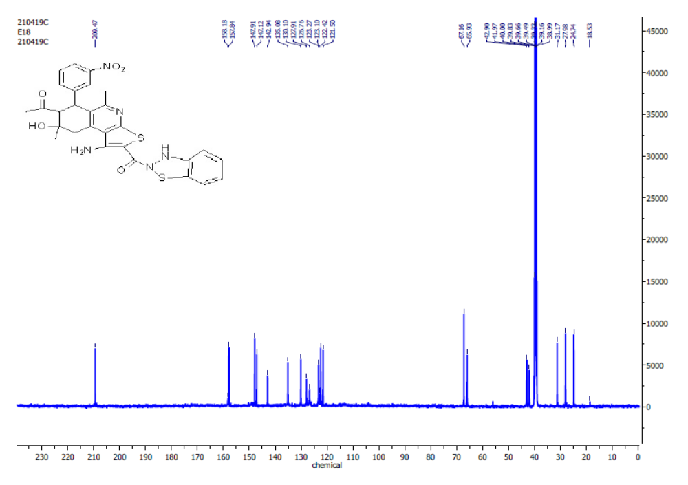
Figure S35: ¹³C spectrum of the 2-((7-acetyl-4-cyano-6-hydroxy-1,6-dimethyl-8-(3-nitrophenyl)-2,3,5,6,7,8-hexahydroisoquinolin-3-yl)thio)-N-phenylacetamide (13).

Table S1: one spot concentration of all synthesized compounds against eight cell line.
 | MEAN | SD | NO
 | MG-63 |  | HCT116 |  |  | CACO2 |  |  |  | A549
3 | 44.257467 | 5.0615101 | 67.072323 | 1.5623534 |  | 59.170306 |  | 2.9743363 |  | 50.552251 |  | 1.2551645
4 | 53.76525 | 1.0201393 | 56.815021 | 2.7360661 |  | 64.379289 |  | 1.2773297 |  | 47.196262 |  | 2.1565064
5 | 55.742533 | 4.3010107 | 58.936022 | 2.1638884 |  | 61.540861 |  | 2.316797 |  | 55.225149 |  | 2.5307342
13 | 46.739588 | 2.7157049 | 59.179416 | 4.3827403 |  | 60.636307 |  | 4.2070406 |  | 47.408666 |  | 2.6924302
2a | 41.901557 | 4.5335982 | 62.308762 | 2.7545622 |  | 55.1466 |  | 2.4425168 |  | 42.438403 |  | 3.4204367
6a | 45.814051 | 2.9228698 | 58.10153 | 1.2531865 |  | 54.834685 |  | 2.7286783 |  | 20.305862 |  | 5.7353913
7a | 50.441733 | 2.051956 | 59.700974 | 1.6700709 |  | 58.203369 |  | 3.2862301 |  | 46.813934 |  | 3.3265543
9a | 38.4939 | 2.012768 | 56.05007 | 3.3139785 |  | 53.181535 |  | 0.8893685 |  | 46.17672 |  | 0.9899049
9b | 57.509466 | 2.1467986 | 67.524339 | 1.0705705 |  | 41.671865 |  | 1.9479095 |  | 15.208156 |  | 7.4587528
10b | 30.164072 | 4.0570681 | 55.632823 | 3.4945665 |  | 51.746725 |  | 3.607579 |  | 44.987256 |  | 1.0987695
DOX | 63.819941 | 1.9278821 | 70.862309 | 5.1487372 |  | 74.828447 |  | 4.2398668 |  | 32.030586 |  | 1.9467186

H460 |  | HUH7 |  | HEPG2 |  | MCF7 |  | HSF
62.004326 | 1.6105485 | 32.940847 | 4.2172522 | 67.742789 | 0.6657711 | 71.531792 | 1.7520745 | 50.605971 | 3.7508045
66.762797 | 0.903386 | 27.474068 | 3.5025507 | 62.132839 | 2.33886 | 76.32948 | 1.4194253 | 49.423589 | 6.20265
66.594569 | 2.5320004 | 35.49201 | 4.2678266 | 68.245568 | 4.2007166 | 67.630058 | 3.0449866 | 66.834171 | 1.365191
63.326124 | 1.3398087 | 21.754976 | 3.7142623 | 55.22625 | 1.6404323 | 75.433526 | 0.9024564 | 54.655631 | 1.5994974
55.299207 | 1.9075352 | 27.389964 | 3.9746136 | 61.286055 | 0.4372244 | 73.988439 | 2.6011561 | 46.201596 | 1.3545893
63.47032 | 3.4072211 | 38.631904 | 3.0791054 | 59.486637 | 2.4906658 | 66.358382 | 3.908472 | 53.502808 | 1.8943506
59.865417 | 2.7295882 | 32.352117 | 6.2692024 | 58.666314 | 2.1098385 | 57.919075 | 6.4450219 | 51.847473 | 2.384451
59.552992 | 3.0951821 | 25.876086 | 8.4713243 | 59.962953 | 1.1236239 | 72.369942 | 2.4298092 | 56.902158 | 3.2071785
62.028359 | 2.2026319 | 30.165405 | 5.2187598 | 66.631384 | 3.8116343 | 57.225434 | 2.6488877 | 48.152527 | 5.917157
58.038933 | 4.0886653 | 35.688253 | 1.7847821 | 69.965599 | 1.0719571 | 55.202312 | 1.8049127 | 56.222288 | 1.4197824
72.891132 | 1.806772 | 52.761424 | 1.2874643 | 58.904472 | 0.5958365 | 73.959538 | 0.1324444 | 58.912208 | 4.1907913

Table2: cytotoxicity of the sythnsizedcompounds.
compound number | Concentration 0 | Concentration 12.5 | Concentration 25 | Concentration 50 | Concentration 100
3 | 1.0276 | 0.7687 | 0.6657 | 0.63227 | 0.4568
 | 0.9103 | 0.6287 | 0.6563 | 0.62339 | 0.3317
 | 1.0266 | 0.72896 | 0.5889 | 0.61914 | 0.3526
AVERGE | 0.9881667 | 0.7087867 | 0.6369667 | 0.6249333 | 0.3803667
4 | 0 | 12.5 | 25 | 50 | 100
 | 1.0276 | 0.7104 | 0.7231 | 0.53934 | 0.479
 | 0.9103 | 0.76882 | 0.7277 | 0.49132 | 0.4559
 | 1.0266 | 0.86413 | 0.7515 | 0.53432 | 0.53984
AVERGE | 0.9881667 | 0.7811167 | 0.7341 | 0.52166 | 0.49158
13 | 0 | 12.5 | 25 | 50 | 100
 | 1.0276 | 0.997437 | 1.0244 | 0.8607 | 0.73312
 | 0.9103 | 0.986 | 0.92 | 0.85914 | 0.64231
 | 1.0266 | 1.1 | 0.9654 | 0.9302 | 0.64832
AVERGE | 0.9881667 | 1.0278123 | 0.9699333 | 0.8833467 | 0.6745833
2A | 0 | 12.5 | 25 | 50 | 100
 | 1.0276 | 0.96577 | 0.74688 | 0.64552 | 0.4277
 | 0.9103 | 0.96412 | 0.74415 | 0.64778 | 0.42184
 | 1.0266 | 1.1486 | 0.8787 | 0.7304 | 0.3671
AVERGE | 0.9881667 | 1.0261633 | 0.78991 | 0.6745667 | 0.4055467
6A | 0 | 12.5 | 25 | 50 | 100
 | 1.0276 | 0.8094 | 0.7265 | 0.65253 | 0.4895
 | 0.9103 | 0.9004 | 0.7856 | 0.6182 | 0.4568
 | 1.0266 | 0.8971 | 0.8697 | 0.7192 | 0.5797
AVERGE | 0.9881667 | 0.8689667 | 0.7939333 | 0.66331 | 0.5086667
7A | 0 | 12.5 | 25 | 50 | 100
 | 1.0276 | 0.9779 | 0.8015 | 0.7673 | 0.4356
 | 0.9103 | 0.9423 | 0.8177 | 0.6711 | 0.5604
 | 1.0266 | 1.0361 | 0.9059994 | 0.7619 | 0.4229
AVERGE | 0.9881667 | 0.9854333 | 0.8417332 | 0.7334333 | 0.4729667
 | 0 | 12.5 | 25 | 50 | 100
9A | 1.3043 | 1.1856 | 0.8324 | 0.76209 | 0.5543
 | 1.3043 | 1.1645 | 0.9594 | 0.8064 | 0.6353
 | 1.3043 | 1.0852 | 0.9527 | 0.7671 | 0.6449
AVERGE | 1.3043 | 1.1451 | 0.9148333 | 0.77853 | 0.6115
9B | 0 | 12.5 | 25 | 50 | 100
 | 0.9063 | 0.9329 | 0.8067 | 0.68007 | 0.4501
 | 0.8542 | 0.98791 | 0.8494 | 0.636 | 0.3823
 | 0.9211 | 0.8723 | 0.8704 | 0.5876 | 0.417
AVERGE | 0.8938667 | 0.9310367 | 0.8421667 | 0.6345567 | 0.4164667
10B | 0 | 12.5 | 25 | 50 | 100
 | 0.9063 | 0.9726 | 0.7934 | 0.6021 | 0.3938
 | 0.8542 | 0.9995728 | 0.7536 | 0.667 | 0.371
 | 0.9211 | 0.899 | 0.7874 | 0.6503 | 0.4041
AVERGE | 0.8938667 | 0.9570576 | 0.7781333 | 0.6398 | 0.3896333

Table S3: cytotoxicity of DOX against HEPG2.
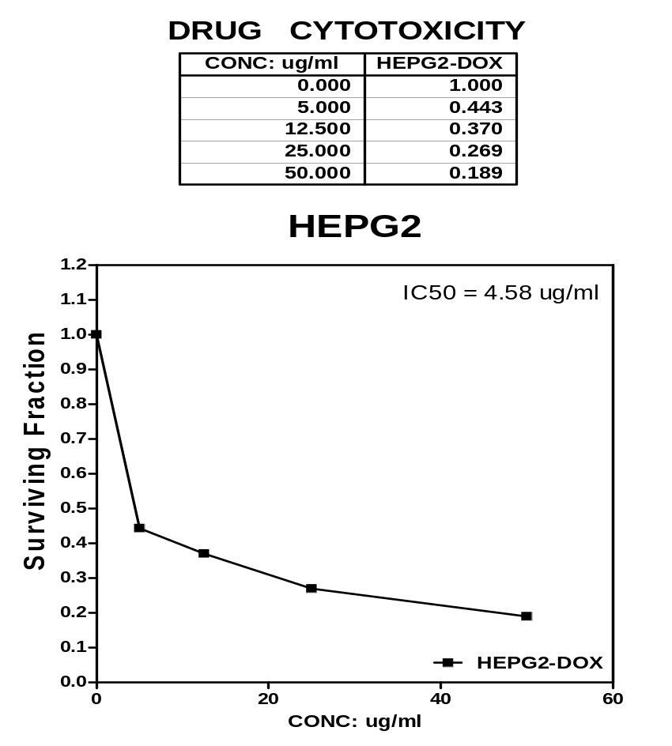

Table S4: cytotoxicity of DOX against MCF7.
