Supplementary Figure S1

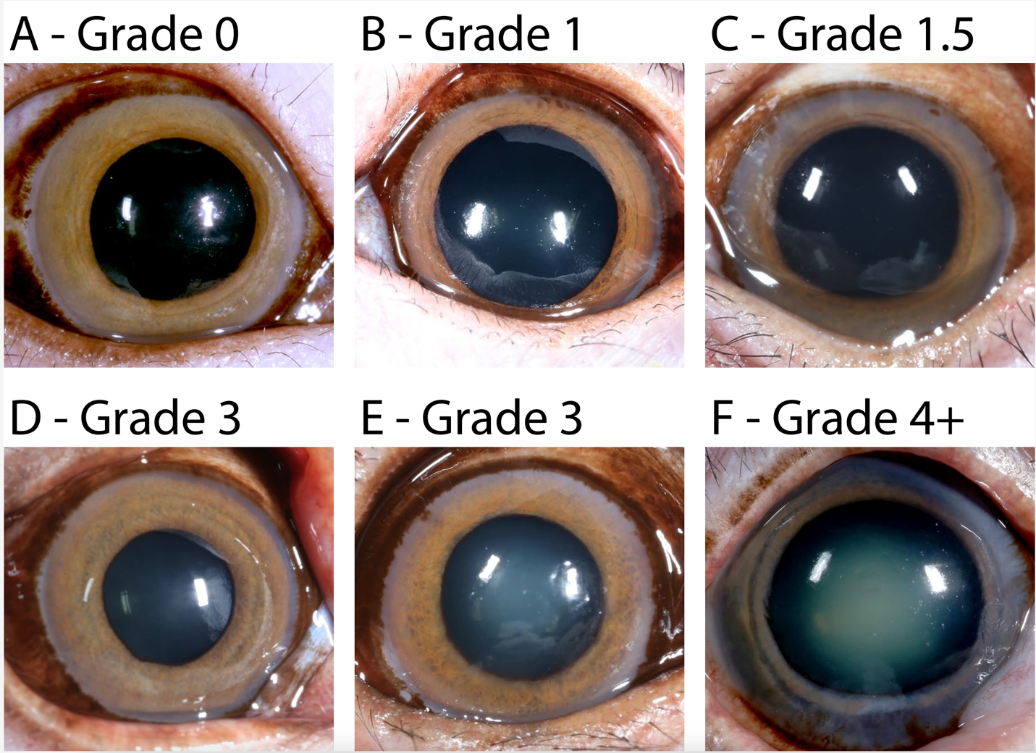
Supplementary Figure S1. Evaluation of nuclear sclerosis with slit lamp biomicroscopy enables the identification of 4 different clinical grades in geriatric rhesus macaques. A, Grade 0, normal lens with no opacity detectable. B, Grade 1 - Minimal opacity; the nucleus is clear with no noticeable cloudiness. C, Grade of 1.5 represents a mild level of lens nucleus cloudiness that falls between Grade 1 (clear/minimal opacity) and Grade 2 (mild opacity). D, Grade 2 - Mild opalescence; the nucleus is slightly cloudy but not significantly impairing vision. E, Grade 3 - Moderate opalescence; cloudiness is visible and may affect visual acuity. F, Grade 4 - Severe opalescence; the nucleus is highly opaque, significantly impairing vision.

Supplementary Figure S2

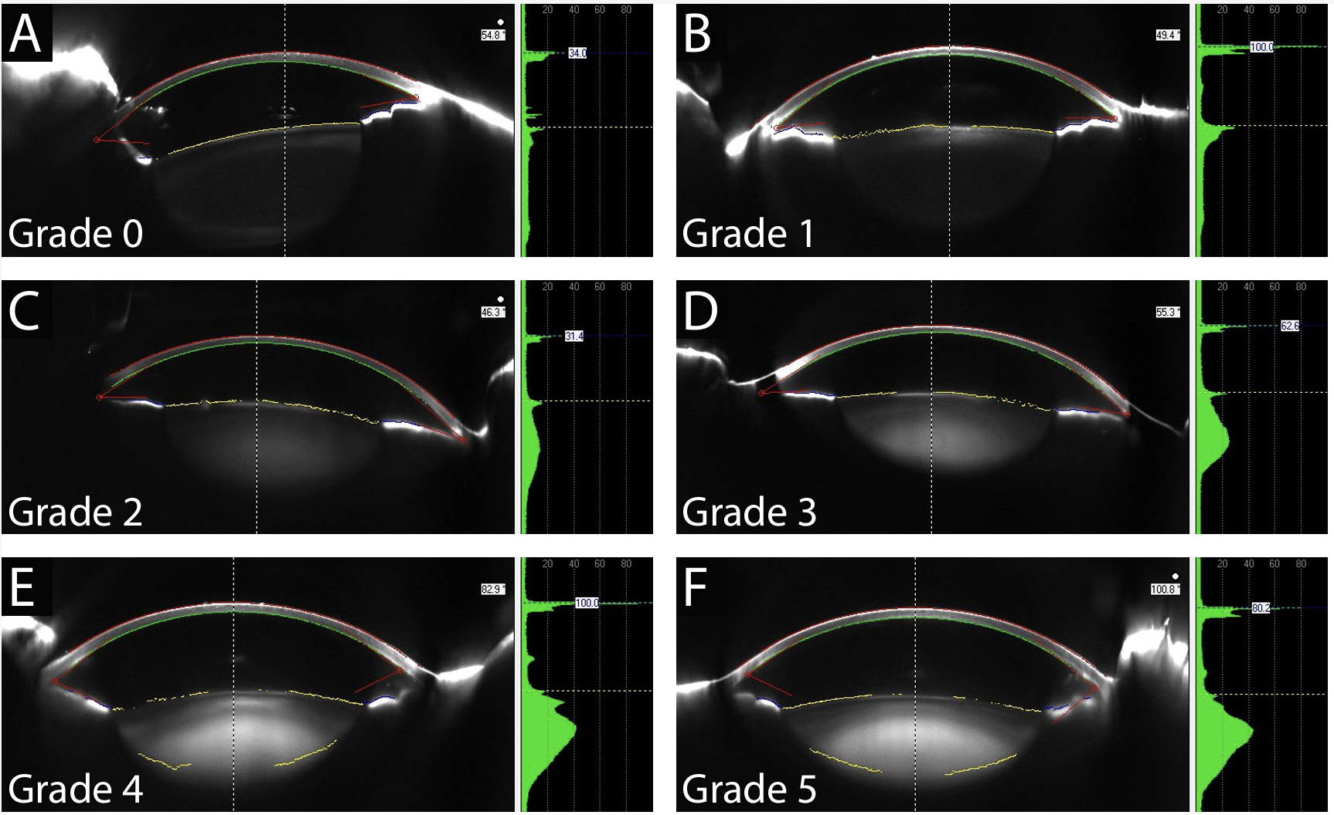Supplementary Figure S2. Evaluation of nuclear sclerosis with Pentacam enables the identification of 5 different clinical grades in geriatric rhesus macaques. A, Grade 0 - Clear nucleus with no visible sclerosis. B, Grade 1 - Very mild sclerosis with minimal lens opacity. C, Grade 2 - Mild sclerosis with slight increase in light scatter but still good transparency. D, Grade 3 - Moderate sclerosis; noticeable opacity with significant impact on transparency and light scatter. E, Grade 4 - Severe nuclear sclerosis; pronounced opacity with high density. F, Grade 5 - Extremely dense nucleus, often appearing as an advanced "brunescent" cataract.
Supplementary Figure S3

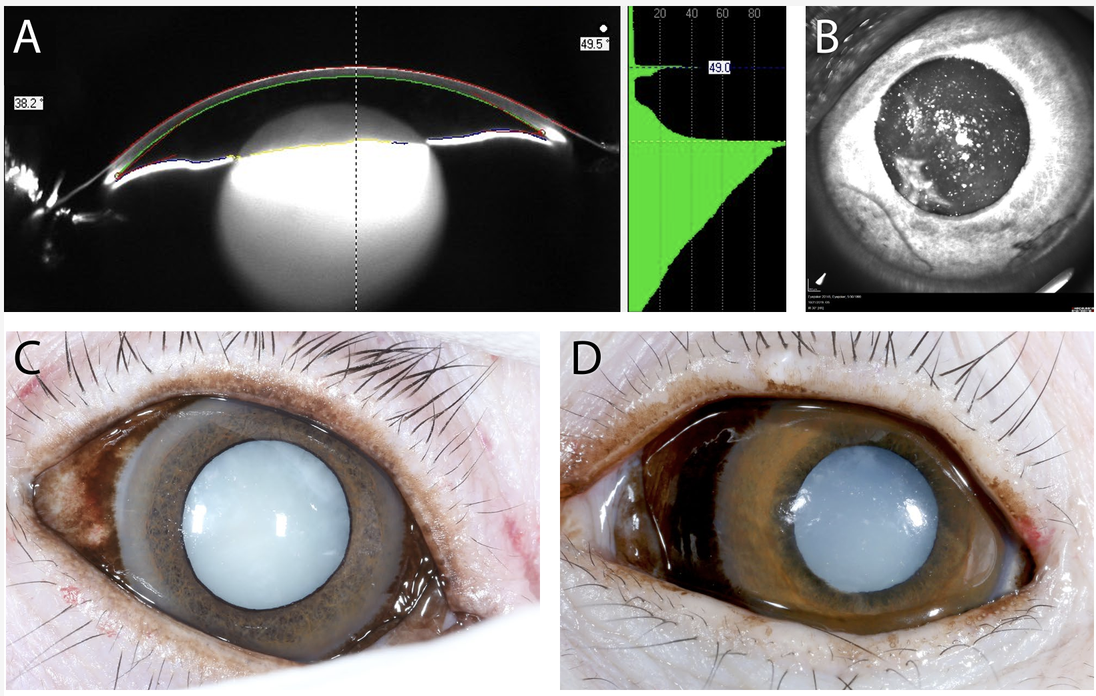
Supplementary Figure S3. Multimodal evaluation of advanced cataract in a representative rhesus macaque illustrating the inability to perform streak retinoscopy due to media opacity. A, Pentacam anterior segment image. B, Infrared confocal scanning laser ophthalmoscopy (cSLO) image showing lack of retinal reflex through the pupil. C-D, Two examples of representative animals in which the advanced cataract completely blocks the retinal reflex.

