Downregulation of SNX5 by KLF9 leads to clear cell renal cell carcinoma progression by inducing CD44 internalization and suppressing epithelial-to-mesenchymal transition

Qingqing Zhou^{1#}, Jiajun Li^{1#}, Chao Ge¹, Jinsi Chen¹, Wei Tian¹, Hua Tian^{1*}

¹State Key Laboratory of Oncogenes and Related Genes, Shanghai Cancer Institute, Renji Hospital, Shanghai Jiaotong University School of Medicine, Shanghai, China

#These authors contribute equally.

Correspondence：Hua Tian, Ph.D., State Key Laboratory of Oncogenes and Related Genes, Shanghai Cancer Institute, Renji Hospital, Shanghai Jiao Tong University School of Medicine, 25/Ln 2200, Xietu Road, Shanghai 200032, China. Tel/Fax: +86-21-64432140，E-mail: htian@shsci.org

Supplementary data
Supplementary Tables

Supplementary Table S1. The sequences of shRNA Target
Identifier | Forward(5’-3’)
SNX5-1 | CCCTCATTGACTATGAGAACT
SNX5-2 | CCCGTAGTTCGTCTTTAGTTA
KLF9-1 | GCTTTGTATGAGTTGTACTTT
KLF9-3 | CTCCCATCTCAAAGCCCATTA

Supplementary Table S2. The sequences of gene-specific primers used for qRT-PCR vector constructs and ChIP assay
Gene name |  | Forward(5’-3’) | Reverse (5’-3’)
Primers for qRT-PCR
SNX5 | GCACACAAAGACCACACTGC |  | TGCATCTTCTCTCGAGGACC
CD44  Oct4 | CCATCCCAGACGAAGACAGT  CTTGCTGCAGAAGTGGGTGGAGGAA |  | GGTTGTGTTTGCTCCACCTT  CTGCAGTGTGGGTTTCGGGCA
KLF9 | GTGACCACCGAATCTGGGTC |  | GGCCGTTCACCTGTATGCA
Primers for vector constructs
SNX5(-1297/-30) | GCAAAGCATCTTCCTCCACC |  | CTCAGCCCGAGTCCAAGATG
Primers for ChIP
ChIP-1 | GCCACACAGTCCTAGGTGAC |  | GCGGTCACAGTAATGGGAC
ChIP-2 | GAATGAACCCGTTGCACAGA |  | AATCCAGACTCCTGCCACAG

Supplementary Table S3. Antibodies used in this study.
Antibody | catalog | Dilution | Company
For Western blotting
SNX5 | ab180520 | 1:500 | Abcam
MMP9  E-cadherin  N-cadherin  Zo-1  Claudin-1  Snail  CD44  Oct4 | Ab38898  3195T  13116T  8193T  13255T  3879T  Sc-7297  CST-2750 | 1:300  1:300  1:800  1:500  1:500  1:500  1:300  1:500 | Abcam  CST  CST  CST  CST  CST  Santa Cruz  CST
KLF9 | A7196 | 1:300 | Abclonal
β-actin | A3854 | 1:20000 | Sigma
Secondary antibody | HRP conjugated goat anti-rabbit IgG | 1:4000 | Sigma
Secondary antibody | HRP conjugated goat anti-mouse IgG | 1:4000 | Sigma
For Immunohistochemistry
SNX5 | 17918-1-AP | 1:50 | Proteintech
Ki67 | Ab16667 | 1:50 | Abcam
PCNA | Ab29 | 1:10000 | Abcam
CD44 | Sc-7297 | 1:50 | Santa Cruz
Secondary antibody | Envision kit (HRP, rabbit/mouse, DAB+) | Ready-to-use | DAKO
For Immunofluorescence staining
E-cadherin | 20874-1-AP | 1:50 | Proteintech
N-cadherin | Ab98952 | 1:50 | Abcam
CD44 | Sc-7297 | 1:30 | Santa Cruz
Secondary antibody | Alexa Fluor 488 anti-mouse IgG | 1:50 | Invitrogen
Secondary antibody | Alexa Fluor 594 anti-rabbit IgG | 1:50 | Invitrogen
For flow cytometryanalysis
E-cadherin  CD44 | 324107  338805 | Ready-to-use  Ready-to-use | Biolegend  Biolegend

Supplementary Figures

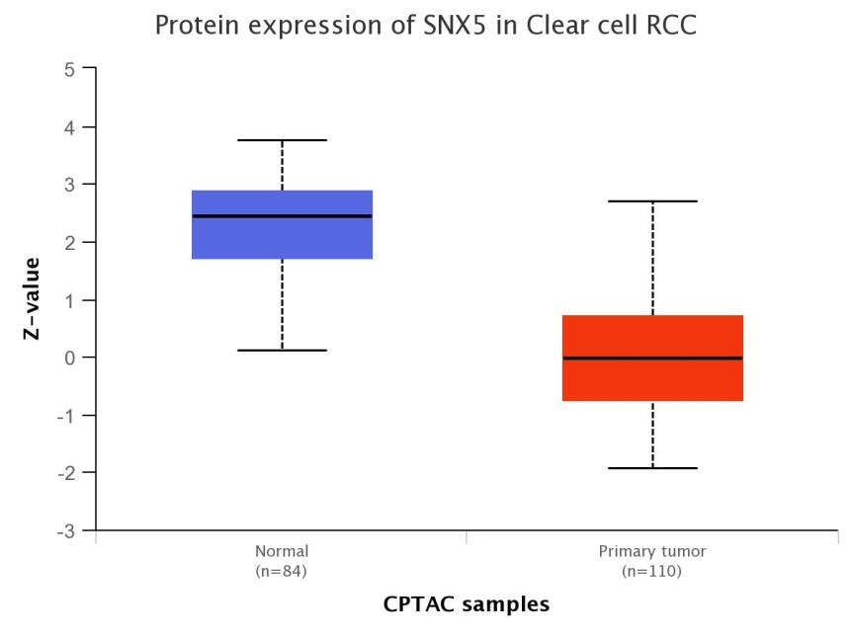
Supplementary Figure S1. SNX5 protein expression was down-regulated in ccRCC tumor tissue using the Clinical Proteomic Tumor Analysis Consortium (CPTAC) datasets

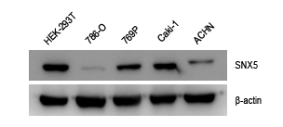
Supplementary Figure S2.The expression of SNX5 was detected by Western blotting in ccRCC cell lines.

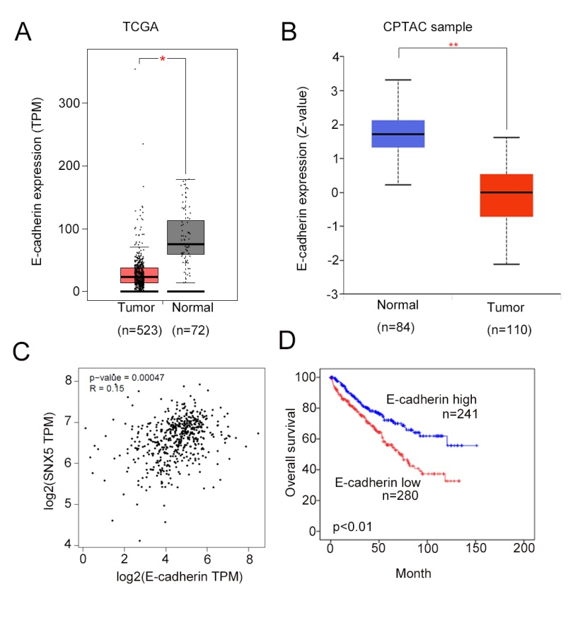
Supplementary Figure S3. E-cadherin is downregulated and is associated with poor prognosis in ccRCC patients.(A) The expression of E-cadherin in ccRCC tissues compared with adjacent normal tissues was analyzed using data sets from TCGA. (B) The expression of E-cadherin in ccRCC tissues compared with adjacent normal tissues was analyzed using data sets from CPTAC. (C) The correlation between SNX5 and E-cadherin in ccRCC tissues using TCGA. (D) Patients with low expression levels of E-cadherin had shorter overall survival than patients with high expression levels as determined using data sets from TCGA.*p< 0.05; **p< 0.01.

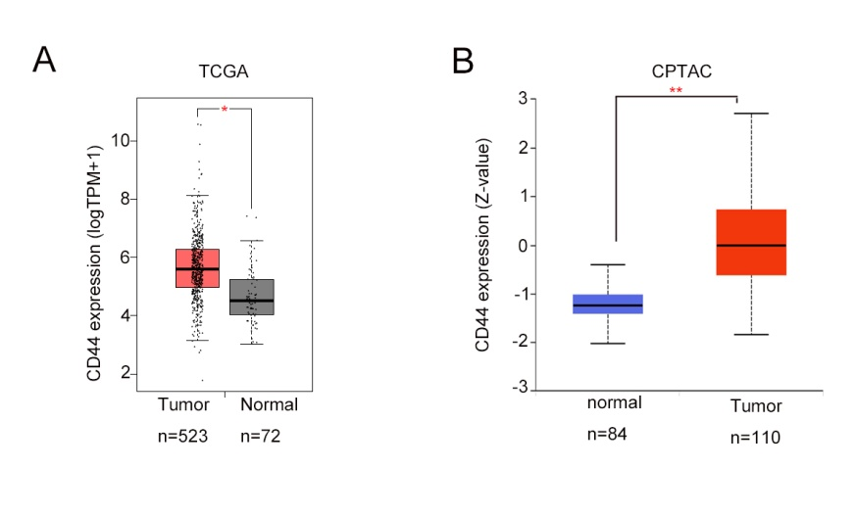
Supplementary Figure S4. (A) The expression of CD44 in ccRCC tissues compared with adjacent normal tissues was analyzed using data sets from TCGA. (B) The expression of CD44 in ccRCC tissues compared with adjacent normal tissues was analyzed using data sets from CPTAC.

