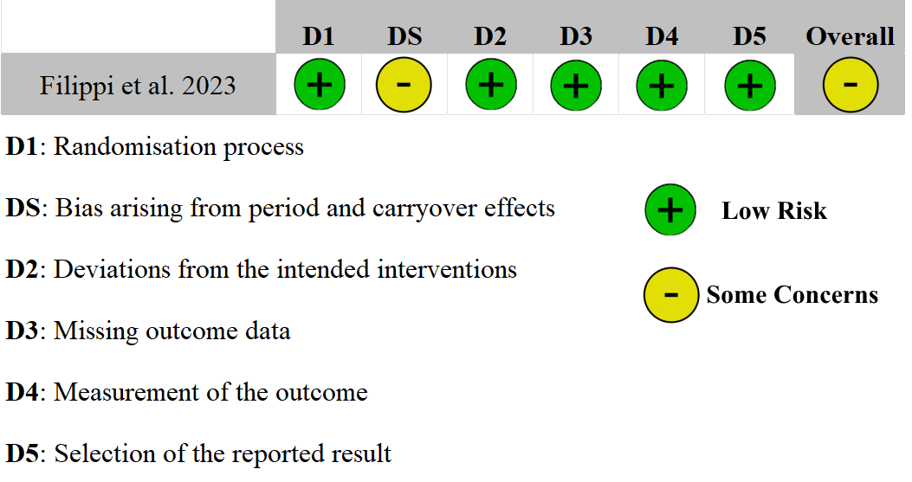

Figure (S1) The risk of bias summary for the crossover study (Filippi et al.)

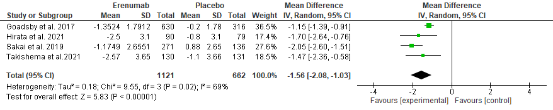
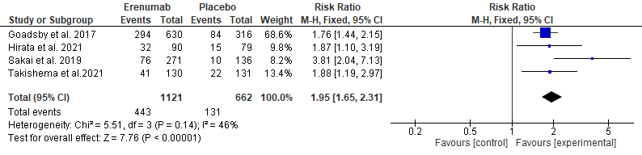
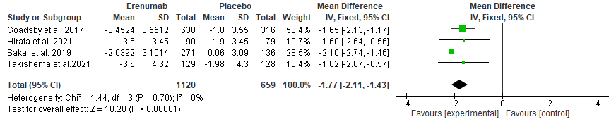
(A)
(C)
(B)

(B)

Figure (S2) Comparison of Erenumab vs placebo at 4-6 months in terms of (A) MMD, (B) MSMD, (C) 50% reduction in MMD

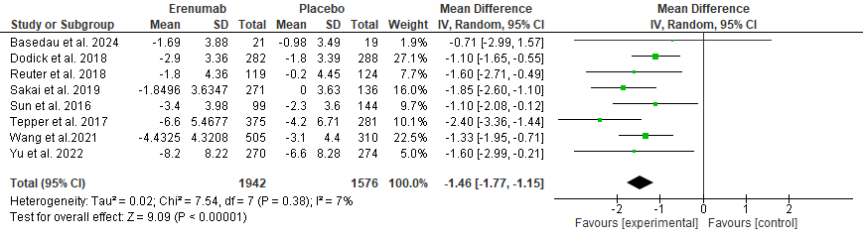
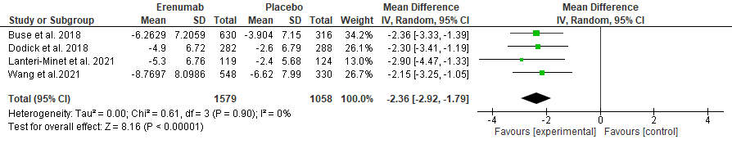
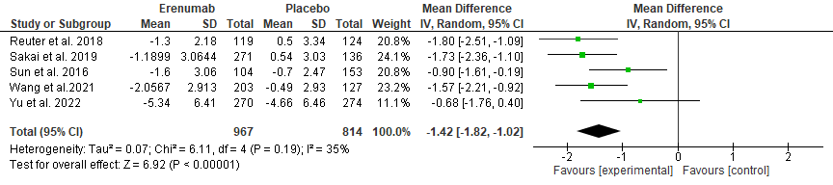
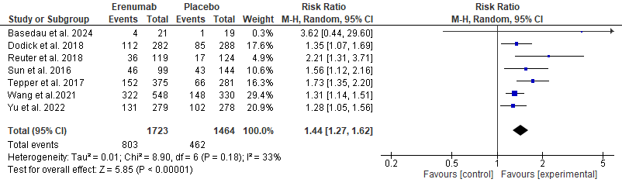
(A)
(B)
(C)
(D)

Figure (S3) Sensitivity Analysis of primary outcomes at 3 months. (A) MMD by excluding Filippi et al., (B) HIT-6 by excluding Filippi et al., (C) MSMD by excluding Dodick et al. and Tepper et al., (D) 50% reduction in MMD by excluding Sakai et al.
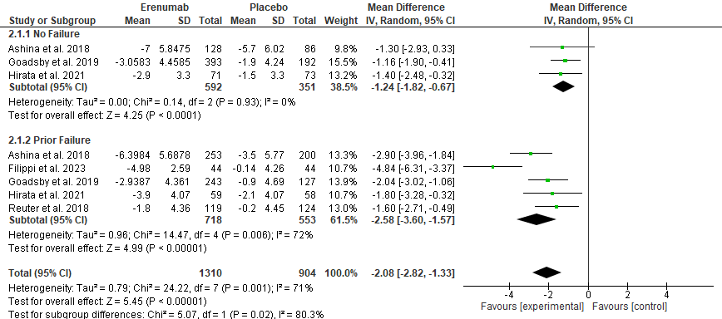
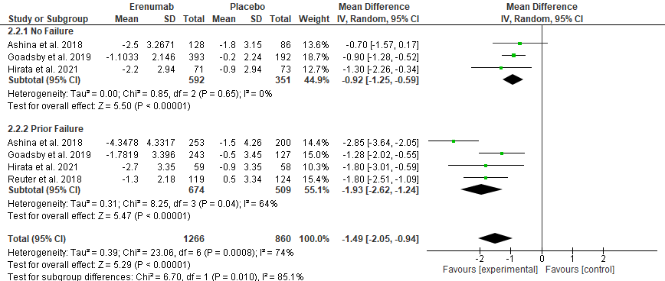
(A)
(B)

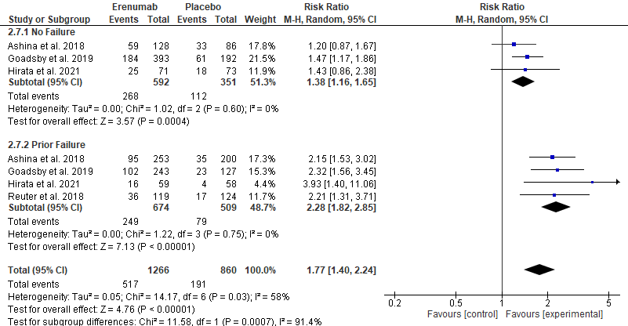
(C)

Figure (S4) Subgroup analysis based on prior preventive treatment failure status (Prior failure versus No failure). (A) MMD at 3 months, (B) MSMD at 3 months (C) 50% reduction in MMD at 3 months

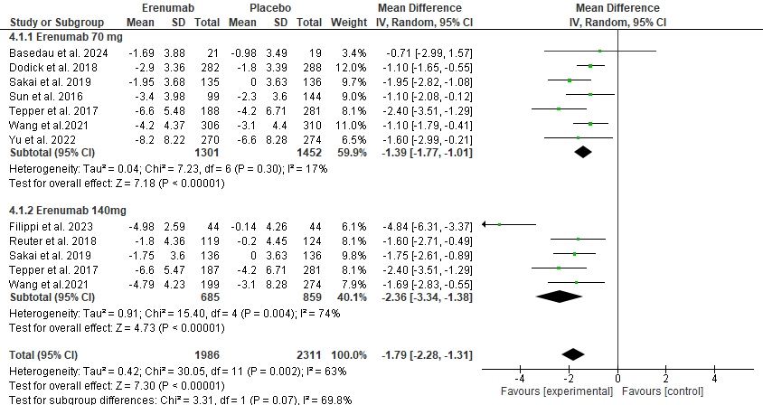
(A)

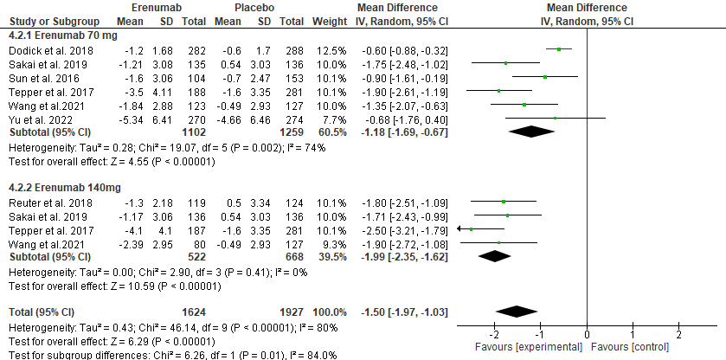
(B)

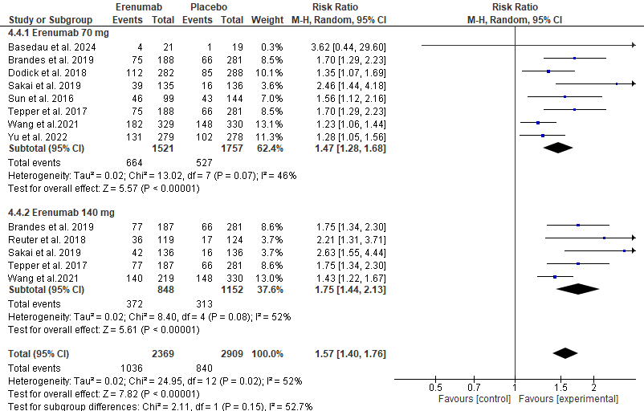
(C)

Figure (S5) Subgroup analysis based on doses (Erenumab 70mg versus Erenumab 140mg). (A) MMD at 3 months, (B) MSMD at 3 months, (C) 50% reduction in MMD at 3 months.

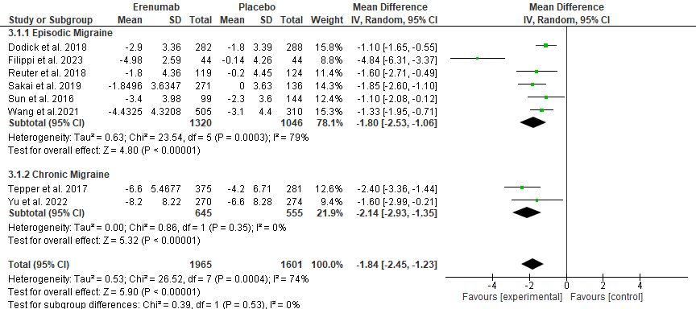
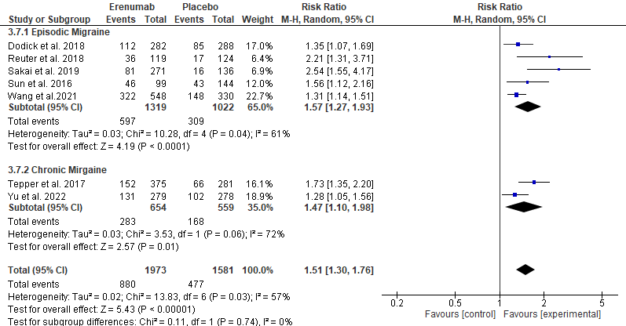
(A)
(B)
Figure (S6) Subgroup analysis based on type of migraine (Episodic versus Chronic). (A) MMD at 3 months, (B) 50% reduction in MMD at 3 months.

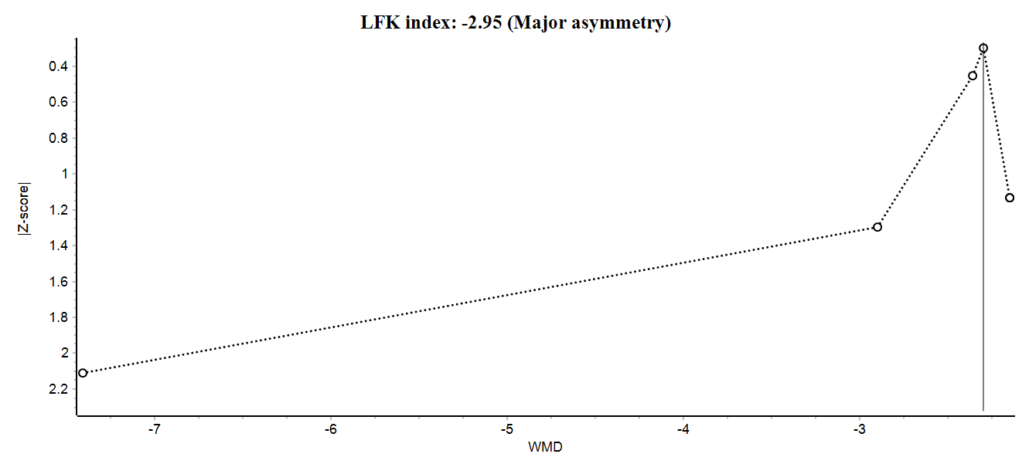
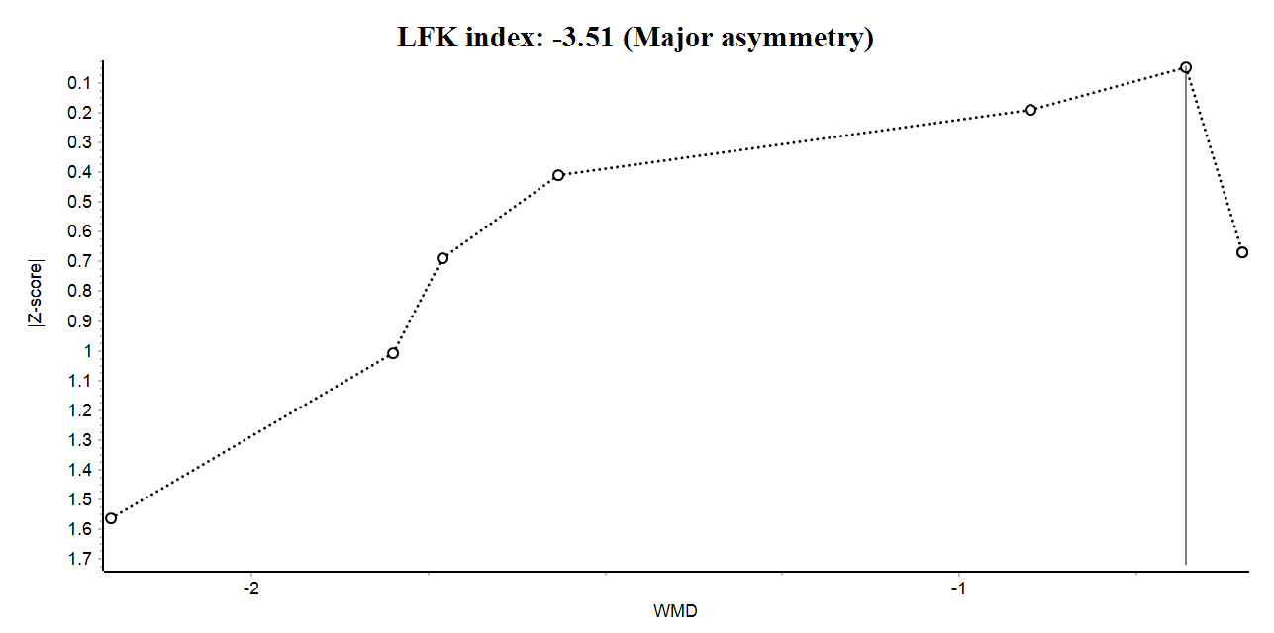
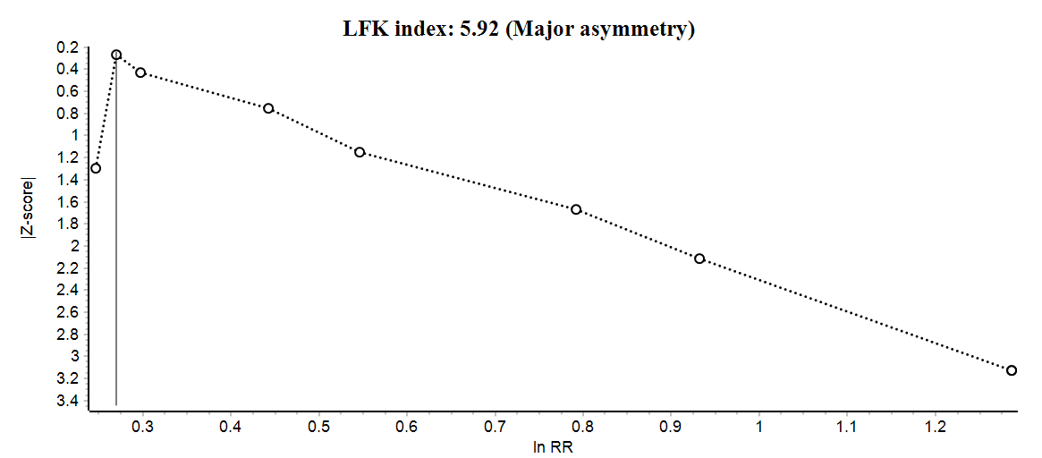
(A)
(B)
(C)

Figure (S7) Doi plot and LFK index for (A) HIT-6 at 3 months, (B) MSMD at 3 months, (C) 50% reduction in MMD at 3 months.
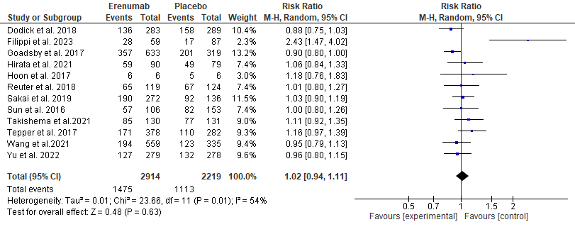
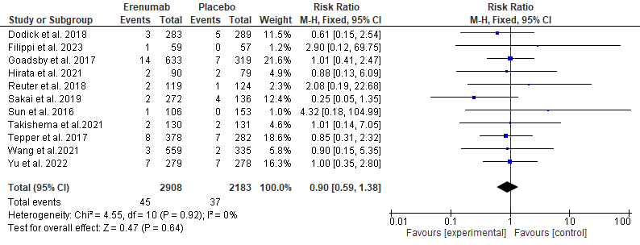
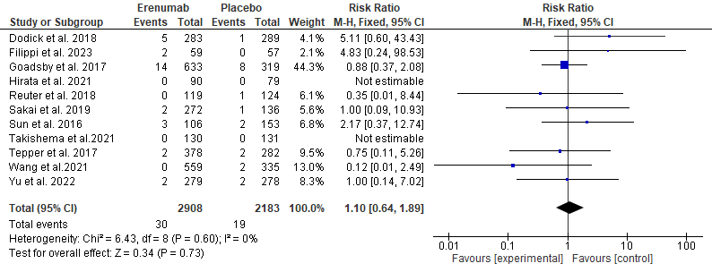
(A)
(B)
(C)

Figure (S8) Adverse Events. (A) Any adverse event, (B) Any serious adverse event (C) Any adverse event leading to treatment discontinuation.
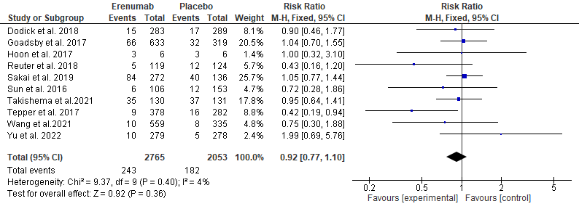
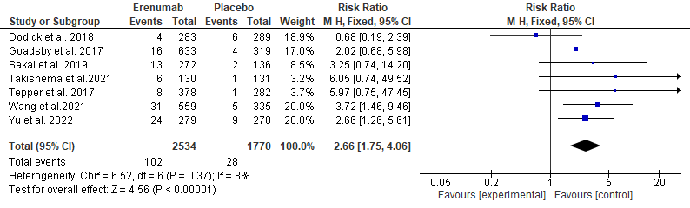
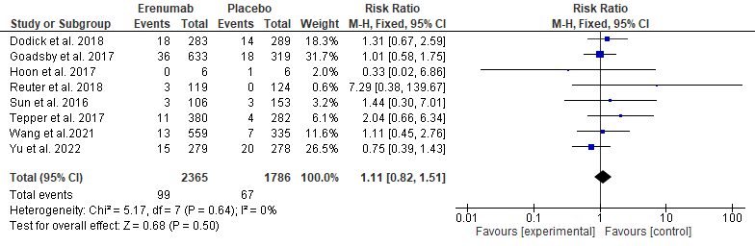
(A)
(B)
(C)

Figure (S9) Adverse Events (A) Nasopharyngitis (B) Upper respiratory tract infection (C) Constipation

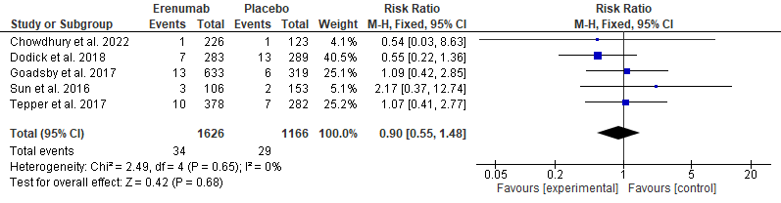
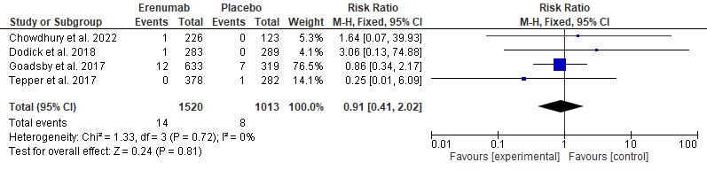
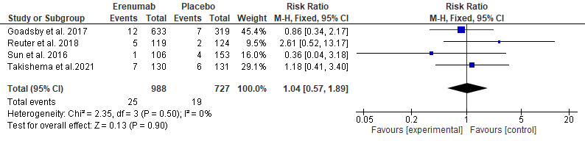
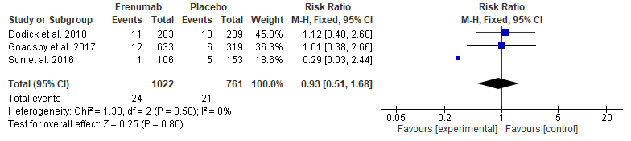
(A)
(B)
(C)
(D)

Figure (S10) Adverse Events (A) Nausea, (B) Urinary Tract Infection, (C) Back pain, (D) Influenza

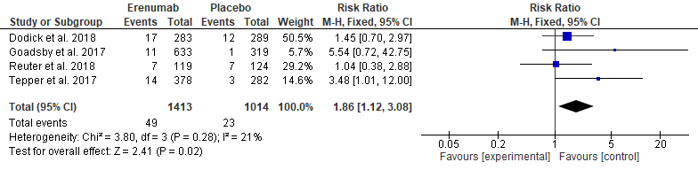
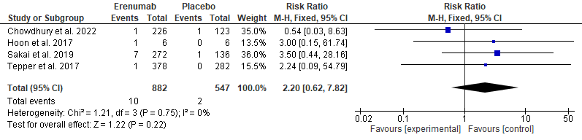
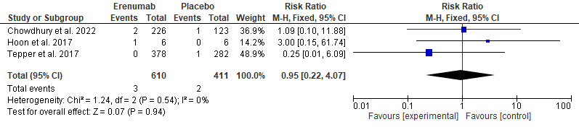
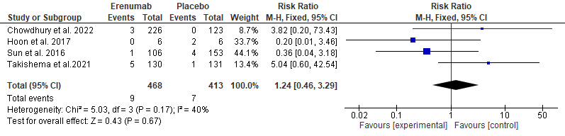
(A)
(B)
(C)
(D)

Figure (S11) Adverse Events (A) Injection site pain, (B) Abdominal pain, (C) Vomiting, (D) Diarrhea.

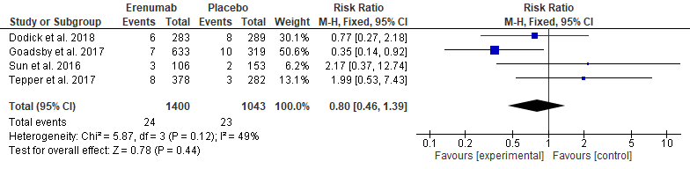
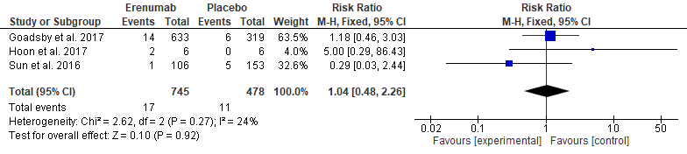
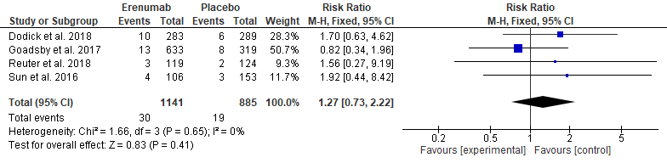
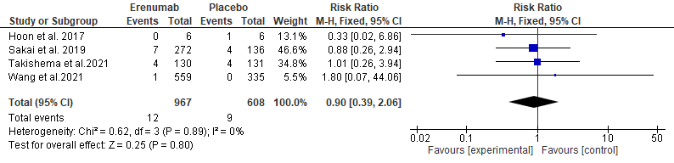
(A)
(B)
(C)
(D)

Figure (S12) Adverse Events (A) Migraine, (B) Arthralgia, (C) Fatigue, (D) Gastroenteritis.

