SUPPORTING INFORMATION (SUPPLEMENTARY MATERIAL)

FOR

“Constructing in silico, molecular self-aggregates and micro-hydrated complexes of Oxirene and Thiirene”

Dipali N. Lande ⋅ Shridhar P. Gejji⋅ Rajeev K. Pathak

DESCRIPTION OF CONTENTS

TABLES

Table S1. Structural Parameters in Oxirene and Thiirene aggregates: monomer through trimer.

Table S2. CHELPG Charge Distribution in Oxirene aggregates and complexes with water.
Table S3. CHELPG Charge Distribution in Thiirene aggregates and complexes with water.
Table S4. LUMO-HOMO orbital energy gaps for the aggregates studied herein.
Table S5. Individual Cartesian coordinates of all the atoms in (Oxirene)_{n} [n=1-10] aggregates.
Table S6. Cartesian coordinates of all the Oxirene clusters with 1, 2, and 3 water molecules.
Table S7. Cartesian coordinates of all the atoms in (Thiirene)_{n} [n=1-10] aggregates.
Table S8. Cartesian coordinates of all the Thiirene clusters with 1, 2, and 3 water molecules.
Table S9. QTAIM Parameters: Energy-densities, Laplacian of the electron density and hydrogen-bonding strengths in Oxirene aggregates.
Table S10. QTAIM Parameters for Thiirene aggregates.
FIGURES
Figure S-I. Complete MESP-map portrayals for the clusters studied.
Figure S-II. QTAIM topology for weak intermolecular interactions in Oxirene aggregates.
Figure S-III. QTAIM topology for weak intermolecular interactions in Thiirene aggregates.
Figure S-IV. NCI-RDG scatter plots. Color-filled RDG isosurfaces depicting intermolecular interaction regions in oxirene aggregates.

Figure S-V. NCI-RDG scatter plots for Oxirene monomer with water.
Figure S-VI. NCI-RDG scatter plots for Thiirene aggregates.
Figure S-VII. NCI-RDG scatter plots for Thiirene-water aggregates.
Table S1. Structural parameters in Oxirene and Thiirene monomers, dimers and trimers derived from ωB97xD/6-311++G(2d,2p) theory (Note: bond-distances in Å; angles in degrees).

C₂H₂X | Oxirene (X≡O) |  |  | Thiirene (X≡S)
Parameter | Monomer | Dimer | Trimer | Monomer | Dimer | Trimer
C-X | 1.487 | 1.437-1.559 | 1.428-1.584 | 1.853 | 1.851-1.862 | 1.851-1.861
C=C | 1.257 | 1.258-1.260 | 1.259-1.260 | 1.268 | 1.267-1.268 | 1.267-1.268
C-H | 1.069 | 1.071-1.073 | 1.071-1.085 | 1.072 | 1.072-1.076 | 1.072-1.076
∠CXC | 50.0 | 49.5 | 49.1-49.3 | 40.0 | 39.8-40.0 | 39.8-39.9
∠XCH | 133.2 | 130.2-132.6 | 131.1-132.2 | 137.9 | 136.2-137.5 | 135.6-137.5
∠HCC | 161.7 | 157.1-168.7 | 156.0-169.9 | 152.1 | 152.0-154.0 | 152.0-154.2

Table S2. Oxirene aggregates and Oxirene-water solvated complexes: CHELPG (CHarges from ELectrostatic Potentials using a Grid) Charge-distribution. 1≡Monomer -through-10 ≡Decamer. Charges are expressed in units of |e|, magnitude of the electronic charge. (Refer to the main text for details).

n | 1 | 2 | 3 | 4 | 5 | 6 | 7 | 8 | 9 | 10 | +1W | +2W | +3W
C | -0.087 | -0.0494  -0.0913  -0.0478  -0.0934 | -0.1859  -0.0021  0.0369  -0.1544  0.0408  -0.1405 | -0.0226  -0.0226  -0.0754  -0.0754  -0.0104  -0.0597  -0.0597  -0.0104 | 0.0456  -0.0727  -0.0777  -0.0703  -0.0404  -0.0493  -0.1656  -0.0432  -0.0643  0.0420 | -0.2072  0.0940  -0.0245  -0.0632  0.0310  -0.1793  -0.0421  -0.0282  -0.0797  -0.0304  -0.2439  0.0374 | 0.0458  0.0654  0.1083  -0.0962  -0.1180  0.0331  0.0124  -0.1587  0.0159  -0.1253  -0.1979  0.1665  -0.0186  -0.1472 | -0.2110  -0.1861  -0.1590  -0.1115  -0.0920  -0.0912  -0.0763  -0.0516  -0.0490  -0.0235  -0.0182  -0.0156  0.0042  0.0302  0.0775  0.1051 | -0.1410  -0.1275  -0.1149  -0.1000  -0.0893  -0.0866  -0.0844  -0.0724  -0.0702  -0.0647  -0.0561  -0.0440  -0.0361  -0.0249  -0.0151  0.0243  0.0592  0.0835 | -0.2354  -0.2308  -0.2204  -0.1916  -0.1611  -0.1499  -0.0864  -0.0736  -0.0724  -0.0498  -0.0461  -0.0382  -0.0344  -0.0141  -0.0011  0.0103  0.0123  0.0315  0.0380  0.0401 | -0.0510  -0.0512 | -0.1287  -0.0335 | -0.0818  -0.0419
H | 0.230 | 0.1888  0.2251  0.1890  0.2256 | 0.2984  0.1956  0.1821  0.2665  0.1787  0.2771 | 0.1695  0.1695  0.2223  0.2223  0.1973  0.1846  0.1846  0.1973 | 0.1297  0.2115  0.2491  0.2059  0.1980  0.1687  0.2929  0.2046  0.2091  0.1653 | 0.1996  0.1340  0.1245  0.2042  0.1775  0.2791  0.1954  0.0546  0.1928  0.2055  0.2898  0.1878 | 0.2140  0.1579  0.0246  0.2190  0.2041  0.1524  0.1819  0.2837  0.1888  0.2486  0.1852  0.1081  0.1868  0.2699 | 0.1198  0.1286  0.1342  0.1430  0.1536  0.1707  0.1860  0.1910  0.1913  0.2013  0.2045  0.2220  0.2526  0.2603  0.2625  0.2676 | 0.1225  0.1422  0.1728  0.1750  0.1795  0.1865  0.1954  0.1998  0.2010  0.2038  0.2043  0.2075  0.2150  0.2151  0.2302  0.2324  0.2654  0.2995 | 0.1135  0.1267  0.1311  0.1637  0.1703  0.1782  0.1818  0.1830  0.1851  0.1934  0.2035  0.2198  0.2390  0.2561  0.2665  0.2721  0.2895  0.3045  0.3078  0.3733 | 0.2263  0.2264  0.3733  0.3480 | 0.2940  0.2126  0.3469  0.3823  0.4047  0.4229 | 0.2299  0.2550  0.2240  0.3794  0.3813  0.4055  0.2578  0.3647
O | -0.286 | -0.2735  -0.2731 | -0.3039  -0.3366  -0.3528 | -0.2878  -0.2900  -0.2900  -0.3438 | -0.2381  -0.2881  -0.3115  -0.3388  -0.3624 | -0.3222  -0.3218  -0.3141  -0.3091  -0.2800  0.0385 | -0.2382  -0.2669  -0.3001  -0.3200  -0.3287  -0.3357  -0.4210 | -0.2208  -0.2254  -0.2438  -0.2566  -0.2900  -0.2996  -0.3372  -0.3477 | -0.2837  -0.3853  -0.2124  -0.3526  -0.3197  -0.2279  -0.3238  -0.3293  -0.2526 | -0.3545  -0.3515  -0.3485  -0.3468  -0.3220  -0.3195  -0.2969  -0.2254  -0.1702  -0.1505 | -0.2987  -0.7730 | -0.2769  -0.7699  -0.8545 | -0.1347  -0.6855  -0.8237  -0.7299

Table S3. Thiirene aggregates and Thiirene-Water solvated complexes: CHELPG Charge-distribution in units of |e| [1≡Monomer –through– 10≡Decamer].
n | 1 | 2 | 3 | 4 | 5 | 6 | 7 | 8 | 9 | 10 | +1W | +2W | +3W
C | -0.1185 | 0.0492  -0.2191  0.0492  -0.2191 | 0.0704  -0.2079  -0.2079  0.0704  -0.0546  -0.0546 | -0.0957  -0.0489  -0.0954  -0.0489  -0.0498  -0.0947  -0.0492  -0.0955 | -0.0179  -0.0190  -0.0523  -0.0988  -0.1075  -0.0168  -0.1238  -0.0477  -0.1679  0.0010 | -0.1376  0.0216  -0.0264  -0.1267  -0.1790  0.0450  -0.1554  0.0731  0.0013  -0.0856  -0.0429  -0.1026 | -0.1945  0.0593  -0.0990  -0.0611  0.0036  -0.2528  -0.1354  -0.0066  -0.1369  0.0366  -0.0381  -0.0334  -0.0947  -0.0447 | 0.0017  -0.0251  -0.1332  -0.0438  -0.2153  0.0539  -0.1379  0.0597  -0.2146  0.0329  -0.0602  -0.0304  -0.1203  -0.0295  -0.0368  -0.0749 | -0.2627  0.0505  -0.0316  -0.0532  0.0317  -0.1363  -0.0634  0.0245  0.0465  -0.1379  -0.1296  -0.0973  -0.1922  0.0878  -0.0510  0.0693  -0.0461  -0.1081 | -0.0739  0.0579  -0.0761  -0.0662  0.0031  -0.2716  -0.1883  0.0630  0.0312  -0.0979  -0.1497  0.0101  -0.0012  -0.1582  0.0281  -0.1484  -0.1316  0.0577  0.0618  -0.1866 | -0.0853  -0.0804 | -0.0846  -0.0635 | -0.0949  -0.1217
H | 0.2078 | 0.1062  0.2295  0.1062  0.2295 | 0.0766  0.2246  0.2246  0.0766  0.1247  0.1247 | 0.1951  0.1280  0.1949  0.1278  0.1284  0.1947  0.1280  0.1948 | 0.1149  0.1277  0.1674  0.1913  0.2038  0.1107  0.1765  0.1727  0.2438  0.1670 | 0.1828  0.1352  0.0903  0.1943  0.2082  0.1179  0.2017  0.0055  0.0679  0.1533  0.1071  0.1843 | 0.2324  0.0367  0.1900  0.1372  0.1685  0.2981  0.1990  0.1410  0.1964  0.0722  0.1388  0.0937  0.1817  0.1550 | 0.1682  0.1084  0.1880  0.1134  0.1698  0.1553  0.1185  0.1066  0.2115  0.1973  0.2886  0.1138  0.2088  0.0517  0.0953  0.2643 | 0.1998  0.1826  0.2253  0.0648  0.0763  0.1714  0.2955  0.1549  0.1212  0.1050  0.0657  0.1634  0.1858  0.1121  0.1631  0.1128  0.1464  0.1979 | 0.1990  0.0978  0.0728  0.2439  0.1951  0.0944  0.0697  0.1021  0.1791  0.1634  0.1510  0.3119  0.2015  0.1130  0.1980  0.0344  0.1206  0.1873  0.0647  0.2429 | 0.2016  0.1999  0.3101  0.3513 | 0.2252  0.1884  0.3631  0.2928  0.3515  0.3721 | 0.2141  0.2509  0.2165  0.3663  0.3866  0.3921  0.2206  0.3504
S | -0.1786 | -0.1658  -0.1658 | -0.1692  -0.1290  -0.1692 | -0.1785  -0.1781  -0.1786  -0.1783 | -0.2101  -0.2067  -0.2101  -0.2171  -0.1811 | -0.0229  -0.2044  -0.2033  -0.1161  -0.1791  -0.2076 | -0.1966  -0.2075  -0.0949  -0.1595  -0.1563  -0.1920  -0.2360 | -0.1489  -0.2198  -0.2060  -0.2312  -0.1303  -0.2242  -0.2097  -0.2156 | -0.2001  -0.1569  -0.1982  -0.1385  -0.2233  -0.2227  -0.2522  -0.1895  -0.1632 | -0.1883  -0.2174  -0.1791  -0.1428  -0.1242  -0.2100  -0.1982  -0.2141  -0.2271  -0.1046 | -0.1607 | -0.1905 | -0.0374
O |  |  |  |  |  |  |  |  |  |  | -0.7365 | -0.7048  -0.7497 | -0.6587  -0.8121  -0.6726

Table S4. LUMO-HOMO energy gaps (in eV) in the Oxirene and Thiirene aggregates.
Species | Oxirene |  |  | Thiirene
Energy | HOMO (Hartree) | LUMO  (Hartree) | LUMO-HOMO gap (eV) | HOMO  (Hartree) | LUMO  (Hartree) | LUMO-HOMO gap (eV )
Monomer | -0.2888 | 0.0427 | 9.0 | -0.2762 | 0.0398 | 8.6
Dimer | -0.2945 | 0.0391 | 9.1 | -0.2815 | 0.0294 | 8.5
Trimer | -0.2960 | 0.0344 | 9.0 | -0.2830 | 0.0253 | 8.4
Tetramer | -0.2680 | 0.0347 | 8.2 | -0.2884 | 0.0273 | 8.6
Pentamer | -0.2873 | 0.0367 | 8.8 | -0.2821 | 0.0211 | 8.3
Hexamer | -0.2764 | 0.0334 | 8.4 | -0.2770 | 0.0232 | 8.2
Heptamer | -0.2932 | 0.0192 | 8.5 | -0.2841 | 0.0153 | 8.1
Octamer | -0.2834 | 0.0276 | 8.5 | -0.2796 | 0.0166 | 8.1
Nonamer | -0.2821 | 0.0260 | 8.4 | -0.2862 | 0.0171 | 8.3
decamer | -0.2816 | 0.0288 | 8.4 | -0.2778 | 0.0136 | 7.9
Monomer+1Water | -0.3105 | 0.0383 | 9.5 | -0.2913 | 0.0335 | 8.8
Monomer+2Waters | -0.3070 | 0.0390 | 9.4 | -0.2891 | 0.0387 | 8.9
Monomer+3Waters | -0.3231 | 0.0358 | 9.8 | -0.3019 | 0.0351 | 9.2

Tables S5. Cartesian coordinates (in Å) of all the atoms in (Oxirene)_{n} [n=1-10] aggregates.

(Oxirene)₁
O 0.00000000 0.00000000 0.88779400
C 0.00000000 -0.62846700 -0.45949200
H -0.00345000 -1.64371300 -0.79422400
C 0.00000000 0.62846700 -0.45949200
H 0.00345000 1.64371300 -0.79422400
(Oxirene)₂
O 1.69915300 0.65261500 -0.51263000
C 1.28923400 -0.74914500 0.03366900
H 0.42244400 -1.34676800 -0.17464200
C 2.30789200 -0.17125600 0.49465200
H 3.17264600 -0.03879600 1.11346000
O -1.69684500 -0.65014300 -0.51565200
C -1.28991700 0.74555400 0.03302400
H -0.42761700 1.34957600 -0.17542700
C -2.30933900 0.17160200 0.49654500
H -3.17315200 0.03568100 1.11552600
(Oxirene)₃
O 2.09356900 -0.50668500 -0.85620000
C 1.89419900 0.48820200 0.36062600
H 1.09044600 1.18010100 0.59180400
C 2.90380500 -0.26295000 0.29363900
H 3.83792000 -0.67976500 0.61490400
O -1.89157400 -1.59435200 -0.50758300
C -1.40031700 -2.25290100 0.67323000
H -1.90045300 -2.70113300 1.50811700
C -0.42654800 -1.88867600 -0.03722800
H 0.52985100 -1.61975200 -0.46941500
O -0.59702700 2.08465100 0.81694000
C -1.11734200 2.56818900 -0.43951200
H -1.06128700 3.52299100 -0.92194300
C -1.44243100 1.36237200 -0.28217900
H -1.80442200 0.34323100 -0.36018300
(Oxirene)₄
O -2.07197100 0.22268800 0.00000000
C -1.85025100 -1.11951900 0.62792400
H -1.75210500 -1.41738500 1.65204200
C -1.85025100 -1.11951900 -0.62792400
H -1.75210500 -1.41738500 -1.65204200
O 2.90857000 -0.32403700 0.00000000
C 1.64032300 -0.78883800 -0.62950200
H 1.30191000 -0.88399900 -1.64625700
C 1.64032300 -0.78883800 0.62950200
H 1.30191000 -0.88399900 1.64625700
O -0.12559200 -0.24300800 -3.13086400
C 0.23210500 1.09799200 -3.52287800
H 0.72109500 1.48896500 -4.39218500
C -0.32664500 1.11678900 -2.39628400
H -0.78574700 1.32333100 -1.44976700
O -0.12559200 -0.24300800 3.13086400
C -0.32664500 1.11678900 2.39628400
H -0.78574700 1.32333100 1.44976700
C 0.23210500 1.09799200 3.52287800
H 0.72109500 1.48896500 4.39218500
(Oxirene)₅
O 0.60749000 -1.48122700 2.34121000
C -0.30869400 -0.31907400 2.21584200
H -1.37502200 -0.21706800 2.27844500
C 0.89489700 -0.03840700 1.98044500
H 1.80699800 0.45546100 1.67492500
O -2.88309200 0.53878600 0.78990500
C -2.75417000 -0.31088700 -0.53941600
H -1.88512300 -0.75536100 -1.01750700
C -3.86833500 0.14940300 -0.17458600
H -4.92241200 0.33446400 -0.23405800
O 0.04994100 2.26196600 -1.48169300
C 0.45574500 3.04068800 -0.28797800
H 1.30134000 3.66254000 -0.08313100
C -0.61603500 2.40027700 -0.13576300
H -1.51081400 1.96047100 0.27688600
O -0.24166900 -1.51920400 -1.60934500
C 0.15823500 -2.46983600 -0.40838400
H 0.40514200 -2.24787900 0.62904000
C -0.09919600 -2.94178800 -1.54827700
H -0.21296600 -3.70515000 -2.29222700
O 3.17685900 0.81113000 0.24226200
C 2.20347400 0.26092300 -0.89248300
H 1.33996600 0.72858000 -1.34346300
C 3.18895900 -0.41281700 -0.49013700
H 3.84738600 -1.25856800 -0.46320000

(Oxirene)₆
O 0.12991700 0.72100500 0.50948600
C 0.22866400 1.09764600 1.94773900
H 0.02320800 2.00933700 2.46606200
C 0.56613900 -0.08840700 1.69579400
H 0.91530500 -1.10902600 1.74224200
O -2.31329400 2.45248900 0.06639900
C -2.08223800 1.71942800 -1.24469400
H -1.28671600 1.08057300 -1.59446900
C -3.16328300 2.35334600 -1.12960300
H -4.12271500 2.75972000 -1.37215900
O -0.53500800 -0.76865200 -2.29142900
C -1.56321400 -1.67199000 -2.74657600
H -1.86114300 -1.98603900 -3.72656900
C -1.58310800 -1.61154700 -1.48890100
H -1.76048600 -1.69946100 -0.42195300
O 4.23676000 1.11811300 0.55041300
C 4.12407800 1.83228400 -0.67911700
H 4.85667100 2.25682500 -1.33683000
C 2.96417500 1.53240100 -0.28781800
H 1.91190000 1.32674300 -0.14340900
O 1.96540600 -2.51815200 0.61052300
C 1.94313500 -1.75488300 -0.69181900
H 1.18699600 -1.60167300 -1.44297500
C 2.97064500 -1.59911300 0.01678500
H 3.88280000 -1.16128700 0.37593900
O -1.98829700 -1.50780600 1.45243800
C -2.74154300 -0.13725500 1.55931200
H -2.52520200 0.84149300 1.14486900
C -3.21203500 -1.16383500 2.11825300
H -3.89296900 -1.74163100 2.71047100
(Oxirene)₇
O -1.65323100 -1.40252500 2.96982400
C -2.35644700 -1.11399200 1.69670900
H -2.96097700 -1.70229100 1.01780500
C -1.67601000 -0.14961100 2.13946500
H -1.15276800 0.78949500 2.18492600
O -3.67250300 1.86533800 -1.42401100
C -4.17763100 1.51317100 -0.02552900
H -3.70590700 1.06056100 0.82310700
C -4.99641100 2.03316300 -0.82497400
H -5.91702400 2.42912400 -1.20139200
O -3.38779600 -2.26147700 -0.89159500
C -2.82684700 -1.11609900 -1.70180100
H -3.23060100 -0.16432300 -1.99970200
C -2.02855800 -2.05405700 -1.44730200
H -1.11176800 -2.60307600 -1.35427400
O 4.60197500 -1.49070900 -0.65992600
C 4.08422200 -1.37177000 -2.00144800
H 3.90381900 -2.09585700 -2.77003800
C 4.12635300 -0.23528400 -1.46123900
H 4.10830800 0.81702700 -1.19480800
O 4.03862100 2.48999200 -0.25018300
C 4.19733600 2.06466800 1.14409100
H 5.06021900 1.84698500 1.73842200
C 2.98910100 2.22101500 0.83010900
H 1.90891300 2.28690400 0.83198100
O -0.03230300 2.00617800 0.78600200
C -0.12601400 0.89710500 -0.35414300
H 0.22341400 -0.13198100 -0.38364900
C -0.68750100 2.01736200 -0.48832100
H -1.31209400 2.74398400 -0.97168300
O 0.71950800 -1.95997300 -0.13336500
C 1.95242900 -1.92486500 0.71165700
H 2.99746000 -1.85639700 0.43107600
C 0.88089500 -2.00477400 1.36861200
H 0.14532800 -2.05093400 2.15893800
(Oxirene)₈
O -2.29930700 3.21568100 0.38393700
O -3.17544600 -2.91537400 -1.30987800
O -4.05265000 0.58694000 -0.08409500
O -1.83722200 -0.69520300 1.76264200
O 2.38563500 -1.63179000 2.35239200
O 4.82065500 1.23442900 0.31526500
O 2.56458300 -1.26179000 -1.77042100
O 1.49788300 2.84739400 -1.61885300
C 3.71470900 0.92359600 1.24866600
C 3.42086700 1.82409000 0.42015500
C 2.65888300 -3.01514300 2.11558000
C 2.56038800 -2.43957300 0.99945100
C -0.39443900 -0.74314000 1.40306200
C -1.14527400 -0.39353500 0.45628800
C -4.14851200 -3.56354100 -0.46660000
C -3.44283200 -2.78611200 0.22685800
C -3.80338100 0.00553900 -1.56639300
C -3.85159000 1.24190800 -1.30349900
C -2.12363300 3.62228900 1.77715600
C -2.29546700 2.38051500 1.67504100
C 0.22869600 2.30547400 -1.09757500
C 0.97561300 1.42006100 -1.59293600
C 4.07334200 -0.69038300 -1.73440300
C 3.68580800 -1.51749900 -2.60382400
H -1.97276200 4.57810700 2.23424900
H -2.42202200 1.32340100 1.84945500
H -0.62483400 2.75750800 -0.60797500
H 1.40934500 0.48178700 -1.89402400
H 3.80049600 -2.14851600 -3.46377100
H 4.53149400 0.02238900 -1.04282700
H 3.59684800 0.18634600 2.02124500
H 2.88270000 2.52933100 -0.20038100
H 2.81145300 -3.83831300 2.78526300
H 2.49668600 -2.11600200 -0.03315800
H 0.49394500 -0.99819500 1.96155100
H -1.53110100 -0.08487100 -0.49429900
H -4.91689200 -4.28091100 -0.67282000
H -2.97733300 -2.16600500 0.97905700
H -3.79809200 2.28762100 -1.54228000
H -3.69204900 -1.02322800 -1.86935300
(Oxirene)₉
O -1.51702800 3.84568100 2.24633600
O 4.99061800 0.07239700 1.44502300
O 0.09888400 0.69463200 0.21029100
O 3.15169200 -2.34990500 -1.60118800
O 1.40967500 -2.76233200 1.35903300
O -3.77111500 1.79036400 -0.57138900
O -2.25616800 -2.89983900 1.52285500
O -5.02178000 -1.96517100 -1.45323800
C -3.35990000 1.68669700 -1.96104100
C -2.43754500 1.28397100 -1.20551800
C 1.66994300 -4.02739900 0.63819600
C 0.49377200 -3.93523000 1.07421500
C 1.83775700 -1.53207400 -1.32473400
C 2.60725300 -1.19644000 -2.26301200
C 4.00577600 -1.00209700 0.93661200
C 3.70146900 -0.37039000 1.97898000
C 0.39459700 2.10716400 0.69870900
C 1.15825500 1.65102200 -0.19291200
C -1.80925700 5.01928400 1.46057000
C -2.45018400 4.03276000 1.01250900
C -5.34970200 -0.82148100 -0.42156300
C -5.98360100 -1.90929100 -0.39494600
C -1.58648600 -1.69503900 0.92048800
C -2.50367900 -2.21115400 0.22919500
H -1.47694600 6.03533500 1.53082700
H -3.07991100 3.33698000 0.47622000
H -4.90758200 0.15388000 -0.28777700
H -6.70359500 -2.61831300 -0.03741700
H -3.22908200 -2.37006000 -0.55551200
H -0.78067300 -1.06310300 1.23886900
H -3.86592300 1.91844700 -2.87597100
H -1.51524500 0.93031500 -0.74778900
H 2.52881300 -4.39179500 0.11436900
H -0.55436000 -4.06209100 1.29741200
H 1.15977700 -1.60335600 -0.49504200
H 2.97746800 -0.58186200 -3.05933300
H 4.00819400 -1.64063500 0.06496400
H 3.13297200 -0.07999900 2.83769900
H 1.95138000 1.58412700 -0.92735900
H -0.11920000 2.73125000 1.42013600
O 3.61396900 1.69380800 -2.00833000
C 4.52890900 1.99052800 -0.74404600
H 4.78694100 1.36536500 0.11142100
C 4.35244900 2.86044700 -1.63870800
H 4.47802400 3.81076100 -2.11880900
(Oxirene)₁₀
O -2.07780800 3.76792500 -0.96991300
O -3.59565000 -2.95975900 -0.90626100
O -4.72541000 1.11046100 -0.57273200
O -2.74249800 -1.03220800 2.54433800
O 1.47124400 0.06856600 1.96352500
O 4.76913200 0.72303900 -1.77807000
O 3.59251700 -2.89026400 -0.32569900
O 0.62680400 0.63255500 -2.29830000
C 4.32279400 1.42978400 -0.58417700
C 3.34855100 1.12336400 -1.32193100
C 2.48559100 -0.40521600 2.93864100
C 2.50862700 -1.01985900 1.84111900
C -1.60929500 -0.34426900 1.91999600
C -2.71143500 0.09545000 1.49838600
C -4.35734400 -3.83302500 -0.07663700
C -3.76030100 -3.02958300 0.68936200
C -4.12245500 0.01991900 -1.48728000
C -3.92579700 1.22447800 -1.78966200
C -1.56960600 3.85478900 0.49263800
C -2.74542800 3.45657500 0.28725000
C -0.38003400 1.23704500 -1.39797900
C 0.00558400 0.10307100 -1.01029300
C 4.83029600 -2.03603500 -0.74481700
C 5.00638100 -3.11894900 -0.12707200
H -0.61182300 4.14850200 0.90625200
H -3.72562300 3.07537600 0.49700300
H -0.93487200 2.16402300 -1.43622700
H 0.14536700 -0.81307200 -0.45051600
H 5.54472300 -3.91770300 0.34144100
H 4.89977300 -1.07674100 -1.25715000
H 4.84857000 1.85434700 0.24606900
H 2.36479600 0.99138200 -1.77959100
H 2.70704400 -0.11428800 3.94345400
H 2.74679300 -1.72233300 1.05241100
H -0.53999200 -0.43668400 2.02987100
H -3.49852800 0.60677800 0.96606400
H -5.00517600 -4.65358000 -0.31537200
H -3.33442900 -2.39758200 1.47404000
H -3.53905800 2.07592700 -2.31328800
H -4.10523800 -1.05622200 -1.41053500
O 0.21971700 -2.58244600 0.35121000
O 1.27917900 4.24697900 1.38803900
C 1.76327500 2.89782900 0.83502000
C 2.03040500 3.93578200 0.17504400
C -0.57242200 -3.30291100 -0.74973700
C 0.68011600 -3.42397800 -0.75782700
H 2.42089000 4.54550800 -0.61344200
H 1.67061000 1.88211200 1.19709700
H -1.62980600 -3.32202100 -0.96765700
H 1.67313700 -3.69809000 -1.05927000

Tables S6. Cartesian coordinates (in Å) of all atoms in Oxirene solvated complexes with 1, 2, and 3 water molecules.
Oxirene+ 1 Water
O -0.47178900 0.00010600 -0.81555500
C -1.21400500 -0.62774700 0.31688400
C -1.21224400 0.62814700 0.31692700
H -1.37915200 -1.64584800 0.59755000
H -1.37611000 1.64652700 0.59744100
O 2.11893900 -0.00034800 0.26874200
H 1.30345500 -0.00113600 -0.25595600
H 2.83210400 -0.00000400 -0.36739800
Oxirene+ 2 Waters
O 1.29790700 -0.44583900 -0.61297500
C 0.95578400 0.90542400 0.04355500
C 2.02275500 0.33434200 0.38481300
H 0.05694600 1.49176100 -0.03269800
H 2.94988200 0.16969300 0.89382100
O -1.12676600 -1.54171100 0.10339600
H -0.19785300 -1.35956100 -0.13124000
H -1.10590700 -2.02060300 0.93053200
O -2.04138900 1.10190700 0.04539100
H -2.73620200 1.22126400 -0.60002500
H -1.87611800 0.14399200 0.08291600
Oxirene+ 3 Waters
O 0.67549000 0.44250966 0.26597613
C 0.95674770 -0.43699616 1.41748434
C 0.11349688 -0.93523242 0.63047024
H 1.62638500 -0.33166237 2.24505829
H -0.67001142 -1.49408539 0.14724516
O -1.85083818 1.54890816 -0.05680083
H -0.91316308 1.37720178 0.13549636
H -2.20648603 1.99396475 0.71109251
O -2.58317451 -1.09125133 -0.64407698
H -2.48846236 -0.13492591 -0.49815688
H -2.94091949 -1.18934439 -1.52500363
O 3.18945500 -0.00163040 -0.95358904
H 2.28642090 0.25298800 -0.71797605
H 3.43730628 0.57094256 -1.67756067

Tables S7. Cartesian coordinates (in Å) of all the atoms in (Thiirene)_{n} [n=1-10] aggregates.

(Thiirene)₁
C 0.00000000 0.63409400 -0.89537600
H 0.00219200 1.58090700 -1.39760500
C 0.00000000 -0.63409400 -0.89537600
H -0.00219200 -1.58090700 -1.39760500
S 0.00000000 0.00000000 0.84623200
(Thiirene)₂
C 1.27807800 -0.88210500 0.21684000
H 0.45016900 -1.51856500 -0.04099700
C 2.17126000 -0.43367500 0.99658800
H 2.70742600 -0.43981400 1.92463300
C -1.27807800 0.88210500 0.21684000
H -0.45016900 1.51856500 -0.04099700
C -2.17126000 0.43367500 0.99658800
H -2.70742600 0.43981400 1.92463300
S -2.17126000 -0.54786100 -0.57276300
S 2.17126000 0.54786100 -0.57276300
(Thiirene)₃
C -2.77152600 1.92207800 0.30374300
H -2.58201900 1.28273500 1.14670700
C -3.33439700 2.22325600 -0.79138100
H -4.03504400 2.03094100 -1.57938000
C 3.33439700 -2.22325600 -0.79138100
H 4.03504400 -2.03094100 -1.57938000
C 2.77152600 -1.92207800 0.30374300
H 2.58201900 -1.28273500 1.14670700
C 0.00000000 -0.63347100 -0.27982900
H 0.03619800 -1.60246100 -0.74624900
C 0.00000000 0.63347100 -0.27982900
H -0.03619800 1.60246100 -0.74624900
S -2.06824100 3.50678100 -0.37320300
S 0.00000000 0.00000000 1.46937200
S 2.06824100 -3.50678100 -0.37320300
(Thiirene)₄
C 1.96465400 0.78513500 -1.52148000
H 1.71613800 1.67860500 -2.05927200
C 1.77150900 -0.42528600 -1.19866400
H 1.25372100 -1.37189000 -1.22223900
C -1.96203900 -0.78455500 -1.52154900
H -1.71188600 -1.67843700 -2.05788300
C -1.77039800 0.42632300 -1.19955900
H -1.25380800 1.37353700 -1.22450000
C -0.42961600 -1.77031600 1.19886200
H -1.37816200 -1.25601400 1.22222900
C 0.78178400 -1.95805000 1.52121500
H 1.67437200 -1.70529000 2.05850000
C 0.42848300 1.76902700 1.19709700
H 1.37725700 1.25510700 1.21913600
C -0.78289400 1.95552900 1.52020900
H -1.67589800 1.69976300 2.05533300
S 0.26006700 -3.23807500 0.28435400
S -3.24053400 -0.25814600 -0.28502500
S -0.26191500 3.23876400 0.28628500
S 3.24171800 0.25856800 -0.28361900
(Thiirene)₅
C -2.33801000 -0.48756300 -1.75234900
H -2.20406200 -1.50859500 -2.05357300
C -1.91630500 0.69858000 -1.60682300
H -1.18656500 1.49230300 -1.66611600
C 0.92243700 -2.24962500 -0.27539300
H 0.60830500 -1.70028000 0.60303900
C 1.53242900 -3.19601200 -0.85789700
H 2.13392700 -4.08308600 -0.85071100
C 3.51195700 1.51283600 -0.58590800
H 3.81242800 2.52384800 -0.77709700
C 3.02287000 0.40045900 -0.94616300
H 2.56884200 -0.27364000 -1.65496400
C -2.11627200 -1.17426500 1.65466100
H -2.73065900 -0.52943200 1.03897900
C -1.82040100 -2.28584700 2.18819700
H -1.99974900 -3.32570000 2.37590400
C 0.27693200 1.94425600 0.87607000
H 1.11707900 1.31094400 1.12227100
C -0.91097100 2.36470500 1.01599800
H -1.88004600 2.34114100 1.47393500
S 3.48307700 0.35203100 0.85891900
S -0.05089000 3.35212900 -0.29848400
S -0.58473100 -1.00419700 2.70319600
S -3.67232200 0.56626600 -1.00091100
S 0.74814700 -2.10451900 -2.12984700
(Thiirene)₆
C 0.73655600 -1.02853400 -2.34009000
H 0.86133000 -1.59011800 -3.24434800
C 0.88307200 0.01925100 -1.64177200
H 1.20921600 1.03417200 -1.45936400
C -3.51786200 -1.40307200 1.20667000
H -2.65795700 -1.04091400 1.75018600
C -4.76163200 -1.47711600 0.96757700
H -5.78069000 -1.21318700 1.16961000
C -1.33548000 1.93698000 2.57407700
H -1.72338900 2.65091700 3.27309900
C -1.04206600 1.56233700 1.39904800
H -0.98532900 1.69324600 0.32535100
C 4.39360100 -2.04738200 1.06680100
H 4.85971700 -2.22556100 2.01540200
C 3.36992600 -1.92748900 0.32799200
H 2.30481500 -1.91187000 0.14470800
C 2.45096400 1.44759900 1.10210200
H 1.85606400 1.10162400 1.93015500
C 3.41261900 1.34826500 0.28160900
H 4.26897700 0.83634900 -0.12670500
C -3.07671100 0.68415100 -1.47468300
H -3.12011600 -0.39491700 -1.47901900
C -3.54206900 1.83202700 -1.20097300
H -4.30086300 2.47751400 -0.80606800
S -0.03188500 -1.29059900 -0.67652200
S 2.37396900 2.83567300 -0.13231500
S 4.93191100 -1.68846100 -0.66565700
S -0.58116200 0.24755900 2.64463000
S -3.83971300 -2.55798500 -0.21699400
S -1.89170000 2.01010300 -2.02209000
(Thiirene)₇
C -2.76850000 -1.89225600 0.37994300
H -3.28861300 -1.47459000 -0.46595900
C -1.96812500 -1.80659600 1.36087500
H -1.27725200 -1.26962600 1.99091000
C -3.47602400 1.46991500 1.92275300
H -3.22984200 1.06843500 2.88583100
C -3.89009000 1.35831000 0.73039100
H -4.25203500 0.79860100 -0.11580200
C -2.26299300 1.28854400 -2.12088000
H -2.19164700 2.33256600 -1.88418600
C -1.77195700 0.12766600 -2.25407100
H -0.96210500 -0.58475600 -2.21539000
C 5.15525700 -1.32937300 -0.20983400
H 5.92814200 -2.01810300 -0.48773100
C 4.32697000 -0.40817200 -0.47777900
H 3.83649000 0.30056400 -1.12880000
C 3.96284500 3.18350100 -0.26715500
H 4.89343600 3.71308500 -0.31388500
C 3.03367000 2.60091200 0.36786200
H 2.55618800 2.22610500 1.25824700
C 0.33109200 0.46296900 0.39162000
H 0.66382500 -0.17884600 -0.40820500
C -0.34742300 1.42839500 0.85363200
H -1.04415000 2.24900700 0.76935600
C 1.55953000 -2.67927400 -0.10950900
H 2.37708700 -2.39668500 0.53775100
C 0.44451900 -3.21898000 -0.37371700
H -0.43672400 -3.78115300 -0.10323300
S 4.24401700 -0.85566200 1.33229300
S 2.67728600 2.57594900 -1.45865700
S 0.60346900 0.60635400 2.22661000
S -3.43708700 3.12600900 1.08329100
S -3.59199200 0.10159000 -2.64299400
S -2.65853000 -3.53096600 1.23818100
S 1.06624700 -2.30439700 -1.87145300
(Thiirene)₈
C 4.28933200 -0.93416300 0.76831100
C 4.25629200 -1.02085600 -0.49656900
C 0.29832700 0.53361400 3.69730500
C 0.76556300 -0.60563000 3.39473300
C -1.56138900 0.79892500 0.73802600
C -2.18726500 1.56101700 -0.05761200
C -5.17275500 -1.29363400 0.40146400
C -4.54876600 -0.49903300 1.16560800
C -2.38156500 -1.07362900 -1.88218100
C -1.60423500 -0.63659900 -2.78485900
C 2.02278300 3.92551700 0.57355000
C 0.76404400 3.77476500 0.60528100
C 1.47280300 1.32011700 -1.88028500
C 1.27415500 0.21751600 -1.28779800
C 1.47328600 -3.17193600 -0.27933000
C 0.45928100 -3.21266700 -1.03882700
H 3.00225100 3.79922300 0.99040600
H -0.15537600 3.43254400 1.05659300
H 1.46154300 2.40041300 -1.93106100
H 0.96537900 -0.37900800 -0.44721600
H -0.01669300 -3.38495900 -1.98429300
H 2.52781900 -3.27717400 -0.05962700
H 4.11992200 -0.40740900 1.68855700
H 4.01844600 -0.65418000 -1.48191600
H -0.34787300 1.18118800 4.25599400
H 0.82529900 -1.67063200 3.50559200
H -0.97768300 -0.07757400 0.96041500
H -2.57445000 1.80505400 -1.03275400
H -5.93602400 -1.51845800 -0.31663900
H -4.34492100 0.46108000 1.60916000
H -0.63800800 -0.54890300 -3.25715300
H -2.60559100 -1.63465200 -0.98726600
S 1.91778000 -0.08943200 -3.01044900
S 4.93964000 -2.58789400 0.24250500
S 1.55145100 0.70475100 2.34410000
S -0.07151500 -2.68628200 0.65356700
S -2.32044900 2.21012600 1.68387900
S -3.79955900 -2.20193300 1.25606100
S 1.26614600 4.72000800 -0.91931100
S -3.29870600 0.07900100 -3.02470900
(Thiirene)₉
C -2.01321800 1.34741400 2.21258400
C -1.31724900 2.26541200 1.68043200
C 4.37010100 -2.53124200 0.85394400
C 4.95782300 -1.66208400 0.14314900
C 1.50733800 -1.25287200 1.18661300
C 0.99481600 -0.66728400 2.18719900
C -0.25284000 -3.54209600 -0.70398200
C -0.00591100 -2.70645200 -1.62527300
C -1.62904200 0.44900000 -1.74039600
C -1.20836200 -0.03736800 -0.64947000
C -5.15793100 0.26989200 -1.30245700
C -4.61983600 1.29315400 -0.78009500
C 1.31211100 4.33969500 -0.73392700
C 2.57142800 4.22225700 -0.67079200
C 3.57739100 0.83467300 -1.44513600
C 3.44283500 1.29725800 -0.27218100
H -5.58009000 -0.71365900 -1.24279300
H -4.22154300 1.87170300 0.04237500
H 0.39039900 4.43707100 -1.27190800
H 3.55590000 4.12021700 -1.09052600
H 2.87311500 1.52333100 0.61085000
H 3.20521400 0.31206700 -2.30402300
H -2.15281000 0.32566200 2.52862200
H -0.41229600 2.63383700 1.22801300
H 4.10657500 -2.97907000 1.79294600
H 5.58768400 -0.80160500 -0.00699300
H 1.92383300 -1.30533900 0.19380100
H 0.63326900 0.20418700 2.69779000
H -0.07147000 -3.96583800 0.26571800
H 0.54908800 -1.88652900 -2.04411200
H -1.29965900 -0.60718800 0.25716000
H -2.39454400 0.65474000 -2.47279200
C -3.34252500 -2.25423400 0.54485900
H -3.08171900 -2.57136700 -0.45569100
C -4.10021200 -1.78536400 1.44648900
H -5.03245500 -1.37532300 1.78208200
S 1.83462200 4.17214800 1.03836800
S 5.13302100 1.70293800 -0.93481500
S 3.88905300 -2.74224800 -0.92764600
S 1.20790800 -2.47144000 2.56141200
S -1.46612300 -3.74881900 -2.09613000
S -2.46446200 -2.24974500 2.19177500
S 0.13986100 0.95536000 -1.45877300
S -3.00896800 2.91053600 2.08939800
S -4.83358600 1.52405600 -2.61983000
(Thiirene)₁₀
C 3.11863300 -0.91211800 -0.67306200
C 2.64533800 -0.94753500 -1.84846200
C 1.59587800 -2.69819200 2.89352800
C 1.20367900 -2.54122700 1.69879800
C -1.74104500 0.94114400 2.34238100
C -2.29804900 1.92407200 1.76657400
C -5.92002700 -0.15302600 -0.58827400
C -4.93576600 -0.06300200 0.20485200
C -2.57068300 2.70919500 -1.92674600
C -1.70931400 3.54963800 -2.32130300
C 1.95168600 3.75499900 0.45913700
C 0.75166000 3.89397000 0.07865300
C -0.12037500 0.43999500 -1.08540600
C -0.74542600 -0.56457300 -0.62955800
C 2.66312400 -4.24581300 -1.26070700
C 2.12354400 -5.25217800 -0.71025400
H 2.76728100 3.77554300 1.16564400
H -0.29272600 4.11877100 0.21527700
H 0.49424700 1.32504200 -1.02424500
H -1.11827800 -1.17461800 0.17968500
H 2.17875300 -6.17919400 -0.17478600
H 3.50167100 -3.63498200 -1.56077600
H 3.00848200 -0.79815500 0.39067900
H 1.81959200 -0.91972000 -2.54074300
H 1.86610100 -3.30440600 3.73501600
H 0.88872600 -2.88359500 0.72054100
H -0.92905600 0.24854600 2.49035100
H -2.34154600 2.72163100 1.04190300
H -6.96955600 -0.12079800 -0.80335000
H -4.49057700 0.11929600 1.17496100
H -0.89057900 3.85548300 -2.94192900
H -3.07433800 1.75311800 -1.94051200
C 4.35786900 1.36540500 1.60570500
C 4.74439500 1.70385900 0.44547400
C -3.08468000 -3.22263100 0.18604100
C -2.22175600 -4.06102000 0.58315700
H 4.86346500 1.51641200 -0.60581400
H 3.87414000 0.68110800 2.27818400
H -3.77389700 -2.79841200 -0.52478200
H -1.64843000 -4.95840100 0.46394900
S 1.83880900 3.45213500 -1.37423700
S -2.74673700 4.31787300 -0.98844000
S -3.39290400 1.26345700 3.12291500
S 1.44965500 -0.88980600 2.53425700
S -0.81770600 -0.57234900 -2.48720900
S 5.18996800 3.02022400 1.67645700
S 4.48035300 -1.23687900 -1.89584900
S 0.81119200 -4.16600800 -1.44693000
S -2.37205900 -2.69462800 1.82676500
S -4.35216900 -0.43579800 -1.53413000

Tables S8. Cartesian coordinates (in Å) of all atoms in Thiirene complexes with 1, 2, and 3 Water molecules
Thiirene+ 1 Water
C 0.93109600 0.85328200 -0.63332000
C 0.92887200 0.85373600 0.63349200
H 0.98147500 1.34300900 -1.58507600
H 0.97623300 1.34402400 1.58511300
O -2.42630900 0.22006900 -0.00051700
H -1.63197800 -0.33119600 -0.00088500
H -3.15830400 -0.39524400 -0.00040000
S 0.69270200 -0.87270300 0.00027200
Thiirene+ 2 Waters
C -0.61717800 -1.08287200 0.09887700
C -1.56097100 -0.72498200 0.86360300
H 0.25941000 -1.64488200 -0.17427900
H -2.15938800 -0.82625000 1.74675200
O 1.43413500 1.50250300 0.49985300
H 1.75280600 2.35516700 0.20650800
H 0.51233100 1.44445800 0.19623700
O 2.39080600 -1.06536600 -0.22528500
H 3.06019400 -1.03014600 -0.90636900
H 2.21069900 -0.14340000 0.01837900
S -1.44791800 0.44969300 -0.56616600
Thiirene+ 3 Waters
C -0.82425300 0.18886100 1.25297300
C -0.04547300 0.79420000 0.46047000
H -1.36702200 0.08700300 2.17116600
H 0.67402100 1.53907800 0.16236400
O 2.58529800 -1.28495100 -0.05861300
H 1.62735000 -1.42494300 -0.10929300
H 2.86586200 -1.69144000 0.76090000
O 2.78030100 1.52104300 -0.28953200
H 2.84342000 0.55379500 -0.23361200
H 3.32258500 1.77633300 -1.03403400
O -3.77488800 0.38335100 -0.32327900
H -2.94158700 0.00887200 -0.63232000
H -4.03615600 1.00815400 -0.99849300
S -0.65598800 -0.79442200 -0.31224600

Table S9. QTAIM parameters namely, the Lagrangian kinetic energy density $G$($\vec{r}$), Hamiltonian kinetic energy density $K$($\vec{r}$), Potential energy density $V$($\vec{r}$), Energy density $H$($\vec{r}$) and the Laplacian of electron density $∇^{2}ρ\left(\vec{r}\right)$at the critical point location $\vec{r}$, corresponding to C-H⋅⋅⋅O and O-H⋅⋅⋅O hydrogen bonding interactions in Oxirene aggregates. $E_{HB}$ refers to the estimated hydrogen-bond energies expressed in kJ⋅mol⁻¹.

Oxirene  Cluster | $$ρ_{bcp(\vec{r})}$$ | $G$($\vec{r}$) | $K$($\vec{r}$) | $V$($\vec{r}$) | $H$($\vec{r}$) | $$∇^{2}ρ(\vec{r})$$ | $$\frac{\left|V\right|}{G}$$ | $E$_{HB}
Dimer | 0.015 | 0.011 | -0.002 | -0.010 | 0.002 | 0.053 | 0.853 | 12.87
Dimer | 0.015 | 0.011 | -0.010 | -0.010 | 0.002 | 0.052 | 0.852 | 12.69
Trimer | 0.027 | 0.020 | -0.001 | -0.019 | 0.001 | 0.085 | 0.959 | 25.58
Trimer | 0.027 | 0.021 | -0.001 | -0.020 | 0.001 | 0.085 | 0.970 | 26.38
Trimer | 0.028 | 0.021 | -0.000 | -0.021 | 0.000 | 0.087 | 0.983 | 27.54
Tetramer | 0.009 | 0.007 | -0.001 | -0.006 | 0.001 | 0.032 | 0.816 | 7.31
Tetramer | 0.018 | 0.014 | -0.001 | -0.012 | 0.001 | 0.060 | 0.899 | 16.17
Tetramer | 0.009 | 0.007 | -0.001 | -0.006 | 0.001 | 0.032 | 0.816 | 7.31
Tetramer | 0.015 | 0.011 | -0.002 | -0.010 | 0.002 | 0.052 | 0.855 | 12.76
Tetramer | 0.015 | 0.011 | -0.002 | -0.010 | 0.002 | 0.052 | 0.855 | 12.76
Tetramer | 0.018 | 0.014 | -0.001 | -0.012 | 0.001 | 0.060 | 0.899 | 16.17
Pentamer | 0.032 | 0.024 | 0.000 | -0.024 | -0.000 | 0.094 | 1.011 | 31.63
Pentamer | 0.029 | 0.022 | -0.000 | -0.022 | 0.000 | 0.089 | 0.989 | 28.55
Pentamer | 0.014 | 0.011 | -0.002 | -0.009 | 0.002 | 0.050 | 0.841 | 11.94
Pentamer | 0.024 | 0.019 | -0.001 | -0.018 | 0.001 | 0.080 | 0.934 | 23.11
Pentamer | 0.022 | 0.017 | -0.001 | -0.015 | 0.001 | 0.072 | 0.922 | 20.13
Pentamer | 0.024 | 0.018 | -0.001 | -0.017 | 0.001 | 0.078 | 0.942 | 22.83
Hexamer | 0.019 | 0.015 | -0.001 | -0.013 | 0.001 | 0.065 | 0.910 | 17.68
Hexamer | 0.029 | 0.022 | -0.001 | -0.022 | 0.001 | 0.092 | 0.977 | 28.72
Hexamer | 0.014 | 0.010 | -0.001 | -0.009 | 0.001 | 0.047 | 0.868 | 11.91
Hexamer | 0.021 | 0.016 | -0.001 | -0.015 | 0.001 | 0.070 | 0.913 | 19.39
Hexamer | 0.019 | 0.014 | -0.001 | -0.013 | 0.001 | 0.062 | 0.907 | 16.91
Hexamer | 0.025 | 0.019 | -0.001 | -0.018 | 0.001 | 0.078 | 0.956 | 23.49
Hexamer | 0.027 | 0.020 | -0.000 | -0.020 | 0.000 | 0.083 | 0.975 | 26.04
Heptamer | 0.029 | 0.022 | -0.000 | -0.022 | 0.000 | 0.089 | 0.988 | 28.61
Heptamer | 0.026 | 0.020 | -0.001 | -0.019 | 0.001 | 0.082 | 0.963 | 25.07
Heptamer | 0.026 | 0.020 | -0.001 | -0.019 | 0.001 | 0.082 | 0.955 | 24.66
Heptamer | 0.009 | 0.006 | -0.001 | -0.005 | 0.001 | 0.029 | 0.842 | 7.02
Heptamer | 0.024 | 0.018 | -0.001 | -0.017 | 0.001 | 0.076 | 0.940 | 22.12
Heptamer | 0.012 | 0.010 | -0.002 | -0.008 | 0.002 | 0.046 | 0.820 | 10.54
Heptamer | 0.018 | 0.013 | -0.001 | -0.012 | 0.001 | 0.059 | 0.898 | 15.75
Heptamer | 0.030 | 0.022 | -0.000 | -0.022 | 0.000 | 0.089 | 0.998 | 29.16
Heptamer | 0.018 | 0.014 | -0.002 | -0.012 | 0.002 | 0.062 | 0.887 | 16.13
Octamer | 0.027 | 0.021 | -0.001 | -0.020 | 0.001 | 0.085 | 0.967 | 26.10
Octamer | 0.023 | 0.017 | -0.001 | -0.016 | 0.001 | 0.075 | 0.919 | 20.88
Octamer | 0.023 | 0.017 | -0.001 | -0.016 | 0.001 | 0.075 | 0.919 | 20.88
Octamer | 0.019 | 0.014 | -0.001 | -0.013 | 0.001 | 0.063 | 0.906 | 17.19
Octamer | 0.022 | 0.017 | -0.001 | -0.016 | 0.001 | 0.073 | 0.930 | 20.86
Octamer | 0.015 | 0.012 | -0.002 | -0.010 | 0.002 | 0.054 | 0.866 | 13.42
Octamer | 0.035 | 0.026 | 0.001 | -0.027 | -0.001 | 0.101 | 1.038 | 35.93
Octamer | 0.008 | 0.007 | -0.001 | -0.006 | 0.001 | 0.034 | 0.812 | 7.57
Octamer | 0.008 | 0.007 | -0.001 | -0.006 | 0.001 | 0.034 | 0.812 | 7.57
Octamer | 0.008 | 0.007 | -0.001 | -0.006 | 0.001 | 0.034 | 0.812 | 7.57
Octamer | 0.024 | 0.018 | -0.001 | -0.017 | 0.001 | 0.076 | 0.956 | 22.78
Octamer | 0.025 | 0.019 | -0.001 | -0.018 | 0.001 | 0.080 | 0.942 | 23.48
Octamer | 0.019 | 0.015 | -0.001 | -0.013 | 0.001 | 0.064 | 0.908 | 17.57
Nonamer | 0.022 | 0.017 | -0.002 | -0.015 | 0.002 | 0.074 | 0.906 | 20.19
Nonamer | 0.023 | 0.017 | -0.001 | -0.016 | 0.001 | 0.074 | 0.928 | 21.13
Nonamer | 0.017 | 0.013 | -0.002 | -0.012 | 0.002 | 0.061 | 0.873 | 15.39
Nonamer | 0.025 | 0.019 | -0.001 | -0.018 | 0.001 | 0.081 | 0.940 | 23.55
Nonamer | 0.014 | 0.012 | -0.002 | -0.010 | 0.002 | 0.054 | 0.830 | 12.55
Nonamer | 0.007 | 0.005 | -0.001 | -0.004 | 0.001 | 0.025 | 0.821 | 5.72
Nonamer | 0.024 | 0.018 | -0.001 | -0.017 | 0.001 | 0.075 | 0.943 | 22.09
Nonamer | 0.031 | 0.023 | 0.000 | -0.023 | -0.000 | 0.092 | 1.007 | 30.74
Nonamer | 0.033 | 0.024 | 0.000 | -0.025 | -0.000 | 0.096 | 1.018 | 32.65
Nonamer | 0.008 | 0.006 | -0.001 | -0.005 | 0.001 | 0.030 | 0.810 | 6.62
Nonamer | 0.025 | 0.019 | -0.001 | -0.018 | 0.001 | 0.079 | 0.955 | 23.80
Nonamer | 0.024 | 0.018 | -0.001 | -0.017 | 0.001 | 0.075 | 0.943 | 22.09
Nonamer | 0.026 | 0.020 | -0.001 | -0.019 | 0.001 | 0.082 | 0.964 | 25.02
Nonamer | 0.022 | 0.017 | -0.002 | -0.015 | 0.002 | 0.074 | 0.906 | 20.19
Decamer | 0.014 | 0.012 | -0.002 | -0.010 | 0.002 | 0.056 | 0.821 | 12.68
Decamer | 0.035 | 0.027 | 0.001 | -0.028 | -0.001 | 0.102 | 1.040 | 36.32
Decamer | 0.024 | 0.018 | -0.001 | -0.017 | 0.001 | 0.076 | 0.957 | 22.89
Decamer | 0.021 | 0.016 | -0.001 | -0.015 | 0.001 | 0.070 | 0.924 | 19.85
Decamer | 0.005 | 0.004 | -0.001 | -0.003 | 0.001 | 0.019 | 0.775 | 3.93
Decamer | 0.028 | 0.021 | -0.001 | -0.021 | 0.001 | 0.087 | 0.976 | 27.14
Decamer | 0.020 | 0.015 | -0.001 | -0.014 | 0.001 | 0.065 | 0.920 | 18.14
Decamer | 0.023 | 0.018 | -0.001 | -0.016 | 0.001 | 0.074 | 0.941 | 21.65
Decamer | 0.032 | 0.024 | 0.000 | -0.025 | -0.000 | 0.096 | 1.015 | 32.27
Decamer | 0.027 | 0.020 | -0.001 | -0.020 | 0.001 | 0.084 | 0.974 | 26.17
Decamer | 0.024 | 0.018 | -0.001 | -0.017 | 0.001 | 0.077 | 0.953 | 22.88
Decamer | 0.034 | 0.026 | 0.001 | -0.026 | -0.001 | 0.099 | 1.033 | 34.69
Decamer | 0.010 | 0.008 | -0.001 | -0.006 | 0.001 | 0.035 | 0.853 | 8.44
Decamer | 0.007 | 0.006 | -0.001 | -0.005 | 0.001 | 0.026 | 0.830 | 6.12
Decamer | 0.024 | 0.018 | -0.001 | -0.017 | 0.001 | 0.075 | 0.949 | 22.09
Monomer+1Water | 0.031 | 0.025 | 0.000 | -0.025 | -0.000 | 0.098 | 1.006 | 32.45
Monomer +2Waters | 0.033 | 0.027 | 0.001 | -0.027 | -0.001 | 0.104 | 1.028 | 35.98
Monomer +2Waters | 0.031 | 0.025 | -0.000 | -0.024 | 0.000 | 0.098 | 0.998 | 32.15
Monomer +2Waters | 0.018 | 0.014 | -0.002 | -0.012 | 0.002 | 0.064 | 0.859 | 15.77
Monomer +3Waters | 0.019 | 0.015 | -0.002 | -0.013 | 0.002 | 0.067 | 0.864 | 16.80
Monomer +3Waters | 0.030 | 0.024 | -0.000 | -0.024 | 0.000 | 0.097 | 0.991 | 31.32
Monomer +3Waters | 0.028 | 0.023 | -0.001 | -0.022 | 0.001 | 0.093 | 0.977 | 29.05

Table S10. QTAIM Parameters for Hydrogen Bonding (C-H⋅⋅⋅S and O-H⋅⋅⋅O) Interactions in Thiirene aggregates.

Thiirene  Cluster | $$ρ_{bcp(\vec{r})}$$ | $G$($\vec{r}$) | $K$($\vec{r}$) | $V$($\vec{r}$) | $H$($\vec{r}$) | $$∇^{2}ρ(\vec{r})$$ | $$\frac{\left|V\right|}{G}$$ | $E$_{HB}
Dimer | 0.009 | 0.006 | -0.001 | -0.005 | 0.001 | 0.027 | 0.810 | 5.99
Dimer | 0.009 | 0.006 | -0.001 | -0.005 | 0.001 | 0.027 | 0.810 | 5.99
Trimer | 0.010 | 0.006 | -0.001 | -0.005 | 0.001 | 0.028 | 0.822 | 6.47
Trimer | 0.008 | 0.005 | -0.001 | -0.004 | 0.001 | 0.025 | 0.793 | 5.36
Trimer | 0.008 | 0.005 | -0.001 | -0.004 | 0.001 | 0.025 | 0.793 | 5.36
Tetramer | 0.014 | 0.009 | -0.001 | -0.008 | 0.001 | 0.037 | 0.913 | 10.19
Tetramer | 0.014 | 0.009 | -0.001 | -0.008 | 0.001 | 0.037 | 0.913 | 10.21
Tetramer | 0.014 | 0.009 | -0.001 | -0.008 | 0.001 | 0.037 | 0.912 | 10.21
Tetramer | 0.014 | 0.009 | -0.001 | -0.008 | 0.001 | 0.037 | 0.910 | 10.21
Pentamer | 0.017 | 0.009 | -0.000 | -0.009 | 0.000 | 0.039 | 0.967 | 12.04
Pentamer | 0.007 | 0.004 | -0.001 | -0.003 | 0.001 | 0.021 | 0.758 | 4.25
Pentamer | 0.017 | 0.010 | -0.000 | -0.010 | 0.000 | 0.040 | 0.975 | 12.62
Pentamer | 0.013 | 0.008 | -0.001 | -0.007 | 0.001 | 0.034 | 0.906 | 9.29
Pentamer | 0.015 | 0.009 | -0.001 | -0.008 | 0.001 | 0.037 | 0.933 | 10.60
Pentamer | 0.015 | 0.009 | -0.001 | -0.008 | 0.001 | 0.038 | 0.950 | 10.80
Hexamer | 0.015 | 0.009 | -0.001 | -0.008 | 0.001 | 0.037 | 0.950 | 10.80
Hexamer | 0.014 | 0.008 | -0.001 | -0.007 | 0.001 | 0.033 | 0.930 | 9.50
Hexamer | 0.014 | 0.008 | -0.001 | -0.007 | 0.001 | 0.035 | 0.919 | 9.79
Hexamer | 0.012 | 0.007 | -0.001 | -0.006 | 0.001 | 0.031 | 0.880 | 8.11
Hexamer | 0.013 | 0.008 | 0.008 | -0.007 | 0.001 | 0.033 | 0.895 | 8.86
Hexamer | 0.016 | 0.009 | -0.000 | -0.009 | 0.000 | 0.038 | 0.954 | 11.41
Hexamer | 0.016 | 0.010 | -0.000 | -0.009 | 0.000 | 0.040 | 0.950 | 11.88
Heptamer | 0.014 | 0.008 | -0.001 | -0.008 | 0.001 | 0.036 | 0.921 | 10.12
Heptamer | 0.016 | 0.009 | -0.000 | -0.009 | 0.000 | 0.038 | 0.951 | 11.32
Heptamer | 0.012 | 0.007 | -0.001 | -0.006 | 0.001 | 0.032 | 0.893 | 8.42
Heptamer | 0.011 | 0.007 | -0.001 | -0.006 | 0.001 | 0.029 | 0.889 | 7.72
Heptamer | 0.012 | 0.006 | -0.001 | -0.006 | 0.001 | 0.028 | 0.904 | 7.69
Heptamer | 0.013 | 0.008 | -0.001 | -0.007 | 0.001 | 0.035 | 0.911 | 9.54
Heptamer | 0.012 | 0.007 | -0.001 | -0.006 | 0.001 | 0.031 | 0.879 | 7.96
Heptamer | 0.011 | 0.007 | -0.001 | -0.006 | 0.001 | 0.030 | 0.862 | 7.42
Heptamer | 0.015 | 0.009 | -0.001 | -0.008 | 0.001 | 0.038 | 0.932 | 10.89
Heptamer | 0.015 | 0.009 | -0.001 | -0.008 | 0.001 | 0.037 | 0.927 | 10.58
Octamer | 0.016 | 0.009 | -0.000 | -0.009 | 0.000 | 0.039 | 0.965 | 11.81
Octamer | 0.014 | 0.008 | -0.001 | -0.007 | 0.001 | 0.035 | 0.918 | 9.64
Octamer | 0.004 | 0.003 | -0.001 | -0.002 | 0.001 | 0.014 | 0.720 | 2.66
Octamer | 0.010 | 0.005 | -0.001 | -0.005 | 0.001 | 0.025 | 0.853 | 6.11
Octamer | 0.010 | 0.006 | -0.001 | -0.005 | 0.001 | 0.028 | 0.844 | 6.64
Octamer | 0.007 | 0.005 | -0.001 | -0.004 | 0.001 | 0.022 | 0.798 | 4.79
Octamer | 0.008 | 0.005 | -0.001 | -0.004 | 0.001 | 0.025 | 0.766 | 5.04
Octamer | 0.007 | 0.004 | -0.001 | -0.003 | 0.001 | 0.019 | 0.776 | 3.89
Octamer | 0.012 | 0.007 | -0.001 | -0.006 | 0.001 | 0.033 | 0.874 | 8.38
Octamer | 0.013 | 0.007 | -0.001 | -0.007 | 0.001 | 0.033 | 0.892 | 8.73
Octamer | 0.014 | 0.008 | -0.001 | -0.007 | 0.001 | 0.035 | 0.920 | 9.76
Octamer | 0.012 | 0.007 | -0.001 | -0.006 | 0.001 | 0.031 | 0.864 | 7.73
Octamer | 0.016 | 0.009 | -0.000 | -0.009 | 0.000 | 0.038 | 0.963 | 11.67
Octamer | 0.015 | 0.008 | -0.000 | -0.008 | 0.000 | 0.036 | 0.943 | 10.44
Nonamer | 0.006 | 0.004 | -0.001 | -0.003 | 0.001 | 0.019 | 0.768 | 3.81
Nonamer | 0.015 | 0.008 | -0.001 | -0.008 | 0.001 | 0.036 | 0.932 | 10.22
Nonamer | 0.007 | 0.004 | -0.001 | -0.003 | 0.001 | 0.021 | 0.741 | 4.11
Nonamer | 0.009 | 0.006 | -0.001 | -0.005 | 0.001 | 0.027 | 0.833 | 6.33
Nonamer | 0.012 | 0.007 | -0.001 | -0.006 | 0.001 | 0.034 | 0.864 | 8.49
Nonamer | 0.014 | 0.008 | -0.001 | -0.007 | 0.001 | 0.034 | 0.932 | 9.63
Nonamer | 0.008 | 0.005 | -0.001 | -0.004 | 0.001 | 0.024 | 0.796 | 5.10
Nonamer | 0.011 | 0.007 | -0.001 | -0.006 | 0.001 | 0.032 | 0.862 | 7.89
Nonamer | 0.015 | 0.009 | -0.001 | -0.008 | 0.001 | 0.037 | 0.925 | 10.47
Nonamer | 0.014 | 0.008 | -0.000 | -0.007 | 0.000 | 0.033 | 0.943 | 9.79
Nonamer | 0.005 | 0.003 | -0.001 | -0.002 | 0.001 | 0.016 | 0.721 | 3.02
Nonamer | 0.009 | 0.005 | -0.001 | -0.004 | 0.001 | 0.026 | 0.805 | 5.76
Nonamer | 0.010 | 0.006 | -0.001 | -0.005 | 0.001 | 0.026 | 0.848 | 6.36
Nonamer | 0.008 | 0.005 | -0.001 | -0.004 | 0.001 | 0.025 | 0.795 | 5.41
Decamer | 0.017 | 0.009 | -0.000 | -0.009 | 0.000 | 0.039 | 0.967 | 11.89
Decamer | 0.013 | 0.008 | -0.001 | -0.007 | 0.001 | 0.035 | 0.894 | 9.27
Decamer | 0.015 | 0.008 | -0.001 | -0.008 | 0.001 | 0.036 | 0.936 | 10.40
Decamer | 0.013 | 0.008 | -0.001 | -0.007 | 0.001 | 0.035 | 0.907 | 9.56
Decamer | 0.004 | 0.003 | -0.001 | -0.002 | 0.001 | 0.013 | 0.677 | 2.22
Decamer | 0.012 | 0.007 | -0.001 | -0.007 | 0.001 | 0.033 | 0.897 | 8.69
Decamer | 0.013 | 0.007 | -0.001 | -0.006 | 0.001 | 0.031 | 0.905 | 8.49
Decamer | 0.017 | 0.010 | -0.000 | -0.009 | 0.000 | 0.039 | 0.971 | 12.15
Decamer | 0.008 | 0.004 | -0.001 | -0.004 | 0.001 | 0.021 | 0.820 | 4.84
Decamer | 0.013 | 0.008 | -0.001 | -0.007 | 0.001 | 0.034 | 0.891 | 8.84
Decamer | 0.015 | 0.008 | -0.001 | -0.008 | 0.001 | 0.035 | 0.937 | 10.09
Decamer | 0.006 | 0.004 | -0.001 | -0.003 | 0.001 | 0.018 | 0.751 | 3.65
Decamer | 0.004 | 0.003 | -0.001 | -0.002 | 0.001 | 0.015 | 0.711 | 2.65
Decamer | 0.015 | 0.009 | -0.000 | -0.008 | 0.000 | 0.038 | 0.948 | 11.14
Decamer | 0.014 | 0.009 | -0.001 | -0.008 | 0.001 | 0.037 | 0.919 | 10.26
Decamer | 0.013 | 0.008 | -0.001 | -0.007 | 0.001 | 0.033 | 0.923 | 9.18
Monomer+1Water | 0.020 | 0.012 | 0.000 | -0.012 | -0.000 | 0.046 | 1.034 | 16.29
Monomer +2Waters | 0.023 | 0.013 | 0.001 | -0.015 | -0.001 | 0.048 | 1.096 | 19.09
Monomer +2Waters | 0.016 | 0.012 | -0.002 | -0.010 | 0.002 | 0.056 | 0.845 | 13.40
Monomer +2Waters | 0.028 | 0.022 | -0.001 | -0.021 | 0.001 | 0.091 | 0.968 | 28.09
Monomer +3Waters | 0.020 | 0.012 | 0.001 | -0.012 | -0.001 | 0.045 | 1.046 | 16.35
Monomer +3Waters | 0.017 | 0.011 | -0.000 | -0.010 | 0.000 | 0.043 | 0.982 | 13.70
Monomer +3Waters | 0.029 | 0.023 | -0.000 | -0.023 | 0.000 | 0.095 | 0.982 | 29.97
Monomer +3Waters | 0.017 | 0.013 | -0.002 | -0.011 | 0.002 | 0.062 | 0.853 | 15.05

Oxirene | Oxirene-Dimer
Oxirene-Trimer | Oxirene-Tetramer
Oxirene-Pentamer | Oxirene-Hexamer
Oxirene-Heptamer | Oxirene-Octamer
Oxirene- Nonamer | Oxirene-Decamer
Oxirene + 1Water | Oxirene + 2Waters
Oxirene + 3Waters | Legend

Thiirene | Thiirene-Dimer
Thiirene-Trimer | Thiirene-Tetramer
Thiirene-Pentamer | Thiirene-Hexamer
Thiirene-Heptamer | Thiirene-Octamer
Thiirene-Nonamer | Thiirene-Decamer
Thiirene + 1Water | Thiirene + 2Waters
Thiirene + 3Waters

Legend

Figure S-I. Molecular electrostatic potential (MESP) portraits overlaid on the electron (number) density isosurface set at 0.004 a.u. (here, 1 a.u. ≡ $\frac{1}{a_{0}^{3}}$ , $a_{0 }$ being the Bohr-radius) for the minimal energy conformers of Oxirene; Oxirene-Dimer through Decamer, and its complexes with water molecules; followed by analogous Thiirene systems. The ωB97xD/6-311++G(2d,2p) theory was employed. Further, note that 1 a. u. of MESP ≡ $\frac{1}{4π∈_{0}}\frac{|e|}{a_{0}}$ .
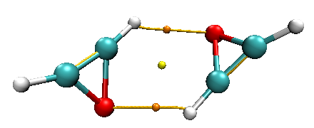 | 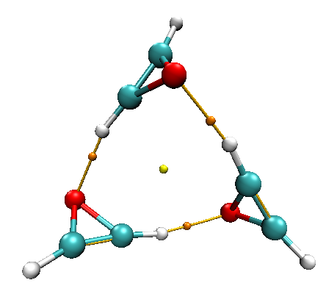
Oxirene-Dimer | Oxirene-Trimer
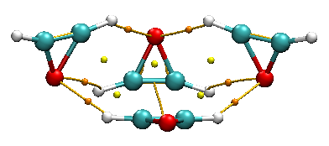 | 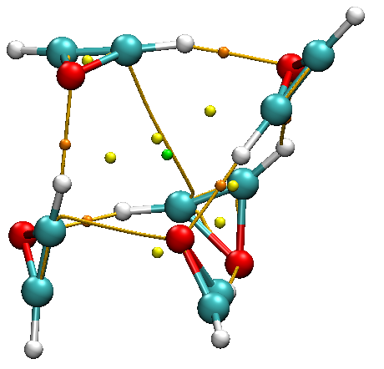
Oxirene-Tetramer | Oxirene-Pentamer
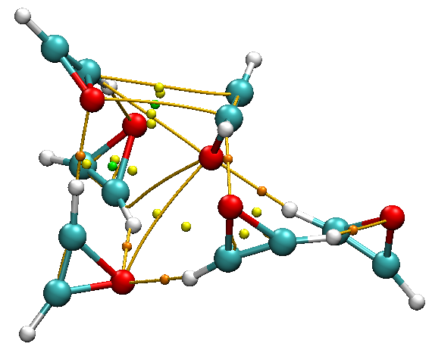 | 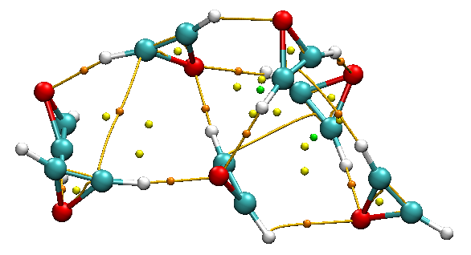
Oxirene-Hexamer | Oxirene-Heptamer
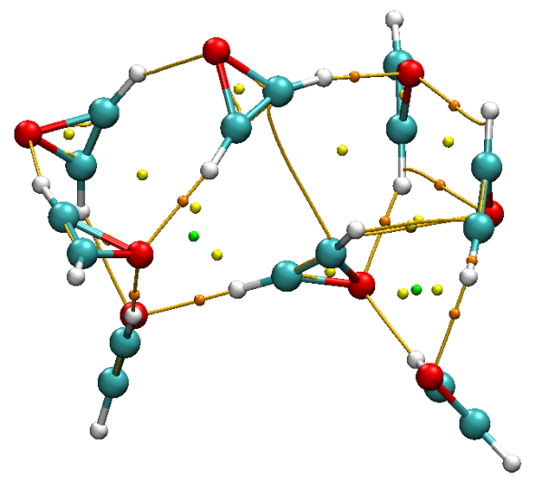 | 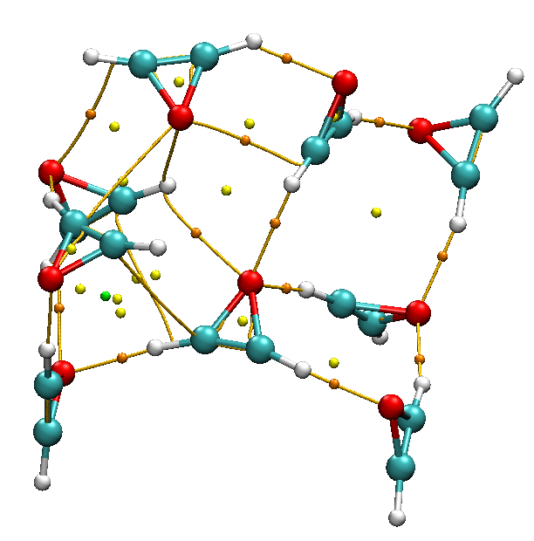
Oxirene-Octamer | Oxirene-Nonamer
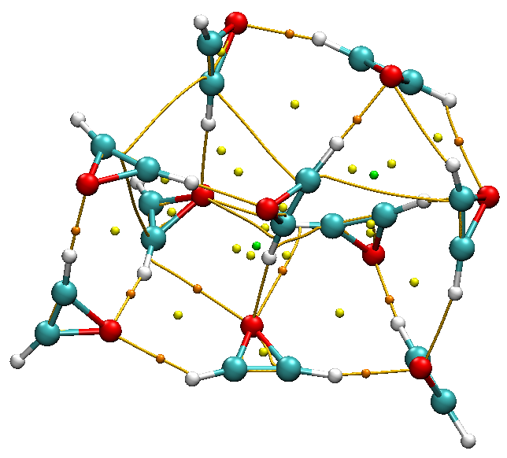 | 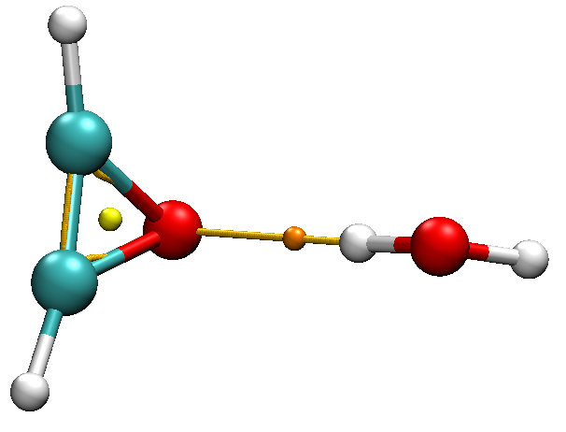
Oxirene Decamer | Oxirene + 1Water
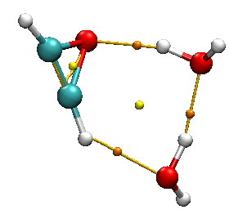 | 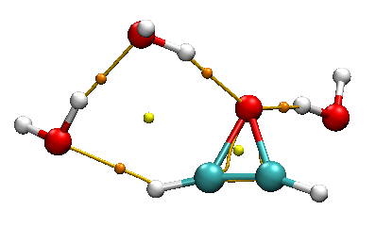
Oxirene+2Waters | Oxirene+3Waters
Figure S-II. QTAIM topology for weak intermolecular interactions in Oxirene aggregates. The bond critical points (bcp’s) for hydrogen bonds are depicted in light brown color; other critical points appear in yellow or green.

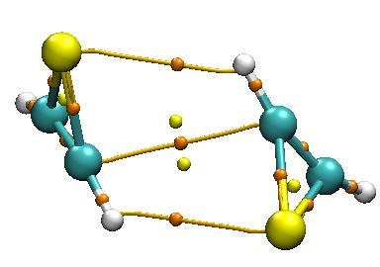 | 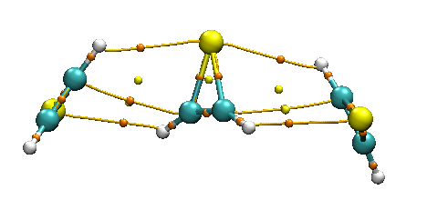
Thiirene-Dimer | Thiirene-Trimer
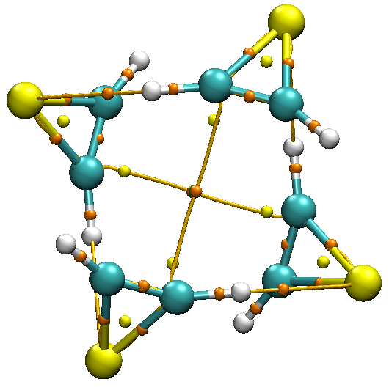 | 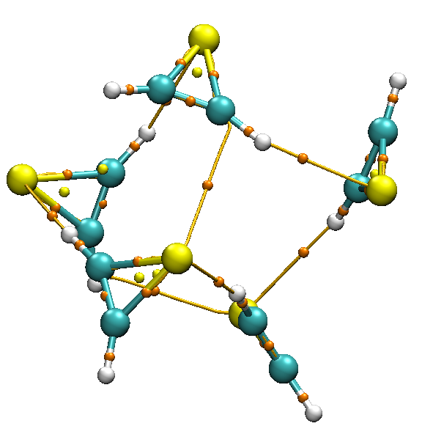
Thiirene-Tetramer | Thiirene-Pentamer
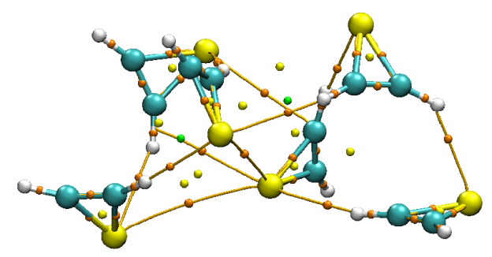 | 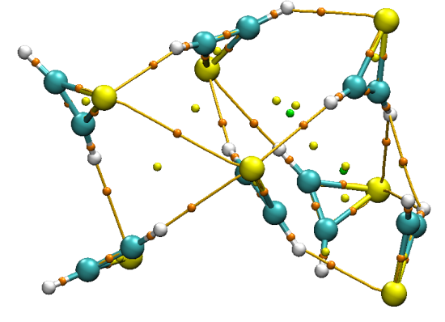
Thiirene-Hexamer | Thiirene-Heptamer
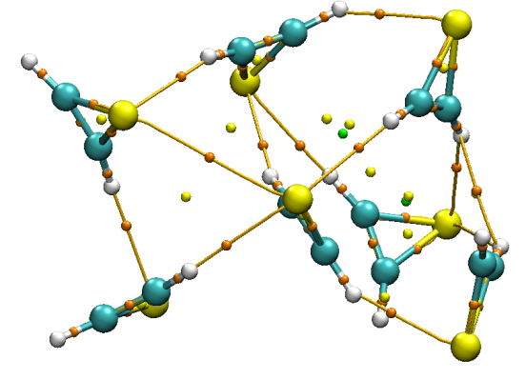 | 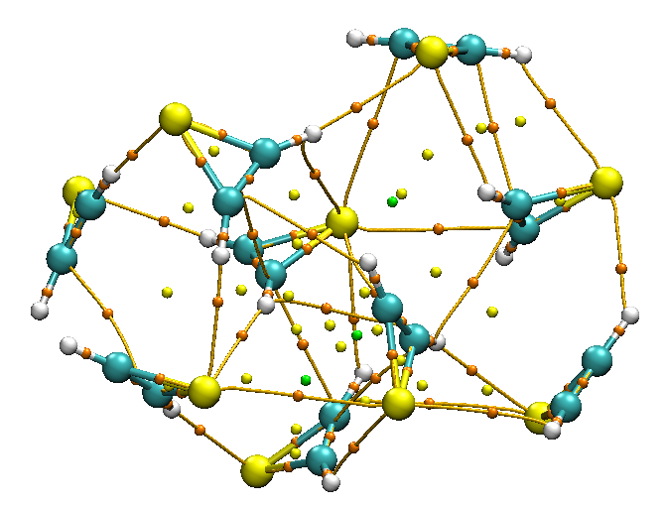
Thiirene-Octamer | Thiirene-Nonamer
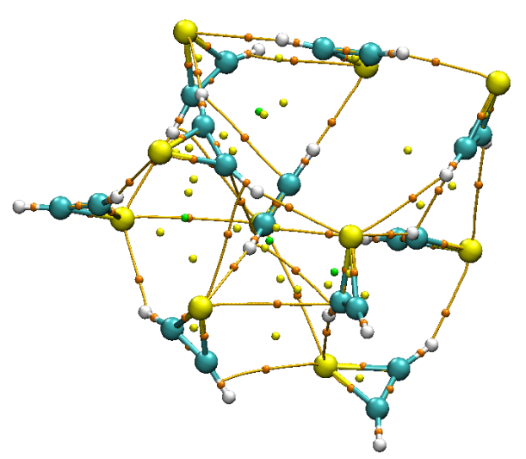 | 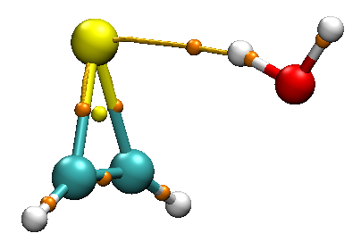
Thiirene-decamer | Thiirene+1Water
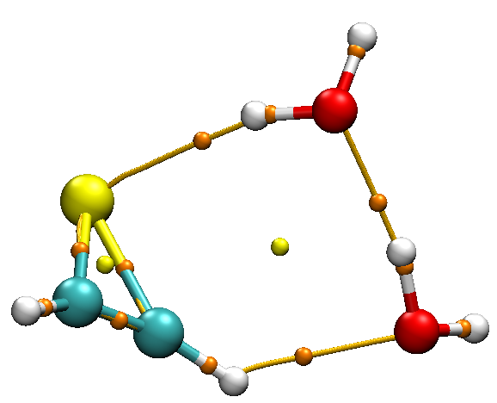 | 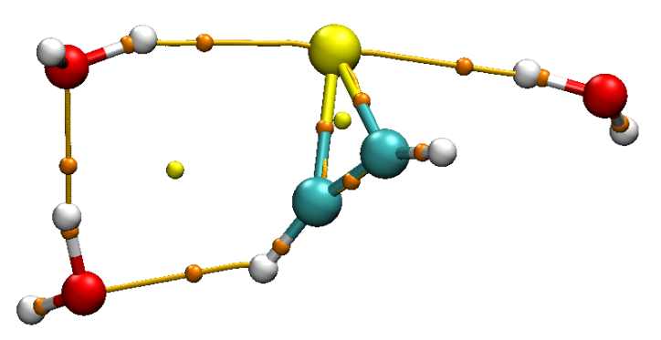
Thiirene+2Waters | Thiirene+3Waters
Figure S-III. QTAIM topology for weak intermolecular interactions in Thiirene water solvated complexes.

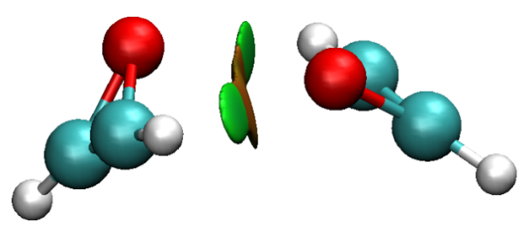 | 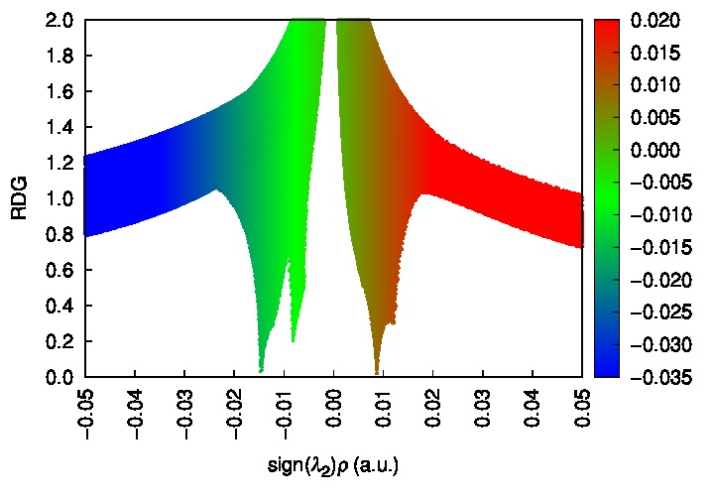
Oxirene-Dimer

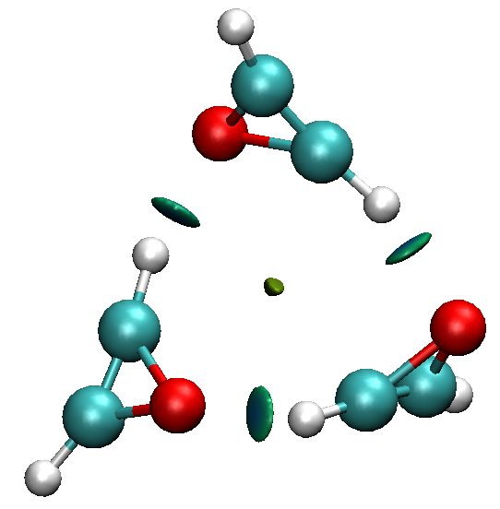 | 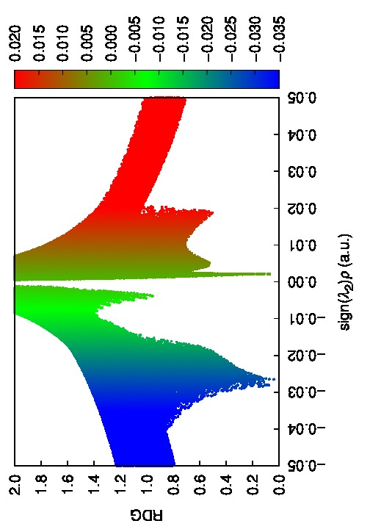
Oxirene-Trimer

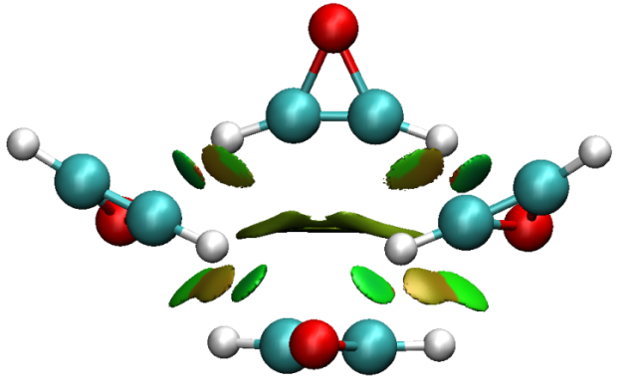 | 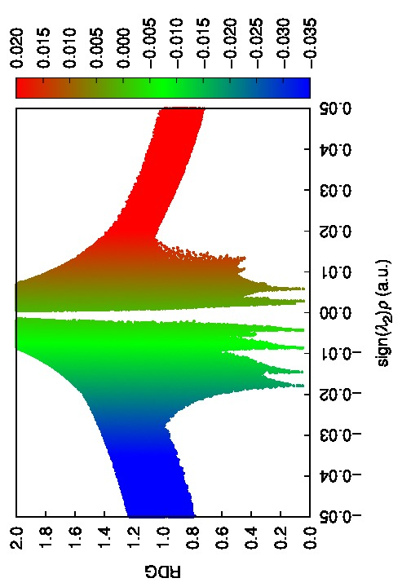
Oxirene-Tetramer
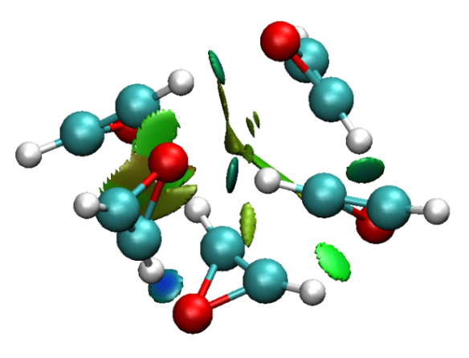 | 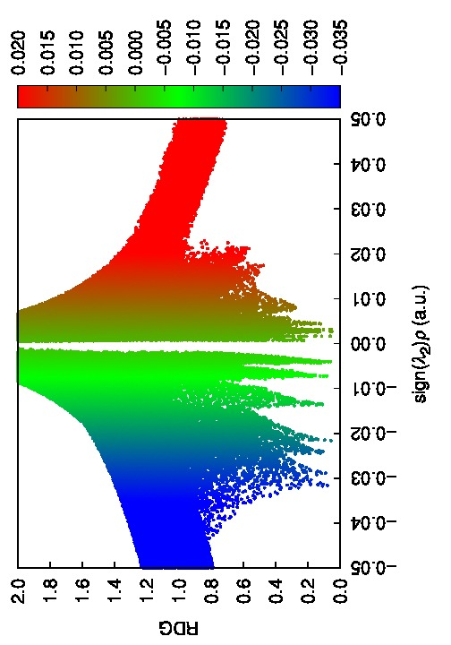
Oxirene-Pentamer

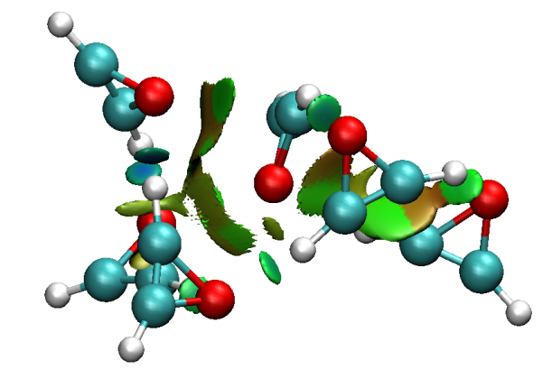 | 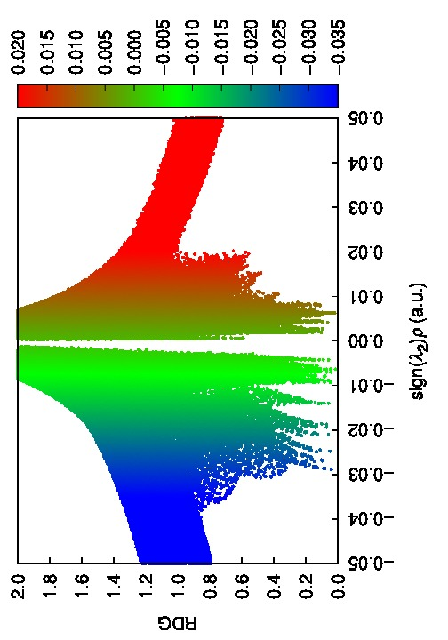
Oxirene-Hexamer

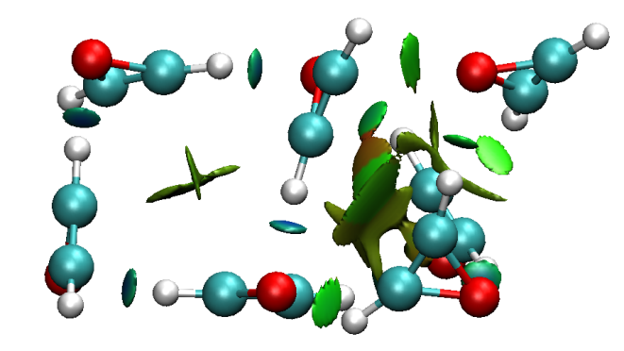 | 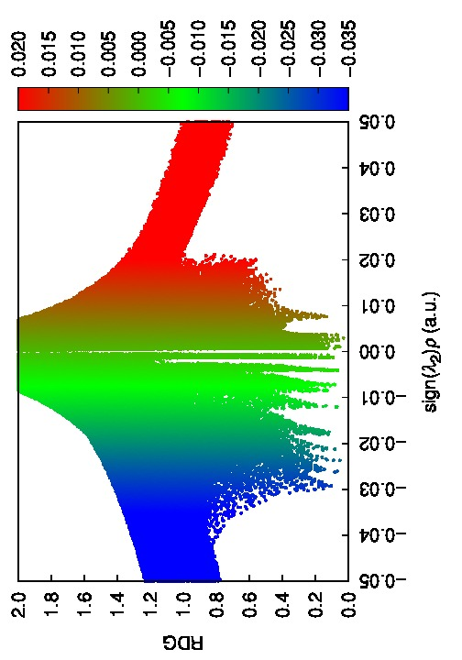
Oxirene-Heptamer

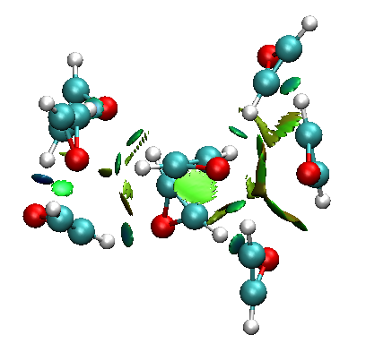 | 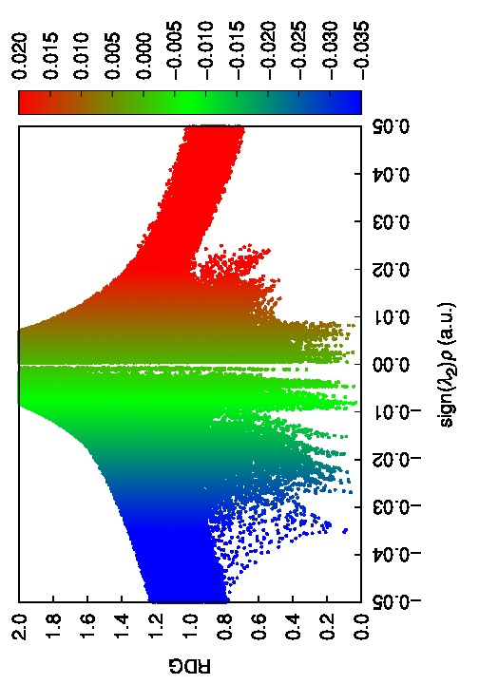
Oxirene-Octamer

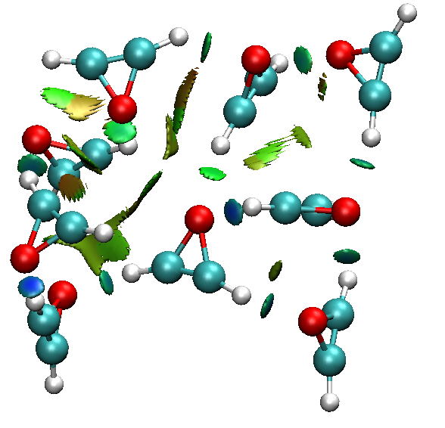 |  | 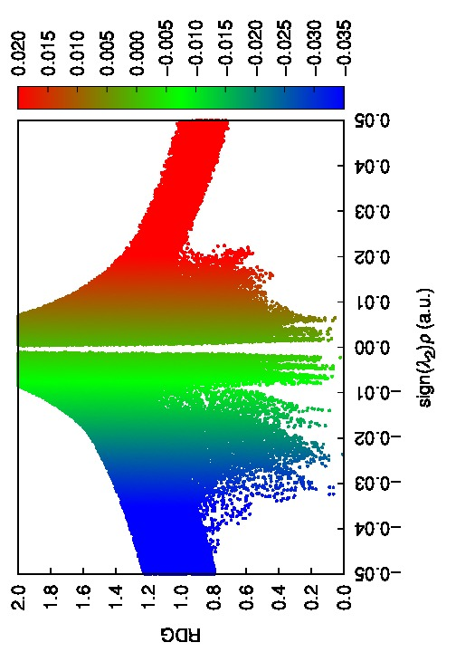
Oxirene-Nonamer
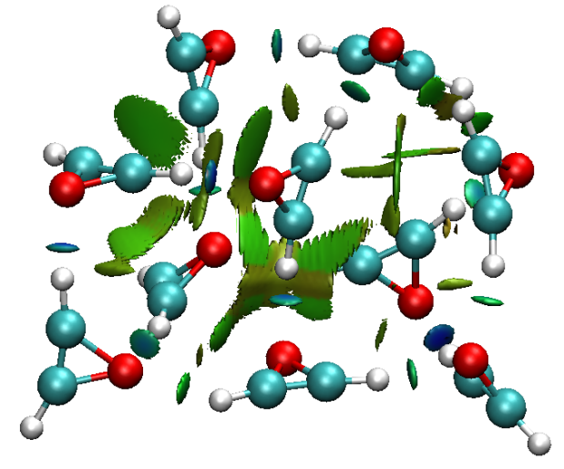 |  | 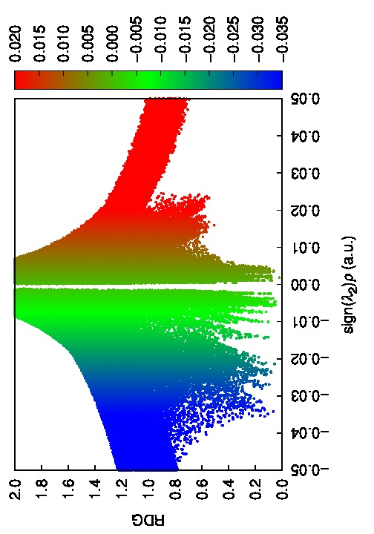
Oxirene-Decamer
Figure S-IV. NCI-RDG scatter plots. Color-filled RDG isosurfaces depicting intermolecular interaction regions in oxirene clusters (n=2-10)

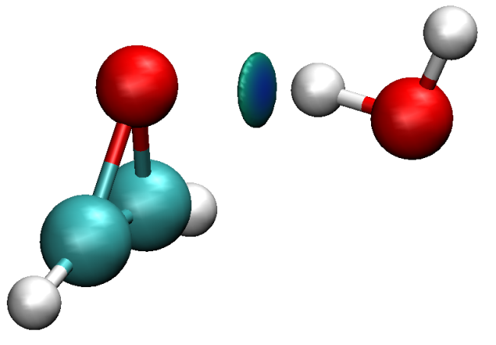 | 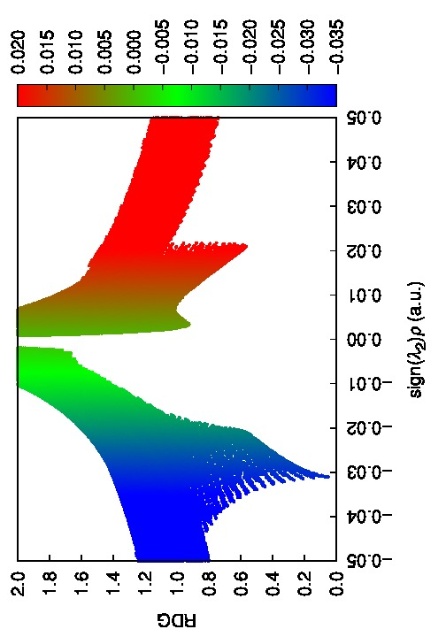
Oxirene + 1 Water

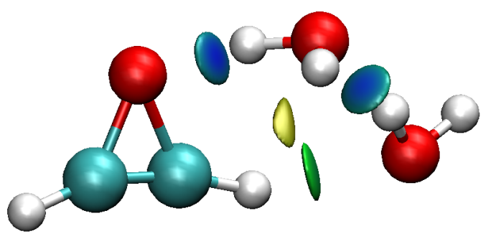 | 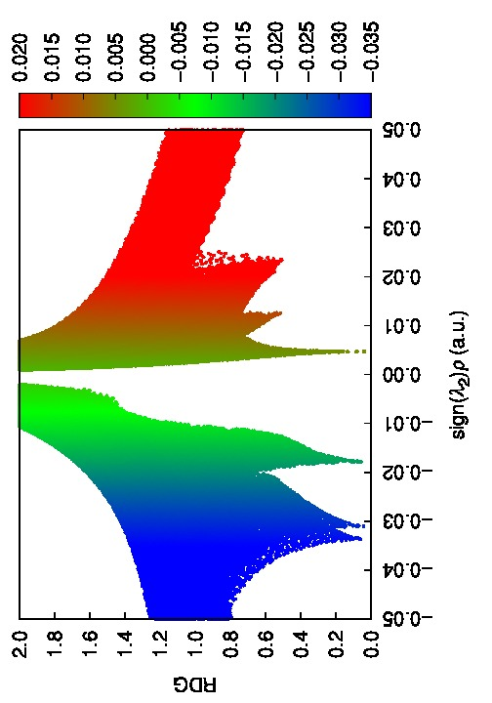
Oxirene + 2 Waters

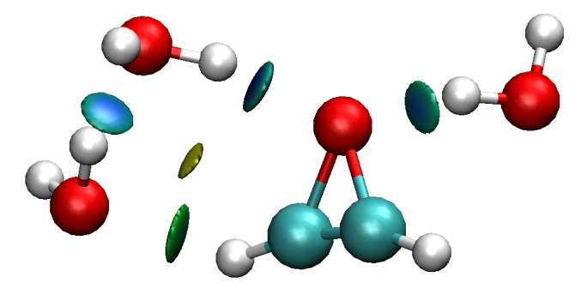 | 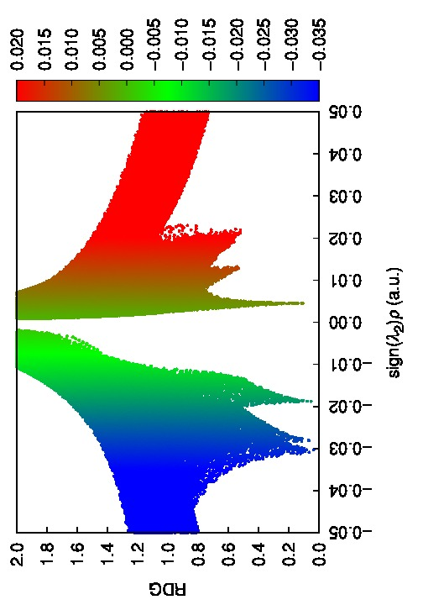
Oxirene + 3 Waters
Figure S-V. NCI-RDG scatter plots for Oxirene monomer with Water.

Scatter Plots

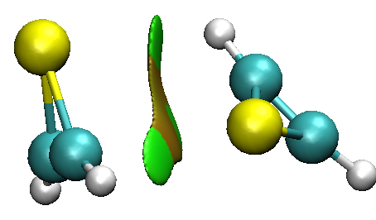 | 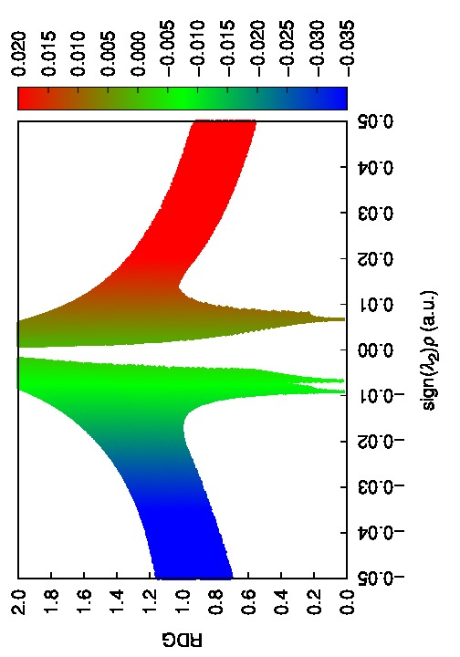
Thiirene-Dimer

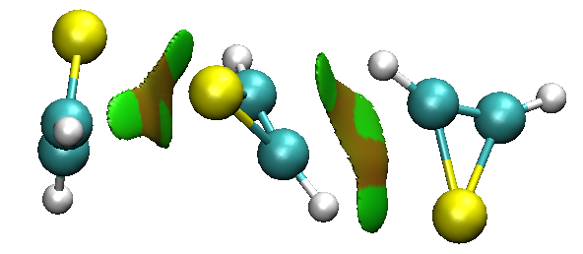 | 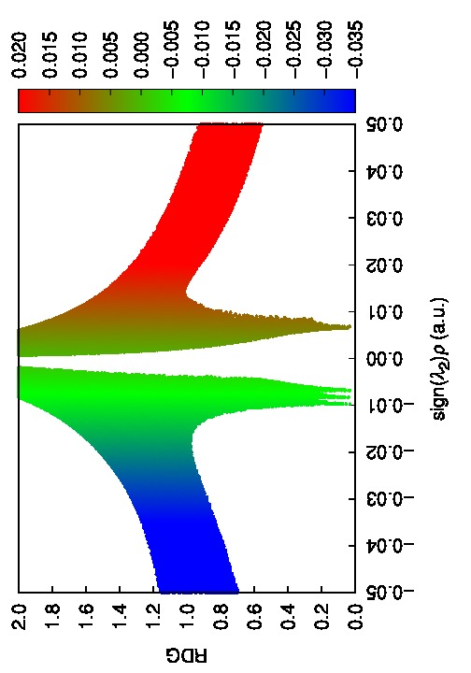
Thiirene-trimer

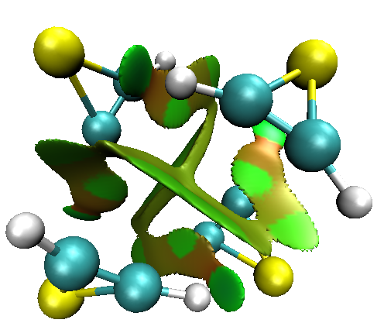 | 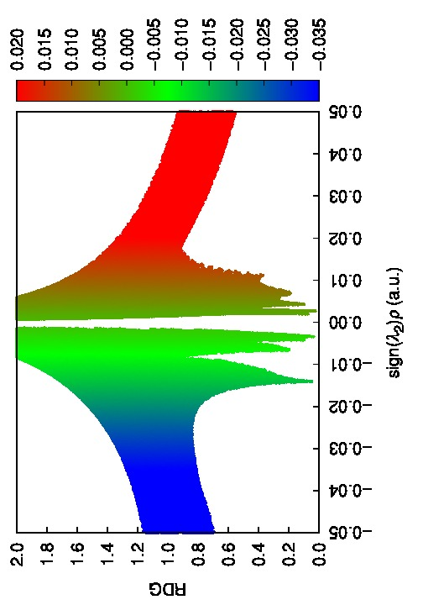
Thiirene-tetramer
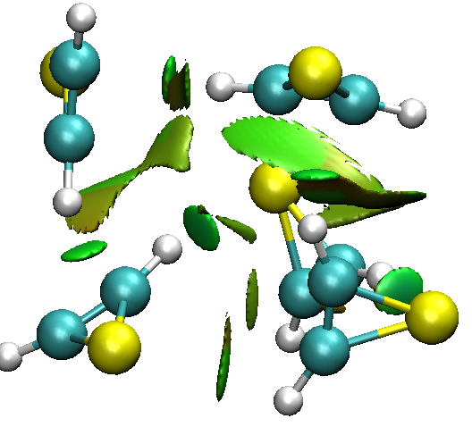 | 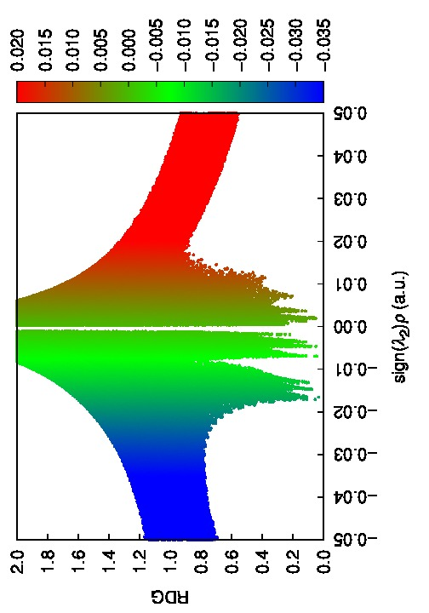
Thiirene-pentamer

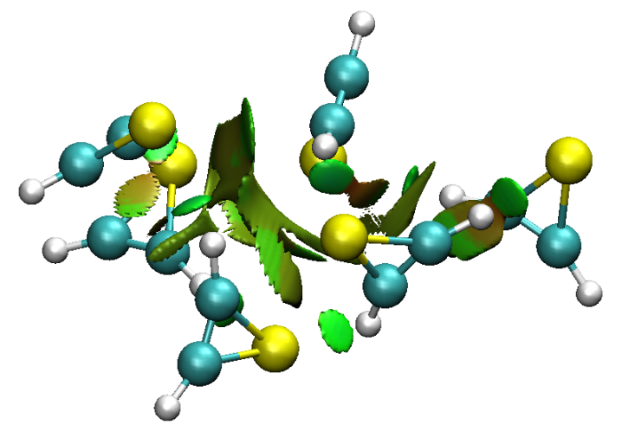 | 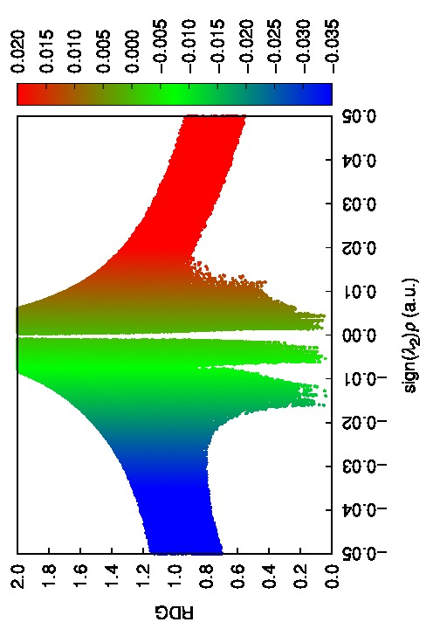
Thiirene-Hexamer

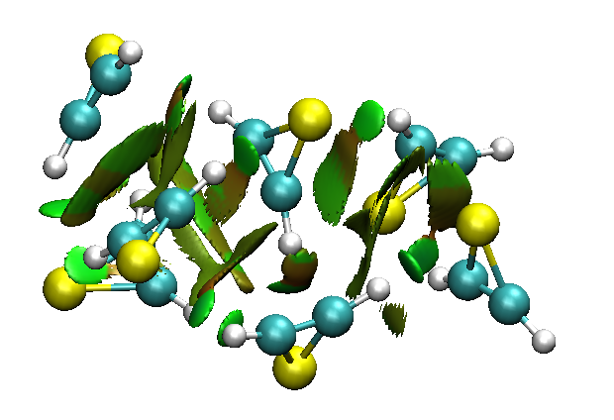 | 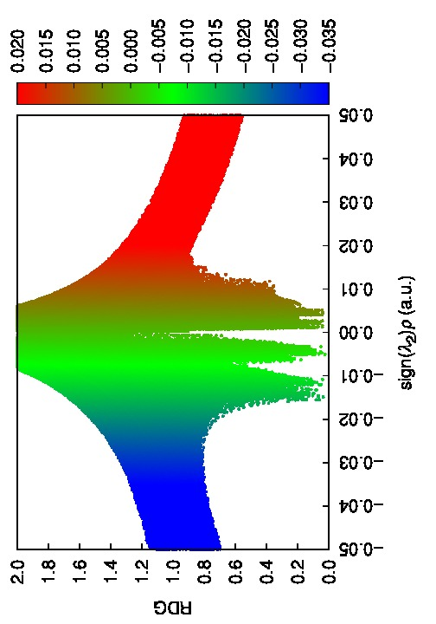
Thiirene-Heptamer
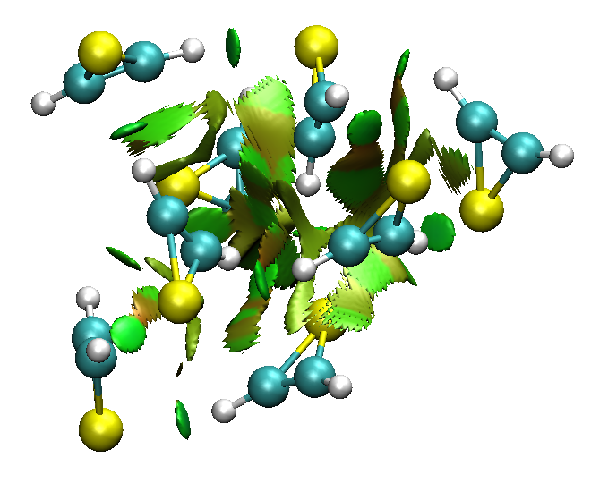  Thiirene-Octamer | 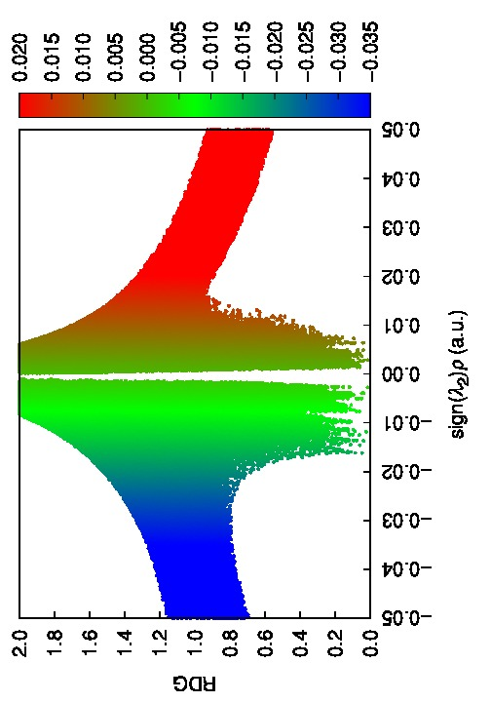
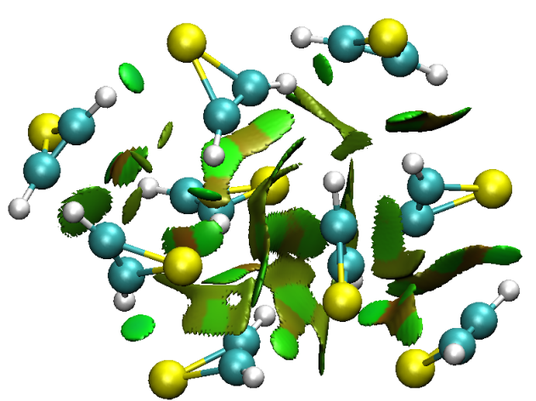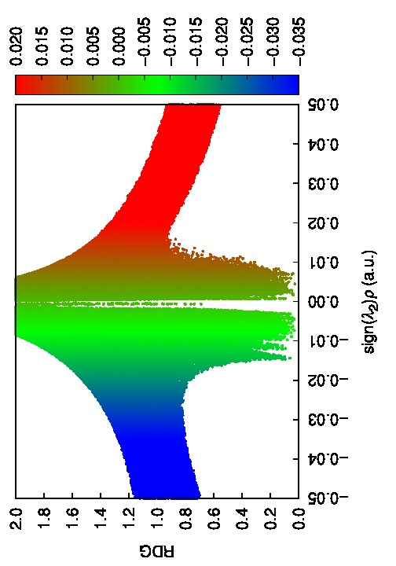
Thiirene-Nonamer

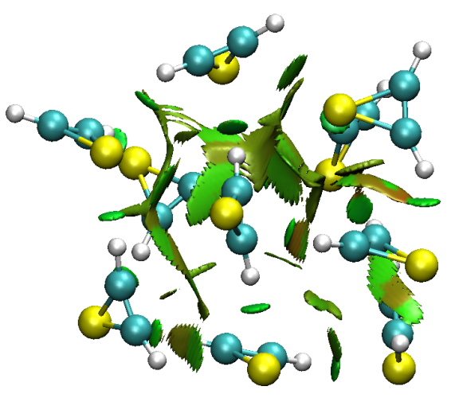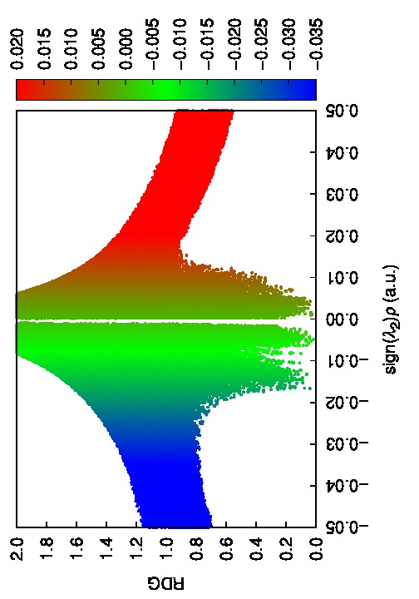
Thiirene-Decamer

Figure S-VI. NCI-RDG scatter plots for Thiirene aggregates (n=2 -10)
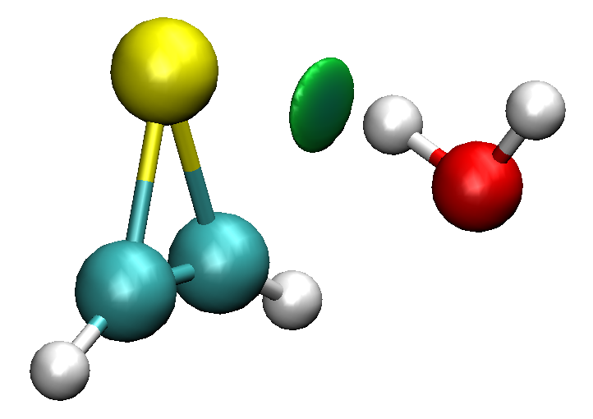 | 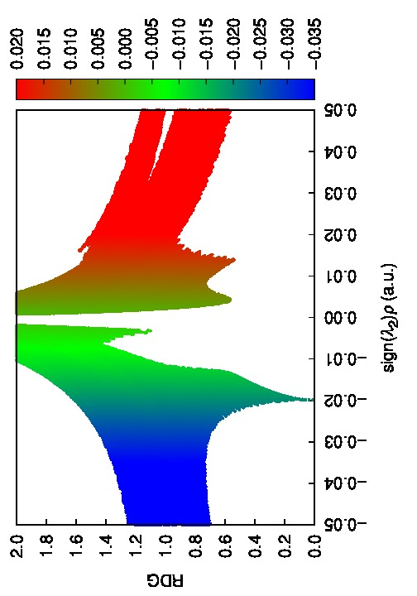
Thiirene-Monomer+1Water

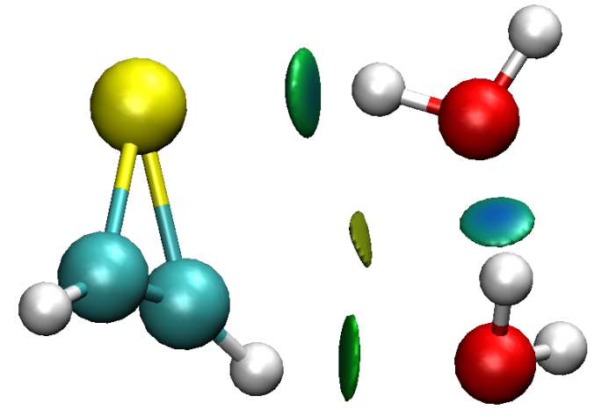 | 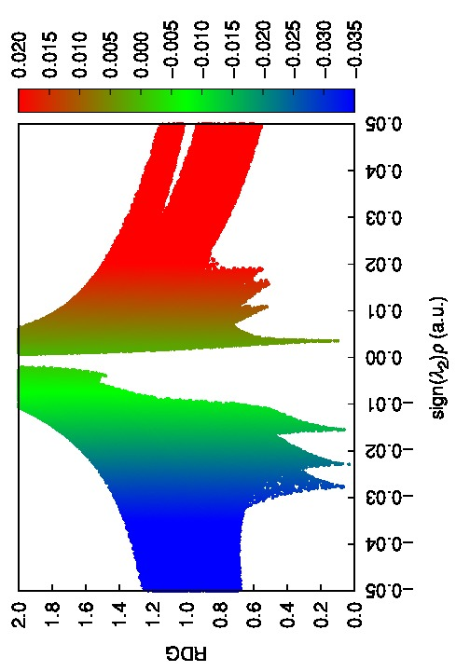
Thiirene-Monomer+2Waters

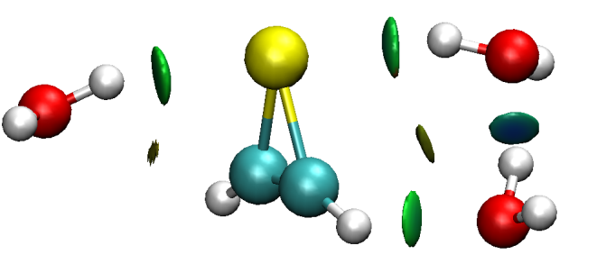 | 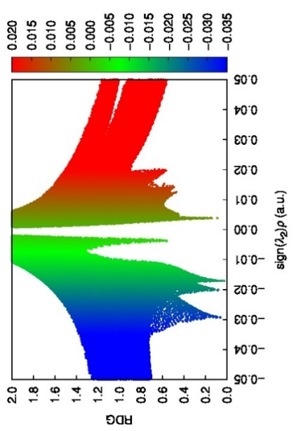
Thiirene-Monomer+3Waters

Figure S-VII. NCI-RDG scatter plots for Thiirene-water solvated complexes.
.

