Supplementary files
Table S1: Biochemical tests of bacterial isolates from CVM.
Samples | Bacterial  Isolates | Gram staining | Catalase | Oxidase | Haemolysis | Sugar fermentation Test
 |  |  |  |  |  | Glucose | Fructose | Maltose | Sucrose
Preestrus | BCVMPE1 | + | + | + | γ | + | + | + | +
Preestrus | BCVMPE1_1 | + | + | - | γ | + | + | + | +
Preestrus | BCVMPE2 | + | + | + | β | - | - | - | -
Estrus | BCVME2 | + | + | - | γ | + | + | + | +
Diestrus | BCVMDE3 | + | + | - | γ | + | + | + | -
Diestrus | BCVMDE5 | + | + | + | γ | + | + | + | +
BCVMPE1: B. subtilis, BCVMPE1_1: S. warneri, BCVMPE2 - B. toyonensis, BCVME2: S. pasteuri, BCVMDE3 - S. epidermidis, BCVMDE5 - B. proteolyticus, +: Positive, -: Negative, γ: Beta haemolysis, β: Gamma haemolysis.

Table S2. Molecular physiochemical properties of 16s RNA genes from target isolates.
Samples | Accession Number | Bacterial Isolates | Base pair length | G+C content (%) | A+T content (%) | Nucleotide bases in numbers (#) |  |  |  | Nucleotide bases in percentage (%)
 |  |  |  |  |  | A | C | G | T | A | C | G | T
Preestrus | MT598012.1 | B. subtilis  (BCVMPE1) | 741 | 55.06 | 44.94 | 175 | 175 | 181 | 227 | 23.62 | 24.43 | 30.63 | 21.32
Preestrus | MT789231.1 | S. warneri  (BCVMPE1_1) | 950 | 52.42 | 47.58 | 248 | 216 | 282 | 204 | 26.11 | 22.74 | 29.68 | 21.47
Preestrus | MT705012.1 | B. toyonensis  (BCVMPE2) | 599 | 52.09 | 47.91 | 146 | 144 | 168 | 141 | 24.37 | 24.04 | 28.05 | 23.54
Estrus | MT598013.1 | S. pasteuri  (BCVME2) | 897 | 51.95 | 48.05 | 238 | 238 | 196 | 270 | 26.9 | 21.95 | 29.89 | 21.26
Distrus | MT598014.1 | S. epidermidis  (BCVMDE3) | 870 | 51.84 | 48.16 | 234 | 234 | 191 | 260 | 26.53 | 21.85 | 30.1 | 21.52
Distrus | MT705014.1 | B. proteolyticus  (BCVMDE5) | 717 | 53.70 | 46.30 | 173 | 174 | 211 | 159 | 24.13 | 24.27 | 29.43 | 22.18

Computation of genetic distance
The estimates of evolutionary genetic divergence between the selected sequences were computed using the Maximum Composite Likelihood model (evolutionary-based algorithm) (Tamura et al., 2014). The analysis involved 14 nucleotide sequences that showed the number of base substitutions per site from between sequences. Standard error estimate(s) and all positions-containing gaps and missing data that were eliminated are shown above the diagonal. The result of inter- and intra-specific pair-wise genetic diversity shows that neutral evolution will take place within the same genus. We found that the pair-wise genetic diversity as 0.0 occurred between species’ of Proteus genus. The diversity range between 0.006 and 0.037 was found within Bacillus and Staphylococcus genera (Suppl. Table 3). This statistical pair-wise genetic diversity data shows that our in vitro and in silico study brought up a strong conclusion that our isolates have maintained a low divergence within species level in sequence and structural features.
Table S3. Estimation of inter- and intra-specific pair-wise genetic distance of 16S RNA genes of our targets and its phylogenetic neighbours’
S. No. | Accession | Organism | 1 | 2 | 3 | 4 | 5 | 6 | 7 | 8 | 9 | 10 | 11
1* | MT705014.1 | Bacillus proteolyticus BCVMDE5
2* | MT598012.1 | Bacillus subtilis BCVMPE1 | 0.011
3 | KF612021.1 | Bacillus cereus SVK1 | 0.009 | 0.006
4* | MT705012.1 | Bacillus toyonensis BCVMPE2 | 0.036 | 0.032 | 0.034
5 | FJ785476.1 | Bacillus pacificus EB422 | 0.013 | 0.006 | 0.004 | 0.030
6* | MT789231.1 | Staphylococcus warneri BCVMPE1 | 0.964 | 0.951 | 0.962 | 0.976 | 0.953
7 | LR134242.1 | Staphylococcus epidermidis NCTC4133 | 0.962 | 0.949 | 0.961 | 0.983 | 0.951 | 0.002
8* | MT598013.1 | Staphylococcus pasteuri BCVME2 | 0.964 | 0.951 | 0.962 | 0.981 | 0.953 | 0.002 | 0.002
9 | MT459283.1 | Staphylococcus sp. GG 54 | 0.964 | 0.951 | 0.962 | 0.981 | 0.953 | 0.002 | 0.002 | 0.000
10* | MT598014.1 | Staphylococcus epidermidis BCVMDE3 | 0.968 | 0.955 | 0.966 | 0.995 | 0.957 | 0.021 | 0.021 | 0.021 | 0.021
11 | FJ957455.1 | Uncultured Staphylococcus sp. JPL-1 G21 | 0.968 | 0.955 | 0.966 | 0.995 | 0.957 | 0.019 | 0.019 | 0.019 | 0.019 | 0.002
Note:
* - Our own isolates; Green colour represents no divergence; Orange colour represents moderate divergence.

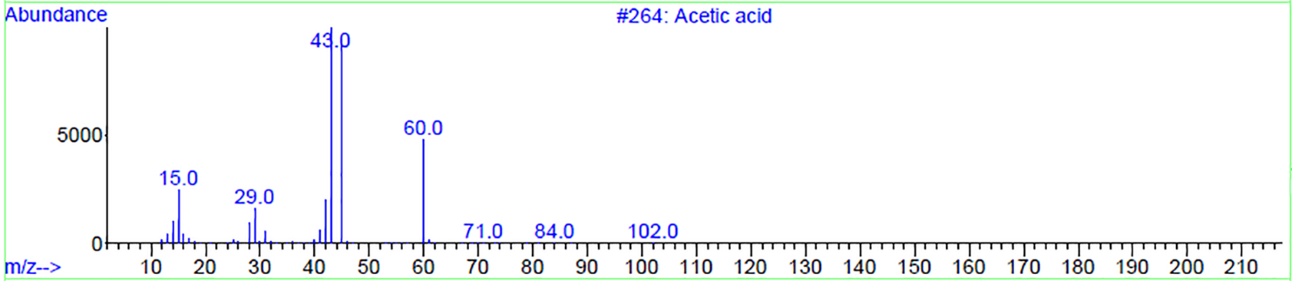
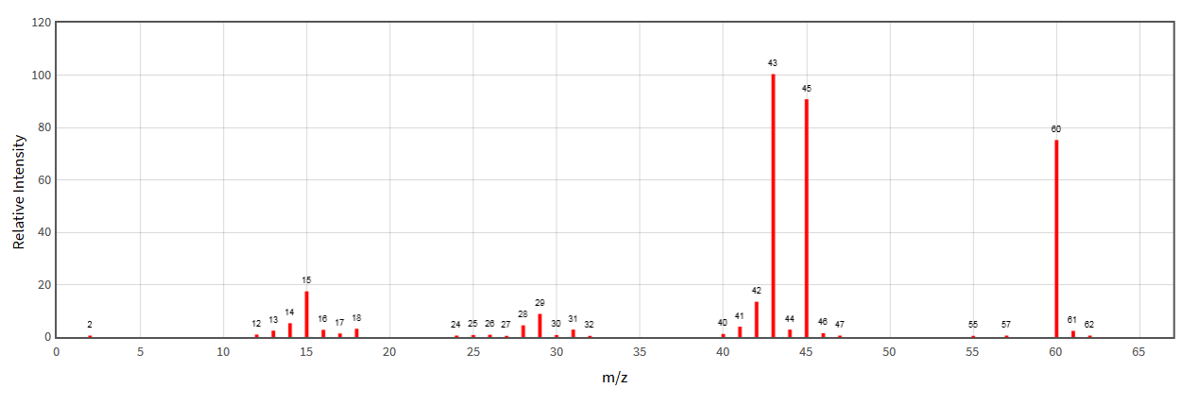

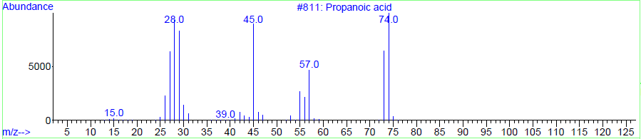
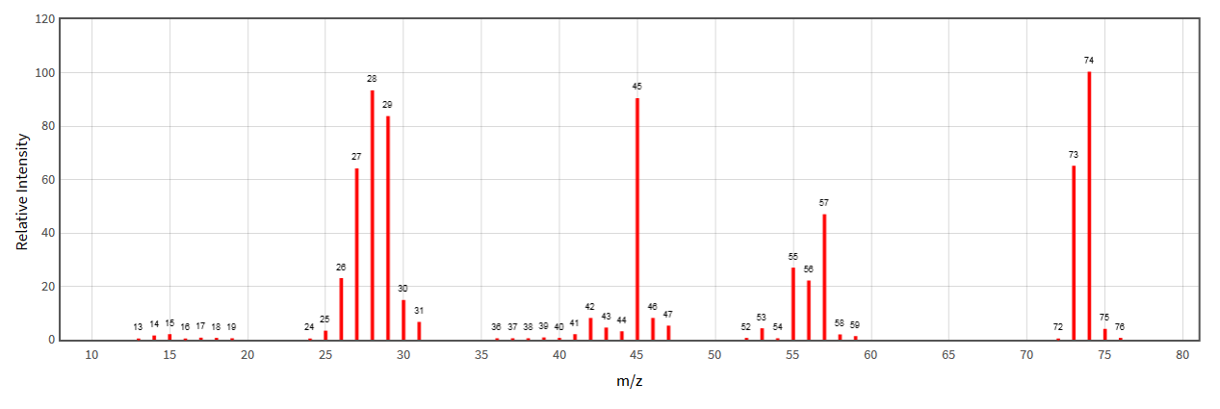

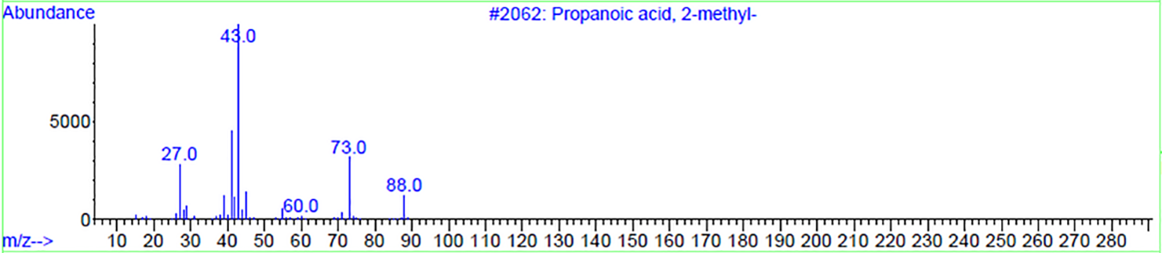
Isobutyric acid
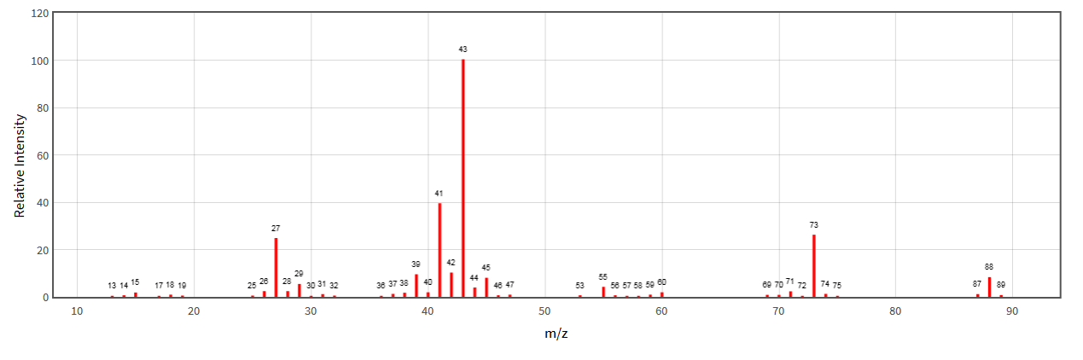

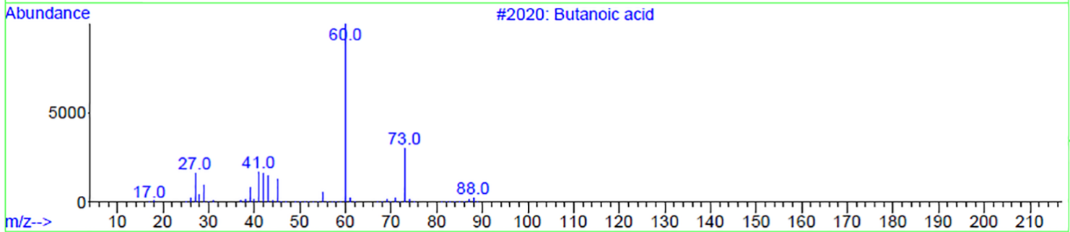
Butyric acid
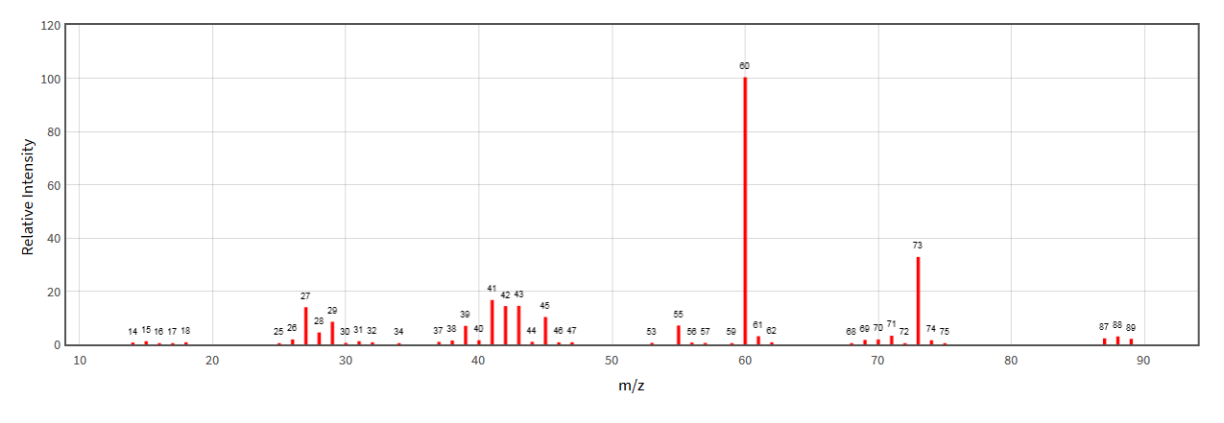

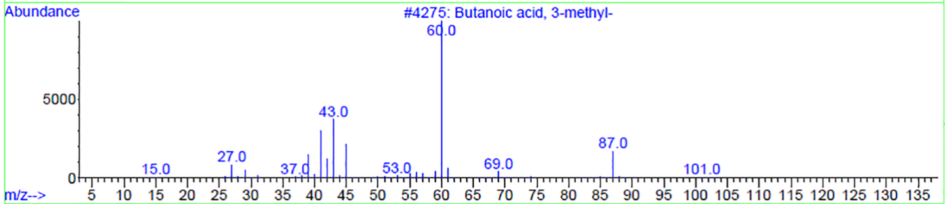
Isovaleric acid
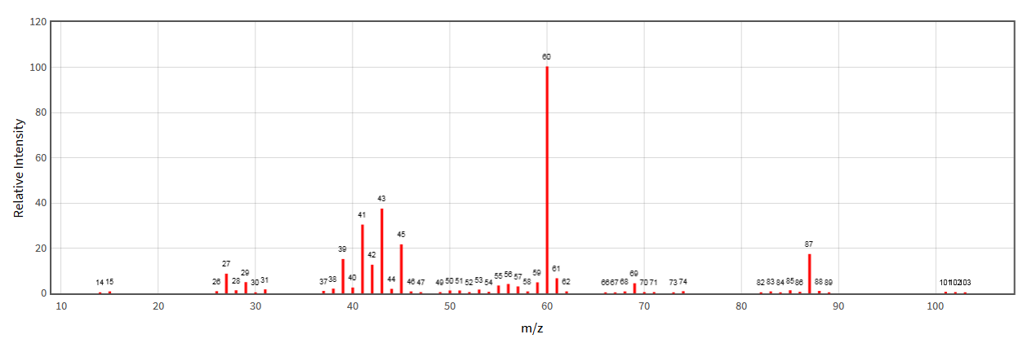

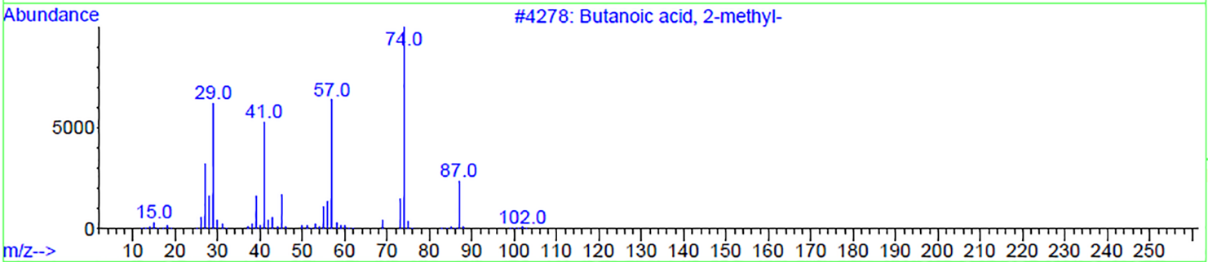
Valeric acid
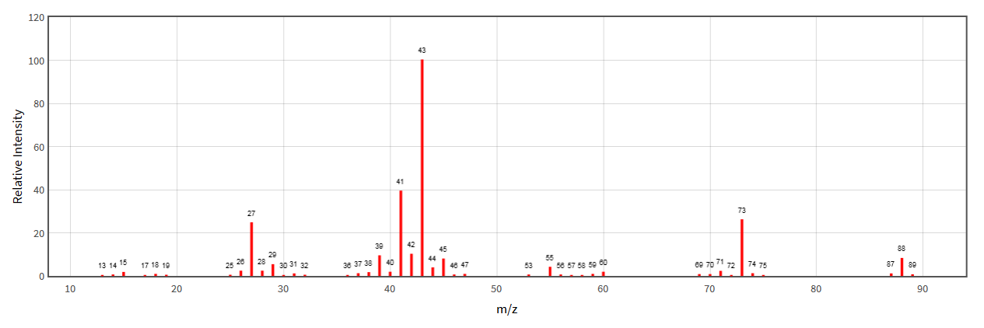
Figure S1. Mass spectrometry of the S. pasteuri volatiles. Mass spectra of the main peaks identified (blue) and of standard compounds (red).

