Supporting Information

Nanoplasmonic SERS on Fidget Spinner for Digital Bacterial Identification

Mamata Karmacharya,¹ Issac Michael,² Jiyun Han,^{1,2} Elizabeth Maria Clarissa,^{1,2} Oleksandra Gulenko,² Sumit Kumar,*^{1,2} Yoon-Kyoung Cho*^{1,2}

¹Center for Algorithmic and Robotic Synthesis (CARS), Institute for Basic Science (IBS), Ulsan 44919, South Korea.
²Department of Biomedical Engineering, Ulsan National Institute of Science and Technology (UNIST), Ulsan 44919, South Korea.

*Correspondence to:
Sumit Kumar: sumitwithchem@gmail.com; ORCID ID: 0000-0002-4979-7677
Yoon-Kyoung Cho: ykcho@unist.ac.kr; ORCID ID: 0000-0001-6423-1834

Supporting Figures.

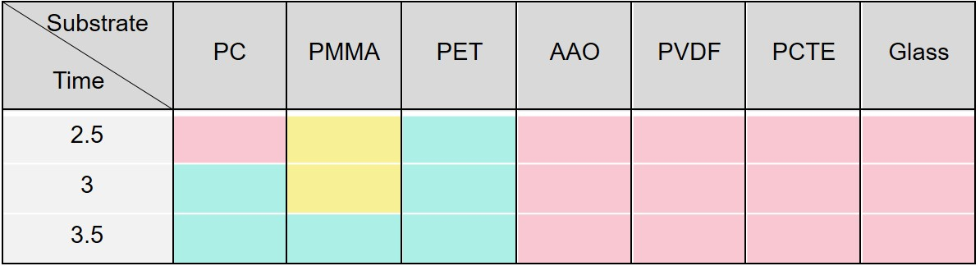

Figure S1. Bonding of DFP with the different substrate. Time dependent bonding of dry film photoresist (DFP) and substrate exposing at 90º C. Exposure time: 2.5, 3 and 3.5 mins. Three different colors denote the bonding property. Turquois: bonded, Yellow: underexposed and Pink: not bonded. PC: polycarbonate, PMMA: polymethyl methacrylate, PVDF: polyvinylidene fluoride, AAO: anodic alumunium oxide, PET: polyethylene terephthalate, PCTE: polycarbonate track etch.

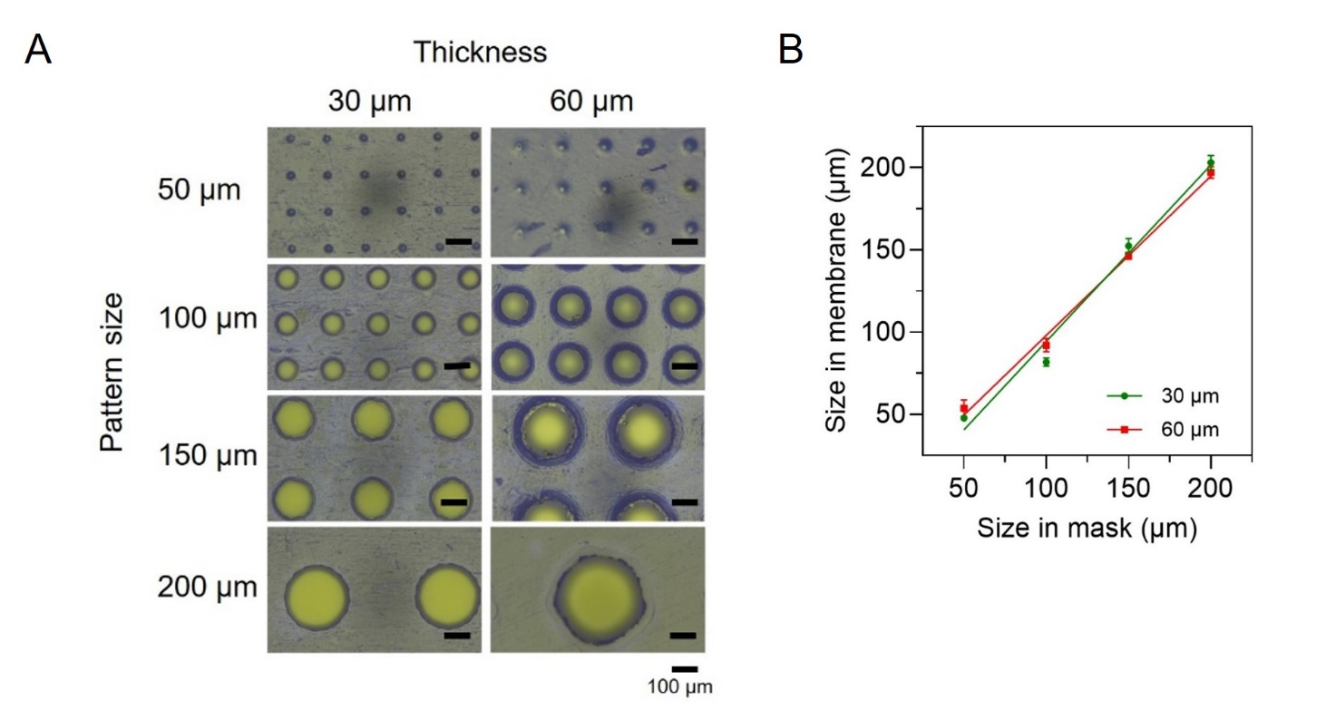
Figure S2. Pore size determination of the plasmonic-membrane. Pattern size in membrane in correspondence to mask pattern. A. Comparison of membrane pattern sizes at different thicknesses. The images display the pattern sizes (50 µm, 100 µm, 150 µm, 200 µm) in membranes with thicknesses of 30 µm (left column) and 60 µm (right column). Scale bars represent 100 µm. Depositing the metal on the membrane of 30 µm and 60 µm thickness using the different pattern size of 25, 70, 120 and 200 µm. B. The graph shows the relationship between the pattern sizes in masks and their corresponding sizes in membranes for 30 µm (green circles) and 60 µm (red squares) membrane thickness. Data points indicate the measured sizes with error bars representing the standard deviation; n = 3 individual batches.

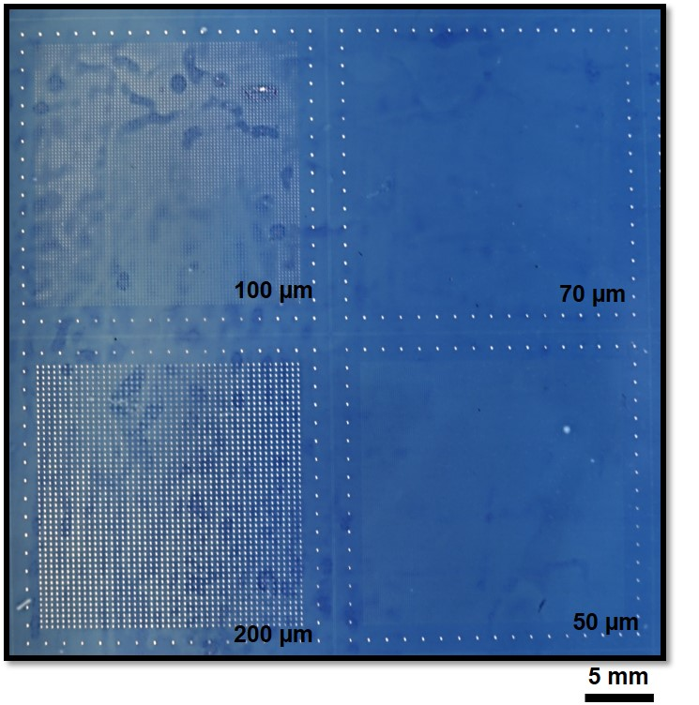

Figure S3. Patterning of NC membrane. Image showing the patterned membrane with different size. Pattern size on NC membrane was generated through photolithography using the mask containing the size 100, 70, 0 and 25 µm pattern. Blue color was seen due to the dry film photoresist (DFP).

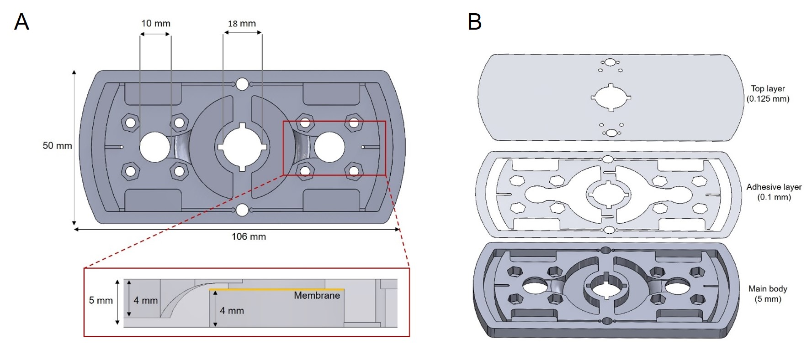

Figure S4. Schematic diagram of the Pl-fidget with detailed dimensions. A. The top view illustrates the overall dimensions of the component, which measures 106 mm in width and 50 mm in height containing the filtration chamber of 10 mm diameter and 18 mm of bearing holder at the middle part of fidget. A red box highlights a specific area that is further detailed in the zoomed-in sectional view below. The sectional view provides a cross-sectional detail of the component, emphasizing the internal structure. The height of the section is shown to be 5 mm. Within this section, a membrane is depicted, represented by a yellow line, positioned in a 4 mm high cavity. B. Three different layers of Pl-FS: top, polycarbonate layer (0.125 mm); middle, adhesive layer (0.1 mm) and bottom layer, main body (5 mm).

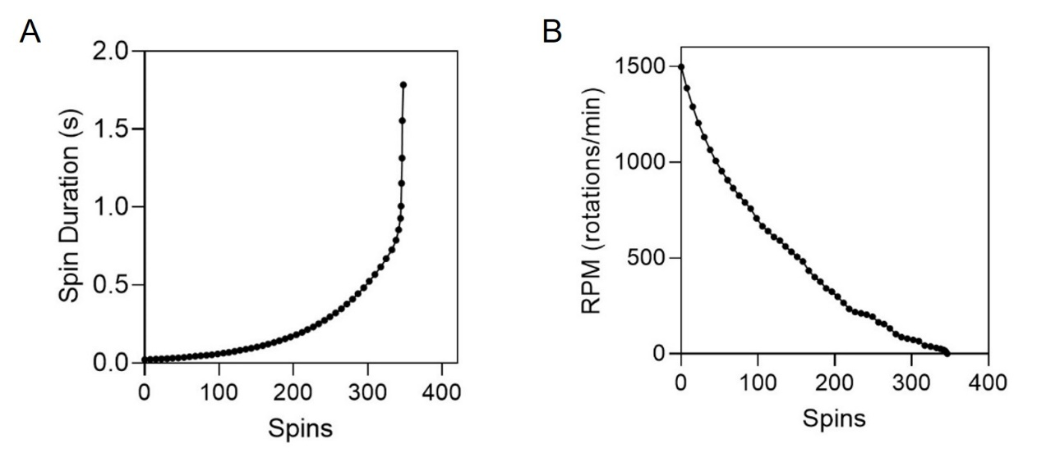

Figure S5. Optimizing the angular velocity of the P-FS. Set up for high speed camera to capture and detect the motion of Pl-FS rotated by hand. Detailed process is explained in the methodology. B. Characterizing the speed of Pl-FS by measuring its spinning duration and rotational speed. The graph displays the spin duration (in seconds) as a function of the number of spins. The data points form an exponential curve, indicating that the spin duration increases rapidly with the number of spins, particularly after 300 spins. Graph presents the RPM (rotations per minute) as a function of the number of spins. The data points show a decreasing trend, with the RPM dropping sharply from around 1500 RPM at the start to nearly 0 RPM after approximately 400 spins.

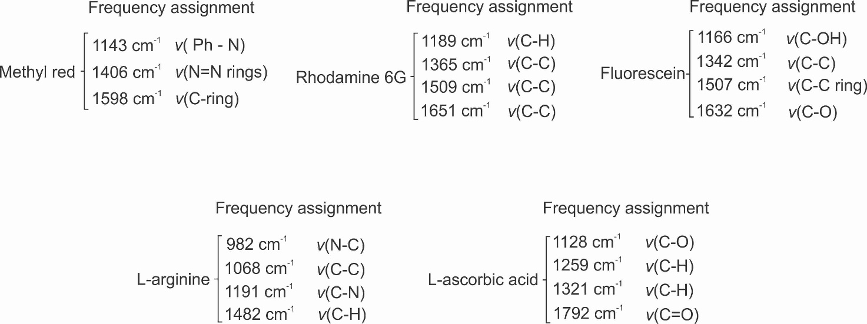

Figure S6. Raman shift assignments for various dye-modified polystyrene (PS) beads are listed, detailing the characteristic Raman shift frequencies (in cm⁻¹) associated with specific vibrational modes for each molecule: Methyl red, Rhodamine 6G, Fluorescein, L-arginine, and L-ascorbic acid.

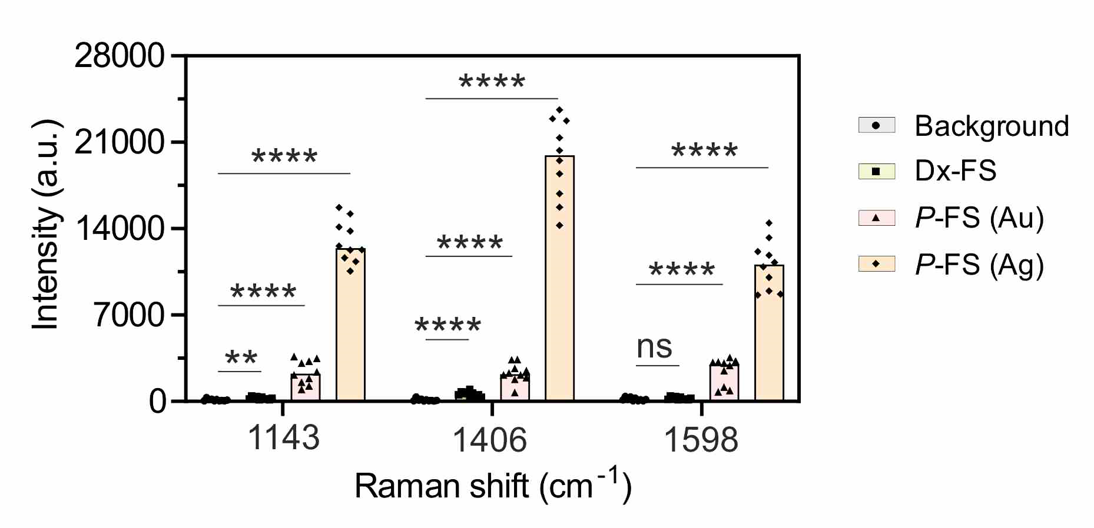

Figure S7. Comparison of Raman signal intensities for different coatings on NC membrane. The figure presents Raman spectra intensity comparisons at specific Raman shifts (1143 cm⁻¹, 1406 cm⁻¹, and 1598 cm⁻¹) for background (grey), diagnostic fidget spinner (Dx-FS, yellow), plasmonic fidget spinner with gold coating (P-FS (Au), pink), and plasmonic fidget spinner with silver coating (P-FS (Ag), orange). The intensity values are shown in arbitrary units (a.u.), and significant differences between the groups are indicated by asterisks (**p < 0.01; **p < 0.0001; ns = not significant), demonstrating the enhanced sensitivity of the P-FS with silver coating compared to other configurations, particularly at the 1406 cm⁻¹ peak. Data represent mean ± s.d.; n = 10 independent experiments; two-tailed unpaired Student’s t-test was used for comparing two groups.

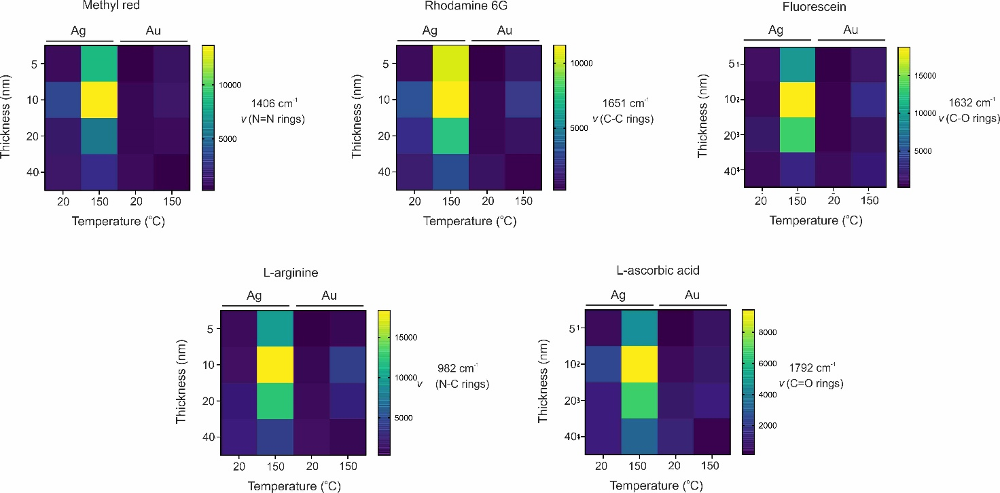

Figure S8. Optimization of metal type, metal film thickness, and temperature on SERS intensity for various dyes on P-FS. Heat maps display the SERS intensity at specific vibrational modes for different dye-coated polystyrene beads (PS): methyl red (1406 cm⁻¹, ν(N=N rings)), rhodamine 6G (1651 cm⁻¹, ν(C-C rings)), fluorescein (1632 cm⁻¹, ν(C-O rings)), L-arginine (982 cm⁻¹, ν(N-C rings)), and L-ascorbic acid (1792 cm⁻¹, ν(C=O rings)). The SERS intensities were measured across varying metal film thicknesses (5 nm, 10 nm, 20 nm, and 40 nm) and temperatures (20°C and 150°C) for silver (Ag) and gold (Au) films. The color scale represents SERS intensity, with yellow indicating higher intensities and blue/purple indicating lower intensities. The results demonstrate the influence of film thickness and temperature on SERS performance, with significant differences observed between Ag and Au films, highlighting the importance of optimizing these parameters for effective SERS-based detection.

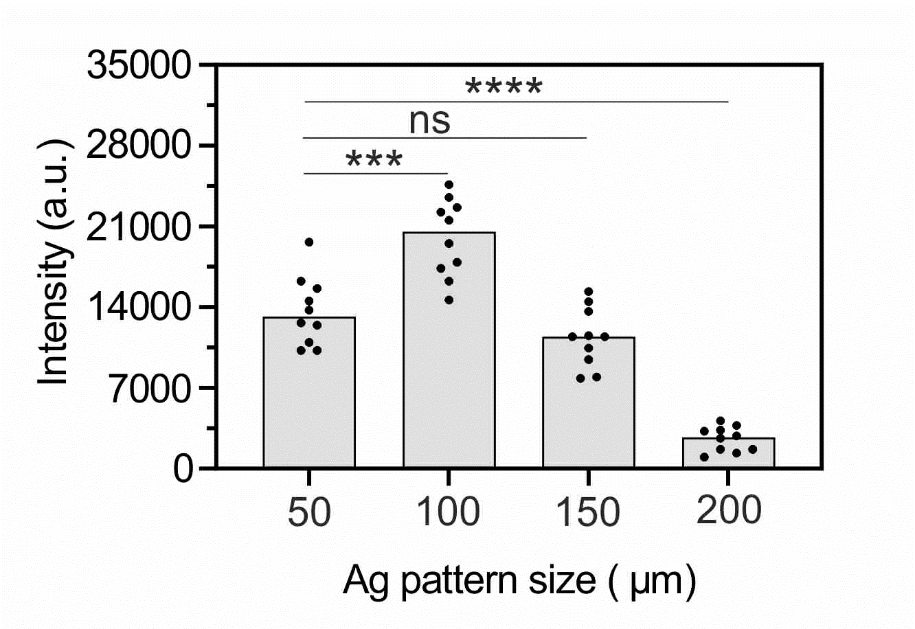
Figure S9. SERS intensity as a function of silver (Ag) pattern size on plasmonic membranes. The bar graph illustrates the SERS intensity (in arbitrary units, a.u.) corresponding to different silver pattern sizes (50 µm, 100 µm, 150 µm, and 200 µm) on plasmonic membranes of P-FS. The data points indicate individual measurements, while the error bars represent the variability within the data. The pattern size of 100 µm produced the highest SERS intensity, suggesting optimal hotspot generation for enhanced Raman signal detection at this pattern size. Statistical significance is denoted by asterisks (**p < 0.001; **p < 0.0001; ns = not significant), indicating significant differences in SERS intensity between certain pattern sizes, particularly between 100 µm and other sizes. Data represent mean ± s.d.; n = 10 independent fusion batches; two-tailed unpaired Student’s t-test was used for comparing two groups.

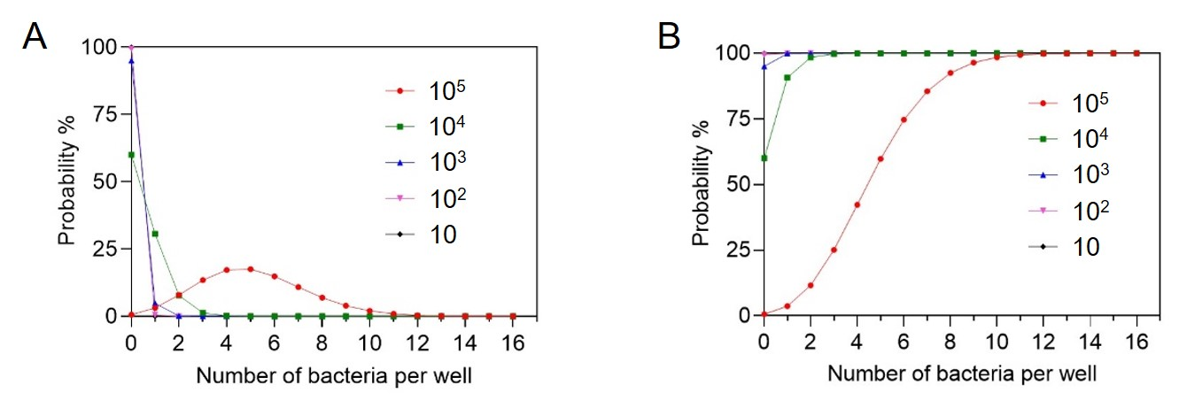

Figure S10. Distribution of bacteria on the microwell of the membrane. A. Probability of a microwell containing κ bacteria, given the average bacteria concentration λ per microwell using the Poisson distribution, p(κ, λ) = λ^{κ}e^{-λ}/κ!. B. The Poisson cumulative distribution indicates that over 90% of microwells contain between 1 and 9 bacteria at concentrations ranging from 10 to 10⁵ bacteria per mL. These concentrations correspond to λ values of 5.10, 0.51, 0.051, 0.0051, and 0.00051, respectively.

Table S1. Media and incubation conditions used for the different bacteria.
Bacterial species | Isolate code | Solid Media | Liquid Media | Temp (°C) | Incubation Atmosphere | Speed (rpm)
E. coli | 25922 | LB agar | LB broth | 37 | Air | 150
E. coli | MG1655 | LB agar + 100 µg Ampicillin | LB agar + 100 µg Ampicillin | 37 | Air | 150
S. aureus | 25923 | LB agar | LB agar | 37 | Air | 150
S. mutan | 3065 | BHI agar + 1% sucrose | BHI agar + 1% sucrose | 37 | 5% CO₂ | 0
L. brevis |  | Lactobacilli MRS agar | Lactobacilli MRS agar | 30 | Air | 0

LB: Lueria-Bertenni, BHI: Brain Heart Infusion and MRS: deMan, Rogosa and Sharpe

