Dual-Role Ion Dynamics in Ferroionic CuInP₂S₆: Insights into the Transition and Boundary from Ferroelectric to Ionic Switching Mechanisms
Xingan Jiang^{1#}, Xiangping Zhang^{2#}, Zunyi Deng^{3#}, Jianming Deng⁴, Xiaolei Wang^{5†}, Xueyun Wang^{3†} and Weiyou Yang^{1†}
¹Institute of Micro/Nano Materials and Devices, Ningbo University of Technology, Ningbo City,315211, P. R. China
²Department of Materials Science and Engineering, Southern University of Science and Technology, Shenzhen, Guangdong 518055, China
³School of Aerospace Engineering, Beijing Institute of Technology, Beijing, 100081, China
⁴Guangdong Provincial Key Laboratory of Electronic Functional Materials and Devices, Huizhou University, Huizhou, Guangdong, 516001, China
⁵School of Physics and Optoelectronic Engineering, Beijing University of Technology, Beijing 100124, China.

†Corresponding Authors Emails: xiaoleiwang@bjut.edu.cn; xueyun@bit.edu.cn; weiyouyang@tsinghua.org.cn
#These authors contribute equally to this work

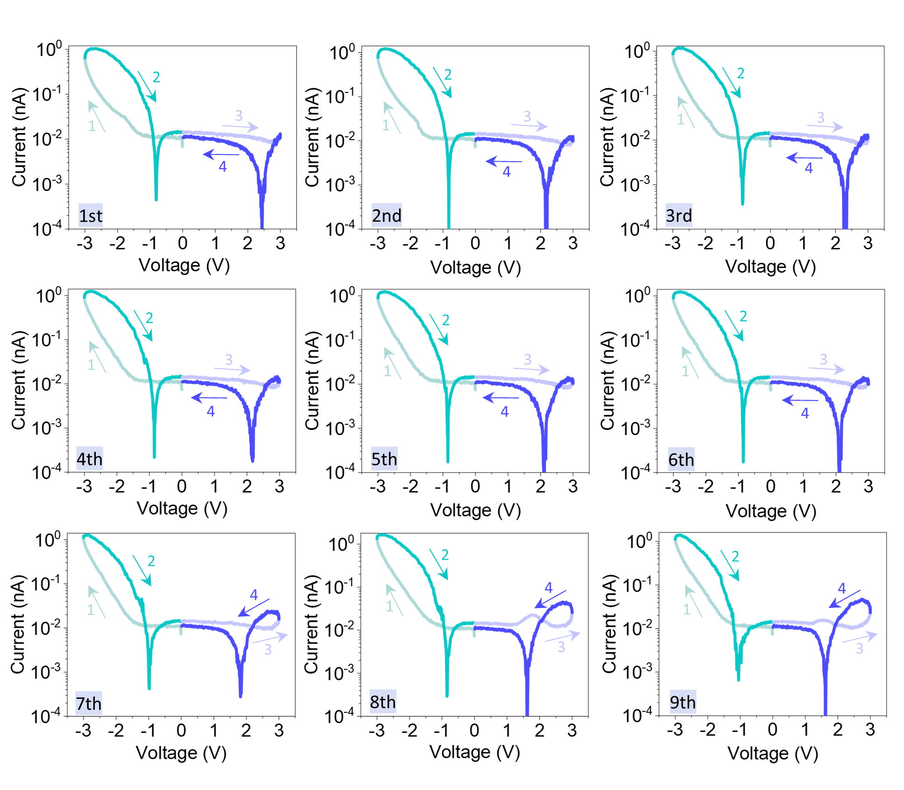
Supplementary Fig. 1 | The semilog I-V curves using fast scans with a time duration of 1 s for each I-V cycle.

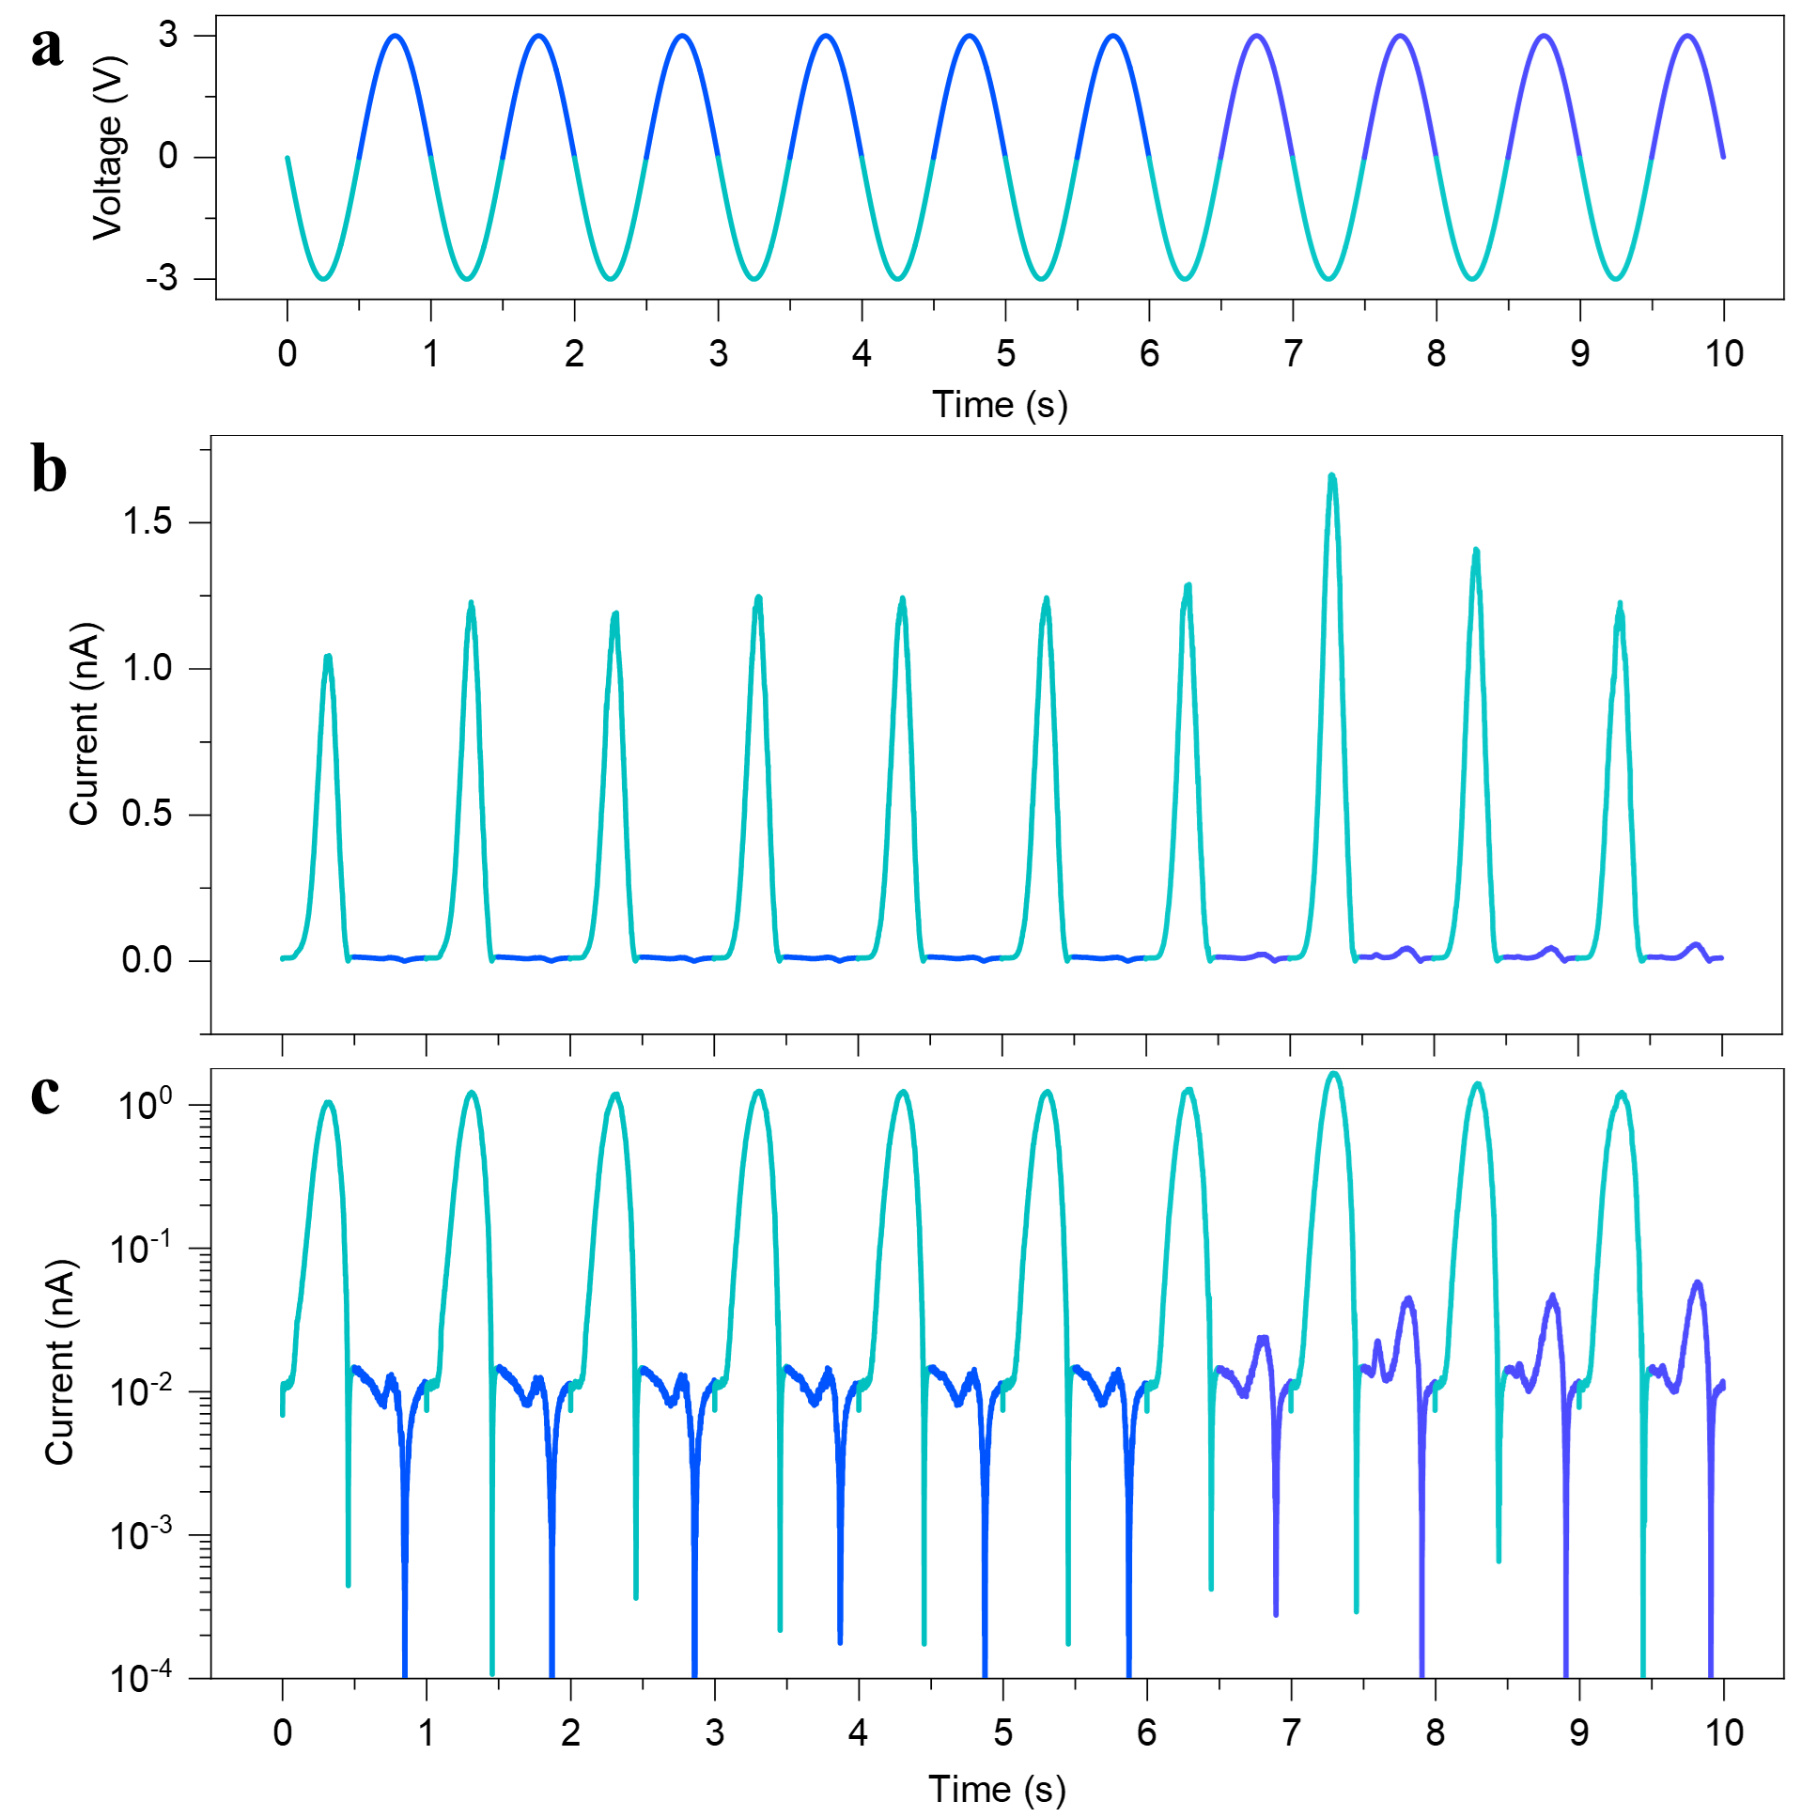
Supplementary Fig. 2 | The voltage-time (V-t) and current-time (I-t) curves for ten consecutive fast scans, with a time duration of 1 s for each I-V cycle. a The linear current -time curve. b The semilog current-time curve.

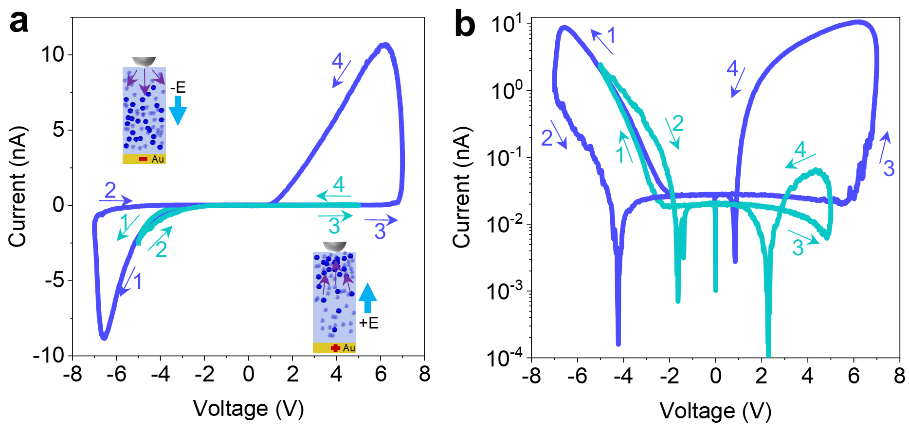
Supplementary Fig. 3 | The I-V curves conducted at different bias voltage range with time duration of 1 s. (a) The linear plots of I-V curves and (b) The semilog plots of I-V curves. The number 1-4 and the arrow represents the bias voltage sweeping sequence.

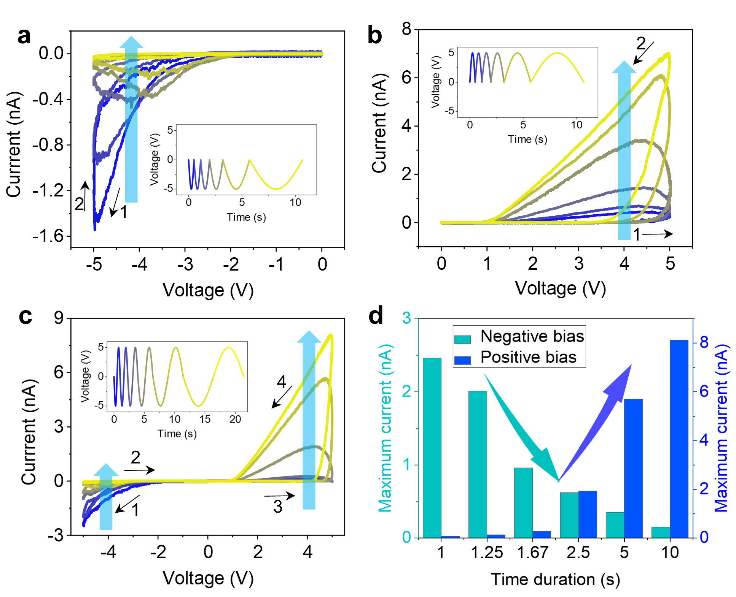
Supplementary Fig. 4 | The six semi-cycle and full cycle of I-V curves conducted with different time duration. a, b The six semi-cycle of I-V curves in (a) negative and (b) positive bias direction with the varied time duration ranging from 0.5 s to 5 s for each semi-cycle, respectively. c The six full-cycle of I-V curves in two bias direction with the varied time duration ranging from 1 to 10 s for each full-cycle.

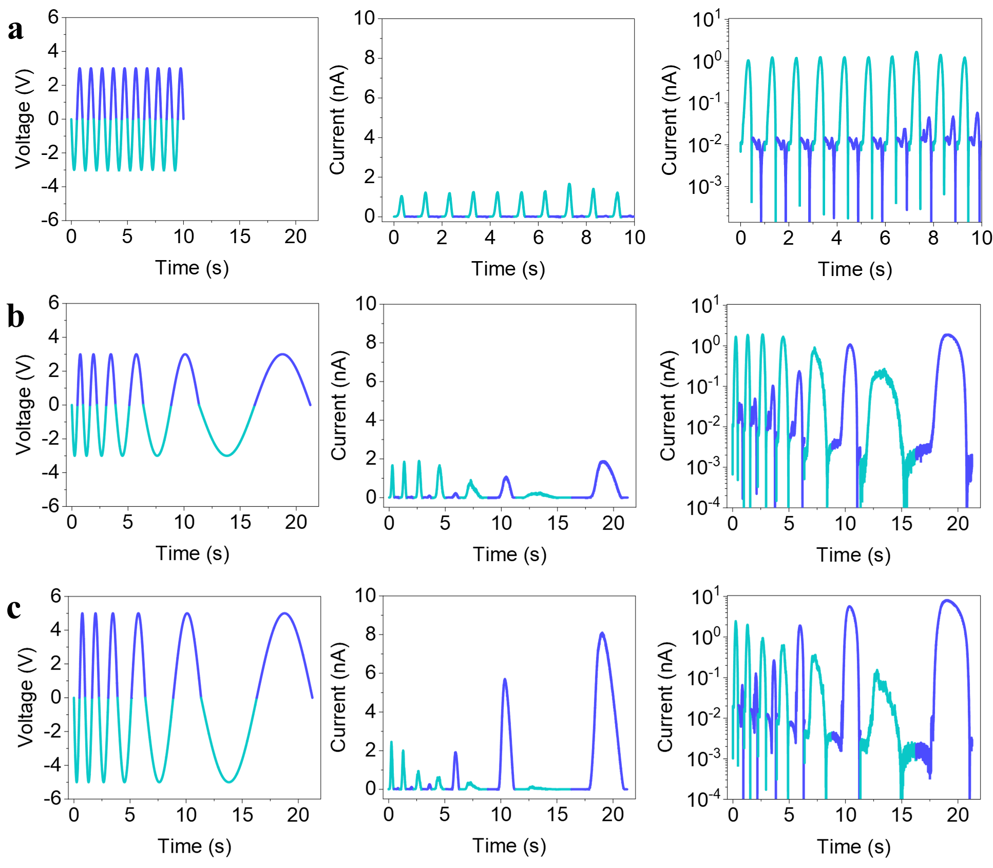
Supplementary Fig. 5 | Voltage-time and current-time curves for sine wave voltage scanning under different bias conditions. a Ten consecutive fast scanning cycles with a maximum voltage V_{max}=3 V and time duration of 1 s for each cycle. b Six consecutive scan cycles with V_{max}=3 V and varied time duration ranging from 1 s to 10 s for each cycle. c Six consecutive scanning cycles with V_{max}=5 V and the varied time duration ranging from 1 s to 10 s for each cycle.

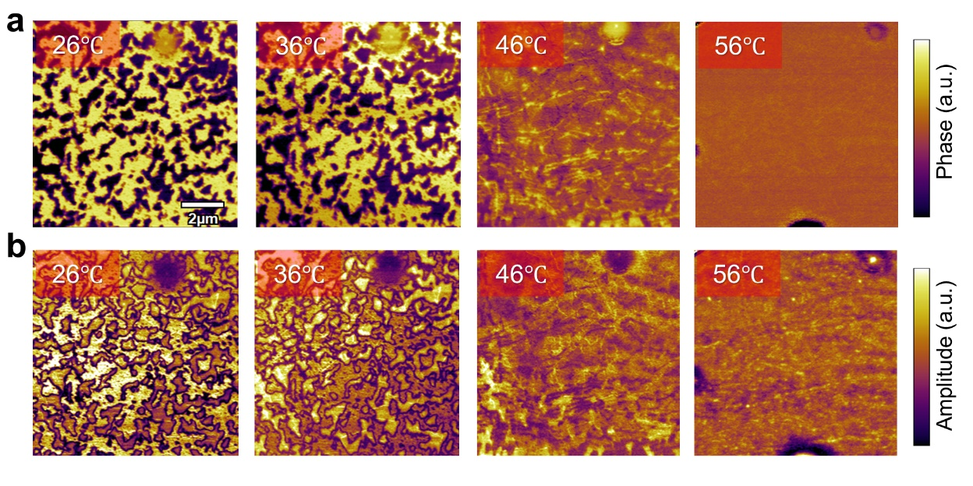
Supplementary Fig. 6 | The in-situ variable PFM images. a, b The phase and amplitude at four set temperatures (26 ℃, 36 ℃, 46 ℃, and 56 ℃), respectively.

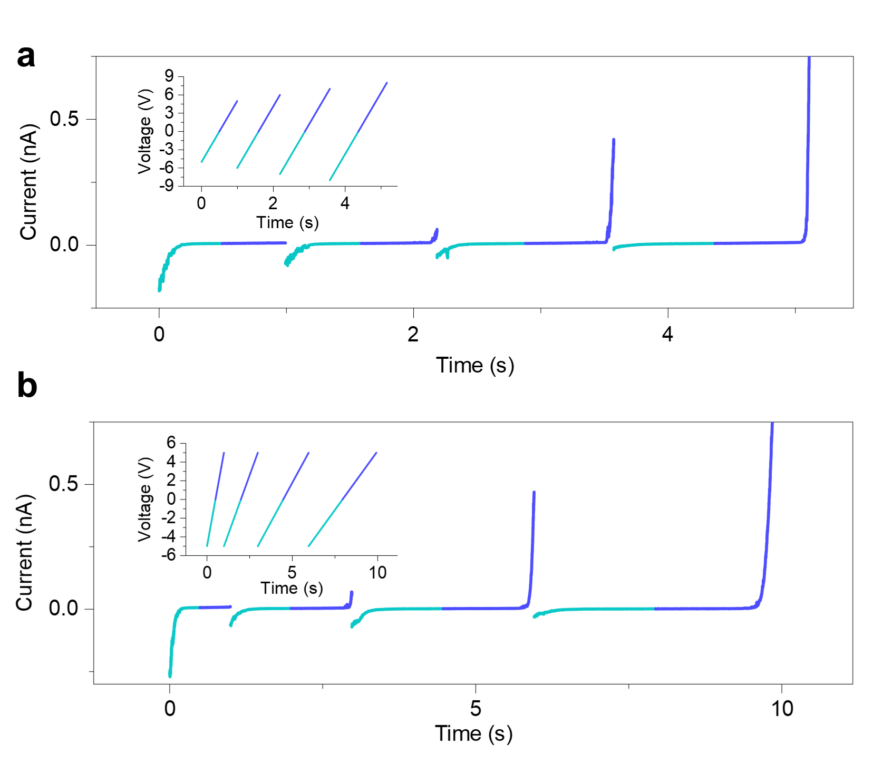
Supplementary Fig. 7 | Reversed current rectification with increased bias voltage magnitude and longer time duration. a The varied bias voltage magnitude with V_{max} ranging from 5 V to 8 V. b The varied time duration ranging from 1 s to 4 s for each I-V curve.

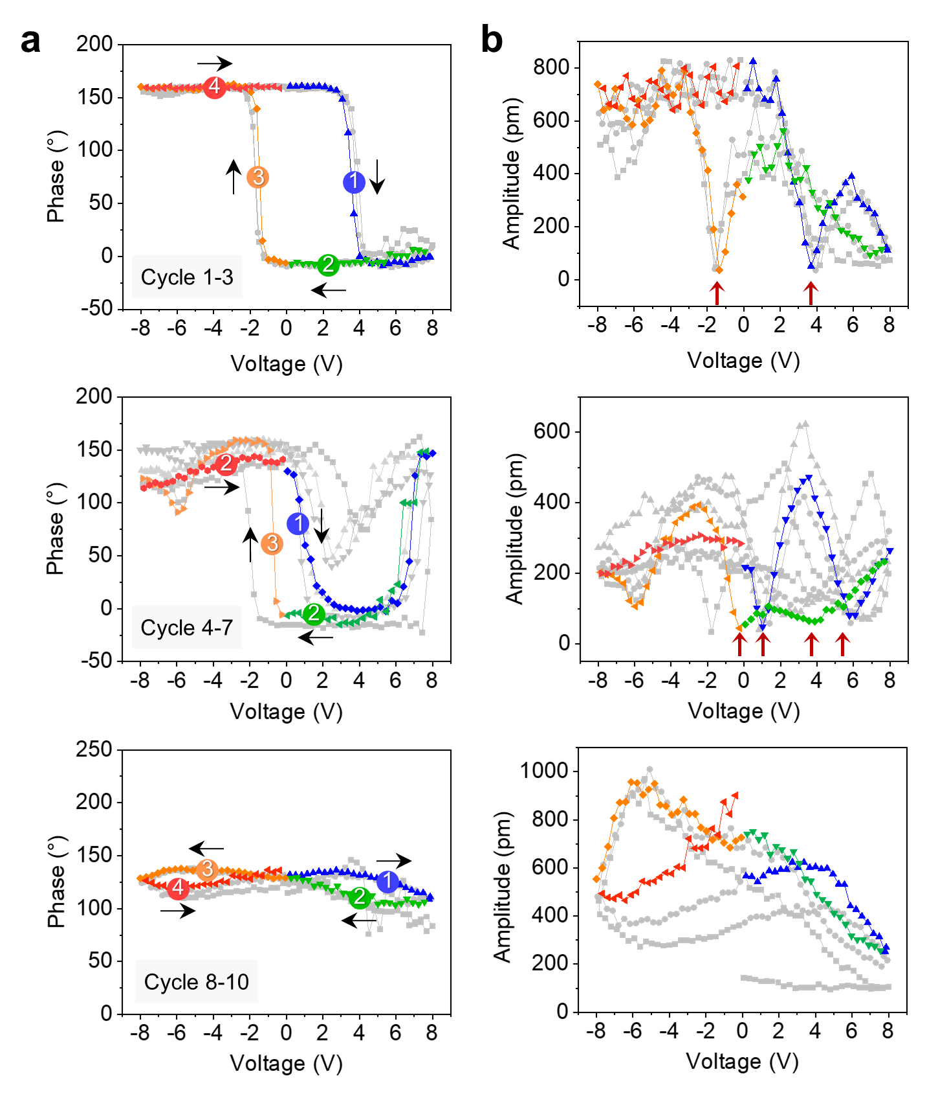
Supplementary Fig. 8 | Ten consecutive SS-PFM performed at a specific location with time duration of 1 s for each I-V cycle. a, b The phase and amplitude at different test cycles, respectively. The numbers1-4 and black arrows represent the bias scanning sequence and direction, respectively.

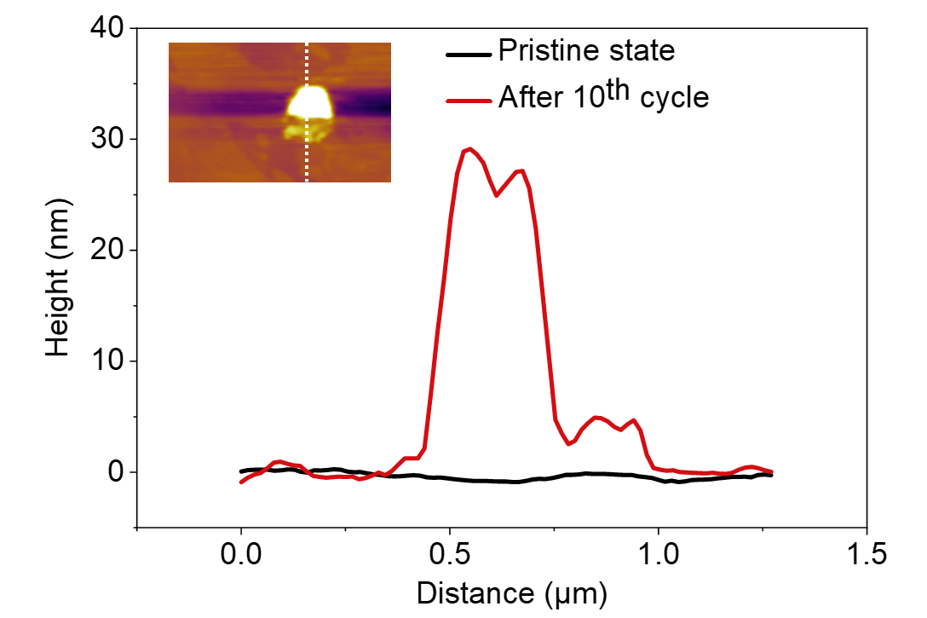
Supplementary Fig. 9 | The topography height changes before and after ten consecutive SS-PFM measurements performed at a specific location. The long-range migration across the vdW gap significantly disrupts the ferroelectric order, which is further confirmed by the formation of topographic bulges up to 30 nm after 10 cycles.

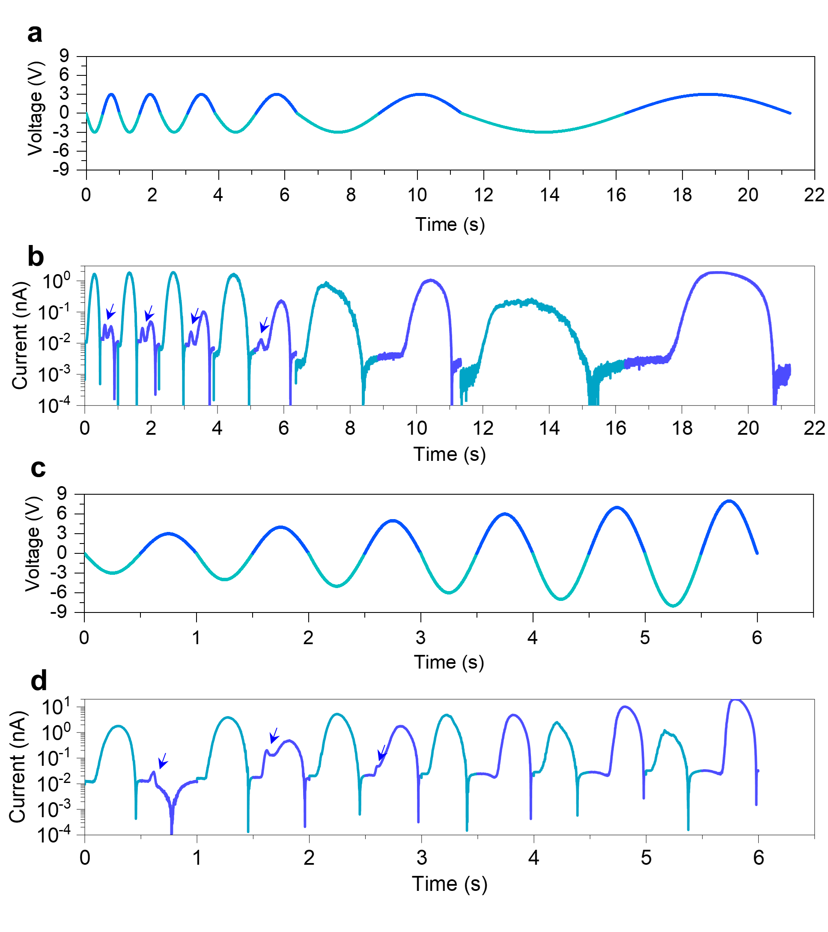
Supplementary Fig. 10 | The voltage-time and current-time curves for Sine wave voltage scanning under different bias condition. a, b Six full cycles with the varied time duration ranging from 1 s to 10 s. c, d Six full cycles with a time duration of 1 s and the varied bias voltage magnitude ranging from 3 V to 8 V.

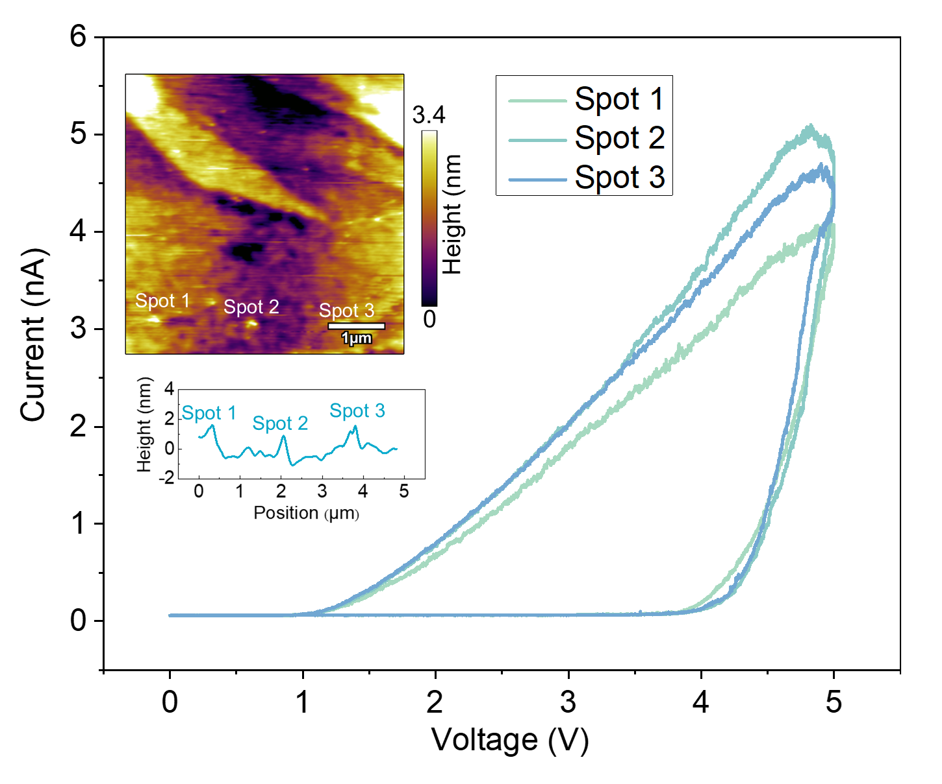
Supplementary Fig. 11 | The semi-cycle of I-V curves measured by the sequence of (0 V→+5 V→0 V) at three different positions and the topographic changes. A slightly topographic bump (~2 nm) appears due to the long-range migration and redistribution of Cu⁺ ions.

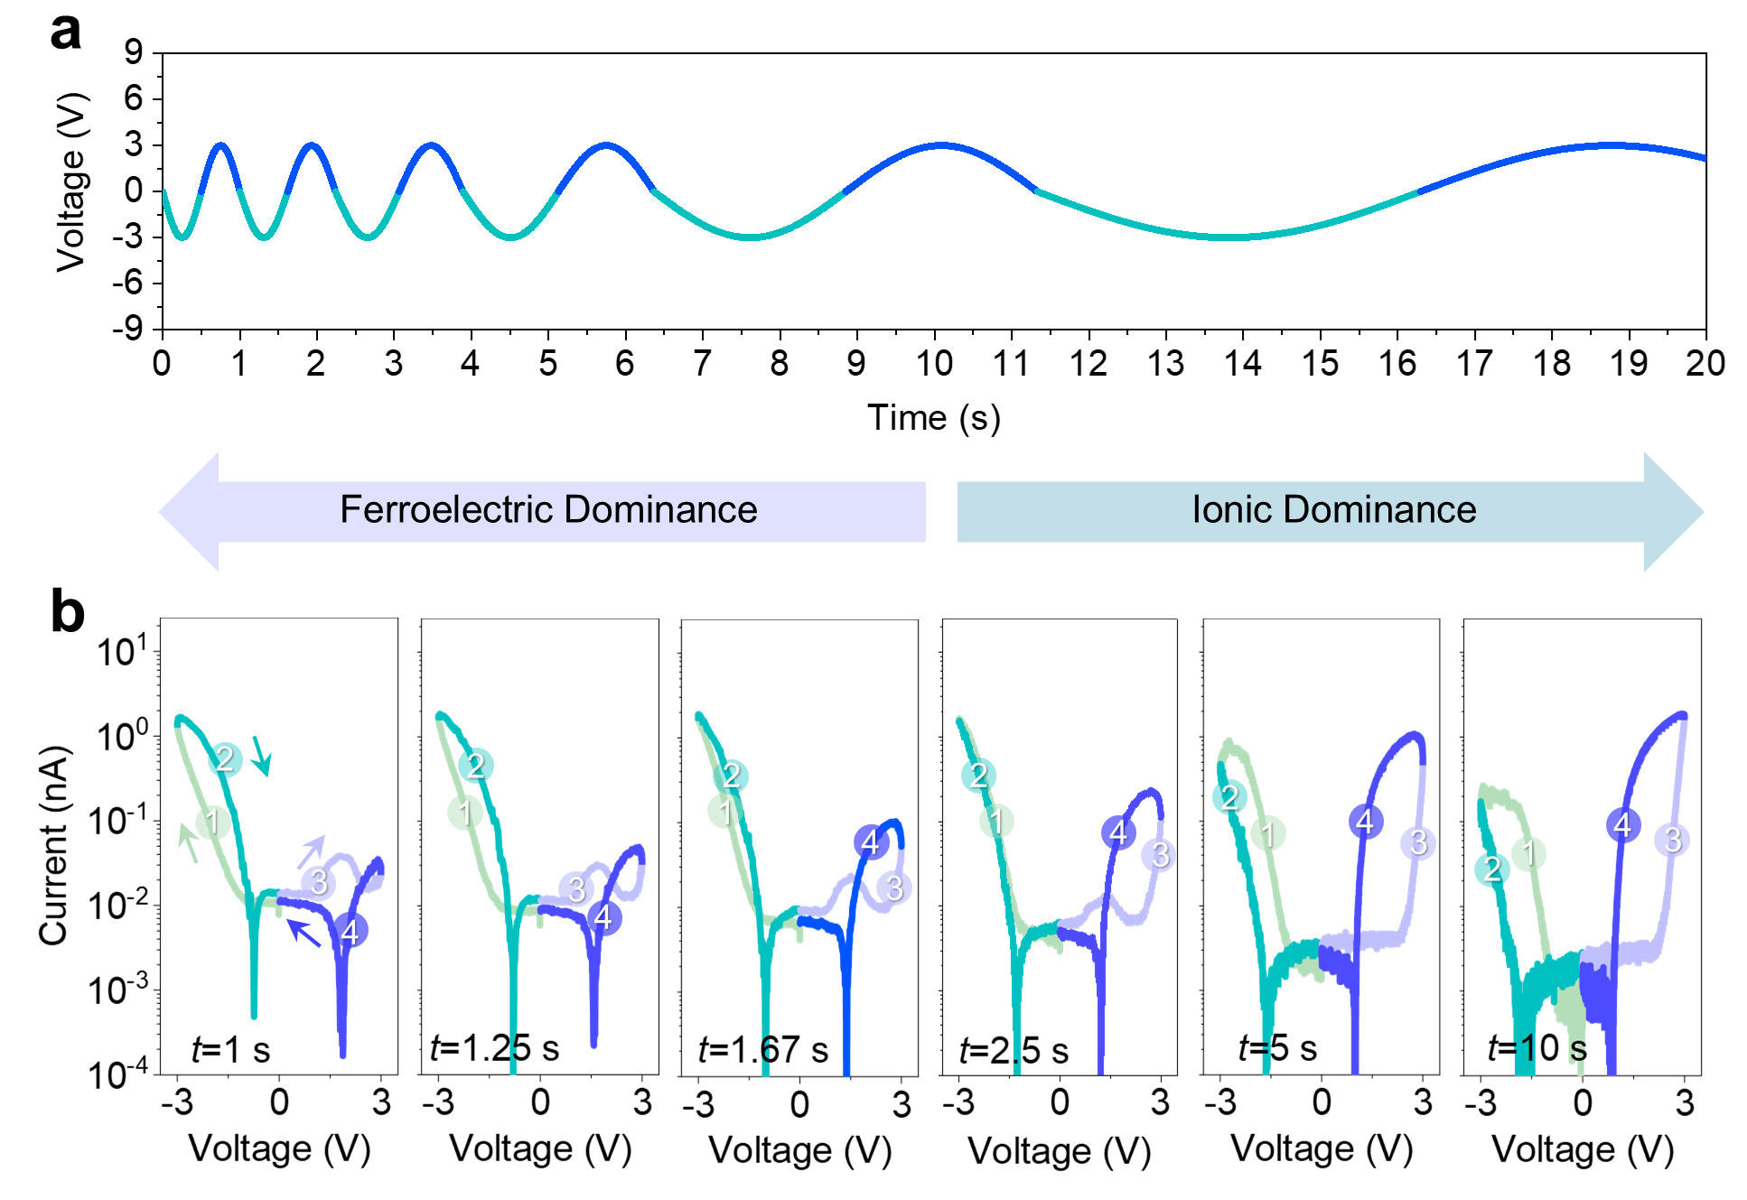
Supplementary Fig. 12 | The voltage-time (V-t) and six full-cycle of semilog I-V curves measured with the varied time duration for each cycle. a The voltage-time (V-t) curves for six cycles of Sine wave voltage sweeping. The time duration varies from 1 s to 10 s for each cycle. b The six full-cycle of semilog I-V curves with the longer time duration from 1 s to 10 s.

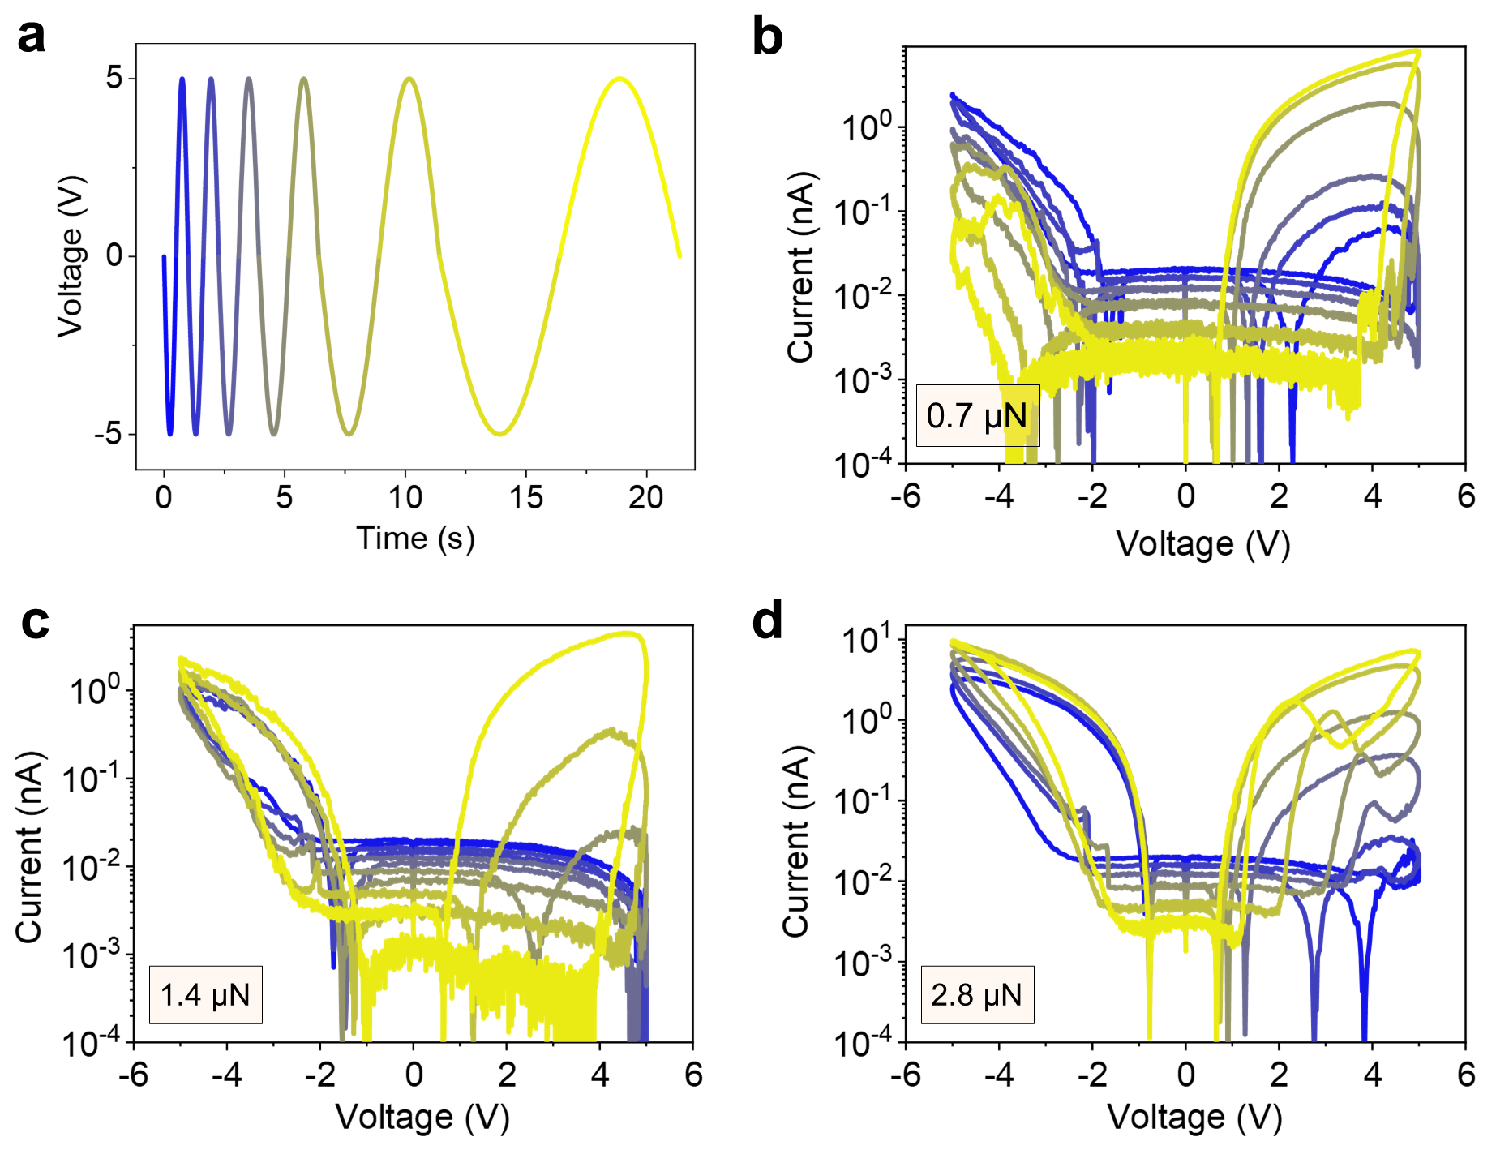
Supplementary Fig. 13 | Six full-cycle of semilog I-V curves measured by varying time duration under three different tip forces. a The voltage-time curves for six full-cycle of I-V curves with the varied time duration from 1 s to 10 s. b-d The six full-cycle of semilog I-V curves under 0.7 µN, 1.4 µN and 2.8 µN, respectively.

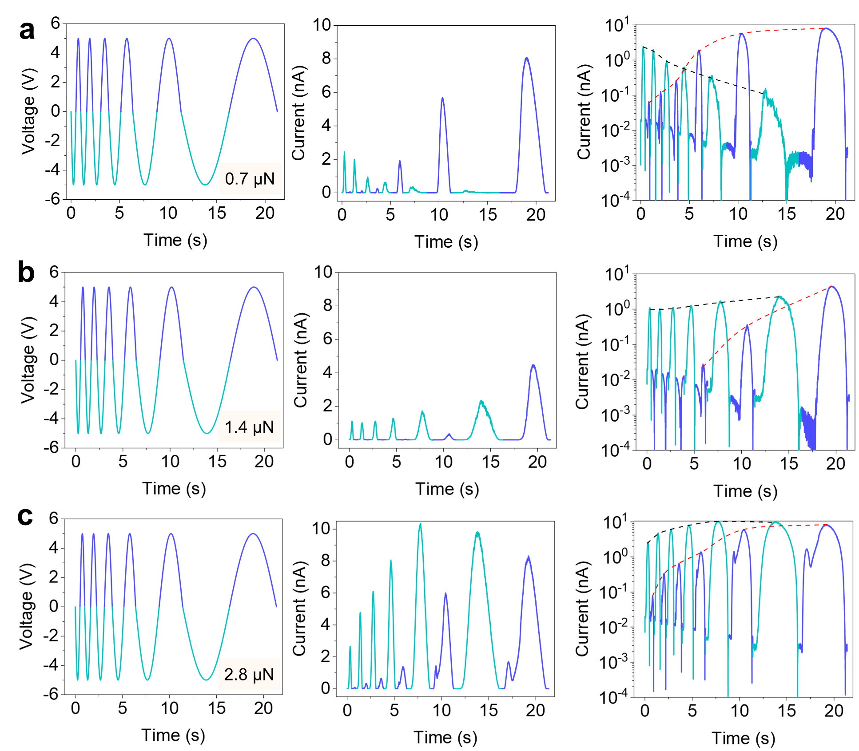
Supplementary Fig. 14 | Voltage-time and current-time curves for six full-cycle of I-V curves varying time duration under three different tip forces. a-c Six cycles with the varied time duration from 1 s to 10 s under (a) 0.7 µN, (b) 1.4 µN, and (c) 2.8 µN, respectively.

