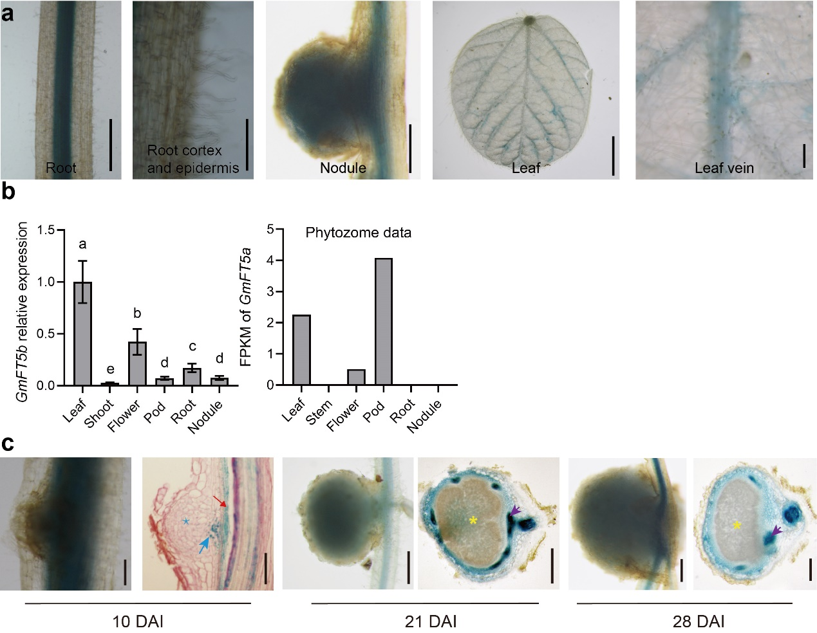
Extended Data Fig. 1 | GmFT5b expression patterns. a, GmFT5b_{pro}:GUS activity in roots without rhizobial infection (scale bar = 100 μm (left) and 10 μm (right)), nodule (scale bar = 500 μm), leaf (scale bar = 1 cm) and leaf vein (scale bar = 500 μm). b, Relative expression levels by RT-qPCR (left) and the FPKM value of by RNA-seq data provided from phytozome (right) of GmFT5b in leaves, stems, flowers, pods, roots, and nodules. c, GmFT5b_{pro}:GUS activity in nodules at various times after inoculation (10 DAI, scale bar = 100 μm; 21 DAI, scale bar = 500 μm, and 28 DAI, scale bar = 500 μm). Red arrow indicates the pericycle cells, blue arrow indicates the primordium cells, blue asterisk indicates nodule primordium, violet arrow indicates the nodule vascular tissues, and yellow asterisk indicates the infection zone. DAI, days after inoculation. GmUKN1 is used as the reference gene (b). Data are mean ± s.d. with n = 3 (b) biological replicates; One-way ANOVA with Bonferroni post hoc test (b), different letters indicate p < 0.05.
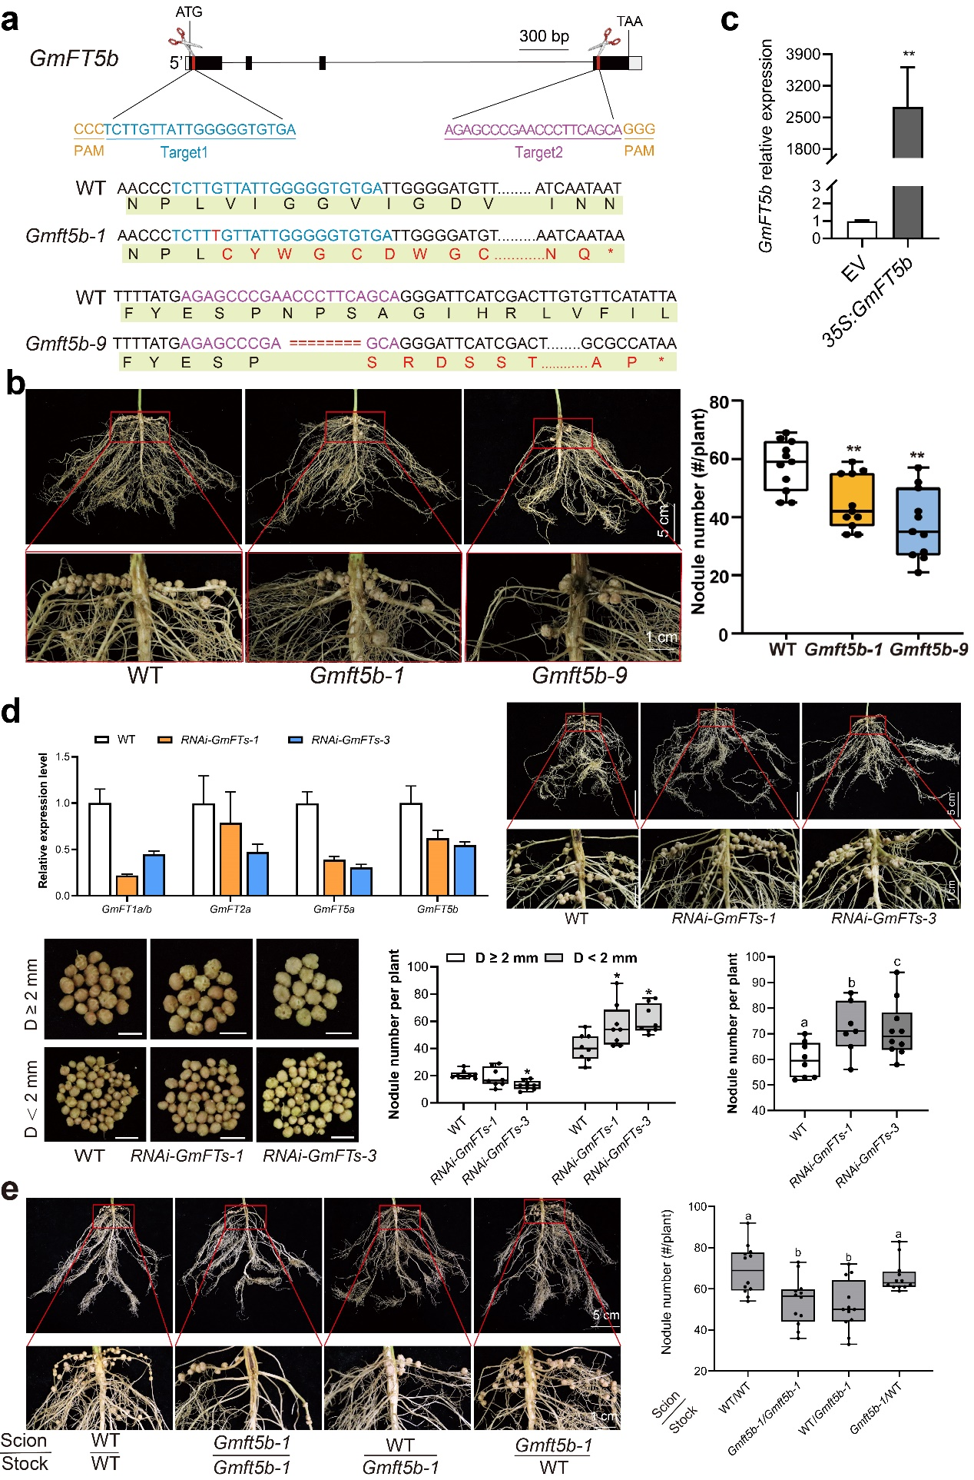
Extended Data Fig. 2 | Effects of GmFT5b on soybean nodulation. a, Two sgRNAs target sequences and positions in gene sequence and the gene editing results in the GmFT5b knockout lines. Blue bases indicate the first target sequence, violet bases indicate the second target sequence, red bases indicate the insert base, the red amino acid indicate the altered amino. Dashes indicate the deleted bases. b, Images and number nodules in WT and GmFT5b knockout lines at 21 DAI. c, Relative expression levels of GmFT5b in 35S:GmFT5b hairy roots. d, Nodule phenotypes and relative expression levels of GmFTs in GmFTs RNAi lines. e, Images and number of nodules in reciprocal grafting between WT and Gmft5b-1 mutant at 21 DAI. WT, wild-type; EV, empty vector. Scale bar = 1 cm (b, d, e). GmUKN1 is used as the reference gene (c, d). Data are normalized to the expression level in EV (c) or WT (d). Data are mean ± s.d. with n = 11 (b), n = 3 (c), n =13 (d) or n = 14 (e) biological replicates; two-tailed Student’s t-test (b, c, d), * p <0.05, ** p <0.01; One-way ANOVA with Bonferroni post hoc test (c, e), different letters indicate p < 0.05.
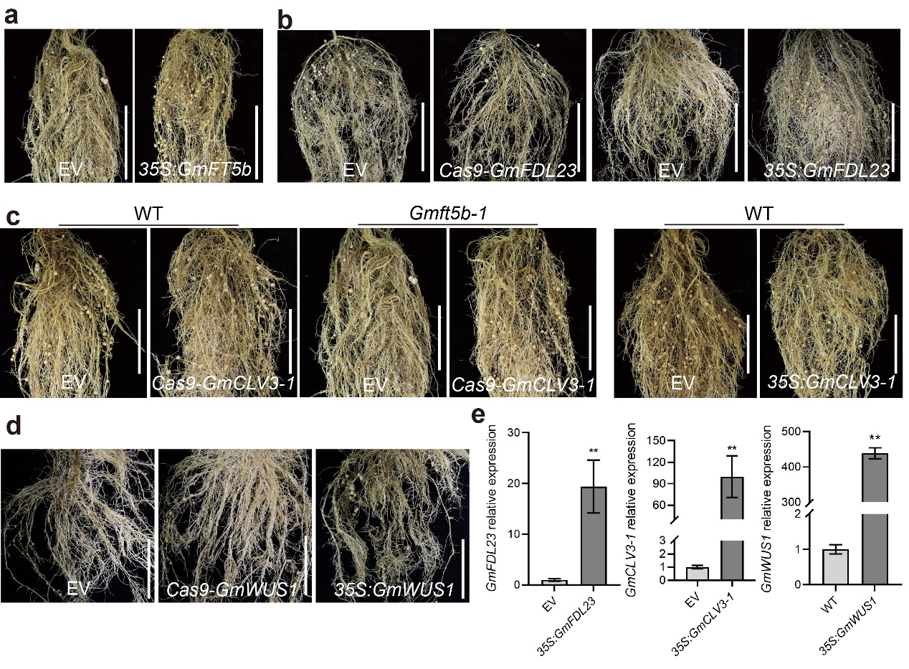
Extended Data Fig. 3 | Images of hairy roots of different genetic modified lines at 21 DAI. a, 35S:GmFT5b. b, Cas9-GmFDL23 and 35S:GmFDL23. c, Cas9-GmCLV3-1 and 35S:GmCLV3-1 in WT or Gmft5b-1 background. d, Cas9-GmWUS1 and 35S:GmWUS1. e, Relative expression levels of GmFDL23, GmCLV3-1 and GmWUS1 in overexpressed hairy roots. WT, wild-type; EV, empty vector. Scale bar = 5 cm (a, b, c, d). GmUKN1 is used as the reference gene (e). Data are normalized to the expression level in EV of RT-qPCR analysis. Data are mean ± s.d. with n = 3 (e) biological replicates; two-tailed Student’s t-test (e), ** p <0.01.
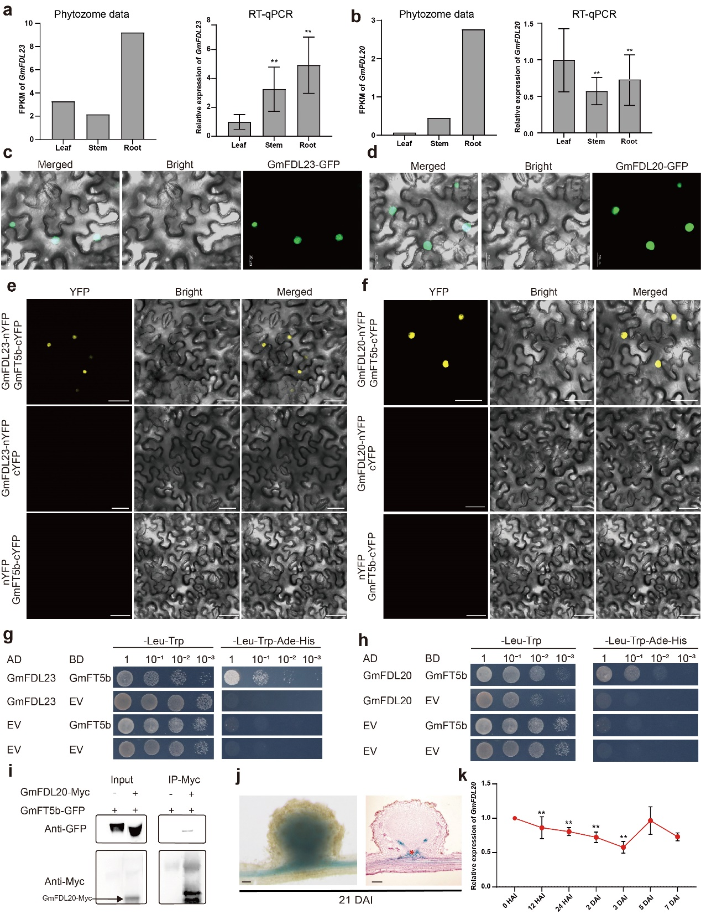
Extended Data Fig. 4 | Expression pattern and interaction with GmFT5b of GmFDL23 and GmFDL20. a and b, The FPKM value of RNA-seq data provided from phytozome and relative expression levels by RT-qPCR of GmFDL23 (a) and GmFDL20 (b) in leaves, stems and roots. c and d, Subcellular localization of GmFDL23 (c) and GmFDL20 (d) proteins in N. benthamiana leaves. e and f, BiFC assay for the interaction between GmFT5b-cYFP and GmFDL23-nYFP (e) or GmFDL20-nYFP (f) in N. benthamiana leaves. g and h, Y2H assay for the interaction between GmFT5b and GmFDL23 (g) or GmFDL20 (h). The yeast was initially grown on SD-Leu/-Trp medium and then transferred to SD-Leu/-Trp/-His/-Ade medium. i, Co-IP assay for GmFDL20-Myc and GmFT5b-GFP in N. benthamiana leaves. Proteins were immunoprecipitated (IP) with anti-Myc beads and probed by anti-Myc or anti-GFP antibody. j, GmFDL23_{pro}:GUS activity in nodules (left) and its longitudinal-section image (right) at 21 DAI. Red asterisk indicates the nodule vascular tissue. k, Time-course expression level of GmFDL20 in roots after HH103 inoculation. HAI, hours after inoculation; DAI, days after inoculation; EV, empty vector. Scale bar = 20 μm (c, d), 50 μm (e, f) or 200 μm (j). GmUKN1 is used as the reference gene (a, b, k). Data are normalized to the expression level in leaf (a, b) or uninfected roots (k) of RT-qPCR analysis. Data are mean ± s.d. with n = 3 (a, b, k) biological replicates; two-tailed Student’s t-test (a, b, k), ** p <0.01.
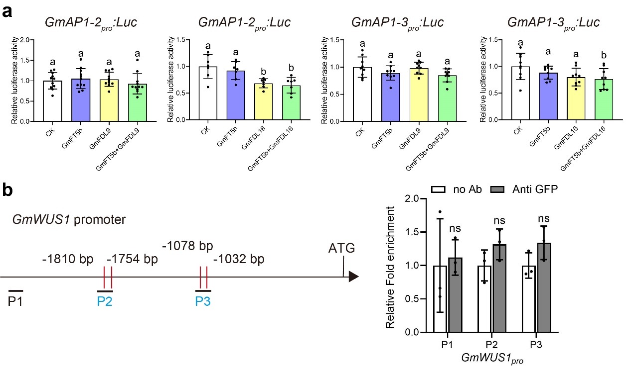
Extended Data Fig. 5 | GmFDL did not activate GmAP1 and GmWUS1 genes. a, Luciferase activity of GmAP1-2_{pro}:LUC and GmAP1-3_{pro}:LUC in N. benthamiana leaves. GmAP1.2_{pro}:LUC and GmAP1.3_{pro}:LUC were co-infiltrated with 35S:GFP, 35S:GmFT5b, 35S:GmFDL9/16, or 35S:GmFT5b and 35S:GmFDL9/16 into N. benthamiana leaves. 35S:GFP was served as a negative control effector. CK, 35S:GFP. Data are normalized to the negative control of luciferase activity analysis. b, ChIP–qPCR assay to identify the binding of GmFDL23 to GmWUS1pro. DNA fragments are shown in the left panel. Red vertical lines indicate the predicted binding site of promoters. Data are mean ± s.d. with n ≥ 7 (a) or n = 3 (b) biological replicates. One-way ANOVA with Bonferroni post hoc test (a), different letters indicate p < 0.05; two-tailed Student’s t-test (b), ns, no significant.
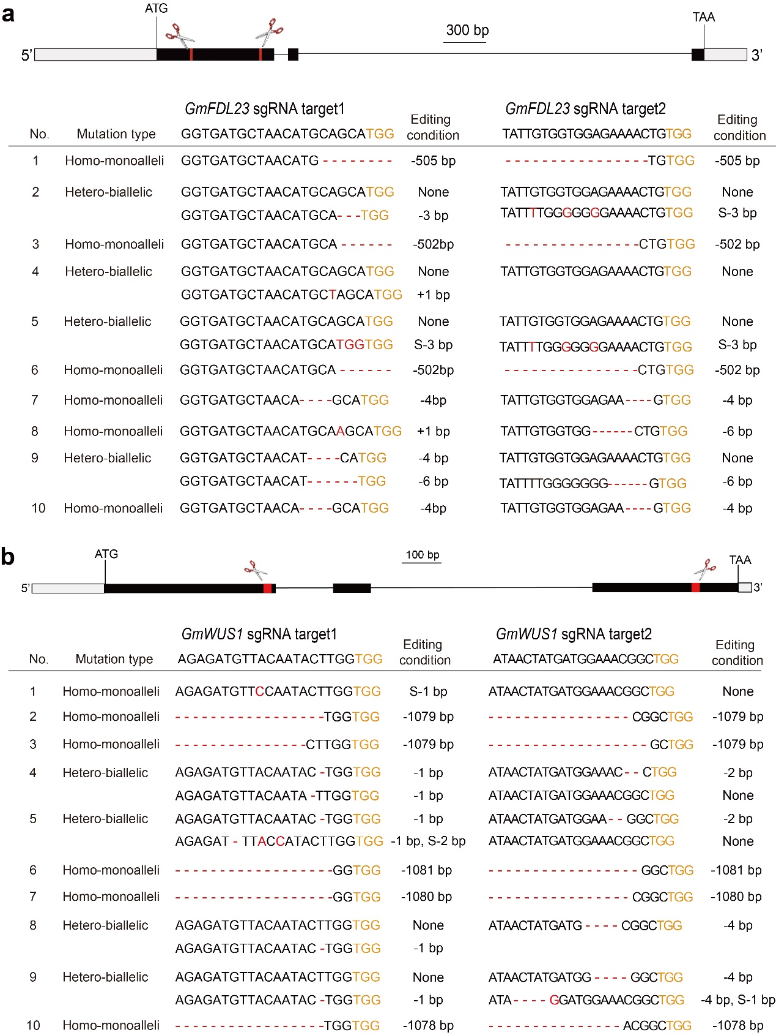
Extended Data Fig. 6. Identification of Cas9-GmFDL23 and Cas9-GmWUS1 edited hairy roots. a, Two sgRNAs position of GmFDL23 and the gene editing conditions of Cas9-GmFDL23 hairy roots. Orange letters indicate the PAM. The letter “S” indicates base substitution. “None” indicates none editing. Dashes indicate deleted bases, red letters indicate insert bases. b, Two sgRNAs position of GmWUS1 and the gene editing conditions of Cas9-GmWUS1 hairy roots. Orange letters indicate the PAM. The letter “S” indicates base substitution. “None” indicates none editing. Dashes indicate the deleted bases, red letters indicate the insert bases.
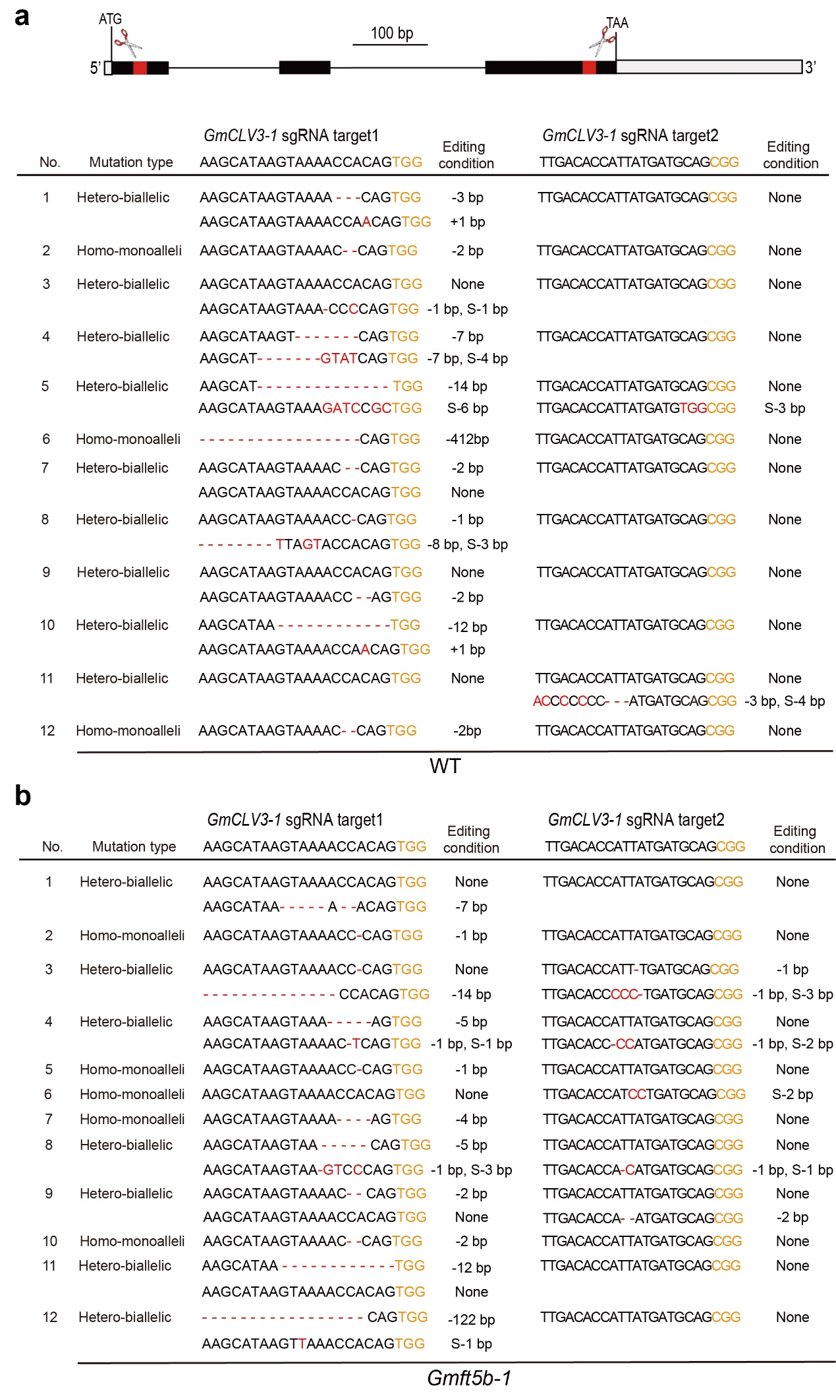
Extended Data Fig. 7. Identification of distinct Cas9-CLV3-1 hairy roots under Williams 82 and Gmft5b-1 background. a, b, Gene editing conditions of Cas9-GmCLV3-1 hairy roots under Williams 82 (a) and Gmft5b-1(b) background. Orange letters indicate the PAM. The letter “S” indicates base substitution. “None” indicates none editing. Dashes indicate the deleted bases, red letters indicate the insert bases.

