Supporting Information for:

The selective and sensitive fluorogenic detection of hydrogen gas using a transition metal activator and a naphthalene-based dye

Mark Potter,¹ Suman Debnath,¹ Pavan Mandapati,² Ken Schmidt,³ Kathy Jansen,³ Marcus W. Drover,^{2,*} Simon Rondeau-Gagné,^{1,*} and Bulent Mutus^{1*}
¹Department of Chemistry and Biochemistry, University of Windsor, 401 Sunset Avenue, Windsor, ON, N9B 3P4, Canada
²Department of Chemistry, Western University, 1151 Richmond Street, London, ON, N8K 3G6, Canada
³Wilson Analytical Services Inc., #2 215 Carnegie Drive, St. Albert, AB, T8N 5B1, Canada

1. Experimental Section | S2
2. Absorbance and Fluorescence Data | S3
3. NMR Spectroscopic Data | S9
4. NMR Spectroscopic Data - Discussion | S21
4. References | S24

1. Experimental Section
Unless otherwise speciﬁed, air sensitive manipulations were carried either in an N₂ -ﬁlled glovebox or using standard Schlenk techniques under nitrogen. H-Acid (Millipore Sigma), Az-H (Millipore Sigma), IrCl₃.3H₂O (Ambeed), Cyclopentadiene (Cp*H, Ambeed), 2-Chloro-4-methoxy-6-methylpyrimidine (Ambeed), Ni(PPh₃)Cl₂ (Ambeed), triphenylphosphine (Millipore Sigma), Tetramethylsilyliodide (Fischer Scientific), and all reagents used in precursor synthesis and catalytic trials were purchased and used without any further puriﬁcation. Reduced Az-H with sodium borohydride,¹ [Cp*IrCl₂]Cl₂,² and [{Ir(Cp*)(Cl)}₂(thbpym)](Cl)₂ (IrCp*, (thbpym = 4,4’,6,6’-tetrahydroxy-2,2’-bipyrimidine),³ were synthesized according to published procedures. Multinuclear 1D and 2D NMR spectra were recorded on Bruker Neo 600 spectrometer. ¹H and ¹³C{¹H} NMR spectra were referenced to residual solvent peaks.

2. Absorbance and Fluorescence Data:
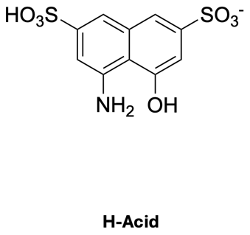
Figure S1. The (A) structure of H-Acid. The (B) fluorescence and (C) absorbance spectra of H-Acid before (black, line) and after (red, dash) exposure to 365 nm light.

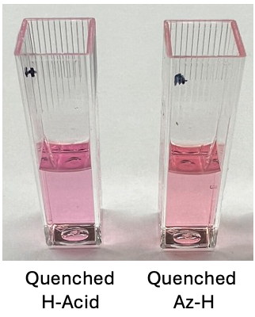
Figure S2. The colour of a H-Acid* solution compared to Az-H* solution.

Figure S3. Quenching kinetics of Az-H (black line), H-acid (red dash) in water and Az-H (blue dots), H-Acid (green dash and dots) in nitrogen gas purged water.

Figure S4. Response of a H-Acid* with IrCp* solution to hydrogen gas. Absorbance (A) and fluorescent (B) spectra of photoquenched H-Acid + IrCp* before (black) and after (red dash) 5-minutes of H₂ gas exposure.

Figure S5. Response of Az-H* to Hydrogen Gas. (A) Absorbance spectra of Az-H* before (black line) and after (red dash) pure hydrogen gas exposure compared to Az-H* + IrCp* after pure hydrogen gas exposure. (B) Change in fluorescent spectra of Az-H* after pure hydrogen gas exposure (black line) compared to Az-H* + IrCp* after pure hydrogen gas exposure (red dash).

Figure S6. Response of Az-H* with Commercial IrCp* Precursor ([{Ir(Cp*)(Cl)(µ-Cl)}]₂) to Hydrogen Gas. (A) Absorbance spectra of Az-H* + IrCp* precursor before (black line) and after (red dash) pure hydrogen gas exposure compared to Az-H* + IrCp* after pure hydrogen gas exposure. (B) Change in fluorescent spectra of Az-H* + IrCp* precursor after pure hydrogen gas exposure (black line) compared to Az-H* + IrCp* after pure hydrogen gas exposure (red dash).

Figure S7. Response of Az-H* with thbpym Ligand to Hydrogen Gas. (A) Absorbance spectra of Az-H* + thbpym ligand before (black line) and after (red dash) pure hydrogen gas exposure compared to Az-H* + IrCp* after pure hydrogen gas exposure. (B) Change in fluorescent spectra of Az-H* + thbpym ligand after pure hydrogen gas exposure (black line) compared to Az-H* + IrCp* after pure hydrogen gas exposure (red dash).

Figure S8. Titration of Az-H* with IrCp*. (A) Reaction rates of solution of 50µM Az-H* with various concentrations of IrCp* with continuous exposure to pure H_{2(g)}. (B) Relationship between the rate of reaction vs concentration or IrCp* (R² = 0.98). (C) Final fluorescent spectra of the reaction of Az-H* + IrCp* with continuous exposure to pure H_{2(g)}.
Figure S9. Titration of IrCp* with Az-H*. (A) Reaction rates of solution of 10µM IrCp* with various concentrations of Az-H* with continuous exposure to pure H_{2(g)}. (B) Relationship of the rate of reaction vs concentration of Az-H*. (C) Final fluorescent spectra of the reaction of IrCp* + Az-H* with continuous exposure to pure H_{2(g)}.
Figure S10. Reaction kinetics of Az-H* + IrCp* fluorogenic response to continuous pure H_{2(g)} exposure monitored under low flux conditions.
Figure S11. Saturation curve of Az-H* + IrCp* exposed to various percent of hydrogen gas.

3. NMR Spectroscopic Data:
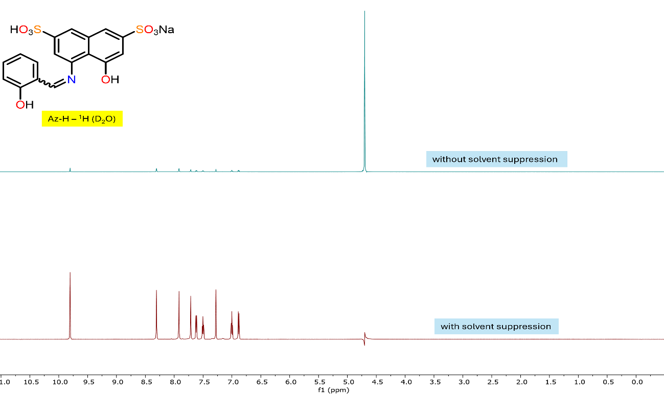
Figure S12. ¹H (600 MHz, D₂O, 22 ℃) NMR of Az-H with and without solvent suppression.

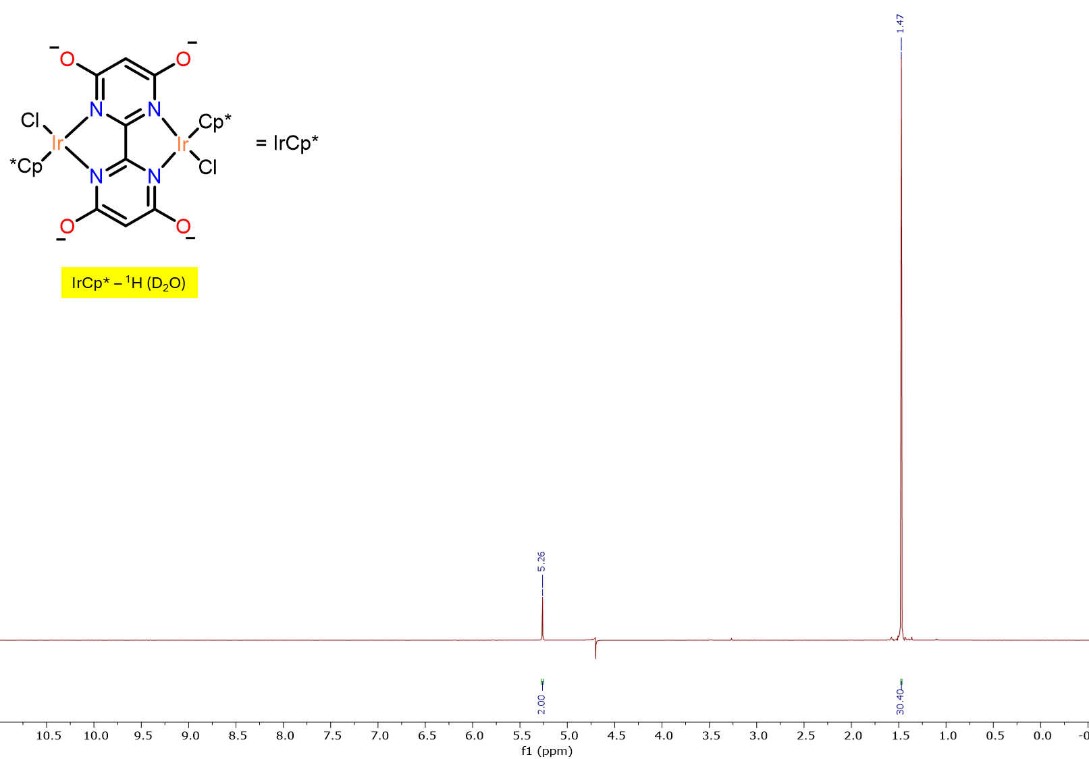

Figure S13. ¹H (600 MHz, D₂O, 22 ℃) NMR of IrCp*.
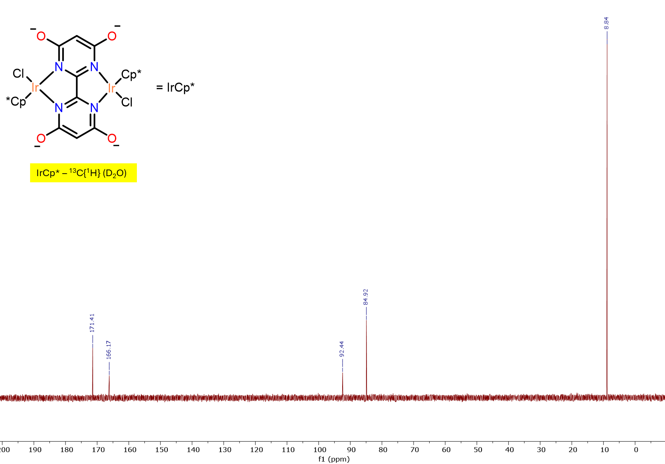

Figure S14. ¹³C{¹H} (151 MHz, D₂O, 22 ℃) NMR of IrCp*.

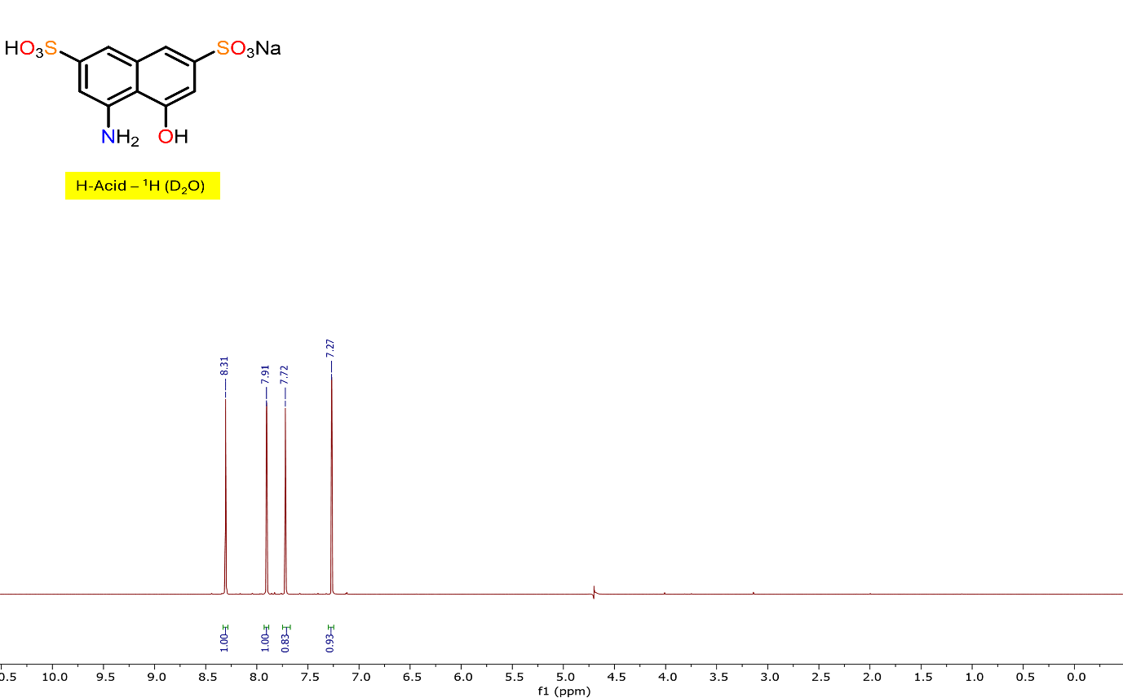
Figure S15. ¹H (600 MHz, D₂O, 22 ℃) NMR of H-Acid.
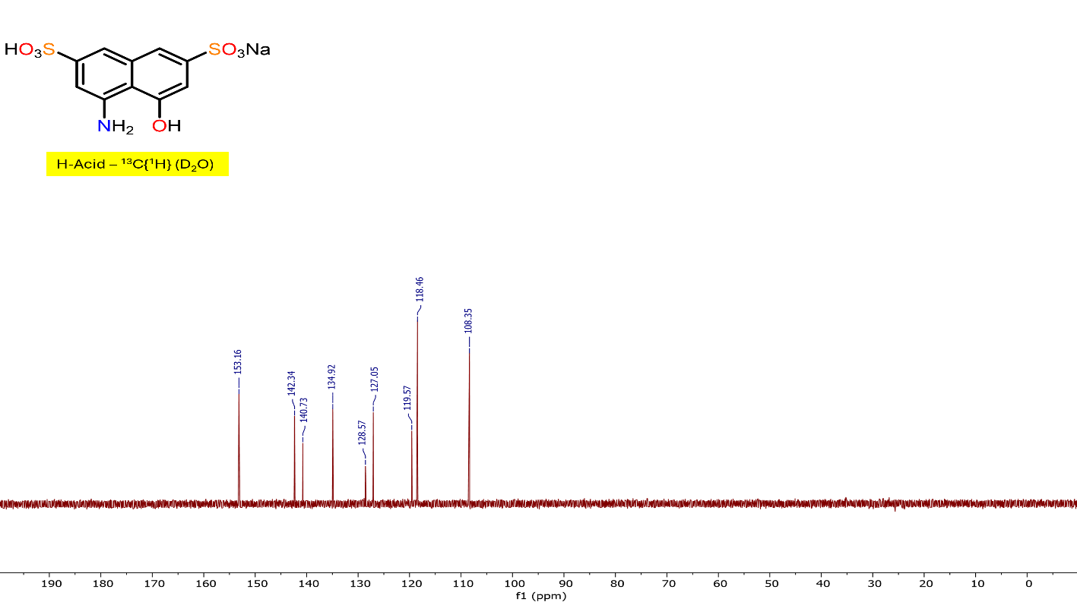

Figure S16. ¹³C{¹H} (151 MHz, D₂O, 22 ℃) NMR of H-Acid.

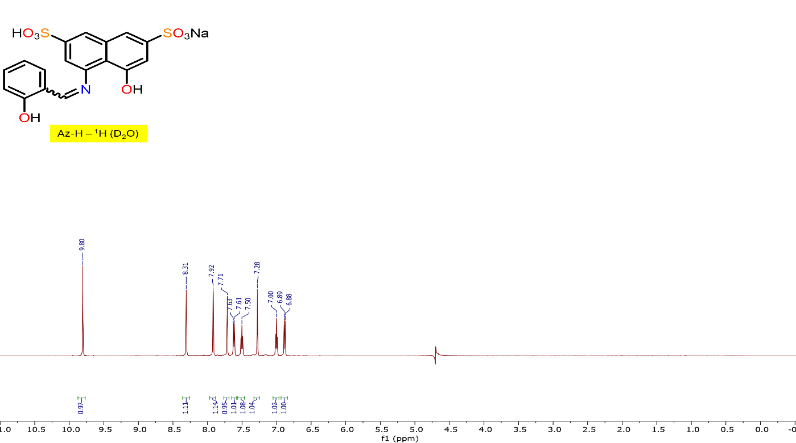

Figure S17. ¹H (600 MHz, D₂O, 22 ℃) NMR of Az-H.

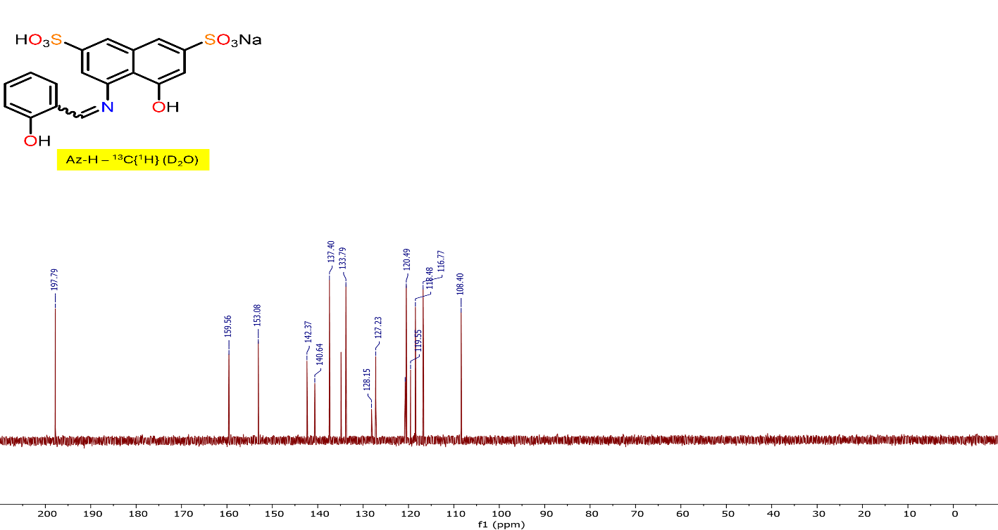

Figure S18. ¹³C{¹H} (151 MHz, D₂O, 22 ℃) NMR of Az-H.

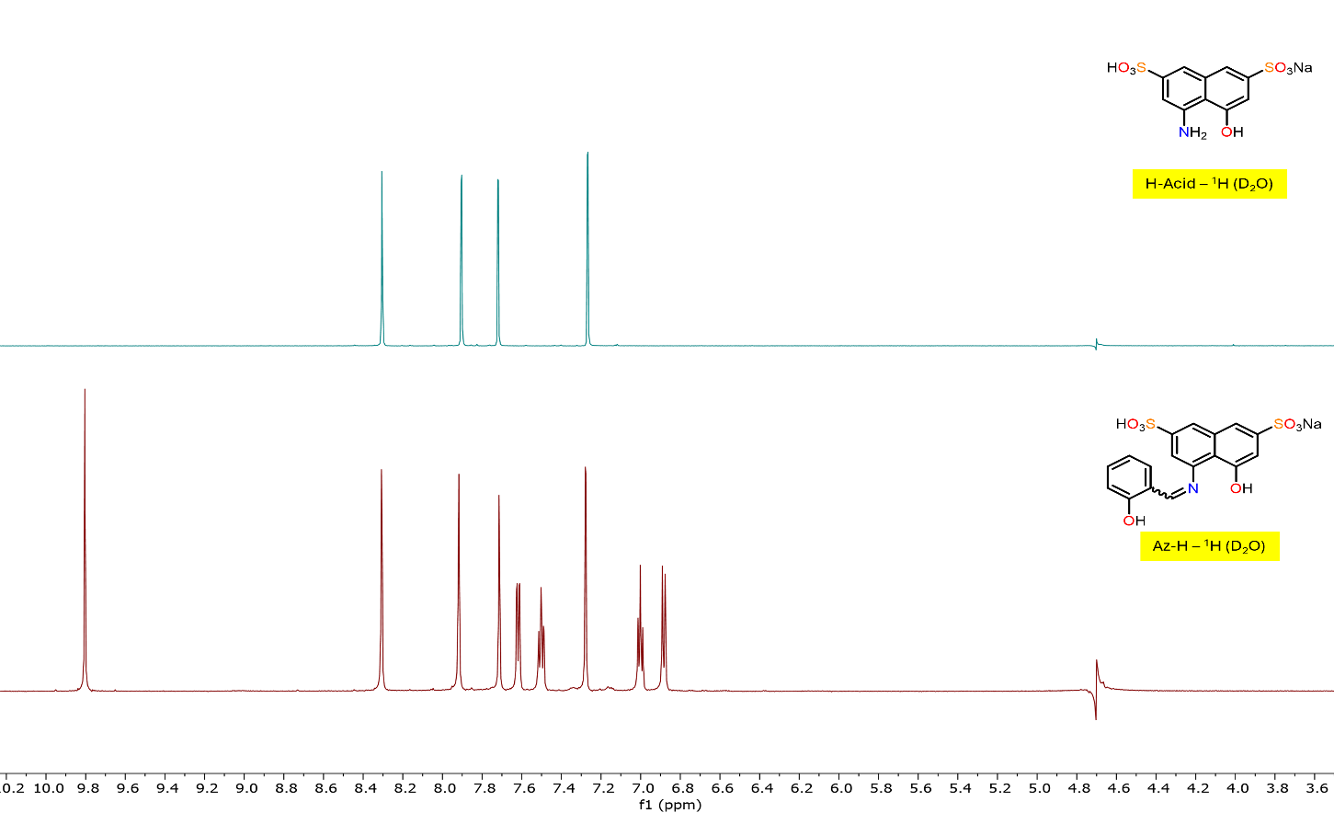

Figure S19. Stacked ¹H NMRs of H-Acid and Az-H in D₂O.
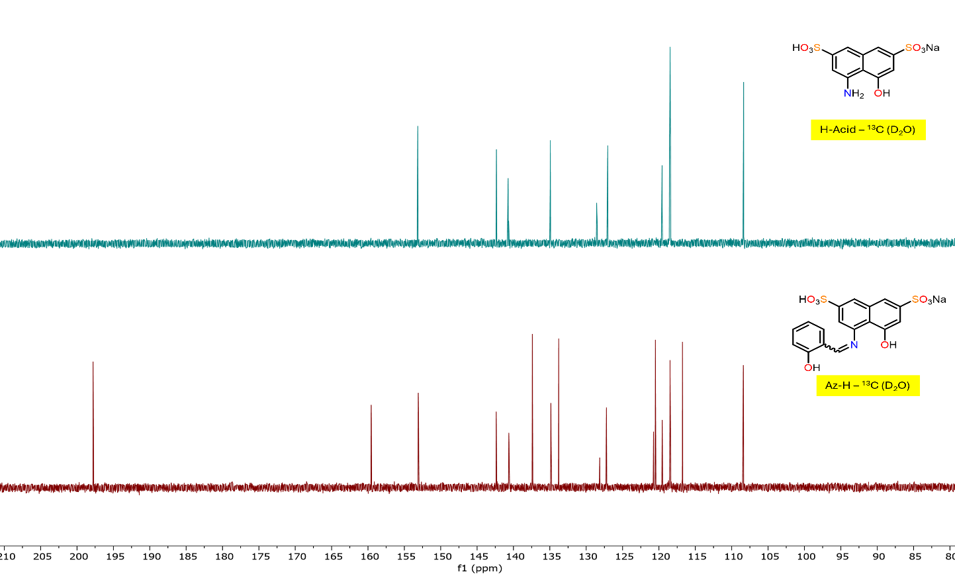

Figure S20. Stacked ¹³C{¹H} NMRs of H-Acid and Az-H in D₂O.

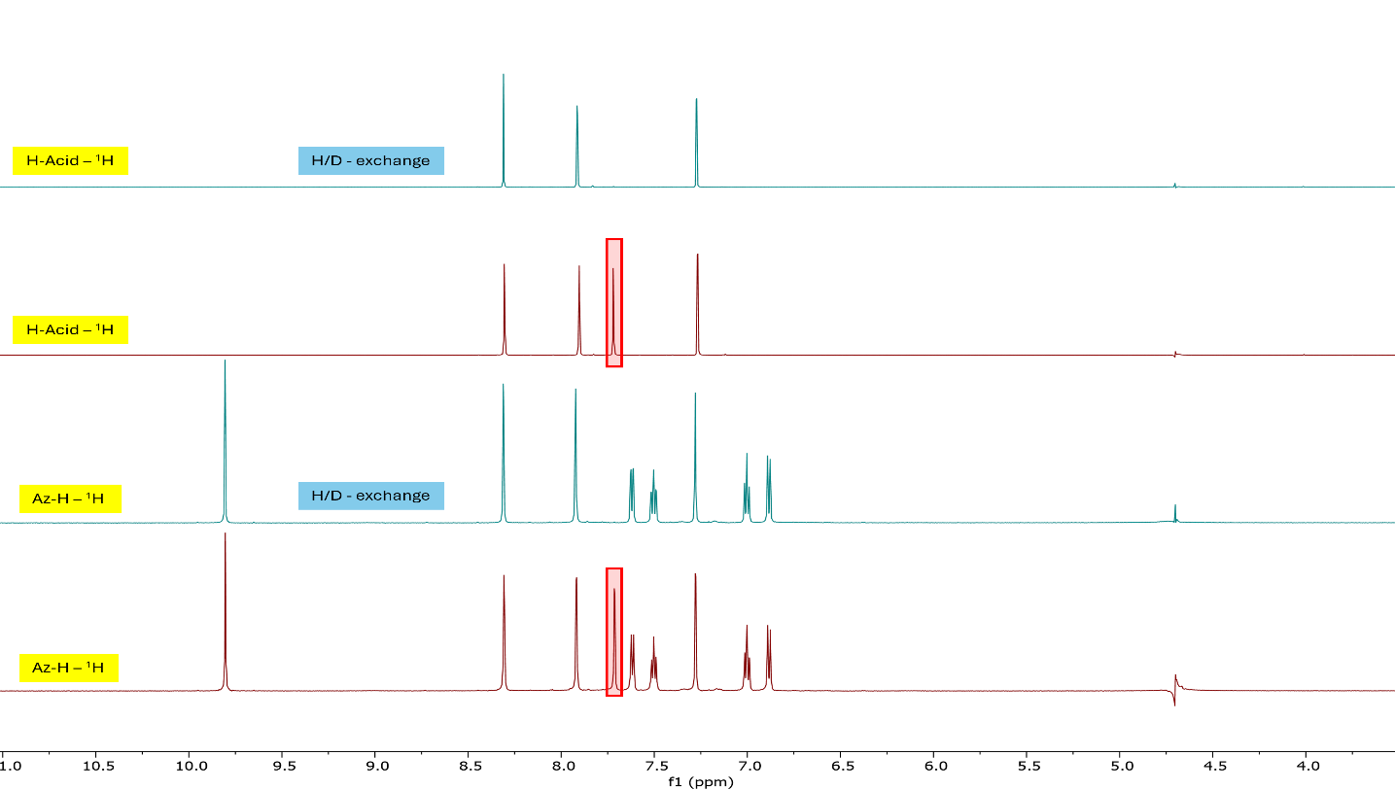

Figure S21. Stacked ¹H NMRs of H-Acid and Az-H in D₂O showing H/D exchange.

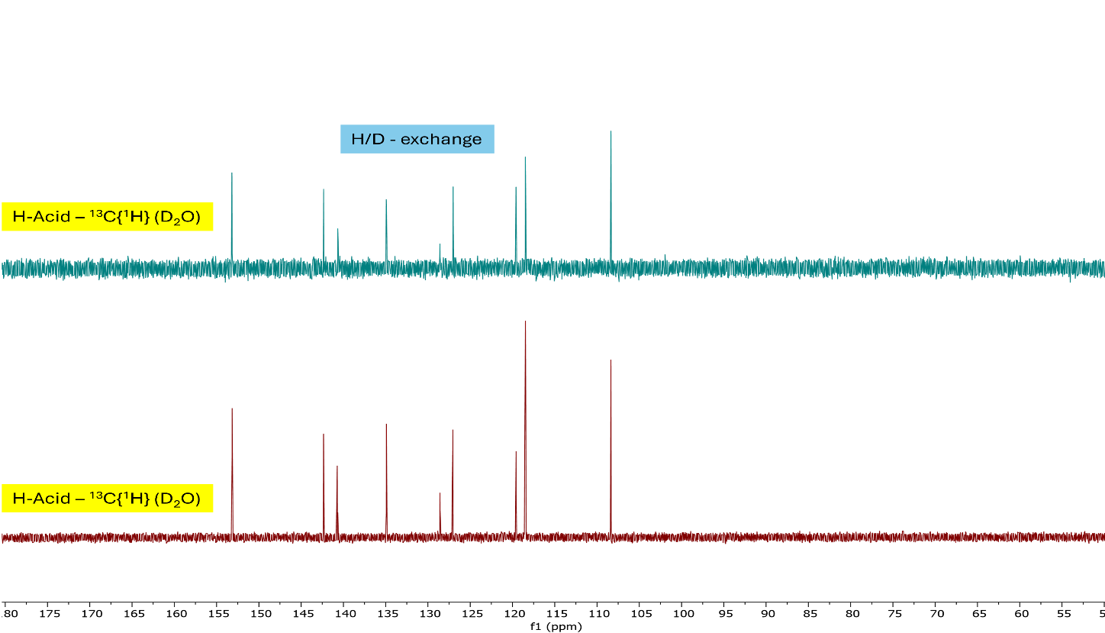
Figure S22. Stacked ¹³C{¹H} NMRs of H-Acid in D₂O, no difference was observed.

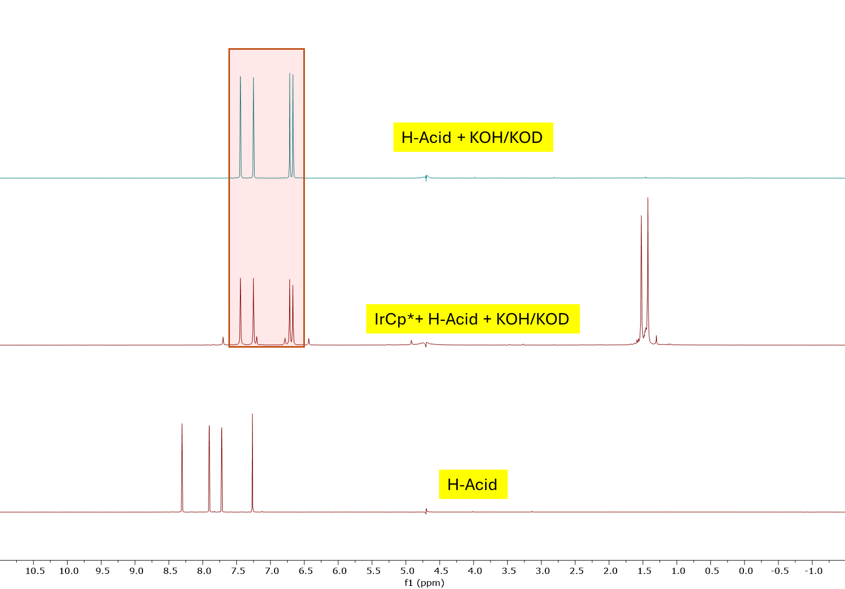

Figure S23. Stacked ¹H NMRs of H-Acid when treated with base (KOH/KOD) in D₂O.
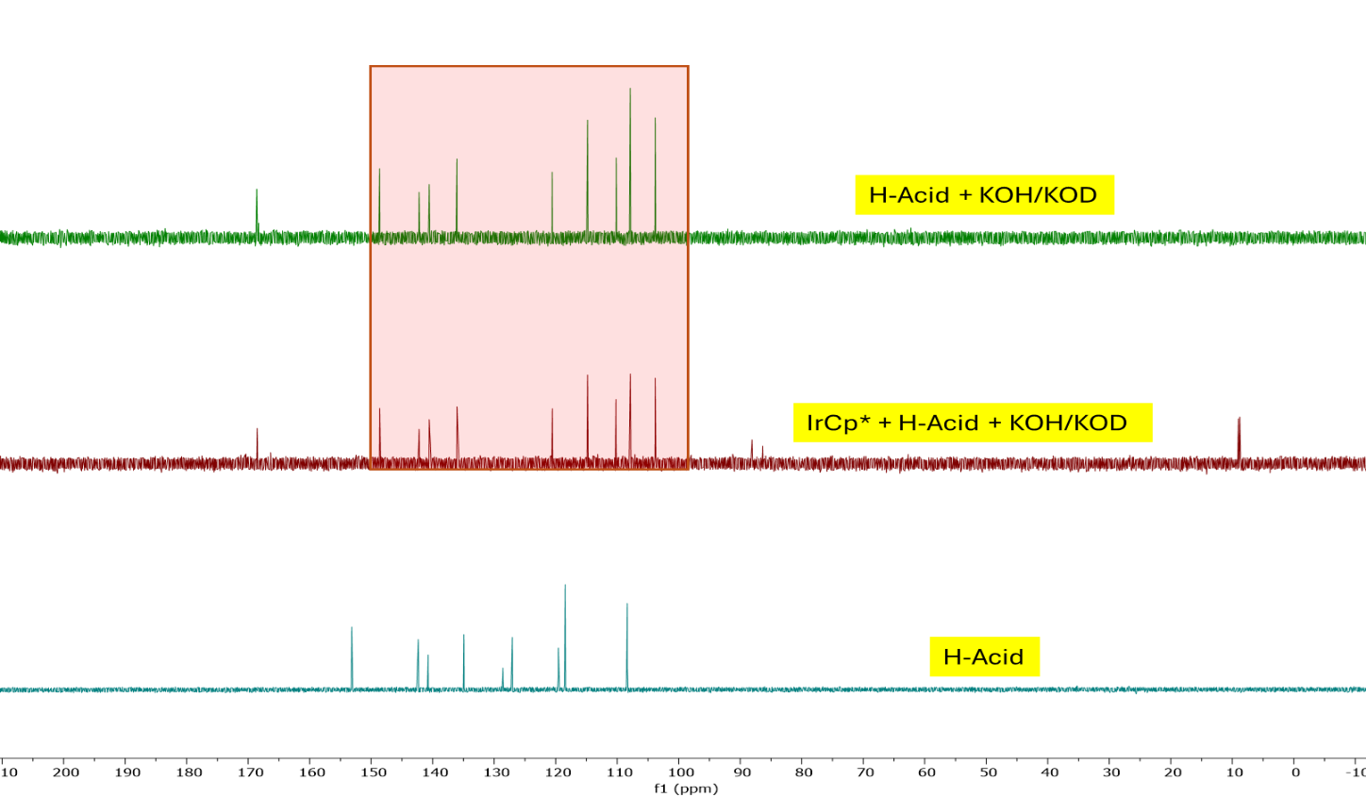

Figure S24. Stacked ¹³C{¹H} NMRs of H-Acid when treated with base (KOH/KOD) in D₂O.
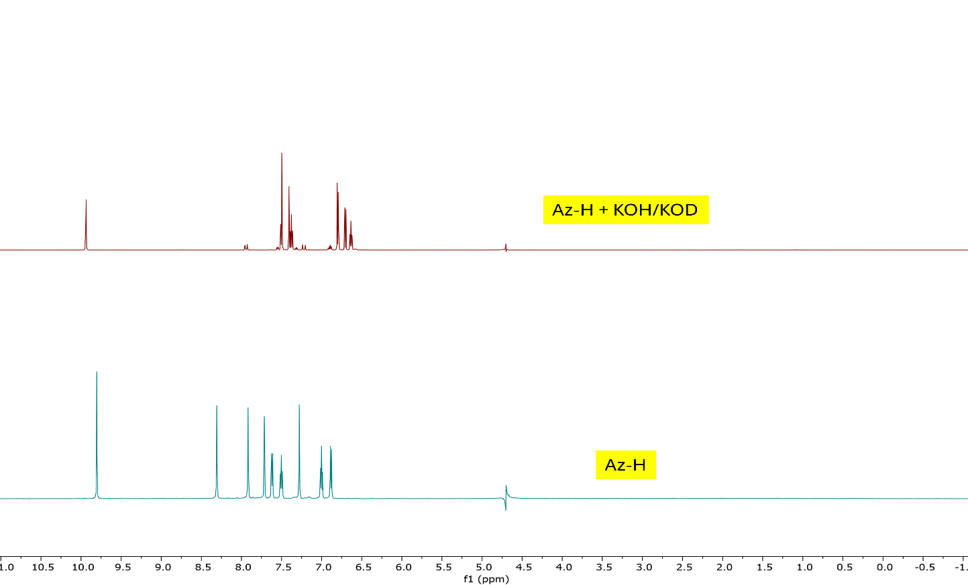
Figure S25. Stacked ¹H NMRs of Az-H when treated with base (KOH/KOD) in D₂O.

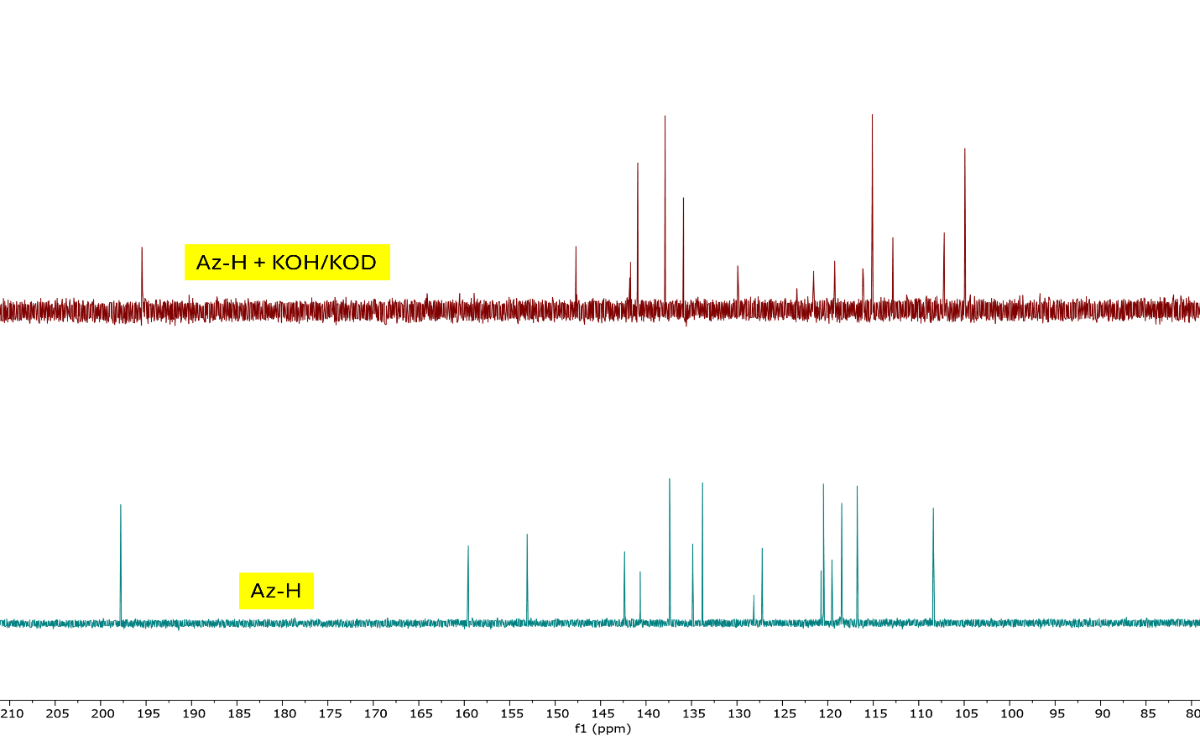

Figure S26. Stacked ¹³C{¹H} NMRs of Az-H when treated with base (KOH/KOD) in D₂O.

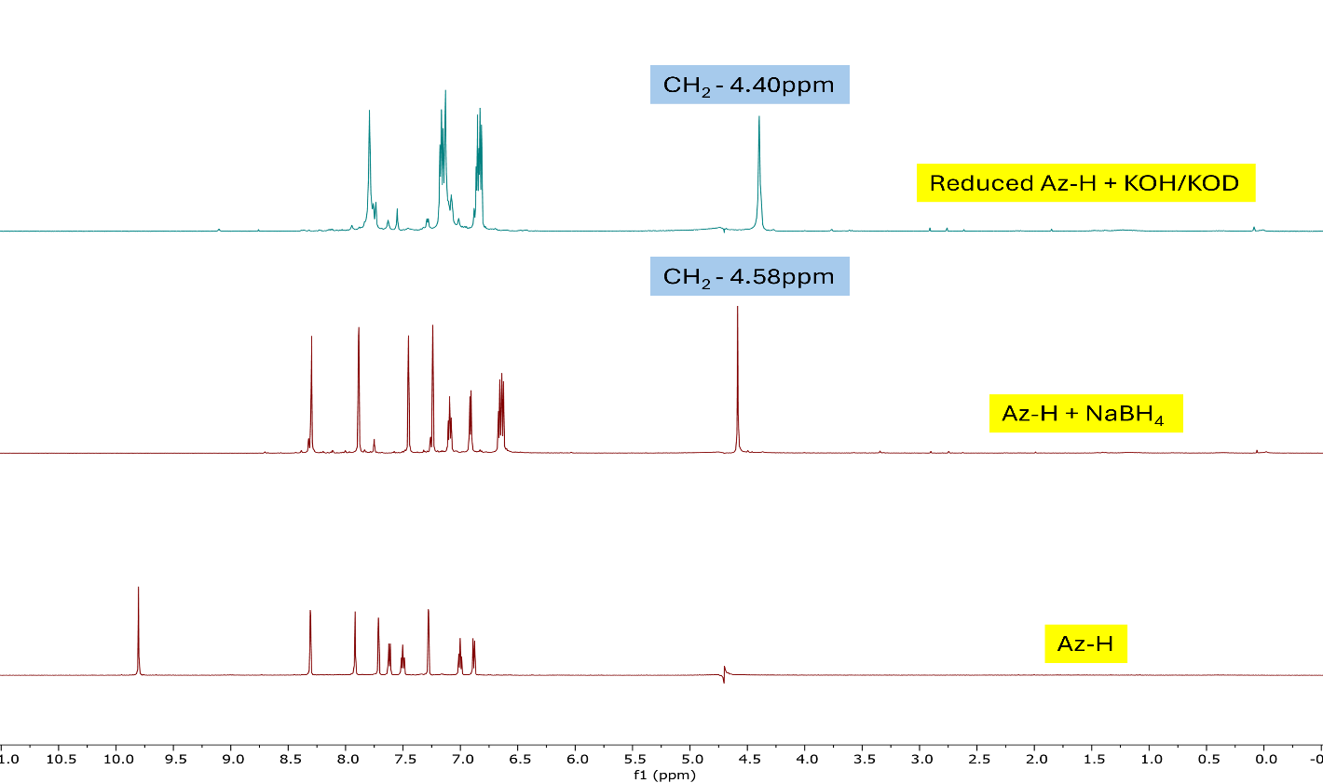

Figure S27. Stacked ¹H NMRs of reduced Az-H with NaBH₄ and its reaction with base.
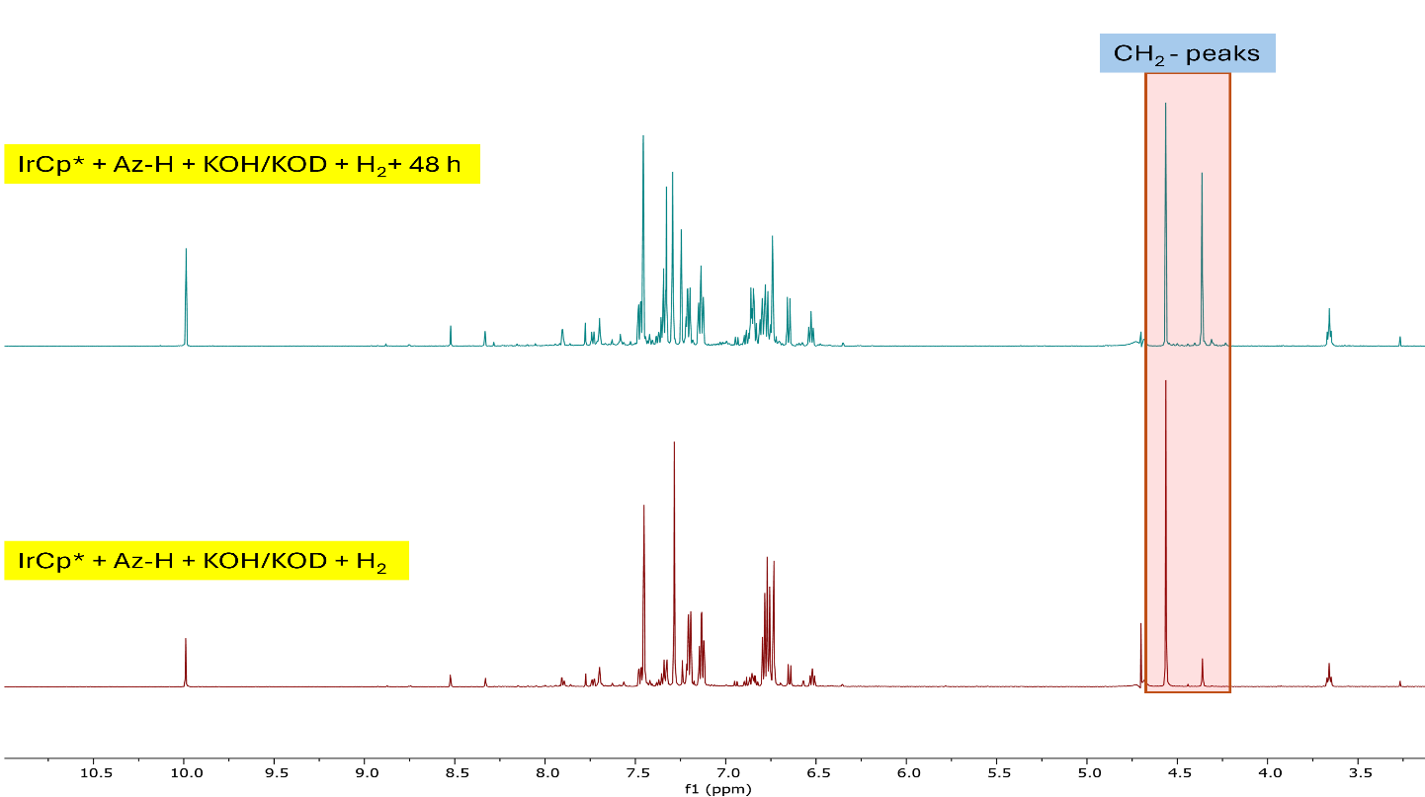

Figure S28. Reduction of imine when treated with H₂ in the presence of IrCp*.

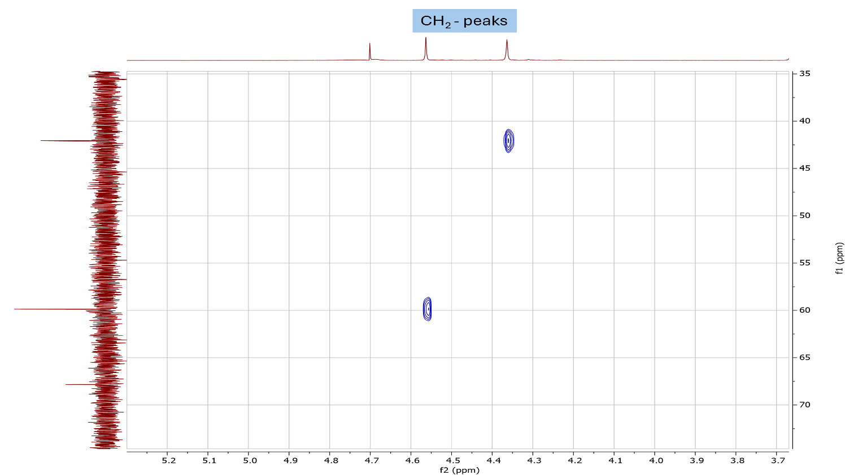
Figure S29. ¹H-¹³C HSQC NMR of the reduced Az-H when treated with H₂ in the presence of IrCp*.

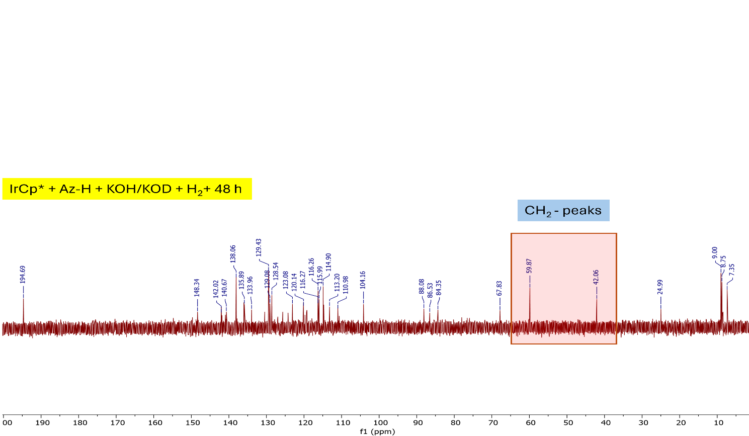
Figure S30. ¹³C{¹H} (151 MHz, D₂O, 22 ℃) NMR of the reduced Az-H when treated with H₂ in the presence of IrCp*.

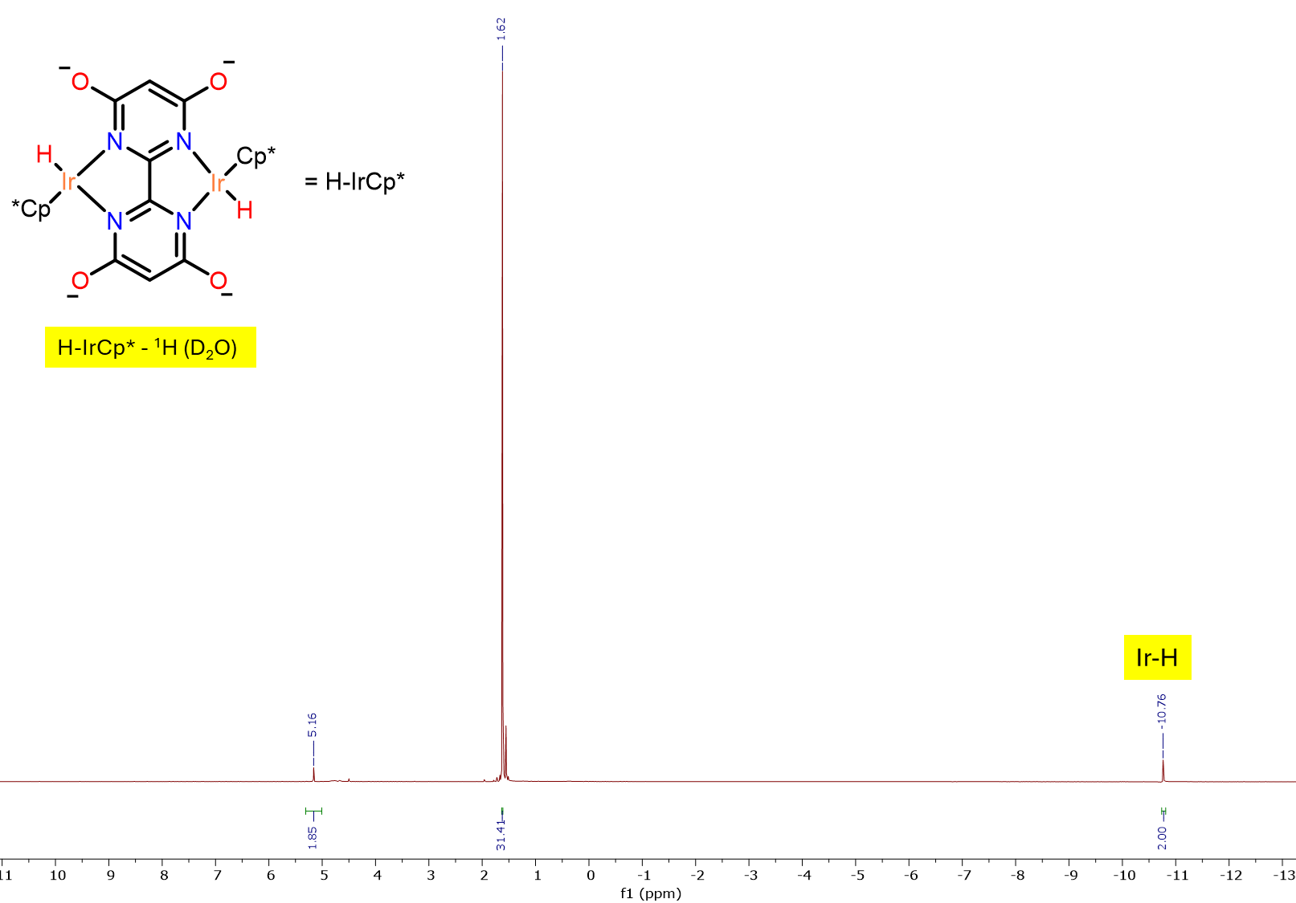

Figure S31. ¹H (600 MHz, D₂O, 22 ℃) NMR of H-IrCp*
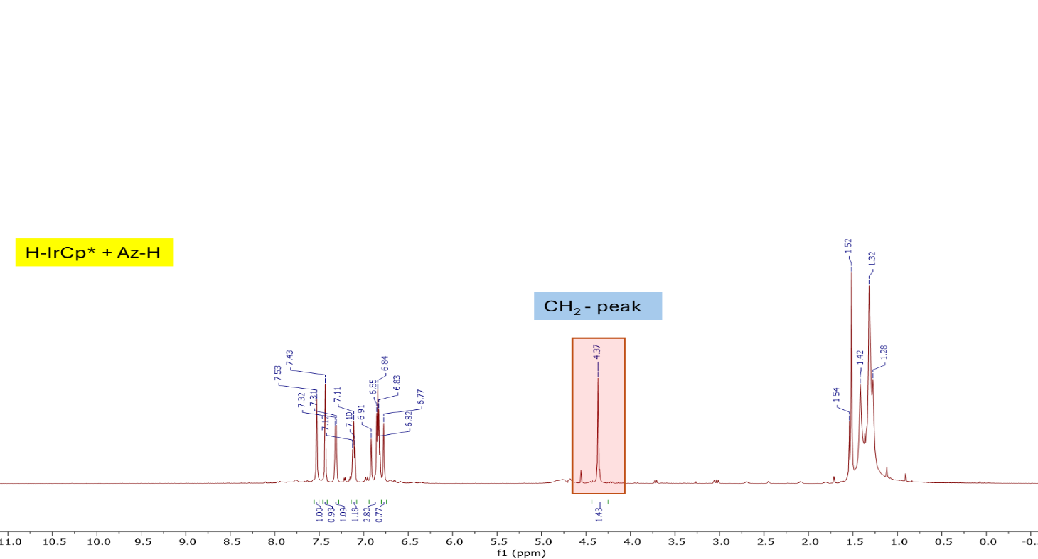

Figure S32. ¹H (600 MHz, D₂O, 22 ℃) NMR of Az-H when treated H-IrCp*

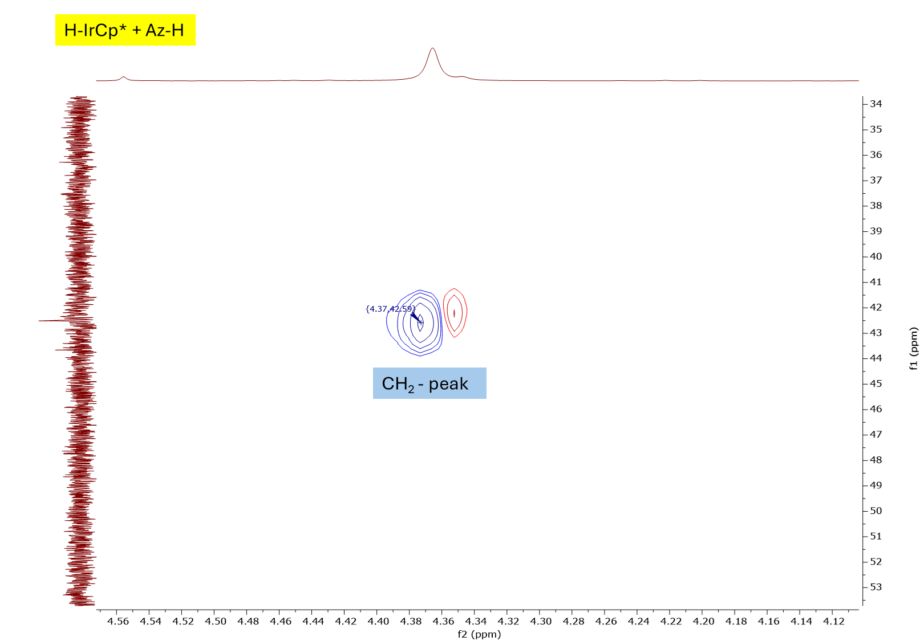

Figure S33. ¹H-¹³C HSQC NMR of Az-H when treated H-IrCp*

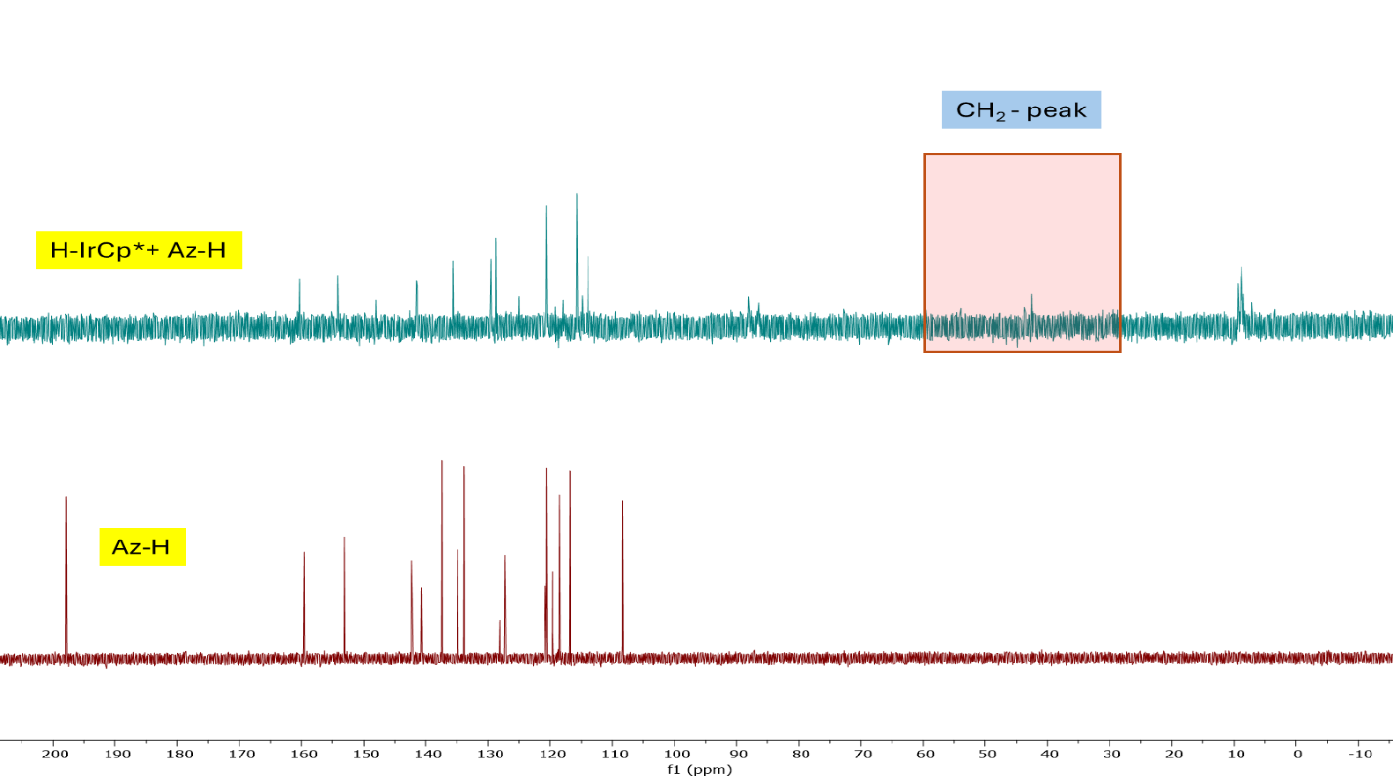

Figure S34. ¹³C{¹H} (151 MHz, D₂O, 22 ℃) NMR of Az-H when treated H-IrCp*.

4. NMR Spectroscopic Data Discussion:
Delving deeper into the mode of possible interaction between Az-H and IrCp*, an NMR investigation was carried out in D₂O. Since the starting materials are not readily soluble in D₂O, solvent suppression experiments (Figure S12) were devised and utilized to reduce the water signal and gather quality data. All reactions were performed in the presence of KOD/KOH to enable solubilization.
The aromatic proton and carbon atoms of H-Acid precisely overlap with those of Az-H (Figures S19 and S20). Notably, an aromatic proton at δ_{H} = 7.72 ppm undergoes ready H/D exchange in solution at ambient conditions (Figure S21); ¹³C NMR of H-Acid (Figure S22) reveals no significant shifts, confirming exchange. Initially, ¹H NMR spectroscopy suggested that both H-Acid and Az-H might coordinate to IrCp* under basic conditions (a change in chemical shift was noted). However, treatment of H-Acid and/or Az-H with KOH/KOD resulted in identical patterns (Figures S23 and S25), suggesting base sensitivity – this was later corroborated by ¹³C NMR (Figures S24 and S26). These findings conclusively demonstrate that both H-Acid and Az-H are susceptible to strong basic conditions, leading to the deprotonation of their sulfonic acid (SO₃H) functional groups, resulting in a change in NMR chemical shift.
When a solution of IrCp* and Az-H was treated with H₂ in the presence of a base (KOH/KOD), two distinct CH₂ signals emerged over time, confirmed by both ¹H and ¹³C NMR (Figures S28, S29, and S30). Additionally, when Az-H was independently reduced with NaBH₄ at room temperature (Figure S27), the imine peak at δ_{H} = 9.80 ppm completely disappeared, yielding a methylene (CH₂) peak at δ_{H} = 4.58 ppm. Under similarly basic conditions, a new compound formed, exhibiting a CH₂ signal slightly shifted to δ_{H} = 4.40 ppm. These experiments demonstrate that Az-H and its reduced form (and their chemical shifts) are base-sensitive.
To investigate the in-situ formation of Ir—H species, a control experiment was conducted where H—IrCp* was synthesized (Figure S31) by reacting IrCp* with H₂. The target compound was prepared in a J-Young NMR tube, yielding an iridium-hydride compound (δ_{H} = -10.8 ppm). Treatment of H—IrCp* with Az-H resulted in spontaneous imine reduction, resulting in a major product with a CH₂ peak at δ_{H} = 4.37 ppm (Figures S32 and S33). This CH₂ peak aligns with that generated previously, indicating the in-situ generation of Ir-hydride (from Ir—Cl and H₂) and subsequent reduction of the imine functional group. ¹³C NMR confirmed complete imine reduction of the signal at δ_{C} = 197.8 ppm. Notably, similar IrCp* compounds are known for the hydrogenation of imines.⁴
Together, these experiments show that:
- The NMR characteristics of all components are pH sensitive and require basic pH for dissolution (as has been implemented in the sensor);
- There is no direct interaction (or reaction) between IrCp* and Az-H under the conditions surveyed (consistent with controls in the absence of H₂);
- H—IrCp* (generated in-situ from IrCp* or in pure form) reacts with Az-H via imine reduction to yield a new CH₂-containing compound. While this chemical reactivity may not manifest in the noted enhanced fluorescence of Az-H, it nonetheless shows that H—IrCp* is competent for the reduction of Az-H-based unsaturated groups – groups that are likely generated during the photooxidation of Az-H e.g., naphthalene imine or carbonyl functions. We suggest reduction of these functional groups results in the observed sensing behaviour. This data is consistent with a sensor that requires all three components –Ir Cp*, Az-H, and H₂ to operate.

5. References:
- Rout, K. C., Chaturvedi, S. K., Khan, R. H. & Mondal, B. A copper (II) complex as selective turn-on fluorosensor for nitric oxide and its intracellular application. Inorg. Chim. Acta 437, 201–206 (2015).
- Ball, R. G., Graham, A. G., Heinekey, D. M., Hoyano, J. K., McMaster, A. D., Mattson, B. M. & Michel, S. T. Synthesis and structure of [ƞ-C₅Me₅)Ir(CO)]₂. Inorg. Chem. 29, 2023-2025 (1990).
- Hull, J. F., Himeda, Y., Wang, W-H., Hashiguchi, B., Periana, R., Szalda, D., Muckerman, J. T. & Fujita, E. Reversible hydrogen storage using CO₂ and a proton-switchable iridium catalyst in aqueous media under mild temperatures and pressures. Nat. Chem. 4, 383-388 (2012).
- Wang, R., Han, X., Xu, J., Liu, P. & Li, F. Transfer hydrogenation of ketones and imines with methanol under base-free conditions catalyzed by an anionic metal-ligand bifunctional iridium catalyst. J. Org. Chem. 85, 2242-2249 (2020).

