Supplementary Materials for
Precession driven low-latitude terrestrial precipitation paced by shifting perihelion
Hu Yang^{1*}, Xiaoxu Shi¹, Xulong Wang², Qingsong Liu³, Yi Zhong³, Xiaodong Liu², Youbin Sun², Yanjun Cai⁴, Fei Liu⁵, Gerrit Lohmann⁶, Martin Werner⁶, Zhimin Jian⁷, Tain˜a M. L. Pinho⁶, Hai Cheng⁴, Lijuan Lu^{5,1}, Jiping Liu^{5,1}, Chao-Yuan Yang¹, Qinghua Yang^{5,1}, Yongyun Hu⁸, Xing Cheng⁹, Jingyu Zhang³, Dake Chen¹
1. Southern Marine Science and Engineering Guangdong Laboratory (Zhuhai), Zhuhai, China
2. State Key Laboratory of Loess and Quaternary Geology, Institute of Earth Environment, Chinese Academy of Sciences, Xi’an, China
3. Centre for Marine Magnetism, Department of Ocean Science and Engineering, Southern University of Science and Technology, Shenzhen, China
4. Institute of Global Environmental Change, Xi’an Jiaotong University, Xi’an, China
5. School of Atmospheric Sciences, Sun Yat-sen University, Zhuhai, China
6. Alfred Wegener Institute, Helmholtz Centre for Polar and Marine Research, Bremerhaven, Germany
7. Laboratory of Marine Geology, Tongji University, Shanghai, China
8. Department of Atmospheric and Oceanic Sciences, School of Physics, Peking University

9. ShanXi Experimental Center of Geological Survey, ShanXi Institute of Geological Survey, Xi’an, China
Corresponding author: yanghu@sml-zhuhai.cn
The PDF file includes:
Methodology
Figs. S1 to S5
Other Supplementary Materials for this manuscript include the following:
Movies S1

Methodology
Model Simulations
We employ the AWI- Earth System Model^{14,15} (AWI-ESM) to investigate the mechanism of low-latitude hydrological cycle changes under precessional forcing. AWI-ESM is a coupled ocean-atmosphere model, that was developed by the Alfred Wegener Institute, Helmholtz Centre for Polar and Marine Research. It consists of the atmospheric component ECHAM6¹⁶ and the oceanic component FESOM^{17,18}. The oceanic component employs an unstructured mesh, with relatively high resolution (up to 25 km) at polar regions, coast areas, and the equator, while the atmospheric component has a spatial resolution of 1.875o. Detailed information on the model setup can also be found in Shi et al. (2016)¹⁹.
Using AWI-ESM, we perform a set of experiment to reconstruct the climate change within a precessional cycle. In these simulations, the obliquity is set to be 24.5º. Twenty-four sensitivity simulations were performed using different precessional phases, i.e., 0º, 15º, 30º, …345º. To allow the low-latitude climate to reach a quasi-equilibrium state to insolation forcing, we integrated the model for 300 years, and the last 100 years mean climate were used to represent the climate at the corresponding precession phase. This approach removes the natural climate variability, such as El Nino–Southern Oscillation.
All these 24 simulations are initialized from a pre-industrial simulation which had participated in the PMIP4 project. For all simulations, the greenhouse gas concentrations in the atmosphere, land-sea distribution and ice sheet configuration are fixed as the pre-industrial condition.
Natural climate variability is ubiquitous that sometimes conceals external forcing. To highlight the external precessional forcing in climate change, in all simulations, the eccentricity is set to a relatively high value (0.058). Consequently, this configuration exposes the Earth to 26% more solar radiation during perihelion than during aphelion. Additionally, we examine the climatology mean of the last 100 years model results. This further eliminates the contribution of natural variability on simulated climate changes.
Due to differences in the Earth's revolution speed, the length of four seasons varies depending on the precessional configurations. This leads the "calendar effect". In our results, we use the present-day calendar, with the spring equinox set at March 21. As a results, the dates of the summer solstice, autumnal equinox, and winter solstice can be changed a couple of days depending on the precessional phases. Since our analysis is based on monthly results, we do not make any additional corrections on these dates to keep consistency.
Speleothem Proxies
Speleothem δ¹⁸O records from China⁵, Malaysia⁶ and Brazil⁴ are used in this study. The record from China is composited by Cheng (2016) ⁵ based on several records from Sanbao (31º40' N, 110 º 26' E), Hulu (32 º 30' N, 119 º 10' E) and Dongge (25 º 17' N, 108 º 5' E) caves²⁰⁻²⁴. The Malaysia records were collected in different caves in Gunung Mulu National Park, Borneo, Malaysia (4 º N, 115 º E)^{6,25}. The Brazil record is collected from the Botuvera Cave (27 º 13' 24" S, 49 º 09' 20" W)⁴.
Method
The Empirical orthogonal functions (EOF) analysis is used to identify the spatial and temporal characteristics of terrestrial precipitation at low latitudes. EOF analysis is widely applied in Earth science. It is generally used to simplify a spatial-temporal data set by converting it into spatial patterns of variability and temporal evolution of these patterns. We applied EOF analysis on the monthly convective precipitation. For example, December precipitation in the 24 simulations is selected and applied a EOF analysis to generate Fig. 2a.
The latitude of the perihelion is introduced as the latitude of Sun's zenith point when perihelion occurs. This latitude also represents the latitude of maximum incoming solar radiation at the top of atmosphere. The insolation characteristics are calculated using MATLAB with aids from two tools, namely the "Orbital, the Box"²⁶ and the Earth Orbit Model v2.1²⁷. These tools were developed based on the theoretical framework presented in references^{28,29}.

Caption for Movie 1: Shifting season and latitude of perihelion due to precession of the Earth’s rotation axis. (A) Schematic view of perihelion. (B). Geometric perspective showing how precession of the Earth's rotation axis alters the latitude of perihelion. The yellow arrows illustrate the solar radiation. The black lines represent the Tropic of Cancer and Tropic of Capricorn, respectively. The pink line gives the latitude of perihelion which is the latitude of the Sun’s zenith point when perihelion occurs. (C). Evolution of seasonal solar radiation pattern within a precessional cycle. The color circle depicts the seasonal distribution of solar radiation, which is determined by the distance between the Sun and the Earth. The changing number at the top of subpanel give the precessional phase. The pink dot represents the position of perihelion. Wherever the perihelion takes places, the insolation at that latitude and season reaches its maximal value within a precessional cycle. (D). Changing latitude of perihelion in a precessional cycle. Within a precessional cycle, the latitude of perihelion moves from the Tropic of Capricorn to the Tropic of Cancer and back again, like the movement of Sun's zenith point within a year. In this movie, the eccentricity is set to 0.058 and the obliquity is fixed at 24.5º.

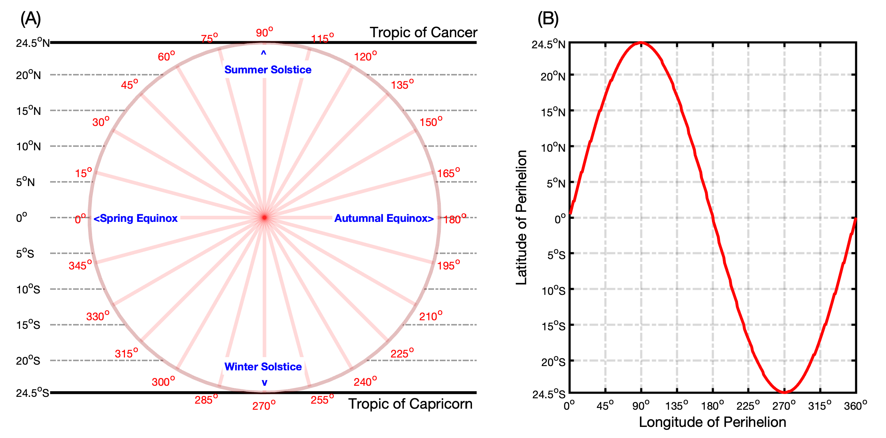
Fig. S1. The latitudinal movement of the perihelion and Sun's zenith point within a precessional cycle and an annual cycle, respectively. The labels outside the circle give the precessional phase, namely the longitude of the perihelion. The labels inside the circle locate the position of season. Within a year, the Sun's zenith point march between the Tropic of Cancer and the Tropic of Capricorn. Within a precessional cycle, the latitude of perihelion also migrates between the Tropic of Cancer and the Tropic of Capricorn. The grey dashed lines give the latitudinal coordinate. When the perihelion occurs, the insolation at the perihelion latitude reaches the maximum within a precessional cycle. To better understand this figure, please also check Supplementary Movie 1, which visually conveys an explanatory description of the seasonal solar radiation variations within a precessional cycle.

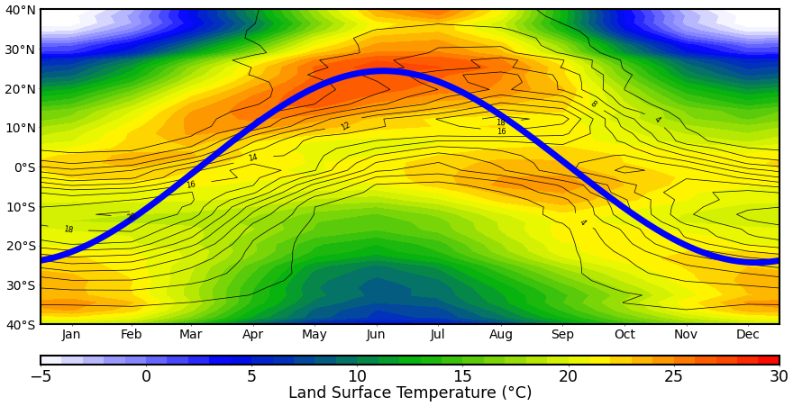
Fig. S2. Seasonal migration of the Sun's zenith point (thick blue line), land thermal equator (shading color) and precipitation over land (black contours). Shading colors represent zonal mean land surface temperature. Contours show the zonal mean precipitation on land (unit: mm/day). The seasonal movement of the Sun's zenith point fundamentally determines the position of the Earth's thermal equator, where deep convection and low-latitude precipitation takes place. Due to the thermal inertia of Earth, the thermal equator and terrestrial precipitation do not precisely coincide with the timing of maximal solar radiation, i.e., the Sun’s zenith point, but rather experience a delay of approximately 1-2 months. Results are based on the ensemble mean of the 24 simulations with different precessional phases (see Methodology).
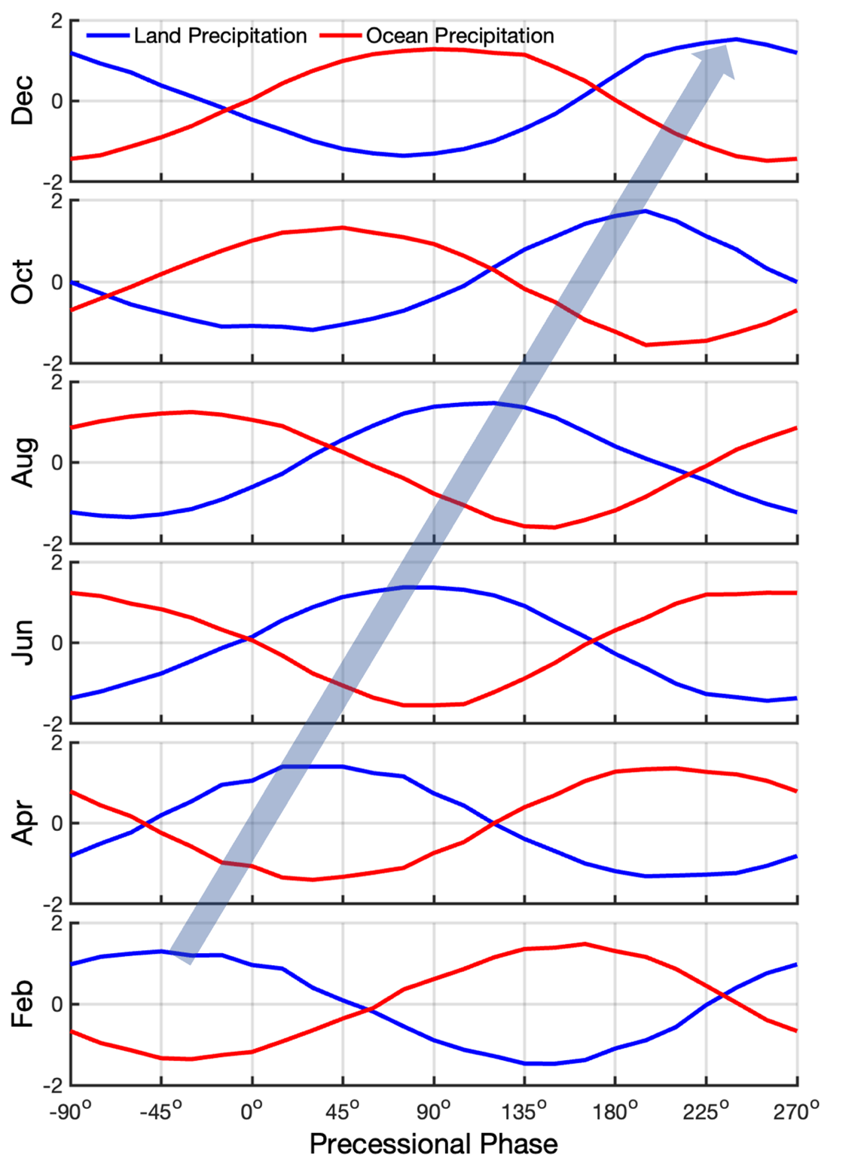
Fig. S3. Tropical convective precipitation over land (blue lines) and ocean (red lines), respectively. These precipitations are shown as standardized total amount of convective precipitation over tropical area (30ºS-30ºN). Enhances terrestrial precipitation around perihelion correspond to decrease precipitation over ocean. Due to seasonal shifting perihelion (blue arrow), the seasonal terrestrial precipitation maxima are achieved at different precessional phases. Results based on 24 AWI-ESM time-slice simulations recovering a precessional cycle (see Materials and Methods).
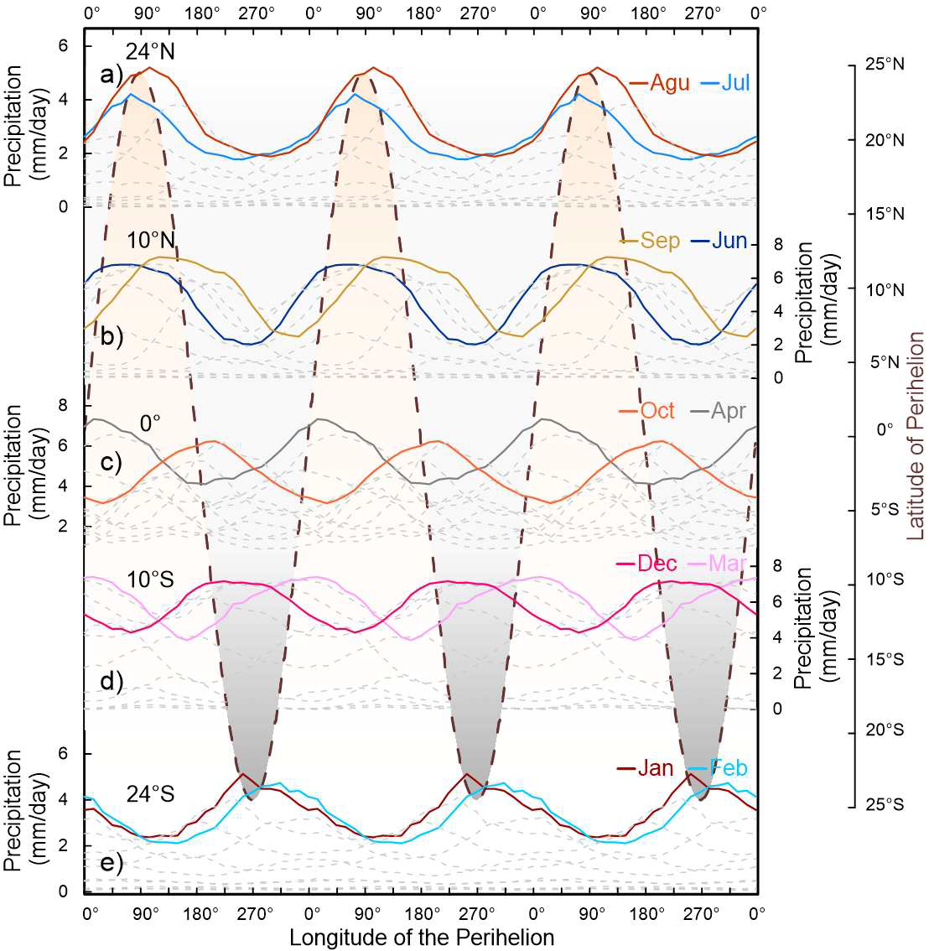
Fig. S4. The simulated evolution of monthly precipitation at different latitudinal bands over three precessional cycles. The precipitation is calculated as zonal mean land precipitation over latitudinal bands covering a width of five degrees. For each latitudinal band, the rainy seasons are highlighted with colored lines, and precipitation in other months is shown as grey dashed lines. The dashed copper line illustrates the meridional movement of Earth's perihelion between the Tropic of Cancer and the Tropic of Capricorn, namely the latitude of perihelion. Whenever (the season) and wherever (the latitude) perihelion occurs, the local land precipitation in the corresponding month reaches its maximum within a precessional cycle.
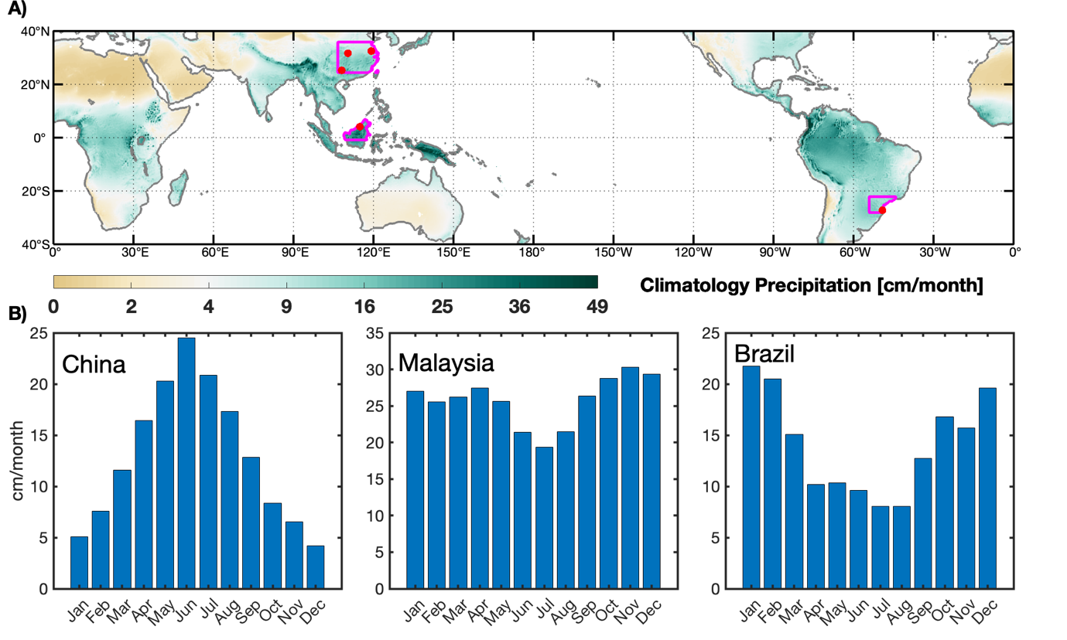
Fig. S5. A: The locations (red dots) of speleothem records used in this study. The background shading shows the climatology annual mean precipitation. B: The seasonal distribution of precipitation in the selected regions (pink lines in subpanel A). Around East China, the dominant rainy season is boreal summer; Around Brazil, it is boreal winter. Near Malaysia, there are two rainy seasons, i.e., boreal spring and autumn. Results based on ECMWF Reanalysis v5 (ERA5) reanalysis dataset³⁰ covering 1940-2022.
References
14. Sidorenko D, Rackow T, Jung T et al. Towards multi- resolution global climate modeling with ECHAM6–FESOm. part I: model formulation and mean climate. Climate Dynamics 2015; 44: 757–780.
15. Sidorenko D, Goessling H, Koldunov N et al. Evaluation of FESOM2. 0 coupled to ECHAM6. 3: preindustrial and HighResMIP simulations. Journal of Advances in Modeling Earth Systems 2019; 11: 3794–3815.
16. Giorgetta MA, Roeckner E, Mauritsen T et al. The atmospheric general circulation model ECHAM6-model description 2013.
17. Wang Q, Danilov S, Sidorenko D et al. he Finite Element Sea Ice-Ocean Model (FESOM) v. 1.4: formulation of an ocean general circulation model. Geoscientific Model Development 2014; 7: 663–693.
18. Danilov S, Sidorenko D, Wang Q et al. The finite-volume sea ice–ocean model (FESOM2). Geoscientific Model Development 2017; 10: 765–789.
19. Shi X and Lohmann G. Simulated response of the mid-Holocene Atlantic Meridional Overturning Circulation in ECHAM6-FESOM/MPIOM. Journal of Geophysical Research: Oceans 2016; 121: 6444–6469.
20. Wang YJ, Cheng H, Edwards RL et al. A high-resolution absolute-dated late pleistocene monsoon record from Hulu Cave, China. Science 2001; 294: 2345–2348.
21. Dykoski CA, Edwards RL, Cheng H et al. A high-resolution, absolute-dated Holocene and deglacial Asian monsoon record from Dongge Cave, China. Earth and Planetary Science Letters 2005; 233: 71–86.
22. Kelly MJ, Edwards RL, Cheng H et al. High-resolution characterization of the Asian monsoon between 146,000 and 99,000 years BP from Dongge cave, China and global correlation of events surrounding termination II. Palaeogeography, Palaeoclimatology, Palaeoecology 2006; 236: 20–38.
23. Wang Y, Cheng H, Edwards RL et al. Millennial-and orbital-scale changes in the East Asian monsoon over the past 224,000 years. Nature 2008; 451: 1090–1093.
24. Cheng H, Edwards RL, Broecker WS et al. Ice age Terminations. Science 2009; 326: 248–252.
25. Carolin SA, Cobb KM, Adkins JF et al. Varied response of western pacific hydrology to climate forcings over the last glacial period. Science 2013; 340: 1564–1566.
26. Lougheed BC. Orbital, the box-an interactive educational tool for in-depth understanding of astronomical climate forcing. 2021.
27. Kostadinov T and Gilb R. Earth orbit v2. 1: a 3-d visualization and analysis model of Earth’s orbit, Milankovitch cycles and insolation. Geoscientific Model Development 2014; 7: 1051–1068.
28. Laskar J. The chaotic motion of the solar system: A numerical estimate of the size of the chaotic zones. Icarus 1990; 88: 266–291.
29. Laskar J, Joutel F and Boudin F. Orbital, Precessional, and insolation quantities for the earth from-20 myr to+ 10 myr. Astronomy and Astrophysics (ISSN 0004-6361), vol. 270, no. 1-2, p. 522-533. 1993; 270: 522–533.
30. Hersbach, H., Bell, B., Berrisford, P., Horányi, A., Sabater, J. M., Nicolas, J., Radu, R., Schepers, D., Simmons, A., Soci, C., & Dee, D. (2019). Global reanalysis: goodbye ERA-Interim, hello ERA5. ECMWF Newsl, 159, 17–24.

