Supplementary Materials
Sex-specific Concordance of Striatal Transcriptional Signatures of Opioid Addiction in Human and Rodent Brains

Micah A. Shelton¹, Nicole Horan^{1,2}, Xiangning Xue³, Lisa Maturin⁴, Darrell Eacret⁵, Julie Michaud⁶, Navsharan Singh⁷, Benjamin R. Williams⁸, Mackenzie C. Gamble^{7,8}, Joseph A. Seggio⁶, Madeline Kuppe-Fish⁸, BaDoi N. Phan⁹, George C. Tseng³, Julie A. Blendy⁵, Leah C Solberg Woods¹⁰, Abraham A. Palmer⁴, Olivier George⁴, Marianne L. Seney^{1,2}*, Ryan W. Logan^{8,11}*

¹Department of Psychiatry, University of Pittsburgh School of Medicine, Pittsburgh, PA, USA
²Center for Neuroscience at University of Pittsburgh, Pittsburgh, PA, USA
³Department of Biostatistics, University of Pittsburgh, Pittsburgh, PA, USA
⁴Department of Psychiatry, University of California, San Diego, La Jolla, CA, USA
⁵Department of Systems Pharmacology and Translational Therapeutics, Perelman School of Medicine, University of Pennsylvania, Philadelphia, PA, USA
⁶Department of Biology, Bridgewater State University, Bridgewater, MA, USA
⁷Department of Pharmacology, Physiology & Biophysics, Boston University School of Medicine, Boston, MA, USA
⁸Department of Psychiatry, University of Massachusetts Chan Medical School, Worcester, MA, USA
⁹Medical Scientist Training Program, University of Pittsburgh School of Medicine, Pittsburgh, PA, 15213, USA
¹⁰Department of Internal Medicine, Section on Molecular Medicine, Wake Forest University School of Medicine, Winston-Salem, NC, USA
¹¹Department of Neurobiology, University of Massachusetts Chan Medical School, Worcester, MA, USA

*Co-Corresponding Authors:
Marianne L. Seney, PhD
450 Technology Drive
Pittsburgh, PA 15219

Ryan W. Logan, PhD
366 Plantation Street
New Education and Research Building
Worcester, MA 01605

Supplementary Methods

Mouse Study
Male and female C57BL/6NTac mice (6–8 weeks of age, 20–30 g) obtained from Taconic Farms (Hudson, NY) were group housed in open cages with a filter top, maintained on a 12-h light/dark cycle (lights on at 0600h and off at 1800h). Food and water were available ad libitum in accordance with the University of Pennsylvania Animal Care and Use Committee. Males and females were split within each experimental group (n=7-9 per group).
NIDA Drug Supply (Research Triangle Park, NC) supplied the morphine sulfate that was used for the mouse experiments. Morphine was ingested via a forced drinking paradigm, as described previously (1, 2). Briefly, morphine at a 0.5mg/mL concentration was dissolved in 0.2% saccharin to mask the bitter taste. Drinking volume and body weights were assessed every 2-3 days. Mice drink approximately 5mL of morphine solution per day, which equates to roughly 100mg morphine per mouse per day. This exposure resulted in dependence as defined by the presence of somatic withdrawal upon removal of drug (2-4). The control group received 0.2% saccharin solution through their drinking water. The “intoxication” group was maintained on a forced drinking paradigm for 11 days. The “withdrawal” group underwent forced drinking for 11 days, and morphine was replaced with 0.2% saccharin on day 12. The “abstinence” group received morphine for 11 days and were switched to 0.2% saccharin without morphine for 2 weeks. The start of the experiment was staggered for each group so that all animals were euthanized between 1200 and 1400hrs on the same day.
Tissue collection: Mice were cervically dislocated, rapidly decapitated, and brains removed immediately. Brains were placed in a cold tissue matrix and 200μm coronal brain sections were used to collect bilateral 1.2 mm punches of the NAc. Punches were flash frozen in liquid nitrogen and stored at -80C. Samples were shipped on dry ice to Boston University for sequencing analysis.

Rat Study
Heterogeneous Stock rats (Rat Genome Database NMcwiWFsm #13673907) created to encompass high genetic diversity by outbreeding eight inbred rat strains (ACI/N, BN/SsN, BUF/N, F344/N, M520/N, MR/N, WKY/N and WN/N) were provided by Dr. Leah Solberg Woods (n = 539). Rats were shipped at 3-4 weeks of age, kept in quarantine for 2 weeks, then housed two per cage on a 12-h light/dark cycle (lights on at 0700h and off at 1900h) in a temperature (20-22°C) and humidity (45-55%) controlled vivarium with ad libitum access to tap water and food pellets (PJ Noyes Company, Lancaster, NH, USA). All the procedures were conducted in strict adherence to the National Institutes of Health Guide for the Care and Use of Laboratory Animals and were approved by the Institutional Animal Care and Use Committees of The Scripps Research Institute and UC San Diego.
Oxycodone (National Institute on Drug Abuse, Bethesda, MD) was dissolved in 0.9% sterile saline and administered intravenously at a dose of 150 ug/kg/infusion. The dose of oxycodone was selected based on previous studies (5-7), also because these doses produce clinically-relevant plasma oxycodone levels (40 ng/ml; (8)).
Intravenous Catheterization
Rats were anesthetized with vaporized isoflurane (1-5%). Intravenous catheters were aseptically inserted into the right jugular vein (5). Catheters consisted of Micro-Renathane tubing (18 cm, 0.023-inch inner diameter, 0.037-inch outer diameter; Braintree Scientific, Braintree, MA, USA) attached to a 90-degree angle bend guide cannula (Plastics One, Roanoke, VA, USA), embedded in dental acrylic, and anchored with mesh (1 mm thick, 2 cm diameter). Tubing was inserted into the vein following a needle puncture (22G) and secured with a suture. The guide cannula was punctured through a small incision on the back. The outside part of the cannula was closed off with a plastic seal and metal cover cap, which allowed for sterility and protection of the catheter base. Flunixin (2.5 mg/kg, s.c.) was administered as analgesic, and Cefazolin (330 mg/kg, i.m.) as antibiotic. Rats were allowed seven days for recovery before any self-administration. They were monitored and flushed daily with heparinized saline (10 U/ml of heparin sodium; American Pharmaceutical Partners, Schaumberg, IL, USA) in 0.9% bacteriostatic sodium chloride (Hospira, Lake Forest, IL, USA) that contained 52.4 mg/0.2 ml of Cefazolin.
Operant self-administration
Self-administration was performed in operant conditioning chambers (29 cm × 24 cm × 19.5 cm; Med Associates, St. Albans, VT, USA) that were enclosed in lit, sound-attenuating, ventilated environmental cubicles. The front door and back wall of the chambers were constructed of transparent plastic, and the other walls were opaque metal. Each chamber was equipped with two retractable levers that were located on the front panel. Each session was initiated by the extension of two retractable levers into the chamber. Drugs (oxycodone, 150 ug/kg/infusion in saline) were delivered through plastic catheter tubing that was connected to an infusion pump. The infusion pump was activated by responses on the right (active) lever that were reinforced on fixed ratio (FR) 1 schedule, with the delivery of 0.1 ml of the drug per lever press over 6 s followed by a 20-s timeout period that was signaled by the illumination of a cue light above the active lever and during which active lever presses did not result in additional infusions. Responses on the left inactive lever were recorded but had no scheduled consequences. Fluid delivery and behavioral data recording was controlled by a computer with the MED-PC IV software installed. Initially, rats were trained to self-administer oxycodone in 4 short access (ShA) sessions (2h/day). At the end of the ShA phase the animals were exposed to 14 extended access sessions (LgA, 12 h/day, 5 days/week Monday–Friday) to measure escalation of drug intake. Self-administration sessions started at the beginning of the dark phase of the light/dark cycle. The animals had access to food during the 12-h sessions. A fresh block of wood (3×3×3cm) was placed daily in the self-administration boxes.

Supplementary Results

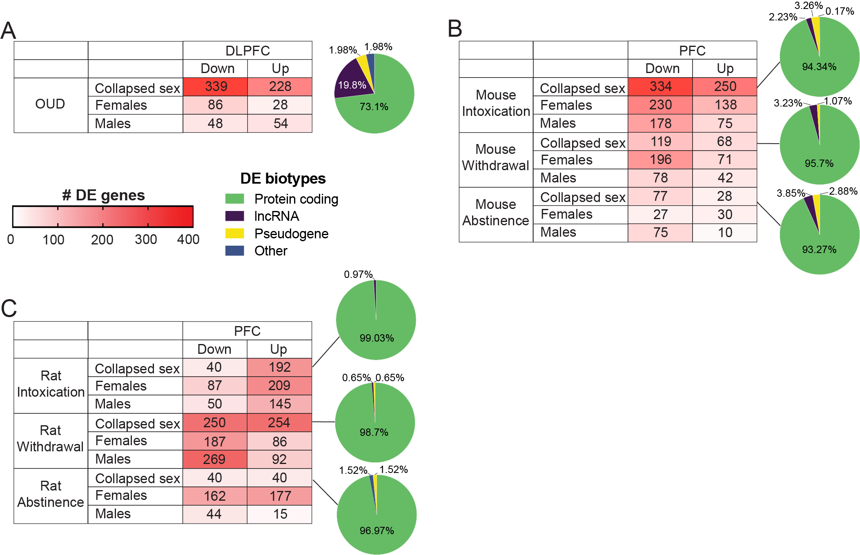
Supplementary Fig. 1. Transcriptomic changes in the PFC from human subjects with OUD and two rodent models of opioid dependence. (A) Down and up-regulated transcripts in Human subjects with OUD with both sexes combined (top row) and then for each sex individually. Increasing number of DE genes (corrected p<0.01 and log2fold change ≤ -0.26 or ≥ 0.26) indicated by saturation of color. Pie chart shows biotypes of DE transcripts in the NAc. While most DE transcripts were protein coding, lncRNAs were overrepresented in the human DLPFC as compared to NAc. (B) Down and up-regulated transcripts in mouse PFC across three stages opioid exposure. (C) Down and up-regulated transcripts in rat PFC across three stages of opioid exposure. DE, differentially expressed; DLPFC, dorsolateral prefrontal cortex; lncRNA, long noncoding RNA; OUD, opioid use disorder; PFC, prefrontal cortex.

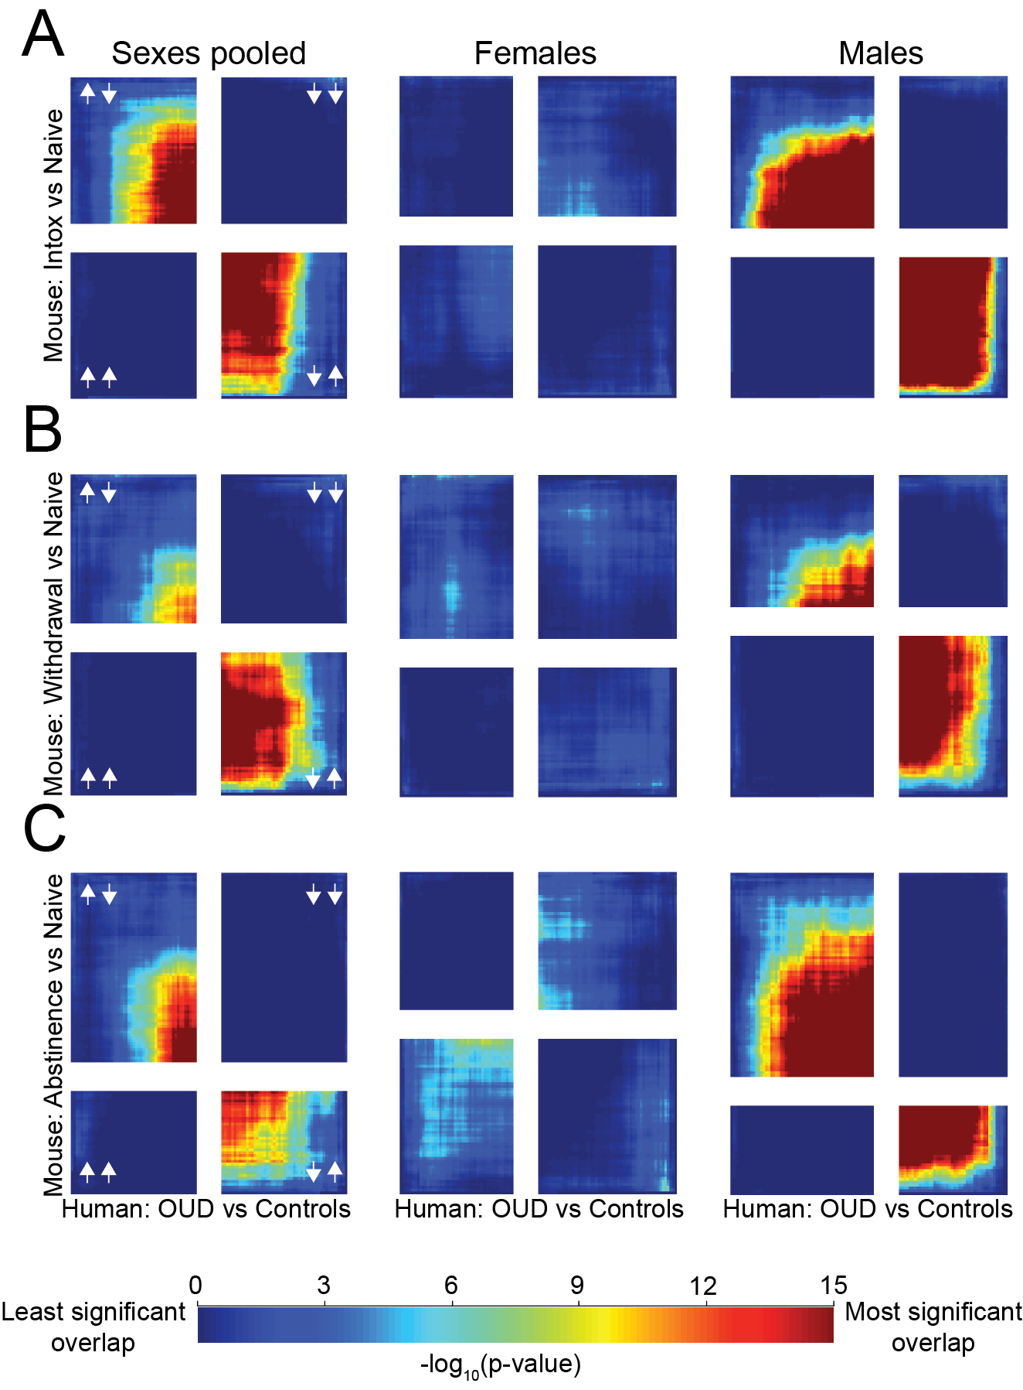
Supplementary Fig. 2 Transcriptional changes in PFC from human OUD are discordant with mouse self-administration models. RRHO2 analysis was used to assess threshold-free overlap in gene expression between humans in our OUD cohort and mice that self-administered opioids. (A) RRHO plots showing concordant gene expression between human OUD subjects pooled by sex (left column), human female OUD (center column), and human male OUD (right column) and mice intoxicated ATOD. Increasing color warmth indicate increasing -log10 p-value. (B) RRHO plots showing concordant gene expression between human OUD subjects pooled by sex (left column), human female OUD (center column), and human male OUD (right column) and mice in acute withdrawal ATOD. (C) RRHO plots showing concordant gene expression between human OUD subjects pooled by sex (left column), human female OUD (center column), and human male OUD (right column) and mice abstinent ATOD. ATOD, at time of death; OUD, opioid use disorder; PFC, prefrontal cortex; RRHO, rank-rank hypergeometric overlap.
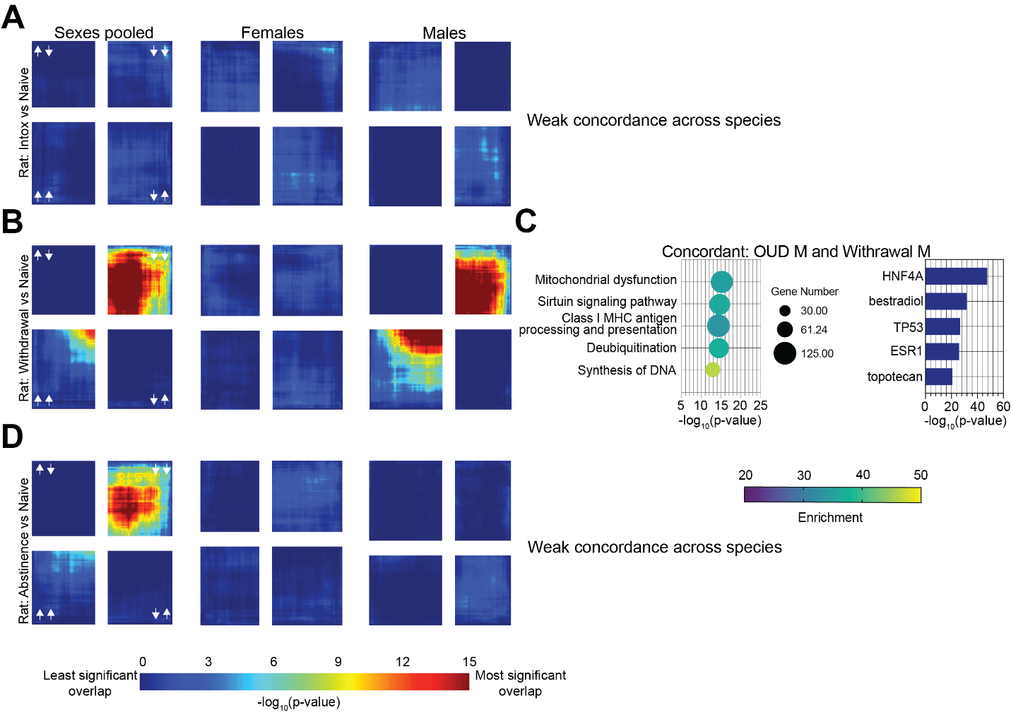
Supplementary Fig. 3 Transcriptional changes in PFC from human OUD are weakly concordant with rat self-administration models. RRHO2 analysis was used to assess threshold-free overlap in gene expression between humans in our OUD cohort and rats that self-administered opioids. (A) RRHO plots showing concordant gene expression between human OUD subjects pooled by sex (left column), human female OUD (center column), and human male OUD (right column) and rats intoxicated ATOD. Increasing color warmth indicates increasing -log10 p-value. (B) RRHO plots showing concordant gene expression between human OUD subjects pooled by sex (left column), human female OUD (center column), and human male OUD (right column) and rats in acute withdrawal ATOD. (C) Pathway enrichment analysis of transcripts concordant between OUD males and male rats in acute withdrawal ATOD (left). Circle size corresponds to gene number and increasing color warmth indicates enrichment of -log10 p-value. Bar graph displays potential identified upstream regulators with -log10 p-value on the x axis (right). (D) RRHO plots showing concordant gene expression between human OUD subjects pooled by sex (left column), human female OUD (center column), and human male OUD (right column) and rats abstinent ATOD. ATOD, at time of death; OUD, opioid use disorder; PFC, prefrontal cortex; RRHO, rank-rank hypergeometric overlap.

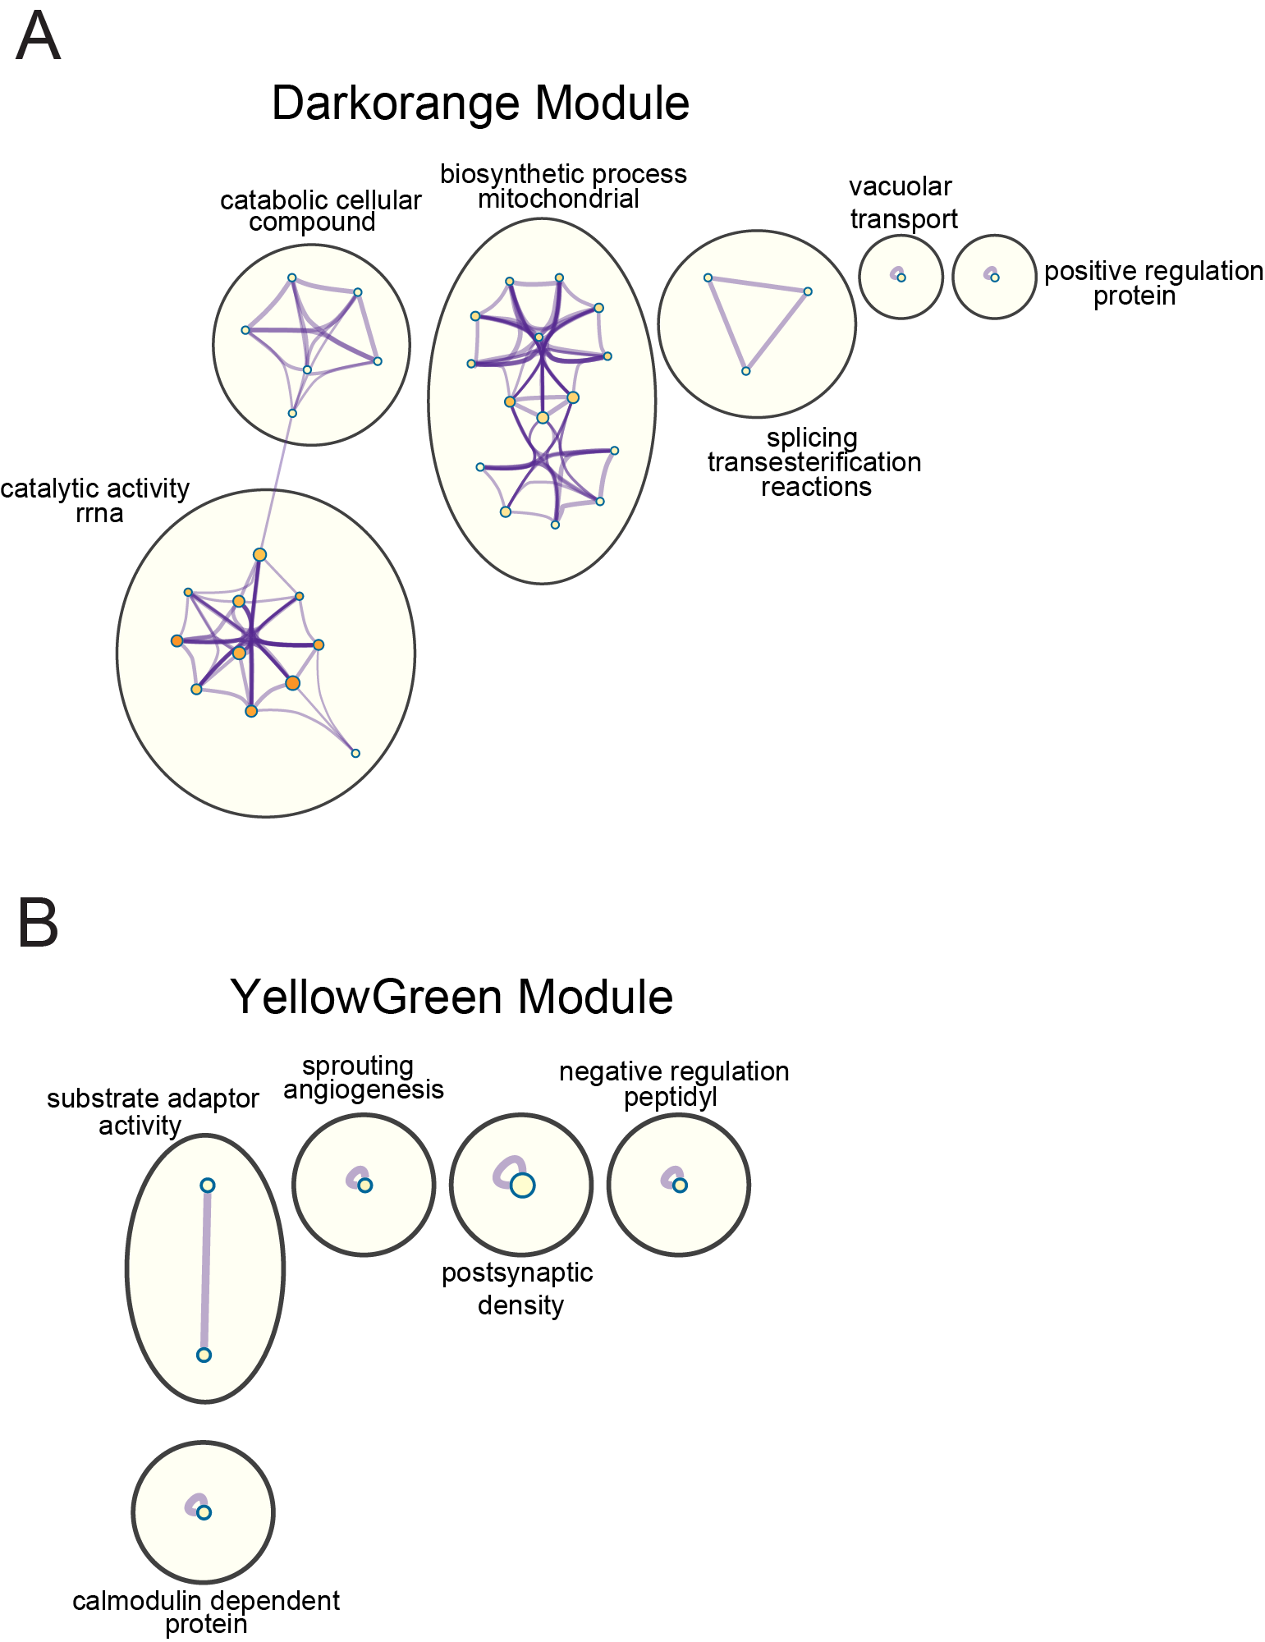

Supplementary Fig. 4 OUD-associated gene networks in the NAc. Network visualization generated using Cytoscape with categorical labels for multiple clusters for two modules with strong enrichment of De transcripts across all human OUD subject groups. The Darkorange module contained clusters involved in cellular metabolism (top) while the YellowGreen module contained several small clusters (bottom).

1. Eacret D, Manduchi E, Noreck J, Tyner E, Fenik P, Dunn AD, et al. Mu-opioid receptor-expressing neurons in the paraventricular thalamus modulate chronic morphine-induced wake alterations. Transl Psychiatry. 2023;13(1):78. doi:10.1038/s41398-023-02382-w
2. Eacret D, Noreck J, Blendy JA. Adenosine Monophosphate-activated Protein Kinase (AMPK) in serotonin neurons mediates select behaviors during protracted withdrawal from morphine in mice. Behav Brain Res. 2022;419:113688. doi:10.1016/j.bbr.2021.113688
3. Maldonado R, Blendy JA, Tzavara E, Gass P, Roques BP, Hanoune J, et al. Reduction of morphine abstinence in mice with a mutation in the gene encoding CREB. Science. 1996;273(5275):657-9. doi:10.1126/science.273.5275.657
4. Walters CL, Blendy JA. Different requirements for cAMP response element binding protein in positive and negative reinforcing properties of drugs of abuse. J Neurosci. 2001;21(23):9438-44. doi:10.1523/jneurosci.21-23-09438.2001
5. Kallupi M, Carrette LLG, Kononoff J, Solberg Woods LC, Palmer AA, Schweitzer P, et al. Nociceptin attenuates the escalation of oxycodone self-administration by normalizing CeA-GABA transmission in highly addicted rats. Proc Natl Acad Sci U S A. 2020;117(4):2140-8. doi:10.1073/pnas.1915143117
6. Kimbrough A, Kononoff J, Simpson S, Kallupi M, Sedighim S, Palomino K, et al. Oxycodone self-administration and withdrawal behaviors in male and female Wistar rats. Psychopharmacology (Berl). 2020;237(5):1545-55. doi:10.1007/s00213-020-05479-y
7. Wade CL, Kallupi M, Hernandez DO, Breysse E, de Guglielmo G, Crawford E, et al. High-Frequency Stimulation of the Subthalamic Nucleus Blocks Compulsive-Like Re-Escalation of Heroin Taking in Rats. Neuropsychopharmacology. 2017;42(9):1850-9. doi:10.1038/npp.2016.270
8. Mavrikaki M, Pravetoni M, Page S, Potter D, Chartoff E. Oxycodone self-administration in male and female rats. Psychopharmacology (Berl). 2017;234(6):977-87. doi:10.1007/s00213-017-4536-6

