SUPPLEMENTAL INFORMATION

Table S1. Strains used in this study
Strain | Genotype | Reference
NCIB 3610 | Marburg undomesticated strain | ⁵²
HB19118 | B. velezensis 118 | This study
HB19121 | 118 sigM::mls | This study
HB19122 | 118 sigX::mls | This study
HB19123 | 118 sigV::kan | This study
HB19124 | 118 sigW::cat | This study
HB19125 | 118 ylaC::cat | This study
HB19140 | 168 sigX::erm | BKE strain -> 168
HB19440 | NCIB 3610 sigX::erm | This study
pPL82 | Expression of gene under Pspac(hy) promoter | ⁴⁸
HB19488 | NCIB 3610 sigX::erm Pspac sigX | This study
HB18926 | 168 amyE::Pspx-GFP (cm) | ⁵³
HB19472 | NCIB 3610 amyE::Pspx-GFP (cm) | This study
CB19506 | NCIB 3610 sigX::erm amyE::Pspx-GFP (cm) | This study

Table S2. Oligonucleotides used in this study
No. | Name | Sequence
6524 | sigM-up-fwd | TTTATATGCGGCCGGAACGA
6525 | sigM-up-rev(mls) | GAGGGTTGCCAGAGTTAAAGGATCTTGCACGTTCCAT GCAAACG
6526 | sigM-do-fwd(mls) | CGATTATGTCTTTTGCGCAGTCGGCAATGGAGAAATGAGCGACCG
6527 | sigM-do-rev | AAGGGTAGGCCCTGTCATAA
6528 | sigX-up-fwd | CCAGAATGGAATCCGG ACAT
6529 | sigX-up-rev(mls) | GAGGGTTGCCAGAGTTAAAGGATCCTCCGTTCACTTTTTTGTCG
6530 | sigX-do-fwd(mls) | CGATTATGTCTTTTGCGCAGTCGGCCGAGGCCATTTACCGGAATA
6531 | sigX-do-rev | GATACTCTTGTCCCAGACTG
6532 | sigW-up-fwd | AACTTTTGTCAGCTCGACGC
6596 | sigW-up-rev(cat) | CTTGATAATAAGGGTAACTATTGCCCCCTTCACCGGTCTGTATCT
6597 | sigW-do-fwd(cat) | GGGTAACTAGCCTCGCCGGTCCACGCGTGCAGCTTATGCATAAGC
6535 | sigW-do-rev | AGTGAAATGAGCCAGAACGG
6536 | sigV-up-fwd | TGATTGAAGCCCTGAAAGCG
6537 | sigV-up-rev(km) | CCTATCACCTCAAATGGTTCGCTGGTATCATAGGCTGCTGCCTA
6538 | sigV-do-fwd(km) | CGAGCGCCTACGAGGAATTTGTATCGTGCCCATTCCTAAGGAACTG
6539 | sigV-do-rev | GGCTCCGTCATATCATCATC
6540 | ylaC-up-fwd | ACCTGA CAGCACCGTTTTAA
6541 | ylaC-up-rev(cat) | CTTGATAATAAGGGTAACTATTGCCCGTACAATCCATACGTCAGG
6542 | ylaC-do-fwd(cat) | GGGTAACTAGCCTCGCCGGTCCACGGAAGGCGATTGTGAAACAGA
6543 | ylaC-do-rev | AAAAGCTGTGGGACAGTTCA
6544 | DR130_GFP Fwd | GGCTTTCCCGGGAAGGAG
6545 | DR131 GFP Rev | CGCGGTAAAATGACTGTAAAGG

Table S3. Deletion of sigX exhibits negligible effects on LP production.
LPs | isoforms | Molecular mass [M+Na]⁺ | WT (118) + Rs | sigX::mls + Rs | WT (118) + Foc | sigX::mls + Foc
iturin | C14 | 1065.4 | 11.3±1.2 | 11.3±0.9 | 12.0±0.6 | 10.0±0.0
iturin | C15 | 1079.5 | 12.7±0.7 | 12.3±0.3 | 13.0±0.6 | 11.0±0.6
Total iturin |  |  | 24.0±1.9 | 23.6±1.2 | 25.0±1.2 | 21.0±0.0
fengycin | C14 | 1485.7 | 16.7±0.7 | 17.3±1.5 | 15.0±1.0 | 18.0±1.0
fengycin | C15 | 1499.7 | 18.7±0.9 | 18.0±1.2 | 15.3±1.9 | 17.3±0.9
fengycin | C16 | 1513.7 | 13.3±0.7 | 12.7±1.2 | 12.3±1.3 | 13.3±0.9
fengycin | C17 | 1529.7 | 9.7±0.7 | 9.3±0.7 | 11.7±0.3 | 10.0±1.0
fengycin | C18 | 1543.7 | 8.3±0.3 | 8.3±0.3 | 9.3±0.9 | 9.3±0.7
Total fengycin |  |  | 66.7±3.3 | 65.6±4.9 | 63.6±5.4 | 67.9±4.5
surfactin | C13 | 1030.6 | 2.0±0.0 | 2.0±0.0 | 2.0±0.0 | 2.0±0.0
surfactin | C14 | 1044.6 | 3.3±0.3 | 3.3±0.3 | 3.7±0.3 | 4.0±0.0
surfactin | C15 | 1058.7 | 4.3±0.9 | 4.7±0.3 | 6.7±0.3 | 5.3±0.3
Total surfactin |  |  | 9.6±1.2 | 10.0±0.6 | 12.4±0.6 | 11.3±0.3

Note: Data presented represent the ratio of peak area (%).

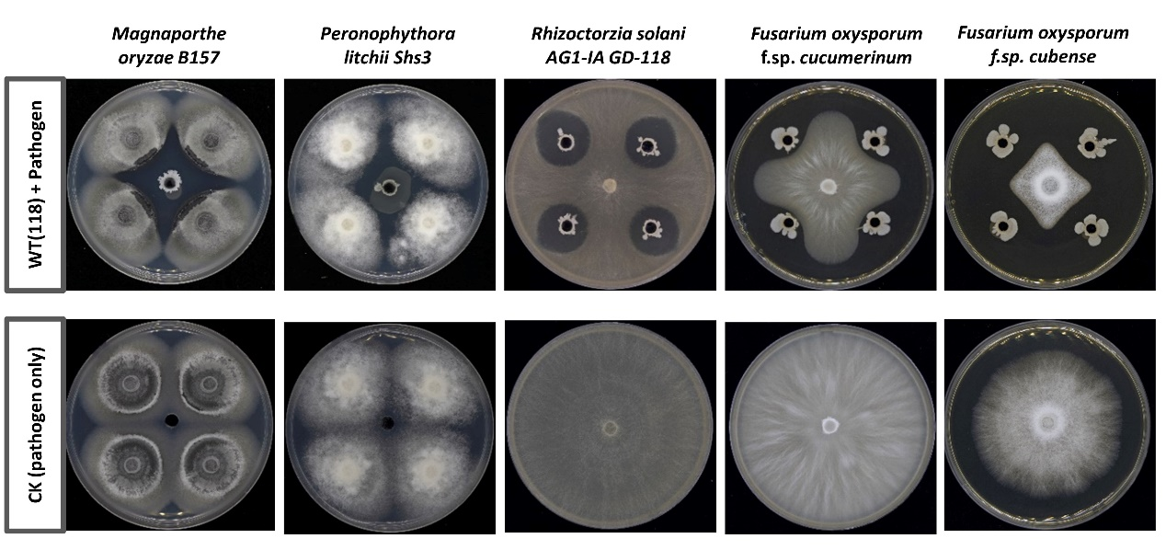
Fig. S1. Antagonistic activity of isolate 118 against various fungal pathogens.
A plate confrontation assay was conducted to assess the antifungal activity of isolate 118 against several common fungal pathogens: Magnaporthe oryzae B157, Peronophythora litchii Shs3, Peronophythora litchii Shs3, and Fusarium oxysporum f.sp. cucumerinum. Fungal cells were cultivated on potato-dextrose-agar (PDA) plates at 30ºC for 5 days. Four blocks of mycelium (5 mm in diameter) were cut and transferred to fresh PDA plate, positioned 2.5 cm away from the center. After 1 day incubation, 50 µl of isolate 118 cells (OD₆₀₀=0.4) grown in LB medium were spotted into the center of the holes. A negative control (CK) was included without the addition of isolate 118 cells. Antifungal activity was evaluated after 7 days of additional incubation at 30ºC. The experiments were performed at least three times, and representative photographs are presented.

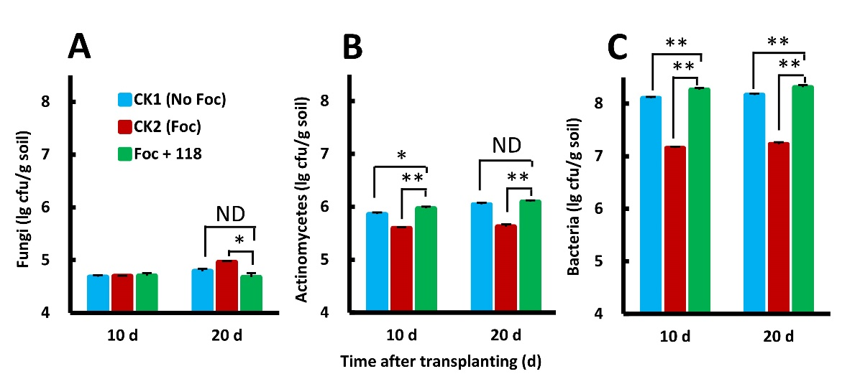
Fig. S2. B. velezensis 118 help restore soil microbial population that was disrupted by the pathogen Foc.
The quantity of fungi (A), actinomycetes (B), and bacteria (C) in the banana rhizosphere from the pot experiments described in Fig. 2 were quantified at 10 and 20 d following transplantation. Three groups were included: CK1 (no Foc): uninfected banana seedlings were directly planted into pots; CK2 (Foc): infected with Foc; and Foc + 118, inoculated with both Foc and 118. Data represent the mean values ± SD (n = 6). Significant differences between these groups were determined by a two-tailed t-test, *P < 0.05 and **P < 0.01.

Fig. S3. B. velezensis isolate 118 is an effective biofilm producer.
Biofilm production was measured for several B. velezensis isolates (118, FZB42, Y6, and F7) and B. subtilis NCIB3610, cultured in LBGM medium for either 15 h or 24 h. The data are expressed as the mean ± SD (n = 6). Significant differences between groups, indicated by different letters above the data bars, were determined using Duncan’s new multiple range test at α = 0.05.
Fig. S4. SigX facilitates the colonization of B. velezensis 118 on Arabiposis thaliana roots. (A) Representative photographs showing biofilms formed on A. thaliana root surfaces by WT (3610) murAA-gfp and sigX::erm murAA-gfp. After co-cultivating A. thaliana plants and Bacillus cells for 0, 12, 24 or 48 h under shaking conditions at 100 rpm (as detailed in the Methods section), following a 3 h incubation without shaking in LBGM, the roots were washed with PBS buffer and examined using confocal laser scanning microscopy (CLSM). The scale bar is 10 μm. (B) Quantification of the bacterial cells at various timepoints as indicated.
Fig. S5. SigX plays a minor role in bacterial swimming and swarming.
Swimming ability on the LBGM plates with 0.3% agar (A) and swarming on the LBGM plates containing 0.7% agar (B) were monitored at different timepoints as indicated. Data represent the mean values ± SD (n = 3). Statistical significance was determined using a student t-test, **P < 0.01. (C) Representative images depict colony swarming morphology. Tested strains include B. velezensis 118 WT and its derived sigX::mls mutant (left panels), and B. subtilis NCIB 3610 WT, its derived sigX null mutant, and the complement strain sigX P_{spac}sigX (sigX PsigX) (right panels).

Fig. S6. Deletion of sigX has minimal impact on lipopeptide production in B. velezensis 118. To evaluate the antagonistic activity of isolate 118 and its derived sigX::mls mutant against Foc (A-B) and Rs (C-D), a spot-on lawn assay was conducted. The clearance zone indicated by black lines was measured after 24 h at 30°C. No significant differences were observed between the two strains, which was determined using a two-tailed t-test (ns, not significant). Scale bars, 5 mm. (E) Quantification of LP compounds extracted from either WT or sigX::mls mutant using UPLC-MS analysis. Mass spectrum [M+Na]⁺ of LPs are shown, surfactin ((i, WT) and (iv, sigX::mls)), fengycin((ii, WT) and (v, sigX::mls)), and iturin((iii, WT) and (vi, sigX::mls)).

