Balance between bile acid conjugation and hydrolysis activity can alter outcomes of gut inflammation
Yousi Fu¹, Douglas V. Guzior^{1, 2}, Maxwell Okros¹, Christopher Bridges¹, Sabrina L. Rosset¹, Cely T. González¹, Christian Martin^{1, 4}, Hansani Karunarathne¹, Victoria E. Watson³, and Robert A. Quinn^{1*}
¹ Department of Biochemistry and Molecular Biology, Michigan State University, East Lansing, MI, USA
² Department of Microbiology, Genetics, and Immunology, Michigan State University, East Lansing, MI, USA
³ Department of Pathobiology and Diagnostic Investigation, College of Veterinary Medicine, Michigan State University, East Lansing, MI, USA
⁴ Mass Spectrometry and Metabolomics Core, Michigan State University, East Lansing, MI, USA

Supplementary results
TCA treatment impacted the fecal microbiome differently than that of the cecum. We observed a significant decrease in the alpha diversity of the feces microbiome in DSS-induced inflammation (Figure S1a, b, p < 0.05). TCA supplementation resulted in a slight rescue of this loss in alpha diversity yet, was not significant (Figure S1a, b, p > 0.05). The composition of the fecal microbiome was significantly different between mice exposed to the DSS treatment and those exposed to the DSS-TCA treatment (Figure S1 c, p <0.05). At the phylum level, we found changes in the dominant bacterial phyla. Firmicutes_D and Proteobacteria were increased in the DSS treatment, while Verrucomicrobiota was increased in the DSS-TCA treatment (Figure S1d, e, p < 0.05). Furthermore, the relative abundance of Ligilactobacillus and Akkermansia significantly improved in the DSS and DSS-TCA groups by linear discriminant analysis effect size (LEfSe) method (Figure S1f, p < 0.05). Consistent with changes in the cecum, TCA treatment also significantly increased the relative abundance of Lachnospiraceae (p < 0.05).

Supplementary figures
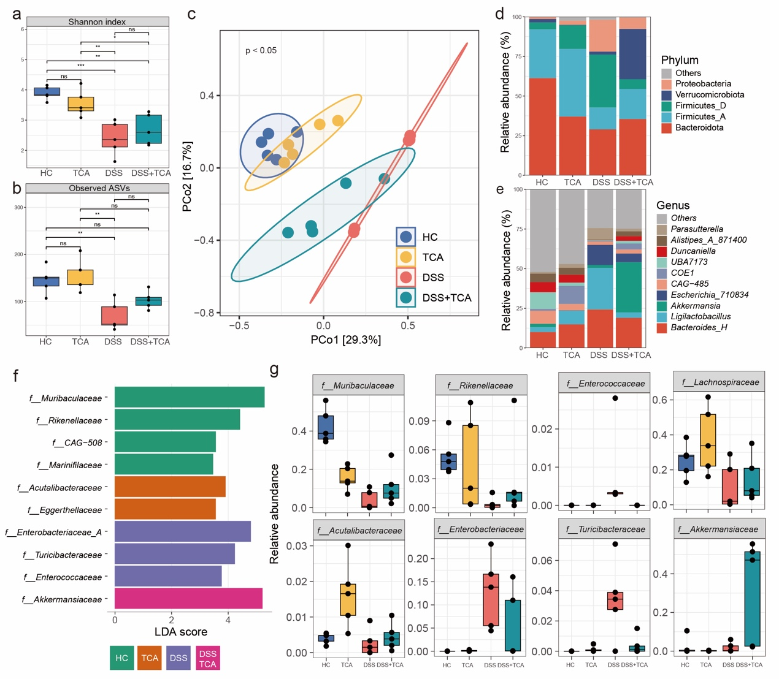
Figure S1. DSS-induced ulcerative colitis in Baat^{-/-} KO mice supplemented with 0.3% taurine-conjugated cholic acid modified the feces microbiome. (a, b) alpha diversity determined by the Shannon index and Observed ASVs. (c) The principal coordinate analysis (PCoA) based on Bray-Curtis dissimilarity shows the microbiome β-diversity. (d) Phylum level microbiome changes. (e) Genus level microbiome changes. (f) Bacterial taxa identified as differentially abundant according to linear discriminant analysis effect size (LEfSe). (g) Significant bacteria changes. Data was analyzed by one-way ANOVA with Tukey’s post hoc, analyzed by one-way ANOVA with Tukey’s post hoc, and different letters indicate groups that are statistically different from each other (p < 0.05).

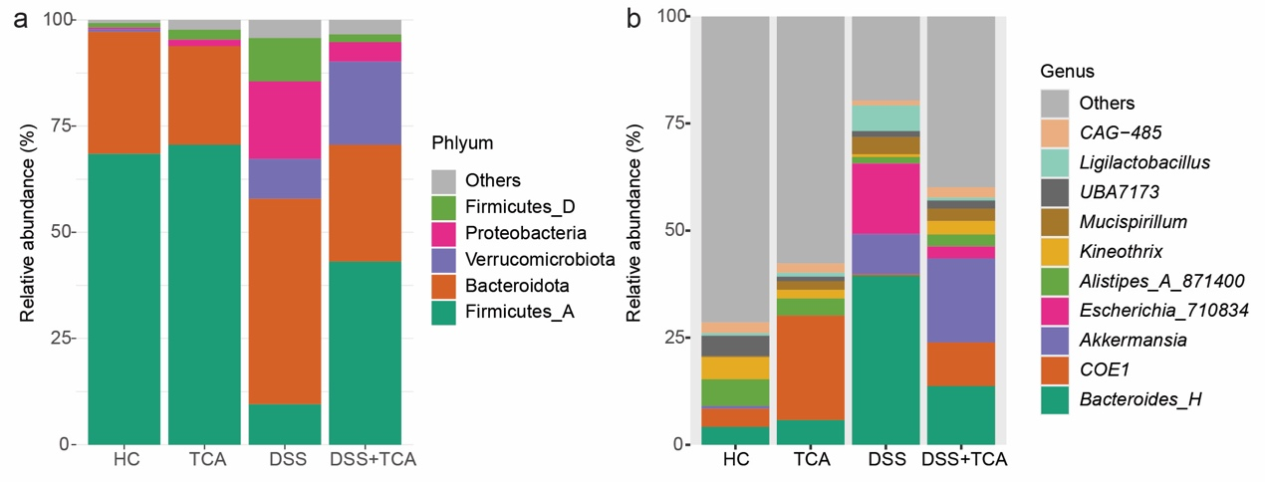
Figure S2. DSS-induced ulcerative colitis in Baat^{-/-} KO mice supplemented with 0.3% taurine-conjugated cholic acid impacted the cecum microbiome at phylum and genus levels. Data analyzed by one-way ANOVA with Tukey’s post hoc.

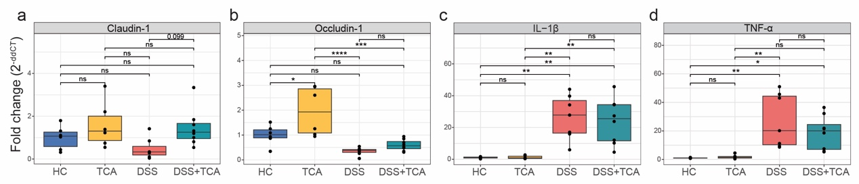
Figure S3. Baat^{-/-} KO mice supplemented with 0.3% taurine-conjugated cholic acid under DSS-induced colitis modified colon mRNA expressions. (a-d) Relative mRNA expressions of Claudin-1, Occludin-1, IL-1β and TNF-α in colon. Data was analyzed by one-way ANOVA with Tukey’s post hoc, and *p < 0.05, **p < 0.01, ***p < 0.001.

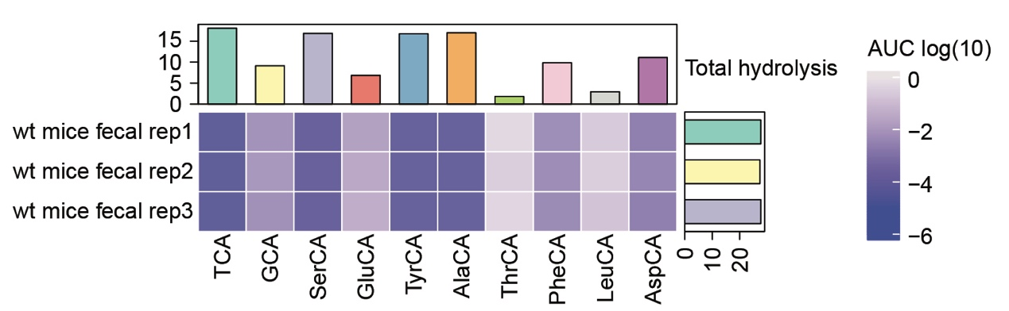
Figure S4 Conjugated cholic acids hydrolysis by mice fecal in vitro culture. The abundances of conjugated BAs are represented as colors corresponding to log10­transformed peak areas (area under the curve, AUC). Values represent n = 3 replicates of log10 areas changes compare to medium after 48 h in vitro culture.

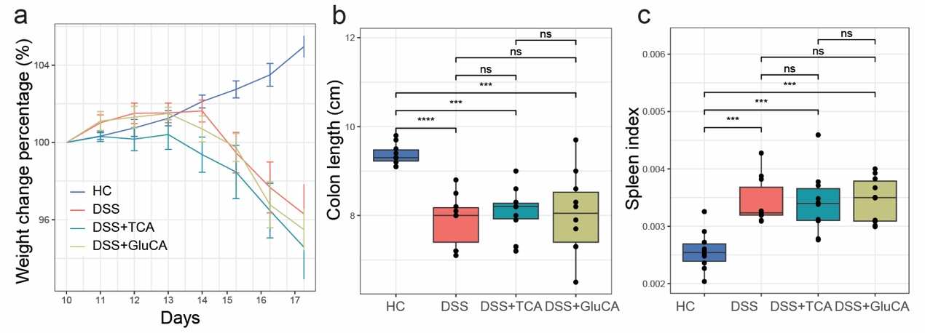
Figure S5 Wild-type C57BL/6J mice supplemented with 50 mg/kg TCA or GluCA via peanut butter pellets self-administrated method under DSS-induced colitis. (a) Weight changes during the DSS-induced colitis. (b) The colon lengths of each animal. (c) Spleen index (spleen weight-to-body weight ratio). Weight change data expressed as the mean ± SEM, weight, colon, and spleen data analyzed by one-way ANOVA with Tukey’s post hoc, and *p < 0.05, **p < 0.01, ***p < 0.001, ****p < 0.0001.

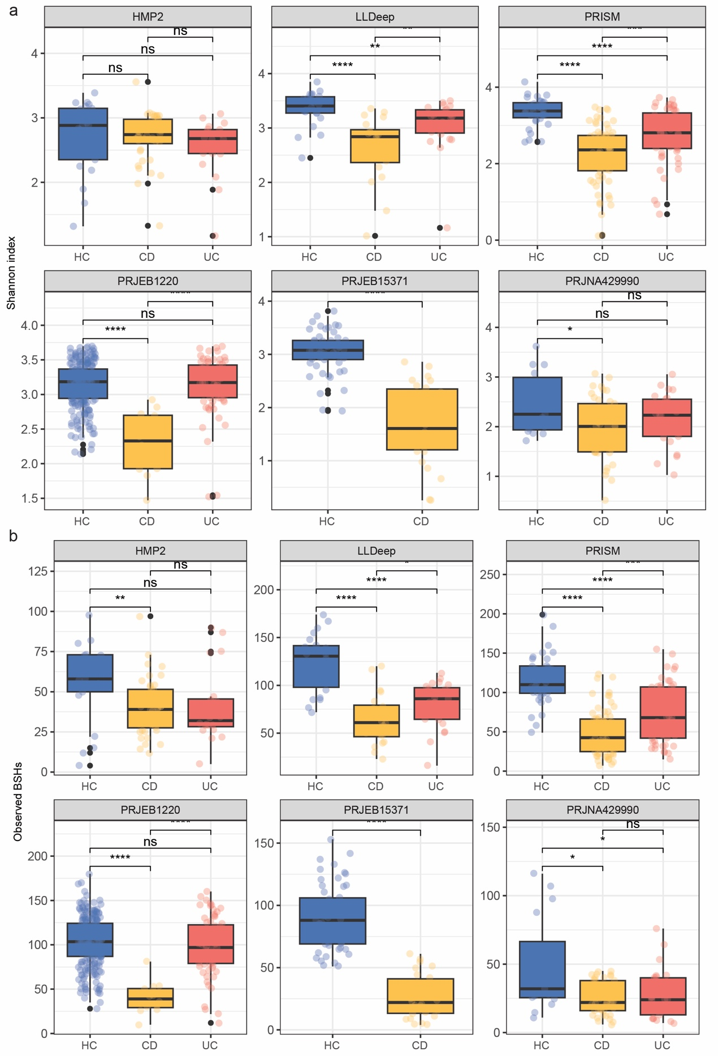
Figure S6. Changes in alpha diversity of BSHs in each cohort of IBD patients and healthy controls. The alpha diversity of BSHs in IBD patients and health controls, which was measured using the Shannon index (a) and Observed BSHs (b). Data was analyzed by Wilcox rank-sum test followed by BH correction, and *p < 0.05, **p < 0.01, ***p < 0.001, ****p < 0.0001.

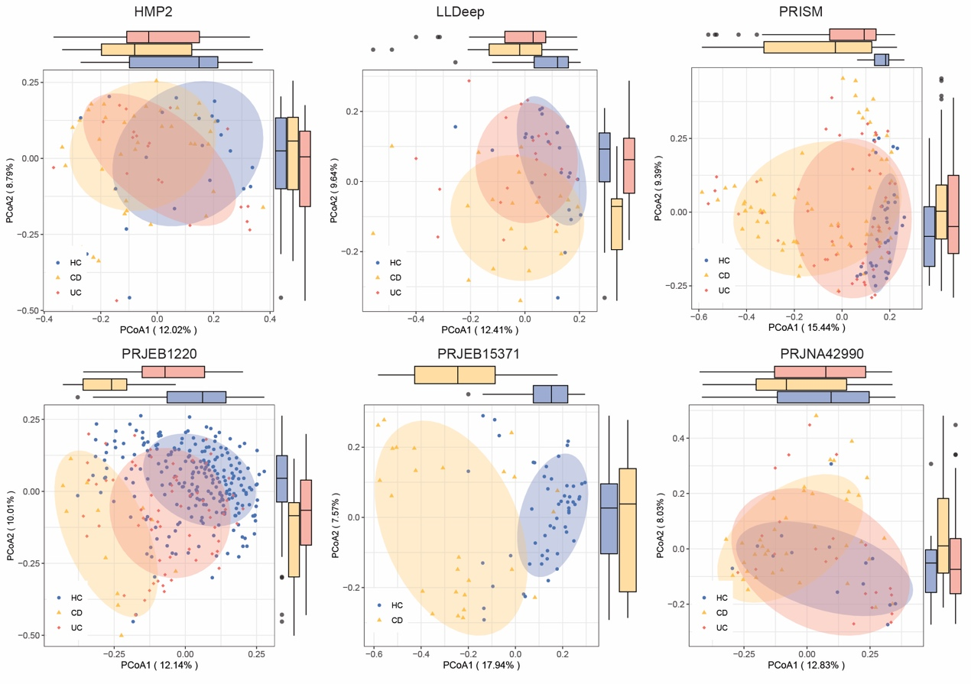
Figure S7. Changes in beta diversity of BSHs in each cohort of IBD patients and healthy controls. Principal coordinate analysis (PCoA) shows significant differences in BSHs between IBD patients and health controls in each cohort. The significance of beta diversity based on Bray-Curtis distance was calculated using PERMANOVA with 999 permutations.
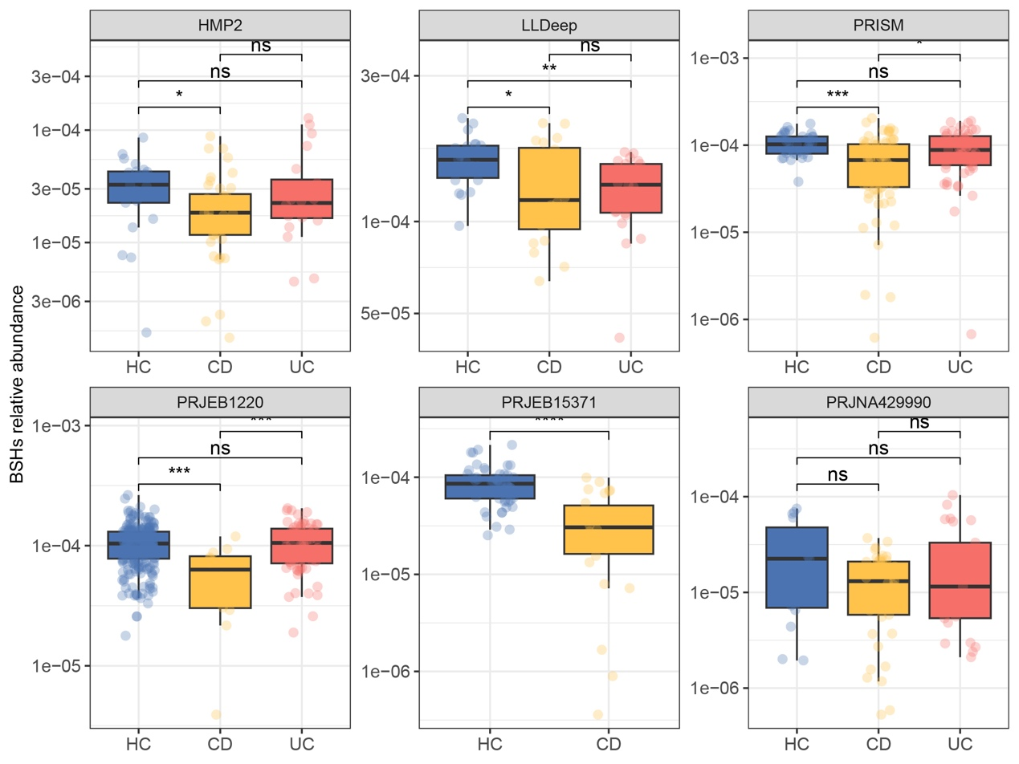
Figure S8. Changes in relative abundance of BSHs in each cohort of IBD patients and healthy controls. Data was analyzed by Wilcox rank-sum test followed by BH correction, and *p < 0.05, **p < 0.01, ***p < 0.001, ****p < 0.0001.
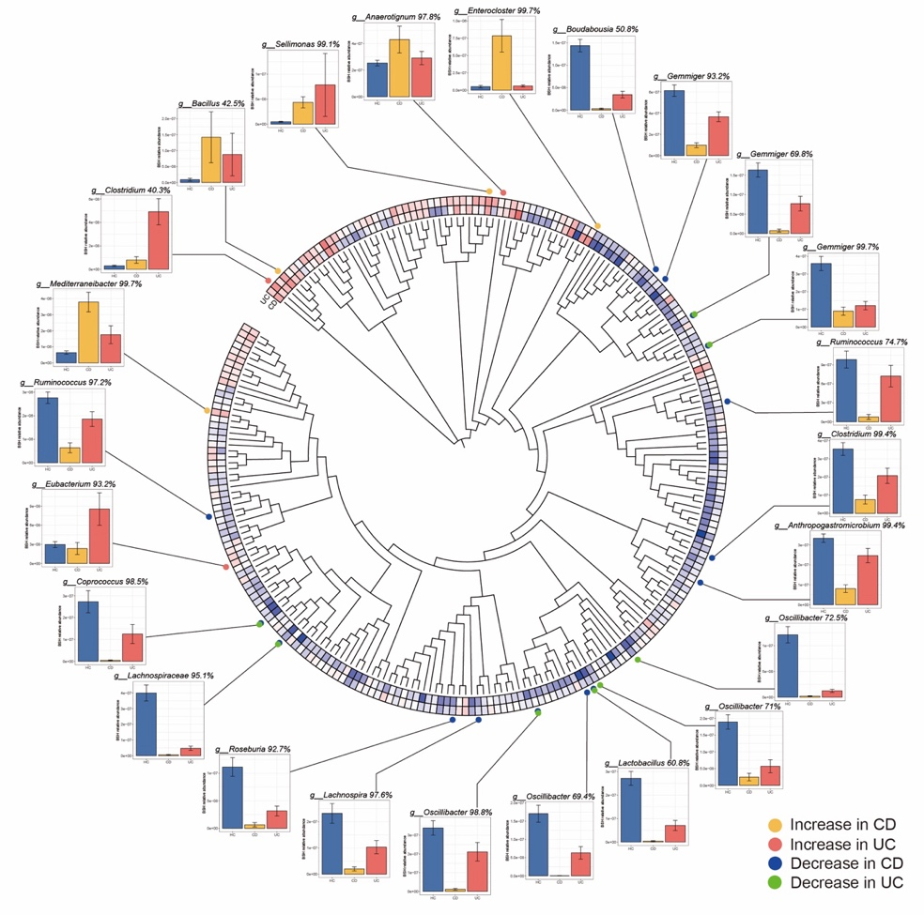
Figure S9. Phylogenetic tree of identified BSHs and significant changes in BSHs among cohorts. Total 244 identified BSHs are shown in a phylogenetic tree. The circular heatmap displays the log2 fold change values of these 244 BSHs, with red indicating enriched and blue indicating depleted in IBD. Data was analyzed by Wilcox rank-sum test followed by BH correction. The outer-circle bar chart displays BSHs with significant differences (p < 0.05).

Table S1. Sequence of the primers.
Gene | Forward: 5ʹ-3’ | Reverse: 5’-3’
IL-1ß | TCAGGCAGGCAGTATCACTCATT | GGAAGGTCCACGGGAAAGA
TNF-α | CGTGCTCCTCACCCACAC | GGGTTCATACCAGGGTTTGA
FXR | TGGGCTCCGAATCCTCTTAGA | TGGTCCTCAAATAAGATCCTTGG
TGR5 | CCTGGCAAGCCTCATCGTC | AGCAGCCCGGCTAGTAGTAG
MUC2 | ATGCCCACCTCCTCAAAGAC | GTAGTTTCCGTTGGAACAGTGAA
Occludin-1 | TTGAAAGTCCACCTCCTTACAGA | CCGGATAAAAAGAGTACGCTGG
ZO-1 | GCCGCTAAGAGCACAGCAA | TCCCCACTCTGAAAATGAGGA
Claudin-1 | GGGGACAACATCGTGACCG | AGGAGTCGAAGACTTTGCACT
ß-actin | GAAATCGTGCGTGACATCAAAG | TGTAGTTTCATGGATGCCACAG

Table S2. Bacterial names, strain number, and source number.
Species | Strain | Source
Enterococcus faecalis | 19433 | ATCC
Lactiplantibacillus plantarum | 30503T | CCUG
Ruminococcus gnavus | 29149 | ATCC
Enterocloster aldenensis | BAA-1318 | ATCC
Clostridium symbiosum | 14940 | ATCC
Clostridium perfringens | 13124 | ATCC
Clostridium hylemonae | 45367T | CCUG
Enterocloster citroniae | 52203T | CCUG
Lacrimispora indolis | 55582T | CCUG
Lacrimispora celerecrescens | 68430T | CCUG
Peptostreptococcus anaerobius | 7835T | CCUG
Clostridium scindens | 35704 | ATCC
Blautia coccoides | 29236 | ATCC
Clostridium sporogenes | 15579 | ATCC
Enterocloster bolteae | BAA-613 | ATCC
Enterocloster clostridioformis | 25537 | ATCC
Lacrimispora aerotolerans | 43524 | ATCC
Bacteroides fragilis | 4856T | CCUG

Table S3. Fecal metagenomic studies of BSH in patients with IBD included in this study.
Cohort | CD | UC | Healthy individual
LLDeep | 20 | 23 | 22
PRISM | 68 | 51 | 34
PRJEB15371 | 26 |  | 53
PRJNA429990 | 41 | 25 | 15
PRJEB1220 | 12 | 67 | 236
HMP2 | 40 | 20 | 21

