Supplementary data

Microbial approach towards anode biofilm engineering for improvement of extracellular electron transfer in microbial electrolysis cell

Summary
Supplementary information includes 20 pages, and 8 figures

Materials and Methods
Electrolysis test
To achieve the optimum mixing of WAS-FOG mixture to optimize the current density potential (Sharma et al., 2023). Bio-electrolysis was carried out in MEC glass with a volume of 200 mL to check the microbial biofilm growth and current density. At the start and end of the electrolysis test, different mixtures of the WAS-FOG (including control test) samples were analyzed with the various parameters COD, VS, TS, pH, conductivity, and current density daily and recorded. Various ratios of WAS-FOG were mixed and tested including 1.5% to 15% w/v to optimize their enhancement of microbial electrolysis for current production.
Fat oil and grease (FOG)
Fat oil and grease (FOG) were collected from common premises (restaurant, residence houses, and food process units) building outlets. Before starting the MEC setup, throughout the process, several parameters are monitored in the laboratory. All determinations in the physical-chemical and biomolecules of FOG were conducted in triplicate, and the mean standard deviation of the three samples was presented in the physical-chemical and biomolecules of FOG values Table 1 (SM1).
Table 1: Collected samples and the characteristics of fat oil grease (FOG) and waste-activated sludge (WAS)

Character | FOG | WAS
pH | 5.7 ± 0.03 | 7.3 ± 0.37
COD | 4.43 ± 0.76 | 1.9 ± 0.067
TCOD | 8.8 ± 1.89 | 1.5 ± 0.031
BOD | 1.3 ± 17.98 | 2.1 ± 0.82
TN | 17.3 ± 2.45 | 6.89 ± 7.45
TP | 0.21± 0.05 | 0.97± 0.13
TDS | 215 ± 10.91 | 135.4 ± 9.45
VSS | 450 ± 13.78 | 389 ± 4.67
MLSS | 1060 ± 117.56 | 2967 ± 25.56
C/N ratio | 23.70 ± 4.78 | 7.34 ± 0.85
VS/TS | 75.55% | 134.29%
VFA | 3.95 | 1.59
Protein | 34.7% | 12.1%
Carbohydrate | 5.35 | 3.32
Fats | 68.4 | 35.5
Lipids | 61.8% | 1.78%

all experiment results in g/L, except pH, protein

Electrochemical analysis
Cyclic voltmeter Calculation (CV) SM1
The CV was conducted in our experiment in wide range of potential
This technique involves transferring electrons, by linearly varying the electrode potential between two limits at a specified rate while monitoring the current that develops in the electrochemical cell. This experiment was carried out at high voltage. The Nernst equation The Nernst equation relates the potential of an electrochemical cell (E) to the standard potential of a species (E0) and the relative activities of the oxidized (Ox) and reduced (Red) analyte in the system at equilibrium. In the equation, F is Faraday’s constant, R is the universal gas constant, n is the number of electrons, and T is the temperature:
$E=E^{°}-\frac{RT}{nF}\ln{\frac{OX}{\left(Red\right)}=E°+2.3026\frac{RT}{nF}}\log_{10}{\frac{OX}{(Red)}}$ (Equ.3)
- E = half–cell potential in V which varies with the molar concentrations [mol dm^{–3}] of the oxidised and reduced species.
- E^{θ} is the standard half–cell potential e.g. at 298K when the molarities are 1.0 mol dm^{–3}.
- in the case of two aqueous ions like Fe²⁺/Fe³⁺, [red] = [ox] i.e. equal concentrations, so that E varies with the ratio of the two ion concentrations.
- R = 8.314 J mol^{–1} K^{–1} (the ideal gas constant).
- T the absolute temperature in K (Kelvin = ºC + 273).
- n = moles of electrons transferred per mole of reactants.
- F =96500 C mol^{–1} (the Faraday constant).
- ln = natural/Napierian logarithm.
- [ox/red] = molar concentration of the oxidised or reduced species. University students might well be using activity values as well as molarity values, in which case the activity of the metal is considered to be unity, i.e. a_{M(s)} = 1.000

Electrochemical characterization
The MEC was a two-chamber glass reactor with dimensions of 8 cm in length and 3.5 cm in width, as illustrated in Fig. 1. The total volume of MEC has a 250 ml capacity. Two compartments were separated by a membrane 1.0 mm thick carbon felt and both anode and cathode electrodes can be made of carbon fiber (Fiber product, UK). During its 60-day operation, the MEC anode and cathode electrodes were connected to the resistor, which produced the voltage needed to measure current production. The research of advanced treatment of WAS-FOG was carried out using a microbial electrolysis cell reactor which filled WAS-FOG sample, activated sludge, and nutrient solution. Initially, the MEC reactor is connected with a potential source to provide voltage (0.1 to 1.5 volts) through an anode chamber for an oxidation reaction that generates current (0 to 16 mA), after degrading the complex organic compounds. Cathode-electrode receives electrons to complete a reduction-oxidation reaction that releases the electrons. The nutrient solution consists of salts which are 1 liter of water distilled water: KCl (0.38 g), NH₄Cl (0.2 g) NaH₂PO₄.H₂O (0.069 g), CaCl₂.2H₂O (0.04 g), MgSO₄.7H₂O (0.2 g) and a mixture of Minerals consisting of MnCl₂.4H₂O (0.1g), FeSO₄.7H₂O (0.3g), CoCl₂.6H₂O (0.17g), ZnCl₂ (0.1g), CuSO₄.5H₂O (0.04g), AlK(SO₄).12H₂O (0.005g), H₃BO₃ (0.005g), Na₂MoO₄ (0.09 g), NiCl₂ (0.12 g). Next, provide the substrate solution by adding acetate in 20 mM and adjusting the pH to 6.8 by adding 2 g of NaHCO₃. At the start of the continuous experiment each day, the catholyte exposed to phosphate buffer and WAS-FOG was added to the MEC with an evaluation of the microbial electrolysis and bacteria biofilm growth and current densities.

Microbe culture and assembly of functionalized bacteria SM2
To enhance the electrochemical performance in the presence of WAS-FOG, optimization strategies such as substrate dilution, intermittent feeding, or microbial acclimation to high substrate concentrations may be explored. These approaches can help mitigate the inhibitory effects of excessive organic loading and promote more efficient electron transfer processes. Organic acids (acetate, butyrate, lactate) and metabolites were measured using HPLC (Agilent1150) equipped with an aminex organic acids column. Analysis of the interspecies electron, transfer capacity (ETC), EDC, and EES of the system was achieved with the aid of an electrochemistry MEC system with two electrodes. In contrast, the bacterial growth efficiency was determined with the amount of new biomass of bacteria (BP) divided by per unit degradation (BD) of organic in the MEC system. On the other hand, the NADH ratio was determined using a kit Promega-USA according to published procedures (Zhong et al., 2024). The reactor was well shaken to detach the cells attached to the electrode in working mode and then after taking samples for analysis, the viable cells and total biomass were measured using the agar plating methods 100 µg/mL (colony forming units). Th e performance MEC, movement of electrons on the anode were analyzed by integrating the anode charge (A) curve mean current mV over time (T), dividing the baseline current recovered (SM 2).
Biofilm EPS characteristic
Displayed in Fig. 1 are the characteristics of extracellular polymeric substances (EPS) in anode Fig. 2. The dense EPS encases microbial biomass interacts with FOG, reducing nutrients and providing a source of carbon and energy for microbial metabolism (Sharma et al., 2023). In this respect, high concentrations of FOG or organics may lead to changes in microbial cell morphology, volume, and metabolic activity, whereas the availability of excessive substrate could result in cellular stress, alter growth kinetics, and reduce electrochemical performance

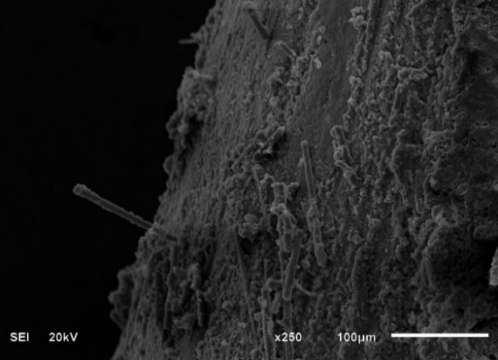
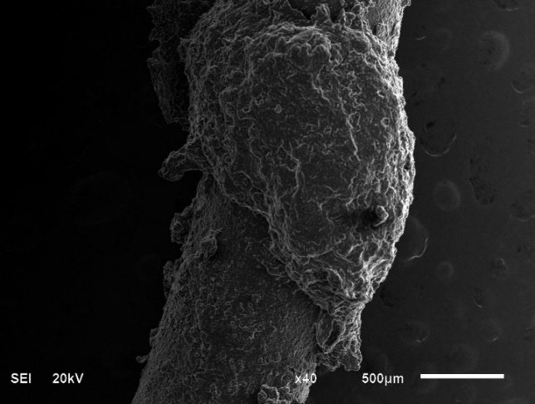
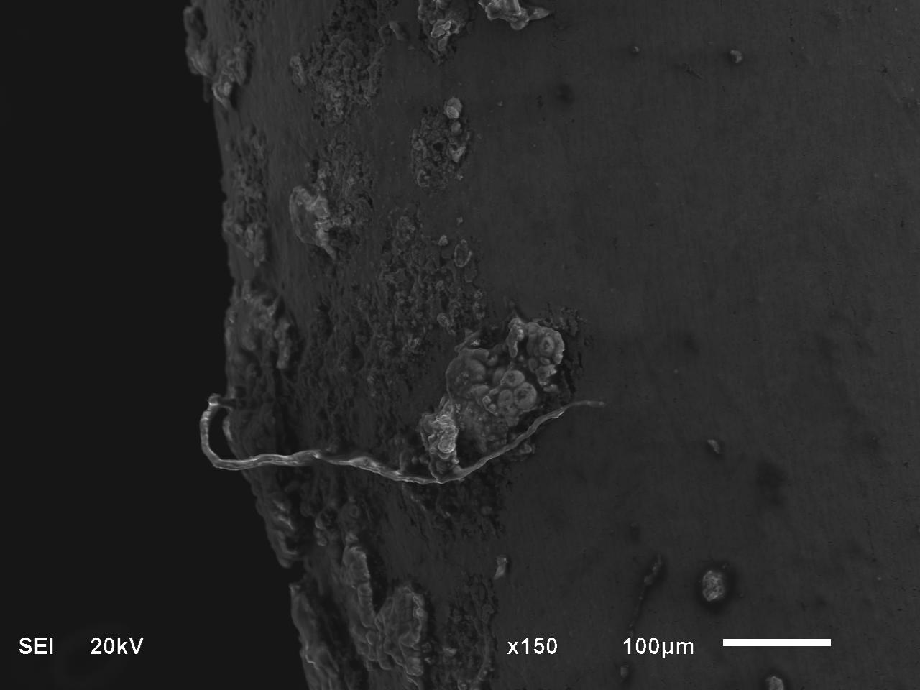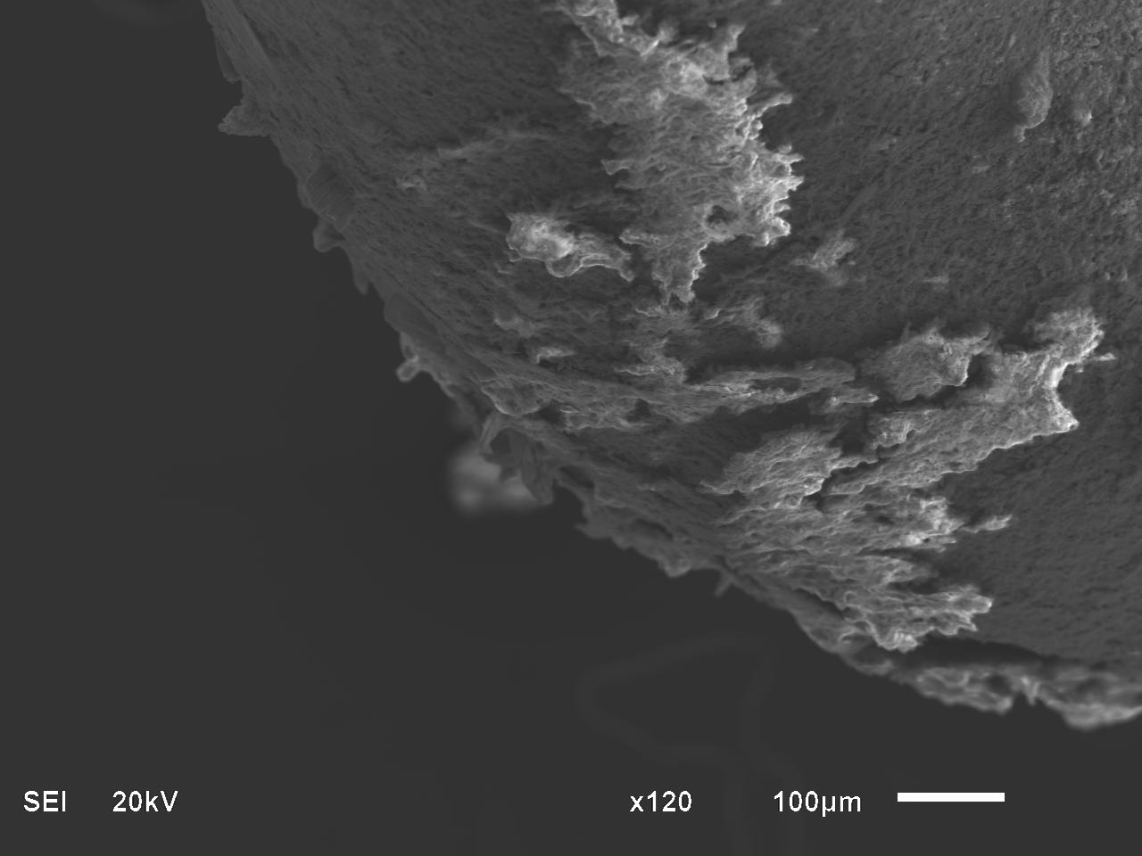
11% FOG
13% FOG
5% FOG
9% FOG

+Figure 2. The operation of microbial electrolysis cell performance: the morphology of microbial electroactive biofilm showed scanning electron microscopy (SEM ) at 11% of FOG the bacteria biofilm growth with pili.

Electron exchange capacity analysis
The MEC was used electrode for measuring the EEC, The working electrode electrolysis potential of EAC is used to -0.50, EDC 0.65. The EAC and EDC, by dividing the reductive and oxidative current peaks.

EPS extraction
The active cell of the biofilm electrode were collected and harvested and clean with 1.5% saline water. The clean cell sample centrifuging at 5ºC, the filtered cell supernatants through 0.55 mm membrane and filtrates were collected on loose EPS samples and stored at -25ºC before applications.
Data analysis
Current is produced through the connection between the anode and cathode at different values of applied voltage. The maximum current value was during three months of MEC operation. By coordinating the current and power with the surface area of the electrode the power and current density can be calculated. All experimental samples were analyzed for pH, TS, and VS, according to APHA standard methods. The FOG is rich in substrates like VFA, protein, polysaccharides, lipids, and iron quantity were analyzed by using HPLC USA aligned with a UV detector. The quantified volume of microbial cells was performed by taking the samples from the MEC system in the middle part of the experiment. Similarly, quantification of the microbial concentration was achieved with the aid of optical density (OD/ mL) in every cultured sample volume. Concurrently, observations of COD were conducted to assess the reduction of complex compounds during the MEC process. The COD levels were measured with digestion facilitated by Hach methods cuvette COD digestor USA. Bacterial growth within the MEC played a crucial role in the oxidation reaction, leading to a reduction in the concentration of complex compounds and an increase in electron generation. To evaluate the enhancement of bacteria within the anode chamber, SEM was employed. Using this technique, the identification of metabolites generated by the bacteria can be achieved. Additionally, every 25 days during the MEC operation, 3 mL of analyte was extracted from the anode compartment. These samples were maintained at room temperature, and the pH range was carefully monitored, typically falling between 6.8 and 7.2. The cyclic voltmeter (CV) was conducted in a wide range of potential ranges (SM2). The CV data were recorded for the MECs operation reactor in the first quarter of the MECs operation period. The redox peak for MEC was followed at 0.00002 and –0.00002 V, 0.0002 and –0.0002 V, and 0.0001 and –0.0001 V. However, the intense redox peak for MECs operation was observed at a higher current of 1.5 mA when the voltage applied reached 0.0002 V.

Result and Discussions
The impact of waste-activated sludge (WAS) and fat, oil, and grease (FOG) on electrolysis for metabolite yields, including acetate, butyrate, ethanol, lactate, and total metabolites, can vary depending on various factors such as FOG dosage, microbial community composition, and anode charge capacity (Roy et al., 2022). Metabolites produce 18.6 mmol mg⁻¹ DW compared to the initial stage of 1.56 at the electrode area, influenced by the combined metabolic activities of microbial communities degrading FOG (Fig. 3). Monitoring the total metabolite concentrations provides insights into the overall microbial activity and substrate utilization (Roy et al., 2022). The performance of MEC was evaluated by characterizing electron transfer capacity (ETC) and current density was significantly changed after adding FOG. In this context, microbial electrolysis is associated with NADH/NAD⁺ ratio and the volume of cells is linked to redox-mediated (Tran et al., 2021). Therefore, we confirmed redox homeostasis via electroactive microbes in 11% FOG under EET conditions estimating intercellular NADH/NAD+ ratio, viable cells, and maximum current density (Fig. 4). Supplemented with WAS-FOG, EET activity was confirmed in a bioelectrochemical reactor, the current density was observed with 11% FOG (215.7 µA/cm²), higher than that 13% FOG (117.3 µA/cm²), and 9% FOG (178.5 µA/cm²) (Fig. 3). The microbial electrolysis was positively influenced by organic oxidation with the exoelectrogenic anode side and electrons released (Yang et al., 2017; Li et al., 2018). The high concentrations of organic compounds like WAS-FOG can exert toxic effects on microorganisms, including electroactive bacteria, and could disrupt the cellular redox balance, affecting the NADH/NAD+ ratio and impairing electron transfer processes (Mkilima et al., 2024; Ishaq et al., 2024). This toxicity may inhibit microbial growth and microbial metabolic activity, thereby reducing the overall electrochemical performance. While organic substrates like WAS-FOG can serve as electron donors for electroactive bacteria, excessively high concentrations of FOG 13% and low levels of 1.5% also may overwhelm the microbial community's capacity for substrate utilization. At good concentrations of WAS-FOG 11%, electroactive bacteria may have better access to the available WAS-FOG, leading to higher metabolic activity, and the EET 17.49 mM and, current production was 783 mV.

Figure 1. The performance of MEC indicates the characteristics of EPS in the anode site and the characteristics of metabolite concentrations in the cathode region and anode regions of metabolite yields in mM (acetate, butyrate, ethanol, lactate, and total metabolites).

Figure 2: The performance of MEC indicates the impact of % FOG on electrolysis for average thickness of biofilm and conductivity; enhance growth cell number and NADH-NAD+ ratio of intercellular bioelectrochemical system.

Figure 3. The performance of MEC indicates the impact of various % FOG on electrolysis for extracellular electron transfer capacity (EET) and a average current density.

Figure 4. The performance of MEC indicates the impact of various % FOG on electrolysis showed highest amount of current production and and power density.

Figure 5. The performance of MEC indicates the impact of various % FOG on electrolysis rate per hour for the current production and 135 hour electrolysis of WAS-FOG 11% achieved highest amount of current production.

Fig.9: microbial fuel cell performance based on the voltage applied Additional
References
Ahmad, A., Senaidi, A.S., 2023. Sustainability for wastewater treatment: bioelectricity generation and emission reduction. Environmental Science and Pollution Research 10.1007/s11356-023-26063-9.
X. Zhou , F. Yang, F. Yang, D. Feng, T. Pan and H. Liao, Analyzing greenhouse gas emissions from municipal wastewater treatment plants using pollutants parameter normalizing method：a case study of Beijing. Cleaner Production, 376, 134093, 2022.
H. Guven, M. E. Ersahin and H. Ozgun, Chapter 7 - Energy self-sufficiency in wastewater treatment plants: perspectives, challenges, and opportunities. Clean Energy and Resource Recovery, 2,105-122, 2022.
Zhou, X., Zhang X., Peng, Y., Douka, A.I., You, F., Yao. J., Jiang, X., Hu, R., Yang, H., 2023. Electroactive Microorganisms in Advanced Energy Technologies. Molecules. 28(11):4372. doi: 10.3390/molecules28114372.
Z. Gao , K. Alshehri, Y. Li, H. Qian, D. Sapsford, P. Cleall and M. Harbottle, Advances in biological techniques for sustainable lignocellulosic waste utilization in biogas production. Renewable and Sustainable Energy Reviews, 170, 112995, 2022.
M. Muddasar, M. Z. U. Rahman, A. H. Khoja, A. Aslam and A. Basit, Coaxial microbial electrolysis cell for cost-effective bioenergy production and wastewater treatment of potato industry effluent. Chemical technology and biotechnology, 98:9, 2203-2213, 2023.
Tong, K. T. X., Tan, I. S., Foo, H. C. Y., Show, P. L., Lam, M. K. and Wong, M. K., 2023. Sustainable circular biorefinery approach for novel building blocks and bioenergy production from algae using microbial fuel cell. Bioengineered,14,1,246–289, doi: 10.1080/21655979.2023.2236842.
Ahmad, A., Senaidi, A.S., Reddyi, S.S., 2023. Electrochemical process for petroleum refinery wastewater treatment to produce power and hydrogen using microbial electrolysis cell. J Environ Health Sci Engineer.2,485-496. doi:10.1007/s40201-023-00874.
Wang, YX., Hou, N., Liu, X.L., Mu, Y., 2022. Advances in interfacial engineering for enhanced microbial extracellular electron transfer. Bioresour Technol. 345,126562.doi: 10.1016/j.biortech.2021.126562.
Barone G. D. et al., 2023. Recent developments in the production and utilization of photosynthetic microorganisms for food applications. Heliyon, 9(4), e14708, 2023, doi: 10.1016/j.heliyon.2023.e14708.
Espinosa R.M.M., 2024. Molecular Advances in Microbial Metabolism.Int J Mol Sci.25(2):1361. doi.org/10.3390/ijms25021361.
Hemdan, B.A., El-Taweel, G.E., Naha, S., Goswami, P., 2023. Bacterial community structure of electrogenic biofilm developed on modified graphite anode in microbial fuel cell. Sci Rep.13(1):1255. doi:10.1038/s41598-023-27795-x
Bird, L.J., Mickol, R.L., Eddie, B.J., Thakur, M., Yates, M.D., Glaven, S.M., 2023. Marinobacter: A case study in bioelectrochemical chassis evaluation. Microb Biotechnol,16(3):494-506. doi: 10.1111/1751-7915.14170.
Ahmad, A., Senaidi, A.S., Al-Rahbi, A.S., Al-Dawery, S.K., 2022. Biodegradation of petroleum wastewater for the production of bioelectricity using activated sludge biomass. J Environ Health Sci Eng 21(1):133-142. doi: 10.1007/s40201-022-00846-7.
Pan, P., Bhattacharyya, N., 2023. Bioelectricity Production from Microbial Fuel Cell (MEC) Using Lysinibacillus xylanilyticus Strain nbpp1 as a Biocatalyst. Curr Microbiol. 80(8):252.doi: :10.1007/s00284-023-03338-5.
Mohanakrishna, G., Al-Raoush, R.I., Abu-Reesh, I.M., 2018. Induced bioelectrochemical metabolism for bioremediation of petroleum refinery wastewater. Optimization of applied potential and flow of wastewater. Bioresour. Technol.260:227–32. doi:10.1016/j.biortech.2018.03.122.
Li, F., L., Tang, R., Zhang, B., Qiao, C., Yu, H., Liu, Q., Zhang, J., Shi,L. & Song, H., 2023. Systematic Full-Cycle Engineering Microbial Biofilms to Boost Electricity Production in Shewanella oneidensis. Research, 6, 0081. doi: 10.34133/research.0081.
Zarenezhad,H., Rezaei,A., Aber,S., Mofrad, R. T., 2024. Enhancing extracellular electron transfer and power generation in microbial fuel cell using a ferrocene-based conjugated oligoelectrolyte, Fuel,358:130271, doi.org/10.1016/j.fuel.2023.130271.
Yang, H., Dong, C.L., Wang, H.M., Qi, R.J., Gong, L.Q., Lu, Y.R., He, C.H., Chen, S.H., You, B., Liu, H.F., 2022. Constructing nickel-iron oxyhydroxides integrated with iron oxides by microorganism corrosion for oxygen evolution. Proc. Natl. Acad. Sci. USA. 119:e2202812119. doi: 10.1073/pnas.2202812119.
Savvidou, M.G., Pandis, P.K., Mamma, D., Sourkouni, G., Argirusis, C., 2022. Organic Waste Substrates for Bioenergy Production via Microbial Fuel Cells: A Key Point Review. Energies,15, 5616. doi.org/10.3390/en15155616.
Tsekouras, G.J., Deligianni, P.M., Kanellos, F.D., Kontargyri, V.T., Kontaxis, P.A., Manousakis, N.M. and Elias, C.N., 2022. Microbial Fuel Cell for Wastewater Treatment as Power Plant in Smart Grids: Utopia or Reality?. Front. Energy Res. 10:843768. doi.org/10.3389/fenrg.2022.843768.
Moreno, M.R., Berenguer, R., Ortiz, J. M., & Esteve‐Núñez, A., 2024. Study of the influence of nanoscale porosity on the microbial electroactivity between expanded graphite electrodes and Geobacter sulfurreducens biofilms. Microbial Biotechnology, 17(1), e14357. doi:10.1111/1751-7915.14357.
Logan, B.E., Rossi, R., Ragab, A., Saikaly, P.E., 2019. Electroactive microorganisms in bioelectrochemical systems. Nature Reviews Microbiology. 17, 307–319. doi:10.1038/ s41579-019-0173-x.
Li, H., Liao, B., Xiang, J., Zhao, X., Zhi, H., Liu, X., Li, X., Li, W., 2018. Power output of microbial fuel cell emphasizing interaction of anodic binder with bacteria. J. Power Sources 379, 115–122. doi:10.1016/j.jpowsour.2018.01.040
Yang, L., Deng, W., Zhang, Y., Tan, Y., Ma, M., Xie, Q., 2017. Boosting current generation in microbial fuel cells by an order of magnitude by coating an ionic liquid polymer on carbon anodes. Biosens. Bioelectron. 91, 644–649.doi:10.1016/j.bios.2017.01.028.
Golzarian, M., Ghiasvand, M., Shokri, S. et al., 2024. Performance evaluation of a dual-chamber plant microbial fuel cell developed for electricity generation and wastewater treatment. Int. J. Environ. Sci. Technol.doi:10.1007/s13762-023-05415-5.
Zhong, L., Chen, Y., Wen, Q. et al., 2024. Enhancing diversified extracellular electron transfer (EET) processes through N-MXene-modified non-adhesive hydrogel bioanodes. Bioprocess Biosyst Eng 47, 105–117.doi:10.1007/s00449-023-02950.
Sarmin, S., Tarek, M., Roopan, S. M., Cheng, C. K. and Khan, M. M., 2012. Significant improvement of power generation through effective substrate-inoculum interaction mechanism in microbial fuel cell. Journal of Power Sources. 484, 229285. doi: 10.1016/j.jpowsour.2020.229285.
Roy, A.S., Sharma, A., Thapa, B.S., Pandit, S., Lahiri, D., Nag. M., Sarkar. T., Pati, S., Ray, R.R., Shariati, M.A., Wilairatana, P., Mubarak, M.S., 2022. Microbiomics for enhancing electron transfer in an electrochemical system. Front Microbiol. 29; 13:868220. doi: 10.3389/fmicb.2022.868220.
Michalska, K., Brown, R.K. & Schröder, U., 2023. Carbon source priority and availability limit bidirectional electron transfer in freshwater mixed culture electrochemically active bacterial biofilms. Bioresour. Bioprocess. 10, 64. doi: 10.1186/s40643-023-00685.
Zhong, L., Chen, Y., Wen, Q., Yang, Y., 2024. Enhancing diversified extracellular electron transfer (EET) processes through N-MXene-modified non-adhesive hydrogel bioanodes. Bioprocess Biosyst Eng. 47(1):105-117. doi: 10.1007/s00449-023-02950.

Naaz, T., Kumar, A., Vempaty, A., Singhal, N., Pandit, S., Gautam, P., Jung, S.P., 2023. Recent advances in biological approaches towards anode biofilm engineering for improvement of extracellular electron transfer in microbial fuel cells. Environmental Engineering Research, 28(5): 220666. doi: 10.4491/eer.2022.666.

Zhao, W., Gao, Y., Zhao, Y. et al., 2022. Impact of anodophilic biofilm bioelectroactivity on the denitrification behavior of air-cathode microbial fuel cells. Biotechnol. Bioeng, 119(1)268–276. doi:10.1002/bit.27972.

