Has the displacement of capelin Mallotus villosus (Müller, 1776) feeding ground to the east coast of Greenland induced a phenotypic response?

Warsha Singh*, Sigurvin Bjarnason, Christophe Pampoulie

Marine and Freshwater Research Institute, Fornubúðir 5, IS-220 Hafnarfjördur, Iceland

W. Singh (https://orcid.org/0000-0002-8302-984X)
S. Bjarnason (https://orcid.org/0000-0002-2036-3082)
C. Pampoulie (https://orcid.org/0000-0001-6425-9060)

*To whom correspondence may be addressed: E-mail: warsha.singh@hafogvatn.is

Table S1: List of surveys names and sample sizes by year and month that were used for analysis. A map of survey tracks with capelin acoustic registrations by season and year can be found at https://shiny.hafogvatn.is/31-cap-dashboard/#section-surveys

Year | Month | Survey code | Sample size
2000 | 11/12 | A8-2000, B14-2000 | 3713
2001 | 11 | A13-2001, B14-2001 | 2213
2003 | 11 | A16-2003, B10-2003 | 422
2004 | 11 | A16-2004, B15-2004 | 1100
2005 | 12 | A14-2005 | 299
2006 | 11 | A11-2006 | 1940
2007 | 11 | A14-2007 | 600
2008 | 11 | A13-2008 | 620
2009 | 11/12 | A14-2009 | 1214
2010 | 10 | A12-2010 | 3463
2011 | 12 | A10-2011 | 1792
2012 | 10 | A10-2012 | 2188
2013 | 9/10 | A9-2013 | 3500
2014 | 9/10 | A7-2014 | 3789
2015 | 9/10 | A9-2015 | 1497
2016 | 9 | A10-2016, B14-2016 | 1693
2017 | 9 | A12-2017, B13-2017 | 2542
2018 | 9 | A11-2018, B12-2018, EROS1-2018, HEIM1-2018 | 2733
2019 | 9/10 | A13-2019, EROS1-2019 | 1920
2020 | 9 | A10-2020, EROS2-2020 | 2359
2021 | 9 | A14-2021, B10-2021 | 3369

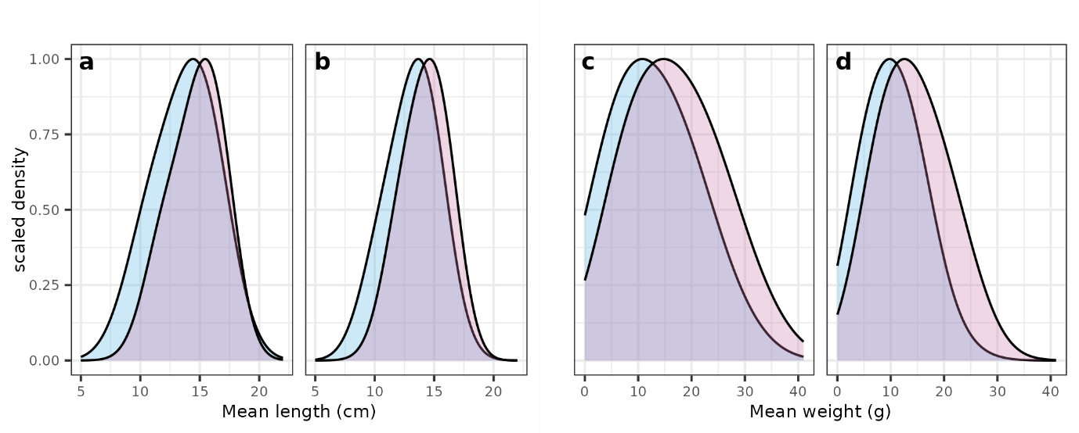
Fig S1 Mean length and mean weight distribution of male (a,c) and female (b,d) capelin for Period 1 (blue) and Period 2 (pink) showing the increase in length and weight of the overall population.

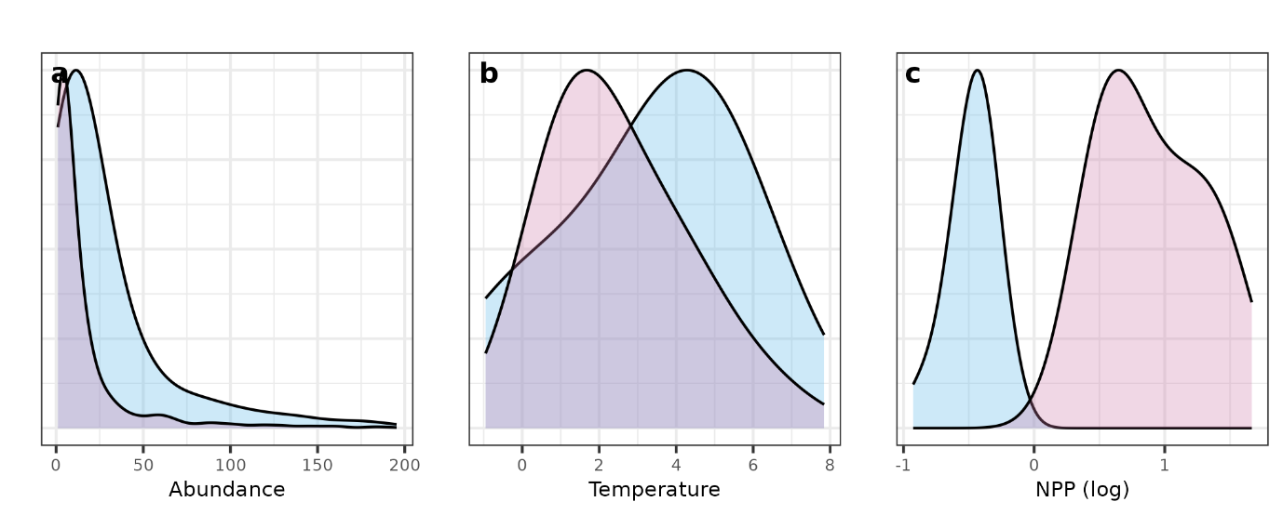
Fig S2 Distribution of abundance (a), temperature (b), and NPP (log scale) (c) in Period 1 (blue) and Period 2 (pink) showing the differences in population abundance, and temperature and NPP conditions in capelin habitat.

