Supplementary Material
Mantle overturn drove early lunar volcanism and the lunar dynamo during the high intensity epoch

S1 Dynamo simulations
We modify four parameters in our simulations to control: the maximum number of simultaneous diapirs that sink through the mantle, D_{max}; the distribution of diapir sizes (with a maximum diameter of 40 km), D_{size}; the maximum time between mantle overturn events, t_{off} ; and the melting time of Ti-rich diapirs a the CMB, c, to investigate their influence on the resulting dynamo. For D_{max} we show that allowing more diapirs to fall to the CMB simultaneously results in a larger average diapir volume for each overturn event, and consequently an increase in the generated surface magnetic field strengths. D_{max} also influences the total intermittent duration of the dynamo; the more diapirs that are released simultaneously, the quicker the entire budget of Ti-rich cumulate material is exhausted.
D_{size}, the distribution from which the diapirs are sampled (Figure S1), has an influence on the volume of material that sinks during each mantle overturn event. Diapirs are sampled from a one-tailed, normal distribution with a maximum diameter of 40 km. The standard deviation is varied from 1–40 km to sample uniformly across all diapir diameters ($D_{size}=1)$, and to bias the distribution towards smaller diapir sizes ($D_{size}=40)$. This results in higher surface magnetic field strengths and a shorter total intermittent dynamo duration when a higher number of large diapirs sink during each overturn event. Therefore, both D_{max} and D_{size} influence the duration of the intermittent dynamo, and play-off directly against t_{off}, the duration of gaps between overturn events.
In our simulations, t_{off} has the largest influence on the duration of the dynamo, since the maximum time between mantle overturn events spans the entire lunar geological history. t_{off} has no impact on any physical characteristics of the simulation, since it does not influence the volume of sinking material or the resulting melting time of material at the CMB. The greater the value of t_{off} the longer the intermittent dynamo is sustained for. Therefore, for simulations where the volume of material sinking to the CMB in a single time step is high, the gaps between overturn events must be long in order to sustain an intermittent dynamo for 100s of Ma.
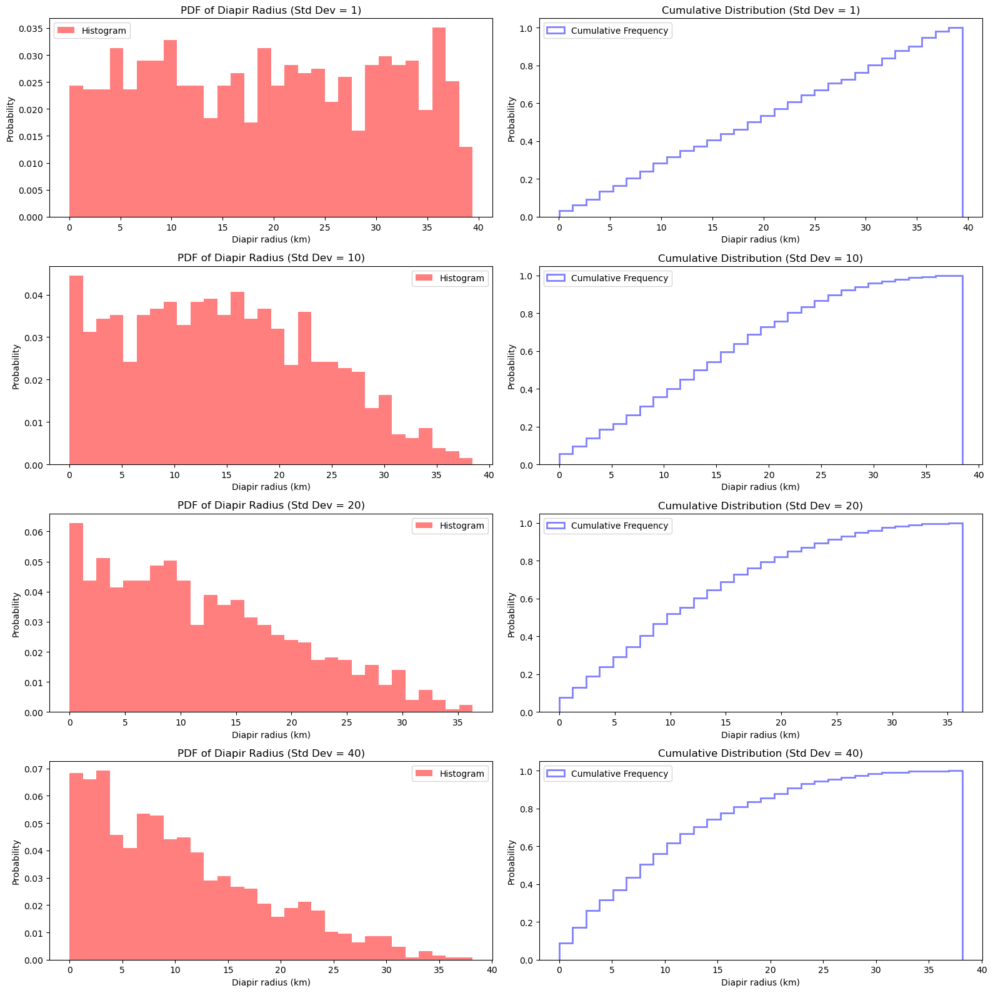
The melting time of diapirs once they reach the CMB is controlled by a constant, c, and three different relationship between melting time and diapirs are considered below. In all cases, melting time strongly influences the intensity of the resulting dynamo, but has very little influence on the total lifetime of the dynamo, since t_{off} must be at least two orders of magnitude larger than the melting times to generate an intermittent dynamo with sufficient strength (> 53 µT) that is sustained throughout the intermittent high intensity epoch (> 664 Ma).

Figure S1 Histograms (left panel) and cumulative distributions (right panel) of the sampled distribution of Ti-rich diapirs that sink within a single time step, controlled by D_{size} which varies 1 (top panels) to 40 (bottom panels). Lower values of D_{size} result in a more even distribution of diapir sizes across the entire range from a radius of 0–40 km. Larger values of D_{size} favour smaller diapirs, allowing an intermittent dynamo to be sustained for longer.

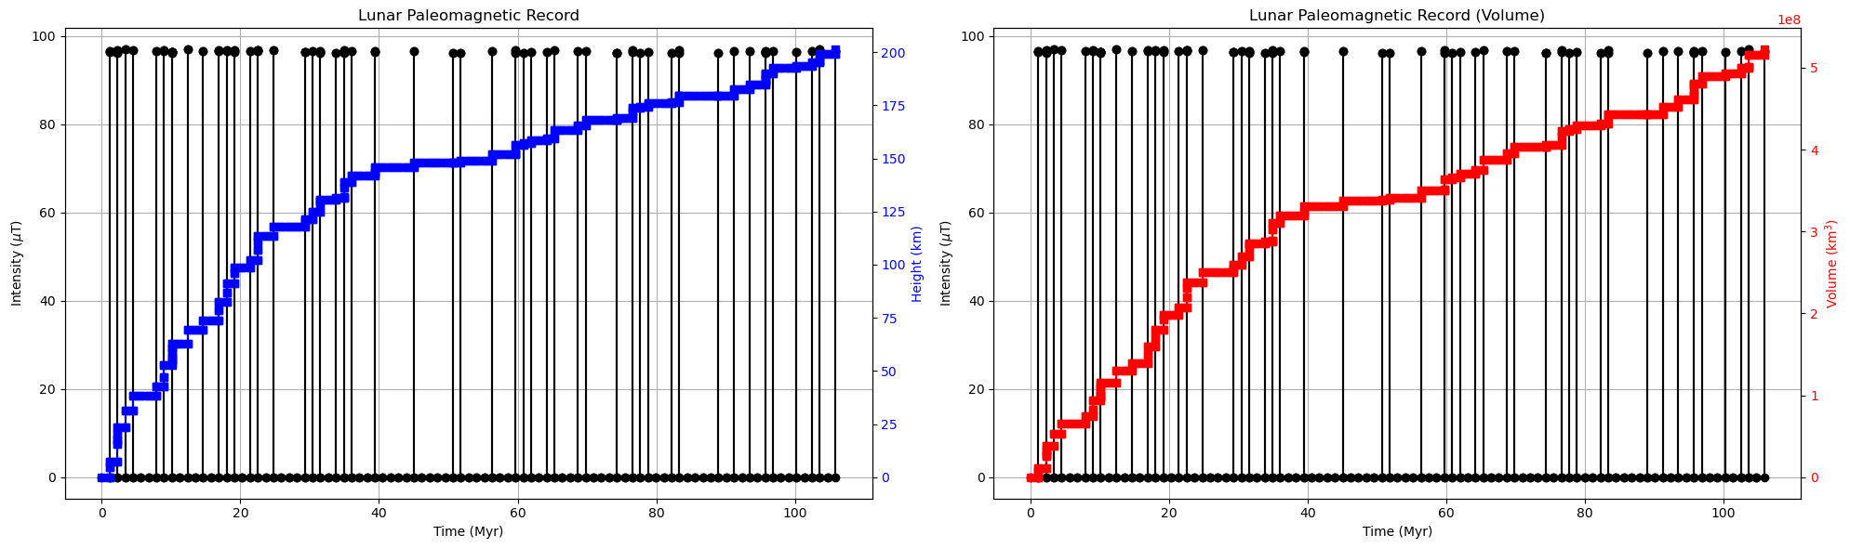
S1.1 Melting of Ti-cumulates: three considered scenarios
Figure S2 Simulated dynamo record for melting scenario 1, where D_{max} = 1000, D_{size} = 1000, t_{off} = 2000, c = 0.001. Black circles = predicted magnetic field strength at each progressive stochastic time step. Black line = predicted dynamo strength as a function of time. Each time step is represented by a black circle. Left panel: Blue squares = cumulative height of Ti-rich material that has sunk to CMB at stochastic time steps. Dashed red line = cumulative height of Ti-rich material that has sunk to the CMB as a function of time. Right panel: Red squares = cumulative volume of Ti-rich material that has sunk to CMB at stochastic time steps. Dashed red line = cumulative volume of Ti-rich material that has sunk to the CMB as a function of time.
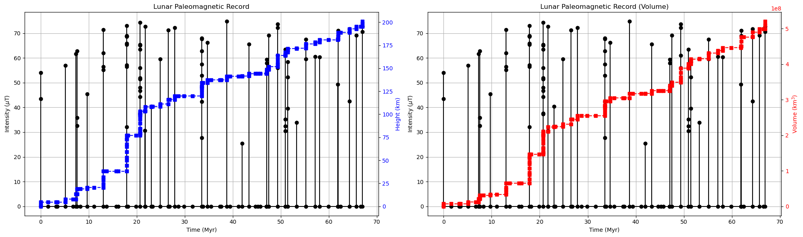
We generate simulated magnetic field histories for three different melting regimes. For Scenario 1, where Ti-rich cumulates are expected to spread uniformly over the CMB, and the melting time is proportional to the layer thickness at the CMB, we show that very uniform paleointensities are generated. This is because the Ti-rich cumulates are spread over a very large surface area (the surface of the core), and are therefore very thin regardless of the volume of Ti-rich material deposited.
Figure S3 Simulated dynamo record for melting scenario 2, where D_{max} = 1000, D_{size} = 1000, t_{off} = 2000, c = $1×{10}^{-7}$. Black circles = predicted magnetic field strength at each progressive stochastic time step. Black line = predicted dynamo strength as a function of time. Each time step is represented by a black circle. Left panel: Blue squares = cumulative height of Ti-rich material that has sunk to CMB at stochastic time steps. Dashed red line = cumulative height of Ti-rich material that has sunk to the CMB as a function of time. Right panel: Red squares = cumulative volume of Ti-rich material that has sunk to CMB at stochastic time steps. Dashed red line = cumulative volume of Ti-rich material that has sunk to the CMB as a function of time.
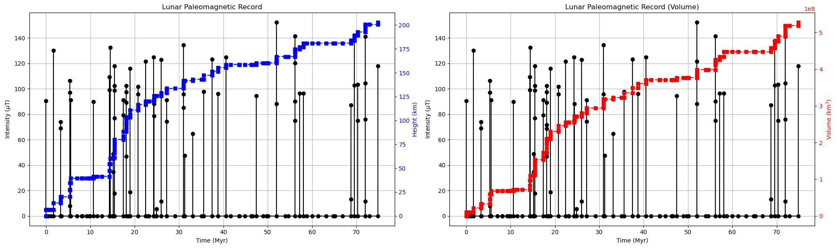
In Scenario 2, the melting time is proportional to the volume of the largest Ti-rich diapir sinking in a single time step. We assume that all diapirs melt simultaneously at a constant rate, and therefore the melting time is dictated by volume of the largest diapir. Scenario 2 results in substantially more variability in the generated magnetic field strengths. The extent of magnetic field strength variability depends upon the sampled distribution of diapirs in a single time step, D_{size}, with larger diapirs generating higher paleointensity values for a given melting constant, c. The smaller the value of c, the stronger the magnetic field strength for all diapir sizes, since melting time has a stronger control on CMB heat flux than the volume of Ti-rich material.
Figure S4 Simulated dynamo record for melting scenario 3, where D_{max} = 1000, D_{size} = 1000, t_{off} = 2000, c = 0.001. Black circles = predicted magnetic field strength at each progressive stochastic time step. Black line = predicted dynamo strength as a function of time. Each time step is represented by a black circle. Left panel: Blue squares = cumulative height of Ti-rich material that has sunk to CMB at stochastic time steps. Dashed red line = cumulative height of Ti-rich material that has sunk to the CMB as a function of time. Right panel: Red squares = cumulative volume of Ti-rich material that has sunk to CMB at stochastic time steps. Dashed red line = cumulative volume of Ti-rich material that has sunk to the CMB as a function of time.
In Scenario 3, melting time is investigated as an entirely independent factor, and has no relationship with the amount of Ti-rich material sinking in a single time step. This demonstrates that the melting time has a much stronger influence on the resulting paleointensities than the volume of Ti-rich material dropped. We find that regardless of the volume of sinking Ti-rich material, the melting time must be relatively short (< 1 ka) in order to generate the required minimum paleointensity criteria (> 53 µT). In addition, in order to sustain an intermittent dynamo for the minimum required duration (> 664 Ma) favours smaller volumes of material descending to the CMB in a single time step, since this depletes the total volume of Ti-rich cumulate material less quickly. The larger the volume of material released in a single time step, the longer the periods of cessation required between dynamo activity.
The main effect of varying the melting scenario is on magnetic field variability. Regardless of which melting scenario is chosen, no generated dynamo can fulfil the four criteria set by the observed paleomagnetic record (Figure S5). This is primarily because of the short melting times required to generate intense magnetic fields, which must then be offset by long periods of cessation in order to generate an intermittent dynamo for hundreds of millions of years. The percentage of time the dynamo is active for is therefore low, with the vast majority of simulations producing an active dynamo for < 1 % of its intermittent history. To some extent, this can be overcome by decoupling melting time and diapir size (Figure S5g-h), although only for very small volumes of diapir material that cannot generate the observed surface fields. Our results highlight that regardless of the exact melting regime of high-Ti cumulates in the deep lunar interior, an intermittent, intense dynamo can only be generated for a very short period of the observed IHIE.

S1.2 Field strength as a function of melting time
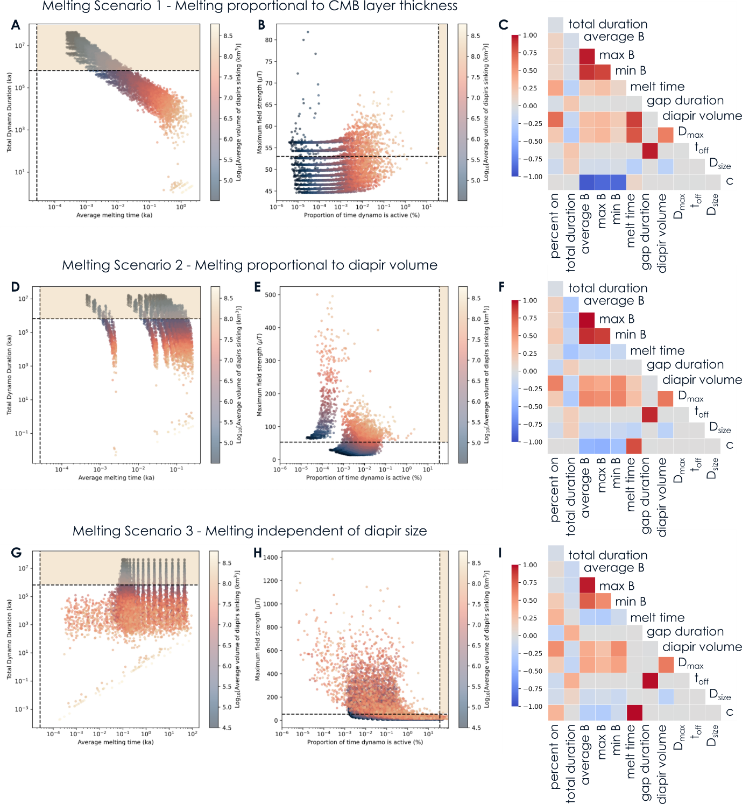
We calculate the maximum field strength generated for a range of melting times (0.1 a–100 ka) for all three melting scenarios (Figure S6). We find that in order to meet our criterion — that the maximum generated melting time must exceed 53 µT — melting times are always < 30 ka, regardless of diapir volume. The longest melting times are recovered for scenario 3, where melting and Ti diapir volume are entirely de-coupled. For melting scenarios 1 and 2, melting times must be less than 6 ka in order to generate the desired magnetic field strength. For both scenarios 1 and 2, high magnetic field strengths are only achieved over longer melting durations for larger diapirs. While these simulations meet the field criterion, they fail to meet the total intermittent dynamo duration criterion (> 664 Ma; Figure S5). As diapir size reduces, the duration criterion can be met, but melting times decrease to less than 10 years. This highlights the crux of the problem with a long-term intermittent dynamo since the cumulative melting times represent a very small proportion (< 0.4%) of the total record, at odds with the high number of measured Apollo samples that record strong paleointensity values (> 35%).
Figure S5 Parameter sweeps across D_{max}, D_{size}, t_{off} and c for the three different melting scenarios. A Total intermittent dynamo duration vs. average melting time for all combinations of parameters. Only small diapir volumes (shown by the colour bar) reach the criteria required by the observation record (shown by the yellow region). B Maximum magnetic field strength vs the proportion of time the dynamo is active for throughout the entire intermittent period. Only very rare, large volume diapirs meet criteria set by the observational record (yellow region). However, these fail to meet the criteria shown in A. C A correlation plot between the properties of the simulated dynamo: the total duration of the intermittent dynamo, the average, maximum and minimum generated field strength during periods of activity, the average melting time of Ti-rich cumulates at the CMB, the average gap between periods of activity and average volume of Ti-rich material sinking in a single time step. These are also correlated with the input parameters for the model D_{max}, D_{size}, t_{off} and c. The strength of positive and negative correlations are shown by the boldness of the red and blue colour, respectively. D, E, F and G, H, I show the same as A,B,C for melting scenarios 2 and 3, respectively.

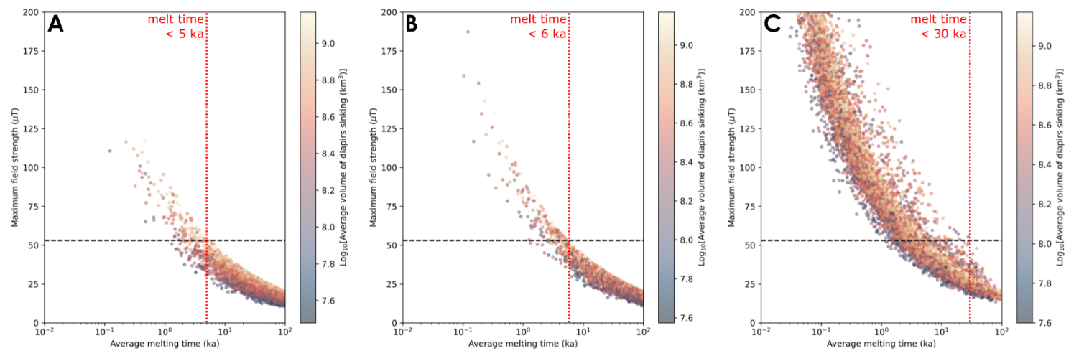
S2 Magnetic field strength variability as a potential proxy for deep mantle melting processes
Figure S6 Maximum generated field strength as a function of melting time for the three melting scenarios. Circles show individual simulations for fixed values of D_{max}, D_{size} and t_{Off} while c is varied. Circle colour represents the average volume of sinking Ti diapirs. The horiztonal black dashed line shows the minimum paleointensity that must be exceeded to explain the observational record (i.e., > 53 µT). The vertical red dotted line shows the maximum melting time required to meet this paleointensity criteria. A For melting scenario 1, melting must occur in less than 5 ka in order to produce the required paleointensity. B In melting scenario 2 melting must occur in less than 6 ka, and for C melting scenario 3, melting must occur in less than 30 ka.
In melting scenarios 1 and 2, where diapir volume and melting time are coupled, we consider the measured paleointensity values and whether these can be used to make inferences about the style of diapir melting.
In scenario 1, where diapirs are allowed to spread out over the CMB, the height of the resulting layer is relatively constant since the volume of material deposited is small compared to the surface area it is spread over. If we disregard existing cumulates at the CMB, this results in very consistent melting times and therefore similar magnetic field strengths every time the dynamo is active (Figure S2). This model may be realistic if the vast majority of material is returned to the lunar surface during melting. However, this cannot explain the mush zone observed at the CMB (Khan et al., 2014).
A more realistic physical model would consider the accumulation of layers at the CMB. As the cumulate pile grows, subsequent Ti-diapirs will not sink and spread out over the CMB, but will instead add to the existing layer thickness of Ti-rich cumulates. This Ti-rich cumulate layer will act to insulate the core, reducing the heat flux across the CMB. This may also increase the melting time of the cumulates as each subsequent layer is deposited, if melting is primarily thermally driven rather than pressure driven. The reducing heat flux across the CMB will cause a steady decline in paleointensity with time, hints of which are preserved in the existing paleomagnetic record (Strauss et al., 2021).
In scenario 2, where melting time is dependent upon the volume of sinking Ti-rich material, there is a much stronger correlation between the amount of material dropped and the resulting paleointensity. This can explain the scatter in the recovered paleointensities in high-Ti lunar basalts. Our results therefore are most well-aligned with Ti-rich cumulates that melt without spreading over the entire surface of the CMB. As sinking diapirs add to the increasing thickness of the cumulate pile at the CMB the core heat flux, and therefore surface magnetic field strengths, steadily decrease. Therefore scenario 2 can explain both the variability and apparent decrease in magnetic field strength with time throughout the lunar history.

S3 Lunar paleomagnetic record and the origin and eruption time of lunar basalts
Table S1 Compilation of age, paleointensity and composition of samples from the modern lunar paleomagnetic record. Samples from the IHIE are shown in itallics.
Sample |  | Age (Ma) | Age S.D. (Ma) | Study | Pint (µT) | Pint S.D. (µT) | Study | Apollo mission | Lithology | TiO₂ wt.%
15498 |  | 1470 | 450 |  | 5 | 2 | e | 15 | Regolith breccia
12008 |  | 3167 | 18 | a | 0 | 7 | f | 12 | olivine vitrophyre basalt | 4.82
12009 |  | 3167 | 18 | a | 0 | 7 | f | 12 | olivine vitrophyre basalt | 3.3
12015 |  | 3167 | 18 | a | 0 | 4 | f | 12 | olivine vitrophyre basalt | 3.2
12040 |  | 3167 | 18 | a | 0 | 0 | g | 12 | olivine-bearing basalt | 2.6
12017 |  | 3176 | 6 | a | 0 | 37 | e,h | 12 | pigeonite-bearing basalt | 3.4
12021 |  | 3176 | 6 | a | 0 | 0 | g | 12 | pigeonite-bearing basalt | 4.17
12053 |  | 3176 | 6 | a | 0 | 0 | g | 12 | pigeonite-bearing basalt | 3.5
12022 |  | 3187 | 11 | a | 0 | 4 | e | 12 | ilmenite-bearing basalt | 5.16
15016 |  | 3285 | 9 | a | 0 | 37 | e | 15 | ol-normative basalt | 3
15556 |  | 3285 | 9 | a | 0 | 75 | e | 15 | ol-normative basalt | 2.76
15597 |  | 3357 | 7 | a | 0 | 7 | e | 15 | qz-normative basalt | 1.87
60015 |  | 3500 | 50 | b | 0 | 5 | j | 16 | Cataclastic anorthosite
10071 |  | 3580 | 9 | a | 11 | 3 | k | 11 | High K ilmenite basalt (Group A) | 11.9
10017 |  | 3580 | 9 | a | 69 | 16 | l | 11 | High Ti, Group A basalt | 11.8
10049 |  | 3580 | 9 | a | 69 | 16 | l | 11 | High Ti, Group A basalt | 11.5
10069 |  | 3580 | 9 | c | 61 | 26 | k | 11 | High K ilmenite basalt (Group A) | 12.75
71055 |  | 3640 | 90 | d | 0 | 0 | g | 17 | vesicular ilmenite basalt | 14.51
10020 |  | 3747 | 3 | a | 66 | 37 | m | 11 | High Ti, Group B3 basalt | 10.7
74275 |  | 3753 | 5 | a | 28 | 84 | n | 17 | High Ti, Group C basalt | 13.1
70035 |  | 3754 | 6 | a | 0 | 0 | n | 17 | High Ti, Group A basalt | 13
71567 |  | 3754 | 6 | a | 111 | 333 | n | 17 | High Ti, Group A basalt | 12.98
75035 |  | 3754 | 6 | a | 51 | 14 | o | 17 | High Ti, Group A basalt | 9.98
75055 |  | 3754 | 6 | a | 57 | 17 | o | 17 | High Ti, Group A basalt | 11.41
70017 |  | 3764 | 12 | a | 42 | 126 | n | 17 | High Ti, Group B basalt | 13.75
70215 |  | 3764 | 12 | a | 95 | 0 | p | 17 | High Ti, Group B2 basalt | 13.2
71505 |  | 3764 | 12 | a | 95 | 285 | n | 17 | High Ti, Group B basalt | 10.5
10003 |  | 3854 | 8 | a | 54 | 5 | k | 11 | High Ti, Group B2 basalt | 12
62295 |  | 3866 | 12 | q | 0 | 0 | n | 16 | Impact melt breccia
68815 |  | 3875 | 245 |  | 0 | 0 | n | 16 | Polymict breccia
62235 |  | 3876 | 32 | q | 0 | 2.9 | j | 16 | Impact melt breccia
72215 |  | 3925 | 95 | r | 0 | 1.8 | j | 17 | Melt breccia
14053 |  | 3955 | 8 | a | 0 | 0 | g | 14 | Low Ti, Group C basalt | 2.91
60215 |  | 4100 | 200 |  | 0 | 0 | n | 16 | Cataclastic anorthosite
65315 |  | 4100 | 200 |  | 0 | 0 | n | 16 | Cataclastic anorthosite
76535 |  | 4236 | 15 | u | 30 | 10 | s,t | 17 | Troctolite | 0.05
78236 |  | 4333 | 59 | v | 0 | 0 | n | 17 | Shocked norite
60025 |  | 4359 | 2 | w | 0 | 0 | n | 16 | Ferroan Anorthosite
Paleomagnetic and geochronology study references used in Table S1 are as follows:
a (Snape et al., 2019), b (Schaeffer and Husain, 1974), c (Stöffler et al., 2006), d (Tera et al., 1974), e (Tikoo et al., 2014), f (Strauss et al., 2021), g (Tarduno et al., 2021), h (Buz et al., 2015), j (Lawrence et al., 2008), k (Jung et al., 2024), l (Suavet et al., 2013), m (Shea et al., 2012), n (Cournède et al., 2012), o (Nichols et al., 2021), p (Gattacceca et al., 2010), q (Norman et al., 2006), r (Schaeffer et al., 1982), s (Garrick-Bethell et al., 2009) , t (Garrick-Bethell et al., 2017), u (Premo and Tatsumoto, 1992), v (Edmunson et al., 2009), w (Borg et al., 2011).

We have compiled a list of modern paleomagnetic studies (conducted since 2008) across the entire lunar history (Table S1). For each measured sample, we summarise the paleointensity, lithology and the most up-to-date geochronology available. In particular, this has improved the age-constraints for the lunar basalts after a recent comprehensive, high resolution U-Pb geochronology study refined the ages of lunar volcanism (Snape et al., 2019). All basaltic samples are assigned to particular lava flows based on their mineralogy, composition and textural characteristics, as discussed below.
Apollo 11 basalts, which all have a high-Ti contents, are divided into Groups A (high K) and B (low K), and further subdivided into Group B1, B2 and B3 based on further petrographic distinctions (Beaty and Albee, 1978; Jerde et al., 1994; Snyder et al., 1994). Apollo 12 basalts, which all have a low-Ti content, are split into four types: olivine-bearing, pigeonite-bearing, ilmenite-bearing and feldspar-bearing (Papike et al., 1976). Apollo 15 basalts also have a low Ti-content, and are divided into olivine-normative and quartz-normative basalts based on their modal mineralogy (Brown et al., 1972; Butler, 1976; Longhi et al., 1972; McGee et al., 1977; Nord et al., 1973; Papike et al., 1976). The Apollo 17 basalts all have a high-Ti content, and are divided into 5 groups: A, B1, B2, C and D based on their whole-rock geochemistry (Brown et al., 1975; Neal et al., 1990; Paces et al., 1991; Papike et al., 1974; Rhodes et al., 1976; Ryder, 1990; Warner et al., 1979).
The contrasting paleointensity record between low-Ti and high-Ti basalts is consistent with their proposed different sources based on their Hf, Nd and Mg isotopic ratios (Beard et al., 1998; Klaver et al., 2024). Low-Ti basalts are thought to originate from a harzburgite source that crystallized when the lunar magma ocean was 65–85% solidified, while high-Ti basalts are associated with ilmenite-rich cumulates that sank to the CMB. This provides further evidence that the process driving the production of high-Ti lunar basalts was also driving the lunar dynamo. The later stage of high-Ti basalt eruption ca. 2.3 Ga ago is also thought to be associated with sinking of Ti-rich cumulates (Kato et al., 2017), and therefore a late mantle overturn even may have generated the magnetic field captured by a young regolith breccia (sample 15498; Tikoo et al., 2014).

S4 Statistical modelling of basalt TiO₂ content and paleointensity
We calculate the weighted mean, weighted variance and precision on the paleointensities recovered for low-Ti basalts (Table S2) and high-Ti basalts (Table S3). These were then used to compare the two populations to see if they are distinct using a Mann-Whitney U-test. The recovered Mann-Whitney U-statistic of 0.0 and corresponding p-value of $1 × {10}^{-4}$ indicates that the paleointensity measurements for the low-Ti basalts are significantly different than those measured for the high-Ti basalts.
Table S2 Weighted mean, variance and precision for low-Ti basalts
Sample | Paleointensity (µT) | Paleointensity S.D. (µT) |  | TiO₂ wt.% (max from literature) | Weighted mean | Weighted uncertainty | weighted normalized mean
76535 | 30.0 | 10.0 |  | 0.05 | 0.30 | 0.01 | 8.11
15597 | 0.0 | 7.0 |  | 1.87 | 0.00 | 0.02 | 0.05
15556 | 0.0 | 75.0 |  | 2.76 | 0.00 | 0.00 | 0.00
15016 | 0.0 | 37.0 |  | 3.00 | 0.00 | 0.00 | 0.00
12015 | 0.0 | 4.0 |  | 3.20 | 0.00 | 0.06 | 0.14
12009 | 0.0 | 7.0 |  | 3.30 | 0.00 | 0.02 | 0.05
12017 | 0.0 | 37.0 |  | 3.40 | 0.00 | 0.00 | 0.00
12008 | 0.0 | 7.0 |  | 4.82 | 0.00 | 0.02 | 0.05
12022 | 0.0 | 4.0 |  | 5.16 | 0.00 | 0.06 | 0.14
 |  |  |  | Total: | 0.30 | 0.20 | 8.55
 |  |  |  | weighted mean: | 1.52
 |  |  |  | weighted variance: | 6.97
 |  |  |  | precision: | 5.05

S5 Probability modelling
Table S3 Weighted mean, variance and precision for high-Ti basalts
Sample | Paleointensity (µT) | Paleointensity S.D. (µT) |  | TiO₂ wt.% (max from literature) | Weighted mean | Weighted uncertainty | weighted normalized mean
75035 | 51.0 | 14.0 |  | 9.98 | 0.26 | 0.01 | 3.03
71505 | 95.0 | 285.0 |  | 10.50 | 0.00 | 0.00 | 0.06
10020 | 66.0 | 37.0 |  | 10.70 | 0.05 | 0.00 | 1.13
75055 | 57.0 | 17.0 |  | 11.41 | 0.20 | 0.00 | 3.19
10049 | 69.0 | 16.0 |  | 11.50 | 0.27 | 0.00 | 7.01
10017 | 69.0 | 16.0 |  | 11.80 | 0.27 | 0.00 | 7.01
10071 | 11.0 | 3.0 |  | 11.90 | 1.22 | 0.11 | 27.16
10069 | 61.0 | 26.0 |  | 12.75 | 0.09 | 0.00 | 1.75
71567 | 111.0 | 333.0 |  | 12.98 | 0.00 | 0.00 | 0.06
74275 | 28.0 | 84.0 |  | 13.10 | 0.00 | 0.00 | 0.00
70017 | 42.0 | 126.0 |  | 13.75 | 0.00 | 0.00 | 0.01
10003 | 54.0 | 5.0 |  | 12.00 | 2.16 | 0.04 | 29.95
 |  |  |  | Total: | 4.53 | 0.17 | 80.37
 |  |  |  | weighted mean: | 26.64
 |  |  |  | weighted variance: | 22.72
 |  |  |  | precision: | 5.89

Apollo samples from the IHIE represent seven discrete time periods (Figure S7). For each of these time periods, at least one sample was used to recover a paleointensity that was within error of zero. For three of the time periods, positive paleointensities were recovered with statistical certainty (i.e., the lower bound on the paleointensity is greater than zero). We therefore calculate the probability, P, that the magnetic field was active for at least three (k = 3) out of the seven discrete time periods (n = 7). We vary the proportion of time the dynamo was active for, p, between 0–100% and calculating the resulting probability using
$$P\left(X≥k\right)=1-P(X<k)$$
where
$$P\left(X<k\right)= \sum_{k=0}^{k}{\left({n \atop k}\right)p^{k}{(1-p)}^{n-k}}$$
and
$$\left({n \atop k}\right)= \frac{n!}{k!(n-k)!}$$
Results of our probability model are shown in Figure S7. We find that there is a 1% chance, i.e., P(X ≥ 3) = 0.01, of recovering at least 3 positive paleointensities from a dynamo that was active 7% of the time (p = 0.07). We therefore take this as a conservative lower limit on the proportion of time the intermittent dynamo must have been active for in order to fulfil our observational criteria.
Next, we calculate P(X ≥ 3) for each recovered proportion of time the dynamo is active for, p, in our simulated dynamo histories (Figure S8). We show that for melting scenarios 1 and 2, where the other three observational criteria are met (for total dynamo duration, minimum magnetic field intensity and minimum melting time per event) the probability of recovering at least three positive paleointensities, $P\left(X≥3\right)$, is less than $1 × {10}^{-15}$. For melting scenario 3, $P\left(X≥3\right)$, is less than $1 × {10}^{-7}$. Therefore, in all cases it is highly improbable that the proposed dynamo mechanism resulted in the observed paleomagnetic record, unless dynamo generation and basalt eruption are inherently linked.
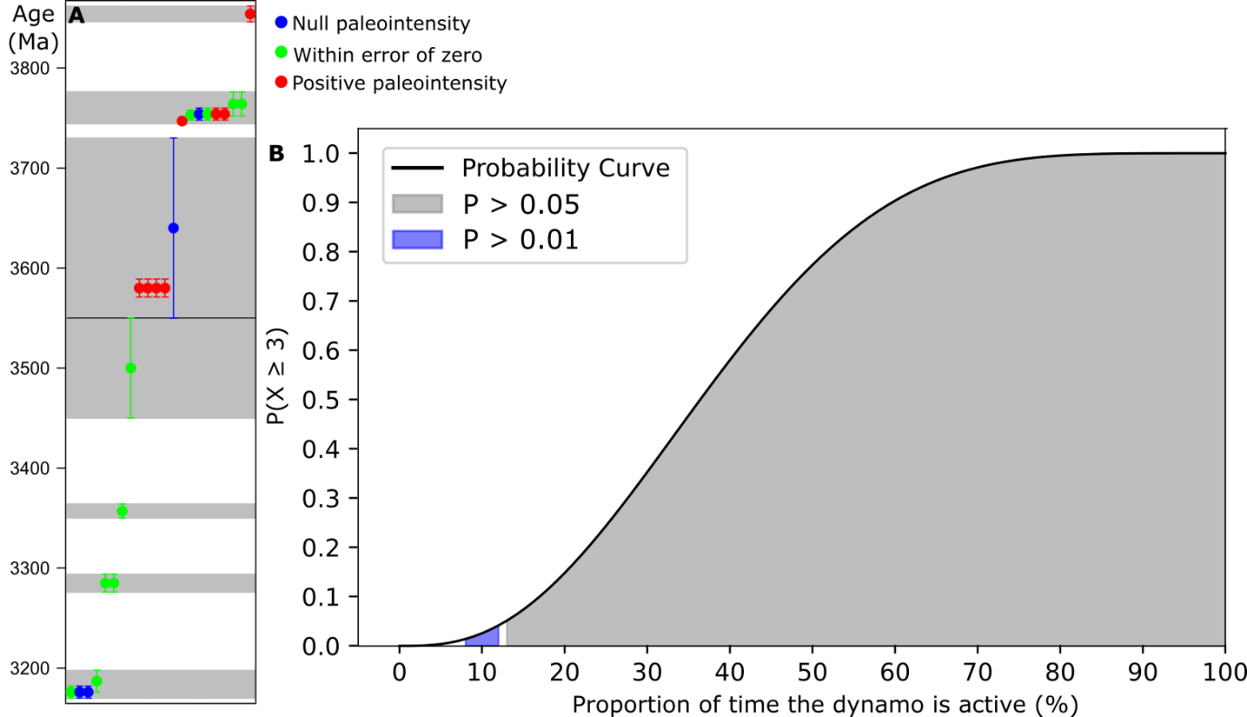
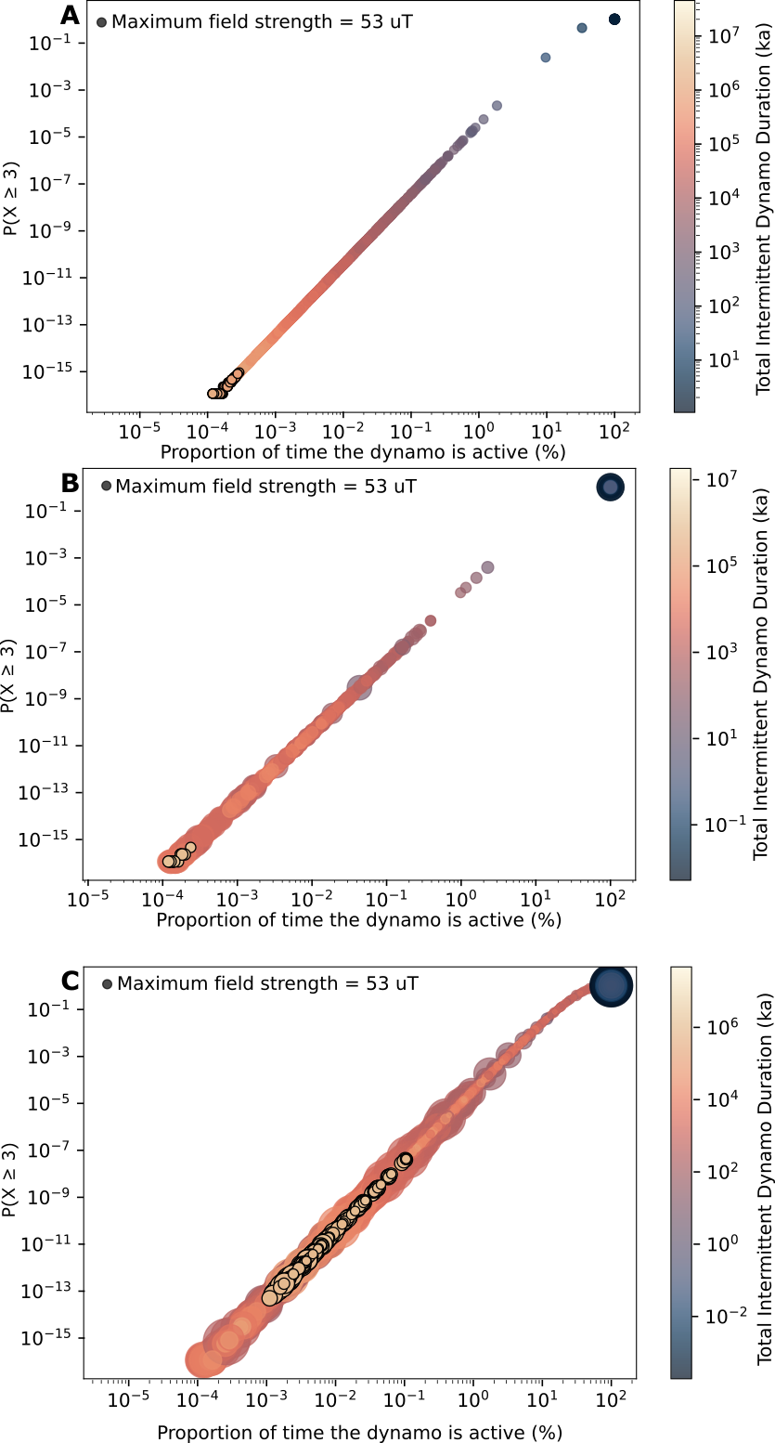
Figure S7 The discrete time periods captured Apollo samples from the IHIE, and the probability of recovering the observed paleomagnetic data. A The twenty-three samples from the IHIE are shown by circles with error bars (1 standard deviation) corresponding to their age. These samples fall into seven discrete time periods shown by the grey shaded regions. Circles are colour-coded red, green and blue to illustrate positive paleointensities, paleointensities within error of zero and null paleointensities, respectively. B The probability of recovering at least three positive paleointensities from seven discrete time periods as a function of the proportion of time for which the dynamo was active, ranging from 1–100 %. The blue shaded region shows highlights a 1–5% probability of recovering at least three positive paleointensities. The grey region highlights > 5% probability of recovering at least three positive paleointensities.
Figure S8 The probability of recovering at least three positive paleointensities from seven discrete time periods during the IHIE as a function of the proportion of time the intermittent dynamo was active for. Circles represent individual simulated dynamo histories. Circle size reflects the strength of the maximum recovered paleointensity. The circle size corresponding to 53 µT, the minimum value which must be exceeded to meet one of our observational criterion is shown on the legend. Circles are colour coded by the total duration of the intermittent dynamo. Circles that fulfil both criteria for the strength and duration of the magnetic field are outlined in black. A Model results for melting scenario 1. B Model results for melting scenario 2. C Model results for melting scenario 3.

Beard, B.L., Taylor, L.A., Scherer, E.E., Johnson, C.M., Snyder, G.A., 1998. The source region and melting mineralogy of high-titanium and low-titanium lunar basalts deduced from Lu-Hf isotope data. Geochim. Cosmochim. Acta 62, 525–544. https://doi.org/10.1016/S0016-7037(97)00373-6
Beaty, D., Albee, A., 1978. Comparative petrology and possible genetic relations among Apollo 11 basalts. Proc. Lunar Planet. Sci. 359–463.
Borg, L.E., Connelly, J.N., Boyet, M., Carlson, R.W., 2011. Chronological evidence that the Moon is either young or did not have a global magma ocean. Nature 477, 70–73. https://doi.org/10.1038/nature10328
Brown, G., Emeleus, C., Holland, J., Peckett, A., Phillips, R., 1972. Mineral-chemical variations in Apollo 14 and Apollo 15 basalts and granitic fractions. 1Proceedings Third Lunar Sci. Conf. 1, 141–157.
Brown, G.M., Peckett, A., Emeleus, C.H., Phillips, R., Pinsent, R.H., 1975. Petrology and mineralogy of Apollo 17 mare basalts, in: 6th Lunar Science Conference. pp. 1–13.
Butler, J., 1976. Variations in chemical composition of Apollo 15 mare basalts. Proc. Seventh Lunar Planet. Sci. Conf. 1429–1447.
Buz, J., Weiss, B.P., Tikoo, S.M., Shuster, D.L., Gattacceca, J., 2015. Magnetism of a very young lunar glass. J. Geophys. Res. Planets. https://doi.org/10.1002/2015JE004878.Received
Cournède, C., Gattacceca, J., Rochette, P., 2012. Magnetic study of large Apollo samples: Possible evidence for an ancient centered dipolar field on the Moon. Earth Planet. Sci. Lett. 331–332, 31–42. https://doi.org/10.1016/j.epsl.2012.03.004
Edmunson, J., Borg, L.E., Nyquist, L.E., Asmerom, Y., 2009. A combined Sm-Nd, Rb-Sr, and U-Pb isotopic study of Mg-suite norite 78238: Further evidence for early differentiation of the Moon. Geochim. Cosmochim. Acta 73, 514–527. https://doi.org/10.1016/j.gca.2008.10.021
Garrick-Bethell, I., Weiss, B.P., Shuster, D.L., Buz, J., 2009. Early lunar magnetism. Science (80-. ). 323, 356–9. https://doi.org/10.1126/science.1166804
Garrick-Bethell, I., Weiss, B.P., Shuster, D.L., Tikoo, S.M., Tremblay, M.M., 2017. Further evidence for early lunar magnetism from troctolite 76535. J. Geophys. Res. 122, 76–93. https://doi.org/10.1002/2016JE005154
Gattacceca, J., Boustie, M., Hood, L., Cuq-Lelandais, J.P., Fuller, M., Bezaeva, N.S., de Resseguier, T., Berthe, L., 2010. Can the lunar crust be magnetized by shock: Experimental groundtruth. Earth Planet. Sci. Lett. 299, 42–53. https://doi.org/10.1016/j.epsl.2010.08.011
Jerde, E.A., Snyder, G.A., Taylor, L.A., Yun-Gang, L., Schmitt, R.A., 1994. The origin and evolution of lunar high-Ti basalts: Periodic melting of a single source at Mare Tranquillitatis. Geochim. Cosmochim. Acta 58, 515–527. https://doi.org/10.1016/0016-7037(94)90480-4
Jung, J.-I., Tikoo, S.M., Burns, D., 2024. Assessing Lunar Paleointensity Variability During the 3.9 - 3.5 Ga High Field Epoch. Earth Planet. Sci. Lett. https://doi.org/10.1016/s0012-821x(04)00049-4
Kato, S., Morota, T., Yamaguchi, Y., Watanabe, S.I., Otake, H., Ohtake, M., 2017. Magma source transition of lunar mare volcanism at 2.3 Ga. Meteorit. Planet. Sci. 52, 1899–1915. https://doi.org/10.1111/maps.12896
Khan, A., Connolly, J.A.D., Pommier, A., Noir, J., 2014. Geophysical evidence for melt in the deep lunar interior 2197–2221. https://doi.org/10.1002/2014JE004661.Received
Klaver, M., Klemme, S., Liu, X.N., Hin, R.C., Coath, C.D., Anand, M., Lissenberg, C.J., Berndt, J., Elliott, T., 2024. Titanium-rich basaltic melts on the Moon modulated by reactive flow processes. Nat. Geosci. https://doi.org/10.1038/s41561-023-01362-5
Lawrence, K., Johnson, C., Tauxe, L., Gee, J., 2008. Lunar paleointensity measurements: Implications for lunar magnetic evolution. Phys. Earth Planet. Inter. 168, 71–87. https://doi.org/10.1016/j.pepi.2008.05.007
Longhi, J., Walker, D., Hays, J., 1972. Petrography and crystallization history of basalts 14310 and 14072. Proc. Third Lunar Sci. Conf. 1, 131–139.
McGee, P.E., Warner, J.L., Simonds, C.H., 1977. Introduction to the Apollo collections. Part 1: Lunar igneous rocks. JSC Publ.
Neal, C.R., Taylor, L.A., Hughes, S.S., Schmitt, R.A., 1990. The significance of fractional crystallization in the petrogenesis of Apollo 17 Type A and B high-Ti basalts. Geochim. Cosmochim. Acta 54, 1817–1833. https://doi.org/10.1016/0016-7037(90)90410-M
Nichols, C.I.O., Weiss, B.P., Getzin, B.L., Schmitt, H.H., Béguin, A., Rae, A.S.P., Shah, J., 2021. The palaeoinclination of the ancient lunar magnetic field from an Apollo 17 basalt. Nat. Astron. 5, 1216–1223. https://doi.org/10.1038/s41550-021-01469-y
Nord, G., Lally, J., Christie, J., Heuer, A., Fisher, R., Griggs, D., Radcliffe, S., 1973. High voltage electron microscopy of igneous rocks from Apollo 15 and 16. Abstr. Lunar Planet. Sci. Conf. 4, 564–566.
Norman, M.D., Duncan, R.A., Huard, J.J., 2006. Identifying impact events within the lunar cataclysm from 40Ar-39Ar ages and compositions of Apollo 16 impact melt rocks. Geochim. Cosmochim. Acta 70, 6032–6049. https://doi.org/10.1016/j.gca.2006.05.021
Paces, J.B., Nakai, S., Neal, C.R., Taylor, L.A., Halliday, A.N., Lee, D.C., 1991. A strontium and neodymium isotopic study of Apollo 17 high-Ti mare basalts: Resolution of ages, evolution of magmas, and origins of source heterogeneities. Geochim. Cosmochim. Acta 55, 2025–2043. https://doi.org/10.1016/0016-7037(91)90040-C
Papike, J., Bence, A., Lindsley, D., 1974. Mare basalts from the Taurus-Littrow region of the moon. Proc. Fifth Lunar Conf. 1, 471–504.
Papike, J.J., Hodges, F.N., Bence, A.E., 1976. Mare Basalts: Crystal Chemistry, Mineralogy, and Petrology 14.
Premo, W.R., Tatsumoto, M., 1992. U-Th-Pb, Rb-Sr, and Sm-Nd isotopic systematics of lunar troctolitic cumulate 76535: Implications on the age and origin of thes early lunar, deep-seated cumulate. Proc. Lunar Planet. Sci. 22, 381–397.
Rhodes, J., Hubbard, N., Wiesmann, H., Rodgers, K., Brannon, J., Bansal, B., 1976. Chemistry, classification, and petrogenesis of Apollo 17 mare basalts. Proc. Lunar Sci. Conf. 1467–1489.
Ryder, G., 1990. A distinct variant of high-titanium mare basalt from the Van Serg core, Apollo 17 landing site. Meteoritics 25, 249–258.
Schaeffer, O., Husain, L., 1974. Chronology of lunar basin formation and ages of lunar anorthositic rocks. Abstr. Lunar Planet. Sci. Conf. 5, 663.
Schaeffer, O., Warasila, R., Labotka, T., 1982. Ages of Serenitatis breccias. Lunar Planet. Sci. XIII Abstr. 685–686.
Shea, E.K., Weiss, B.P., Cassata, W.S., Shuster, D.L., Tikoo, S.M., Gattacceca, J., Grove, T.L., Fuller, M.D., 2012. A long-lived lunar core dynamo. Science (80-. ). 335, 453–456. https://doi.org/10.1126/science.1215359
Snape, J.F., Nemchin, A.A., Whitehouse, M.J., Merle, R.E., Hopkinson, T., Anand, M., 2019. The timing of basaltic volcanism at the Apollo landing sites. Geochim. Cosmochim. Acta 266, 29–53. https://doi.org/10.1016/j.gca.2019.07.042
Snyder, G.A., Lee, D.C., Taylor, L.A., Halliday, A.N., Jerde, E.A., 1994. Evolution of the upper mantle of the Earth’s Moon: Neodymium and strontium isotopic constraints from high-Ti mare basalts. Geochim. Cosmochim. Acta 58, 4795–4808. https://doi.org/10.1016/0016-7037(94)90209-7
Stöffler, D., Ryder, G., Ivanov, B.A., Artemieva, N.A., Cintala, M.J., Grieve, R.A.F., 2006. Cratering history and Lunar Chrnology. Rev. Mineral. Geochemistry 60, 519–596. https://doi.org/10.2138/rmg.2006.60.05
Strauss, B.E., Tikoo, S.M., Gross, J., Setera, J.B., Turrin, B., 2021. Constraining the decline of the lunar dynamo field at ≈ 3.1 Ga through paleomagnetic analyses of Apollo 12 mare basalts. J. Geophys. Res. 1–21. https://doi.org/10.1029/2020je006715
Suavet, C., Weiss, B.P., Cassata, W.S., Shuster, D.L., Gattacceca, J., Chan, L., Garrick-Bethell, I., Head, J.W., Grove, T.L., Fuller, M.D., 2013. Persistence and origin of the lunar core dynamo. Proc. Natl Acad. Sci. 110, 8453–8. https://doi.org/10.1073/pnas.1300341110
Tarduno, J.A., Cottrell, R.D., Lawrence, K., Bono, R.K., Huang, W., Johnson, C.L., Blackman, E.G., Smirnov, A. V, Nakajima, M., Neal, C.R., Zhou, T., Ibanez-Mejia, M., Oda, H., Crummins, B., 2021. Absence of a long-lived lunar paleomagnetosphere. Sci. Adv. 7, 1–15. https://doi.org/10.1126/sciadv.abi7647
Tera, F., Papanastassiou, D., Wasserburg, G., 1974. The lunar time scale and a summary of isotopic evidence for a terminal lunar cataclysm. Abstr. Lunar Planet. Sci. Conf. 5, 792.
Tikoo, S.M., Weiss, B.P., Cassata, W.S., Shuster, D.L., Gattacceca, J.J., Lima, E.A., Suavet, C.C., Nimmo, F., Fuller, M.D., 2014. Decline of the lunar core dynamo. Earth Planet. Sci. Lett. 404, 89–97. https://doi.org/10.1016/j.epsl.2014.07.010
Warner, R., Taylor, G., Conrad, G., Northrop, H., Barker, S., Keil, K., 1979. Apollo 17 high-Ti mare basalts: New bulk compositional data, magma types, and petrogenesis. Proc. Tenth Lunar Planet. Sci. Conf. 225–247.

