Phewas-based clustering of mendelian randomization instruments reveals predisposition of atrial fibrillation
Honghao H, Yi Z, Xiaohong W, Zhen Z, Ke Yang* and Mei Xin*
Department of Cardiovascular Surgery, General Hospital of Western Theater Command (Chengdu Military General Hospital), Chengdu 610036,
*Correspondence: yangke0119@163.com; xinmei197212@163.com

The causal effect of associated risk on AF: ukb-b-7352
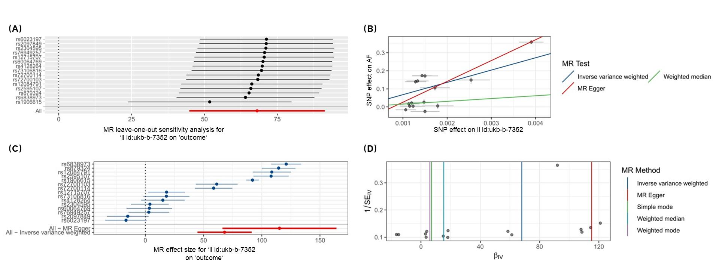
(A) MR leave-one-out sensitivity analysis. (B) MR scatter plot (Three detection methods, namely inverse variance weighted, weighted median, and mr-egger, were utilized). (C) MR_forest_plot. (D) MR_funnel_plot.

The causal effect of AF on associated risk: ukb-b-7352
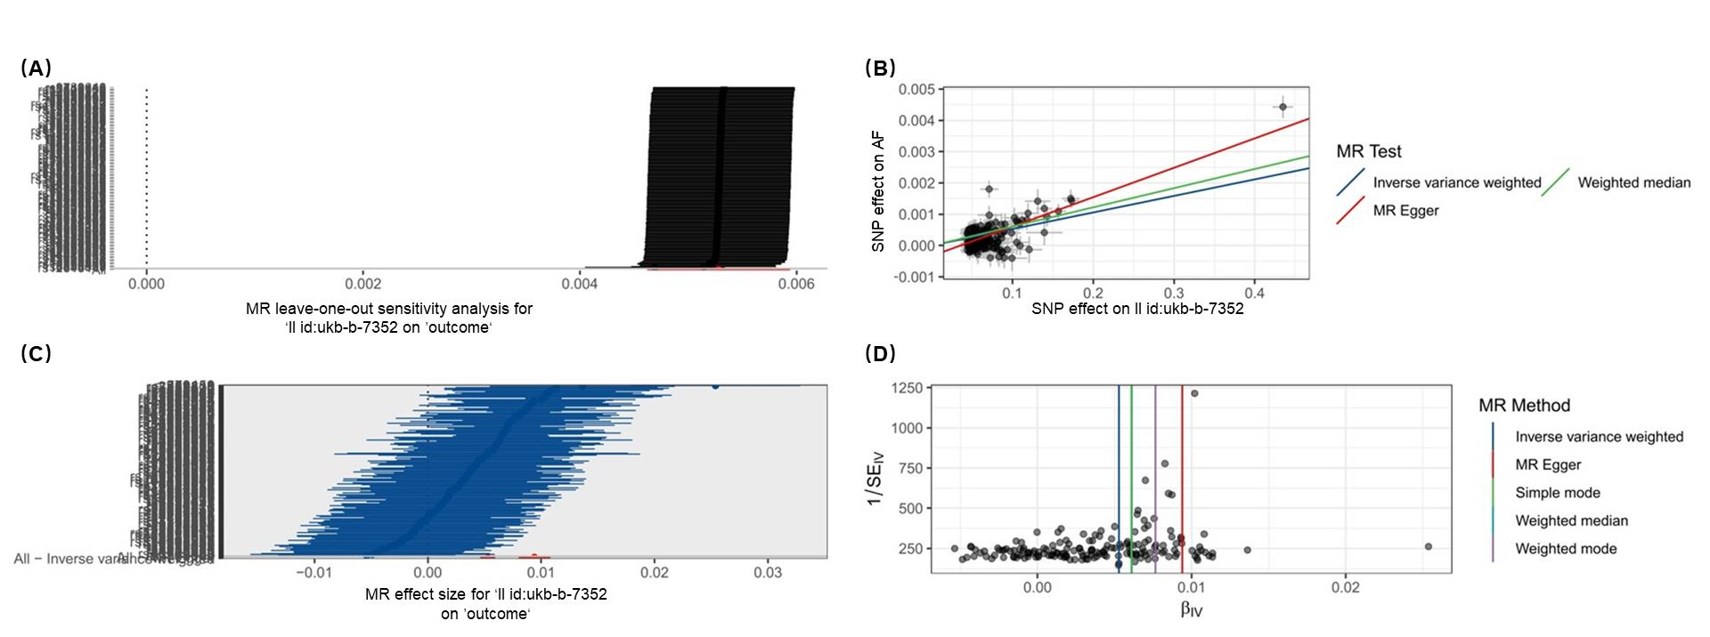
(A) MR leave-one-out sensitivity analysis. (B) MR scatter plot (Three detection methods, namely inverse variance weighted, weighted median, and mr-egger, were utilized). (C) MR_forest_plot. (D) MR_funnel_plot.

The causal effect of associated risk on AF: ukb-b-10272
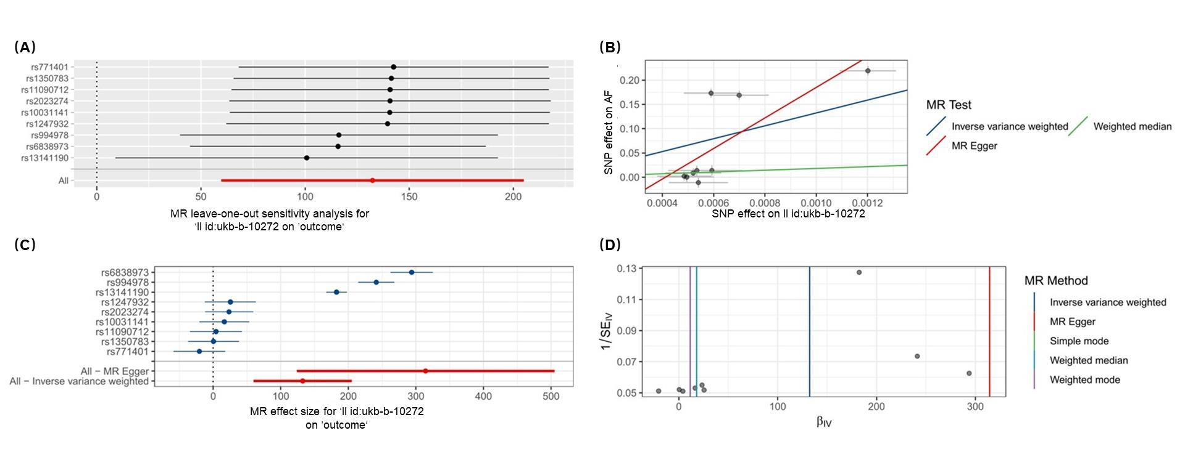
(A) MR leave-one-out sensitivity analysis. (B) MR scatter plot (Three detection methods, namely inverse variance weighted, weighted median, and mr-egger, were utilized). (C) MR_forest_plot. (D) MR_funnel_plot.

The causal effect of AF on associated risk: ukb-b-10272
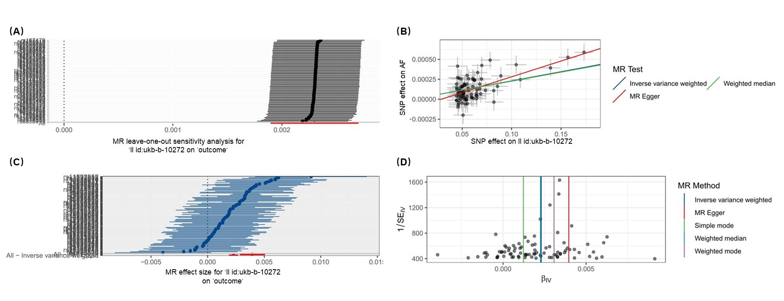
(A) MR leave-one-out sensitivity analysis. (B) MR scatter plot (Three detection methods, namely inverse variance weighted, weighted median, and mr-egger, were utilized). (C) MR_forest_plot. (D) MR_funnel_plot.

The causal effect of associated risk on AF: ukb-b-10444
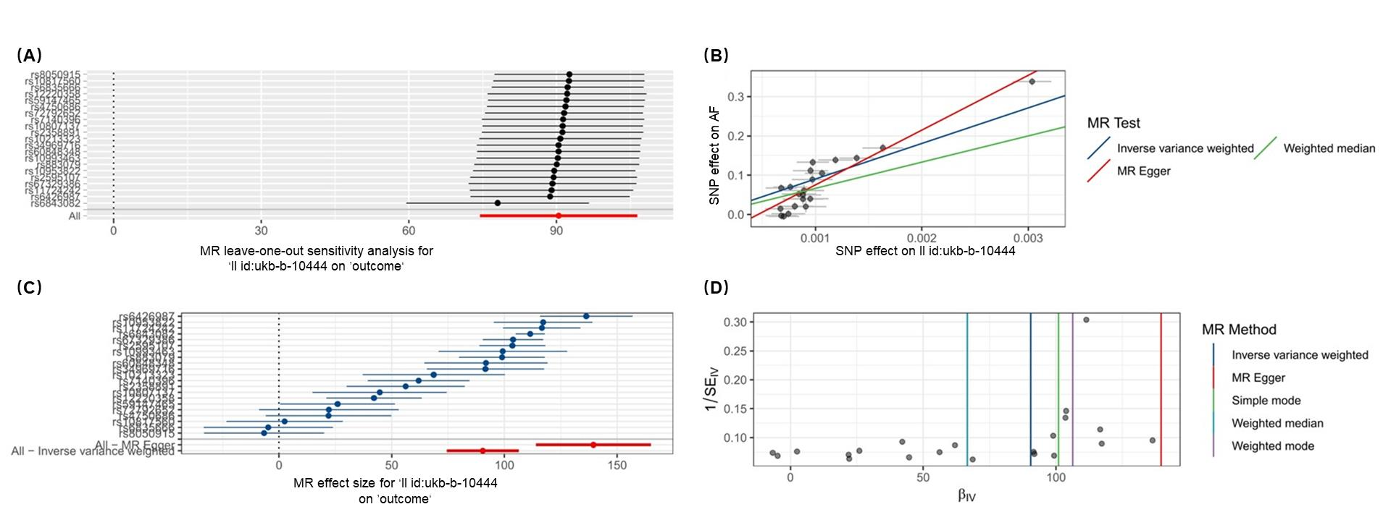
(A) MR leave-one-out sensitivity analysis. (B) MR scatter plot (Three detection methods, namely inverse variance weighted, weighted median, and mr-egger, were utilized). (C) MR_forest_plot. (D) MR_funnel_plot.

The causal effect of AF on associated risk: ukb-b-10444
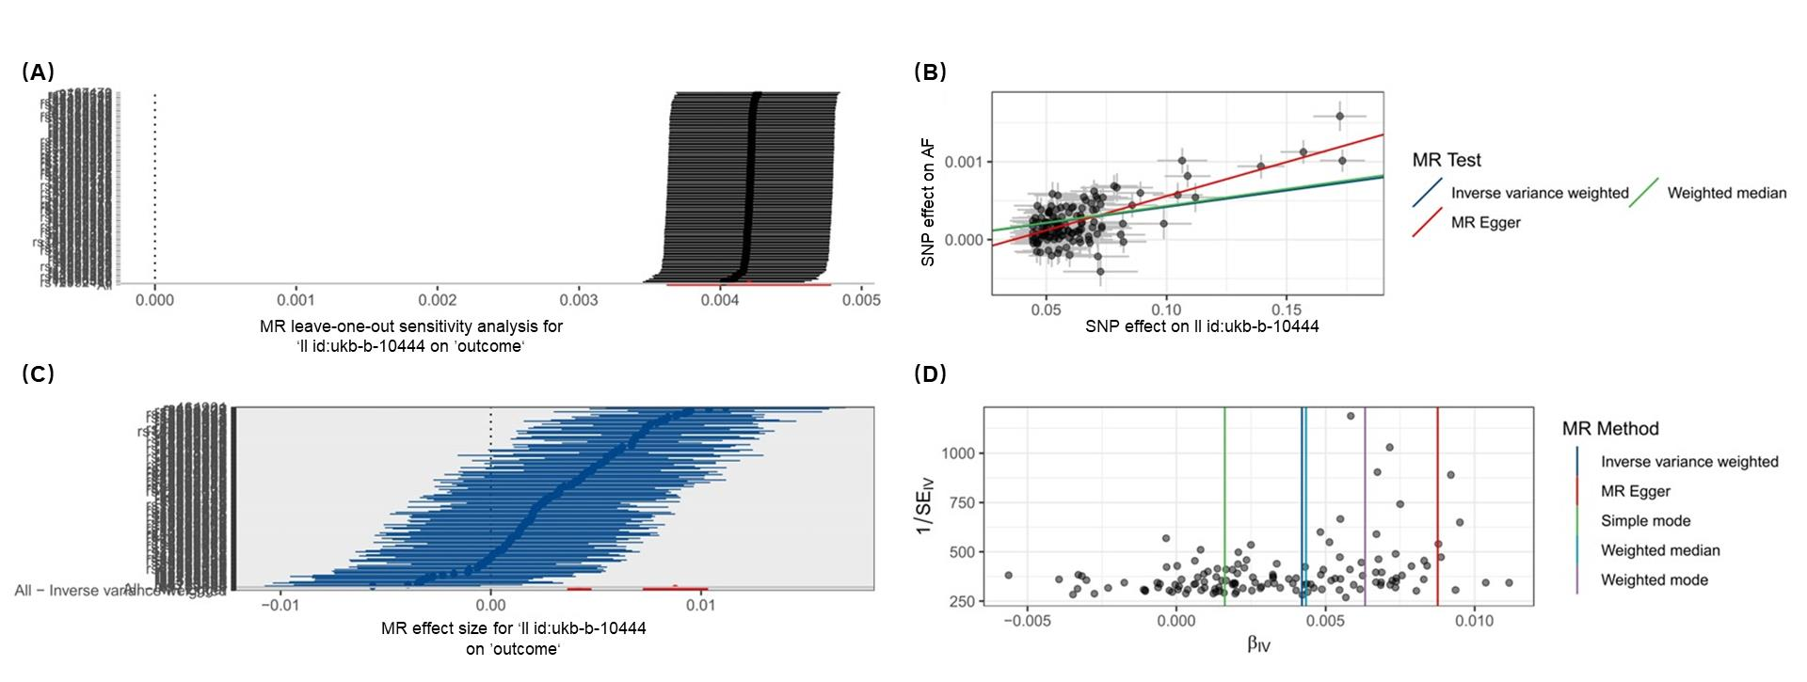
(A) MR leave-one-out sensitivity analysis. (B) MR scatter plot (Three detection methods, namely inverse variance weighted, weighted median, and mr-egger, were utilized). (C) MR_forest_plot. (D) MR_funnel_plot.

The causal effect of associated risk on AF: ukb-b-13248
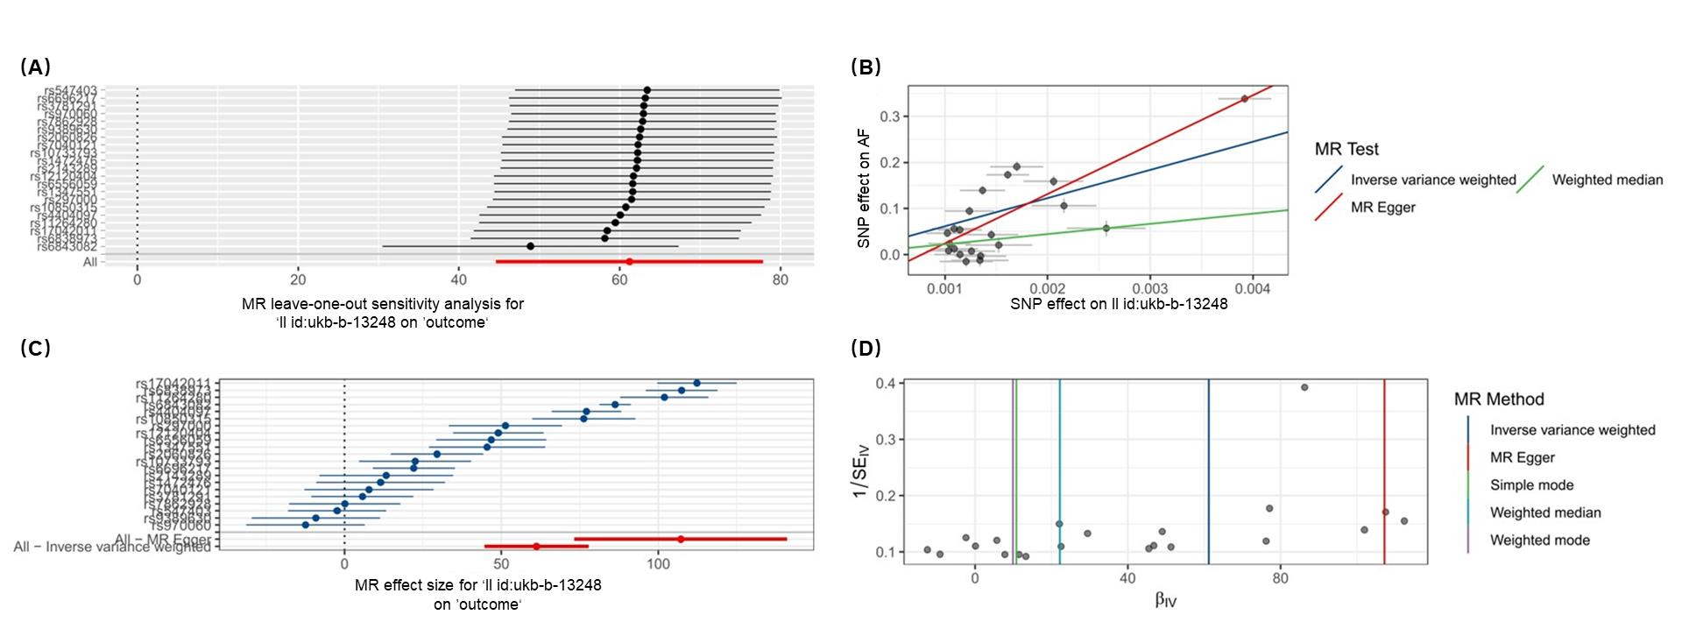
(A) MR leave-one-out sensitivity analysis. (B) MR scatter plot (Three detection methods, namely inverse variance weighted, weighted median, and mr-egger, were utilized). (C) MR_forest_plot. (D) MR_funnel_plot.

The causal effect of AF on associated risk: ukb-b-13248
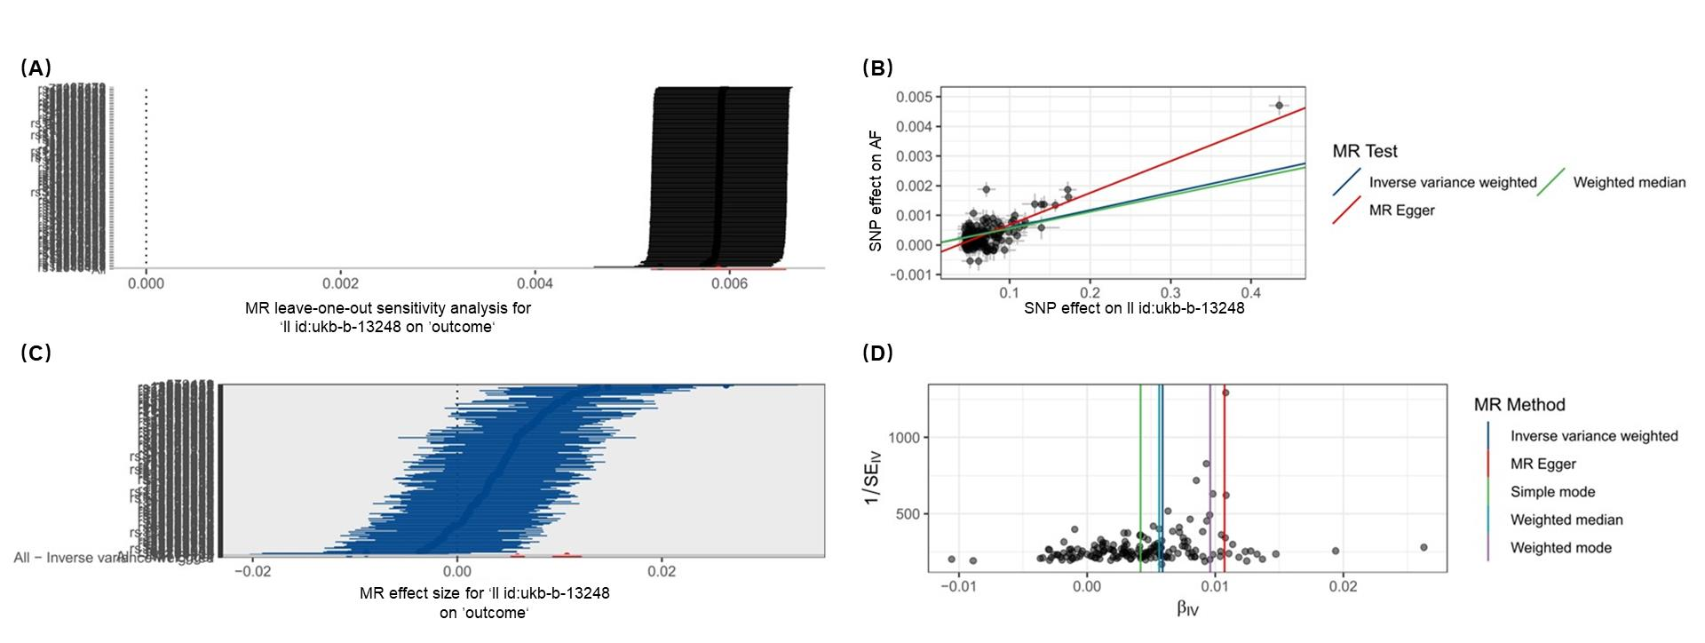
(A) MR leave-one-out sensitivity analysis. (B) MR scatter plot (Three detection methods, namely inverse variance weighted, weighted median, and mr-egger, were utilized). (C) MR_forest_plot. (D) MR_funnel_plot.

The causal effect of associated risk on AF: ukb-b-18103
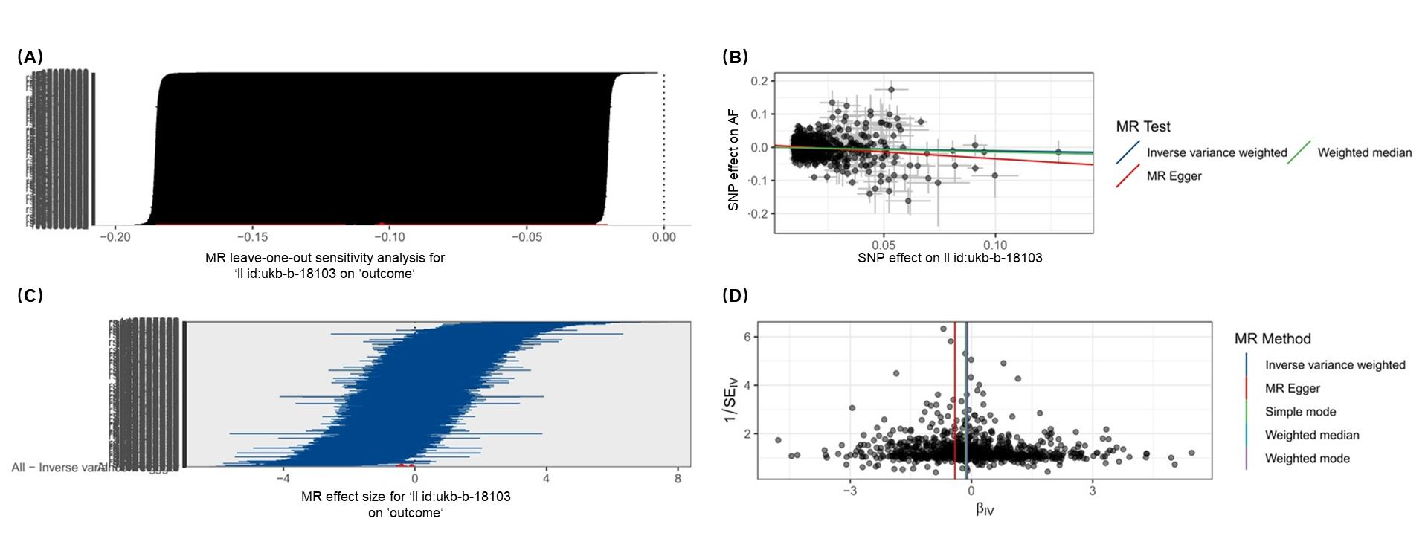
(A) MR leave-one-out sensitivity analysis. (B) MR scatter plot (Three detection methods, namely inverse variance weighted, weighted median, and mr-egger, were utilized). (C) MR_forest_plot. (D) MR_funnel_plot.

The causal effect of AF on associated risk: ukb-b-18103
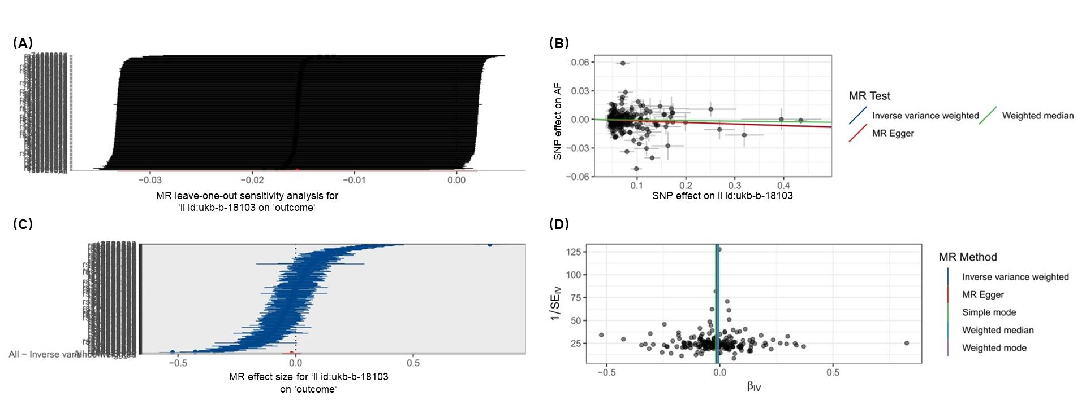
(A) MR leave-one-out sensitivity analysis. (B) MR scatter plot (Three detection methods, namely inverse variance weighted, weighted median, and mr-egger, were utilized). (C) MR_forest_plot. (D) MR_funnel_plot.

