Trophic Status Analysis and Nutrient Source Allocation in Urban Lakes of Dhaka, Bangladesh: A Comprehensive Approach to Eutrophication Monitoring
Table S1. Classification of Trophic Status and Water Quality Status of lakes Based on the trophic State Index (TSI), Trophic Level Index (TLI) & Water Quality Index (WQI) (Carlson et al., 1977; Burns et al., 2005; Brown et al., 1972; Tyagi et al.,2013)
Carlson Trophic State Index |  | Burns Trophic Level Index |  | Weighted Arithmetic Water Quality Index
TSI Range | Status | TLI Range | Status | WQI Range | Status
< 40 | Oligotrophic | 2-3 | Oligotrophic | 0-25 | Excellent
40-50 | Mesotrophic | 3-4 | Mesotrophic | 26-50 | Good
50-60 | Eutrophic(Mild) | 4-5 | Eutrophic | 51-75 | Poor
60-80 | Eutrophic | 5-6 | Super-trophic | 76-100 | Very Poor
>80 | Hyper eutrophic | >6 | Hyper eutrophic | >100 | Unsuitable

Table S2. Seasonal variation of Trophic State Index (TSI) and Trophic Level Index (TLI) of each sampling site of Dhanmondi, Gulshan, Banani Lakes during the year 2023-2024
Lake | Sampling Site | Trophic State Index (TSI) |  |  | Trophic Level Index (TLI)
Lake | Sampling Site | Monsoon | Post Monsoon | Pre-Monsoon | Monsoon | Post Monsoon | Pre-Monsoon
Dhanmondi | D-1 | 74.420 | 70.477 | 78.565 | 8.561 | 8.311 | 8.920
Dhanmondi | D-2 | 75.951 | 73.720 | 79.905 | 8.666 | 8.467 | 9.027
Dhanmondi | D-3 | 66.806 | 74.600 | 79.556 | 8.162 | 8.599 | 9.039
Dhanmondi | D-4 | 70.715 | 75.758 | 80.571 | 8.362 | 8.662 | 9.037
Dhanmondi | D-5 | 75.933 | 75.326 | 80.512 | 8.689 | 8.700 | 9.099
Gulshan | G-1 | 93.173 | 91.002 | 95.886 | 9.830 | 9.773 | 10.114
Gulshan | G-2 | 88.522 | 89.905 | 92.608 | 9.447 | 9.649 | 9.847
Gulshan | G-3 | 91.177 | 92.266 | 95.494 | 9.666 | 9.854 | 10.070
Gulshan | G-4 | 88.719 | 93.429 | 96.785 | 9.523 | 9.938 | 10.167
Gulshan | G-5 | 85.767 | 92.950 | 95.653 | 9.343 | 9.922 | 10.129
Banani | B-1 | 76.493 | 91.461 | 94.625 | 8.676 | 9.887 | 10.127
Banani | B-2 | 77.867 | 92.615 | 95.879 | 8.812 | 9.882 | 10.122
Banani | B-3 | 79.513 | 93.389 | 96.572 | 8.892 | 9.962 | 10.193
Banani | B-4 | 74.302 | 91.438 | 96.058 | 8.526 | 9.770 | 10.135
Banani | B-5 | 75.490 | 90.974 | 95.200 | 8.565 | 9.706 | 10.028

Table S3. Source apportioning contributions of water quality parameters of Dhanmondi Lake by the Positive Matrix Factorization (PMF) model
Parameters | Profile Contribution (ppm) |  | Profile Contribution (%)
Parameters | Factor 1 | Factor 2 | Factor 1 | Factor 2
Temperature | 60.86509096 | 39.13490904 | 14.668 | 9.4312
pH | 56.1823836 | 43.8176164 | 3.8481 | 3.0012
EC | 67.16370892 | 32.83629108 | 255.84 | 125.08
TDS | 65.12125656 | 34.87874344 | 115.01 | 61.599
Transparency | 53.76292068 | 46.23707932 | 33.34 | 28.673
Hardness | 64.79908784 | 35.20091216 | 65.924 | 35.812
Alkalinity | 53.85462445 | 46.14537555 | 53.797 | 46.096
NO₃- | 59.16832848 | 40.83167152 | 1.8099 | 1.249
PO₄- | 76.69737052 | 23.30262948 | 0.076771 | 0.023325
Chl-a | 62.64422337 | 37.35577663 | 0.48865 | 0.29139
DO | 51.90446662 | 48.09553338 | 2.7622 | 2.5595
BOD | 57.97333084 | 42.02666916 | 4.9693 | 3.6024
Turbidity | 6.1243E-06 | 99.99999388 | 6.88E-07 | 11.157

Table S4. Principal Component Analysis (PCA) of water quality parameters of Dhanmondi Lake
Chemical Component | Principal Component
Chemical Component | PC 1 | PC 2
Hardness | .984 | .105
Chl-a | .957 | -.132
EC | .930 | .246
TDS | .903 | .260
Transparency | -.889 | .316
DO | -.862 | .161
BOD | .827 | -.197
PO₄- | .690 | .465
NO₃- | .654 | .630
Temperature | .075 | .897
Alkalinity | .342 | -.872
Turbidity | .145 | -.685
pH | .400 | .522
Extraction Method: Principal Component Analysis.
Rotation Method: Varimax with Kaiser Normalization.

Table S5. Pearson’s correlation matrix of water quality parameters in Dhanmondi Lake.
 | Temp | pH | EC | TDS | Trans | TH | TA | NO₃⁻ | PO₄⁻ | Chl-a | DO | BOD | Turb
Temp | 1
pH | .953 | 1
EC | .472 | .717 | 1
TDS | .496 | .737 | 1.00* | 1
Trans | .205 | -.101 | -.766 | -.748 | 1
TH | .277 | .556 | .978 | .972 | -.884 | 1
TA | -.916 | -.751 | -.079 | -.107 | -.580 | .131 | 1
NO₃⁻ | .849 | .969 | .867 | .881 | -.344 | .743 | -.565 | 1
PO₄⁻ | .795 | .942 | .910 | .921 | -.431 | .803 | -.485 | .996 | 1
Chl-a | .062 | .362 | .909 | .897 | -.964 | .976 | .343 | .581 | .655 | 1
DO | .041 | -.264 | -.862 | -.847 | .986 | -.949 | -.438 | -.494 | -.574 | -.995 | 1
BOD | .029 | .331 | .895 | .882 | -.972 | .968 | .374 | .554 | .630 | .999* | -.998* | 1
Turb | -.935 | -.783 | -.128 | -.156 | -.540 | .082 | .999* | -.605 | -.527 | .297 | -.393 | .328 | 1
*. Correlation is significant at the 0.05 level (2-tailed).
**. Correlation is significant at the 0.01 level (2-tailed).
Temp=Temperature; EC=Electric Conductivity; Trans.=Transparency; TDS=Total Dissolved Solid; TA=Total Alkalinity; TH=Total Hardness; NO₃⁻ =Nitrate; PO₄⁻ =Phosphate; Chl-a =Chlorophyll-a; DO = Dissolved Oxygen; BOD= Biological Oxygen Demand; Turb = Turbidity.

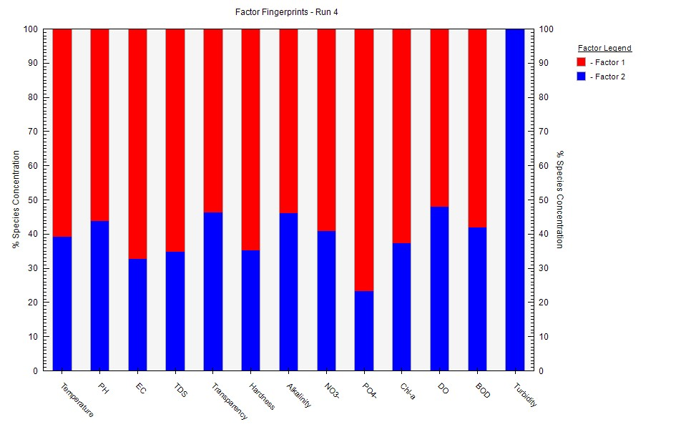
Fig S1. Fingerprint of Factor contribution of Dhanmondi Lake
Table S6. Source apportioning contributions of water quality parameters of Gulshan Lake by the Positive Matrix Factorization (PMF) model
Parameters | Profile Contribution (ppm) |  |  |  | Profile Contribution (%)
Parameters | Factor 1 | Factor 2 | Factor 3 | Factor 4 | Factor 1 | Factor 2 | Factor 3 | Factor 4
Temperature | 4.6311 | 6.0121 | 3.0052 | 12.514 | 17.701 | 22.98 | 11.487 | 47.832
PH | 1.068 | 2.0086 | 0.72211 | 3.3172 | 15.009 | 28.227 | 10.148 | 46.617
EC | 162.06 | 242.36 | 97.114 | 195.99 | 23.234 | 34.746 | 13.923 | 28.098
TDS | 104.34 | 97.151 | 62.803 | 92.311 | 29.259 | 27.243 | 17.611 | 25.886
Transparency | 0.6544 | 5.095 | 1.1546 | 10.033 | 3.864 | 30.082 | 6.817 | 59.237
Hardness | 24.943 | 39.325 | 12.161 | 80.451 | 15.899 | 25.067 | 7.752 | 51.282
Alkalinity | 23.427 | 61.017 | 7.1049 | 83.655 | 13.371 | 34.826 | 4.055 | 47.747
NO₃- | 1.034 | 1.1802 | 0.53631 | 1.9201 | 22.138 | 25.269 | 11.483 | 41.11
PO₄- | 0.094157 | 0.14156 | 0.11608 | 0.29573 | 14.541 | 21.862 | 17.927 | 45.671
Chl-a | 0.14856 | 0.18778 | 0.13965 | 0.43027 | 16.393 | 20.72 | 15.409 | 47.478
DO | 0.92058 | 1.2979 | 0.41301 | 2.2291 | 18.94 | 26.703 | 8.497 | 45.861
BOD | 3.2398 | 4.9954 | 1.8246 | 8.3742 | 17.575 | 27.099 | 9.898 | 45.428
Turbidity | 2.2863 | 0.40688 | 31.594 | 19.772 | 4.229 | 0.753 | 58.443 | 36.575
Table S7. Principal Component Analysis (PCA) of water quality parameters of Gulshan Lake
Chemical Component | Principal Component
Chemical Component | PC 1 | PC 2 | PC 3 | PC 4
Chl-a | .940 | .097 | -.063 | .227
Hardness | .905 | -.168 | -.316 | -.023
Transparency | -.854 | -.421 | .107 | -.244
NO₃- | .753 | .473 | -.031 | .382
EC | .195 | .934 | -.156 | .154
TDS | .387 | .882 | .169 | .177
pH | -.411 | .869 | .149 | -.104
BOD | .607 | .727 | -.043 | .228
Temperature | -.167 | .100 | .947 | -.048
Alkalinity | .259 | .130 | -.894 | .103
Turbidity | .499 | .123 | .595 | -.212
PO₄- | -.093 | -.036 | .224 | -.915
DO | .475 | .421 | .027 | .703
Extraction Method: Principal Component Analysis.
Rotation Method: Varimax with Kaiser Normalization.

Table S8. Pearson’s correlation matrix of water quality parameters in Gulshan Lake
 | Temp | pH | EC | TDS | Trans | TH | TA | NO₃⁻ | PO₄⁻ | Chl-a | DO | BOD | Turb
Temp | 1
pH | .946 | 1
EC | .250 | .550 | 1
TDS | .374 | .654 | .992 | 1
Trans | .210 | -.118 | -.894 | -.829 | 1
TH | -.706 | -.438 | .509 | .394 | -.841 | 1
TA | -.943 | -.784 | .087 | -.043 | -.524 | .901 | 1
NO₃⁻ | -.205 | .123 | .896 | .831 | -1.00** | .838 | .52 | 1
PO₄⁻ | .731 | .471 | -.478 | -.360 | .821 | -.999* | -.917 | -.818 | 1
Chl-a | -.421 | -.104 | .773 | .684 | -.975 | .940 | .699 | .974 | -.927 | 1
DO | -.185 | .143 | .905 | .842 | -1.00* | .827 | .502 | 1.00* | -.806 | .969 | 1
BOD | .104 | .421 | .989 | .962 | -.950 | .631 | .233 | .952 | -.602 | .858 | .958 | 1
Turb | .753 | .926 | .825 | .892 | -.485 | -.065 | -.491 | .489 | .102 | .280 | .507 | .733 | 1
*. Correlation is significant at the 0.05 level (2-tailed).
**. Correlation is significant at the 0.01 level (2-tailed).
Temp=Temperature; EC=Electric Conductivity; Trans.=Transparency; TDS=Total Dissolved Solid; TA=Total Alkalinity; TH=Total Hardness; NO₃⁻ =Nitrate; PO₄⁻ =Phosphate; Chl-a =Chlorophyll-a; DO = Dissolved Oxygen; BOD= Biological Oxygen Demand; Turb = Turbidity.

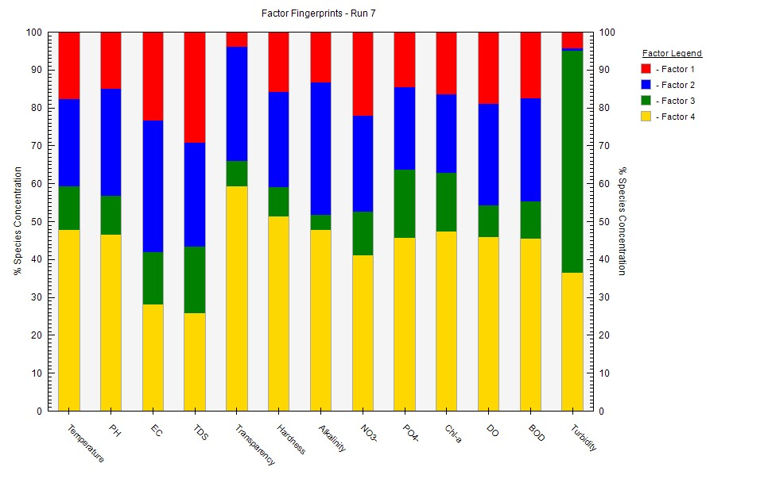
Fig S2. Fingerprint of Factor contribution of Gulshan Lake
Table S9. Source apportioning contributions of water quality parameters of Banani Lake by the Positive Matrix Factorization (PMF) model
Parameters | Profile Contribution (ppm) |  |  | Profile Contribution (%)
Parameters | Factor 1 | Factor 2 | Factor 3 | Factor 1 | Factor 2 | Factor 3
Temperature | 6.6577 | 6.1087 | 13.122 | 25.717 | 23.596 | 50.687
pH | 1.0572 | 2.4161 | 3.6055 | 14.935 | 34.131 | 50.934
EC | 166.2 | 278.31 | 207.98 | 25.472 | 42.654 | 31.875
TDS | 99.85 | 157.74 | 85.317 | 29.119 | 46.001 | 24.881
Transparency | 0.22469 | 5.9713 | 12.96 | 1.173 | 31.172 | 67.655
Hardness | 20.646 | 42.492 | 59.924 | 16.777 | 34.529 | 48.694
Alkalinity | 3.789 | 49.153 | 79.599 | 2.859 | 37.085 | 60.056
NO₃- | 0.60869 | 1.5233 | 2.4998 | 13.142 | 32.888 | 53.97
PO₄- | 0.28273 | 0.1933 | 0.081656 | 50.697 | 34.661 | 14.642
Chl-a | 0.15646 | 0.25213 | 0.56663 | 16.044 | 25.854 | 58.103
DO | 1.0224 | 1.0275 | 2.9763 | 20.341 | 20.443 | 59.216
BOD | 2.1082 | 4.7991 | 7.7962 | 14.338 | 32.639 | 53.023
Turbidity | 37.96 | 5.6843 | 0.64099 | 85.717 | 12.836 | 1.447

Table S10. Principal Component Analysis (PCA) of water quality parameters of Banani Lake
Chemical Component | Principal Component
Chemical Component | PC 1 | PC 2 | PC 3
Transparency | -.964 | -.194 | .113
Chl-a | .935 | -.145 | -.106
BOD | .920 | .342 | -.165
NO₃- | .910 | .139 | -.052
PO₄- | .909 | .240 | .050
Hardness | .879 | .261 | -.110
DO | -.791 | -.500 | .222
pH | -.126 | .950 | .185
TDS | .498 | .856 | -.043
EC | .504 | .843 | -.083
Temperature | -.061 | -.002 | .977
Alkalinity | .319 | .016 | -.907
Turbidity | .567 | .375 | .572
Extraction Method: Principal Component Analysis.
Rotation Method: Varimax with Kaiser Normalization.

Table S11. Pearson’s correlation matrix of water quality parameters in Banani Lake
 | Temp | pH |  | EC |  | TDS |  | Trans |  | TH |  | TA |  | NO₃⁻ |  | PO₄⁻ |  | Chl-a |  | DO |  | BOD |  | Turb
Temp | 1
pH | .827 | 1
EC | .171 | .696 | 1
TDS | .247 | .750 | .997* |  | 1
Trans | .262 | -.326 | -.906 |  | -.870 |  | 1
TH | -.171 | .413 | .941 |  | .912 |  | -.996 |  | 1
TA | -.957 | -.628 | .121 |  | .044 |  | -.531 |  | .449 |  | 1
NO₃⁻ | -.301 | .287 | .888 |  | .849 |  | -.999* |  | .991 |  | .564 |  | 1
PO₄⁻ | -.143 | .439 | .951 |  | .924 |  | -.993 |  | 1.00* |  | .423 |  | .987 |  | 1
Chl-a | -.405 | .179 | .831 |  | .786 |  | -.989 |  | .970 |  | .652 |  | .994 |  | .963 |  | 1
DO | .178 | -.407 | -.939 |  | -.909 |  | .996 |  | -1.00** |  | -.455 |  | -.992 |  | -.999* |  | -.972 |  | 1
BOD | -.219 | .368 | .924 |  | .892 |  | -.999* |  | .999* |  | .492 |  | .996 |  | .997* |  | .981 |  | -.999* |  | 1
Turb | .574 | .935 | .905 |  | .936 |  | -.640 |  | .709 |  | -.312 |  | .608 |  | .729 |  | .516 |  | -.704 |  | .674 |  | 1
*. Correlation is significant at the 0.05 level (2-tailed).
**. Correlation is significant at the 0.01 level (2-tailed).
Temp=Temperature; EC=Electric Conductivity; Trans.=Transparency; TDS=Total Dissolved Solid; TA=Total Alkalinity; TH=Total Hardness; NO₃⁻ =Nitrate; PO₄⁻ =Phosphate; Chl-a =Chlorophyll-a; DO = Dissolved Oxygen; BOD= Biological Oxygen Demand; Turb = Turbidity.

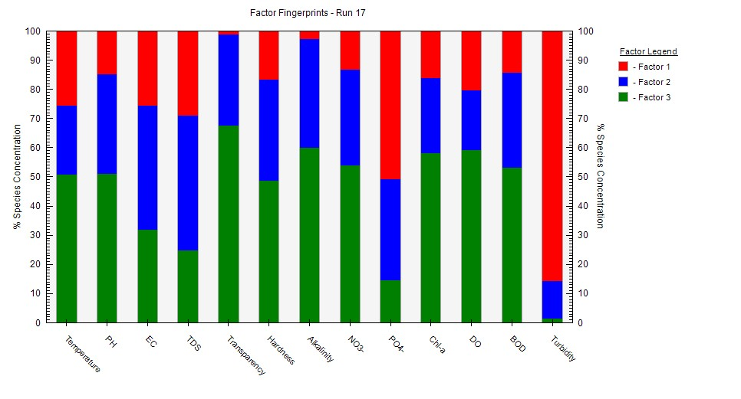
Fig S3. Fingerprint of Factor contribution of Banani Lake

References
Brown, R. M., McClelland, N. I., Deininger, R. A., & O’Connor, M. F. (1972). A water quality index—crashing the psychological barrier. In Indicators of Environmental Quality: Proceedings of a symposium held during the AAAS meeting in Philadelphia, Pennsylvania, December 26–31, 1971 (pp. 173-182). Springer US.
Burns, N., McIntosh, J., & Scholes, P. (2005). Strategies for managing the lakes of the Rotorua District, New Zealand. Lake and Reservoir management, 21(1), 61-72. https://doi.org/10.1080/07438140509354413
Carlson, R. E. (1977). A trophic state index for lakes 1. Limnology and oceanography, 22(2), 361-369. https://doi.org/10.4319/lo.1977.22.2.0361
Tyagi, S., Sharma, B., Singh, P., & Dobhal, R. (2013). Water quality assessment in terms of water quality index. American Journal of water resources, 1(3), 34-38. https://doi.org/10.12691/ajwr-1-3-3

