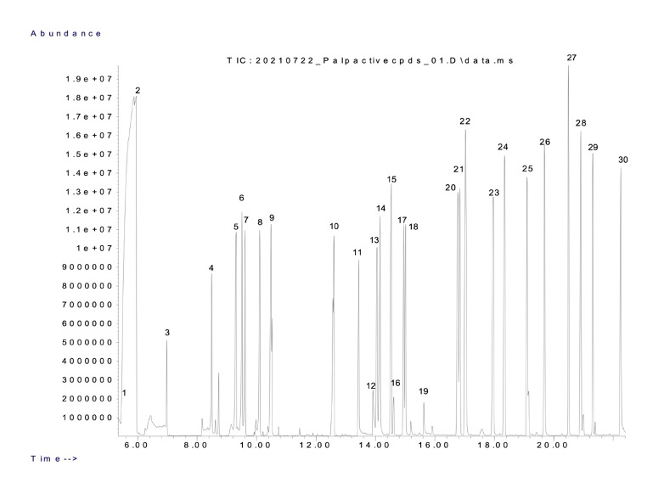
Figure S1. Chromatogram showing the palp-active compound peaks labeled with corresponding numbers. The x-axis represents the retention times (in minutes), while the y-axis indicates the abundance of the compounds. Peaks correspond to specific compounds that elicited responses in the maxillary palps of Bactrocera dorsalisand other fruit fly species during GC-EPD analysis. The numbered peaks correspond to the compounds listed in Table 1.

