Supplementary information
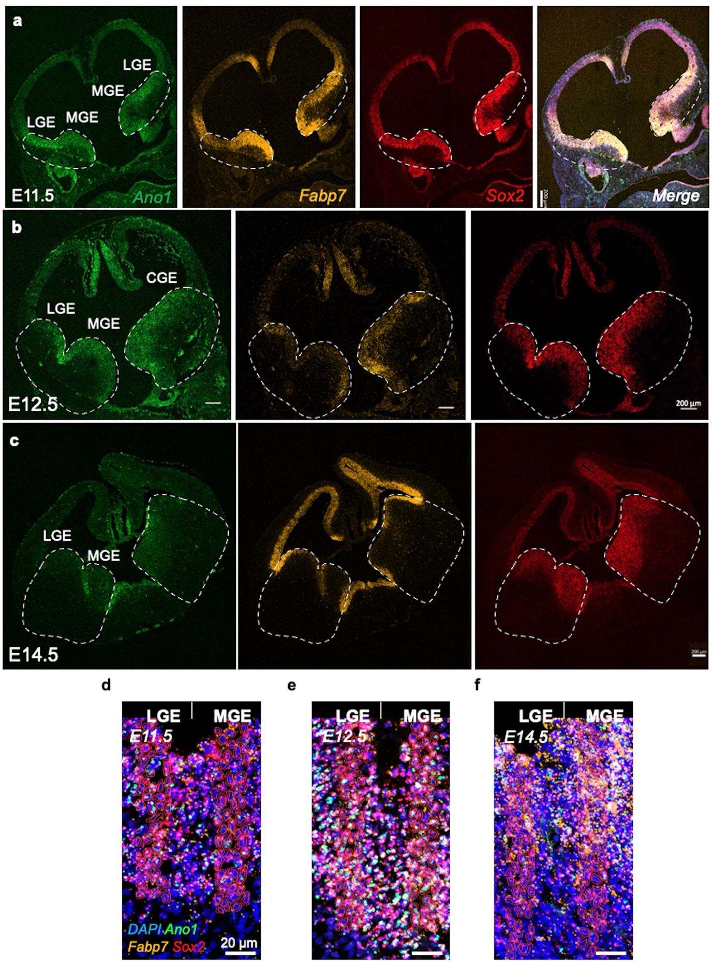
Supplementary Fig. 1 Expression and distribution of Ano1 in the whole embryonic brain. a–c, Whole brain RNAscope images of the E11.5 (a), E12.5 (b), and E14.5 (c) with Ano1, Fabp7, and Sox2 probes. Scale bar, 200 μm. d–f, Qupath program analyzed the cell population of each probe-positive population based on the DAPI stain at E11.5 (d), E12.5 (e), and E14.5 (f). The red circle indicates a DAPI-dependent cell boundary. Scale bar, 20 μm.

Supplementary Fig. 2 Whole brain scans of RNAscope for the progeny of PV⁺ and SST⁺ neurons. a,b, Representative RNAscope images showing Ano1^{+/+} (a) and Ano1^{−/−} (b) brains at E14.5 by staining with Sst and Ccnd2 probes. The white dash boxes on LGE and MGE were expanded on the right. c,d, RNAscope images showing Ano1^{+/+} (c) and Ano1^{−/−} (d) brains at E14.5 by staining with Sst and Gad1 probes. VZ; ventricular zone, Sub-VZ; subventricular zone, MZ; mantle zone
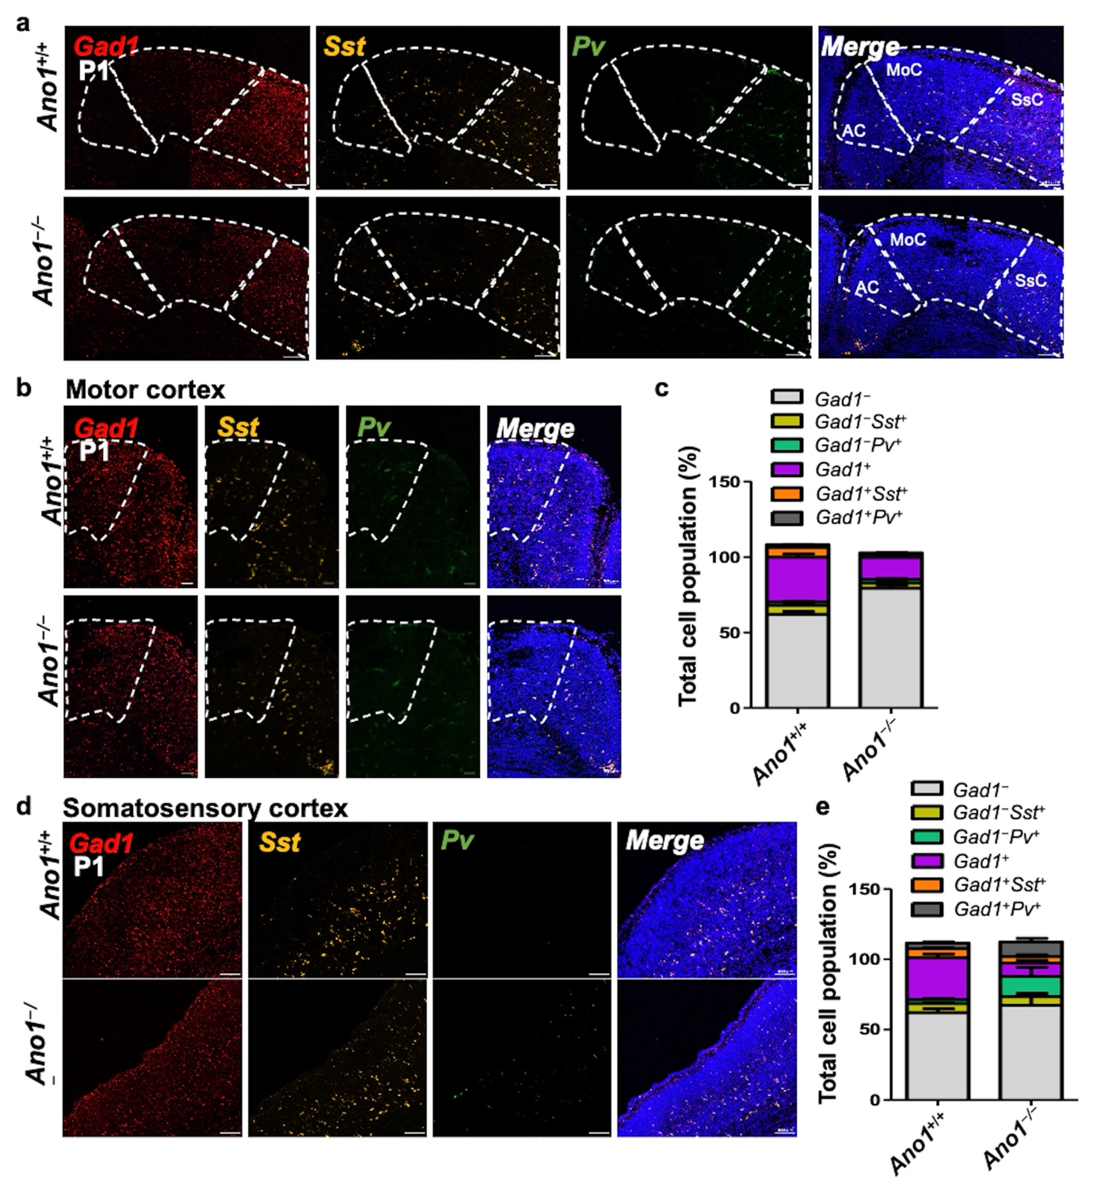
Supplementary Fig. 3 Expression patterns of Gad1, Sst, and Pv mRNA in motor and somatosensory cortices of Ano1^{+/+} and Ano1^{−/−} brains at postnatal day 1 (P1). a, Simultaneous detection of Gad1 (red), Sst (yellow), and Pv (green) mRNAs in motor and somatosensory cortices of P1 Ano1^{+/+} and Ano1^{−/−} brains. b,d, Magnified images of motor (b) and somatosensory (d) cortices from (d). c,e, Quantification of total cell populations stained with Gad1, Sst, and Pv probes in the motor (c) and somatosensory cortex (e).

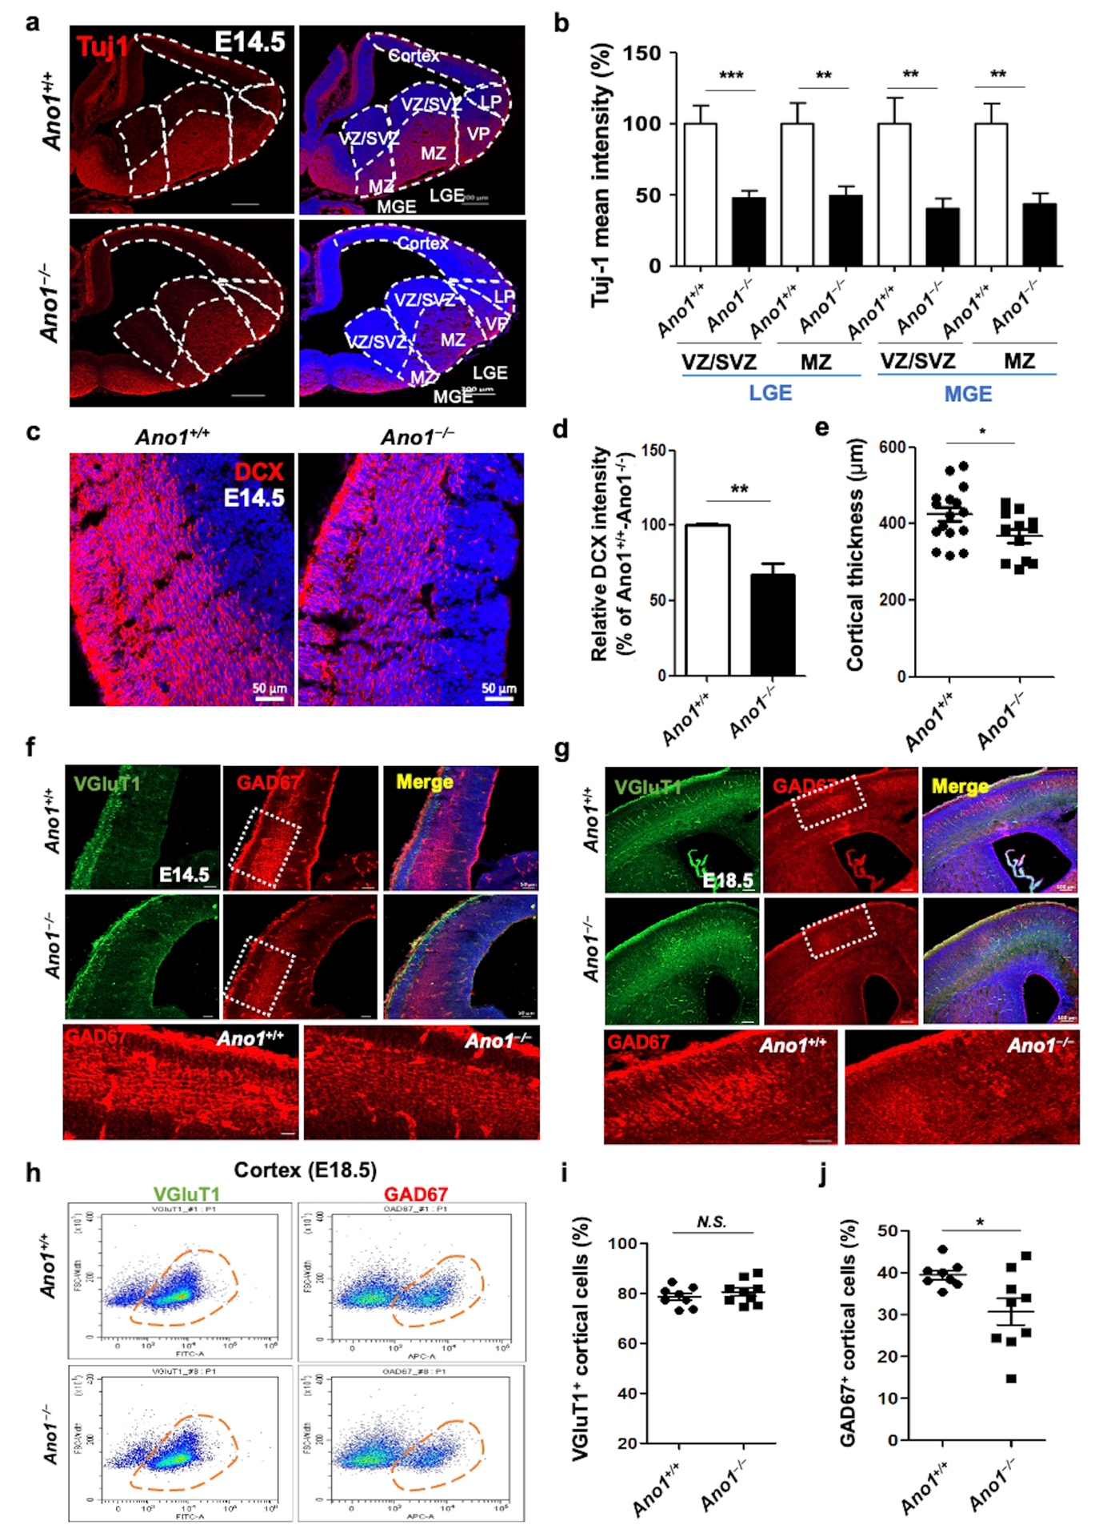
Supplementary Fig. 4 Ano1^{−/−} mice show a decrease in the proportion of GAD67-expressing interneurons in the embryonic cortex. a, Tiled images of Tuj-1-stained hemisphere using E14.5 Ano1^{+/+} (n = 6, 2 mice) and Ano1^{−/−} embryonic brains (n = 9, 3 mice) (LGE VZ/SVZ: p = 0.0008, MZ: p = 0.0038, MGE VZ/SVZ: p = 0.0039, MZ: p = 0.0021). b, Fluorescence mean intensity (%) shown in (a), analyzed by Zen software. The average intensity of the Ano1^{+/+} brain was normalized to 100%. c, Immunofluorescence images (Left) of the cortex stained with DCX as an immature neuron marker on E14.5 Ano1^{+/+} (n = 5, 2 mice) and Ano1^{−/−} embryonic brain (n = 6, 2 mice). Scale bar, 50 μm. d, Quantification of signal intensities shown in panel c (p = 0.0075). e, The cortical thickness (μm) of the Ano1^{+/+} and Ano1^{−/−} embryonic brain (E14.5, p = 0.0428). f,g, Representative images of the cortex of the Ano1^{+/+} and Ano1^{−/−} brains at E14.5 (f) and E18.5 (g) stained with VGluT1 (green) and GAD67 (red). Sections were counterstained with DAPI (blue). The GAD67 signal in the white dash boxes is enlarged in the bottom two frames. h–j FACS dot plot (h) and each cell population of the E18.5 Ano1^{+/+} (8 mice) and Ano1^{−/−} (9 mice) cortical cells stained with VGluT1 (i) and GAD67 (j) antibodies. GAD67⁺ cell population was significantly decreased in Ano1^{−/−} cortex (p = 0.0236). All data were analyzed using student unpaired t-test and are shown as mean ± sem.

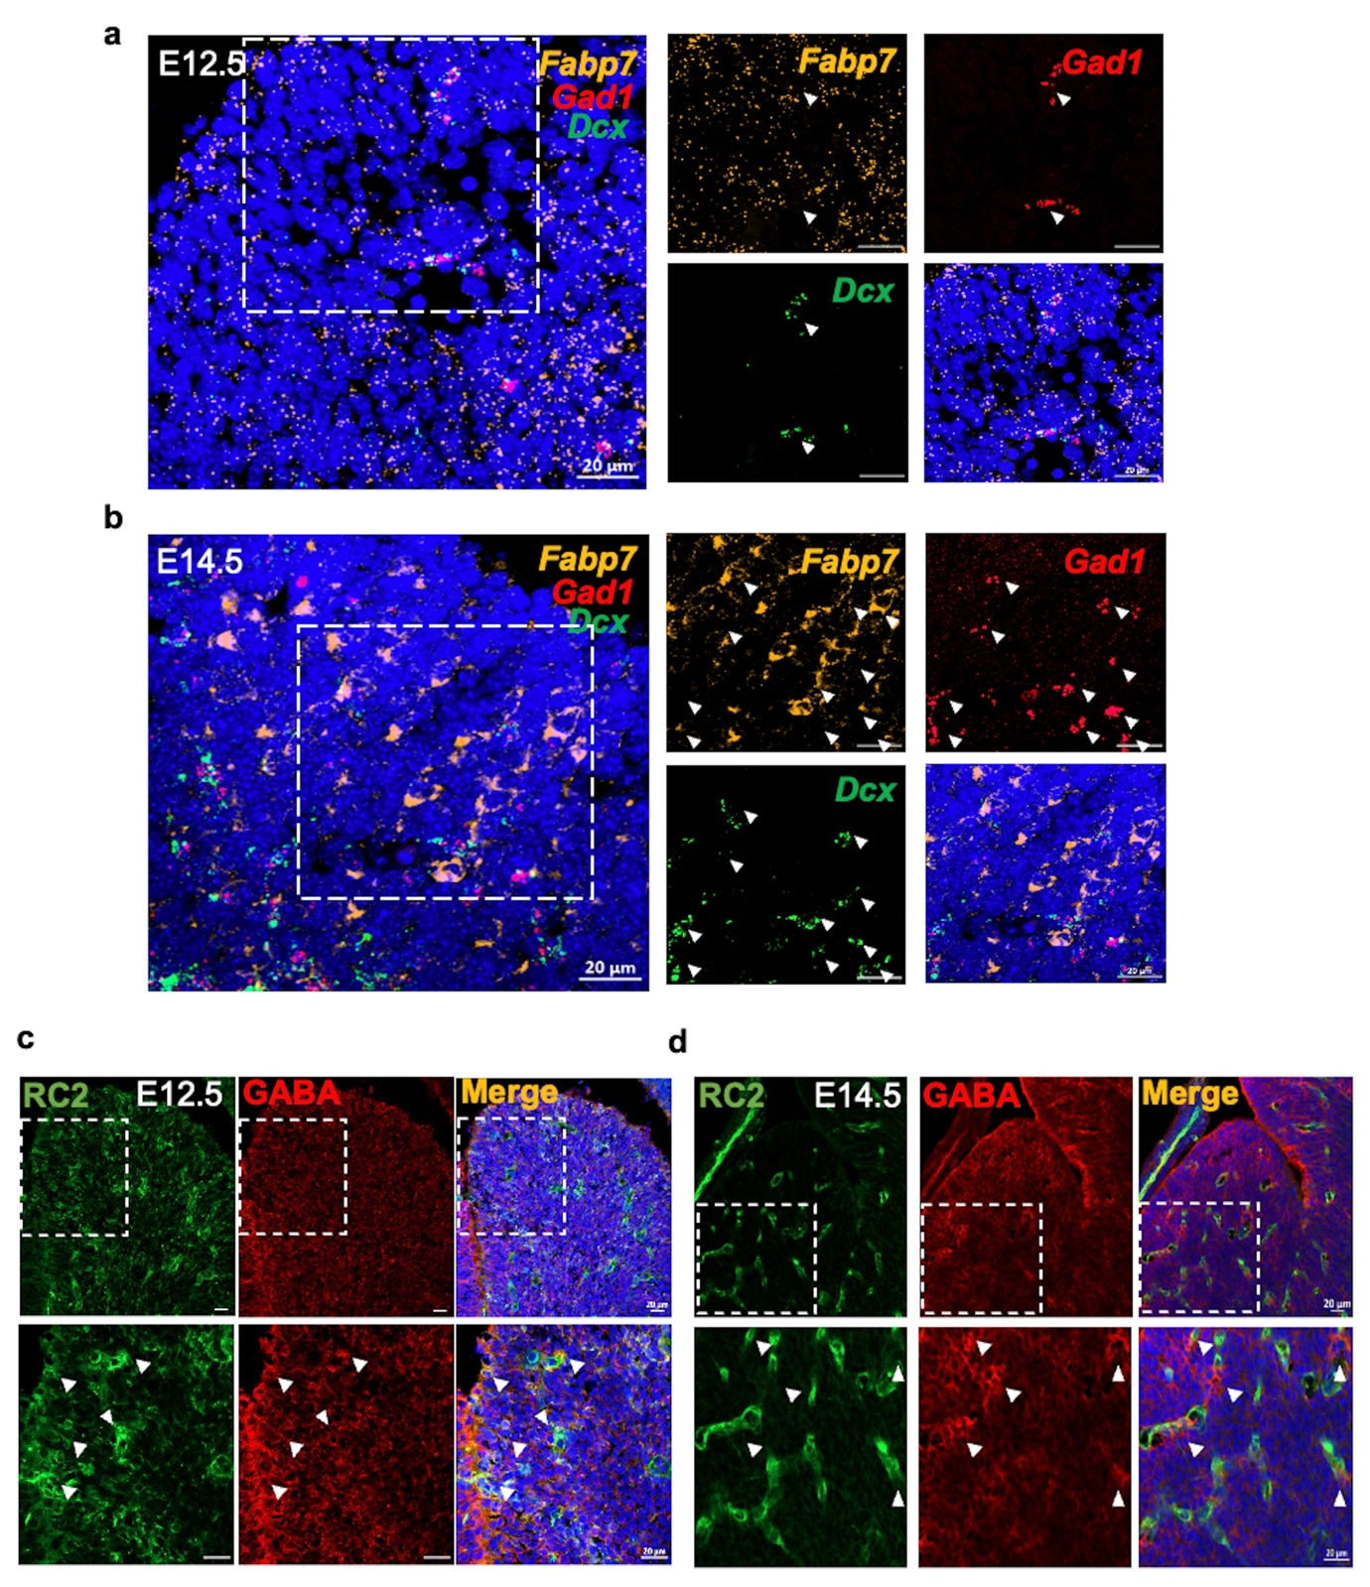
Supplementary Fig. 5 GABA expression in VZ/SVZ of the embryonic brains. a,b, RNAscope on the E12.5 (a) and E14.5 (b) MGE regions using probes directed to Fapb7 (yellow), Gad1 (red), and Dcx (green). Magnified images of the regions within white dash boxes are presented on the right, with arrowheads indicating Gad1⁺ cells. Scale bar, 20 μm. c,d, Fluorescence images of the E12.5 (c) and E14.5 (d) MGE regions stained with RC2 and GABA antibodies. Magnified images of the regions within white dash boxes are presented at the bottom, with arrowheads indicating GABA. Scale bar, 20 μm
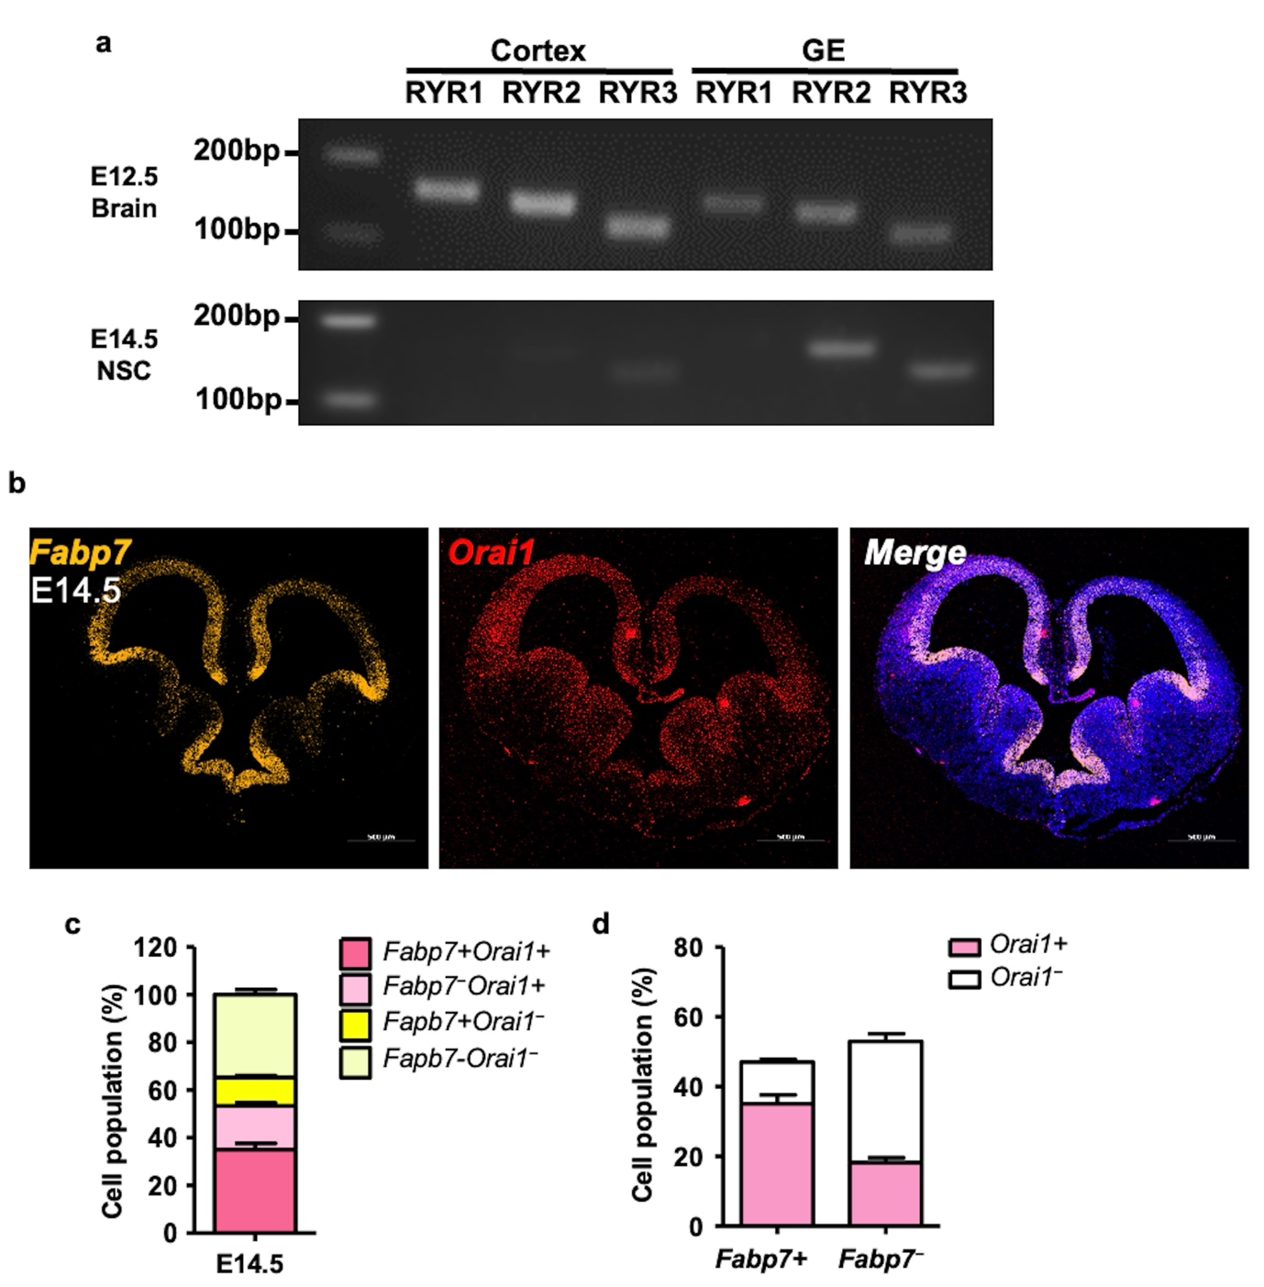
Supplementary Fig. 6 mRNA expression of ER Ca²⁺-sensing proteins induced by GABA_{A} receptor activation in the embryonic brain. a, RT-PCR of Ryanodine receptor (RyR) subtypes 1–3 on the cortex and GE of the embryonic brain and cultured NSCs. b, Hybridization using Orai1 and Fabp1 probes on E14.5 whole brain section. c, Quantification of cell populations (%) in the MGE region shown in panel b. d, Stacked bar graph representing Orai1⁺ cell population within each Fabp7⁺ or Fabp7⁻ group. Data are shown as mean ± sem.

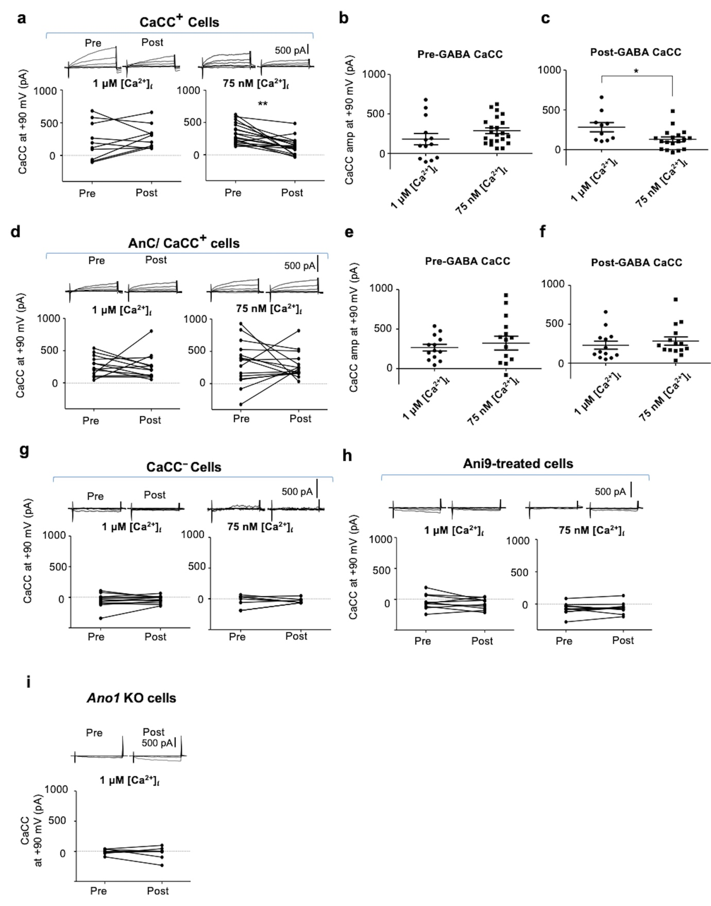
Supplementary Fig. 7 CaCC amplitudes before and after GABA application. a, CaCC amplitudes at +90 mV are shown before and after the application of GABA with the specified internal Ca²⁺ concentrations. The insets show voltage-induced CaCC with six 100 ms voltage steps ranging from −90 to +110 mV starting at a holding potential of −70 mV. The lines connecting pre- and post-samples indicate the same cell (p = 0.0021). b, The CaCC amplitudes at +90 mV pre-GABA are compared. c, Same as in (b) comparing post-GABA CaCC amplitudes (p=0.016). d, Same as (a) but with AnC applied to the bath solution. e,f, Same as in (b) and (c) comparing the AnC-treated cells. g–i, Same as in (a), showing conditions where CaCC was not detected.

