Supplementary Information

Strong turbulent flow in the sub-auroral region in the Antarctic can deteriorate satellite-based navigation signals
Daria Kotova, Aleksandr Sinevich, Alexander Chernyshov, Dmitrii Chugunin, Yaqi Jin, and Wojciech Miloch

Corresponding author: Daria Kotova (dariakot@fys.uio.no)

Contents of this file
Supplementary Figures S1, S2, videos: sig_phi_18th.mp4, s4_18th.mp4, locktime_18th.mp4, sig_phi_25th.mp4, s4_25th.mp4, locktime_25th.mp4
The phase and amplitude scintillation indices corresponding to IPPs of GNSS satellites observed by two SANAE IV (⬚) and Troll (◯) receivers at different time instances on March 18th 2018 are presented in Fig. S1. The dashed circles show respectively the projections of the elevation angles of 20° and 10° of the field of view of the stations (SANAE IV in blue and Troll in purple) at an altitude of 350 km. The star shows the magnetometer at the Neumayer station. The colour bar shows the magnitude of indices. Thick black and red lines show AACGM projections of magnetic isolines at 60° and 65°, respectively. Note that to separate different satellite systems recorded by the receiver at the Troll station from each other on one plot, we use PRN+0 for GPS, PRN+40 for GLONASS, and PRN+70 for Galileo systems.

In the video materials, the dynamics of parameters (such as scintillation indices and lock of time) are presented in the same form:
- σ_{ϕ} index values over the area of study from 18:00-03:00 UT:
sig_phi_18th.mp4 during 18-19.03.2018;
sig_phi_25th.mp4 during 25-26.03.2018.
- S4 index values over the area of study from 18:00-03:00 UT:
s4_18th.mp4 during 18-19.03.2018;
s4_25th.mp4 during 25-26.03.2018.
- Loss of lock time over the area of study from 18:00-03:00 UT:
locktime_18th.mp4 during 18-19.03.2018;
locktime_25th.mp4 during 25-26.03.2018.

March 18, 2018
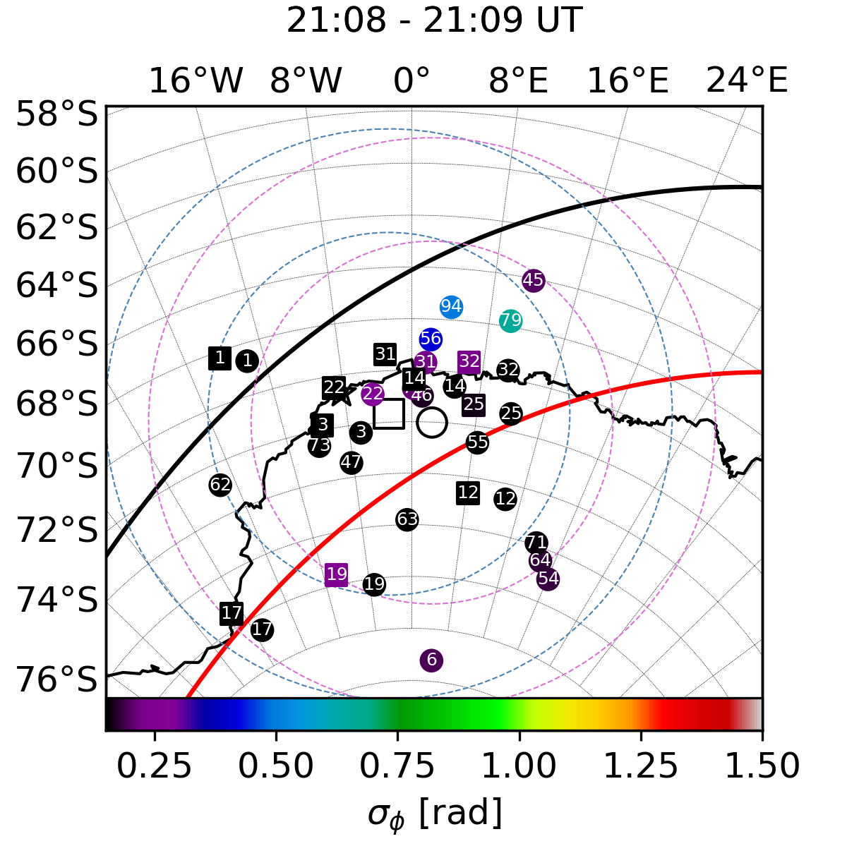 | 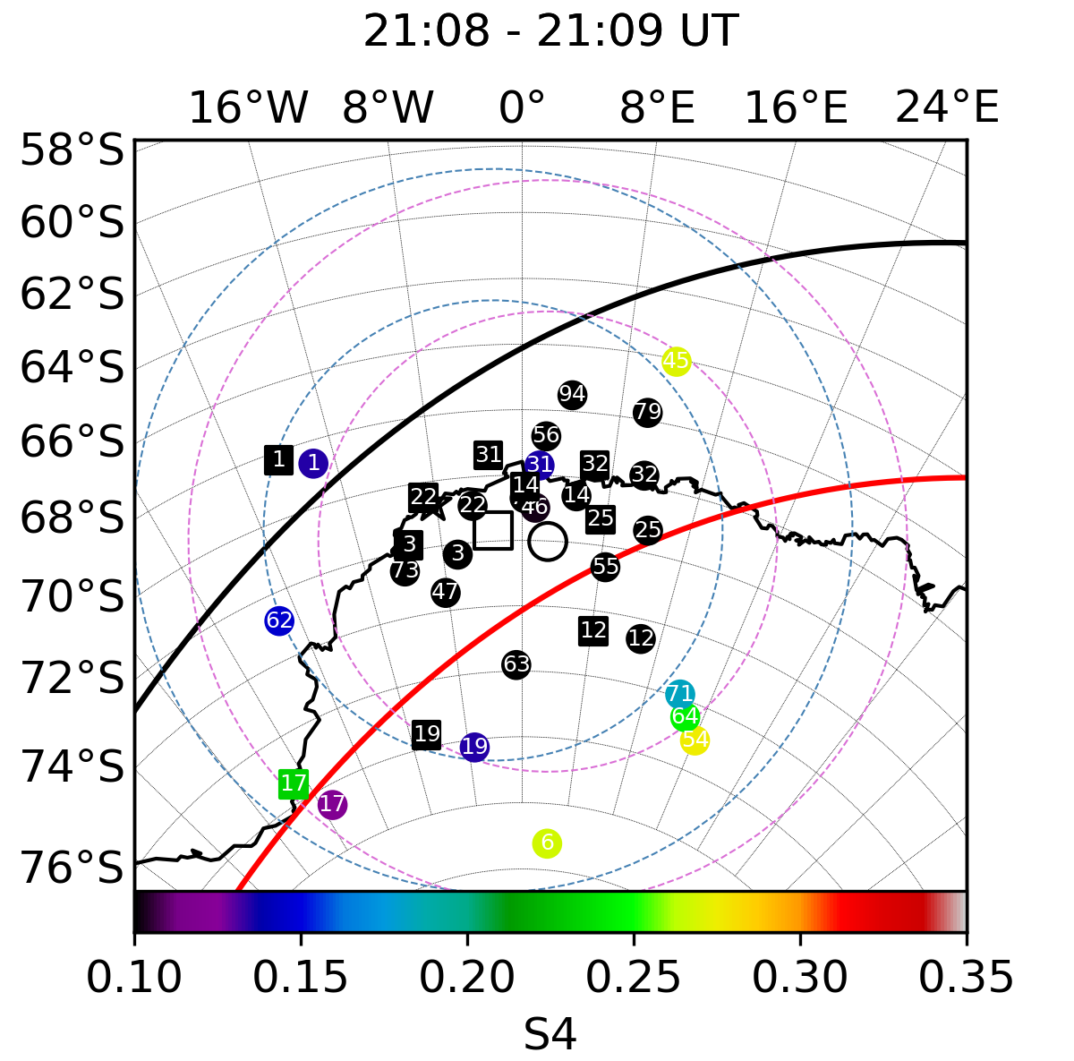
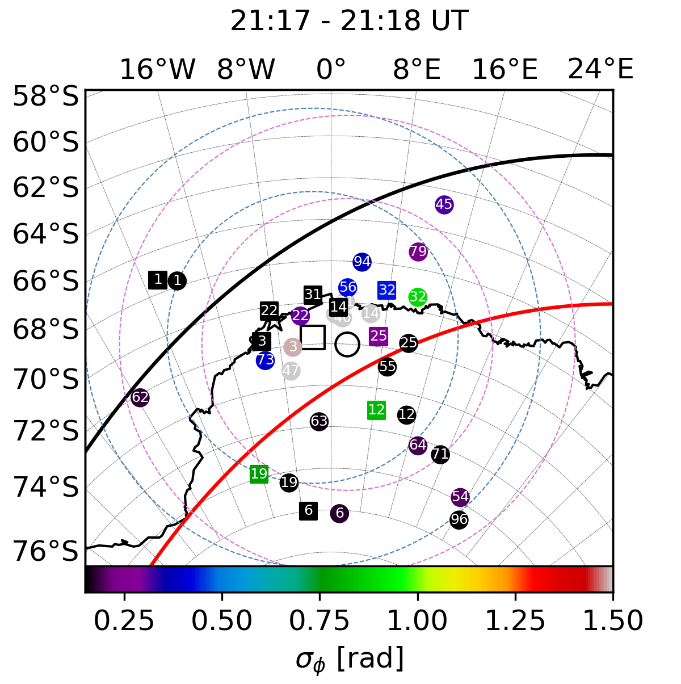 | 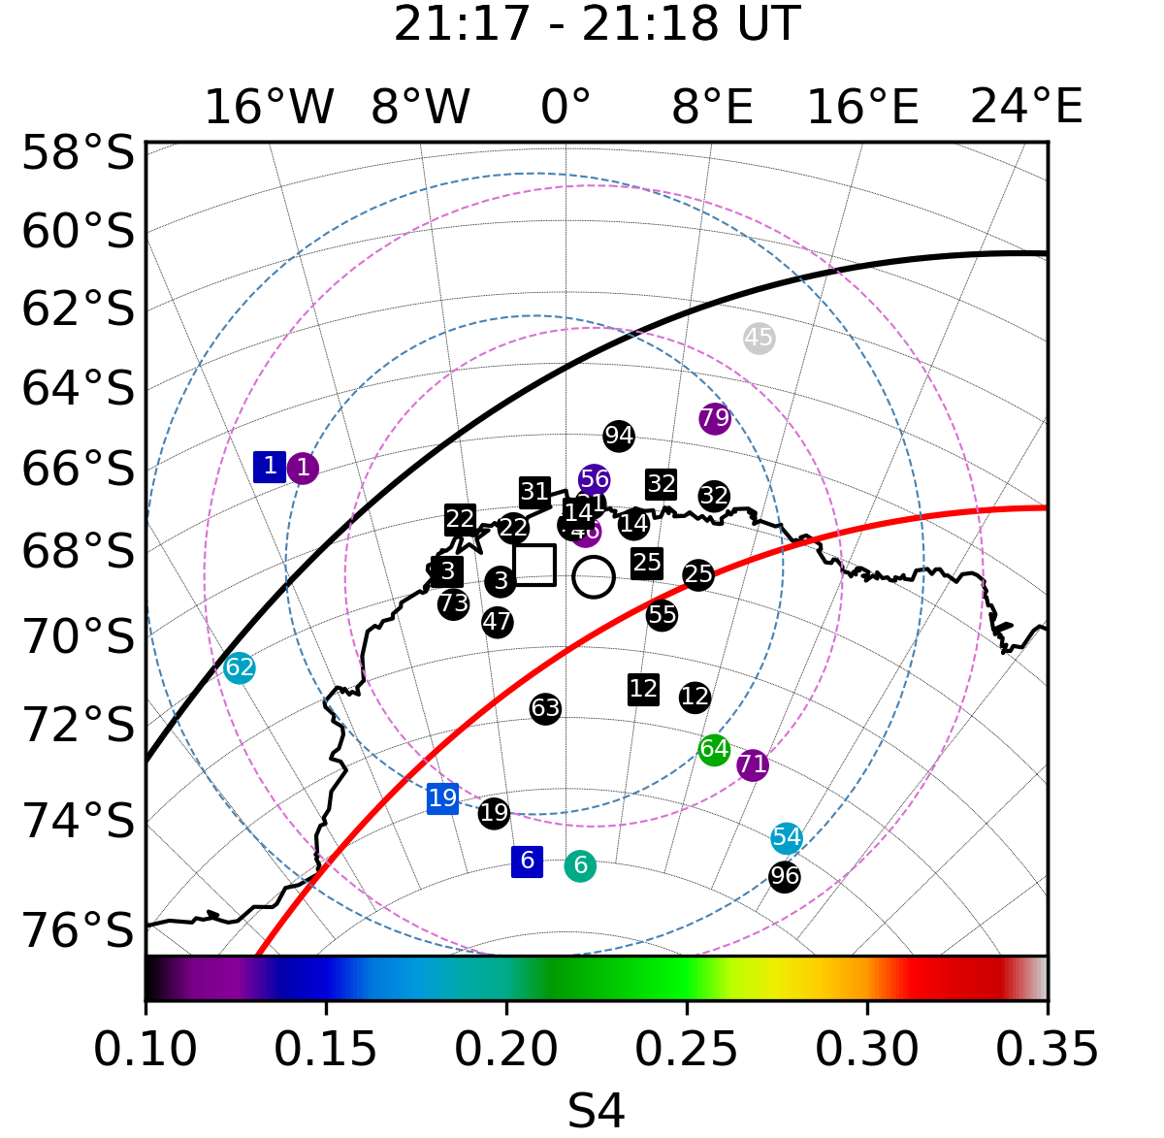
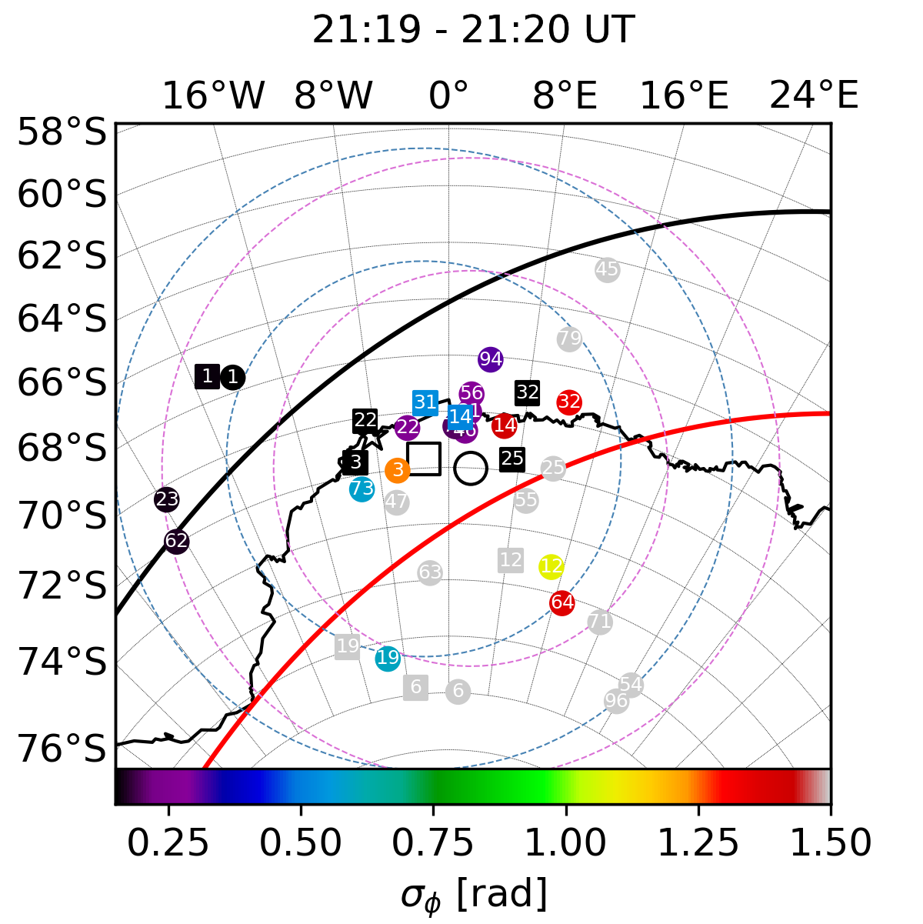 | 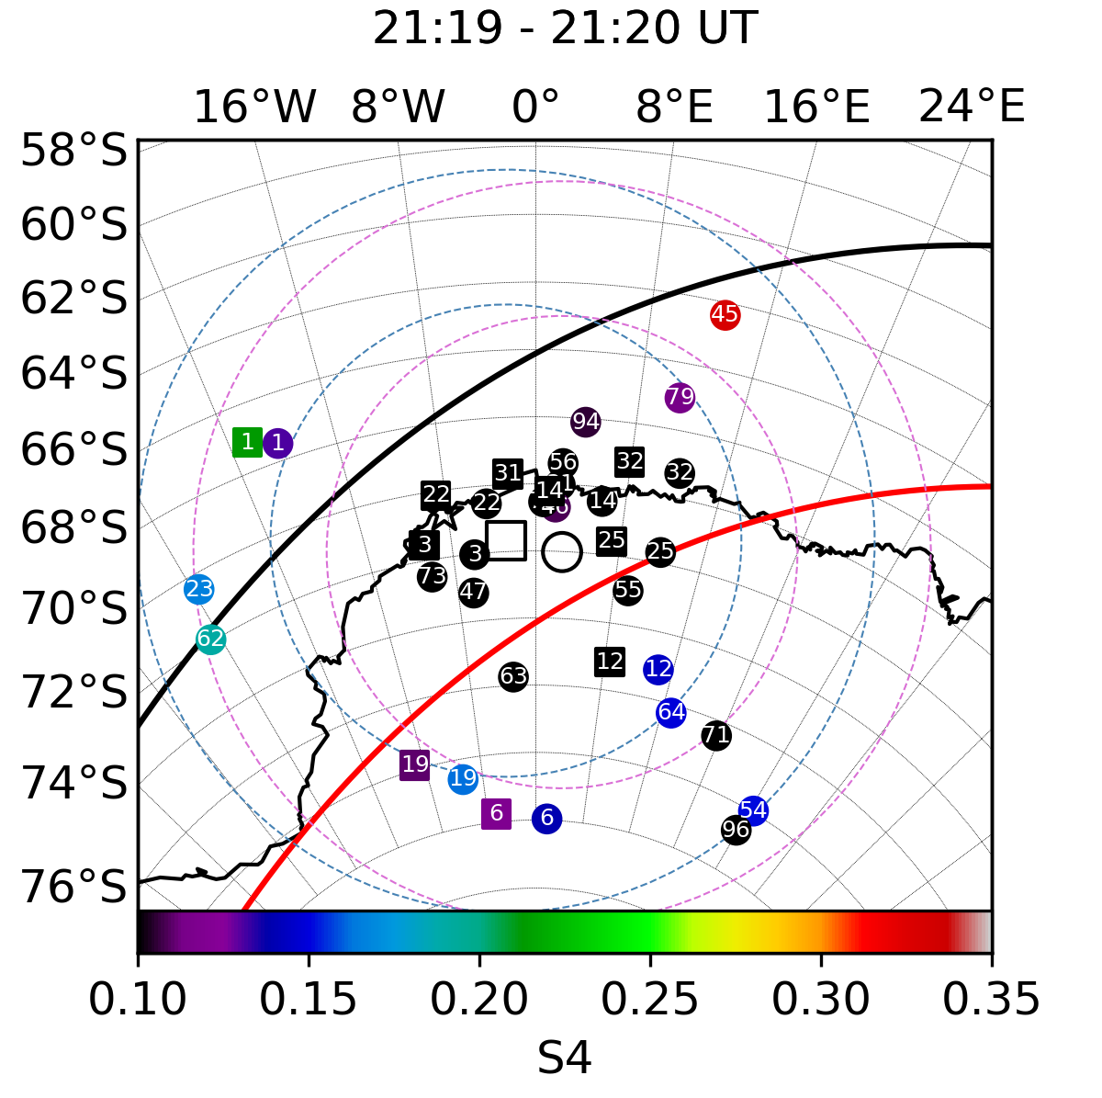
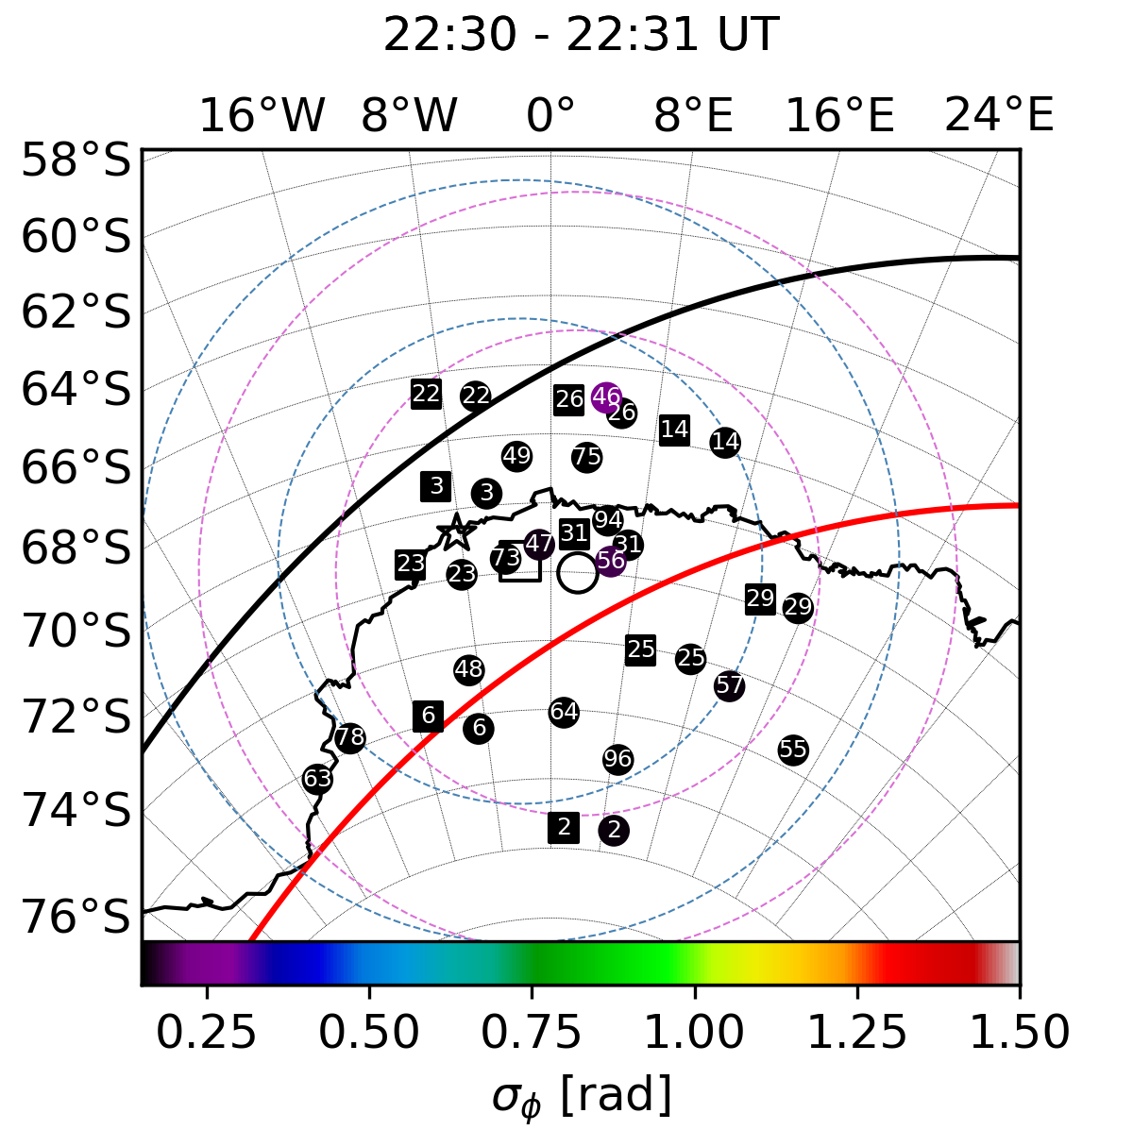 | 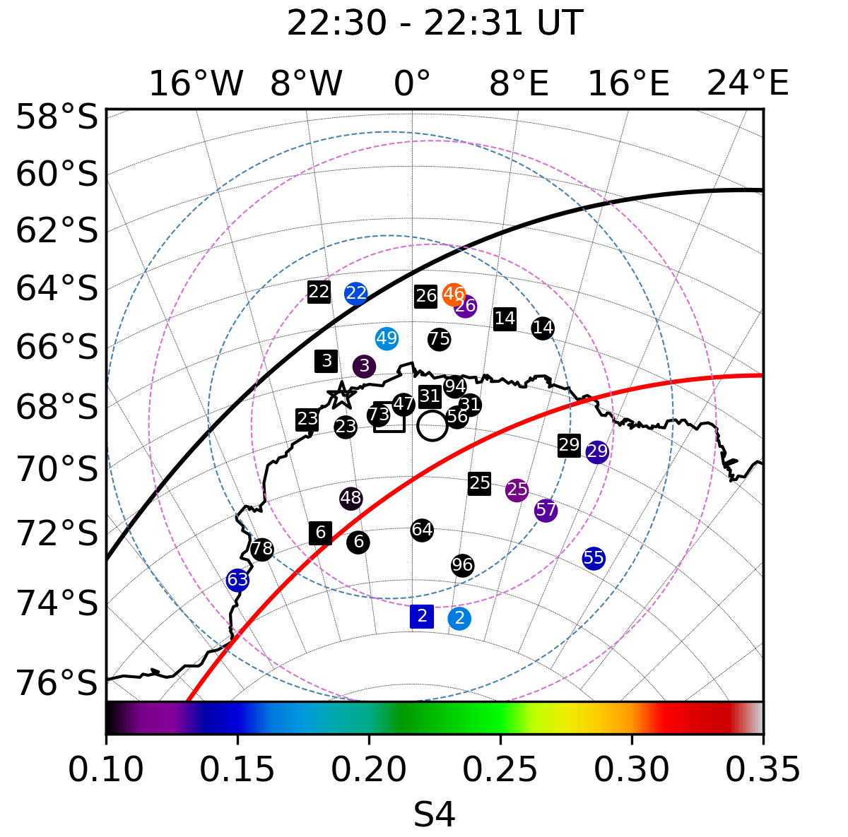

Supplementary Figure S1. Phase (left) and amplitude (right) scintillation indices over the area of study on 2018.03.18.
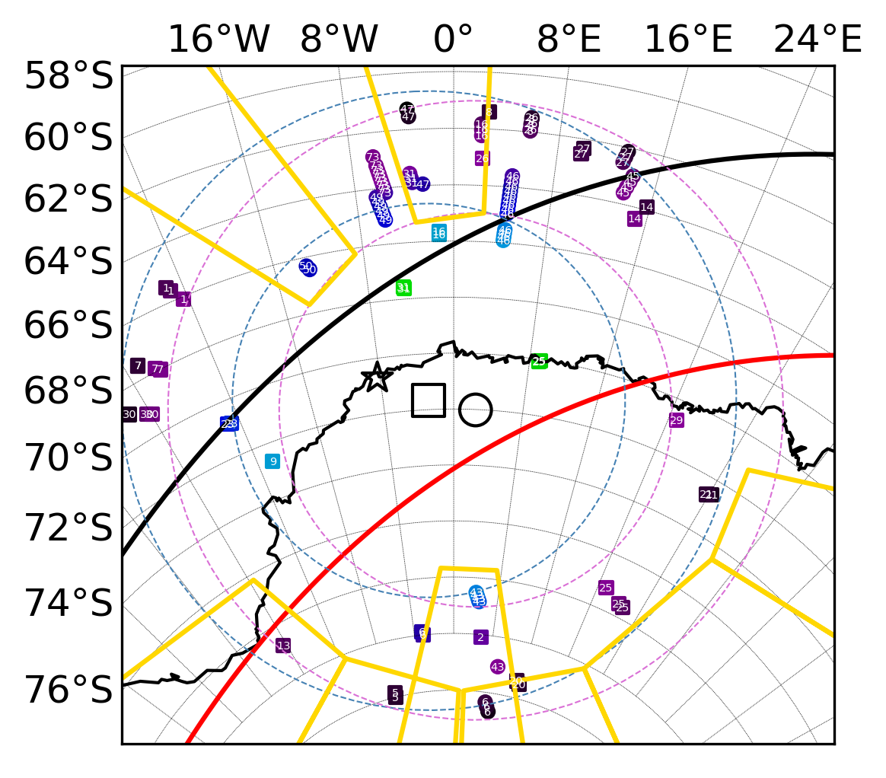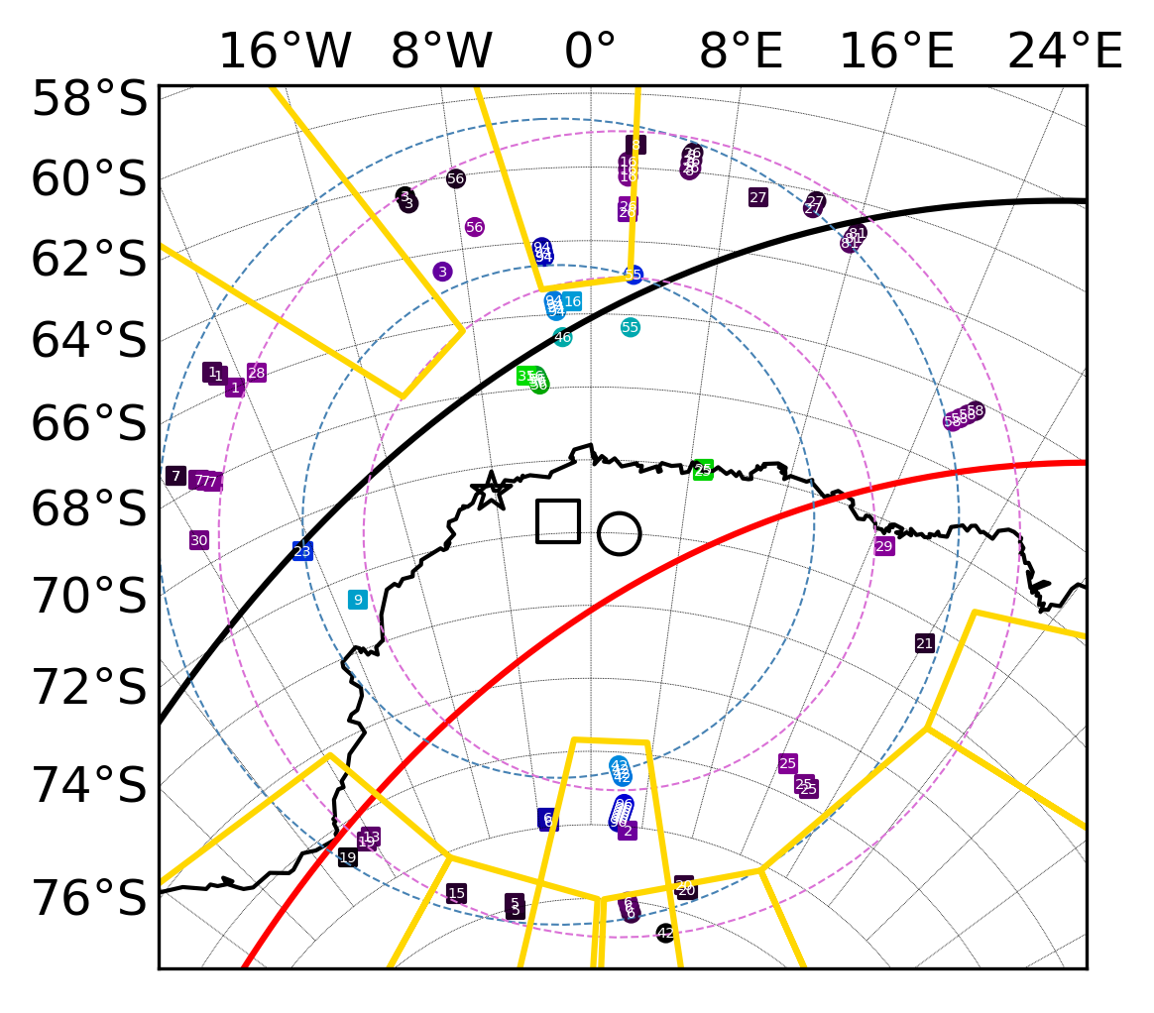
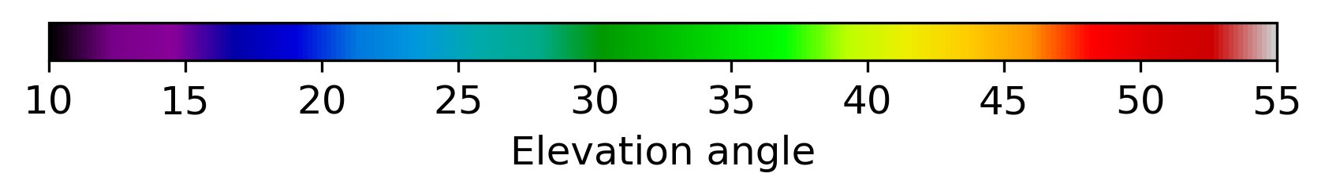
Supplementary Figure S2. IPPs of loss of signal lock from GNSS satellites recorded by two SANAE IV (⬚) and Troll (◯) receivers on March 18th (left) and 25th (right) in 2018 for the nighttime of 18-03 MLT. The dashed circles show the projections of the elevation angles of 20° and 10° of the field of view of the stations (SANAE IV in blue and Troll in purple) at an altitude of 350 km. The star shows the magnetometer in Neumayer. The colour bar shows the elevation angle. Thick black and red lines show AACGM projections of magnetic isolines at 60° and 65°, respectively. The golden areas mark projections of antennas and other interference around the Troll receiver.

