Gels and blots (Figure 1p)
Protein marker: 200, 140,110, 75, 55, 42, 30, 23, 18, 10
TGF-β1 (44kDa)
PBS (w16) ZYM (w16)
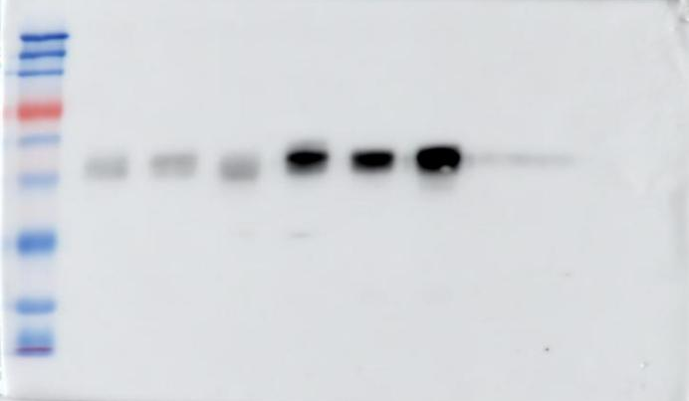
10
75

α-SMA (42kDa)
PBS (w16) ZYM (w16)
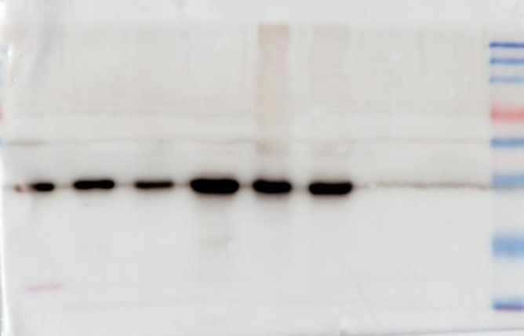
10
75

GAPDH (36kDa)
PBS (w16) ZYM (w16)
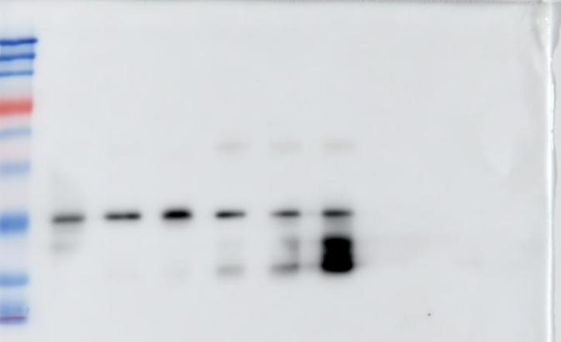
10
75

Gels and blots (Figure 3j)
Protein marker: 200, 140,110, 75, 55, 42, 30, 23, 18, 10
PADI4 (67kDa)
PBS (w16) ZYM (w16)
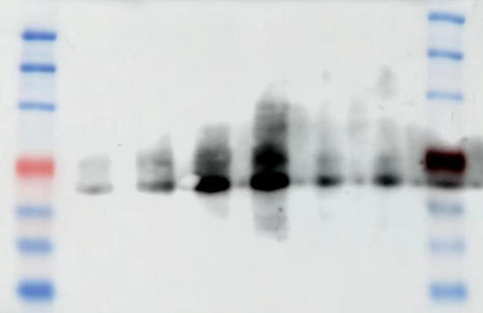
75

Cit-H3 (17kDa)
PBS (w16) ZYM (w16)
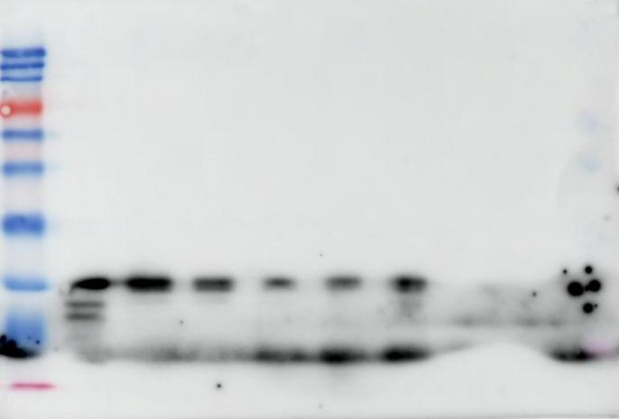
10
75

GAPDH (36kDa)
PBS (w16) ZYM (w16)
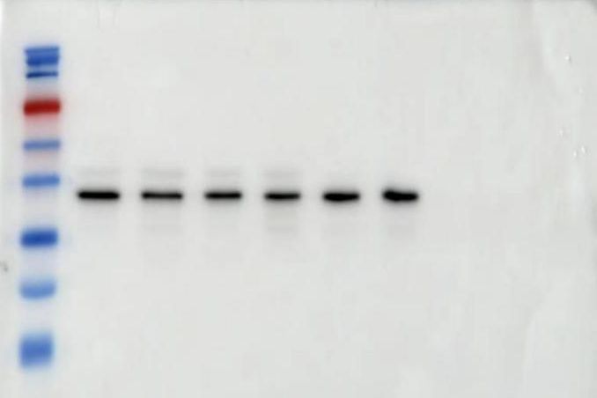
75

