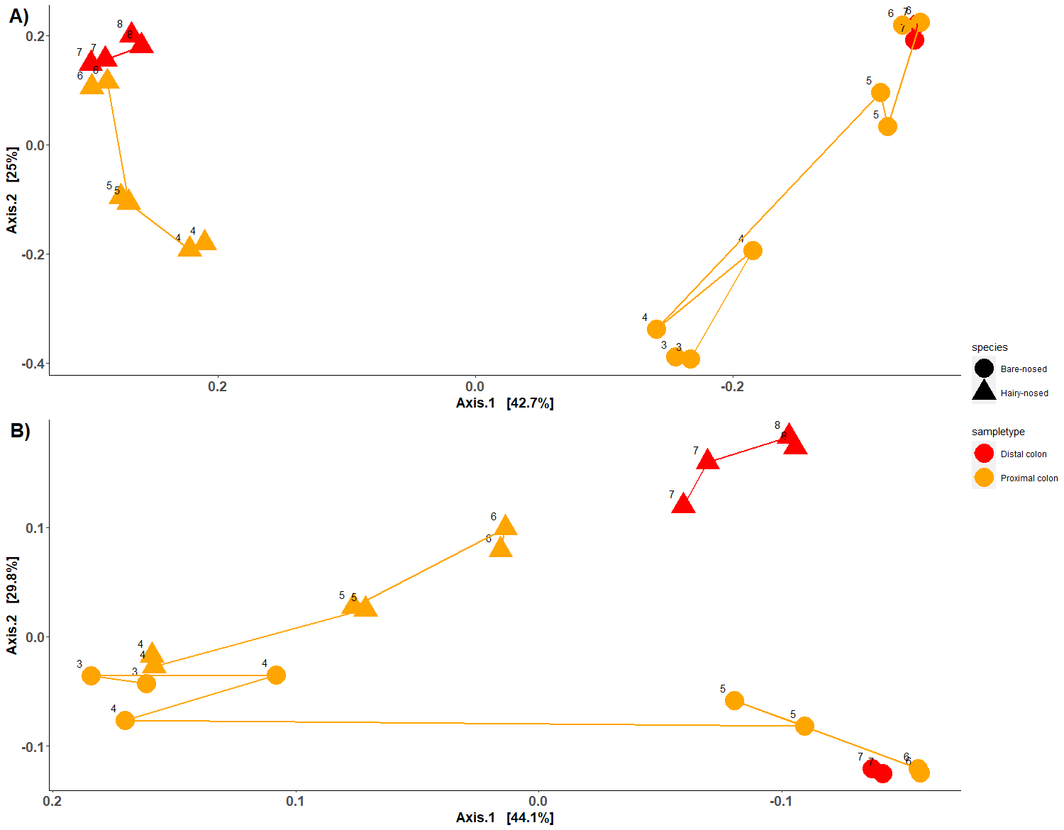
Supplementary figure 1 | Ordination of colon samples only. A) PCoA of unweighted UniFrac distances and B) PCoA of weighted UniFrac distances. Samples are coloured by sample type, and shaped by host species.
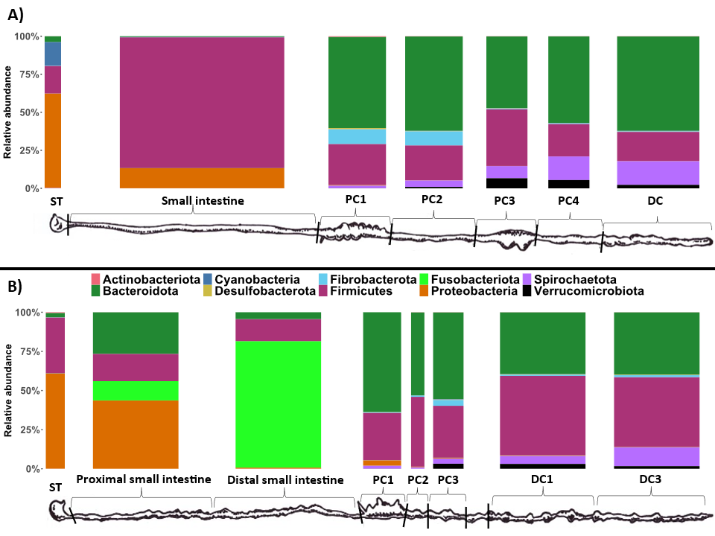
Supplementary figure 2 | Taxonomic composition of the different sample types at the phylum level. Only the top 10 most abundant phyla are displayed for clarity (these phyla account for >99% of reads). Replicate samples were merged per sample site. A) bare-nosed wombat. B) southern hairy-nosed wombat. The widths of the bars are scaled to the length of the GI region.
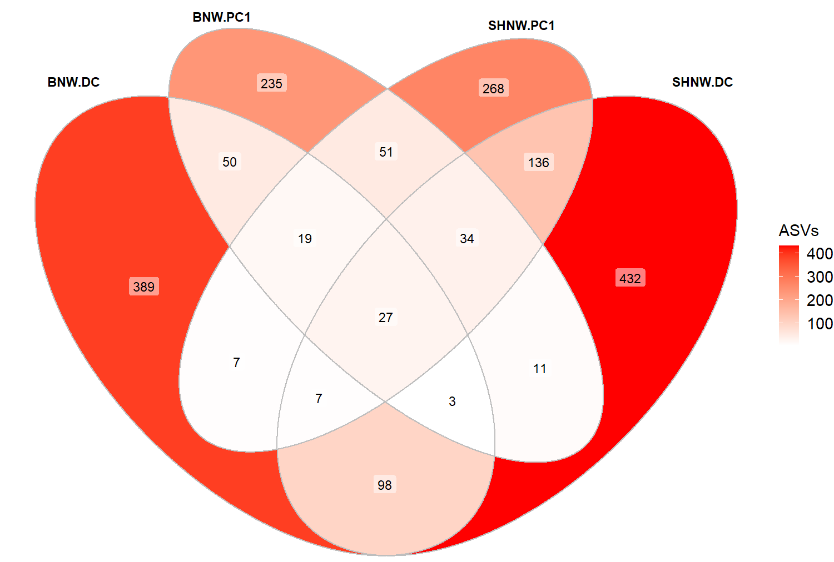
Supplementary figure 3 | Venn diagram of ASVs shared between PC1 and DC for both species of wombat.

Supplementary table 1 | ANCOM results for the rarefied genera found significantly differentially abundant between the hind-gut sites at a W-statistic threshold at 0.7.

Phylum;best hit | W | DC | PC1 | PC2 | PC3 | PC4
Bacteroidota;;;;F082 | 250 | 4685 | 0 | 7 | 1877 | 186
Bacteroidota;;;;Bacteroidales_BS11_gut_group | 250 | 18513 | 10 | 69 | 8164 | 14848
Firmicutes;;;;UCG-010 | 249 | 6333 | 8 | 1907 | 5125 | 1547
Bacteroidota;;;SP3-e08 | 248 | 2451 | 0 | 3 | 453 | 534
Bacteroidota;;;Rikenellaceae | 247 | 720 | 0 | 2 | 295 | 289
Firmicutes;;;;Izemoplasmataceae | 245 | 3217 | 3 | 14 | 1152 | 480
Bacteroidota;;;;Prevotella | 245 | 1107 | 41707 | 16694 | 2501 | 186
Bacteroidota;;;;Bacteroidales_UCG-001 | 243 | 21053 | 22 | 56 | 9403 | 10767
Verrucomicrobiota;;;;WCHB1-41 | 242 | 6050 | 26 | 788 | 8829 | 4931
Firmicutes;;;;Papillibacter | 241 | 2303 | 0 | 0 | 236 | 39
Bacteroidota;;;;Prevotellaceae_UCG-001 | 241 | 110 | 15238 | 18860 | 1558 | 37
Bacteroidota;;;;Bacteroides | 239 | 447 | 14336 | 2331 | 1228 | 55
Synergistota;;;;Pyramidobacter | 237 | 339 | 0 | 0 | 36 | 41
Thermoplasmatota;;;Methanomethylophilaceae | 236 | 300 | 0 | 0 | 57 | 37
Verrucomicrobiota;;;;Victivallaceae | 236 | 445 | 0 | 0 | 117 | 134
Firmicutes;;;;UCG-002 | 231 | 561 | 3 | 55 | 321 | 152
Unknown | 231 | 823 | 14 | 9 | 189 | 84
Bacteroidota;;;;Bacteroidales_RF16_group | 231 | 2601 | 11000 | 21640 | 3731 | 24
Firmicutes;;;;Family_XIII_AD3011_group | 230 | 854 | 30 | 228 | 1615 | 303
Firmicutes;;;;Anaerosporobacter | 230 | 1700 | 39 | 3265 | 1843 | 0
Firmicutes;;Oscillospirales | 229 | 254 | 0 | 10 | 67 | 36
Thermoplasmatota;;;;Candidatus_Methanomethylophilus | 227 | 284 | 11 | 65 | 201 | 0
Firmicutes;;;;Roseburia | 227 | 53 | 955 | 1003 | 781 | 31
Firmicutes;;;;Izemoplasmatales | 226 | 16866 | 25 | 30 | 1677 | 122
Firmicutes;;;;Anaerovibrio | 224 | 67 | 441 | 183 | 489 | 0
Firmicutes;;;;Subdoligranulum | 223 | 135 | 307 | 678 | 279 | 0
Firmicutes;;;;Saccharofermentans | 223 | 1128 | 0 | 2 | 102 | 833
Halobacterota;;;;Methanocorpusculum | 222 | 149 | 10 | 3 | 11 | 100
Firmicutes;;;;[Eubacterium]_coprostanoligenes_group | 218 | 2339 | 132 | 1003 | 6644 | 1556
Firmicutes;;;;Oscillibacter | 216 | 283 | 159 | 729 | 536 | 0
Firmicutes;;;RF39 | 216 | 2240 | 186 | 1267 | 4922 | 2283
Firmicutes;;;;Anaerofustis | 213 | 97 | 7 | 0 | 30 | 42
Firmicutes;;;;Marvinbryantia | 213 | 75 | 374 | 238 | 153 | 1
Firmicutes;;;;Blautia | 211 | 177 | 564 | 311 | 353 | 0
Desulfobacterota;;;;uncultured genus | 210 | 2 | 115 | 17 | 0 | 0
Bacteroidota;;;Sphingobacteriaceae | 207 | 3003 | 0 | 0 | 659 | 0
Firmicutes;;uncultured Clostridia | 205 | 90 | 0 | 0 | 43 | 26
Bacteroidota;;;uncultured Marinilabiliaceae | 205 | 919 | 0 | 0 | 6 | 333
Firmicutes;;;;Tyzzerella | 203 | 16 | 420 | 14 | 18 | 2
Desulfobacterota;;;;Bradymonadales | 201 | 57 | 0 | 28 | 223 | 26
Firmicutes;;;;uncultured Erysipelotrichaceae | 201 | 202 | 13 | 7 | 59 | 147
Firmicutes;;;;UCG-012 | 201 | 8658 | 2 | 5 | 7 | 3
Firmicutes;;;Lachnospiraceae | 201 | 8757 | 12097 | 21332 | 5902 | 450
Firmicutes;;;;Peptococcus | 197 | 93 | 41 | 120 | 124 | 0
Campilobacterota;;;;Campylobacter | 196 | 121 | 102 | 12 | 84 | 2
Bacteroidota;;;;DMER64 | 195 | 180 | 0 | 0 | 15 | 108
Firmicutes;;;;uncultured Ruminococcaceae | 195 | 801 | 28 | 267 | 447 | 124
Proteobacteria;;;;Sutterella | 194 | 55 | 235 | 110 | 184 | 0
Firmicutes;;;;[Ruminococcus]_torques_group | 192 | 6 | 38 | 0 | 5 | 0
Firmicutes;;;Anaerovoracaceae | 192 | 253 | 23 | 202 | 397 | 153
Firmicutes;;;;UCG-011 | 192 | 1370 | 2 | 0 | 530 | 969
Firmicutes;;;;UCG-004 | 192 | 1143 | 152 | 247 | 1625 | 904
Firmicutes;;;;Anaeroplasma | 192 | 531 | 5074 | 1597 | 777 | 105
Cyanobacteria;;;;Chloroplast | 190 | 23 | 1 | 11 | 11 | 34
Firmicutes;;;;Streptococcus | 190 | 84 | 2246 | 33 | 10 | 6
Bacteroidota;;;Tannerellaceae | 190 | 1427 | 50 | 971 | 958 | 11
Firmicutes;;;Erysipelotrichaceae | 189 | 11 | 283 | 85 | 81 | 9
Cyanobacteria;;;;Gastranaerophilales | 189 | 285 | 30 | 99 | 396 | 225
Bacteroidota;;Bacteroidales | 187 | 5926 | 13514 | 20164 | 14427 | 1480
Firmicutes;;;;Christensenellaceae_R-7_group | 186 | 9940 | 583 | 1325 | 4020 | 2255
Firmicutes;;;;Clostridia_vadinBB60_group | 185 | 7714 | 161 | 700 | 3014 | 647
Firmicutes;unknown | 183 | 466 | 0 | 12 | 162 | 1
Firmicutes;;;;NK4A214_group | 182 | 2893 | 357 | 954 | 2596 | 1562
Firmicutes;;;;Selenomonas | 181 | 30 | 0 | 0 | 0 | 24
Firmicutes;;;;NED5E9 | 181 | 581 | 1668 | 398 | 599 | 1
Firmicutes;;;;Coprococcus | 177 | 100 | 869 | 2273 | 534 | 84
Verrucomicrobiota;;;;Z20 | 175 | 41 | 0 | 0 | 29 | 0
Proteobacteria;;;;uncultured Rhodospirillales | 174 | 189 | 1153 | 113 | 155 | 0
Firmicutes;;;;Lachnospiraceae_NC2004_group | 172 | 2 | 83 | 125 | 20 | 1
Actinobacteriota;;;;Enterorhabdus | 171 | 13 | 72 | 7 | 17 | 14
Firmicutes;;;;Lachnoclostridium | 168 | 143 | 352 | 407 | 558 | 2
Spirochaetota;;;;Treponema | 166 | 18780 | 3252 | 4928 | 10124 | 14778
Bacteroidota;;;;Rikenellaceae_RC9_gut_group | 165 | 24818 | 3057 | 18301 | 24297 | 13325
Bacteroidota;;;;hoa5-07d05_gut_group | 164 | 45 | 0 | 0 | 237 | 47
Firmicutes;;;Oscillospiraceae | 164 | 514 | 100 | 244 | 486 | 139
Bacteroidota;;;;M2PB4-65_termite_group | 163 | 293 | 0 | 0 | 2 | 73
Firmicutes;;;;Lachnospiraceae_UCG-008 | 162 | 361 | 11 | 442 | 207 | 8
Firmicutes;;;;uncultured Peptococcaceae | 160 | 454 | 125 | 249 | 390 | 12
Firmicutes;;;;uncultured Oscillospirales | 157 | 5 | 0 | 0 | 5 | 7
Firmicutes;;;;Lachnospiraceae_NK4A136_group | 157 | 137 | 428 | 208 | 97 | 0
Firmicutes;;;;Phascolarctobacterium | 157 | 729 | 1042 | 2830 | 1065 | 93
Firmicutes;;;Christensenellaceae | 156 | 52 | 3 | 0 | 4 | 0
Firmicutes;;;;Lachnospiraceae_ND3007_group | 156 | 50 | 1044 | 130 | 84 | 21
Firmicutes;;;;Lachnospiraceae_UCG-006 | 153 | 6 | 11 | 36 | 23 | 0

