Supplementary Information

Fig1 B Western Blotting of LIN7A
LIN7A protein band appeared at approximately 26 kDa, while the α-tubulin band, used as a loading control, was observed at 55 kDa.
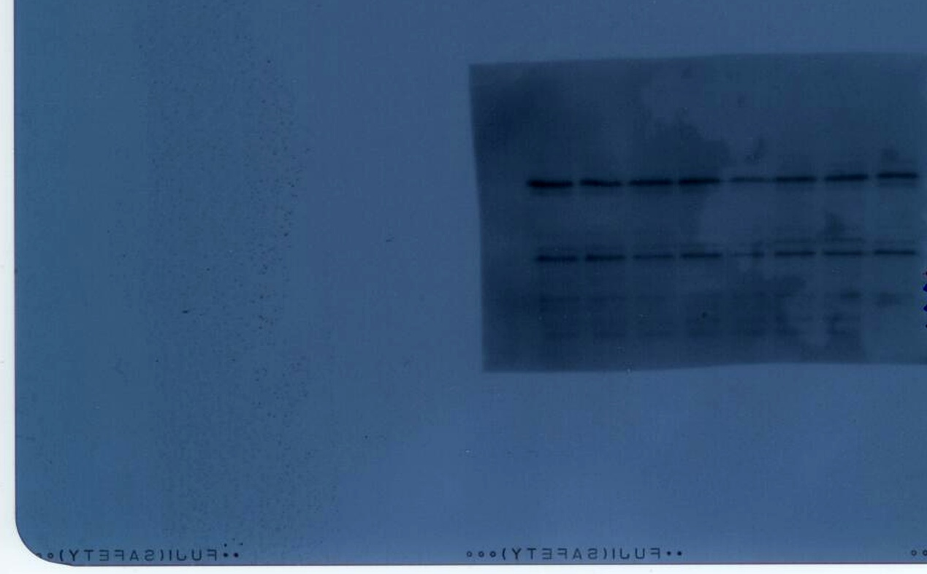
α-tubulin ~ 55kDa
LIN7A ~ 26kDa
U87Ctrl U87shLIN7A

Fig2 D

Time | Relative Invading Area
 | U87Ctrl |  |  |  |  | U87shLIN7A
0h | 1 | 1 | 1 | 1 |  | 1 | 1 | 1 | 1
24h | 1.5172 | 1.423 | 1.356 | 1.402 |  | 2.863 | 2.93 | 3.114 | 2.96
48h | 1.523 | 1.754 | 1.517 | 1.562 |  | 3.11 | 3.268 | 3.47 | 3.36
72h | 1.825 | 2.018 | 1.765 | 1.753 |  | 4.065 | 4.336 | 4.456 | 4.563

Fig2 F
Limiting dilution data entered
Group | Dose | Tested | Response
U87Ctrl | 300 | 48 | 48
U87Ctrl | 50 | 48 | 48
U87Ctrl | 8 | 48 | 41
U87Ctrl | 1 | 48 | 12
U87shLIN7A | 300 | 48 | 44
U87shLIN7A | 50 | 48 | 37
U87shLIN7A | 8 | 48 | 16
U87shLIN7A | 1 | 48 | 2

Confidence intervals for 1/ (stem cell frequency)
Group | Lower | Estimate | Upper
U87RNAi | 5.9 | 4.48 | 3.44
U87shLIN7A | 71.2 | 52.38 | 38.59*
* P<0.01

Fig3 B Western Blotting of β-Catenin
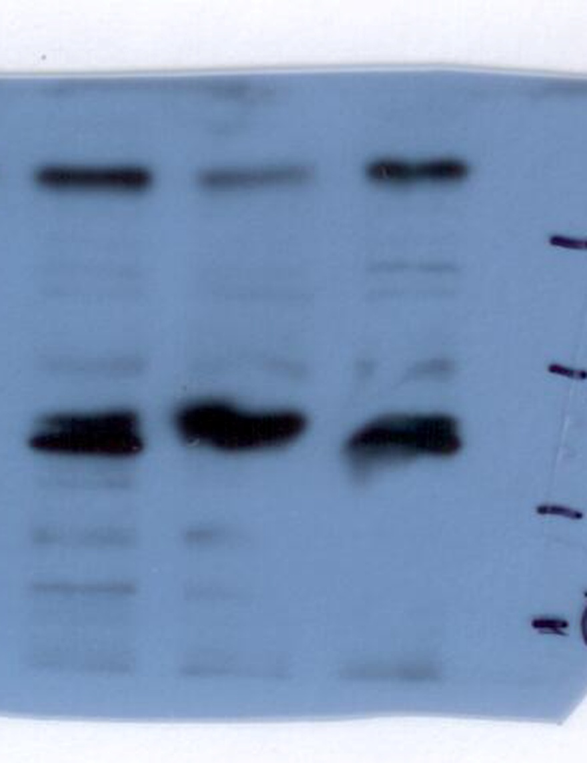
β- catenin (nuclear) ~ 86kDa
Lamin B1 ~ 67kDa
U87Ctrl U87shLIN7A

U87Ctrl U87shLIN7A
β- catenin (whole cell)
~ 86kDa
α-tubulin ~ 55kDa

Fig3 D Zymography gels for MMP-2 and MMP-9 activity analysis
U87Ctrl U87shLIN7A
MMP-2
MMP-9

