Supplementary Figure S3
A
B
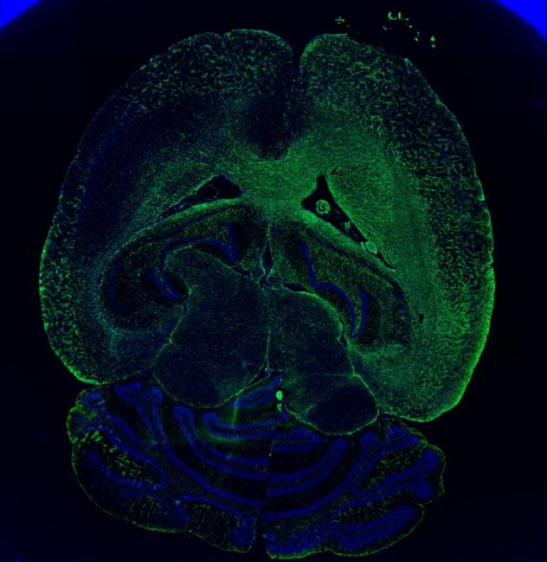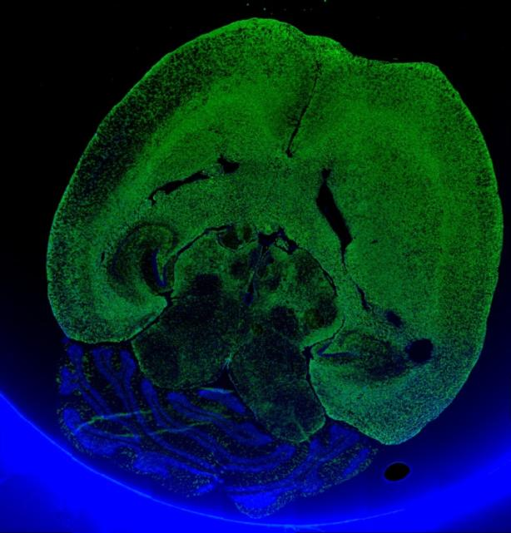
T269LIN7AFlag
T269lv902

Supplementary Figure S2. Overexpression of LIN7A in T269 shows inhibition effect on invasion. Based on these findings, the researchers selected the highly invasive T269 GIC cell line with low LIN7A expression as the experimental model. They constructed an overexpression system (lv902-LIN7A-Flag) and transfected it into T269 GIC cells, using T269 GIC cells transfected with the empty vector lv902 as controls. The efficiency of the overexpression transfection was confirmed using RT-qPCR. (Figure S2 A)
The intracranial growth and infiltration patterns of LIN7A-overexpressing T269 GIC cells were then compared to the control group in a nude mouse model, with each group consisting of four experimental animals. In the T269lv902 group, three out of four mice developed severe symptoms, with one mouse succumbing 8 weeks post-inoculation. In contrast, all four mice in the T269LIN7AFlag group remained alive, exhibiting no or only mild symptoms. At this time point, the animals were euthanized, and horizontal whole-brain sections were prepared for immunofluorescence staining with anti-human nestin to label the tumor cells. The horizontal sections (stained with DAPI and anti-human nestin at 50× magnification) revealed significant differences in invasiveness between the T269lv902 (control) and T269LIN7AFlag groups. The orange curve delineates the invasive range of the tumor cells. Qualitative observations of the images indicated that tumors in the LIN7A-overexpressing group exhibited a smaller invasion range compared to the control group, although quantitative analysis was not performed. (Figure S2 B)

