Additional files

Additional file 1 – R code for creation of prioritization index and maps
Syntax and code for each step listed in the prioritization framework (Table 2) can be found in the public GitHub repository titled “ITN targeting methodology Malaria Consortium Tulane”, and can be accessed using the following link: https://github.com/weaton5061/ITN_targeting_methodology_Malaria_Consortium_Tulane

Additional file 2 – Covariate raster layer utilised in creation of spatially interpolated ITN availability layer: 2015 Settlement Model
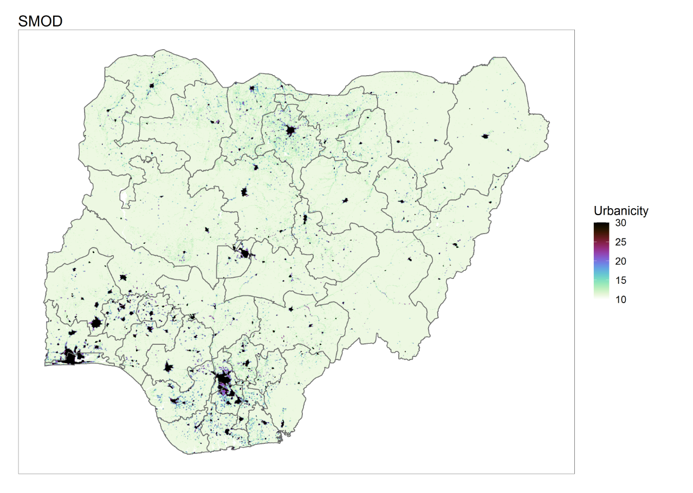

Additional file 3 – Covariate raster layer utilised in creation of spatially interpolated ITN availability layer: 2015 Prevalence of Improved Housing
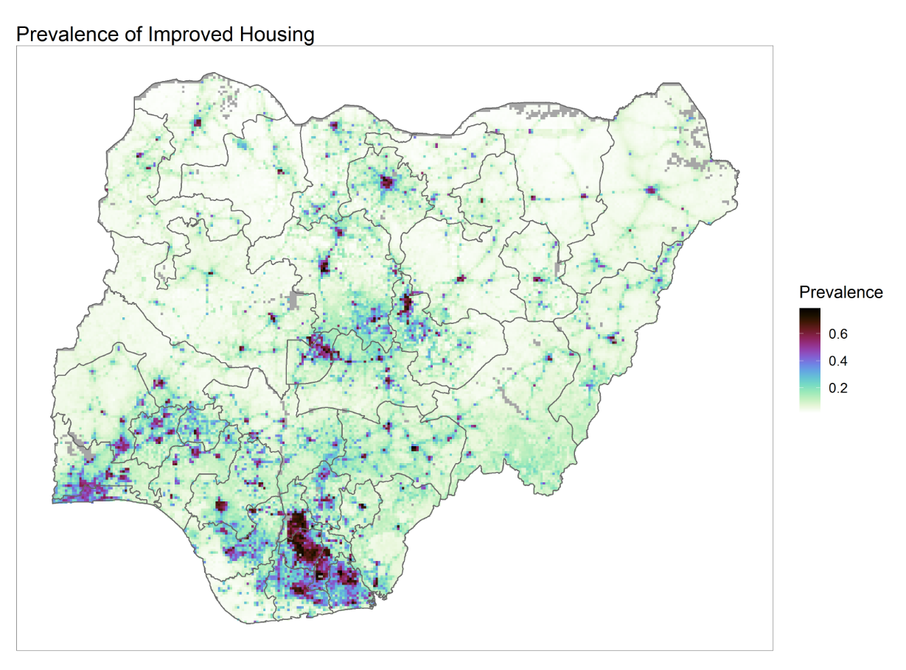

Additional file 4 – Covariate raster layer utilised in creation of spatially interpolated ITN availability layer: Travel time to nearest city of 60,000 or more inhabitants
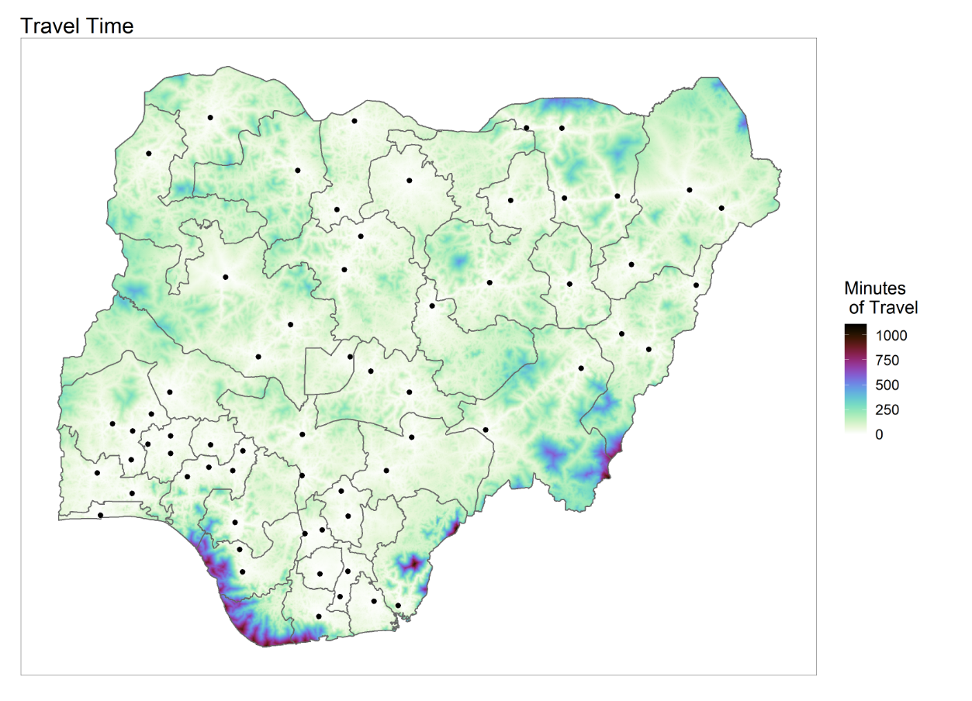

Additional file 5– Covariate raster layer utilised in creation of spatially interpolated ITN availability layer: 2015 mean years of educational attainment for women aged 15-29 years
