Table 1: Characteristics of survey participants, Somalia, 2024
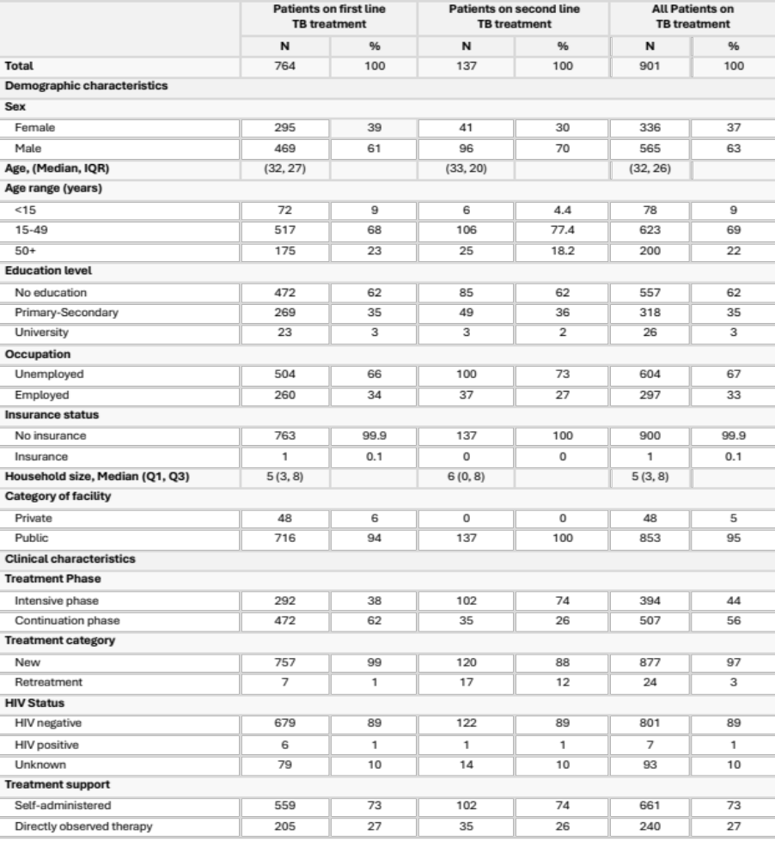
Table 2: Key Model of Care Variables for TB (Hospitalization, treatment duration, and delay), Somalia, 2024.
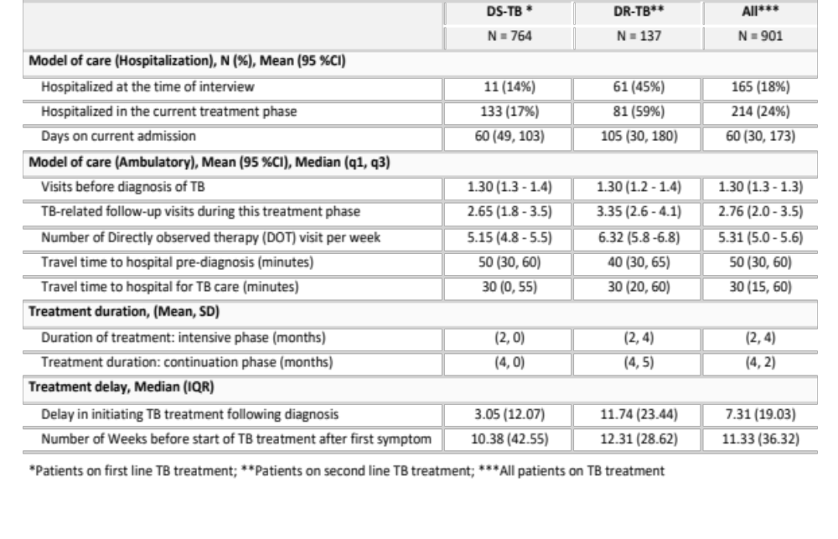
Table 3: Cost incurred by patients in TB care and their households by phase of treatment and cost type, Somalia, 2024
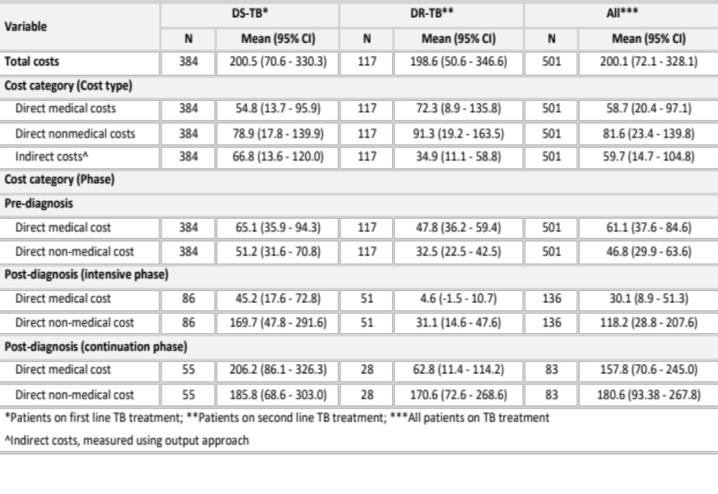
Table 4: Changes in household income due to TB, Somalia, 2024
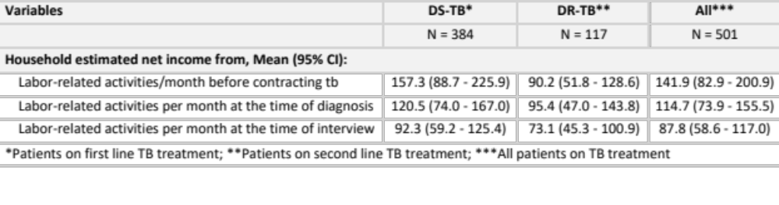

Table 5: Coping strategies and impact of catastrophic costs on the social life and finance of TB patients, Somalia, 2024
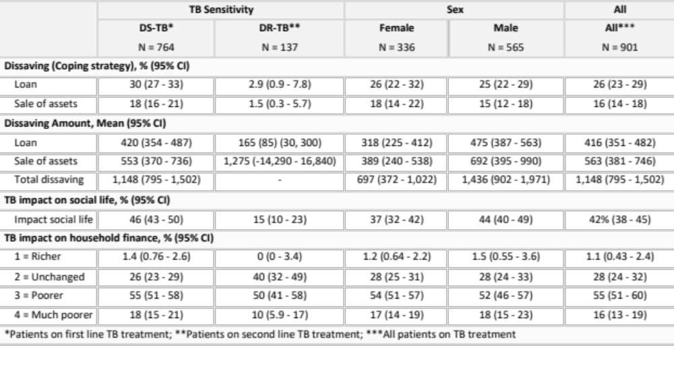

Table 6: Risk factors associated with high catastrophic costs among Patients in TB care and their households, Somalia, 2024
