>AF487905|AF487905.1 Homo sapiens MLL/AF4 fusion protein mRNA, partial cds.
TTGPPRKEVPKTTPSEPKKKQPPPPESGPEQSKQKKVAPRPSIPVKQKPKEKEKPPPVNK
QENAGTLNILSTLSNGNSSKQKIPADGVHRIRVDFKEDCEAENVWEMGGLGILTSVPITP
RVVCFLCASSGHVEQTYSNEVHCVEEILKEMTHSWPPPLAAIHTPSTAEPSKFPFPTKDS
QHVSSVTQNQKQYDTSSKTHSNSQQGTSSMLEDDLQLSDSEDSDSEQTPEKPPSHLHLQV
LHSPFQNQWHQHIPAVQSQKAPVTQTVPQTQRARAVQVTASSSDSEENEPLETPAPEPEP
PTTNKWQLDNWLTKVSQPAAPPEGPRSTEPPRRHPESKGSSDSATSQEHSESKDPPPKSS
SKAPRAPPEAPHPGKRSCQKSPAQQEPPQRQTVGTKQPKKPVKASARAGSRTSLQGEREP
GLLPYGSRDQTSKDKPKVKTKGRPRAAASNEPKPAVPPSSEKKKHKSSLPAPSKALSGPE
PAKDNVEDRTPEHFALVPLTESQGPPHSGSGSRTSGCRQAVVVQEDSRKDRLPLPLRDTK
LLSPLRDTPPPQSLMVKITLDLLSRIPQPPGKGSRQRKAEDKQPPAGKKHSSEKRSSDSS
SKLAKKRKGEAERDCDNKKIRLEK

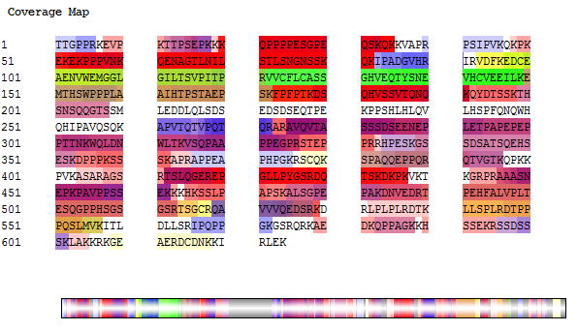

>AF297746|AF297746.1 Homo sapiens clone 1426-11 MLL/GMPS fusion protein mRNA, partial cds.
VVIPPQPPTTGPPRKEVPKTTPSEPKKKQPPPPESGPEQSKQKKVAPRPSIPVKQKPKEK
EKPPPVNKQENAGTLNILSTLSNGNSSKQKIPADGVHRIRVDFKLENAGGDLKDGHHHYE
GAVVILDAGAQYGKVIDRRVRELFVQSEIFPLETPAFAIKEQGFRAIIISGGPNSVYAED
APWFDPAIFTIGKPVLGICYGMQMMNKVFGGTVHKKSDRGSWSGGLFGFRPRGRDIPFFT
LF

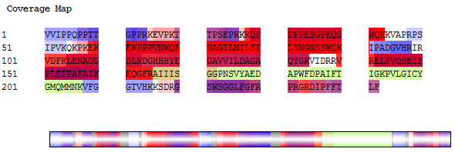

>a1ENA|AF231998|AF231998.1 Homo sapiens MLL/GAS7 fusion protein (MLL/GAS7) mRNA, partial cds.
VVIPPQPPTTGPPRKEVPKTTPSEPKKKQPPPPESGPEQSKQKKVAPRPSIPVKQKPKEK
EKPPPVNKQENAGTLNILSTLSNGNSSKQKIPADGVHRIRVDFKEDCEAENVWEMGGLGI
LTSVPITPRVVCFLCASSGHVEKPGMVPPPPGEESQTVILPPGWQSYLSPQGRRYYVNTT
TNETTWERPSSSPGIPASPGSHRSSLPPTVNGYHASGTPAHPPETAHMSVRKSTGDSQNL
GSSSPSKKQKLEWWPVWIQAQGPRHSLLHSF

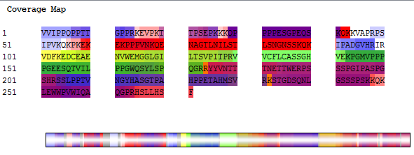
>a1ENA|AF231997|AF231997.1 Homo sapiens MLL/GAS7 fusion protein (MLL/GAS7) mRNA, partial cds.
VVIPPQPPTTGPPRKEVPKTTPSEPKKKQPPPPESGPEQSKQKKVAPRPSIPVKQKPKEK
EKPPPVNKQENAGTLNILSTLSNGNSSKQKIPADGVHRIRVDFKKPGMVPPPPGEESQTV
ILPPGWQSYLSPQGRRYYVNTTTNETTWERPSSSPGIPASPGSHRSSLPPTVNGYHASGT
PAHPPETAHMSVRKSTGDSQNLGSSSPSKKQSKENTITINCVTFPHPDTMPEQQLLKPTE
WSYCDYFWADKKDPQGNGTVAGFELLLQKQLKGKQMQKEMSEFIRERIKIEEDYAKNLAK
LSQNSLASQEEGSLGEAWAQVKKSLADEAEVHLKFSAKLHSEVEKPLMNFRENFKKDMKK
CDHHIADLRKQLASRYASVEKARKALTERQRDLEMKTREAGVVACLDSGPGAETFPSSLF
S

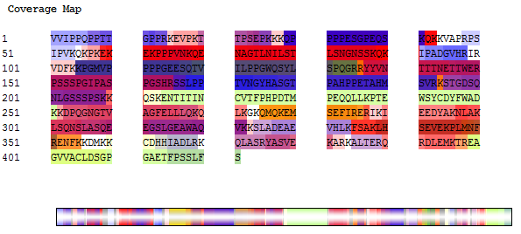
>a2ENA|CN311554|CN311554.1 17000532188925 GRN_ES Homo sapiens cDNA 5', mRNA sequence.
GLSWKLAWPPELPGVGTGGFVLYAPFSLCAMGDVKESKMQITPETPGRIPVLNPFESPSD
YSNLHEQTLASPSVFKSTKLPDEEESLNEVGYDDIGGCRKQLAQIKEMVELPLRHPALFK
AIGVKPPRGILLYGPPGTGKTLIARAVANETGAFFFLINGPEIMSKLAGESESNLRKAFE
EAEKNAPAIIFIDELDAIAPKREKTHGEVERRIVSQLLTLMDGLKQRAHVIVMAATNRPN
SIDPALRRF

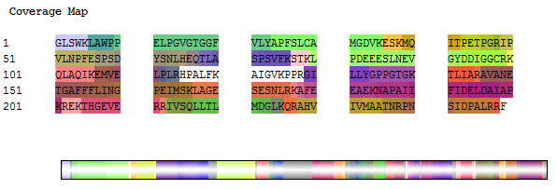
>a1ENA|AF512945|AF512945.1 Homo sapiens MLL/SEPTIN6 fusion protein mRNA, partial cds.
VVIPPQPPTTGPPRKEVPKATPSEPKKKQPPPPESGPEQSKQKKVAPRPSIPVKQKPKEK
EKPPPVNKQENAGTLNILSTLSNGNSSKQKIPADGVHRIRVDFKEDCEAENVWEMGGLGI
LTSVPITPRVVCFLCASSGHVEGEGCRTVPLAGHVGFDSLPDQLVNKSVSQGFCFNILCV
GETGLGKSTLMDTLFNTKFEGEPATHTQPGVQLQSNTYDLQESNVRLKLTIVSTVGFGDQ
INKEDSYKPIVEFIDAQFEAYLQEELKIRRVLHTYHDSRIHVCLYFIAPTGHSLKSLDLV
TMKKLDSKVNIIPIIAKADAISKSELTKFKIKITSELVSNGVQIYQFPTDDESVAEINGT
MNAHLPFAVIGSTEELKIGNKMMRARQYPWGTVQVENEAHCDFVKLREMLIRVNMEDLRE
QTHTRHYELYRRCKLEEMGFKDTDPDSKPFSLQETYEAKRNEFLGELQKKEEEMRQMFVQ
RVKEKEAELKEAEKEL

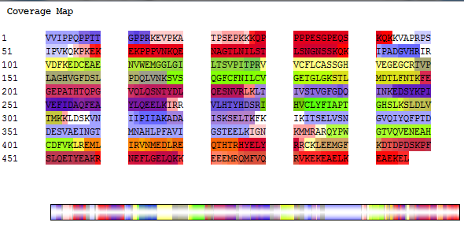
>a3ENA|AF477006|AF477006.1 Homo sapiens myeloid/lymphoid or mixed-lineage leukemia/clathrin assembly protein fusion protein (MLL/CALM fusion) mRNA, partial cds.
VKKKEKKSKTSEKKDSKESSVVKNVVDSSQKPTPSAREDPAPKKSSSEPPPRKPVEEKSE
EGNVSAPGPESKQATTPASRKSSKQVSQPALVIPPQPPTTGPPRKEVPKTTPSEPKKKQP
PPPESGPEQSKQKKVAPRPSIPVKQKPKEKEKPPPVNKQENAGTLNILSTLSNGNSSKQK
IPADGVHRIRVDFKQVGIDRGDIPDLSQAPSSLLDALEQHLASLEGKKIKDSTAASRATT
LSNAVSSLASTGLSLTKVDEREKQAALEEEQARLKALKEQRLKELAKKPHTSLTTAASPV
STSAGGIMTAPAIDIFSTPSSSNSTSKLPNDLLDLQQPTFHPSVHPMSTASQVASTWGDP
FSATVDAVDDAIPSLNPFLTKSSGDVHLSISSDVSTFTTRTPTHEMFVGFTPSPVAQPHP
SAGLNVDFESVFGNKSTNVIVDSGGFDELGGLLKPTVASQNQNLPVAKLPPSKLVSDDLD
SSLANLVGNLGIGNGTTKNDVNWSQPGEKKLTGGSNCEPKVAPTTAWNAATMNGMHFPQY
APPVMAYPATTPTGMIGYGIPPQMGSVPVMTQPTLIYSQPVMRPPNPFGPVSGAQIQFM

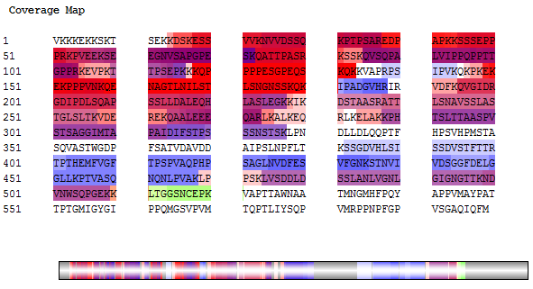

>AF231999|AF231999.1 Homo sapiens MLL/GAS7 fusion protein (MLL/GAS7) mRNA, partial cds.
VVIPPQPPTTGPPRKEVPKTTPSEPKKKQPPPPESGPEQSKQKKVAPRPSIPVKQKPKEK
EEPPPVNKQENAGTLNILSTLSNGNSSKQKIPADGVHRIRVDFKEDCEAENVWEMGGLGI
LTSVPITPRVVCFLCASSGHVEKPGMVPPPPGEESQTVILPPGWQSYLSPQGRRYYVNTT
TNETTWERPSSSPGIPASPGSHRSSLPSTVNGYHASGIPAHPPETAHMSVRKFTGDSQNL
GSSSPSKKQSKENTITINCVTFPHPDTMPEQQLLKPTDEAGVVACLDSGPGAETFPSSLF
S

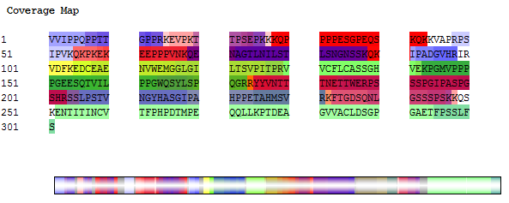

>AF272375|AF272375.1 Homo sapiens clone 1370-44 MLL/AF-10 fusion protein mRNA, partial cds.
VVIPPQPPTTGPPRKEVPKTTPSEPKKKQPPPPESGPEQSKQKKVAPRPSIPVKQKPKEK
EKPPPVNKQENAGTLNILSTLSNGNSSKQKIPADGVHRIRVDFKTYTSTSNNSISGSLKR
LEDTTARFTNANFQEVSAHTSSGKDVSETRGSEGKGKKSSAHSSGQRGRKPGGGRNPGTK
LEWWPVWIQAQGPRHSLLHSF

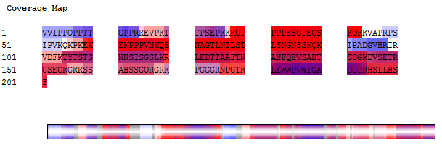

>AF512943|AF512943.1 Homo sapiens clone 1838-11 MLL/SEPTIN6 fusion protein mRNA, partial cds.
VVIPPQPPTTGPPRKEVPKATPSEPKKKQPPPPESGPEQSKQKKVAPRPSIPVKQKPKEK
EKPPPVNKQENAGTLNILSTLSNGNSSKQKIPADGVHRIRVDFKEDCEAENVWEMGGLGI
LTSVPITPRVVCFLCASSGHVEGEGCRTVPLAGHVGFDSLPDQLVNKSVSQGFCFNILCV
GETGLGKSTLMDTLFNTKFEGEPATHTQPGVQLQSNTYDLQESNVRLKLTIVSTVGFGDQ
INKEDSYKPIVEFIDAQFEAYLQEELKIRRVLHTYHDSRIHVCLYFIAPTGHSLKSLDLV
TMKKLDSKVNIIPIIAKADAISKSELTKFKIKITSELVSNGVQIYQFPTDDESVAEINGT
MNAHLPFAVIGSTEELKIGNKMMRARQYPWGTVQVENEAHCDFVKLREMLIRVNMEDLRE
QTHTRHYELYRRCKLEEMGFKDTDPDSKPFSLQETYEAKRNEFLGELQKK

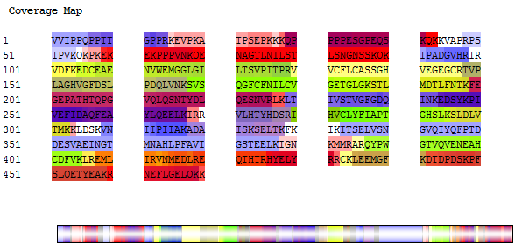

>AF297749|AF297749.1 Homo sapiens MLL/GMPS fusion protein mRNA, partial cds.
RPSIPVKQKPKEKEKPPPVNKQENAGTLNILSTLSNGNSSKQKIPADGVHRIRVDFKEDC
EAENVWEMGGLGILTSVPITPRVVCFLCASSGHVELENAGGDLKDGHHHYEGAVVILDAG
AQYGKVIDRRVRELFVQSEIFPLETPAFAIKEQGFRA

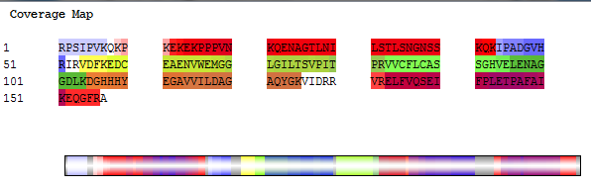

>AF186110|AF186110.1 Homo sapiens TPM4-ALK fusion oncoprotein type 1 (TPM4-ALK fusion) mRNA, partial cds.
LSARRIEGWNSNEAPPPRPTLAEGDVAALNRRIQLVEEELDRAQERLATALQKLEEAEKA
ADESERGMKVIENRAMKDEEKMEIQEMQLKEAKHIAEEADRKYEEVARKLVILEGELERA
EERAEVSELKCGDLEEELKNVTNNLKSLEAASEKYSEKEDKYEEEIKLLSDKLKEAETRA
EFAERTVAKLEKTIDDLEVYRRKHQELQAMQMELQSPEYKLSKLRTSTIMTDYNPNYCFA
GKTSSISDLKEVPRKNITLIRGLGHGAFGEVYEGQVSGMPNDPSPLQVAVKTLP

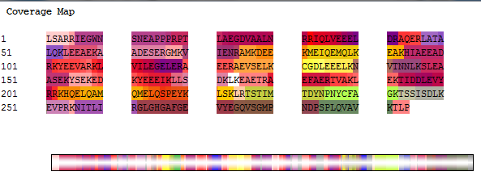

>AM491362|AM491362.1 Homo sapiens partial mRNA for bcr-abl1 e6a2 chimeric protein
YQPYQSIYVGGMMEGEGKGPLLRSQSTSEQEKRLTWPRRSYSPRSFEDCGGGYTPDCSSN
ENLTSSEEDFSSGQSSRVSPSPTTYRMFRDKSRSPSQNSQQSFDSSSPPTPQCHKRHRHC
PVVVSEATIVGVRKTGQIWPNDGEGAFHGDADGSFGTPPGYGCAADRAEEQRRHQDGLPY
IDDSPSSSPHLSSKGRGSRDALVSGALESTKASELDLEKGLEMRKWVLSGILASEETYLS
HLEALLLPMKPLKAAATTSQPVLTSQQIETIFFKVPELYEIHKEFYDGLFPRVQQWSHQQ
RVGDLFQKLASQLGVYRASVDNYGVAMEMAEKCCQANAQFAEISENLRARSNKDAKDPTT
KNSLEKALQRPVASDFEPQGLSEAARWNSKEDLLAGPSENDPNLFVALYDFVASGDNTLS
ITKGEKLRVLGYNHNGEWCEAQTKNGQGWVPSNYITPVNSLEKHSWYHGPVSRNAAEYLL
SSGINGSFLVRESESSPGQRSISLRYEGRVYHYRINTASDGKLYVSSESRFNTLAELVHH
HSTVADGLITTLHYPAPKRNKPTVYGVSPNYDKWEMERTDITMKH

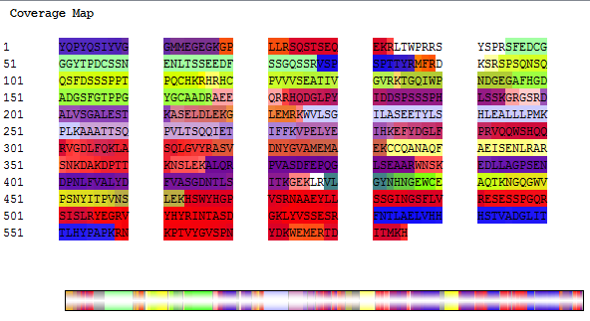

>AM491363|AM491363.1 Homo sapiens partial mRNA for bcr-abl1 e19a2 chimeric protein
PSMAFRVHSRNGKSYTFLISSDYERAEWRENIREQQKKCFRSFSLTSVELQMPTNSCVKL
QTVHSIPLTINKEDDESPGLYGFLNVIVHSATGFKQSSNLYCTLEVDSFGYFVNKAKTRV
YRDTAEPNWNEEFEIELEGSQTLRILCYEKCYNKTKIPKEDGESTDRLMGKGQVQLDPQA
LQDRDWQRTVIAMNGIEVKLSVKFNSREFSLKRMPSRKQTGVLGVKIAVVTKRERSKVPY
IVRQCVEEIERRGMEEVGIYRVSGVATDIQALKAAFDVKALQRPVASDFEPQGLSEAARW
NSKENLLAGPSENDPNLFVALYDFVASGDNTLSITKGEKLRVLGYNHNGEWCEAQTKNGQ
GWVPSNYITPVNSLEKHSWYHGPVSRNAAEHLLSSGINGSFLVRESESSPGQRSISLRYE
GRVYHYRINTASDGKLYVSSESRFNTLAELVHHHSTVADGLITTLHYPAPKRNKPSVYGV
SPNYDKWEMERTDITMKH

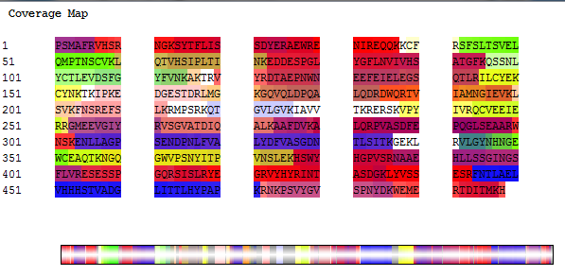
>AJ131466|AJ131466.1 Homo sapiens partial mRNA for bcr-abl1 e14a2 chimeric protein
ANKGSKATERLKKKLSEQESLLLLMSPSMAFRVHSRNGKSYTFLISSDYERAEWRENIRE
QQKKCFRSFSLTSVELQMLTNSCVKLQTVHSIPLTINKEDDESPGLYGFLNVIVHSATGF
KQSSKALQRPVASDFEPQGLSEAARWNSKENLLAGPSENDPNLFVALYDFVASGDNTLSI
TKGEKLRVLGYNHNGEWCEAQTKNGQGWVPSNYITPVNSLEKHSWYHGPVSRNAAEYLLS
SGINGSFLVRESESSPGQRSISLRYEGRVYHYRINTASDGKLYVSSESRFNTLAELVHHH
STVADGLITTLHYPAPKRNKPTVYGVSPNYDK

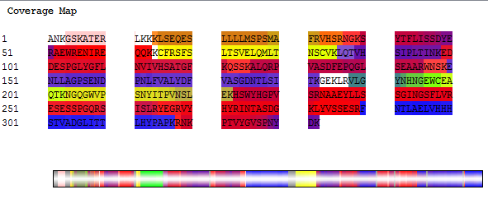

>a1ENA|AJ131467|AJ131467.1 Homo sapiens partial mRNA for bcr-abl1 e13a2 chimeric protein
ANKGSKATERLKKKLSEQESLLLLMSPSMAFRVHSRNGKSYTFLISSDYERAEWRENIRE
QQKKCFRSFSLTSVELQMLTNSCVKLQTVHSIPLTINKEEALQRPVASDFEPQGLSEAAR
WNSKENLLAGPSENDPNLFVALYDFVASGDNTLSITKGEKLRVLGYNHNGEWCEAQTKNG
QGWVPSNYITPVNSLEKHSWYHGPVSRNAAEYLLSSGINGSFLVRESESSPGQRSISLRY
EGRVYHYRINTASDGKLYVSSESRFNTLAELVHHHSTVADGLITTLHYPAPKRNKPTVYG
VSPNYDK

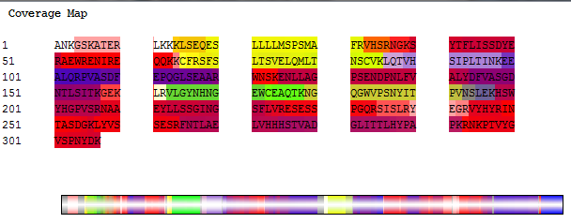

>a2ENA|AF113911|AF113911.1 Homo sapiens BCR-ABL1 e1a2 chimeric protein (BCR/ABL fusion) mRNA, partial cds.
YQPYQSIYVGGMMEGEGKGPLLRSQSTSEQEKRLTWPRRSYSPRSFEDCGGGYTPDCSSN
ENLTSSEEDFSSGQSSRVSPSPTTYRMFRDKSRSPSQNSQQSFDSSSPPTPQCHKRHRHC
PVVVSEATIVGVRKTGQIWPNDGEGAFHGDAEALQRPVASDFEPQGLSEAARWNSKENLL
AGPSENDPNLFVALYDFVASGDNTLSITKGEKLRVLGYNHNGEWCEAQTKNGQGWVPSNY
ITPVNSLEKHSWYHGPVSRNAAEYLLSSGINGSFLVRESESSPGQRSISLRYEGRVYHYR
INTASDGKLYVSSESRFNTLAELVHHHSTVADGLITTLHYPAPKRNKPTVYGVSPNYDK

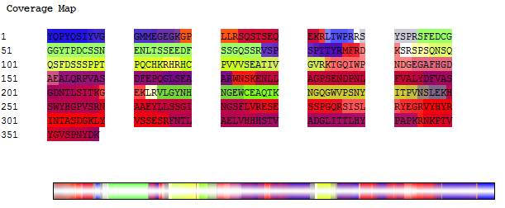
>a1ENA|DQ898314|DQ898314.1 Homo sapiens isolate e13a4 BCR/ABL fusion protein (BCR/ABL fusion) mRNA, partial cds, alternatively spliced.
QMLTNSCVKLQTVHSIPLTINKEALRLLREPLQHPGRVGSSSFNGGR

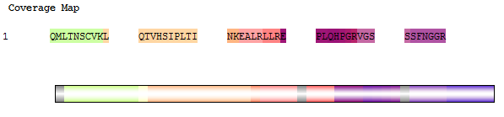

>DQ451148|DQ451148.1 Homo sapiens MLL-AF4 fusion protein (MLL/AF4 fusion) mRNA, partial cds.
TTPSEPKKKQPPPPESGPEQSKQKKVAPRPSIPVKQKPKEKDSQHVSSVTQNQKQYDTSS
KTHSNSQQGTS
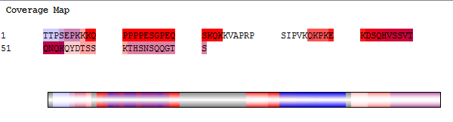
>a1ENA|AF231996|AF231996.1 Homo sapiens MLL/GAS7 fusion protein (MLL/GAS7) mRNA, partial cds.
VVIPPQPPTTGPPRKEVPKTTPSEPKKKQPPPPESGPEQSKQKKVAPRPSIPVKQKPKEK
EKPPPVNKQENAGTLNILSTLSNGNSSKQKIPADGVHRIRVDFKKPGMVPPPPGEESQTV
ILPPGWQSYLSPQGRRYYVNTTTNETTWERPSSSPGIPASPGSHRSSLPPTVNGYHASGT
PAHPPETAHMSVRKSIGYSQNLGSSSPSKKQKLEW*PVWIQAQGPRHSLLHSF

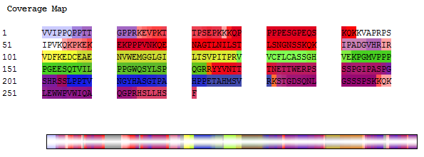
>a3ENA|AF031404|AF031404.1 Homo sapiens MLL-AF4 fusion protein mRNA, partial cds.
KQKKVAPRPSIPVKQKPKEKEKPPPVNKQENAGTLNILSTLSNGNSSKQKIPADGVHRIR
VDFKEDCEAENVWEMGGLGILTSVPITPRVVCFLCASSGHVEQTYSNEVHCVEEILKEMT
HSWPPPLTAIHTPSTAEPSKFPFPTKDSQHVSSVTQNQKQYDTSSKTHSNSQQGTSSMLE
DDLQLSDSEDSDSEQTPEKPPSSSAPPSAPQSLPEPVASAHSSSAESESTSDSDSSSDSE
SESSSS

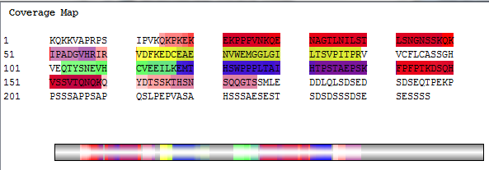
>a1ENA|AM491360|AM491360.1 Homo sapiens partial mRNA for bcr-abl1 e14a3 chimeric protein
PSMAFRVHSRNGKSYTFLISSDYERAEWRENIREQQKKCFRSFSLTSVELQMLTNSCVKL
QTVHSIPLTINKEDDESPGLYGFLNVIVHSATGFKQSSSEKLRVLGYNHNGEWCEAQTKN
GQGWVPSNYITPVNSLEKHSWYHGPVSRNAAEYLLSSGINGSFLVRESESSPGQRSISLR
YEGRVYHYRINTASDGKLYVSSESRFNTLAELVHHHSTVADGLITTLHYPAPKRNKPTVY
GVSPNYDKWEMERTDITMKH

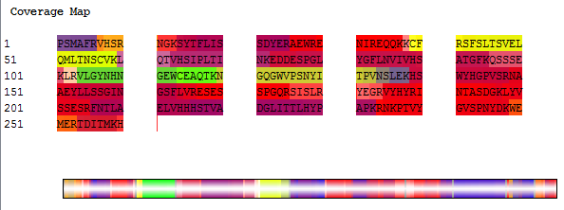
>a1ENA|AY187921|AY187921.1 Homo sapiens MLL/ENL fusion mRNA, partial sequence.
EDPAPKKSSSEPPPRKPVEEKSEEGNVSAPGPESKQATTPASRKSSKQVSQPALVIPPQP
PTTGPPRKEVPKTTPSEPKKKQPPPPESGPEQSKQKKVAPRPSIPVKQKPKEKEKPPPVN
KQENAGTLNILSTLSNGNSSKQKIPADGVHRIGVDFKEDCEAENVWEMGGLGILTSVPIT
PRVVCFLCASSGHVECTVQVRLELGHRAQLRKKPTTEGFTHDWMVFVRGPEQ

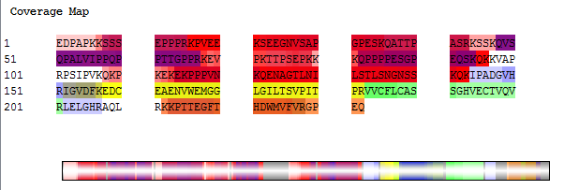

>a1ENA|AF422798|AF422798.1 Homo sapiens MLL/LAF4 fusion protein mRNA, partial cds.
EDPAPKKSSSEPPPRKPVEEKSEEGNVSAPGPESKQATTPASRKSSKQVSQPALVIPPQP
PTTGPPRKEVPKTTPSEPKKKQPPPPESGPEQSKQKKVAPRPSIPVKQKPKEKEMTWLPP
LSAIQAPGKVEPTKFPFPNKDSQLVSSGHNNPKKGDAEPESPDNG

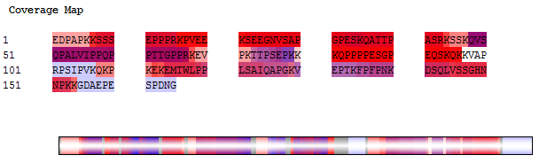
>a1ENA|FM165198|FM165198.1 Homo sapiens partial mRNA for TET1-MLL fusion transcript in acute lymphoblastic leukemia, patient 4765
VEKKPIPRIKRKNNSTTTNNSKPSSLPTLAVKKKEKKSKTSEKKDSKESSVVKNVVDSSQ
KPTPSAREDPAPKKSSSEPPPRKPVEEKSEEGNVSAPGPESKQATTPASRKSSKQVSQPA
LVIPPQPPTTGPPRKEVPKTTPSEPKKKQPPPPESGPEQSKQKKVAPRPSIPVKQKPKEK
EKPPPVNKQENAGTLNILSTLSNG
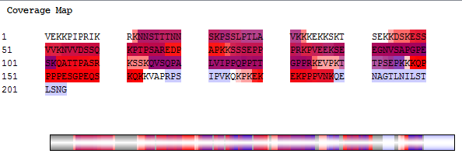
>a2ENA|AF533682|AF533682.1 Homo sapiens IL1RAPL1/dystrophin fusion protein mRNA, partial cds.
DFLLPTREPEILWYKECRTKTWRPSIVFKRDTLLIREVREDDIGNYTCELKYGGFVVRRT
TELTVTVERIQNQWDEVQEHLQNRRQQLNEMLKDSTQWLEAKEEAEQVLGQARAKLESWK
EGPYTVDAIQKKI

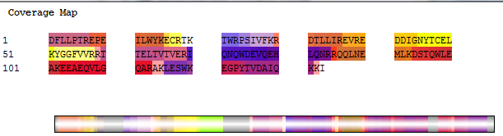

>DT217282|DT217282.1 KB-EST0002366 BNS6 Homo sapiens cDNA, mRNA sequence. hnRNPA2/B1/FAM96A fusion gene
VAAAPGPVRRCSSQSCFSSSGSSHYSARTSPVRVRPRRSLSSRSAAGNRAEATESAMERE
KEQFRKLFIGGLSFETTEESLRNYYEQWGKLTDCVVMRDPASKRSRGFGFVTFSSMAEVD
AAMAARPHSIDGRVVEPKRAVAREESGKPGAHVTVKKLFVGGIKEDTEEHHLRDYFEEYL
VIIRFTPTVPHCSLTTLTVGNLHF

