Supplementary Tables
Supplementary Table 1. Admixture proportions by 1000 Genomes population
Population | Ancestry Proportion
GIH | 60.24%
CEU | 70.30%
PJL | 73.55%
CHB | 77.45%
YRI | 82.87%
BEB | 83.79%
IBS | 84.84%
STU | 85.80%
CDX | 87.67%
MSL | 91.35%
TSI | 92.07%
FIN | 92.43%
JPT | 92.91%
ESN | 94.46%
LWK | 94.69%
GWD | 96.66%
LWK – Luhya in Webuye, Kenya; GWD – Gambian in Western Divisions in the Gambia; ESN – Esan in Nigeria; MSL – Mende in Sierra Leone; YRI – Yoruba in Ibadan, Nigeria; FIN – Finnish in Finland; CEU – Utah Residents (CEPH) with Northern and Western European Ancestry; IBS – Iberian Population in Spain; TSI – Toscani in Italia; CDX – Chinese Dai in Xishuangbanna, China; CHB – Han Chinese in Beijing, China; JPT – Japanese in Tokyo, Japan; PJL – Punjabi from Lahore, Pakistan; BEB – Bengali from Bangladesh; STU – Sri Lankan Tamil from the UK; GIH – Gujarati Indian from Houston.

Supplementary Table 2. Admixture proportions in 1000 Genomes reference samples using BioVU White SNP set with k=6
 | EAFR | WAFR | NEUR | SEUR | EAS | SAS
Q1 | 0.95 | 0.33 | 0.00 | 0.00 | 0.00 | 0.00
Q2 | 0.01 | 0.67 | 0.00 | 0.00 | 0.00 | 0.00
Q3 | 0.00 | 0.00 | 0.65 | 0.02 | 0.00 | 0.02
Q4 | 0.00 | 0.00 | 0.35 | 0.97 | 0.00 | 0.04
Q5 | 0.01 | 0.00 | 0.00 | 0.00 | 1.00 | 0.04
Q6 | 0.03 | 0.00 | 0.00 | 0.01 | 0.00 | 0.90
EAFR – East African; WAFR – West African; NEUR – Northern European; SEUR – Southern European; EAS – East Asian; SAS – South Asian.

Supplementary Table 3. Admixture proportions in 1000 Genomes reference samples using BioVU Black SNP set with k=6
 | EAFR | WAFR | NEUR | SEUR | EAS | SAS
Q1 | 0.95 | 0.36 | 0.00 | 0.00 | 0.00 | 0.00
Q2 | 0.00 | 0.64 | 0.00 | 0.00 | 0.00 | 0.00
Q3 | 0.00 | 0.00 | 0.65 | 0.03 | 0.00 | 0.03
Q4 | 0.01 | 0.00 | 0.35 | 0.95 | 0.00 | 0.04
Q5 | 0.01 | 0.00 | 0.00 | 0.00 | 1.00 | 0.04
Q6 | 0.03 | 0.00 | 0.00 | 0.02 | 0.00 | 0.89
EAFR – East African; WAFR – West African; NEUR – Northern European; SEUR – Southern European; EAS – East Asian; SAS – South Asian; Q1-6 – Ancestry proportions from ADMIXTURE.

Supplementary Figures
Supplementary Figure 1. Estimation of 26 ancestries from 1000 Genomes reference data. Stacked bar plot of ancestry proportions estimated in ADMIXTURE for 26 1000 Genomes populations grouped by continent. LWK – Luhya in Webuye, Kenya; GWD – Gambian in Western Divisions in the Gambia; ESN – Esan in Nigeria; MSL – Mende in Sierra Leone; YRI – Yoruba in Ibadan, Nigeria; FIN – Finnish in Finland; CEU – Utah Residents (CEPH) with Northern and Western European Ancestry; IBS – Iberian Population in Spain; TSI – Toscani in Italia; CDX – Chinese Dai in Xishuangbanna, China; CHB – Han Chinese in Beijing, China; JPT – Japanese in Tokyo, Japan; PJL – Punjabi from Lahore, Pakistan; BEB – Bengali from Bangladesh; STU – Sri Lankan Tamil from the UK; GIH – Gujarati Indian from Houston; AFR – African; AMR – American; EAS – East Asian; EUR – European; SAS – South Asian.
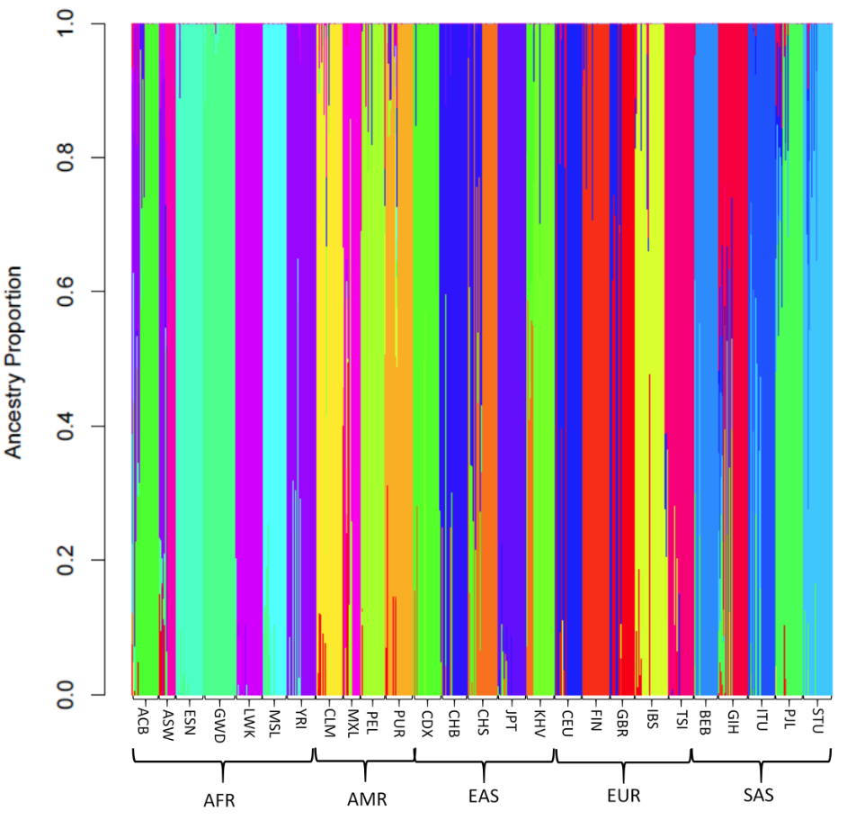
Supplementary Figure 2. Analysis of optimal K means. Plot of cross-validation errors at kmeans ranging from 1 to 20.
