Supplementary information

Self-template Synthesis of Nanoporous Carbons from
π-conjugated Ionic Liquids with Aromatic Functionalities

Toshinori Seki¹, Ryusuke Futamura ^{1*}, Kento Nakamura¹, Yumeto Murata¹, Ryuta Sekiguchi² and Taku Iiyama¹
¹ Faculty of Science, Department of Chemistry, Shinshu University, 3-1-1, Asahi, Matsumoto-City, 390-8621, Japan.
² Graduate School of Science and Technology, Hirosaki University, 3, Bunkyouchou, Hirosaki-City, 036-8561, Japan.
*e-mail: ryu_f@shinshu-u.ac.jp

Content

- Synthesis of π-conjugated Ionic Liquids
- Supplementary Figures

1. Synthesis of π-conjugated Ionic Liquids
1-methylimidazole (99.0%) and Li-TFSI (98.0%) were purchased from Tokyo Chemical Industry Co., Ltd. (TCI). 2-bromomethylnaphthalene (92%), toluene (99.5%), and benzyl bromide (97.0%) were from FUJIFILM Wako Pure Chemical Co. Milli-Q water was produced and used by Milli-Q Lab of Milli Pore Japan Co. The synthesis of π-conjugated ionic liquids was carried out in two steps: menshutkin reaction and metathesis reaction.

  - Synthesis of NMMI-TFSI
2-Bromomethylnaphthalene (5.295 g, 23.9 mmol) was dissolved in toluene (15 mL) to which 1-methylimidazole (2.811 g, 34.2 mmol) was added. Further toluene (5 mL) was added and the mixture was stirred at room temperature for 5 hours. The reaction product was washed out with toluene and filtered by aspiration through a membrane filter. The product was then thoroughly dried by vacuum heating and drying at 70 °C to afford NMMI-Br, the white solid, in 84% yield. ¹H NMR (500 MHz, CDCl₃) δ = 4.06 (s, 3 H), 5.75 (s, 2 H), 7.27–7.28 (m, 2 H), 7.52–7.54 (m, 3 H), 7.85–7.86 (m, 3 H), 7.98 (s, 1 H), 10.75 (s, 1 H) ppm.
NMMI-Br (6.164 g, 20.3 mmol) was then dissolved in Milli-Q water (15 mL) and Li-TFSI (7.451 g, 26.0 mmol) was added. Milli-Q water (10 mL) was further added and the mixture was stirred at 40 °C for 5 hours. The reaction product was decanted thoroughly with Milli-Q water. The product was further purified by column chromatography using alumina as packing material and chloroform as expansion solvent. The purified product was thoroughly dried by vacuum heating at 70 °C to afford NMMI-TFSI, a yellowish-brown liquid, in 97% yield. ¹H NMR (500 MHz, CDCl₃) δ = 3.83 (s, 3 H), 5.39 (s, 2 H), 7.34–7.36 (m, 1 H), 7.49–7.50 (m, 2 H), 7.78–7.87 (m, 4 H), 7.98 (s, 1 H), 8.74 (s, 1 H) ppm.

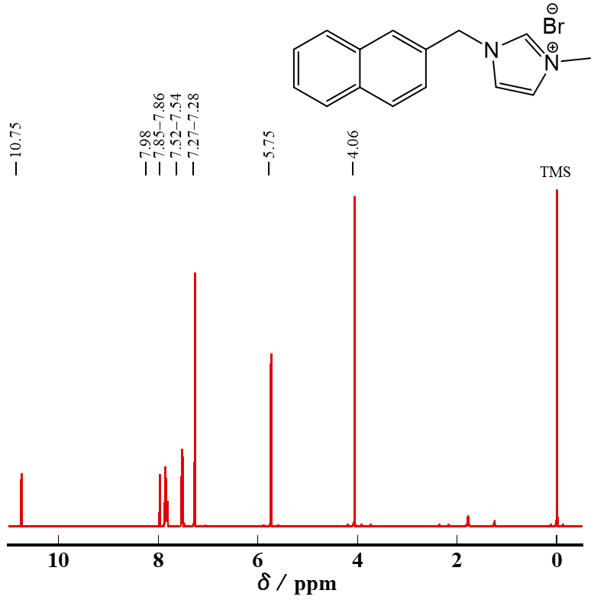
Fig. S1 ¹H NMR spectrum of NMMI-Br in CDCl₃ (500 MHz)

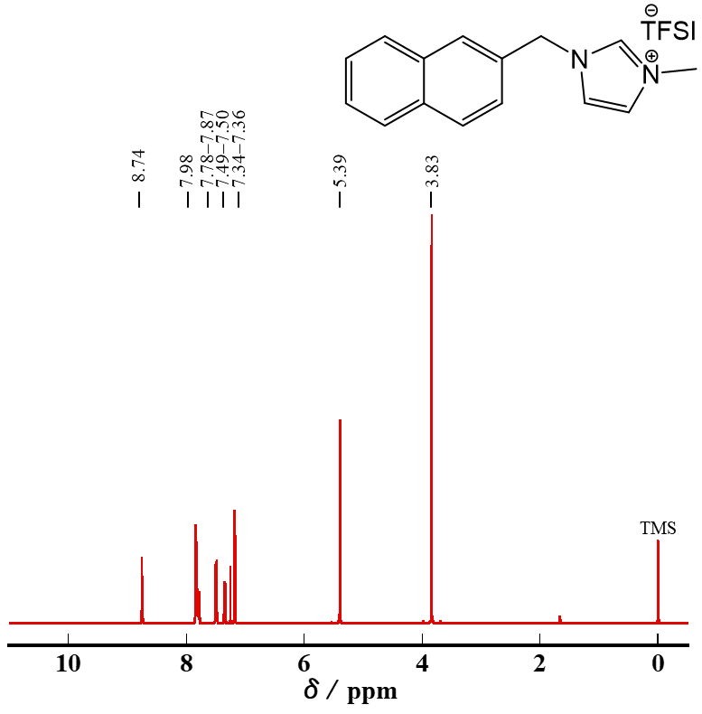
Fig. S2 ¹H NMR spectrum of NMMI-TFSI in CDCl₃ (500 MHz)

  - Synthesis of BzMI-TFSI
Benzyl bromide (13.70 g, 80.1 mmol) was dissolved in toluene, 1-methylimidazole (7.16 g, 87.2 mmol) was added, and the mixture was stirred at room temperature for 24 hours. The product was separated into two layers, a product layer and a toluene layer, and the product was washed by decantation three times with toluene. The product was then heated and vacuum dried overnight at 100 °C to afford the colorless liquid BzMI-Br in 99% yield. ¹H NMR (500 MHz, CDCl₃) δ = 4.06 (s, 3 H), 5.59 (s, 2 H), 7.36–7.38 (m, 3 H), 7.40–7.41 (m, 1 H), 7. 49–7.53 (m, 3 H), 10.45 (s, 1 H) ppm.
BzMI-Br (20.06 g, 79.3 mmol) was dissolved in Milli-Q water, Li-TFSI (23.22 g, 80.9 mmol) was added, and the mixture was stirred at 60 °C for 24 hours. After the reaction, the product was separated into two layers, a product layer and an aqueous layer, and the product was washed by decantation three times with Milli-Q water. The product was then heated and vacuum dried overnight at 120 °C to afford BzMI-TFSI, a colorless liquid, in 98% yield.
The product was further purified by column chromatography using alumina as a packing material and chloroform as the expansion solvent. After purification, the product was dried in a specimen dryer at 120 °C for 15 h. ¹H NMR (500 MHz, CDCl₃) δ = 3.92 (s, 3 H), 5.30 (s, 2 H), 7.17–7.18 (m, 1 H), 7.35–7.37 (m, 2 H), 7.40–7.43 (m, 3 H), 8.82 (s, 1 H) ppm.

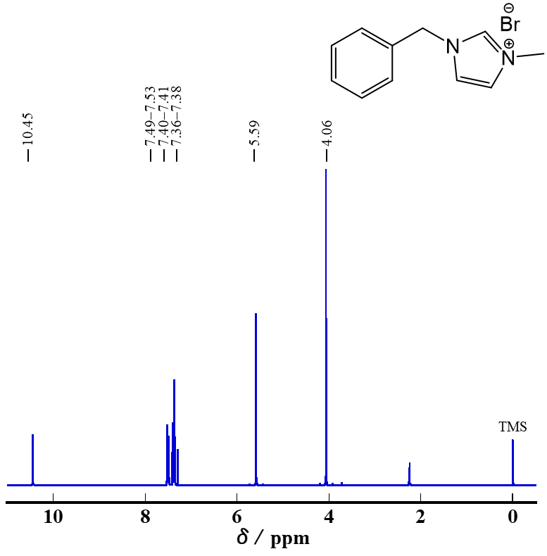
Fig. S3 ¹H NMR spectrum of BzMI-Br in CDCl₃ (500 MHz)

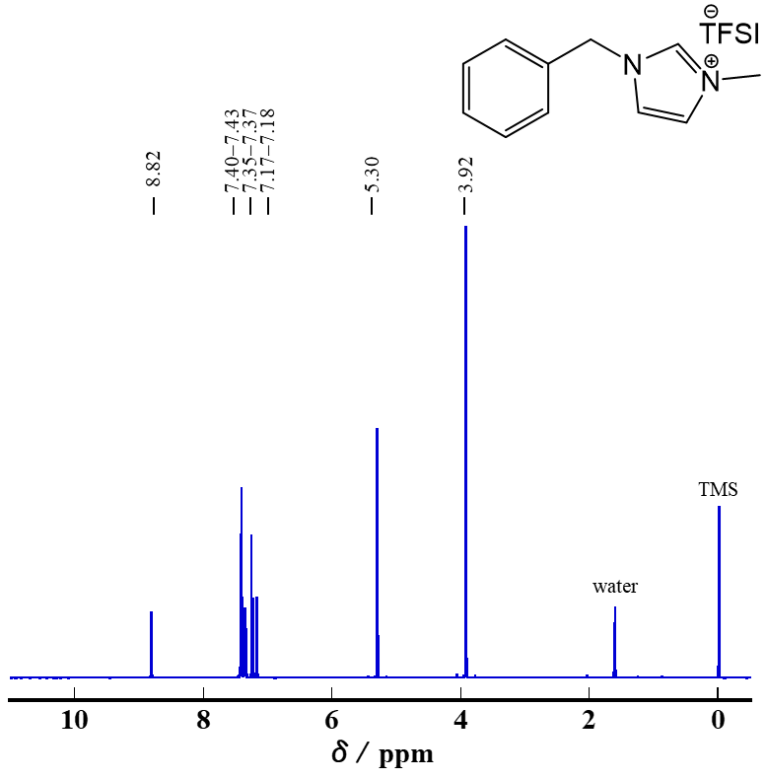
Fig. S4 ¹H NMR spectrum of BzMI-TFSI in CDCl₃ (500 MHz)

- Supplementary Figures

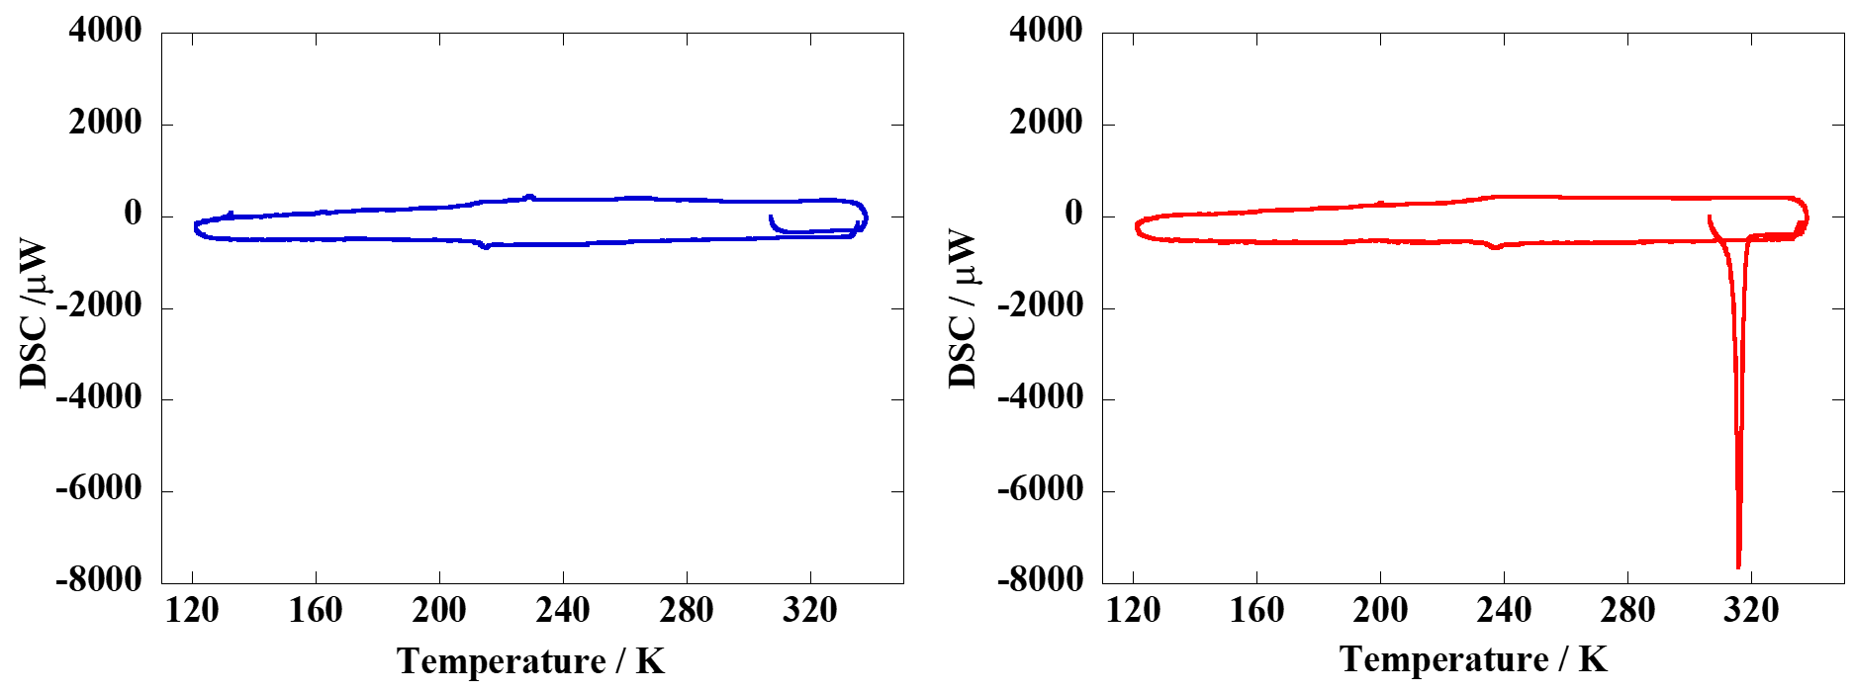
Fig. S5 DSC curves of BzMI-TFSI (blue) and NMMI-TFSI (red)

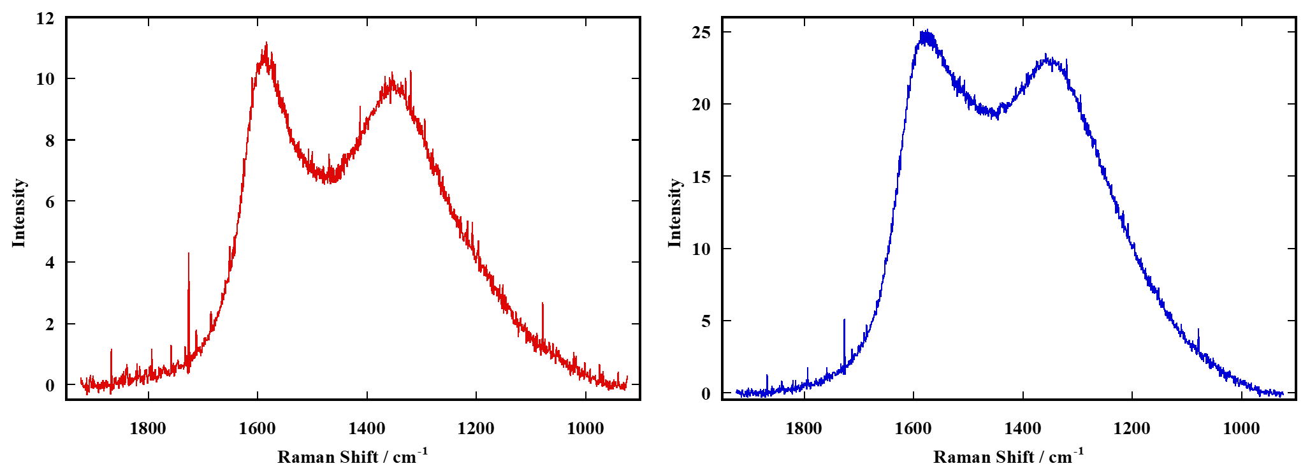
Fig. S6 Raman spectra for π-ILDCs obtained from NMMI-TFSI (left) and BzMI-TFSI (right)

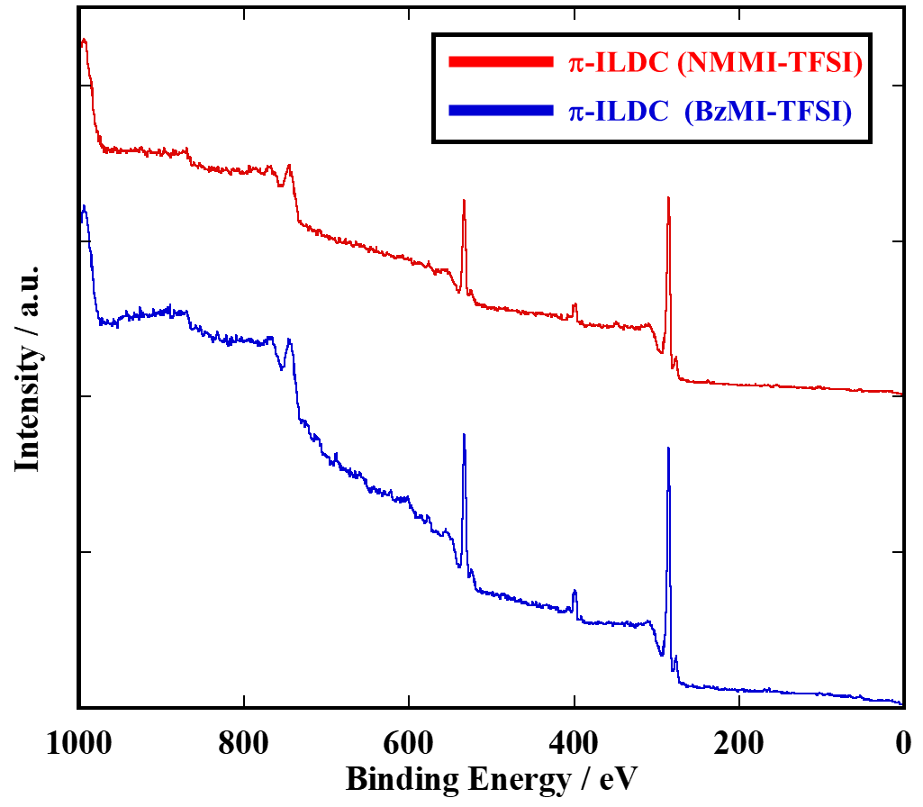
Fig. S7 XPS wide scans for π-ILDCs obtained from NMMI-TFSI (red) and BzMI-TFSI (blue)

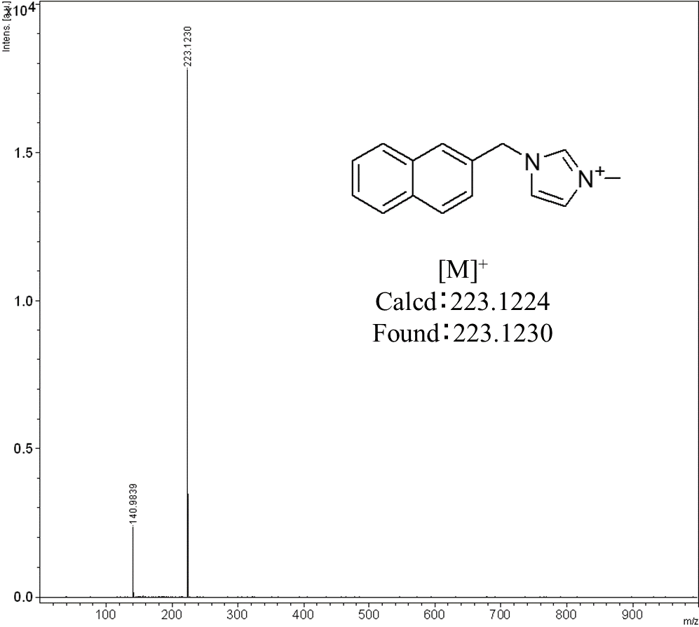
Fig. S8 MALDI-TOF mass spectrum of NMMI cation.
(Matrix: dithranol)

