Entry for the Table of Contents
Zhanfeng Qi，Xinshu Zhao，Xiuli Guo* Shuo Wang and Hengye Zhang
Title:Study on preparation mechanism by planetary ball mill

Nanometer fly ash was obtained using planetary mill. Under ideal conditions, the entire motion process of planetary ball mill preparation can be divided into two stages: centrifugal motion state and impact motion state. The ratio of the two is approximately 3:2, with centrifugal motion occupying the dominant position and impact motion being negligible. | 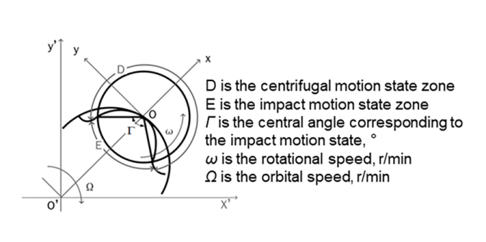
The grinding rate coefficient is proposed, and a mechanism function for the preparation of nanomaterials in planetary ball mills is established. The grinding rate coefficient is only related to the material hardness. The grinding rate coefficient of different materials need be obtained by measuring experimentally. | 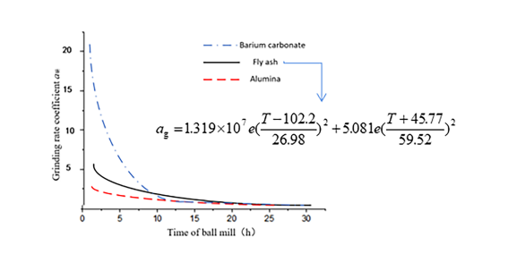
The mechanism function for the preparation of nanomaterials in planetary ball mills can be applied to the preparation of fly ash nanomaterials with grinding particle sizes above 1300 nm, with an experimental error of within 5%. For other nanomaterials, there is also an applicable grinding particle size threshold that can be directly applied to this mechanism function. | 