Supplementary note
  - Original article: ” 131 genetic loci highlight immunological pathways and tissues in nasal polyposis and asthma”
Contents
Tables 2
Figures 9

Tables

Table 1:Genome-wide association study metrics and summary statistics. $λ_{GC}$ is the genomic inflation factor; “Intercept” denotes the LD Score regression intercept; and “Intercept SE” denotes its standard error. ${\hat{h}}_{SNP}^{2}$ denotes the SNP-based heritability estimate derived from LD Score regression, and converted to liability scale. Population frequency estimates for observed-to-liability transformation were set at K=0.15 for asthma, K=0.04 for CRSwNP, and K=0.035 for CRSsNP. “${\hat{h}}_{SNP}^{2}$ 95 % CI” denotes a 95 % confidence interval, first calculated at the observed scale and converted to the liability scale.
Phenotype | Cohort | $$λ_{GC}$$ | Intercept | Intercept SE | $${\hat{h}}_{SNP}^{2}$$ | ${\hat{h}}_{SNP}^{2}$ 95 % CI
Asthma | UKB | 1.23 | 1.04 | 0.0093 | 17.1 % | 14.6 %–19.6 %
Asthma | FinnGen | 1.38 | 1.14 | 0.0124 | 13.7 % | 11.5 %–16.0 %
Asthma | Meta-analysis | 1.52 | 1.12 | 0.013 | N/A | N/A
CRSwNP | UKB | 1.06 | 1.01 | 0.0076 | 24.1 % | 14.8 %–33.4 %
CRSwNP | FinnGen | 1.16 | 1.06 | 0.0109 | 33.2 % | 25.3 %–41.1 %
CRSwNP | Meta-analysis | 1.17 | 1.05 | 0.0106 | N/A | N/A
CRSsNP | UKB | 1.01 | 1.00 | 0.0067 | 7.2 % | -2.9 %–17.3 %
CRSsNP | FinnGen | 1.13 | 1.04 | 0.0075 | 6.6 % | 5.0 %–8.1 %
CRSsNP | Meta-analysis | 1.13 | 1.04 | 0.0071 | N/A | N/A
Asthma and/or CRS | UKB | 1.22 | 1.04 | 0.0094 | N/A | N/A
Asthma and/or CRS | FinnGen | 1.38 | 1.13 | 0.0124 | N/A | N/A
Asthma and/or CRS | Meta-analysis | 1.49 | 1.12 | 0.0135 | N/A | N/A

Table 2: Tissues significantly enriched in MAGMA tissue enrichment analysis. Phenotype: phenotype of GWAS used in analysis. Tissue: GTEx v8 tissue from which expression data is derived (54 tissues). $β_{STD}$: standardized beta from analysis. SE: standard error. p: p-value from χ² distribution with one degree of freedom. Only tissues with significant enrichment after multiple testing correction are included (p < 3.09E-04); no significant enrichment was observed for CRSwNP.
Phenotype | Tissue | $$β_{STD}$$ | SE | p
Asthma | EBV-transformed lymphocytes | 0.0487 | 0.0055 | 2.17E-05
Asthma | Spleen | 0.0690 | 0.0082 | 1.04E-05
Asthma | Whole blood | 0.0423 | 0.0063 | 8.57E-05
Asthma and/or CRS | Spleen | 0.0732 | 0.0081 | 2.43E-06
Asthma and/or CRS | Whole blood | 0.0433 | 0.0062 | 5.26E-05

Table 3: Genetic correlation analyses using LD Score Regression. Phenotype #: GWAS phenotype and cohort, such that FG = FinnGen R9, and UK = UK Biobank. $r_{G}$ = genetic correlation coefficient. $r_{G}$ 95 % CI = 95 % confidence interval for genetic correlation coefficient (maximum is 100 %). p = p-value of correlation under x2 approximation (one degree of freedom). CRSsNP (UK) had a non-significant heritability under LD Score Regression and was excluded from these analyses.
Phenotype 1 | Phenotype 2 | $$r_{G}$$ | $r_{G}$ 95 % CI | p
Asthma (FG) | Asthma (UK) | 86.5 % | 80.6 %–92.3 % | 7.04E-185
CRSwNP (FG) | CRSwNP (UK) | 91.8 % | 75.8 %–100.0 % | 1.66E-29
Asthma (FG) | CRSwNP (FG) | 52.7 % | 42.7 %–62.7 % | 4.43E-25
Asthma (UK) | CRSwNP (UK) | 61.6 % | 48.6 %–74.7 % | 2.27E-20
Asthma (FG) | CRSsNP (FG) | 63.3 % | 52.3 %–74.2 % | 1.56E-29
CRSwNP (FG) | CRSsNP (FG) | 59.3 % | 46.9 %–71.7 % | 8.80E-21

Table 4: FinnGen study approvals.
Institution | Permit number
Finnish Institute for Health and Welfare (THL) | THL/2031/6.02.00/2017
Finnish Institute for Health and Welfare (THL) | THL/1101/5.05.00/2017
Finnish Institute for Health and Welfare (THL) | THL/341/6.02.00/2018
Finnish Institute for Health and Welfare (THL) | THL/2222/6.02.00/2018
Finnish Institute for Health and Welfare (THL) | THL/283/6.02.00/2019
Finnish Institute for Health and Welfare (THL) | THL/1721/5.05.00/2019
Finnish Institute for Health and Welfare (THL) | THL/1524/5.05.00/2020
Finnish Institute for Health and Welfare (THL) | THL/2364/14.02/2020
Finnish Institute for Health and Welfare (THL) | THL/4055/14.06.00/2020
Finnish Institute for Health and Welfare (THL) | THL/3433/14.06.00/2020
Finnish Institute for Health and Welfare (THL) | THL/4432/14.06/2020
Finnish Institute for Health and Welfare (THL) | THL/5189/14.06/2020
Finnish Institute for Health and Welfare (THL) | THL/5894/14.06.00/2020
Finnish Institute for Health and Welfare (THL) | THL/6619/14.06.00/2020
Finnish Institute for Health and Welfare (THL) | THL/209/14.06.00/2021
Finnish Institute for Health and Welfare (THL) | THL/688/14.06.00/2021
Finnish Institute for Health and Welfare (THL) | THL/1284/14.06.00/2021
Finnish Institute for Health and Welfare (THL) | THL/1965/14.06.00/2021
Finnish Institute for Health and Welfare (THL) | THL/5546/14.02.00/2020
Finnish Institute for Health and Welfare (THL) | THL/2658/14.06.00/2021
Finnish Institute for Health and Welfare (THL) | THL/4235/14.06.00/202
Digital and population data service agency (VRK) | VRK43431/2017-3
Digital and population data service agency (VRK) | VRK/6909/2018-3
Digital and population data service agency (VRK) | VRK/4415/2019-3
the Social Insurance Institution (KELA) | KELA 58/522/2017
the Social Insurance Institution (KELA) | KELA 131/522/2018
the Social Insurance Institution (KELA) | KELA 70/522/2019
the Social Insurance Institution (KELA) | KELA 98/522/2019
the Social Insurance Institution (KELA) | KELA 138/522/2019
the Social Insurance Institution (KELA) | KELA 2/522/2020
the Social Insurance Institution (KELA) | KELA 16/522/2020
Statistics Finland | TK-53-1041-17
Statistics Finland | TK/143/07.03.00/2020
Statistics Finland | TK/1735/07.03.00/2021
Statistics Finland | TK/3112/07.03.00/2021

Table 5: FinnGen study Biobank access decisions
Biobank | Accession number
THL Biobank | BB2017_55
THL Biobank | BB2017_111
THL Biobank | BB2018_19
THL Biobank | BB_2018_34
THL Biobank | BB_2018_67
THL Biobank | BB2018_71
THL Biobank | BB2019_7
THL Biobank | BB2019_8
THL Biobank | BB2019_26
THL Biobank | BB2020_1
Finnish Red Cross Blood Service Biobank | 7.12.2017
Helsinki Biobank | HUS/359/2017
Helsinki Biobank | HUS/248/2020
Auria Biobank | AB17-5154 and amendment #1 (Aug 17, 2020)
Auria Biobank | AB20-5926 and amendment #1 (Apr 23, 2020)  and modification (Sep 22, 2021)
Biobank Borealis of Northern Finland | Biobank Borealis of Northern Finland_2017_1013
Biobank of Eastern Finland | 1186/2018 and amendment 22 § /2020
Finnish Clinical Biobank Tampere | MH0004 and amendments (Feb 21, 2020 and Oct 6, 2020)
Central Finland Biobank | 1-2017
Terveystalo Biobank | STB 2018001 and amendment (Aug 25, 2020)

Table 6: Epidemiological overlaps of cases in FinnGen R9. Diagonal corresponds to full case count.
FinnGen | Asthma cases | CRSwNP cases | CRSsNP cases
…with asthma | 42163 | 2336 | 3711
…with CRSwNP | 2336 | 6255 | 0
…with CRSsNP | 3711 | 0 | 13534

Table 7: Epidemiological overlaps of cases in the UK Biobank. Diagonal corresponds to full case count.
UKB | Asthma cases | CRSwNP cases | CRSsNP cases
…with asthma | 29318 | 1185
…with CRSwNP | 1185 | 3371 | 0
…with CRSsNP |  | 0 | 1914

Figures

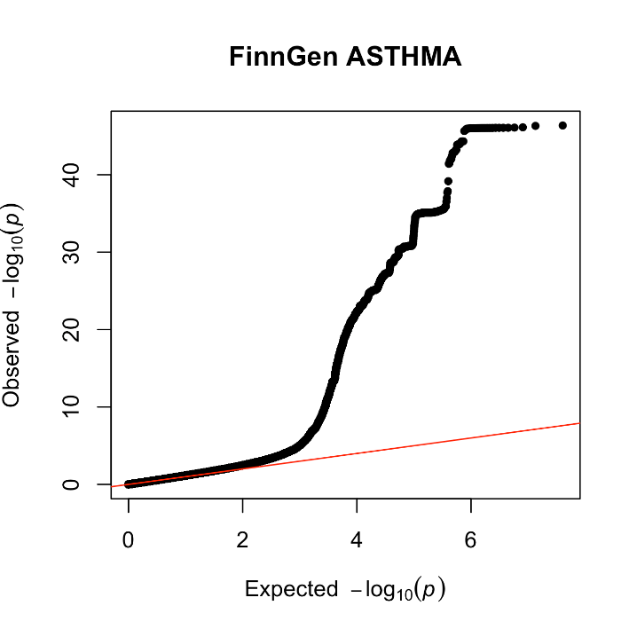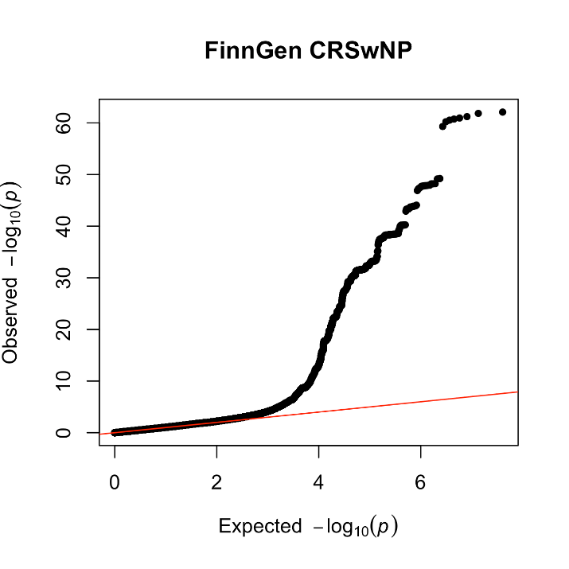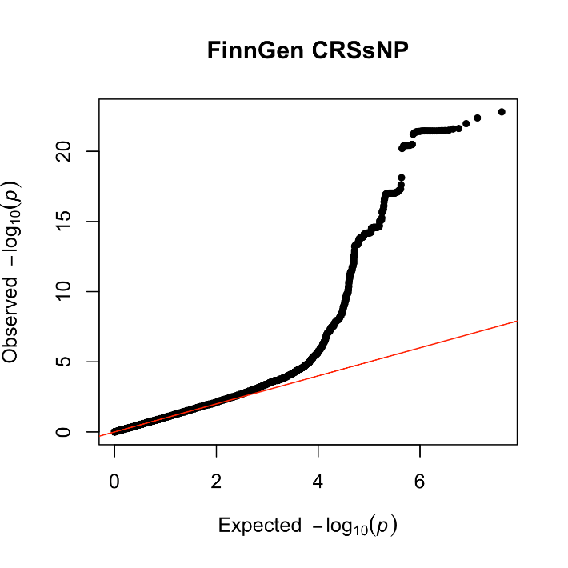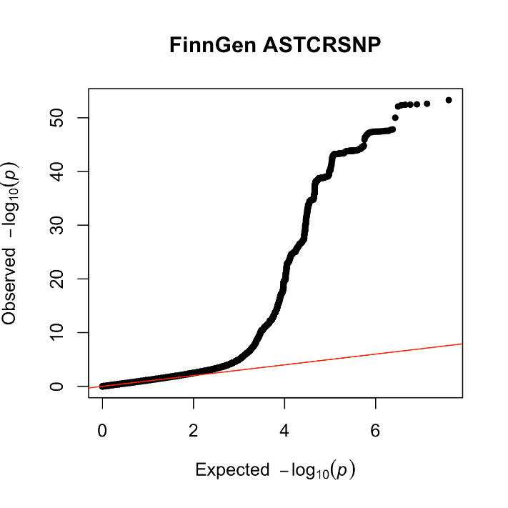
Figure 1: Quantile-quantile plots for genome-wide association studies performed in FinnGen R9. Vertical axis is observed p-value frequency, and horizontal axis is expected p-value frequency. Red is equal frequency trendline. Top left: Asthma GWAS. Top right: CRSwNP GWAS. Bottom left: CRSsNP GWAS. Bottom right: Asthma and/or CRS GWAS. Early adherence to trendline in all plots suggests true polygenicity for all GWAS.

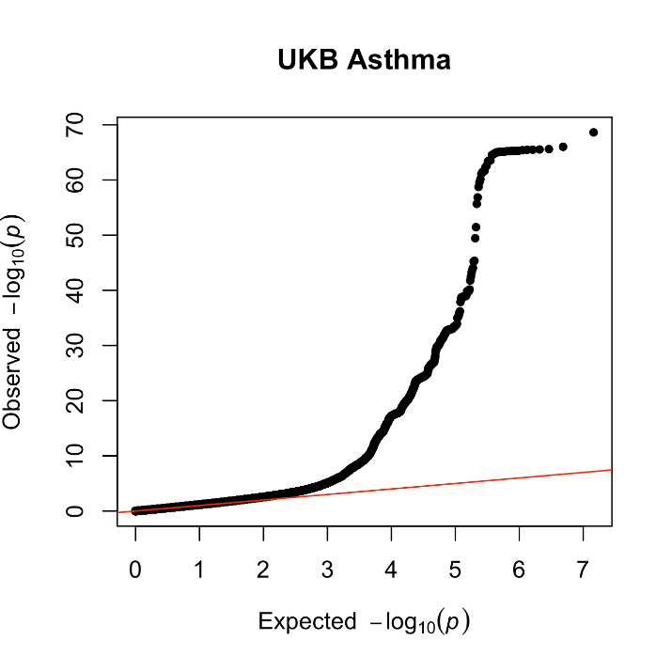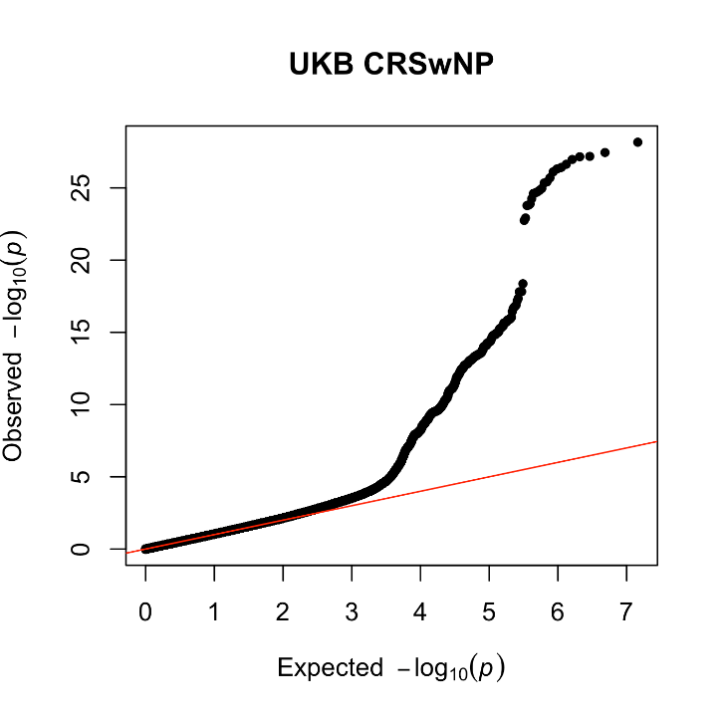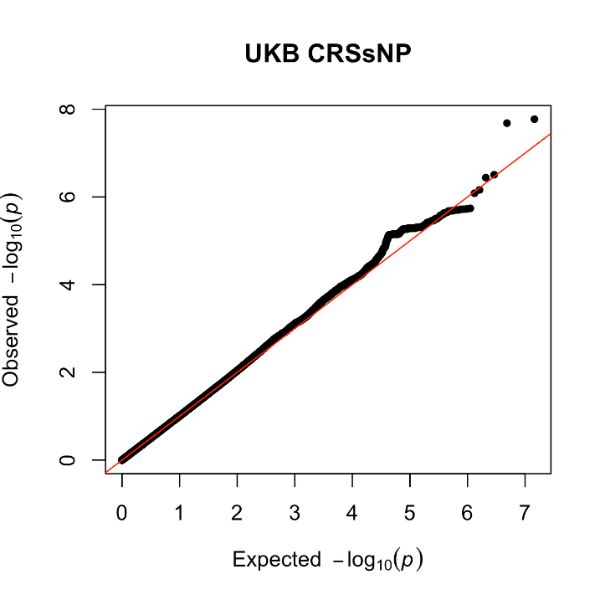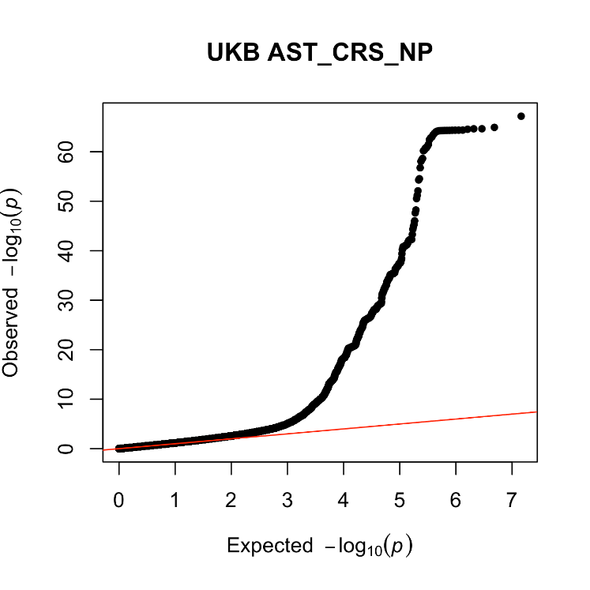
Figure 2: Quantile-quantile plots for genome-wide association studies performed in the UK Biobank. Vertical axis is observed p-value frequency, and horizontal axis is expected p-value frequency. Red is equal frequency trendline. Top left: Asthma GWAS. Top right: CRSwNP GWAS. Bottom left: CRSsNP GWAS. Bottom right: Asthma and/or CRS GWAS. Early adherence to trendline in all plots suggests true polygenicity for all GWAS except CRSsNP, where little deviation from expected values suggests no significant signal.

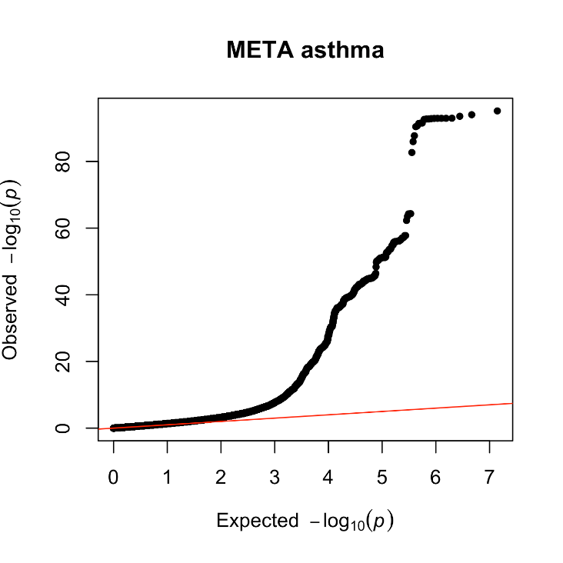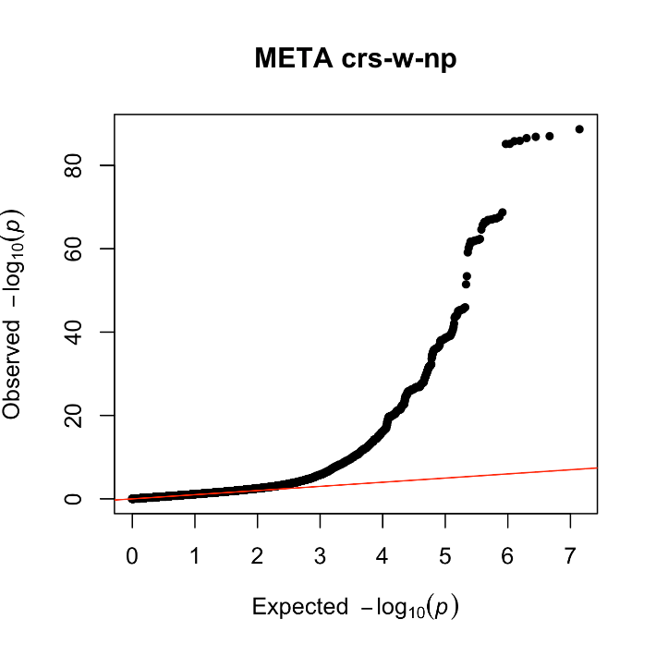
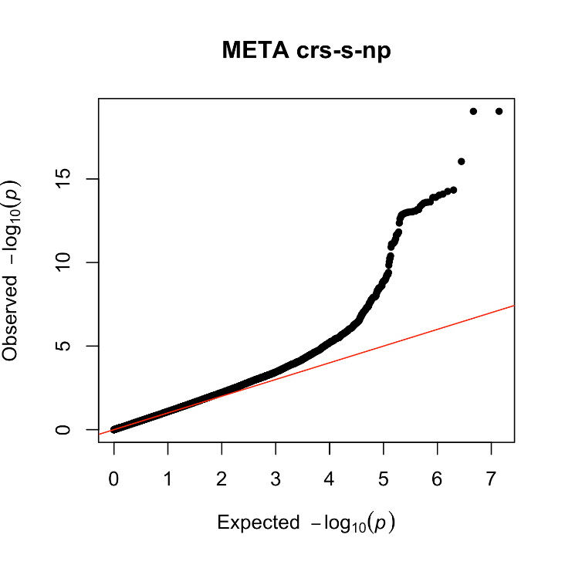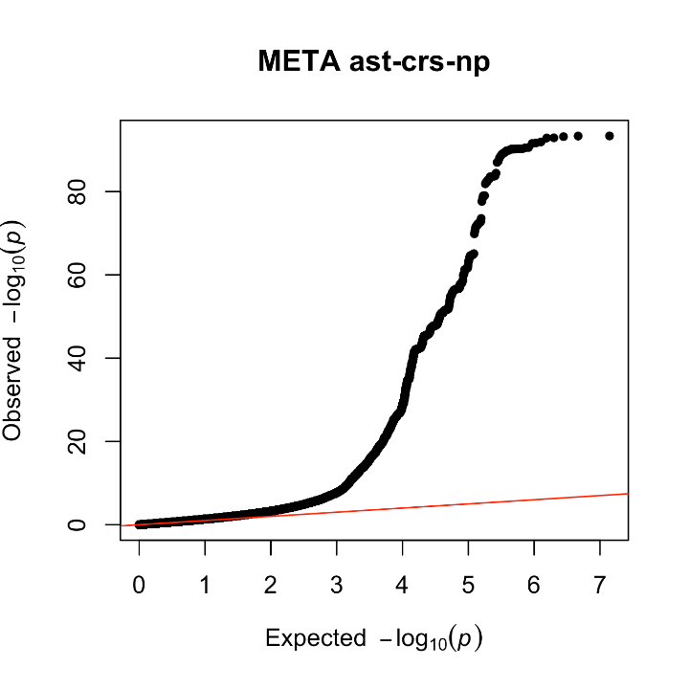
Figure 3: Quantile-quantile plots for genome-wide association study meta-analyses. Vertical axis is observed p-value frequency, and horizontal axis is expected p-value frequency. Red is equal frequency trendline. Top left: Asthma GWAS. Top right: CRSwNP GWAS. Bottom left: CRSsNP GWAS. Bottom right: Asthma and/or CRS GWAS. Early adherence to trendline with deviation in all plots suggests true polygenicity and mild degree of inflation.

