Supplementary Information

The novel target, mechanism and agonist of α-Ketoglutaric acid in delaying mesenchymal stem cell senescence

The PDF file includes:

1. Tables S1 to S2
2. Figures S1 to S7

Table S1 The primers used for RT‒qPCR
Gene | Forward primer | Reverse primer
p16 | TTCCTGGACACGCTGGTGGT | CATGGTTACTGCCTCTGGTGCC
p21 | GCCCGTGAGCGATGGAACTT | TGCAGCAGAGCAGGTGAGGT
IL6 | CCTTCGGTCCAGTTGCCTTCTC | AGAGGTGAGTGGCTGTCTGTGT
IL8 | ATGTGAAGCTGACGCAGAGTGG | GCCTTTACGATCCGCTGTACCC
LMNB1 | GAAAAAGACAACTCTCGTCGCA | GTAAGCACTGATTTCCATGTCCA

Table S2 Specific detected protein list in TPP (Top 100)
Protein IDs | Relatived protein level
Protein IDs | aKG  0 μM | aKG  0 μM | aKG  5 μM | aKG  5 μM | aKG  40 μM | aKG  40 μM
sp|P62266|RS23_HUMAN 40S ribosomal protein S23 OS=Homo sapiens OX=9606 GN=RPS23 PE=1 SV=3 | 0.92 | 1.08 | 2.85 | 3.17 | 8.93 | 6.65
sp|P13645|K1C10_HUMAN;CON P13645;CON__P08730-1;CON__P02535-1;sp|Q7Z3Z0|K1C25_HUMAN | 1.06 | 0.94 | 1.80 | 2.15 | 2.84 | 2.74
sp|P04264|K2C1_HUMAN;CON_P04264 | 1.13 | 0.87 | 1.57 | 2.19 | 2.75 | 2.72
CON__P35908v2;sp|P35908|K22E_HUMAN;CON__P35908;CON__Q3TTY5;CON__Q32MB2;CON__P19013;sp|Q7Z794|K2C1B_HUMAN; | 1.24 | 0.76 | 1.00 | 0.95 | 2.69 | 2.00
CON__P35527;sp|P35527|K1C9_HUMAN;tr|K7EQQ3|K7EQQ3_HUMAN | 1.27 | 0.73 | 0.97 | 1.59 | 2.26 | 2.12
sp|P81605|DCD_HUMAN | 1.21 | 0.79 | 0.95 | 1.97 | 2.09 | 2.23
tr|A0A087X1J6|A0A087X1J6_HUMAN;sp|A8MZA4|GG6L6_HUMAN;sp|H0YM25|GG6LV_HUMAN | 0.99 | 1.01 | 0.98 | 1.41 | 1.85 | 1.79
CON__P02533;sp|P02533|K1C14_HUMAN;CON__P19012;sp|P19012|K1C15_HUMAN | 1.04 | 0.96 | 1.00 | 1.84 | 1.81 | 2.01
tr|K7EKP8|K7EKP8_HUMAN;sp|O00154|BACH_HUMAN | 1.00 | 1.00 | 1.38 | 1.70 | 1.75 | 1.90
sp|Q92688|AN32B_HUMAN | 1.11 | 0.89 | 0.85 | 1.32 | 1.71 | 1.67
sp|Q93077|H2A1C_HUMAN;sp|Q7L7L0|H2A3_HUMAN;sp|P04908|H2A1B_HUMAN | 1.56 | 0.44 | 0.86 | 0.91 | 1.57 | 1.36
sp|Q12841|FSTL1_HUMAN | 0.94 | 1.06 | 1.80 | 2.59 | 1.45 | 2.22
sp|O43765|SGTA_HUMAN | 1.10 | 0.90 | 1.14 | 1.22 | 1.42 | 1.45
sp|P32929|CGL_HUMAN | 1.16 | 0.84 | 1.38 | 1.86 | 1.40 | 1.79
sp|Q9NUM4|T106B_HUMAN | 1.04 | 0.96 | 1.11 | 1.39 | 1.39 | 1.53
tr|C9J795|C9J795_HUMAN;tr|C9JMW3|C9JMW3_HUMAN;tr|H7C4L0|H7C4L0_HUMAN;sp|Q9NQS3|NECT3_HUMAN | 1.28 | 0.72 | 1.59 | 1.83 | 1.39 | 1.77
sp|P62805|H4_HUMAN | 1.02 | 0.98 | 1.28 | 1.05 | 1.39 | 1.34
sp|P62854|RS26_HUMAN;sp|Q5JNZ5|RS26L_HUMAN | 1.03 | 0.97 | 1.43 | 1.81 | 1.37 | 1.75
tr|F2Z2K0|F2Z2K0_HUMAN;sp|Q9UNZ2|NSF1C_HUMAN | 1.13 | 0.87 | 1.41 | 1.84 | 1.37 | 1.76
sp|P10599|THIO_HUMAN | 1.06 | 0.94 | 1.37 | 1.46 | 1.37 | 1.55
tr|E9PGZ1|E9PGZ1_HUMAN | 1.02 | 0.98 | 1.34 | 1.74 | 1.36 | 1.71
sp|Q9BWD1|THIC_HUMAN | 0.96 | 1.04 | 1.08 | 1.51 | 1.36 | 1.58
sp|P84157|MXRA7_HUMAN | 1.02 | 0.98 | 1.46 | 1.77 | 1.36 | 1.72
tr|Q5TEC6|Q5TEC6_HUMAN | 1.14 | 0.86 | 1.46 | 1.93 | 1.35 | 1.81
sp|P62306|RUXF_HUMAN;tr|A0A0B4J254|A0A0B4J254_HUMAN;tr|F8W0W6|F8W0W6_HUMAN | 0.97 | 1.03 | 1.40 | 1.40 | 1.35 | 1.51
tr|F8VZG5|F8VZG5_HUMAN;tr|F8VY04|F8VY04_HUMAN;tr|F8W1A4|F8W1A4_HUMAN;sp|P54819|KAD2_HUMAN | 1.03 | 0.97 | 1.32 | 1.46 | 1.35 | 1.54
tr|K7EK07|K7EK07_HUMAN;sp|Q71DI3|H32_HUMAN;sp|Q16695|H31T_HUMAN;sp|P84243|H33_HUMAN | 1.07 | 0.93 | 1.09 | 1.41 | 1.35 | 1.51
sp|O43286|B4GT5_HUMAN | 1.23 | 0.77 | 1.62 | 1.87 | 1.34 | 1.76
sp|Q00325|MPCP_HUMAN | 1.13 | 0.87 | 1.48 | 1.65 | 1.34 | 1.64
tr|A0A0U1RQF0|A0A0U1RQF0_HUMAN;sp|P49327|FAS_HUMAN | 0.95 | 1.05 | 0.94 | 1.21 | 1.33 | 1.40
sp|P43686|PRS6B_HUMAN | 1.18 | 0.82 | 1.39 | 1.56 | 1.32 | 1.59
sp|Q9Y383|LC7L2_HUMAN;tr|A0A0A6YYJ8|A0A0A6YYJ8_HUMAN | 1.04 | 0.96 | 1.36 | 1.57 | 1.32 | 1.59
sp|P14174|MIF_HUMAN | 1.19 | 0.81 | 1.36 | 1.65 | 1.32 | 1.64
tr|Q5T7C4|Q5T7C4_HUMAN;sp|P09429|HMGB1_HUMAN | 1.17 | 0.83 | 1.36 | 1.51 | 1.32 | 1.55
tr|F8W7C6|F8W7C6_HUMAN;tr|A0A087WV22|A0A087WV22_HUMAN | 1.15 | 0.85 | 1.66 | 1.71 | 1.31 | 1.66
sp|Q99614|TTC1_HUMAN | 1.04 | 0.96 | 1.32 | 1.43 | 1.31 | 1.51
tr|F5H018|F5H018_HUMAN;sp|P62826|RAN_HUMAN;tr|B5MDF5|B5MDF5_HUMAN | 1.27 | 0.73 | 1.46 | 1.56 | 1.31 | 1.58
tr|X1WI22|X1WI22_HUMAN;tr|D6RAA2|D6RAA2_HUMAN;tr|Q5SQT8|Q5SQT8_HUMAN | 1.23 | 0.77 | 1.42 | 1.58 | 1.30 | 1.58
sp|Q9H1E5|TMX4_HUMAN | 1.12 | 0.88 | 1.39 | 1.61 | 1.30 | 1.60
REV__sp|P78540|ARGI2_HUMAN | 1.10 | 0.90 | 1.22 | 1.46 | 1.30 | 1.52
sp|P08708|RS17_HUMAN;tr|H3BNC9|H3BNC9_HUMAN;tr|H0YN88|H0YN88_HUMAN | 1.15 | 0.85 | 1.51 | 1.50 | 1.30 | 1.54
tr|E9PLL6|E9PLL6_HUMAN;sp|P46776|RL27A_HUMAN | 1.01 | 0.99 | 1.51 | 1.73 | 1.30 | 1.66
tr|J3KN67|J3KN67_HUMAN;tr|A0A2R2Y2Q3|A0A2R2Y2Q3_HUMAN;tr|A0A494C0P6|A0A494C0P6_HUMAN | 1.05 | 0.95 | 1.33 | 1.16 | 1.30 | 1.35
tr|B1AHF3|B1AHF3_HUMAN;sp|P00387|NB5R3_HUMAN | 1.24 | 0.76 | 1.57 | 1.87 | 1.29 | 1.74
sp|P50454|SERPH_HUMAN;tr|E9PPV6|E9PPV6_HUMAN;tr|E9PR70|E9PR70_HUMAN | 1.24 | 0.76 | 1.49 | 1.78 | 1.29 | 1.69
tr|H7C2L4|H7C2L4_HUMAN;tr|H7BXF3|H7BXF3_HUMAN;sp|P62995|TRA2B_HUMAN | 1.17 | 0.83 | 1.39 | 1.75 | 1.29 | 1.67
sp|P61604|CH10_HUMAN;tr|B8ZZL8|B8ZZL8_HUMAN;tr|B8ZZ54|B8ZZ54_HUMAN | 1.07 | 0.93 | 1.21 | 1.41 | 1.29 | 1.48
tr|E9PM92|E9PM92_HUMAN;sp|O00193|SMAP_HUMAN;tr|E9PRZ9|E9PRZ9_HUMAN;tr|E9PQA1|E9PQA1_HUMAN | 1.13 | 0.87 | 1.53 | 1.81 | 1.29 | 1.71
sp|P78417|GSTO1_HUMAN;tr|Q5TA02|Q5TA02_HUMAN;tr|Q5TA01|Q5TA01_HUMAN | 1.16 | 0.84 | 1.37 | 1.63 | 1.29 | 1.60
tr|E9PGX9|E9PGX9_HUMAN;tr|E7ERC4|E7ERC4_HUMAN;sp|P05455|LA_HUMAN | 1.15 | 0.85 | 1.26 | 1.36 | 1.29 | 1.46
tr|D6R9P3|D6R9P3_HUMAN;tr|D6RD18|D6RD18_HUMAN;tr|D6RBZ0|D6RBZ0_HUMAN;sp|Q99729|ROAA_HUMAN | 1.14 | 0.86 | 1.23 | 1.38 | 1.28 | 1.47
tr|R4GMT0|R4GMT0_HUMAN;sp|P61163|ACTZ_HUMAN | 1.10 | 0.90 | 1.23 | 1.81 | 1.28 | 1.70
tr|Q5HYB6|Q5HYB6_HUMAN;tr|A0A494C034|A0A494C034_HUMAN | 1.01 | 0.99 | 1.40 | 1.65 | 1.28 | 1.61
sp|P05976|MYL1_HUMAN;sp|P08590|MYL3_HUMAN | 1.11 | 0.89 | 1.46 | 1.52 | 1.28 | 1.54
tr|I3L397|I3L397_HUMAN;sp|Q6IS14|IF5AL_HUMAN;sp|P63241|IF5A1_HUMAN | 1.18 | 0.82 | 1.26 | 1.65 | 1.28 | 1.61
sp|P05387|RLA2_HUMAN;tr|H0YDD8|H0YDD8_HUMAN | 1.07 | 0.93 | 1.31 | 1.53 | 1.28 | 1.55
tr|F8WBS5|F8WBS5_HUMAN;tr|F8WB72|F8WB72_HUMAN;tr|C9K025|C9K025_HUMAN;sp|P18077|RL35A_HUMAN | 1.09 | 0.91 | 1.59 | 1.68 | 1.28 | 1.63
tr|J3QR91|J3QR91_HUMAN;tr|D6RFH4|D6RFH4_HUMAN;tr|H3BUX2|H3BUX2_HUMAN | 1.14 | 0.86 | 1.43 | 2.14 | 1.28 | 1.88
sp|P54136|SYRC_HUMAN | 0.89 | 1.11 | 1.48 | 1.46 | 1.28 | 1.50
sp|Q96QK1|VPS35_HUMAN | 1.19 | 0.81 | 1.26 | 1.42 | 1.28 | 1.48
sp|Q6P587|FAHD1_HUMAN | 1.01 | 0.99 | 1.22 | 1.52 | 1.27 | 1.54
sp|Q9BRK5|CAB45_HUMAN;tr|H0Y3T6|H0Y3T6_HUMAN;tr|G3V1E2|G3V1E2_HUMAN | 1.01 | 0.99 | 1.33 | 1.64 | 1.27 | 1.60
sp|Q99878|H2A1J_HUMAN;sp|Q96KK5|H2A1H_HUMAN;sp|Q9BTM1|H2AJ_HUMAN;sp|Q16777|H2A2C_HUMAN;sp|Q6FI13|H2A2A_HUMAN | 1.13 | 0.87 | 1.60 | 1.94 | 1.27 | 1.76
sp|P17066|HSP76_HUMAN;sp|P48741|HSP77_HUMAN | 1.07 | 0.93 | 1.44 | 1.60 | 1.26 | 1.58
tr|A0A087WUL2|A0A087WUL2_HUMAN;sp|P49720|PSB3_HUMAN;tr|A0A087WXQ8|A0A087WXQ8_HUMAN;tr|A0A087WY10|A0A087WY10_HUMAN | 1.07 | 0.93 | 1.30 | 1.57 | 1.26 | 1.56
tr|K7EMH1|K7EMH1_HUMAN;tr|K7ERI7|K7ERI7_HUMAN;sp|P35268|RL22_HUMAN;tr|K7EP65|K7EP65_HUMAN;tr|K7EKS7|K7EKS7_HUMAN;tr|K7ELC4|K7ELC4_HUMAN;tr|K7EJT5|K7EJT5_HUMAN | 1.19 | 0.81 | 1.54 | 1.63 | 1.26 | 1.59
tr|E9PMD7|E9PMD7_HUMAN;tr|F8VYE8|F8VYE8_HUMAN;sp|P36873|PP1G_HUMAN;sp|P62140|PP1B_HUMAN;sp|P62136|PP1A_HUMAN | 1.14 | 0.86 | 1.31 | 1.49 | 1.26 | 1.51
sp|O43852|CALU_HUMAN;tr|H0Y875|H0Y875_HUMAN | 1.05 | 0.95 | 1.32 | 1.53 | 1.26 | 1.53
sp|Q13283|G3BP1_HUMAN | 1.10 | 0.90 | 1.21 | 1.32 | 1.26 | 1.42
sp|Q8NBS9|TXND5_HUMAN | 1.15 | 0.85 | 1.24 | 1.45 | 1.26 | 1.49
sp|Q99436|PSB7_HUMAN | 1.03 | 0.97 | 1.39 | 1.75 | 1.26 | 1.66
sp|P09382|LEG1_HUMAN;tr|F8WEI7|F8WEI7_HUMAN | 1.21 | 0.79 | 1.33 | 1.57 | 1.26 | 1.56
sp|P67936|TPM4_HUMAN;tr|A0A2R8Y5V9|A0A2R8Y5V9_HUMAN;tr|A0A2R8YH90|A0A2R8YH90_HUMAN;tr|A0A2R8YGX3|A0A2R8YGX3_HUMAN | 1.06 | 0.94 | 1.33 | 1.51 | 1.26 | 1.52
sp|Q5VTE0|EF1A3_HUMAN;sp|P68104|EF1A1_HUMAN;tr|A0A087WVQ9|A0A087WVQ9_HUMAN;tr|A0A087WV01|A0A087WV01_HUMAN | 1.16 | 0.84 | 1.47 | 1.64 | 1.26 | 1.59
tr|A0A0G2JNZ5|A0A0G2JNZ5_HUMAN;tr|A0A0G2JNZ0|A0A0G2JNZ0_HUMAN;tr|A0A0G2JLB3|A0A0G2JLB3_HUMAN;sp|P04062|GLCM_HUMAN | 1.03 | 0.97 | 1.23 | 1.33 | 1.26 | 1.42
sp|P39019|RS19_HUMAN;tr|A0A075B6E2|A0A075B6E2_HUMAN;tr|M0R2L9|M0R2L9_HUMAN;tr|M0QXK4|M0QXK4_HUMAN;tr|M0QYF7|M0QYF7_HUMAN;tr|M0R140|M0R140_HUMAN | 1.07 | 0.93 | 1.44 | 1.65 | 1.26 | 1.60
tr|A0A0A0MSA9|A0A0A0MSA9_HUMAN;tr|A0A0C4DG49|A0A0C4DG49_HUMAN;sp|P15151|PVR_HUMAN | 1.08 | 0.92 | 1.48 | 1.55 | 1.25 | 1.54
sp|Q15388|TOM20_HUMAN | 1.18 | 0.82 | 1.12 | 1.33 | 1.25 | 1.42
sp|Q9BTV4|TMM43_HUMAN | 1.14 | 0.86 | 1.49 | 1.69 | 1.25 | 1.61
sp|Q02878|RL6_HUMAN | 1.30 | 0.70 | 1.40 | 1.94 | 1.24 | 1.75
tr|E5RGN3|E5RGN3_HUMAN;sp|O00244|ATOX1_HUMAN;tr|E5RIM7|E5RIM7_HUMAN | 1.26 | 0.74 | 1.29 | 1.58 | 1.24 | 1.55
sp|P27797|CALR_HUMAN;tr|K7EJB9|K7EJB9_HUMAN;tr|K7EL50|K7EL50_HUMAN | 1.25 | 0.75 | 1.34 | 1.55 | 1.24 | 1.53
sp|P09936|UCHL1_HUMAN;tr|D6RE83|D6RE83_HUMAN;tr|D6R956|D6R956_HUMAN;tr|D6RF53|D6RF53_HUMAN;tr|D6R974|D6R974_HUMAN | 1.18 | 0.82 | 1.28 | 1.47 | 1.24 | 1.49
sp|P50914|RL14_HUMAN;tr|E7EPB3|E7EPB3_HUMAN | 1.31 | 0.69 | 1.46 | 1.53 | 1.24 | 1.52
tr|J3KT73|J3KT73_HUMAN;tr|J3QL01|J3QL01_HUMAN;sp|P63173|RL38_HUMAN;tr|J3KSP2|J3KSP2_HUMAN | 1.16 | 0.84 | 1.37 | 1.46 | 1.24 | 1.48
sp|Q15631|TSN_HUMAN;tr|E9PGT1|E9PGT1_HUMAN;tr|H7C1D4|H7C1D4_HUMAN | 1.24 | 0.76 | 1.26 | 1.53 | 1.24 | 1.52
sp|P60709|ACTB_HUMAN;tr|A0A2R8Y793|A0A2R8Y793_HUMAN;tr|A0A2R8YGF8|A0A2R8YGF8_HUMAN;tr|G5E9R0|G5E9R0_HUMAN | 1.10 | 0.90 | 1.42 | 1.50 | 1.24 | 1.50
sp|O60869|EDF1_HUMAN | 1.19 | 0.81 | 1.18 | 1.40 | 1.23 | 1.45
sp|P23142|FBLN1_HUMAN;CON__ENSEMBL:ENSBTAP00000016046 | 1.10 | 0.90 | 1.30 | 1.52 | 1.23 | 1.51
sp|P62191|PRS4_HUMAN | 0.96 | 1.04 | 1.06 | 1.15 | 1.23 | 1.31
tr|G3XAN0|G3XAN0_HUMAN;sp|P60866|RS20_HUMAN | 1.06 | 0.94 | 1.27 | 1.39 | 1.23 | 1.44
sp|Q16270|IBP7_HUMAN | 1.02 | 0.98 | 1.03 | 1.30 | 1.23 | 1.39
tr|E5RIT6|E5RIT6_HUMAN;sp|Q9UNX3|RL26L_HUMAN;sp|P61254|RL26_HUMAN;tr|J3KS10|J3KS10_HUMAN | 1.07 | 0.93 | 1.52 | 1.59 | 1.23 | 1.55
sp|P39656|OST48_HUMAN;tr|A0A0C4DGS1|A0A0C4DGS1_HUMAN;tr|U3KQ84|U3KQ84_HUMAN | 1.18 | 0.82 | 1.45 | 1.59 | 1.23 | 1.55
tr|F8VW28|F8VW28_HUMAN;tr|H0YHL8|H0YHL8_HUMAN;tr|F8VZN8|F8VZN8_HUMAN;sp|O14974|MYPT1_HUMAN | 1.21 | 0.79 | 1.28 | 1.42 | 1.23 | 1.46
sp|Q01813|PFKAP_HUMAN;tr|Q5VSR5|Q5VSR5_HUMAN;tr|V9GYV7|V9GYV7_HUMAN;tr|V9GY25|V9GY25_HUMAN;tr|B1APP6|B1APP6_HUMAN | 1.10 | 0.90 | 1.28 | 1.48 | 1.23 | 1.49
sp|P61006|RAB8A_HUMAN | 1.25 | 0.75 | 1.44 | 1.66 | 1.23 | 1.59
tr|D6RCB3|D6RCB3_HUMAN;tr|D6RJE8|D6RJE8_HUMAN;tr|I3L492|I3L492_HUMAN;tr|B7Z7P8|B7Z7P8_HUMAN;sp|P62495|ERF1_HUMAN | 1.17 | 0.83 | 1.16 | 1.54 | 1.23 | 1.52
sp|P62328|TYB4_HUMAN;CON__p21752;sp|O14604|TYB4Y_HUMAN | 0.99 | 1.01 | 1.17 | 1.13 | 1.23 | 1.29

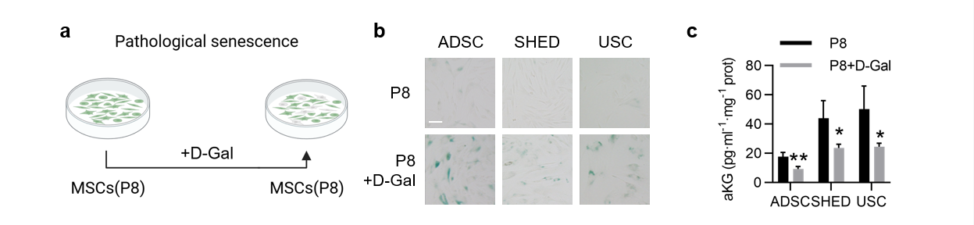
Figure S1 aKG is reduced in D-Gal-induced pathological senescent MSCs.
a Schematic diagram of the pathological senescence of MSCs induced by D-Gal. b MSCs were stained with SA-β-Gal after pathological senescence. Scale bars, 100 μm. c Detection of aKG in MSCs after pathological senescence. n = 3. The data are presented as the means ± s.e.m. All compared with the P8 group, *P < 0.05; **P < 0.01; ***P < 0.001.

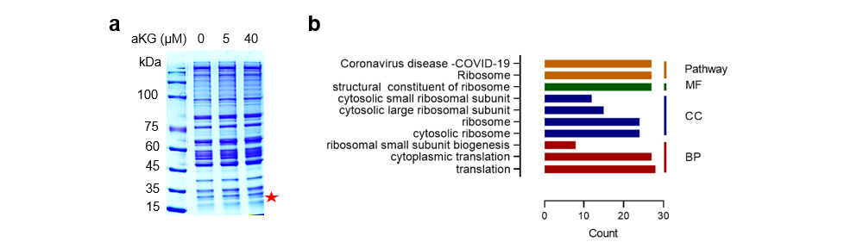
Figure S2 Quality control in TPP experiments.
a After heat treatment, the mixture of cell lysate and aKG was centrifuged, and the supernatant was collected for sodium dodecyl sulfate‒polyacrylamide gel electrophoresis separation and Coomassie brilliant blue staining. b Pathway enrichment of potential target proteins of aKG in TPP experiments.

Figure S3 Diagram showing aKG-generating pathways in the TCA cycle.

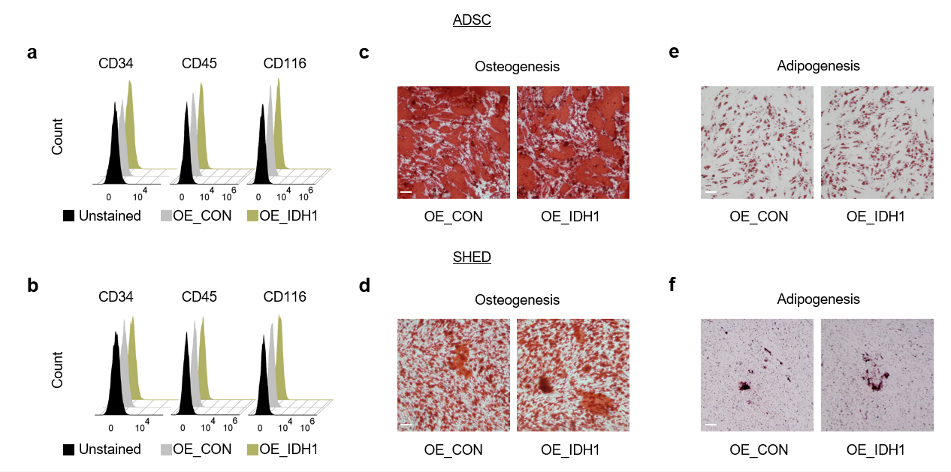
Figure S4 Characterization of IDH1-overexpressing MSCs.
a, b Flow cytometry analysis of the expression of the cell surface markers CD34, CD45, and CD116 in ADSCs and SHEDs at P7. c, d Representative images of ADSCs and SHEDs that formed mineralized nodules and were stained with Alizarin Red S after osteogenic induction at P7. e, f Representative images of ADSCs and SHEDs that formed lipid droplets stained with Oil Red O after adipogenic induction at P7. Scale bars, 100 μm.

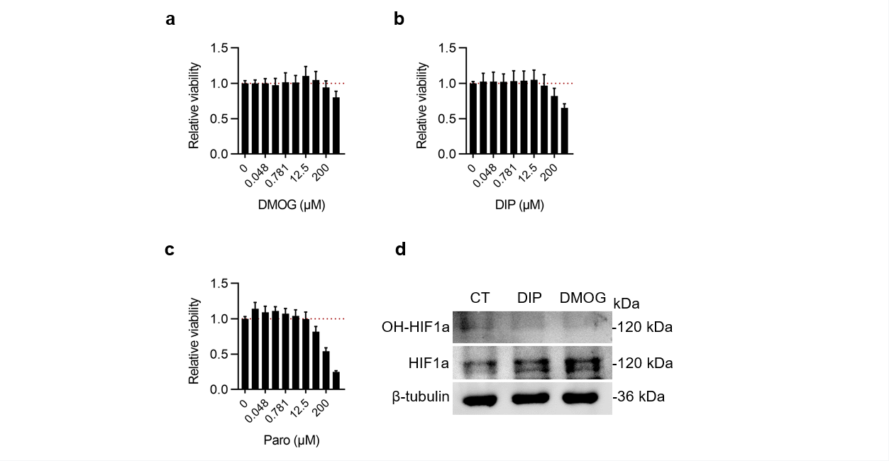
Figure S5 Testing the toxicity of HIF1a hydroxylation inhibitors and paromomycin to MSCs.
a-c The compounds were selected at concentrations that did not affect the proliferation of MSCs. n = 4. d Treatment with 50 μM DIP and 200 μM DMOG inhibited the hydroxylation of HIF1a without affecting MSC proliferation. n = 3.

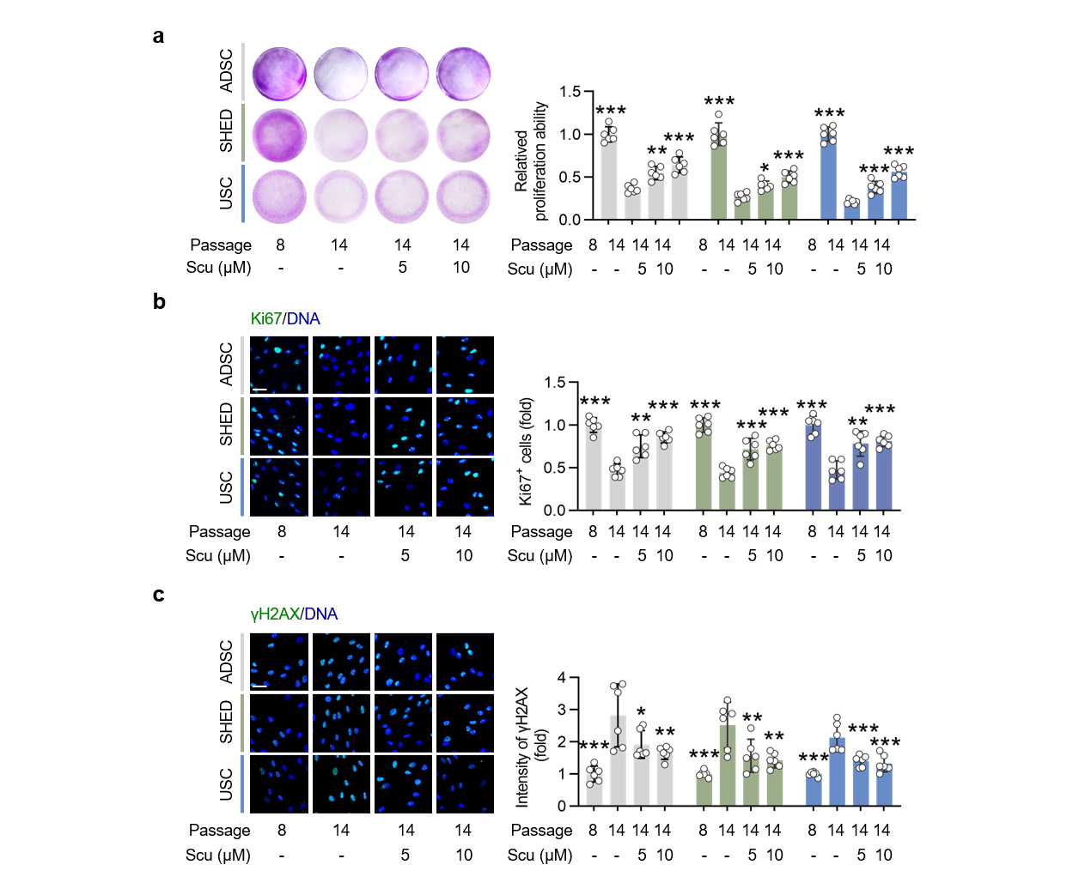
Figure S6 Effect of Scu on the proliferation and chromatin stability of MSCs.
a Colony formation, b Ki67 staining, and c γH2AX staining of young MSCs (P8) and senescent MSCs (P14) treatment with Scu. n = 6. Scale bars, 100 μm. The data are presented as the means ± s.e.m. All compared to MSCs at P14 without Scu group. *P < 0.05; **P < 0.01; ***P < 0.001.

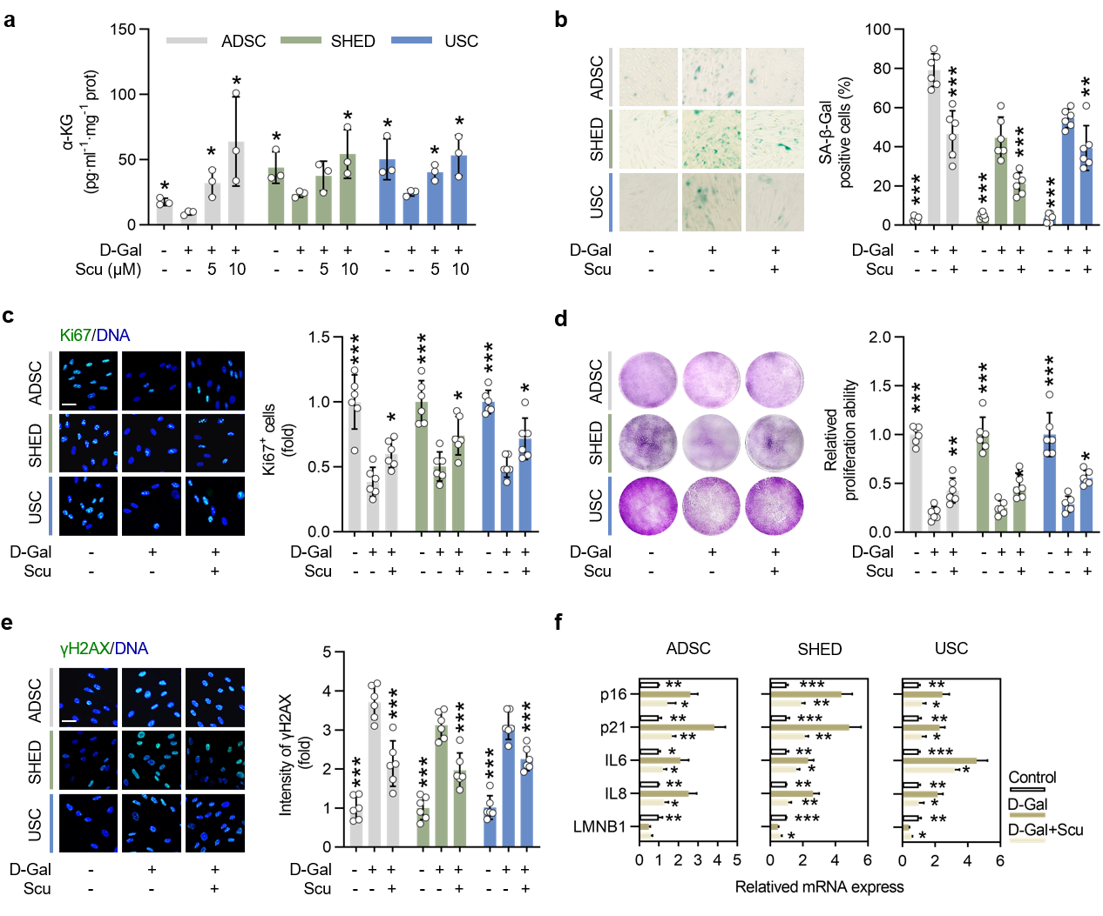
Figure S7 Scu protects MSCs from D-Gal-induced pathological senescence.
a Effect of treatment of Scu for 48 h on aKG production in D-Gal-induced pathological senescent MSCs (P8). n = 3. b SA-β-Gal staining, c Ki67 staining, d colony formation, and e γH2AX staining of young MSCs (P8) and pathological senescent MSCs (P8) treated with 10 μM Scu for 48 h. n = 6. Scale bars, 50 μm. f qRT‒PCR analysis of the expression of senescence marker genes in young MSCs (P8) and pathological senescent MSCs (P8) treated with 10 μM Scu for 48 h. n = 3. The data are presented as the means ± s.e.m. a-f All compared to D-Gal-induced pathological senescent MSCs without Scu group. *P < 0.05; **P < 0.01; ***P < 0.001.

