Supplementary Materials
Synthesis, Optimization and Performance Evaluation of a Biomass-based Environment-friendly Dust Suppressant
Zhichen Liu ª, Shihao Kan ª, Junru Ma ª, Tao Xu ª, Yanyu Che ª, Wenjie Liu ª, Xiang Zeng ^{b}, Xuhui Mao ^{a, *}

ª School of Resources and Environmental Science, Wuhan University, Wuhan, 430079, China
^{b} Jiangxi Cimo Environmental Technology Ltd., Nanchang, 330500, China

* Corresponding author: clab@whu.edu.cn

Text S1
Pretreatment of biomasses and simulated dust. After being dried at 105 ℃ in a drying oven for 4 h, the straw biomass was crushed by a high-speed grinder and passed through a 60-mesh sieve, then stored in a desiccator for later use. For the simulated sample, the sandy loam soils were passed through a 70-mesh sieve and the sifted soils were dried for 24 h at 60 ℃. After cooling to room temperature, they were used as experimental soil samples.
Text S2
Measurement of wind erosion resistance. An equal amount (30±0.05 g) of soil sample was placed in multiple plastic dishes of the same size (30 mm). The dry soil samples served as the control. Equal portions of the dust suppressant solution were evenly sprayed on the surface of the soil samples (experimental groups). All the samples were dried at 60℃ and weighed. The treated sample was placed on the sample stage of the device, and blown through a blower at a certain wind speed for 20 minutes. After turning off the blower, the dust particles in the duct were allowed to settle naturally onto the wafer for 10 min. The amount of dust on the wafer was observed and counted in the 500x lens using a VHX digital microscope. At the end of the experiment, the blower was turned on again to blow out the residual dust in the duct. At the same time, the silicon wafers were washed with ethanol for subsequent experiments.
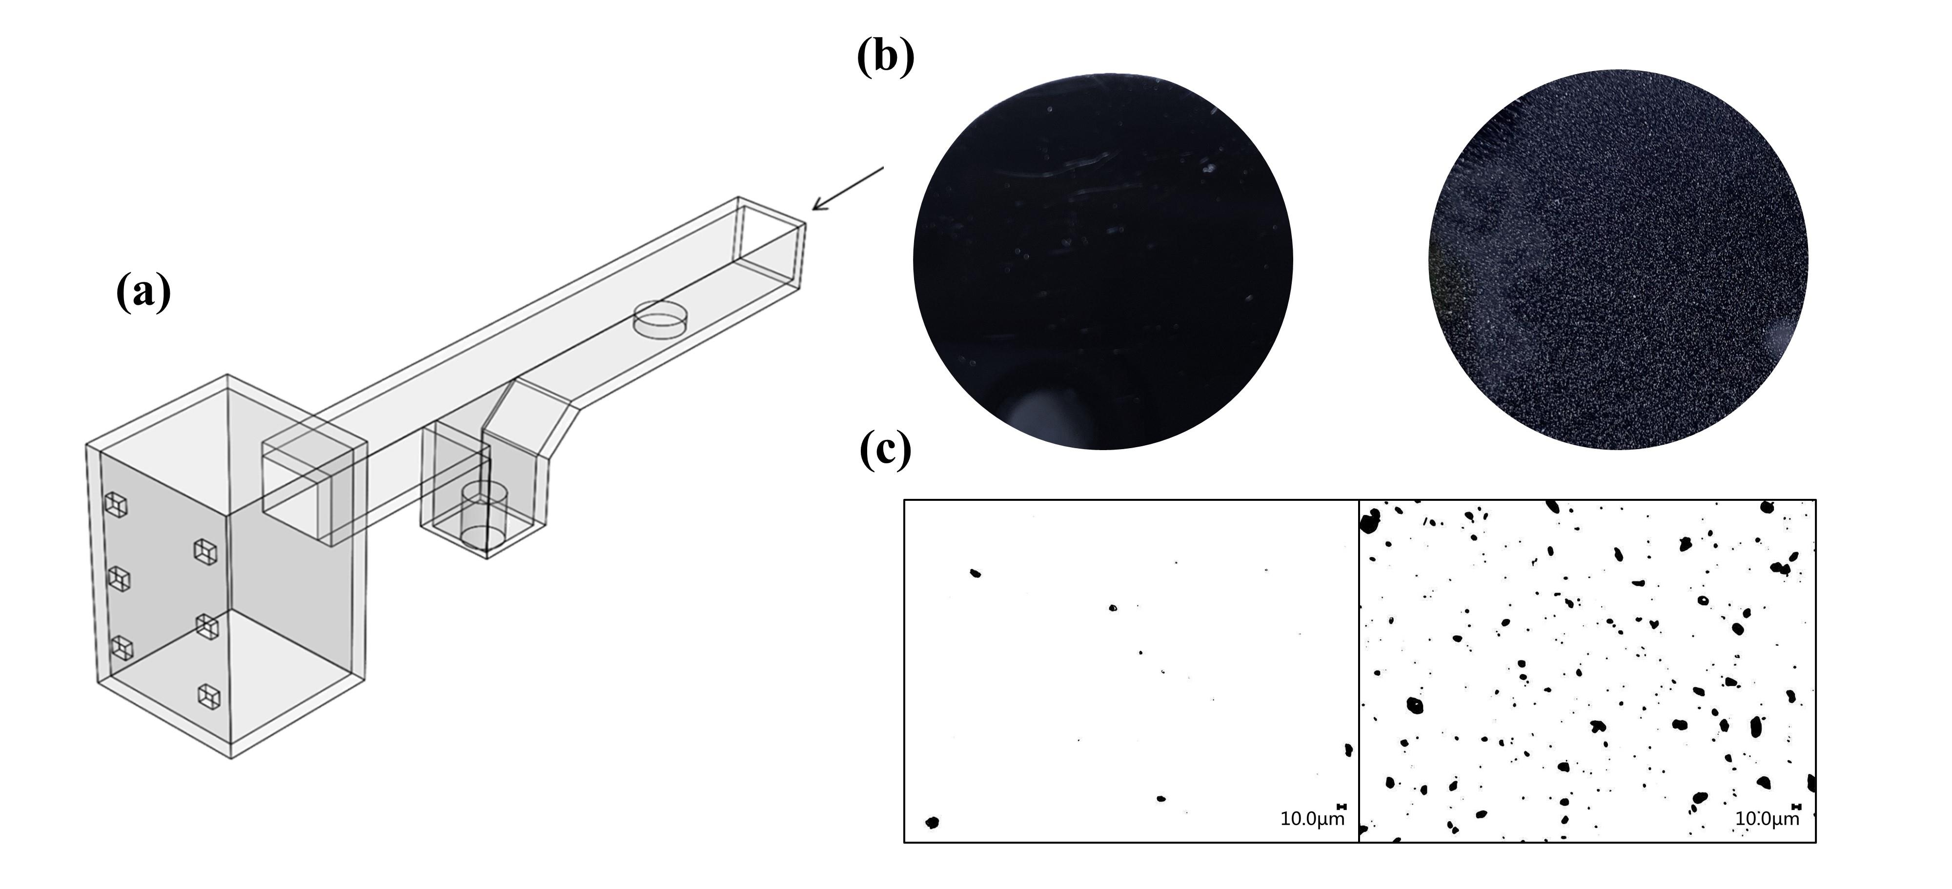
Fig. S1 (a) The three-dimensional diagram of the device. (b) Silicon wafer surface before and after the experiment (left: there is no dust particle before air blowing; right: dust distribution after air blowing). (c) Image of dust distribution by using the VHX digital microscope in wind erosion resistance experiment (left: before air blowing, right: after air blowing).
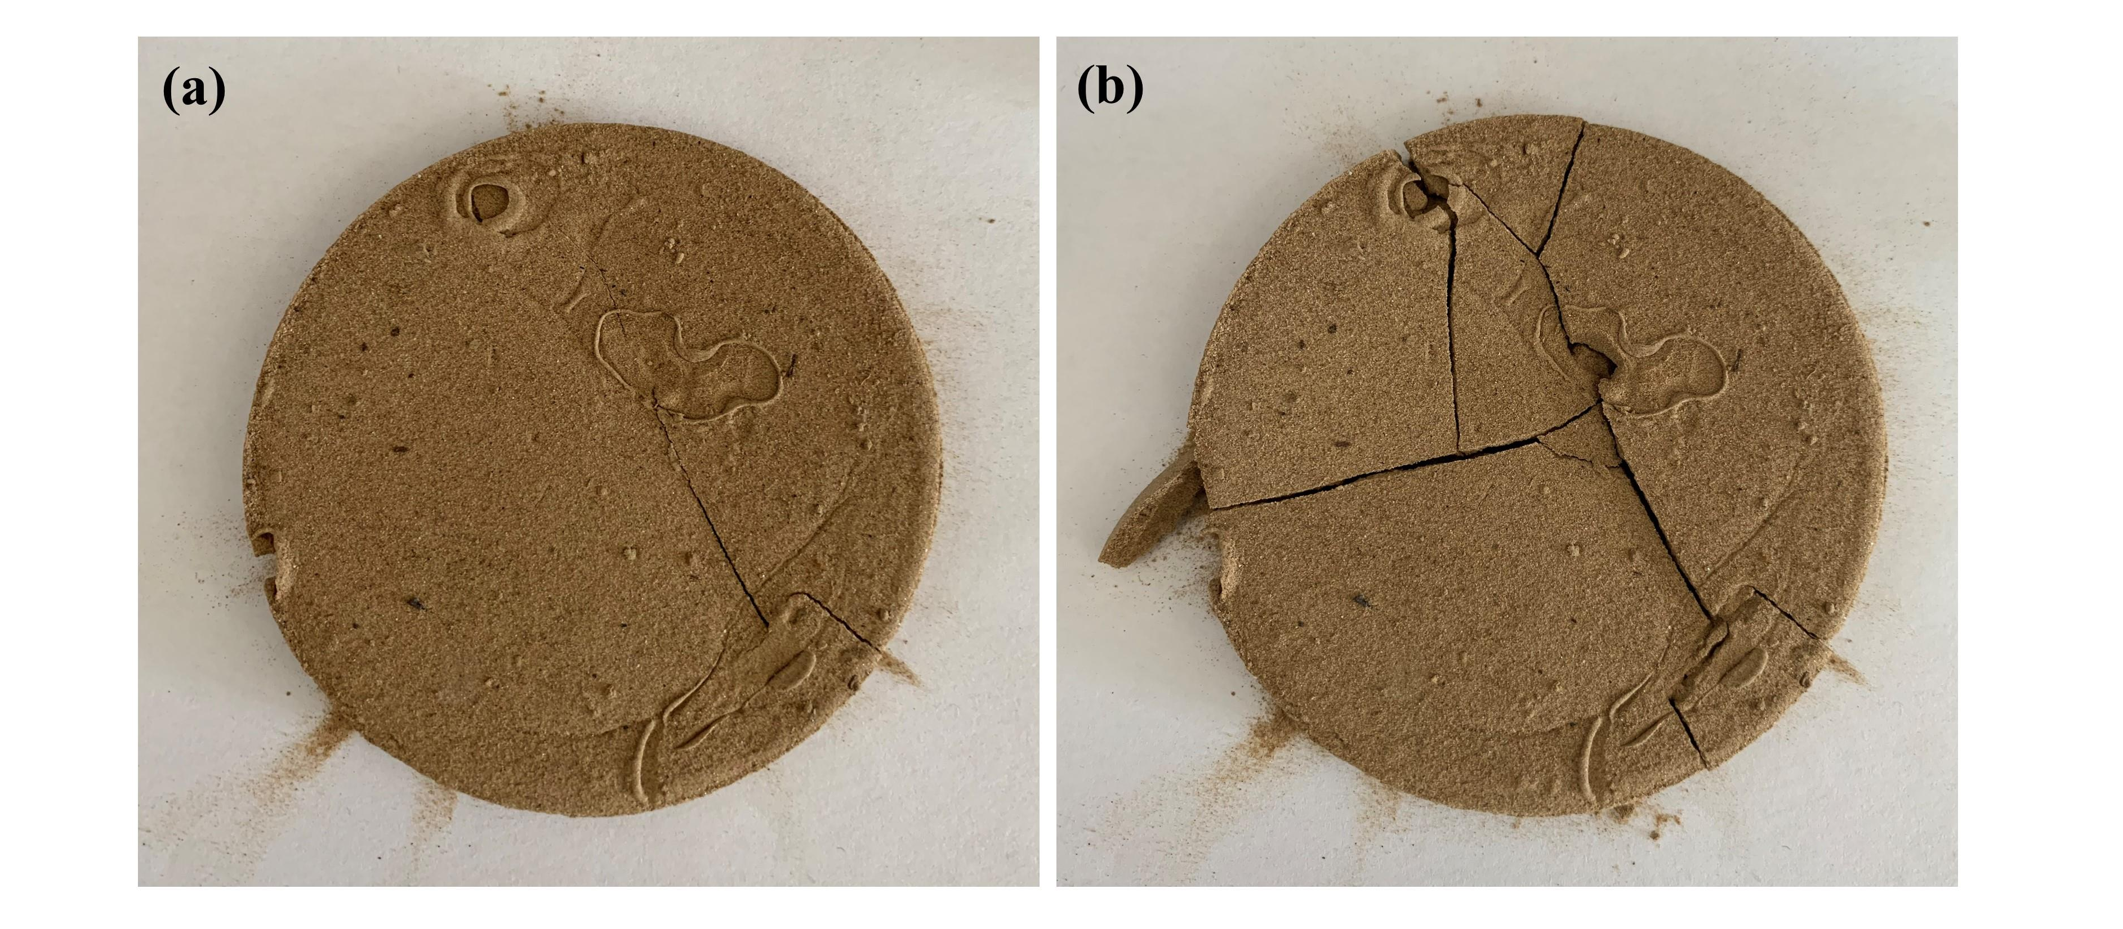
Fig. S2 (a) The curing layer (general sample) before weight impact experiment; (b) the broken sample after it was crushed by the weight.
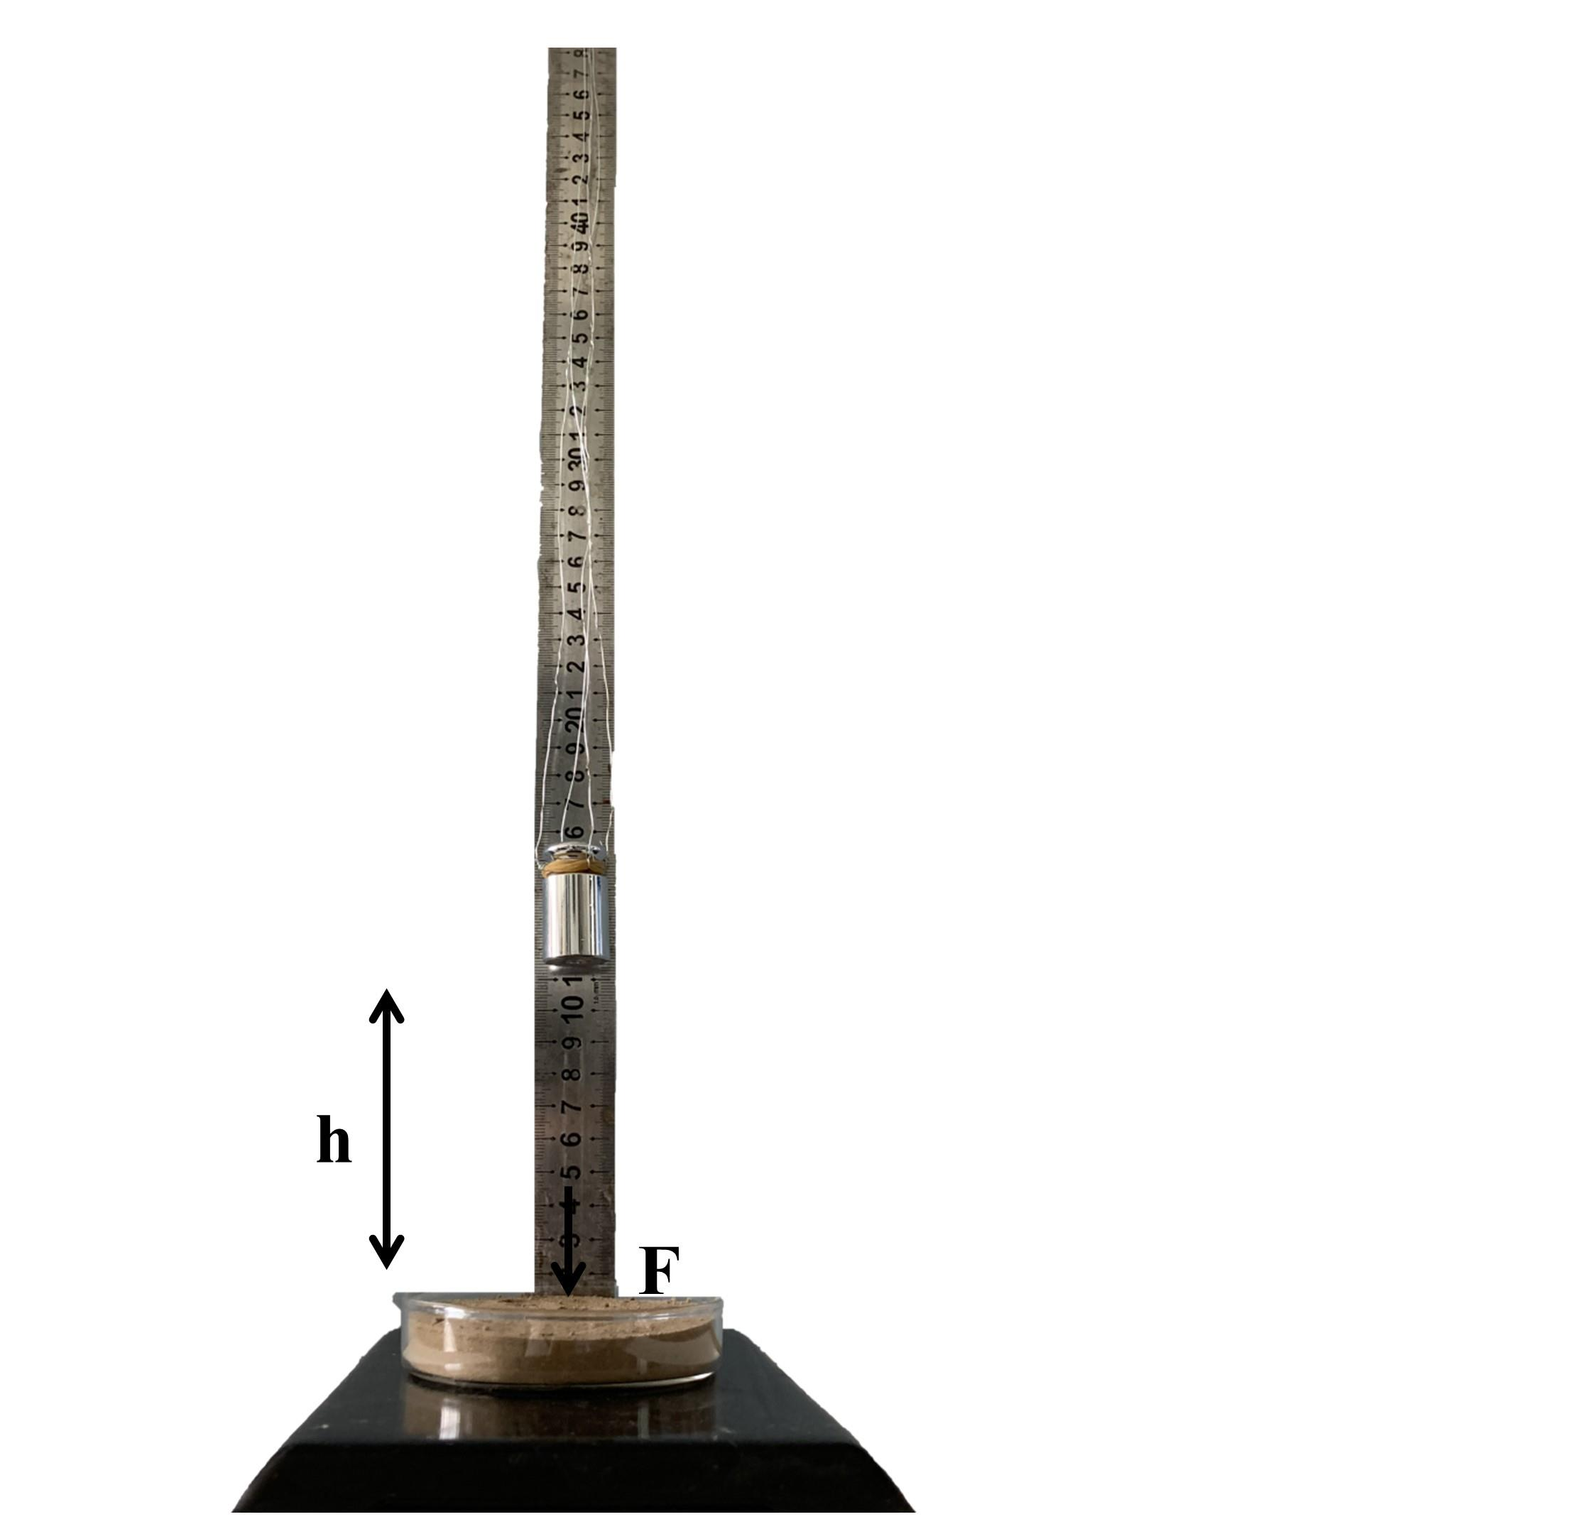
Fig. S3 The illustration of weight impact experiment for the evaluation of hardness of curing layer of soil sample.
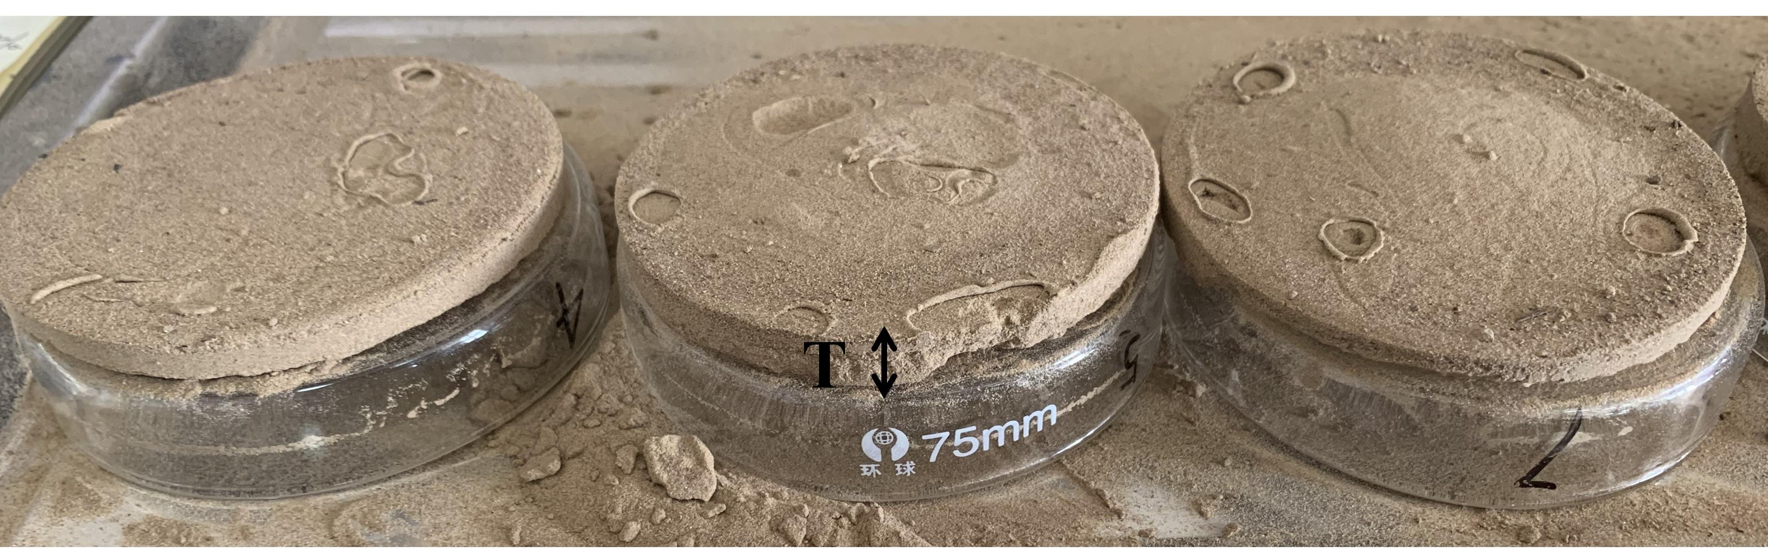
Fig. S4 Illustration of the thickness measurement of curing layer.
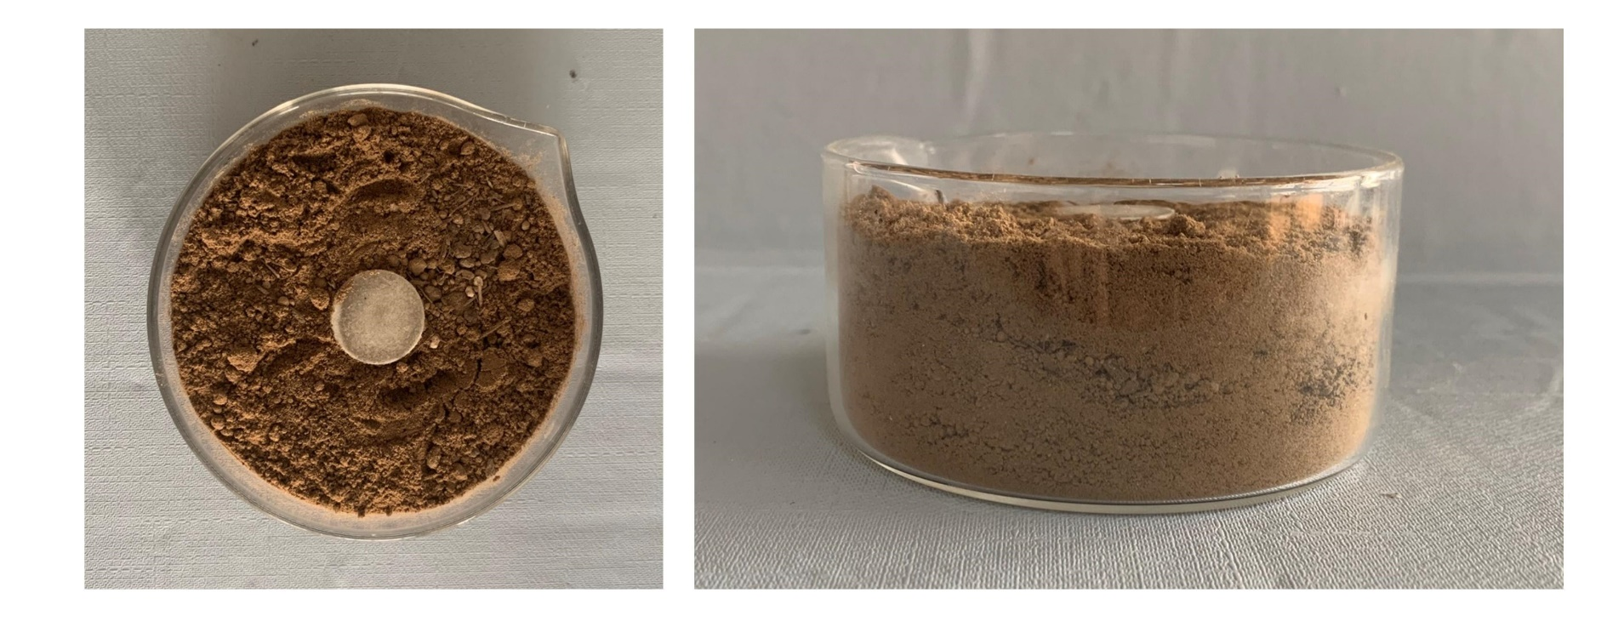
Fig. S5 Schematic diagram of soil sample degradation experiment.
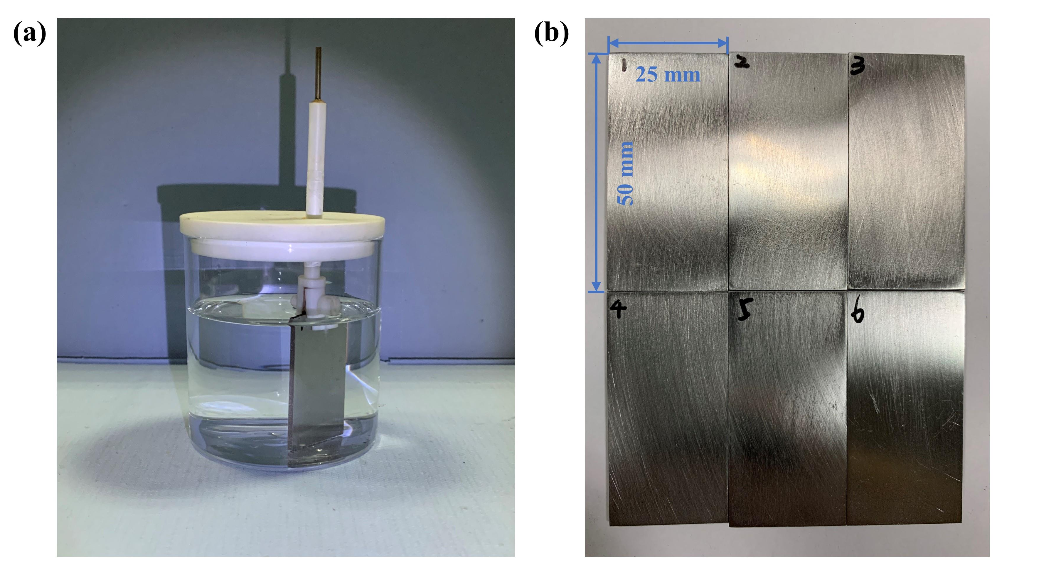
Fig. S6 (a) Diagram of experimental apparatus for metal corrosion. (b) Carbon steel original appearance.
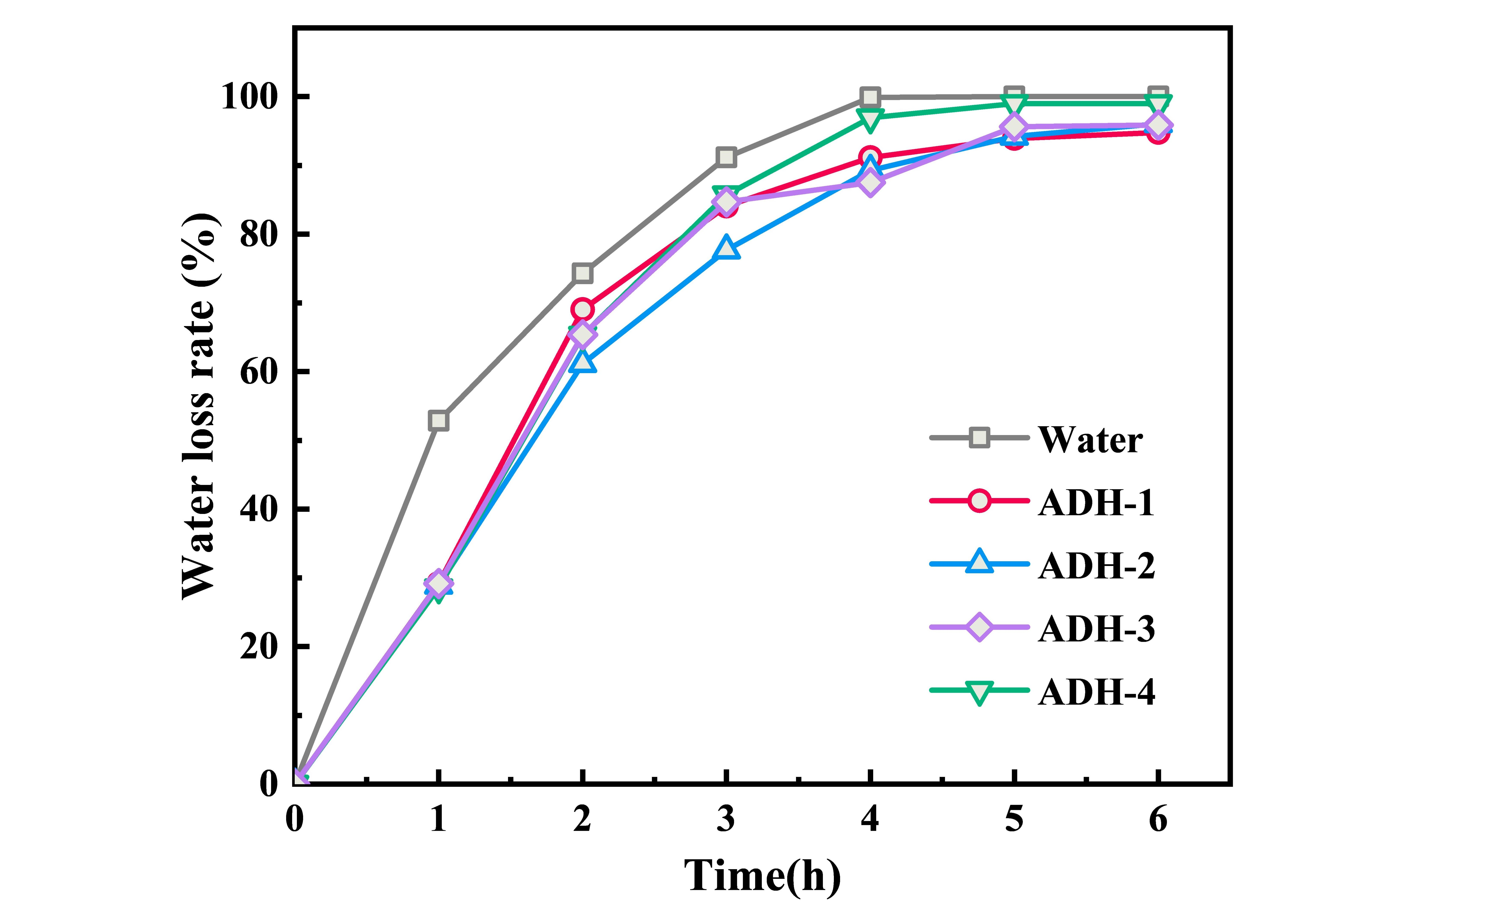
Fig. S7 Water loss rates of soil samples treated with different binders.
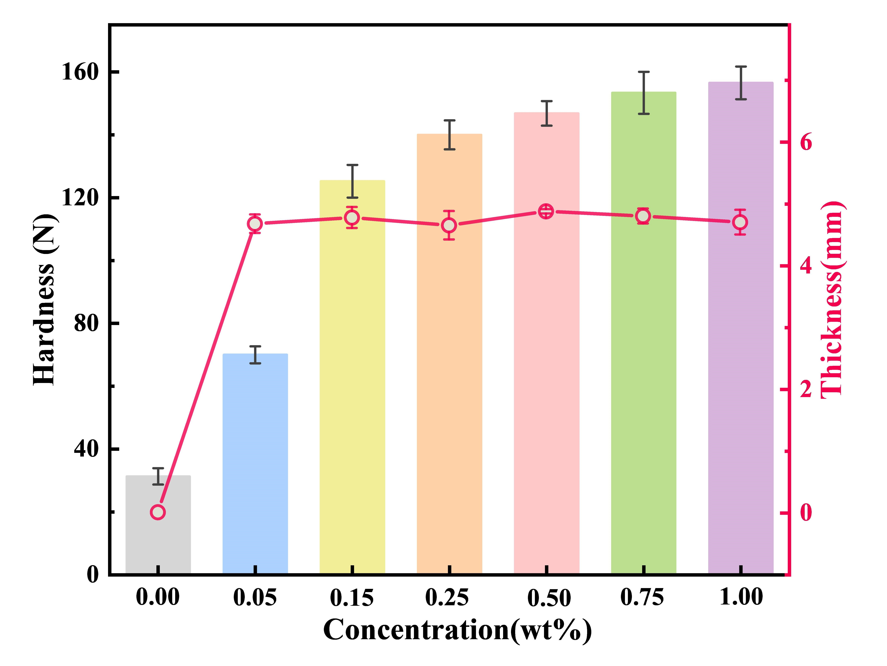
Fig. S8 Hardness and thickness of the curing layer formed by different concentrations of ADH-2.
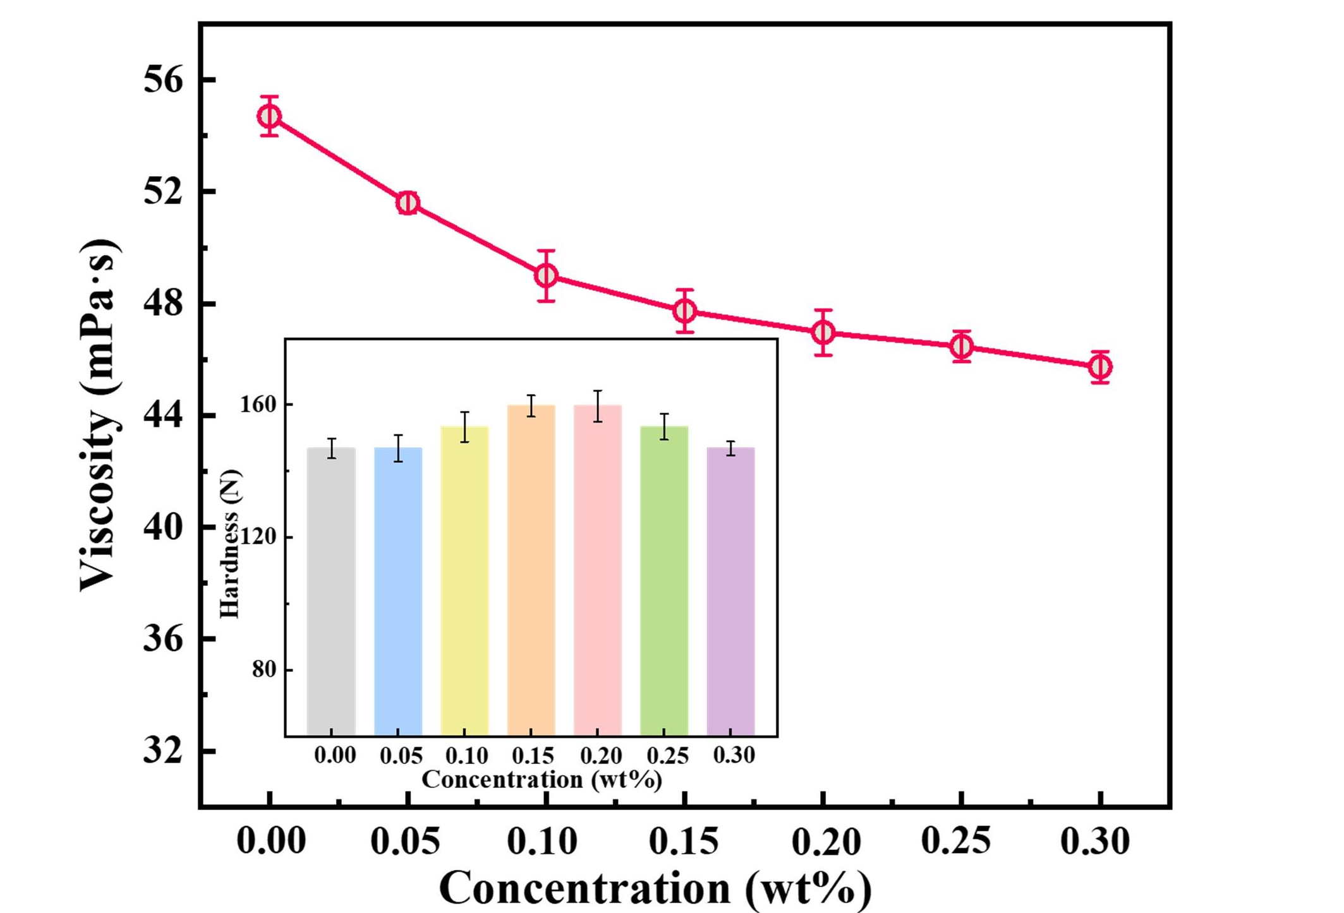
Fig. S9 Viscosity curve of dust suppressant solution with different SAA-1 concentrations (inset: curing layer hardness of different SAA-1 concentrations).
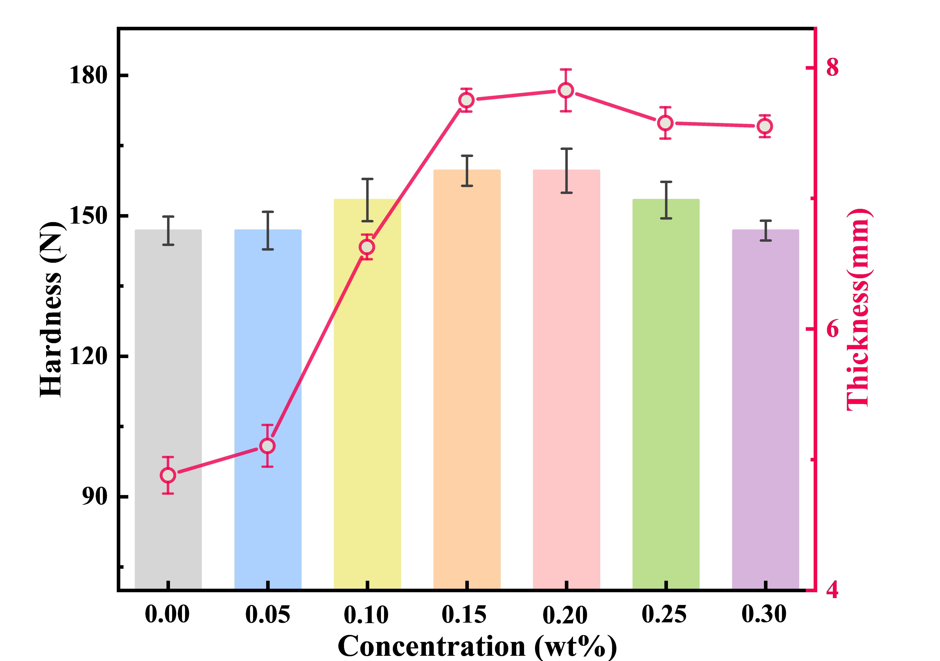
Fig. S10 Hardness and thickness of the curing layer formed by different concentrations of SAA-1.

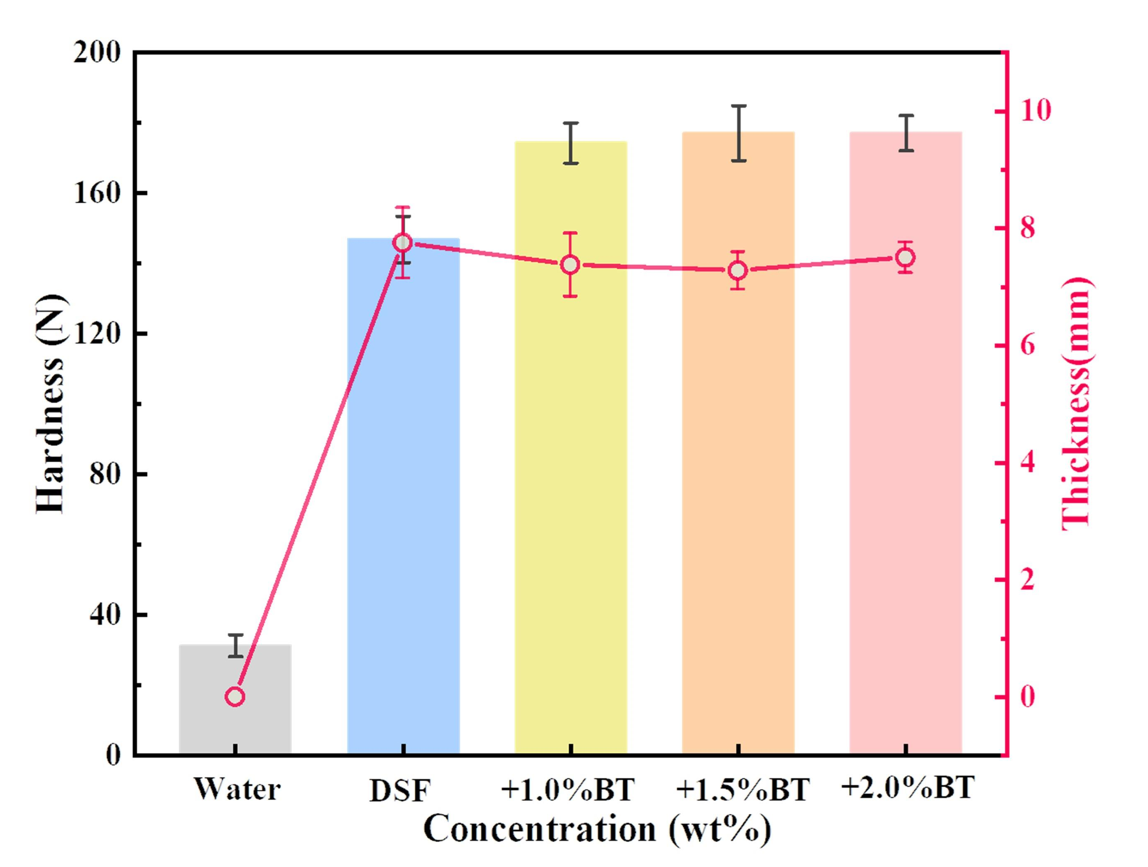
Fig. S11 Hardness and thickness of curing layer formed by dust suppressant with adding different bentonite amounts.
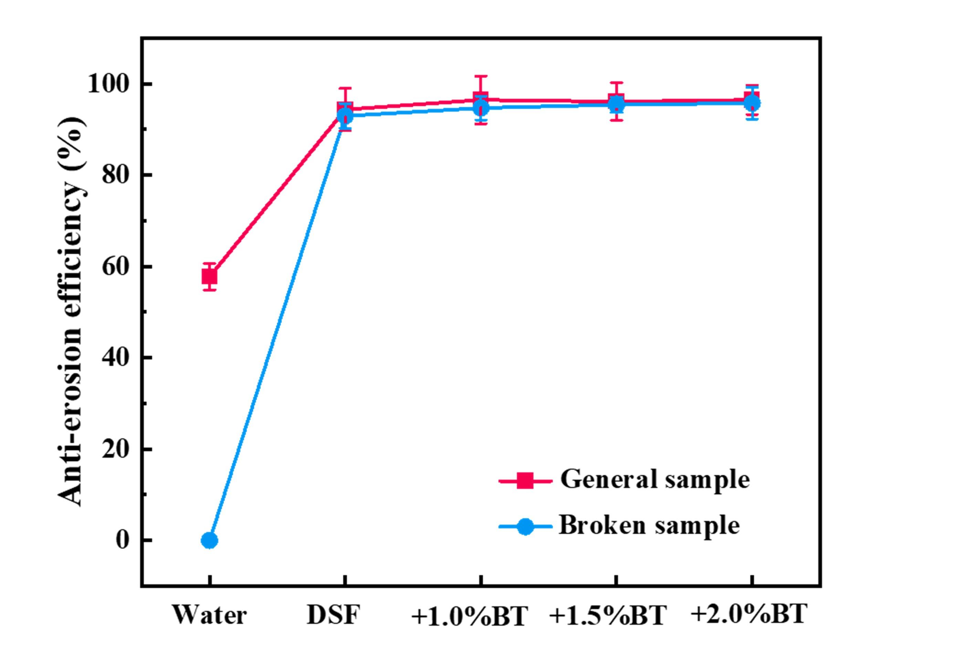
Fig. S12 Anti-erosion efficiency before and after crushing of the curing layer formed with different bentonite concentrations (all broken samples were obtained from general samples through impacts induced by falling weights as described in section 2.2.4.).

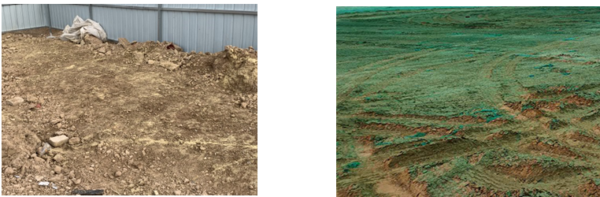
Fig. S13 Photos showing the construction site before (left) and after (right) spraying dust suppressants with green pigments.

Table S1
Orthogonal experiment results.

Serial number | Level of factor |  |  | Combination | Parameters
Serial number | A | B | C | Combination | pH | Water loss rate (%) | Penetration  velocity (mm/s) | Anti-erosion efficiency (%)
1 | 1 | 1 | 1 | A₁B₁C₁ | 7.52 | 16.74 | 0.25 | 50.7
2 | 1 | 2 | 2 | A₁B₂C₂ | 7.79 | 13 | 0.32 | 57.75
3 | 1 | 3 | 3 | A₁B₃C₃ | 8.55 | 9.56 | 0.38 | 65.85
4 | 2 | 1 | 2 | A₂B₁C₂ | 7.81 | 15.24 | 0.23 | 83.8
5 | 2 | 2 | 3 | A₂B₂C₃ | 8.73 | 12.37 | 0.25 | 86.27
6 | 2 | 3 | 1 | A₂B₃C₁ | 7.34 | 8.43 | 0.19 | 78.17
7 | 3 | 1 | 3 | A₃B₁C₃ | 8.9 | 14.45 | 0.22 | 92.96
8 | 3 | 2 | 1 | A₃B₂C₁ | 7.46 | 12.16 | 0.11 | 92.25
9 | 3 | 3 | 2 | A₃B₃C₂ | 7.72 | 7.29 | 0.17 | 92.96

