Supplementary Information

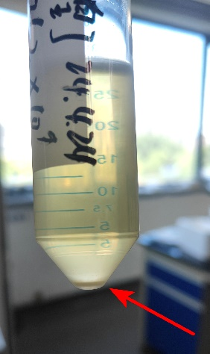

Figure S1. A tube of viral stock with visible precipitates at the bottom of the tube (red arrow).

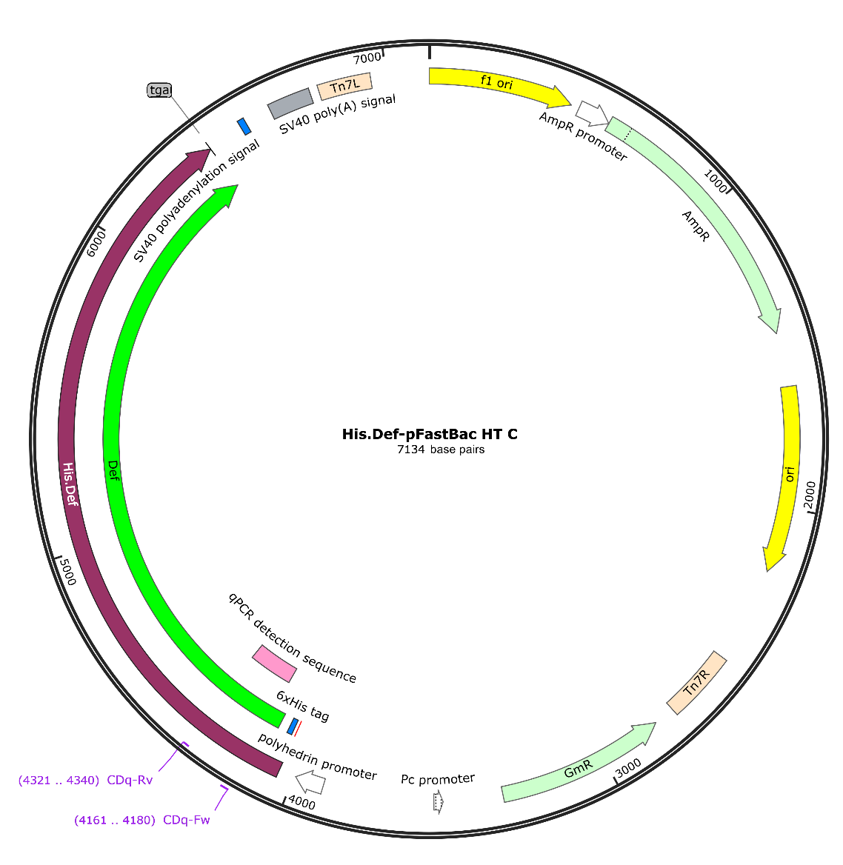

Figure S2. The map of His.Def virus donor plasmid, with DEF gene inserted into the multiple cloning sites. His.Def-pFastBac HT C contains two resistance genes, GmR for resisting gentamycin and AmpR for resisting ampicillin. Tn7L and Tn7R sites are recognized by transposase derived from Helper plasmid to fulfill transposition of the gene of interest into the bacmid. His.Def-pFastBac HT C harbors the Polyhedrin promoter, which is very effective in driving gene expression in Sf9 cells.

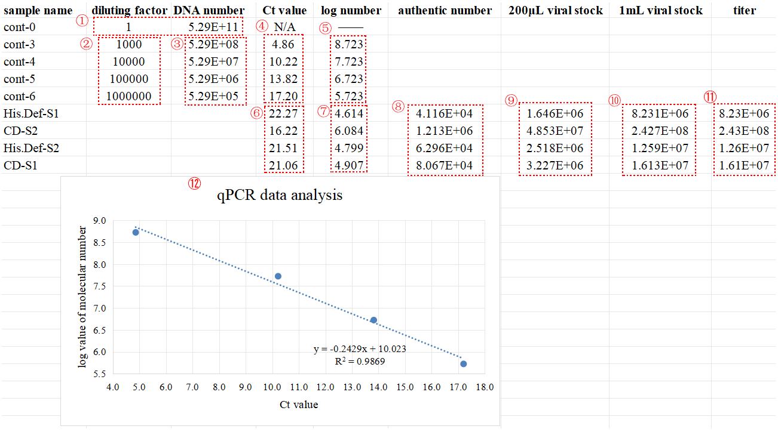

Figure S3. The detailed workflow of qPCR data analysis for generating standard curve as shown in Figure 2. ①, ②, ③, ④, and ⑥ were first input into the table. ⑤ was derived from ③. By virtue of ④ and ⑤, ⑫ was generated. According to the linear equation in ⑫ and the Ct values in ⑥, ⑦ was calculated. And then ⑧ was obtained, ⑨ was obtained, ⑩ was obtained, and finally, ⑪ was procured.

Table S1. Sequence of primers for generation of the control PCR product and for performing qPCR .
Primer name | Orientation | Sequence (5’-3’) | Target virus
CDq-Fw | Forward | AGCCAGCTACTCAACACCCT | CD virus; His.Def virus; R3 virus
CDq-Rv | Reverse | AACTTGTTCTGGTTCACTCT | CD virus; His.Def virus; R3 virus
His.C129S-Fw | Forward | CGTCTGGAAGAGACCTCCGG | His.C129S virus
His.C129S-Rv | Reverse | TCGATGAAACTTTGATCATG | His.C129S virus
Note: The CD virus, His.Def virus, and R3 virus all contain the gene DEF, so the DEF specific primers designed could apply to all three virus. As for His.C129S virus, the designed primers are derived from the CAPN3^{C129S} gene.

Table S2. The components of qPCR reaction.
Component | Volume
qPCR mix | 5 µL
Former primer | 0.2 µL
Reverse primer | 0.2 µL
MQ water | 3.6 µL
template | 1 µL
Note: Use Vazyme 2×AceQ qPCR SYBR Green Master Mix for the qPCR reaction. Begin by labeling a 96-well optical plate (Hangzhou Vtuo Biotechnology Co.,ltd.) according to the sample names. Cover the 96-well plate with Microseal (Bio-Rad's Microseal) and centrifuge at 2,000×g for 3 minutes. After centrifugation, vortex thoroughly to mix, then centrifuge again at 2,000×g for 5 minutes.

Table S3. The parameters of the qPCR program.
Step | Temperature | Duration
1 | 95.0℃ | For 5:00
2 | 95.0℃ | For 0:10
3 | 60.0℃ | For 0:30
+Plate Read
4 | GOTO 2, 39 more times
5 | 95.0℃ | For 0:15
6 | Melt Curve 65.0℃ to 95.0℃, increment 0.5℃,
 | For 0:05 | +Plate Read
 | END
Note: The Express Load mode we selected was “Quick Plate_96 wells_SYBR Only.pltd”.

