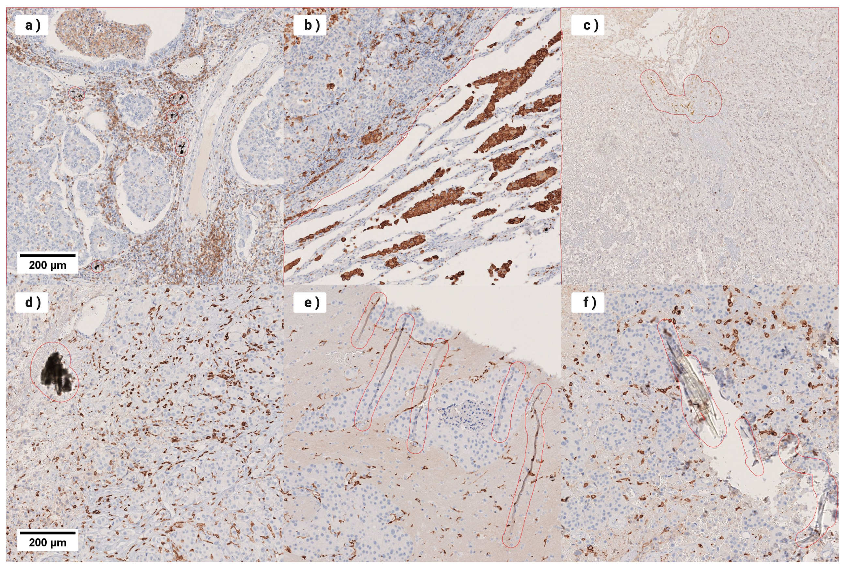
Supplementary Fig. 1 - Manual removal of artefacts to avoid false positive detection.
a) Anthracotic pigmentation due to tabacco consumption b) Adjacent healthy tissue c) Hemosiderin d) Pollution due to sample-preparation and processing errors e) Tissue tear, folds or curling artefacts. f) Air bubble and microscopic glas damage.

