Supplementary Information

The human cost of current and recommended diets in the U.S.

Edgar Rodríguez-Huerta, Brooke M. Bell, Kyra Battaglia, Jessica L. Decker Sparks, Catherine Benoit Norris, Alejandra Sofia Marquez, Zach Conrad, Julia Matteson, Bethany Jackson, Nicole Tichenor Blackstone

Table of Contents
Supplementary Methods 1
Forced Labor Risk in Seafood 1
Forced Labor Risk in Animal Feed 3
Forced Labor Risk Average Scores 6
Sensitivity Analyses 8
Supplementary Figures 10
Supplementary Figure 1. Distribution of FCID-commodity intake (g), by food subgroup 10
Supplementary Figure 2. Risk by food subgroup, feed vs. without feed 11
Supplementary Figure 3. Overall risk for each pattern, feed vs. without feed 12
List of Supplementary Tables 13
Supplementary Table 1. Minimum and maximum commodity-level risk scores that replaced the group-level scores (sensitivity analysis) 13
Supplementary Table 2.1. List of data sources and adaptations used to calculate livestock feed risk scores 13
Supplementary Table 2.2. List of data sources and adaptations used to calculate seafood feed risk scores 13
Supplementary Table 3. Total amount of food consumed, inedible, and wasted for all five patterns 13
Supplementary Table 4. Mapping from FCID commodity codes to food subgroups 13
Supplementary Table 5.1. Mapping from FNDDS dish codes to food subgroups 13
Supplementary Table 5.2. Mapping from FNDDS dish codes to food subgroups (grains only) 13
Supplementary Table 6.1. Forced labor risk scores utilized in the analysis (plant-based food commodities) 13
Supplementary Table 6.2. Forced labor risk scores utilized in the analysis (land animal-based food commodities) 13
Supplementary Table 6.3. Forced labor risk scores utilized in the analysis (sea animal-based food commodities) 13
Supplementary Table 7. Protocol for mapping forced labor risk scores to land-based FCID commodities 13
Supplementary Table 8. Protocol for selecting weight conversion factors 14
Supplementary Table 9. Protocol for mapping forced labor risk scores to sea-based FNDDS dishes 14
Supplementary References 15

Supplementary Methods

Forced Labor Risk in Seafood
The main data source that we used to estimate the risk of forced labor in the U.S. seafood supply was FishStat from the Food and Agriculture Organization (FAO)¹. We utilized the food balance sheets of fish and fishery products, which include imported commodities as well as domestically produced ones. We used the Supply and Utilization Accounting (SUA) values obtained from internal documentation provided by the FAO² because the official dataset was too aggregated for our intended use. However, we validated concordance in both data sources.
The time frame that we selected for this analysis was 2015-2017. Because the SUA database aggregated imports (at the partner country-level), we incorporated import values from FishStatJ software (Global Fish Trade Statistics v.2022.1.0)³. Since country-disaggregated data for the time frame were not available, we used the proportionality of origin of imports based on the 2019-2020 average (database: ‘Global fish trade by partner 2019-2020’) and applied it to the 2015-2017 average imports (database: ‘Global fish trade all partners aggregated’) to smooth interannual variability.
Production, import, and price values were provided at the ISSCAAP species group-level but were aggregated at the FAOSTAT group-level for seafood products, excluding the cases of tuna in pelagic, shrimp in crustaceans, and tilapia for freshwater fish. In total, there were 50 seafood products with food consumption in the U.S., ten of which were primary and 40 of which were processed. FAO uses 'commodities trees' to associate primary items with processed products.
There were significant gaps in data availability for prices. For seafood, there were no producer prices. The FishStatJ software (trade databases) included export and import prices, which had better coverage within our database, but included additional markups (e.g., for transport) beyond the producer price. To estimate price data for each commodity-country combination, a data hierarchy was established following the same criteria from Blackstone et al. (2023)⁴.

Forced Labor Risk in Animal Feed

Seafood
Our method to estimate risk in seafood and livestock feed involved six steps to estimate forced labor risk per unit for each feed category. We used multiple data sources^{5–7} in order to generate estimates that were as accurate and reliable as possible.
- Assign feed categories to FAO items. Beginning with the MacLeod et al. (2020)⁷ dataset, we selected feeds that could be mapped to FAO items, considering feed type ‘Commercial’ (C). We excluded categories without corresponding FAO items and normalized feed share values to 1. Likewise, we linked feed categories from Gephart et al. (2021)⁶ to each MacLeod category and FAO item. Gephart et al. (2021)⁶ classified feed items into four categories: crops, soybean products, fishmeal and fish oil (FMFO), and animal sources.
- Estimate regional and global averages for rations and feed conversion ratio (FCR). Rations refer to share of each type of feed (%) required per unit of aquaculture production by species, while FCR refers to the ratio of feed used to the weight gain of the animal. These estimates were based on the previous three references^{5–7}.
- Merge references and define priority. Each species from each country of origin could have multiple options for ration and FCR values, depending on data availability. In this step, we connected each possible country-species combination in the U.S. seafood supply to one FCR and ration value, considering the following prioritization rules:
  - Gephart (country-level)
  - Gephart (average value for region)
  - MacLeod (average value for region)
  - Gephart (average value for ‘global’)
  - MacLeod (average value for ‘global’)
  - Bouwman (average value for ‘global’)
- Estimate forced labor risk per unit for each feed item. Using regional or U.S. data, we associated the forced labor risk to the primary item of each feed item, taking into account extract rate and allocation share.
- Apply weights (proportions) within each feed category. Since Gephart et al. (2021) use highly aggregated feed categories, it was necessary to weight the risk of each item in each category based on global production or MacLeod reference values⁷. For example, using global processed production, we estimated that pelagic meal (excluding tuna) represented 90% of the total fish meal and fish oil (FMFO), while demersal meals represented 5%, and pelagic oil (excluding tuna) also represented 5%. For MacLeod values, we had a similar issue for 'oilseed meal' since it could be from rapeseed or sunflower. Since the Bouwman reference doesn't consider feed items (only FCR for crustaceans and mollusks), we applied the same ration distribution from MacLeod used for crustaceans.
- Multiply forced labor risk score by FCR and ration share. The final step was to multiply the forced labor risk score (from Step 5) by the FCR and ration share for country-item combination (from Step 3).

Livestock
While we relied on obtaining risk scores for many feeds from our prior dataset (Blackstone et al., 2023)⁴, there were several cases where we needed to generate new risk scores for feed items. A summary of the data sources used and the adaptations made in order to calculate the feed risk scores is provided in Supplementary Tables 2.1 and 2.2.
We calculated risk for the following feed items:
- Grazed pasture: Risk was assumed to be equal to zero to avoid double counting. This is because any risk in pasture-based ruminant livestock production would be coded as the “agricultural” stage of that commodity according to our coding rules and already counted in the risk assessment.
- Silage: To calculate the extract rate for silage, we used conversion factors for barley, corn, oats, and wheat silage from the Center for Dairy Excellence⁸, where wheat was used as a proxy for buckwheat and fonio. We combined this with data from ERS⁹ and the U.S. Grains Council¹⁰ on commodity crop weights to derive the extract rate.
- Distillers Grains: There was no available risk dataset for wet and dry by-product from distillers grains, which are primarily protein feeds. To estimate risk data, we reclassified these items as soy by calculating the amount of crude protein present in 1kg of both wet and dry grain by-product, as well as the amount of protein present in 1kg of soy. These values were used to develop a conversion ratio (crude protein of soy/crude protein of grain by-product). The conversion ratio was multiplied by the risk present in soybeans for each region.
- Residues: To calculate the extract rate for crop residue, we used equations 3.1 and 3.2 from GLEAM v3 methodology¹¹ to calculate the gross dry matter yield and the gross dry matter yield of crop residue. Data for gross dry matter yield are 2015-2019 averages from FAOSTAT¹². Results from these equations were used to calculate the extract rate.

Forced Labor Risk Average Scores

Seafood
Our forced labor risk dataset included 48 seafood products. For each species, there were multiple seafood products that represented different types of upstream processing. For instance, there were four cephalopod products in our dataset: fresh, frozen, cured, and canned. To account for this, we computed a weighted average risk score for each seafood species, where the weights were based on the proportion of each processing type in the U.S. seafood supply. If the FNDDS dish description specified a particular upstream processing type, we used that processing-specific risk score (e.g., canned tuna). However, if the dish description did not specify an upstream processing type (e.g., cooked salmon), we used the weighted average risk score for that seafood species.

Non-Seafood
There were several FCID codes that did not have an obvious 1-1 or proxy mapping, therefore in some cases, we created average forced labor risk scores to map to these FCID codes. We created seven average scores:
- Root, other: Average of (i) Chicory roots and (ii) Roots and tubers nes
- Green bean, other: Average of (i) Beans, green and (ii) String beans
- Seed, other: Average of (i) Sesame seed, (ii) Poppy seed, (iii) Sunflower seed, and (iv) Mustard seed
- Tropical fruit, other: Average of (i) Mangoes, mangosteens, guavas, (ii) Pineapples, (iii) Avocados, and (iv) Papayas
- Poultry, other =Average of (i) Meat, chicken and (ii) Meat, turkey)
- Grain, other = Average of (i) Rice, milled, (ii) Oats rolled, (iii) Fonio, (iv) Quinoa, (v) Bulgur, (vi) Barley, pearled, and (vii) Sorghum
- Flour, other = Average of (i) Flour, wheat, (ii) Flour, maize, (iii) Flour, buckwheat, (iv) Flour, rye, and (v) Flour, cereals
These average values were then used to map the remaining FCID codes without direct matches or appropriate proxies.

Sensitivity Analyses
We conducted two sets of sensitivity analyses to explore the robustness of our results: one with maximum and minimum risk scores for each food subgroup, and one with and without risk in feed integrated.
For each, we assessed whether the relationships between the patterns changed using ranks. The total amount of forced labor risk for the five patterns was ranked from 1 (lowest total risk) to 5 (highest total risk). At baseline, the PHD pattern had the lowest total forced labor risk (0.533 mrh-eq/capita/day) and was assigned Rank 1, and the MED pattern had the highest total forced labor risk (0.788 mrh-eq/capita/day) and was assigned Rank 5 (Figure 4). The VEG pattern was assigned Rank 2, the CURRENT pattern was assigned Rank 3, and the HUS pattern was assigned Rank 4.
Because commodity risk scores vary widely within food groups, we replaced the weighted average group-level risk scores with the lowest and highest corresponding commodity-level risk scores, rerunning the original analysis, and recalculating the ranks (see Methods). The minimum and maximum commodity-level risk scores that replaced the group-level scores are provided in Supplementary Table 1. A total of 36 different scenarios were analyzed, 18 scenarios where each food group-level score was replaced with its minimum commodity-level score, and 18 scenarios where the maximum commodity-level score was used.
Overall, approximately three fifths of the total 36 scenarios (22/36, 61.1%) resulted in the same pattern ranking as the baseline scenario (Figure 4). The PHD pattern remained Rank 1 in 77.8% (28/36) of scenarios, the VEG pattern remained Rank 2 in 66.7% (24/36) of scenarios, the CURRENT pattern remained Rank 3 in 72.2% (26/36) of scenarios, and the HUS and MED patterns remained Rank 4 and 5, respectively, in 88.9% (32/36) of scenarios (Figure 4). There were no scenarios where the rank for all five patterns changed. Of the 14 scenarios where ranks shifted, the rank shifted the most in three of them: when the (i) minimum seafood, (ii) maximum whole grain, and (iii) maximum nuts and seeds scores were used (Figure 4). In the minimum seafood scenario, the HUS and MED patterns switched ranks (HUS changed from Rank 4 to 5 (highest total risk), and vice versa). Given that the HUS and MED diets have very similar recommended intake values other than the higher seafood intake recommendation for MED, this change in rank is driven by the overall decrease in risk for the MED pattern when the lowest seafood risk score is used. In the other two scenarios, the PHD pattern changed from Rank 1 (lowest risk) to 5 (highest risk), driven by the fact that the PHD recommends the highest amounts of whole grains and nuts and seeds across all five patterns, The highest risk foods included in these scenarios were quinoa (whole grains) and shelled cashews (nuts and seeds) (Supplementary Table 1).
To assess the contribution of feed to overall risk in the patterns and ascertain sensitivity of our results to feed risk, we ran the analysis with and without feed risk scores integrated. Risk scores for animal products with and without feed are provided in (Supplementary Tables 6.2 and 6.3). When feed was completely excluded from the analysis, there was only one change in the overall ranking of the dietary patterns (Supplementary Figure 3). The MED and HUS patterns remained the top two highest risk patterns, however, the CURRENT (originally 3rd highest) and VEG (originally 4th highest) patterns switched rankings. The change in rank between these two patterns was driven in large part by the decrease in red meat risk when feed was removed, which accounted for almost half of the change in risk (Supplementary Figure 2).

Supplementary Figures

Supplementary Figure 1. Distribution of FCID-commodity intake (g), by food subgroup

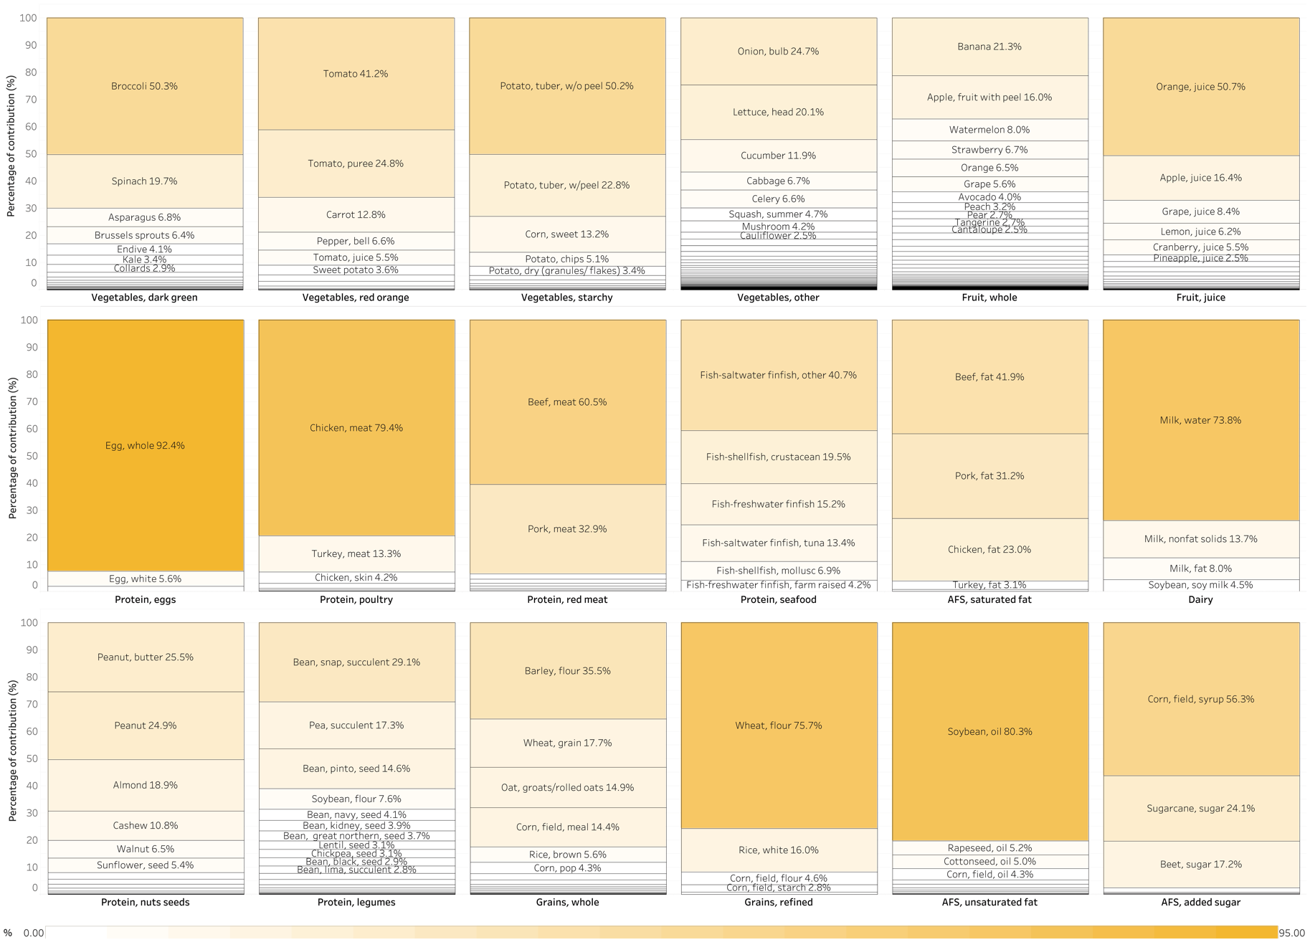

Supplementary Figure 2. Risk by food subgroup, feed vs. without feed

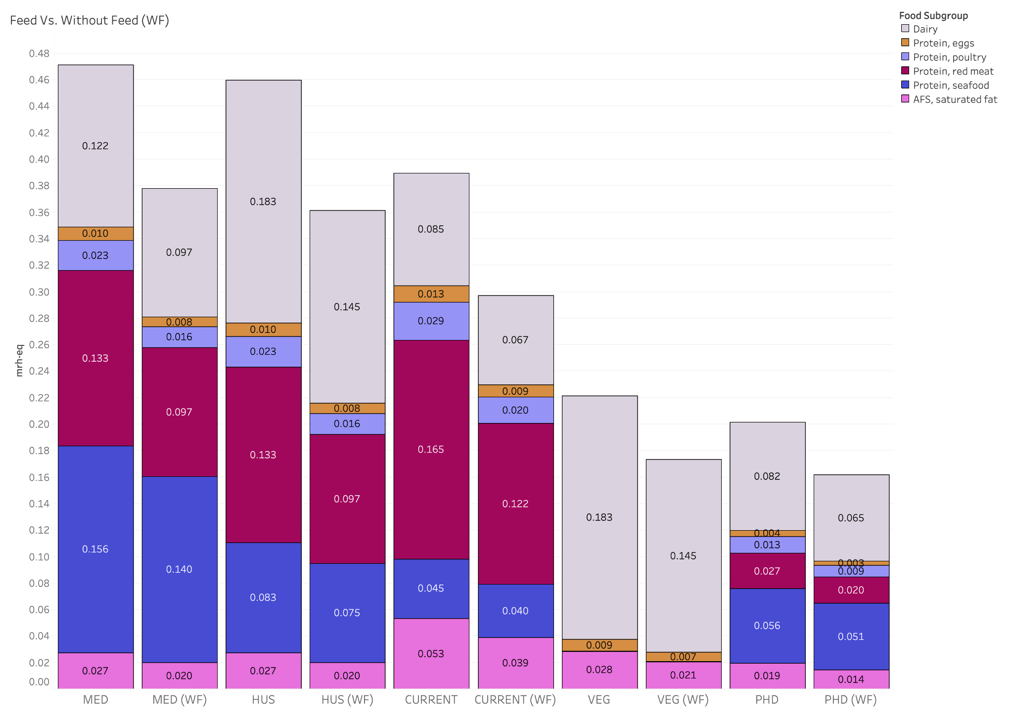

Supplementary Figure 3. Overall risk for each pattern, feed vs. without feed

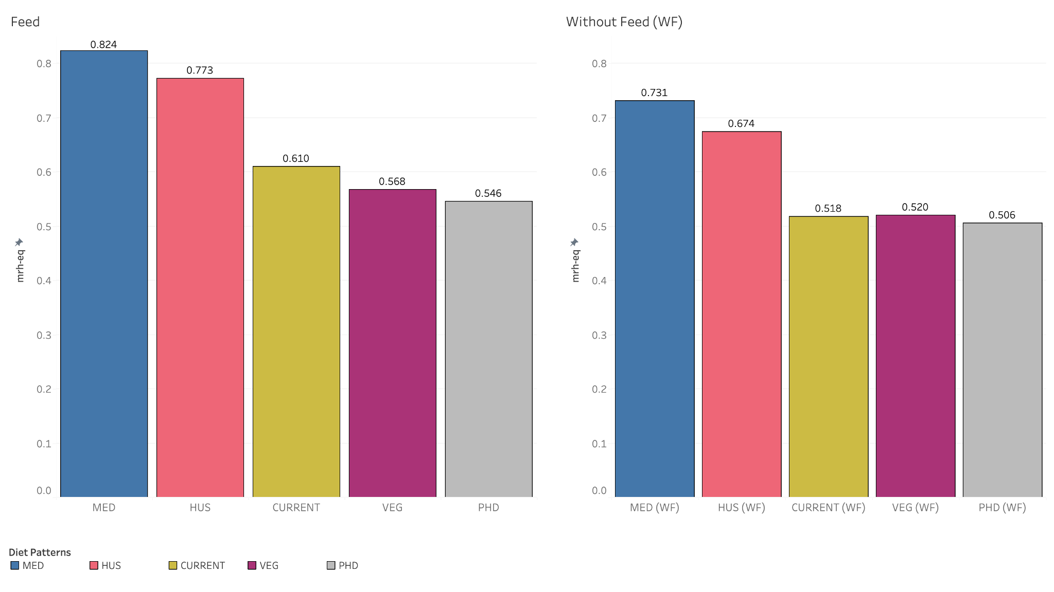

List of Supplementary Tables

Supplementary Table 1. Minimum and maximum commodity-level risk scores that replaced the group-level scores (sensitivity analysis)

Supplementary Table 2.1. List of data sources and adaptations used to calculate livestock feed risk scores

Supplementary Table 2.2. List of data sources and adaptations used to calculate seafood feed risk scores

Supplementary Table 3. Total amount of food consumed, inedible, and wasted for all five patterns

Supplementary Table 4. Mapping from FCID commodity codes to food subgroups

Supplementary Table 5.1. Mapping from FNDDS dish codes to food subgroups

Supplementary Table 5.2. Mapping from FNDDS dish codes to food subgroups (grains only)

Supplementary Table 6.1. Forced labor risk scores utilized in the analysis (plant-based food commodities)

Supplementary Table 6.2. Forced labor risk scores utilized in the analysis (land animal-based food commodities)

Supplementary Table 6.3. Forced labor risk scores utilized in the analysis (sea animal-based food commodities)

Supplementary Table 7. Protocol for mapping forced labor risk scores to land-based FCID commodities

Supplementary Table 8. Protocol for selecting weight conversion factors

Supplementary Table 9. Protocol for mapping forced labor risk scores to sea-based FNDDS dishes

Supplementary References

1. Food and Agriculture Organization. FishStat. (2019).
2. Rosa, F. SWS-Methodology: Fish Standardization. (2019).
3. Statistics Team (NFISS); Food and Aquaculture Division. FishStatJ - Software for Fishery and Aquaculture Statistical Time Series - Fisheries and Aquaculture. Food and Agriculture Organization (2022).
4. Blackstone, N. T. et al. Forced labour risk is pervasive in the US land-based food supply. Nat Food 4, 596–606 (2023).
5. Bouwman, A. F. et al. Global Hindcasts and Future Projections of Coastal Nitrogen and Phosphorus Loads Due to Shellfish and Seaweed Aquaculture. Reviews in Fisheries Science (2011).
6. Gephart, J. A. et al. Environmental performance of blue foods. Nature 597, 360–365 (2021).
7. MacLeod, M. J., Hasan, M. R., Robb, D. H. F. & Mamun-Ur-Rashid, M. Quantifying greenhouse gas emissions from global aquaculture. Sci Rep 10, 11679 (2020).
8. Center for Dairy Excellence. Silage and Hay Production. https://www.centerfordairyexcellence.org/wp-content/uploads/Silage-and-Hay-Conversion-Factors.pdf (2020).
9. U.S. Department of Agriculture, Economic Research Service. Feed Grains Database: Documentation. (2023).
10. U.S. Grains Council. Converting Grain Units. https://grains.org/markets-tools-data/tools/converting-grain-units/ (2024).
11. Falcucci, A. et al. Global Livestock Environmental Assessment Model v3.0. (2022).
12. Food and Agriculture Organization of the United Nations. FAOSTAT: Crops and livestock products. https://www.fao.org/faostat/en/#data/QCL (2023).

We omitted the country import values for “Other, nei”
International standard statistical classification of aquatic animals and plants (ISSCAAP)

