Table 2: Performance Metrics of Model-Pre- and Poststacking. Performance metrics of the base models and the stacked model showing % accuracy, sensitivity, specificity, precision and F score (used to assess the balance between sensitivity and precision). of the models in each of the 4 clinical samples. Let $t_{n}, f_{n}, t_{p}, f_{p}$ be the number of true negatives, false negatives, true positives, and false positives, respectively. Then, $Accuracy=\frac{t_{n}+t_{p}}{t_{n}+t_{p}+f_{n}+f_{p}}*100$, $Specificity=\frac{t_{n}}{t_{n}+f_{p}}*100$, $Sensitivity=\frac{t_{p}}{t_{p}+f_{n}}*100$, $Precision=\frac{t_{p}}{t_{p}+f_{p}}*100$, and $F_{score}=2*\frac{Precision*Sensitivity}{Precision+Sensitivity}*100$.

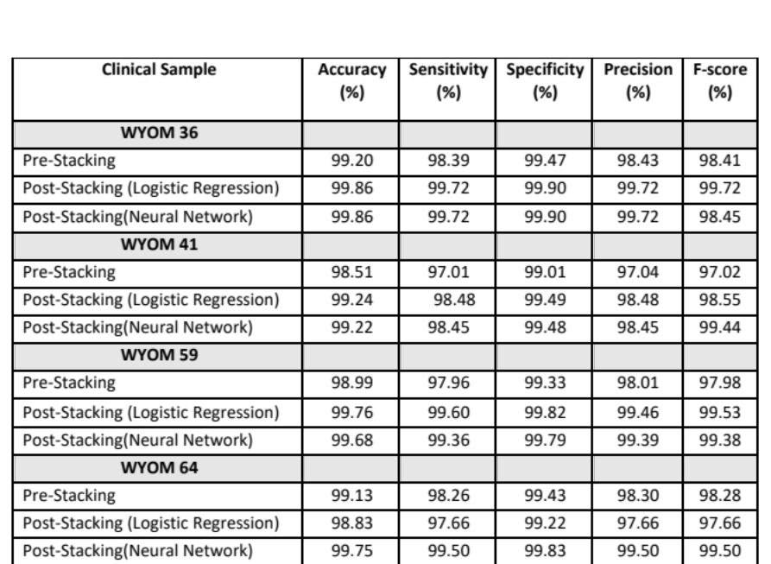

Table 3: Coverage and accuracy values for all 4 samples before and after stacking at a Q score = 20. Performance metrics of the base models and the stacked model showing accuracy and coverage (%) for each of the 4 clinical samples at Q = 20
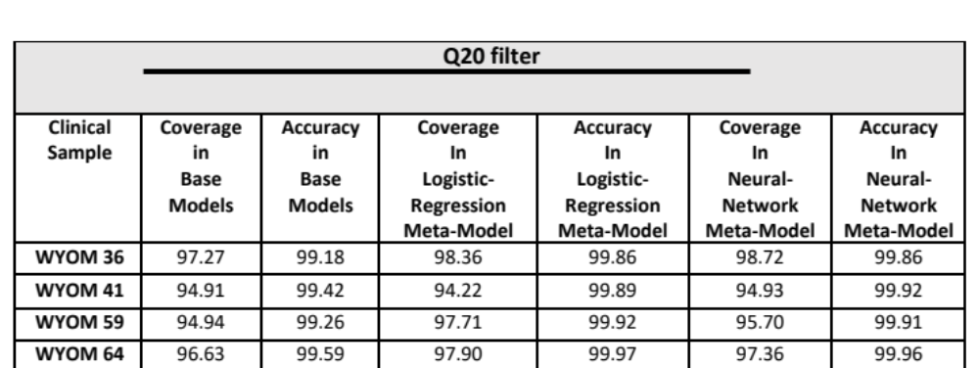

Table 4: Coverage and accuracy values for all 4 clinical samples before and after stacking at a Q score = 10. Performance metrics of the base models and the stacked model showing accuracy and coverage (%) for each of the 4 clinical samples at Q = 10
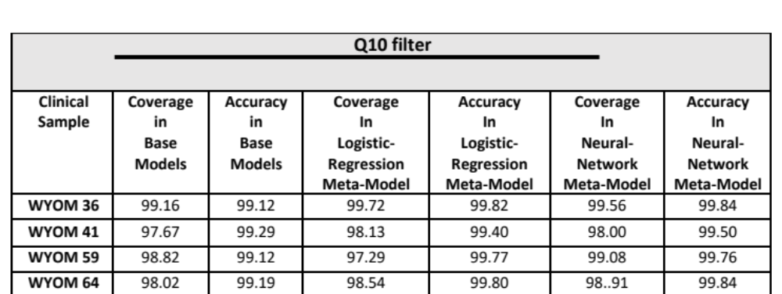

Table 5: Results for the identification of base call variants from Illumina-sequenced clinical samples with Ct values less than 25. Variant identification via neural network models (variants are presented as RpV. R = reference base, p = position, V = variant base.)
