Supplementary Figures

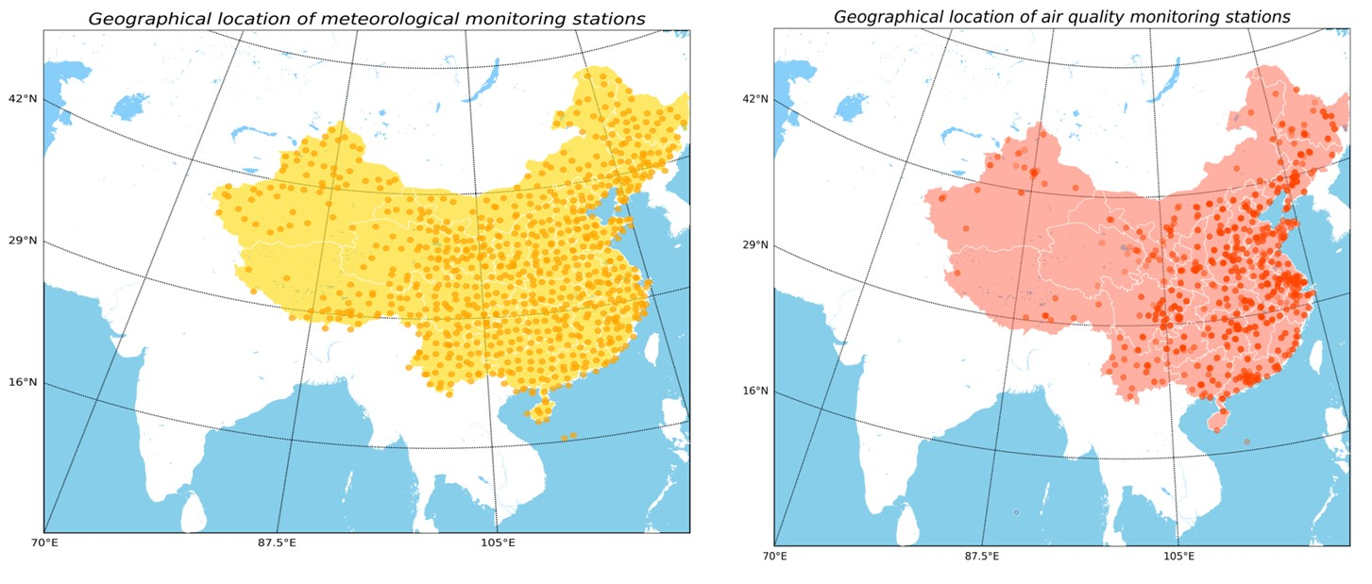
Supplementary Figure 1. Geographical location of meteorological monitoring stations
(N=756) and air quality monitoring stations (N=1498) in China.

Supplementary Figure 2. Trends and joinpoints of incidence of pulmonary tuberculosis (PTB) in China, 2004-18.

Supplementary Figure 3. 15-year trends in incidence, and mortality for 7 respiratory infectious diseases, by year from 2004 to 2018. Each concentric circle represents one year starting from 2004 in the center to 2018.

Supplementary Figure 4. Trends and joinpoints of incidence and mortality of meningococcal meningitis in China, 2004-18.

Supplementary Figure 5. Trends and joinpoints of incidence of rubella in China, 2004-18.

Supplementary Figure 6. Trends and joinpoints of incidence and mortality of pertussis in China, 2004-18.

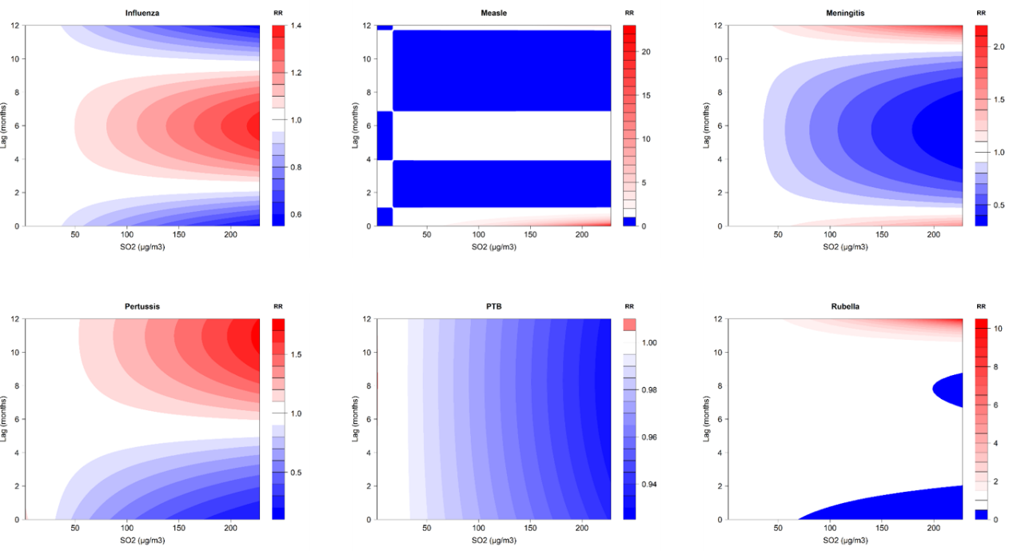
Supplementary Figure 7. Contour plots of the relative risk (RR) along SO₂ and lag time on specific respiratory infectious diseases. The X-axis represents the value of SO₂ and the Y-axis represents lag months ranging from 0 to 12. The RR was determined based on the median value of SO₂. The red and blue colors indicate RR greater than 1 and less than 1, respectively. The white color represents no difference, at RR=1.

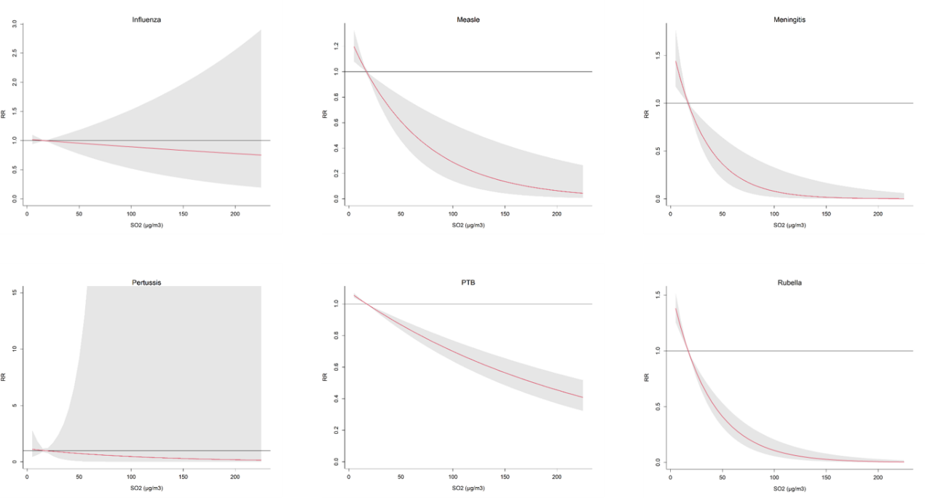
Supplementary Figure 8. The overall cumulative relative risks of SO₂ on specific respiratory infectious diseases across lag 0–12 months. The red lines are the cumulative relative risks, the gray shaded areas indicate the 95% confidence intervals. Reference level is the median.

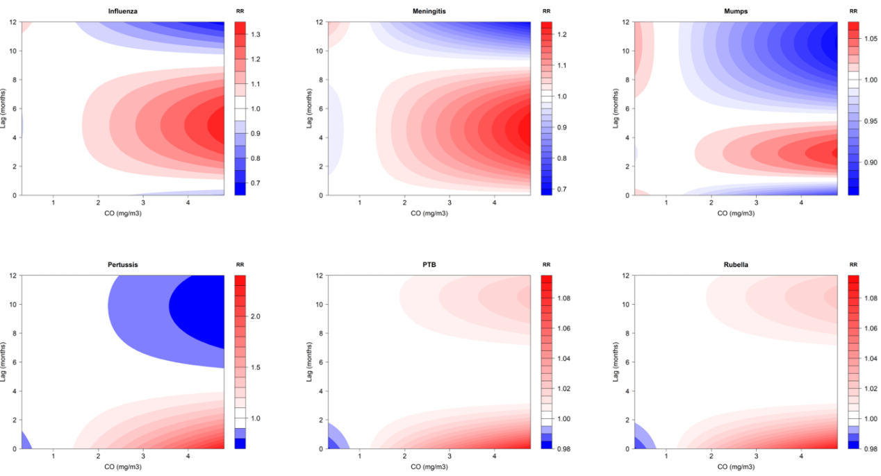
Supplementary Figure 9. Contour plots of the relative risk (RR) along CO and lag time on specific respiratory infectious diseases. The X-axis represents the value of CO and the Y-axis represents lag months ranging from 0 to 12. The RR was determined based on the median value of CO. The red and blue colors indicate RR greater than 1 and less than 1, respectively. The white color represents no difference, at RR=1.

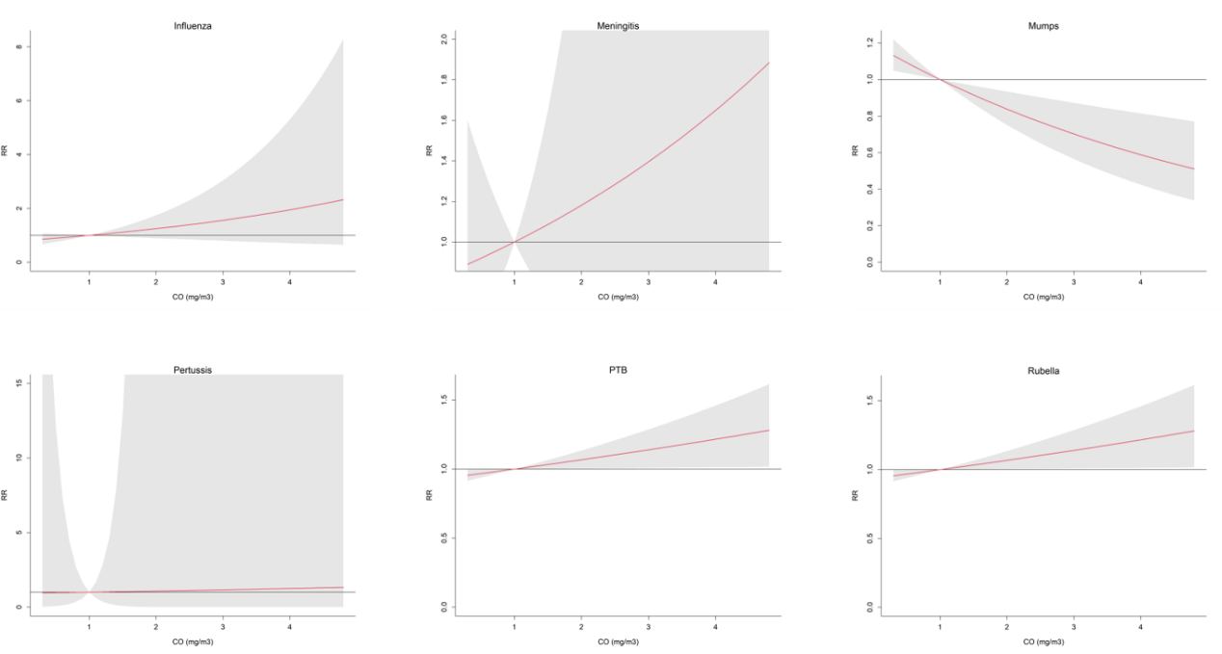
Supplementary Figure 10. The overall cumulative relative risks of CO on specific respiratory infectious diseases across lag 0–12 months. The red lines are the cumulative relative risks, the gray shaded areas indicate the 95% confidence intervals. Reference level is the median.

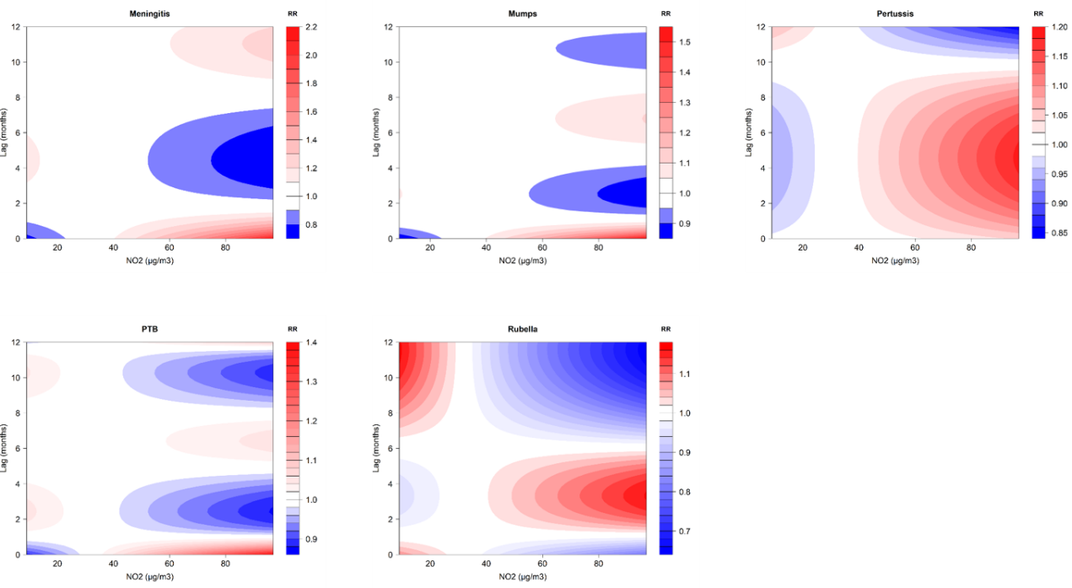
Supplementary Figure 11. Contour plots of the relative risk (RR) along NO₂ and lag time on specific respiratory infectious diseases. The X-axis represents the value of NO₂ and the Y-axis represents lag months ranging from 0 to 12. The RR was determined based on the median value of NO₂. The red and blue colors indicate RR greater than 1 and less than 1, respectively. The white color represents no difference, at RR=1.

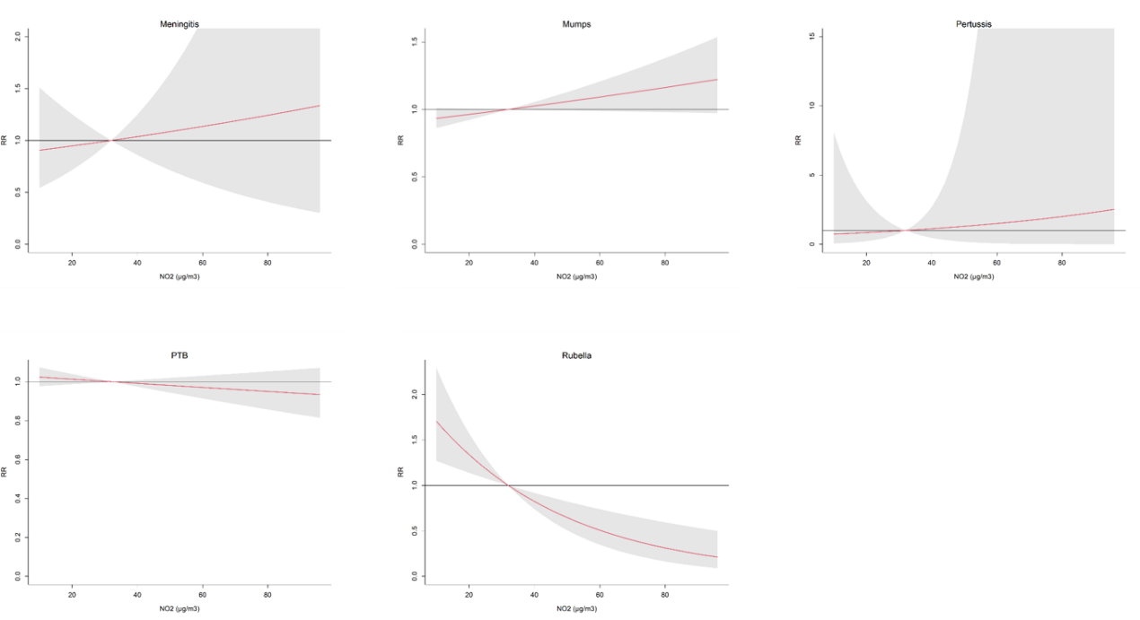
Supplementary Figure 12. The overall cumulative relative risks of NO₂ on specific respiratory infectious diseases across lag 0–12 months. The red lines are the cumulative relative risks, the gray shaded areas indicate the 95% confidence intervals. Reference level is the median.

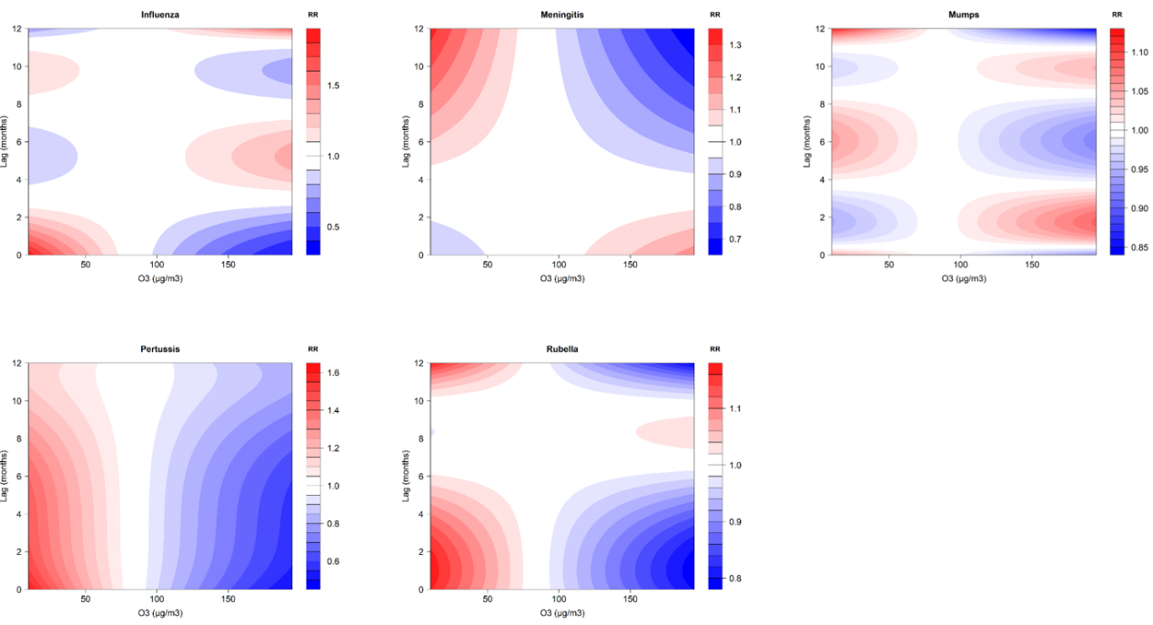
Supplementary Figure 13. Contour plots of the relative risk (RR) along O₃ and lag time on specific respiratory infectious diseases. The X-axis represents the value of O₃ and the Y-axis represents lag months ranging from 0 to 12. The RR was determined based on the median value of O₃. The red and blue colors indicate RR greater than 1 and less than 1, respectively. The white color represents no difference, at RR=1.

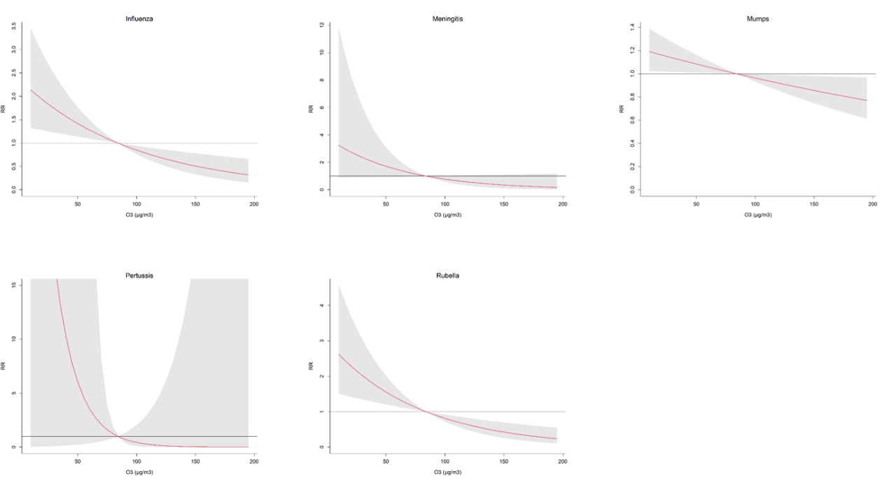
Supplementary Figure 14. The overall cumulative relative risks of O₃ on specific respiratory infectious diseases across lag 0–12 months. The red lines are the cumulative relative risks, the gray shaded areas indicate the 95% confidence intervals. Reference level is the median.

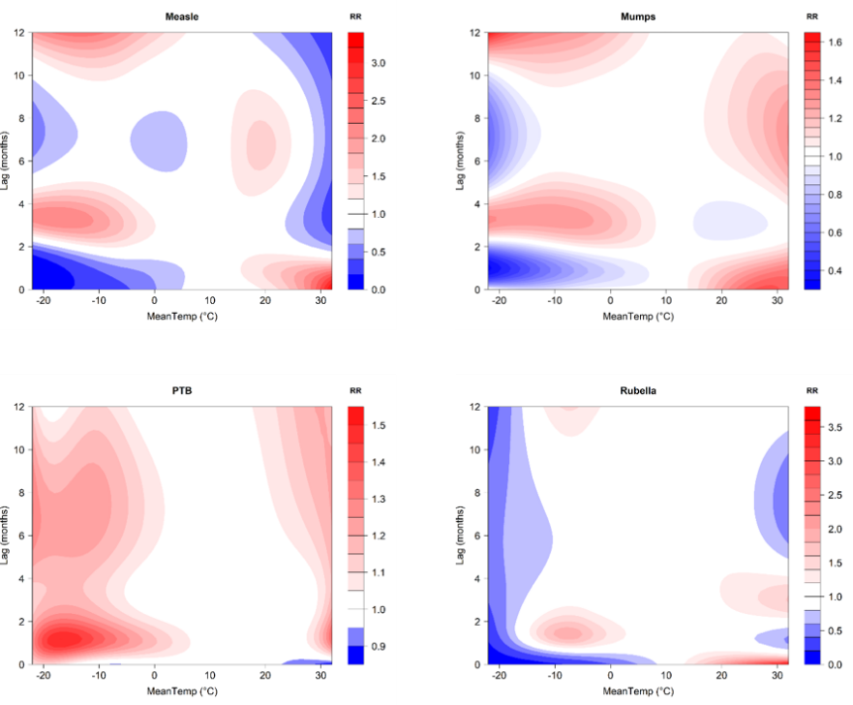
Supplementary Figure 15. Contour plots of the relative risk (RR) along mean temperature and lag time on specific respiratory infectious diseases. The X-axis represents the value of mean temperature and the Y-axis represents lag months ranging from 0 to 12. The RR was determined based on the median value of mean temperature. The red and blue colors indicate RR greater than 1 and less than 1, respectively. The white color represents no difference, at RR=1.

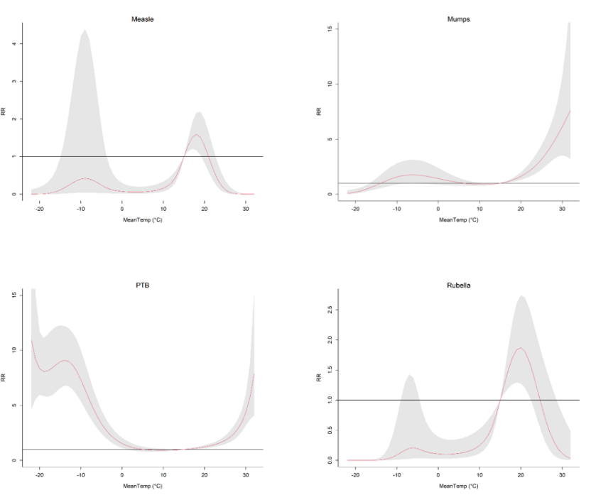
Supplementary Figure 16. The overall cumulative relative risks of mean temperature on specific respiratory infectious diseases across lag 0–12 months. The red lines are the cumulative relative risks, the gray shaded areas indicate the 95% confidence intervals. Reference level is the median.

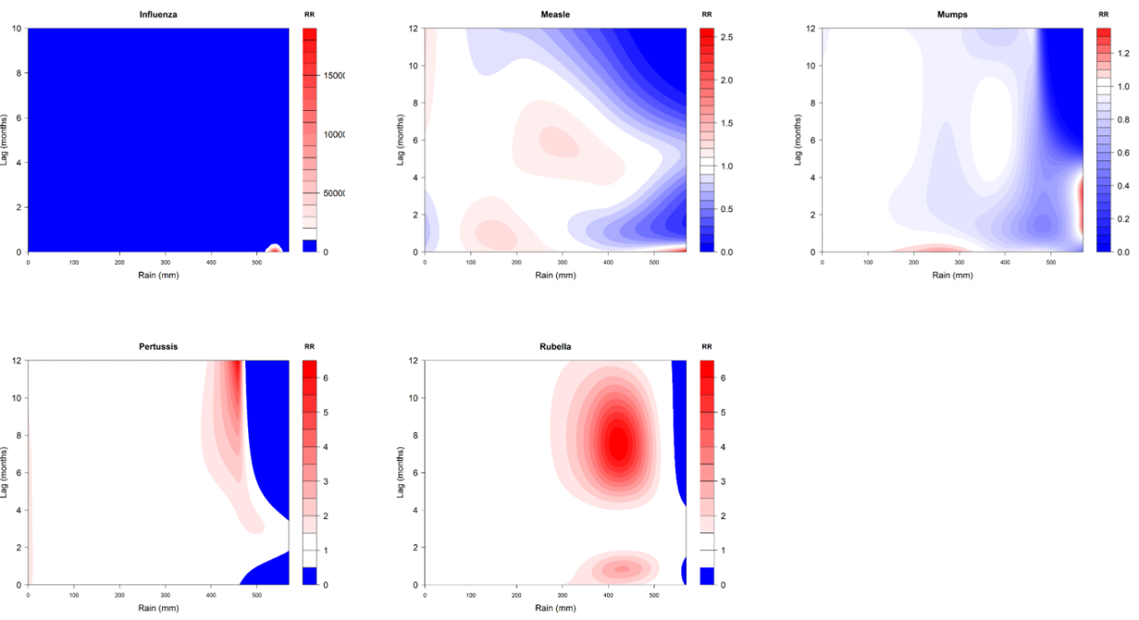
Supplementary Figure 17. Contour plots of the relative risk (RR) along rainfall and lag time on specific respiratory infectious diseases. The X-axis represents the value of rainfall and the Y-axis represents lag months ranging from 0 to 12. The RR was determined based on the median value of rainfall. The red and blue colors indicate RR greater than 1 and less than 1, respectively. The white color represents no difference, at RR=1.

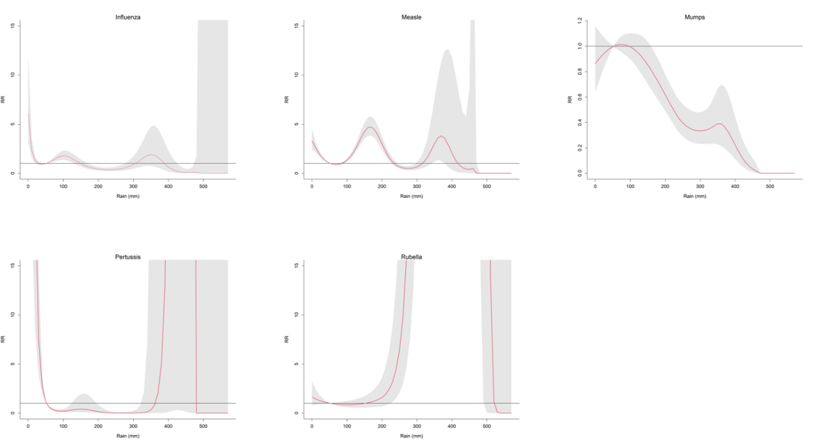
Supplementary Figure 18. The overall cumulative relative risks of rainfall on specific respiratory infectious diseases across lag 0–12 months. The red lines are the cumulative relative risks, the gray shaded areas indicate the 95% confidence intervals. Reference level is the median.

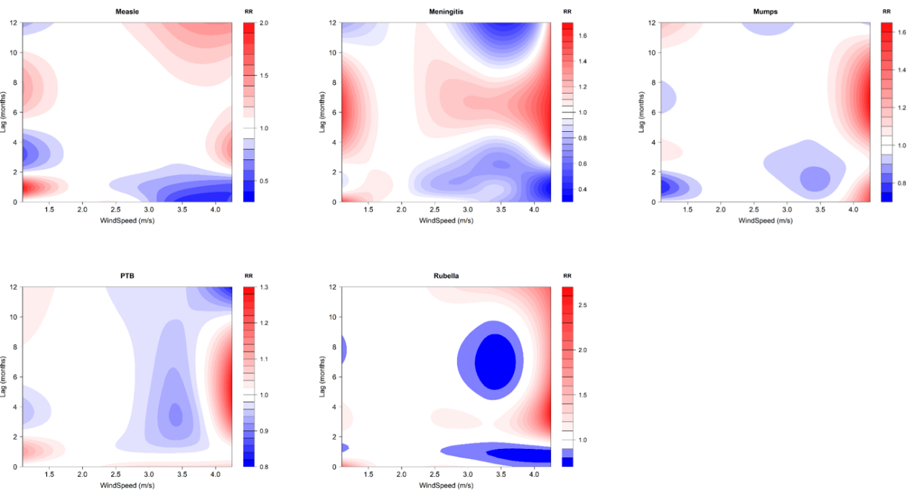
Supplementary Figure 19. Contour plots of the relative risk (RR) along wind speed and lag time on specific respiratory infectious diseases. The X-axis represents the value of wind speed and the Y-axis represents lag months ranging from 0 to 12. The RR was determined based on the median value of wind speed. The red and blue colors indicate RR greater than 1 and less than 1, respectively. The white color represents no difference, at RR=1.

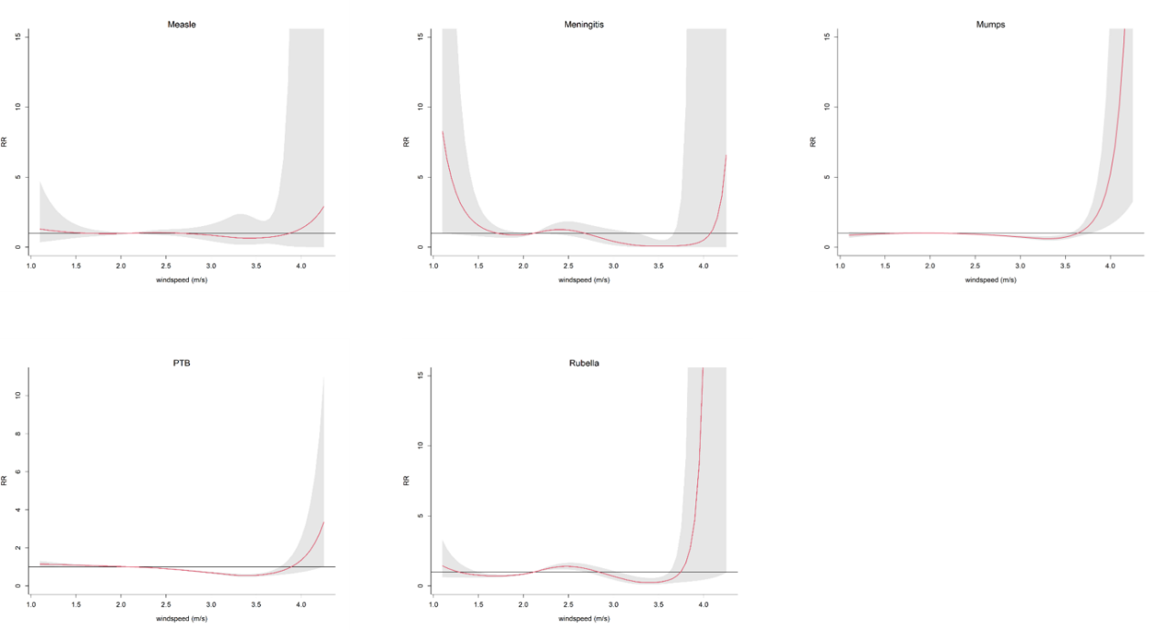
Supplementary Figure 20. The overall cumulative relative risks of wind speed on specific respiratory infectious diseases across lag 0–12 months. The red lines are the cumulative relative risks, the gray shaded areas indicate the 95% confidence intervals. Reference level is the median.

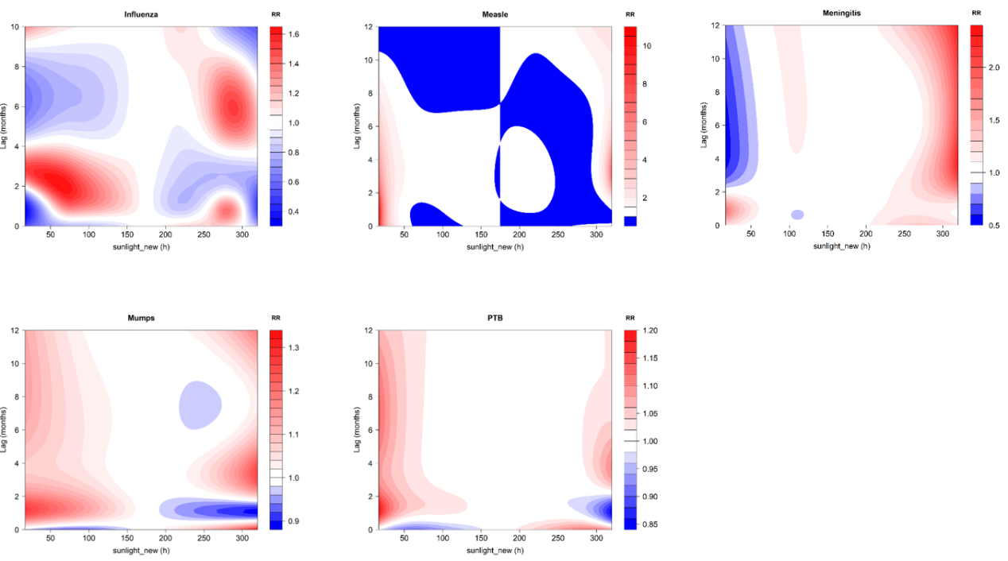
Supplementary Figure 21. Contour plots of the relative risk (RR) along sunshine hour and lag time on specific respiratory infectious diseases. The X-axis represents the value of sunshine hour and the Y-axis represents lag months ranging from 0 to 12. The RR was determined based on the median value of sunshine hour. The red and blue colors indicate RR greater than 1 and less than 1, respectively. The white color represents no difference, at RR=1.

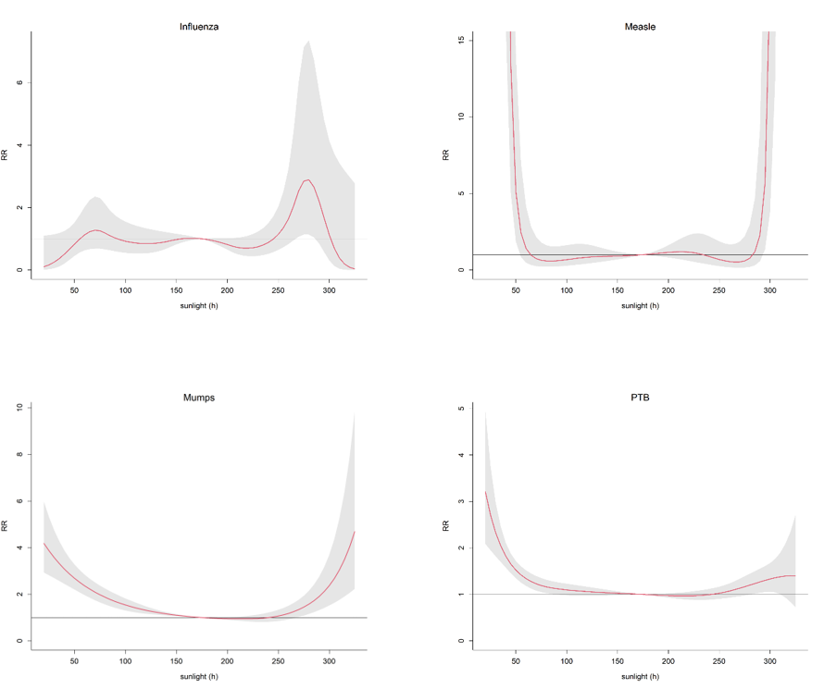
Supplementary Figure 22. The overall cumulative relative risks of sunshine hour on specific respiratory infectious diseases across lag 0–12 months. The red lines are the cumulative relative risks, the gray shaded areas indicate the 95% confidence intervals. Reference level is the median.

