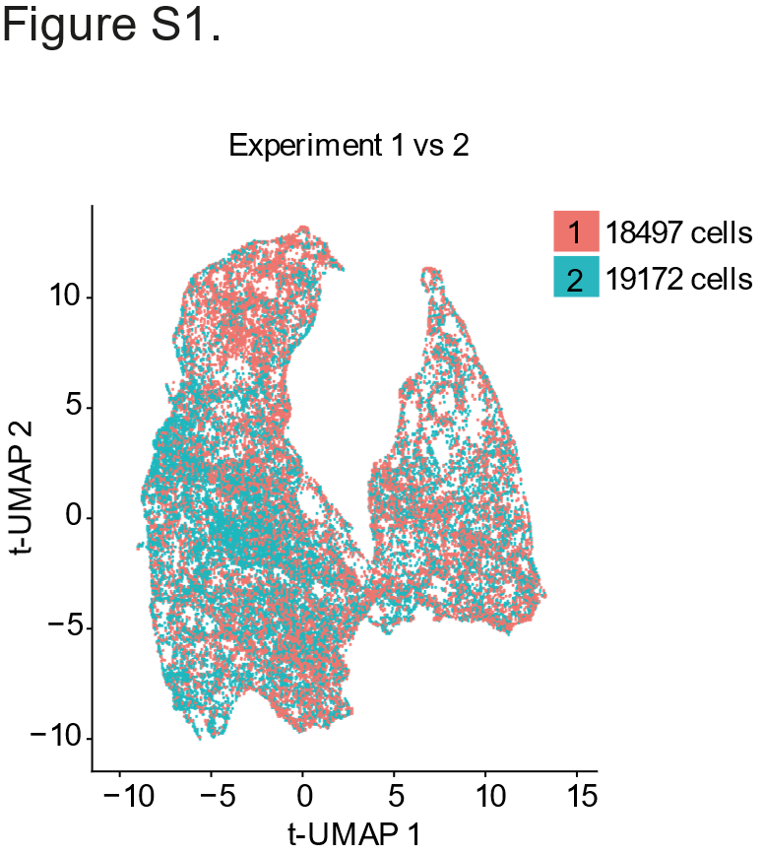

Supplementary Figure S1. Consistent representation of Ly6C⁺MHCII⁺CD64⁺ myeloid cells in tUMAP across two independent experiments. (A) tUMAP visualization of scRNA-seq data obtained from infected and bystander Ly6C⁺MHCII⁺CD64⁺ myeloid cells depicting the number and location of cells from two independent experiments.

Supplementary Table S1. Total DEGs for infected versus bystander cells. Average log fold change >0.5, p-value <0.05, consistent across the two experiments.

Supplementary Table S2. Total DEGs for WT/EspK versus ΔRD1 infected cells. Average log fold change >0.5, p-value <0.05, consistent across the two experiments.

Supplementary Table S3. Total DEGs for WT versus ΔRD1 bystander cells. Average log fold change >0.5, p-value <0.05, consistent across the two experiments.

