SUPPLEMENTAL MATERIAL

1

Supplementary tables

Supplementary Table 1. Individual components of healthy aging index in UK Biobank.
Supplementary Table 2. ICD-9 and ICD-10 codes used to ascertain all-cause and sub-type dementia cases.
Supplementary Table 3.The single nucleotide polymorphisms (SNPs) that showed significant genome-wide association with AD.
Supplementary Table 4.Overview of the covariates included in each model
Supplementary Table 5. Sensitivity analyses for association of healthy aging index with all-cause dementia and sub-type dementia after additional adjustment.
Supplementary Table 6. Sensitivity analyses for associations between healthy aging index with all-cause dementia, AD, VCD, excluding dementia cases recorded within the first 5 years of follow-up.
Supplementary Table 7. Sensitivity analyses for associations between healthy aging index with all-cause dementia, AD, VCD, after imputation of missing values.
Supplementary Table 8. The Joint association between healthy aging index and Apoe4/ AD‑GRS for AD risk.
Supplementary Table 9. Association of healthy aging index with all cause dementia by baseline subgroup.

Supplementary figures

Supplementary Figure 1. Kaplan–Meier survival curve illustrating the risk of different outcomes (all-cause dementia, AD, and vascular dementia) among healthy aging index groups.
Supplementary Figure 2. Association of eGFR and the risk of all-cause dementia stratified by potential risk factors.

Supplementary Table 1. Individual components of healthy aging index in UK Biobank.
Component | Field ID | Score | Definition
Systolic blood pressure | 4080 for automated reading/  93 for manual reading | 0 | Men: <132 mmHg  Women: <125 mmHg
Systolic blood pressure | 4080 for automated reading/  93 for manual reading | 1 | Men: 132-147mmHg  Women: 125-142 mmHg
Systolic blood pressure | 4080 for automated reading/  93 for manual reading | 2 | Men: ≥147 mmHg  Women: ≥142 mmHg  or participants with baseline diagnosis or treatments of hypertension
Random glucose | 30740 | 0 | <140 mg/dL
Random glucose | 30740 | 1 | 140-200 mg/dL
Random glucose | 30740 | 2 | ≥200 mg/dL  or participants with baseline diagnosis or treatments of diabetes
Forced vital capacity | 3062 | 0 | Men: ≥4,750 mL  Women: ≥3,400 mL
Forced vital capacity | 3062 | 1 | Men: 4,000-4,750 mL  Women: 2,870-3,400 mL
Forced vital capacity | 3062 | 2 | Men: <4000 mL  Women: <2,870 mL
Cystatin C | 30720 | 0 | Men: <0.868 mg/dL  Women: <0.804 mg/dL
Cystatin C | 30720 | 1 | Men: 0.868-0.975 mg/dL  Women: 0.804-0.914 mg/dL
Cystatin C | 30720 | 2 | Men: ≥0.975 mg/dL  Women: ≥0.914 mg/dL
Reaction time | 20023 | 0 | Men: <492 milliseconds  Women: <508 milliseconds
Reaction time | 20023 | 1 | Men: 492-574 milliseconds  Women: 508-590 milliseconds
Reaction time | 20023 | 2 | Men: ≥574 milliseconds  Women: ≥590 milliseconds

Supplementary Table 2. ICD-9 and ICD-10 codes used to ascertain all-cause and sub-type dementia cases.
ICD-9 code
ICD-9 code | ICD-9 text | Alzheimer’s disease | Vascular dementia | All-cause dementia
290.2 | Senile dementia, depressed or paranoid type |  |  | √
290.3 | Senile dementia with acute confusional state |  |  | √
290.4 | Arteriosclerotic dementia |  | √ | √
291.2 | Other alcoholic dementia |  |  | √
294.1 | Dementia in other conditions classified elsewhere |  |  | √
331.0 | Alzheimer's disease | √ |  | √
331.1 | Pick's disease |  |  | √
331.2 | Senile degeneration of brain |  |  | √
331.5 | Creutzfeldt-Jakob disease |  |  | √
ICD-10 code
ICD-10 code | ICD-10 text | Alzheimer’s disease | Vascular dementia | All-cause dementia
A81.0 | Sporadic Creutzfeldt-Jakob disease |  |  | √
F00 | Dementia in Alzheimer's disease | √ |  | √
F00.0 | Dementia in Alzheimer's disease with early onset | √ |  | √
F00.1 | Dementia in Alzheimer's disease with late onset | √ |  | √
F00.2 | Dementia in Alzheimer's disease, atypical or mixed type | √ |  | √
F00.9 | Dementia in Alzheimer's disease, unspecified | √ |  | √
F01 | Vascular dementia |  | √ | √
F01.0 | Vascular dementia of acute onset |  | √ | √
F01.1 | Multi-infarct dementia |  | √ | √
F01.2 | Subcortical vascular dementia |  | √ | √
F01.3 | Mixed cortical and sub-cortical vascular dementia |  | √ | √
F01.8 | Other vascular dementia |  | √ | √
F01.9 | Vascular dementia, unspecified |  | √ | √
F02 | Dementia in other diseases classified elsewhere |  |  | √
F02.0 | Dementia in Picks disease |  |  | √

F02.1 | Dementia in Creutzfeldt-Jacob disease |  |  | √
F02.2 | Dementia in Huntington’s disease |  |  | √
F02.3 | Dementia in Parkinson’s disease |  |  | √
F02.4 | Dementia in HIV disease |  |  | √
F02.8 | Dementia in other specified diseases classified elsewhere |  |  | √
F03 | Unspecified dementia |  |  | √
F05.1 | Delirium superimposed on dementia |  |  | √
F10.6 | Mental and behavioural disorders due to use of alcohol - amnesic  syndrome |  |  | √
G30 | Alzheimer’s disease | √ |  | √
G30.0 | Alzheimer’s disease with early onset | √ |  | √
G30.1 | Alzheimer’s disease with late onset | √ |  | √
G30.8 | Other Alzheimer's disease | √ |  | √
G30.9 | Alzheimer's disease unspecified | √ |  | √
G31.0 | Circumscribed brain atrophy |  |  | √
G31.1 | Senile degeneration of brain |  |  | √
G31.8 | Other specified degenerative diseases of  nervous system |  |  | √
I67.3 | Binswanger’s disease |  | √ | √

Supplementary Table 3.The single nucleotide polymorphisms (SNPs) that showed significant genome-wide association with AD.
SNP | CHR | BP | A1 | A2 | P | BETA
rs4575098 | 1 | 161155392 | A | G | 1.9E-10 | 0.016412
rs6656401 | 1 | 207692049 | A | G | 2.58E-18 | 0.025014
rs4663105 | 2 | 127891427 | C | A | 1.45E-44 | 0.031095
rs10933431 | 2 | 233981912 | G | C | 7.62E-10 | -0.01544
rs6448453 | 4 | 11026028 | A | G | 1.98E-09 | 0.014705
rs7657553 | 4 | 11723235 | A | G | 0.044664 | 0.00484
rs9269853 | 6 | 32550322 | A | C | 3.04E-08 | 0.013069
rs9381563 | 6 | 47432637 | C | T | 1.99E-10 | 0.014451
rs1859788 | 7 | 99971834 | A | G | 1.8E-15 | -0.0184
rs11763230 | 7 | 143108841 | T | C | 5.37E-09 | -0.01577
rs4236673 | 8 | 27464929 | A | G | 1.48E-19 | -0.02016
rs11257242 | 10 | 11721119 | C | G | 8.11E-06 | -0.01001
rs7935829 | 11 | 59942815 | G | A | 2.7E-15 | -0.0176
rs10792832 | 11 | 85867875 | A | G | 4.5E-18 | -0.01948
rs11218343 | 11 | 121435587 | C | T | 8.12E-12 | -0.03593
rs12590654 | 14 | 92938855 | A | G | 1.32E-10 | -0.01483
rs442495 | 15 | 59022615 | C | T | 1.22E-09 | -0.01372
rs117618017 | 15 | 63569902 | T | C | 3.44E-08 | 0.018027
rs59735493 | 16 | 31133100 | A | G | 3.73E-08 | -0.01299
rs113260531 | 17 | 5138980 | A | G | 7.91E-10 | 0.019986
rs28394864 | 17 | 47450775 | A | G | 1.68E-08 | 0.012302
rs2632516 | 17 | 56409089 | C | G | 7.63E-07 | -0.01078
rs8093731 | 18 | 29088958 | T | C | 0.026745 | -0.01774
rs76726049 | 18 | 56189459 | C | T | 3.38E-08 | 0.056797
rs4147929 | 19 | 1063443 | A | G | 4.43E-07 | 0.014413
rs41289512 | 19 | 45351516 | G | C | 1.5E-278 | 0.206303
rs76320948 | 19 | 46241841 | T | C | 4.08E-08 | 0.034933
rs3865444 | 19 | 51727962 | A | C | 5.15E-09 | -0.01376
rs6014724 | 20 | 54998544 | G | A | 5.38E-10 | -0.02289

Supplementary Table 4.Overview of the covariates included in each model
Model | Covariates
Model 1 | age
Model 2 | age, sociodemographic characteristics (gender, TDI, ethnicity)
Model 3 | age, sociodemographic characteristics (gender, TDI, ethnicity), lifestyle factors (education level, sleep duration, smoking status, alcohol consumption, dietary health score, and physical activity level), BMI
Model 4 | age, sociodemographic characteristics (gender, TDI, ethnicity), lifestyle factors (education level, sleep duration, smoking status, alcohol consumption, dietary health score, and physical activity level), BMI, cardiovascular-related risk factors: comorbidities (hypertension, diabetes, myocardial infarction, stroke, obesity, coronary heart disease, heart failure), medication usage (antihypertensives, cholesterol-lowering drugs, insulin), and biomarkers (HDL, LDL, triglycerides, total cholesterol)
Model 5 | age, sociodemographic characteristics (gender, TDI, ethnicity), lifestyle factors (education level, sleep duration, smoking status, alcohol consumption, dietary health score, and physical activity level), BMI, genetic factors related to dementia, including family history of AD (parents or siblings) and APOE4 gene carriage
Model 6 | age, sociodemographic characteristics (gender, TDI, ethnicity), lifestyle factors (education level, sleep duration, smoking status, alcohol consumption, dietary health score, and physical activity level), BMI,cardiovascular-related risk factors: comorbidities (hypertension, diabetes, myocardial infarction, stroke, obesity, coronary heart disease, heart failure), medication usage (antihypertensives, cholesterol-lowering drugs, insulin), and biomarkers (HDL, LDL, triglycerides, total cholesterol), genetic factors related to dementia, including family history of AD (parents or siblings) and APOE4 gene carriage
Note:TDI:Townsend deprivation index, BMI:Body Mass Index, AD:Alzheimer’s disease, HDL:high-density lipoprotein, LDL:low-density lipoprotein, APOE4:APOliprotein E.

Supplementary Table 5. Sensitivity analyses for association of healthy aging index with all-cause dementia and sub-type dementia after additional adjustment.
 |  | Per score point | Total HAI score
 |  | Per score point | 0-2 | 3-4 | 5-6 | 7-10
Model 4
Total cases |  | 301,518 | 82,182 | 97,209 | 82,022 | 40,105
ACD | HR(95%CI) | 1.095(1.073,1.117) | Ref. | 1.193(1.049,1.358) | 1.387(1.219,1.578) | 1.684(1.462,1.940)
ACD | P value | < 0.001 | - | 0.007 | < 0.001 | < 0.001
AD | HR(95%CI) | 1.066(1.035,1.098) | Ref. | 1.210(1.001,1.464) | 1.279(1.057,1.547) | 1.531(1.243,1.886)
AD | P value | < 0.001 | - | 0.049 | 0.012 | < 0.001
VD | HR(95%CI) | 1.143(1.093,1.195) | Ref. | 1.381(0.972,1.962) | 1.621(1.147,2.293) | 2.138(1.485,3.078)
VD | P value | < 0.001 | - | 0.072 | 0.006 | < 0.001
Model 5
Total cases |  | 199,160 | 59,502 | 65,378 | 51,080 | 23,200
ACD | HR(95%CI) | 1.131(1.105,1.157) | Ref. | 1.224(1.043,1.435) | 1.390(1.185,1.630) | 1.916(1.616,2.272)
ACD | P value | < 0.001 | - | 0.013 | < 0.001 | < 0.001
AD | HR(95%CI) | 1.084(1.047,1.121) | Ref. | 1.126(0.891,1.424) | 1.177(0.931,1.488) | 1.541(1.200,1.979)
AD | P value | < 0.001 | - | 0.320 | 0.173 | < 0.001
VD | HR(95%CI) | 1.290(1.226,1.357) | Ref. | 1.696(1.078,2.670) | 2.024(1.293,3.170) | 3.739(2.362,5.919)
VD | P value | < 0.001 | - | 0.022 | 0.002 | < 0.001
Model 6
Total cases |  | 199,160 | 59,502 | 65,378 | 51,080 | 23,200
ACD | HR(95%CI) | 1.089(1.061,1.118) | Ref. | 1.220(1.039,1.432) | 1.341(1.140,1.578) | 1.634(1.363,1.957)
ACD | P value | < 0.001 | - | 0.015 | < 0.001 | < 0.001
AD | HR(95%CI) | 1.052(1.012,1.094) | Ref. | 1.124(0.888,1.422) | 1.150(0.906,1.459) | 1.376(1.056,1.793)
AD | P value | 0.010 | - | 0.330 | 0.252 | 0.018
VD | HR(95%CI) | 1.152(1.085,1.223) | Ref. | 1.595(1.012,2.513) | 1.711(1.086,2.695) | 2.314(1.429,3.749)
VD | P value | < 0.001 | - | 0.044 | 0.021 | < 0.001
Note: HR, hazard ratio; CI, confidence interval; ACD, All-cause dementia;AD, Alzheimer’s disease;VD,Vascular dementia.
Model 4 adjusted for age, sex, Townsend deprivation index, ethnicity, education, alcohol drinking status, smoking status, sleep hours,Body Mass Index,physical activity group,healthy diet score,medication use(Cholesterol lowering medication,Blood pressure medication and Insulin),Biological factors(Cholesterol, HDL, LDL and Triglycerides), and Medical history(Hypertension,Diabetes,Myocardial infarction,Stroke,Obesity,Coronary Heart Disease and Heart failure).
Model 5 adjusted for age, sex, Townsend deprivation index, ethnicity, education, alcohol drinking status, smoking status, sleep hours,Body Mass Index,physical activity group,healthy diet score and Family history of AD(include father,mother and siblings) and apoe4 carry status.
Model 6 includes all covariates from models 4 and 5.

Supplementary Table 6. Sensitivity analyses for associations between healthy aging index with all-cause dementia, AD, VCD, excluding dementia cases recorded within the first 5 years of follow-up.
 | Model 1 |  | Model 2 |  | Model 3
all-cause dementia
 | HR(95%CI) | P value | HR(95%CI) | P value | HR(95%CI) | P value
Per score point | 1.146(1.127,1.165) | < 0.001 | 1.129(1.110-1.148) | < 0.001 | 1.137(1.117,1.158) | < 0.001
HAI group
0-2 | Reference |  | Reference |  | Reference
3-4 | 1.215(1.063,1.388) | 0.004 | 1.190(1.041,1.360) | 0.011 | 1.202(1.052,1.375) | 0.007
5-6 | 1.444(1.267,1.645) | < 0.001 | 1.387(1.217,1.581) | < 0.001 | 1.416(1.240,1.617) | < 0.001
7-10 | 2.083(1.822,2.381) | < 0.001 | 1.920(1.677,2.197) | < 0.001 | 1.978(1.720,2.274) | < 0.001
AD
Per score point | 1.232(1.218,1.245) | < 0.001 | 1.069(1.043-1.096) | < 0.001 | 1.088(1.059,1.118) | < 0.001
HAI group
0-2 | Reference |  | Reference |  | Reference
3-4 | 1.182(0.975,1.435) | 0.090 | 1.151(0.949,1.397) | 0.154 | 1.184(0.975,1.438) | 0.088
5-6 | 1.257(1.039,1.519) | 0.018 | 1.193(0.986,1.443) | 0.070 | 1.262(1.040,1.530) | 0.018
7-10 | 1.613(1.327,1.962) | < 0.001 | 1.471(1.208,1.793) | < 0.001 | 1.610(1.312,1.974) | < 0.001
VCD
Per score point | 1.221(1.201,1.242) | < 0.001 | 1.294(1.247-1.344) | < 0.001 | 1.276(1.226,1.328) | < 0.001
HAI group
0-2 | Reference |  | Reference |  | Reference
3-4 | 1.580(1.087,2.294) | 0.016 | 1.553(1.069,2.256) | 0.021 | 1.504(1.035,2.186) | 0.032
5-6 | 2.134(1.485,3.065) | < 0.001 | 2.073(1.442,2.978) | < 0.001 | 1.941(1.347,2.797) | < 0.001
7-10 | 4.247(2.955,6.103) | < 0.001 | 3.951(2.745,5.686) | < 0.001 | 3.540(2.441,5.135) | < 0.001
Note: HR, hazard ratio; CI, confidence interval; Model 1 adjusted for age; Model 2 adjusted for age, sex, Townsend deprivation index, ethnicity, education; Model 3 adjusted for age, sex, Townsend deprivation index, ethnicity, education, alcohol drinking status, smoking status, sleep hours,Body Mass Index, physical activity level, healthy diet score.

Supplementary Table 7. Sensitivity analyses for associations between healthy aging index with all-cause dementia, AD, VCD, after imputation of missing values.
 | Model 1 |  | Model 2 |  | Model 3
all-cause dementia
 | HR(95%CI) | P value | HR(95%CI) | P value | HR(95%CI) | P value
Per score point | 1.189(1.183,1.196) | < 0.001 | 1.146(1.130-1.161) | < 0.001 | 1.152(1.135,1.169) | < 0.001
HAI group
0-2 | Reference |  | Reference |  | Reference
3-4 | 1.246(1.113,1.395) | < 0.001 | 1.217(1.087,1.363) | < 0.001 | 1.228(1.097,1.376) | < 0.001
5-6 | 1.546(1.385,1.725) | < 0.001 | 1.474(1.321,1.646) | < 0.001 | 1.497(1.339,1.674) | < 0.001
7-10 | 2.244(2.007,2.510) | < 0.001 | 2.042(1.824,2.286) | < 0.001 | 2.077(1.849,2.333) | < 0.001
AD
Per score point | 1.226(1.215,1.237) | < 0.001 | 1.092(1.071-1.115) | < 0.001 | 1.112(1.089,1.137) | < 0.001
HAI group
0-2 | Reference |  | Reference |  | Reference
3-4 | 1.235(1.046,1.457) | 0.013 | 1.202(1.018,1.419) | 0.030 | 1.237(1.047,1.461) | 0.013
5-6 | 1.381(1.175,1.624) | < 0.001 | 1.307(1.111,1.537) | 0.001 | 1.383(1.173,1.630) | < 0.001
7-10 | 1.802(1.527,2.127) | < 0.001 | 1.635(1.383,1.932) | < 0.001 | 1.786(1.504,2.122) | < 0.001
VCD
Per score point | 1.207(1.191,1.223) | < 0.001 | 1.307(1.269-1.347) | < 0.001 | 1.289(1.249,1.331) | < 0.001
HAI group
0-2 | Reference |  | Reference |  | Reference
3-4 | 1.602(1.171,2.192) | 0.003 | 1.568(1.146,2.146) | 0.005 | 1.525(1.114,2.087) | 0.008
5-6 | 2.338(1.727,3.164) | < 0.001 | 2.240(1.654,3.032) | < 0.001 | 2.107(1.553,2.858) | < 0.001
7-10 | 4.545(3.357,6.154) | < 0.001 | 4.133(3.048,5.603) | < 0.001 | 3.706(2.717,5.054) | < 0.001
Note: HR, hazard ratio; CI, confidence interval; Model 1 adjusted for age; Model 2 adjusted for age, sex, Townsend deprivation index, ethnicity, education; Model 3 adjusted for age, sex, Townsend deprivation index, ethnicity, education, alcohol drinking status, smoking status, sleep hours,Body Mass Index, physical activity level, healthy diet score.
Supplementary Table 8. The Joint association between healthy aging index and Apoe4/ AD‑GRS for AD risk

AD | Apoe4 Model |  | ADGRS Model
 | HR(95%CI) | P value | HR(95%CI) | P value
Per score point | 1.103(1.075-1.132) | < 0.001 | 1.100(1.071-1.128) | < 0.001
HAI group
0-2 | Reference |  | Reference
3-4 | 1.216(1.005-1.472) | 0.045 | 1.228(1.015-1.487) | 0.034
5-6 | 1.322(1.094-1.598) | 0.004 | 1.321(1.093-1.597) | 0.004
7-10 | 1.760(1.441-2.149) | < 0.001 | 1.743(1.428-2.128) | < 0.001
Note: HR, hazard ratio; CI, confidence interval; Apoe4 Model adjusted for age, sex, Townsend deprivation index, ethnicity, education, alcohol drinking status, smoking status, sleep hours,Body Mass Index, physical activity level, healthy diet score and Apoe4 carry statue. ADGRS Model adjusted for age, sex, Townsend deprivation index, ethnicity, education, alcohol drinking status, smoking status, sleep hours,Body Mass Index, physical activity level, healthy diet score and AD-GRS level.

Supplementary Table 9. Association of healthy aging index with all cause dementia by baseline subgroup.
Subgroup | Healthy aging index |  |  |  |  |  |  |  |  |  |  |  | P for interaction
Subgroup | 0-2 Healthy |  |  | 3-4 |  |  | 5-6 |  |  | 7-10 Unhealthy |  |  | P for interaction
Subgroup | No. of person years | No. of dementia | HR (95%CI) | No. of person years | No. of dementia | HR (95%CI) | No. of person years | No. of dementia | HR (95%CI) | No. of person years | No. of dementia | HR (95%CI) | P for interaction
Sex |  |  |  |  |  |  |  |  |  |  |  |  | 0.7204
female | 644761.8 | 138 | (Reference) | 692645.6 | 481 | 1.241(1.023-1.507) | 578467.7 | 819 | 1.442(1.189-1.748) | 264345.7 | 710 | 1.978(1.614-2.425)
male | 505651.4 | 175 | (Reference) | 647697.4 | 574 | 1.182(0.995-1.404) | 530772.4 | 968 | 1.463(1.234-1.733) | 257472.3 | 914 | 2.060(1.724-2.460)
Age |  |  |  |  |  |  |  |  |  |  |  |  | <0.001
<65 | 1119269.9 | 225 | (Reference) | 1188107.7 | 538 | 1.157(0.987-1.357) | 819385.9 | 731 | 1.568(1.337-1.840) | 303268.9 | 519 | 2.394(2.008-2.855)
>=65 | 31143.3 | 88 | (Reference) | 152235.3 | 517 | 1.183(0.944-1.484) | 289854.1 | 1056 | 1.250(1.004-1.557) | 218549.2 | 1105 | 1.697(1.358-2.120)
Ethnicity |  |  |  |  |  |  |  |  |  |  |  |  | 0.732
White | 1115017.2 | 308 | (Reference) | 1287356.3 | 1042 | 1.220(1.072-1.389) | 1055790.9 | 1743 | 1.466(1.289-1.667) | 482543.8 | 1530 | 2.039(1.781-2.335)
Other | 35396.0 | 5 | (Reference) | 52986.7 | 13 | 0.748(0.262-2.132) | 53449.2 | 44 | 1.152(0.434-3.057) | 39274.3 | 94 | 1.728(0.632-4.644)
Education |  |  |  |  |  |  |  |  |  |  |  |  | 0.778
Higher | 644178.3 | 158 | (Reference) | 658737.8 | 455 | 1.207(1.003-1.452) | 469129.7 | 660 | 1.476(1.227-1.777) | 182131 | 455 | 1.968(1.607-2.409)
Lower | 506234.8 | 155 | (Reference) | 681605.2 | 600 | 1.209(1.010-1.447) | 640110.4 | 1127 | 1.444(1.211-1.722) | 339687.1 | 1169 | 2.061(1.718-2.473)
Smoking status |  |  |  |  |  |  |  |  |  |  |  |  | 0.539
Never | 698227.3 | 172 | (Reference) | 758173.3 | 525 | 1.136(0.953-1.354) | 588971.1 | 812 | 1.285(1.078-1.532) | 255341.4 | 693 | 1.775(1.472-2.141)
Previous /Current | 452185.8 | 141 | (Reference) | 582169.7 | 530 | 1.302(1.078-1.572) | 520269.0 | 975 | 1.660(1.379-1.999) | 266476.7 | 931 | 2.338(1.928-2.837)
Alcohol drinking status |  |  |  |  |  |  |  |  |  |  |  |  | 0.711
Never | 25089.6 | 12 | (Reference) | 40730.2 | 42 | 0.905(0.473-1.732) | 48309.7 | 99 | 1.028(0.551-1.917) | 34467.3 | 127 | 1.282(0.676-2.431)
Previous/Current | 1125323.6 | 301 | (Reference) | 1299612.8 | 1013 | 1.226(1.075-1.398) | 1060930.4 | 1688 | 1.484(1.303-1.690) | 487350.8 | 1497 | 2.088(1.821-2.394)
BMI |  |  |  |  |  |  |  |  |  |  |  |  | 0.213
<25 | 571341.5 | 169 | (Reference) | 482633.3 | 484 | 1.316(1.099-1.576) | 283067.9 | 581 | 1.596(1.329-1.917) | 81105.3 | 295 | 2.027(1.647-2.495)
>=25 | 579071.6 | 144 | (Reference) | 857709.7 | 571 | 1.134(0.942-1.364) | 826172.1 | 1206 | 1.397(1.167-1.672) | 440712.8 | 1329 | 1.986(1.651-2.389)
Physical activity level |  |  |  |  |  |  |  |  |  |  |  |  | 0.303
Low MET | 188873.3 | 40 | (Reference) | 240167.8 | 166 | 1.370(0.965-1.944) | 210484.6 | 300 | 1.578(1.117-2.227) | 114690.9 | 371 | 2.348(1.674-3.346)
Moderate MET | 463028.3 | 138 | (Reference) | 544695.7 | 427 | 1.135(0.933-1.381) | 460793.8 | 771 | 1.477(1.218-1.791) | 219497.0 | 687 | 2.066(1.686-2.532)
High MET | 498511.6 | 135 | (Reference) | 555479.4 | 462 | 1.253(1.030-1.523) | 437961.6 | 716 | 1.428(1.176-1.735) | 187630.2 | 566 | 1.914(1.556-2.354)
Note:Models were adjusted for age, sex, Townsend deprivation index, ethnicity, education, alcohol drinking status, smoking status, sleep hours,Body Mass Index, physical activity level, healthy diet score.
A B C
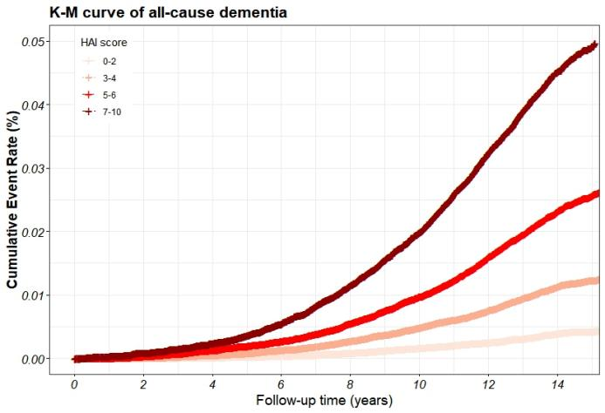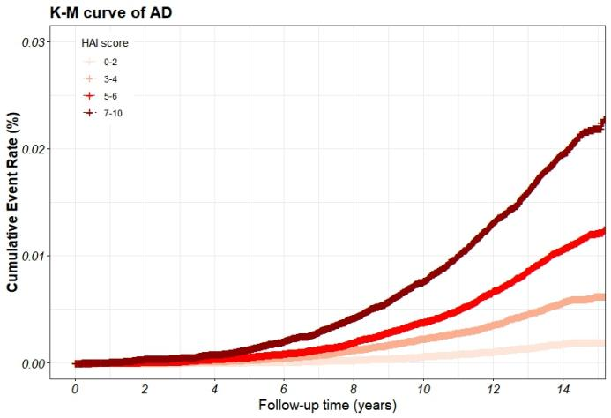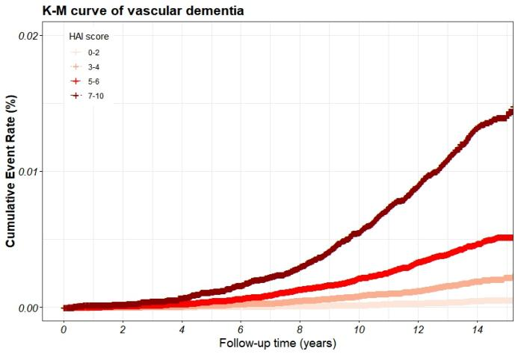

Supplementary Figure 1. Kaplan–Meier survival curve illustrating the risk of different outcomes (all-cause dementia, AD, and vascular dementia) among healthy aging index groups. (A)all-cause dementia, (B) AD:Alzheimer’s disease, (C)Vascular dementia.

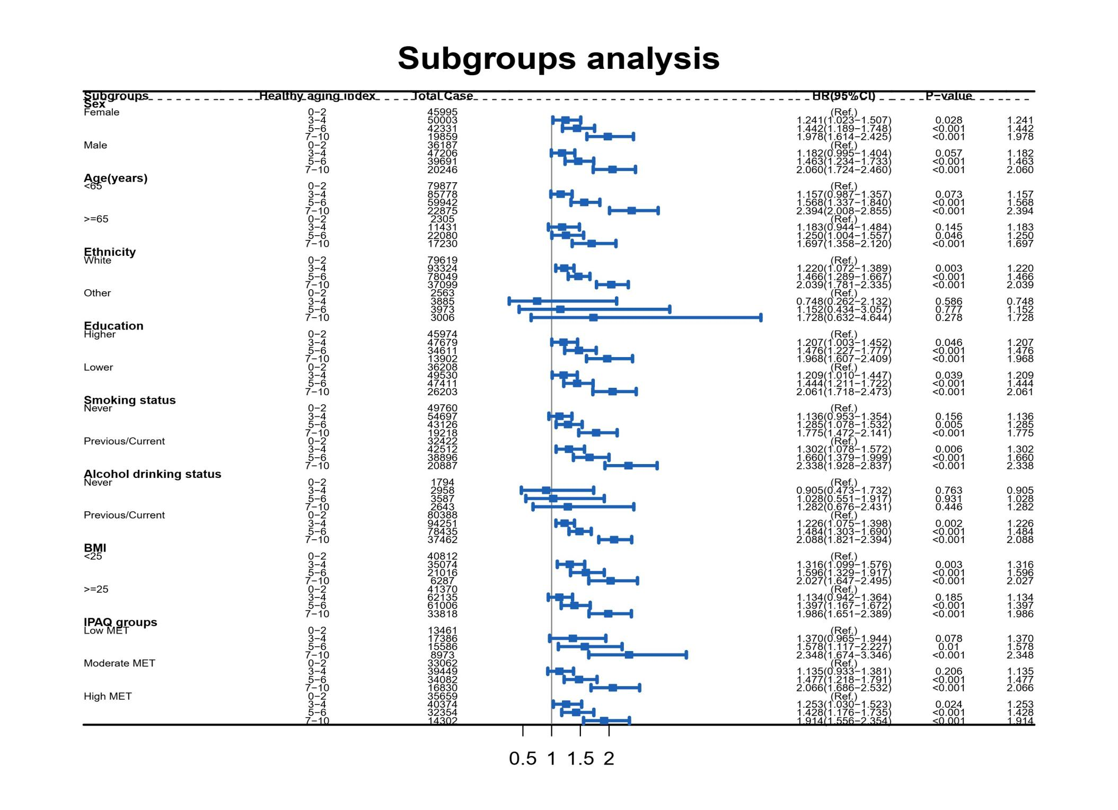
Supplementary Figure 2. Association of eGFR and the risk of all-cause dementia stratified by potential risk factors.
Note: Models were adjusted for age, sex, Townsend deprivation index, ethnicity, education, alcohol drinking status, smoking status, sleep hours,Body Mass Index, physical activity level, healthy diet score.

