Trehalose catalytic shift is an intrinsic factor in Mycobacterium tuberculosis that enhances phenotypic heterogeneity and multidrug resistance.
Jae Jin Lee¹, Daniel H. Swanson², Sun-Kyung Lee³, Stephanie Dihardjo¹, Gi Yong Lee¹, Sree Gelle¹, Emily R. Maskill², Zachary E. Taylor⁴, Michael S. Van Nieuwenhze⁴, Abhyudai Singh⁵, Jong-Seok Lee,³ Seokyong Eum³, SangNae Cho³, Benjamin M. Swarts², Hyungjin Eoh^{*,1,6}

¹ Department of Molecular Microbiology and Immunology, Keck School of Medicine, University of Southern California, Los Angeles, CA., 90033, USA
² Department of Chemistry and Biochemistry, Central Michigan University, Mount Pleasant, MI, 48859, USA.
³ Division of Immunology and Cellular Immunology, International Tuberculosis Research Center, Changwon 51755, Republic of Korea.
⁴ Department of Chemistry and Biochemistry, Baylor University, Waco, TX, 76798, USA
⁵ Department of Electrical and Computer Engineering, Biomedical Engineering, Mathematical Sciences, University of Delaware, Newark, DE., 19716, USA
⁶ Department of Ophthalmology, Keck School of Medicine, University of Southern California, Los Angeles, CA., 90033, USA

*, Corresponding authors: Hyungjin Eoh (heoh@usc.edu).

Supplementary Information
This PDF file includes:
Supplementary Figures 1 to 8
Supplementary Tables 1 to 2

Supplementary Figures and Legends
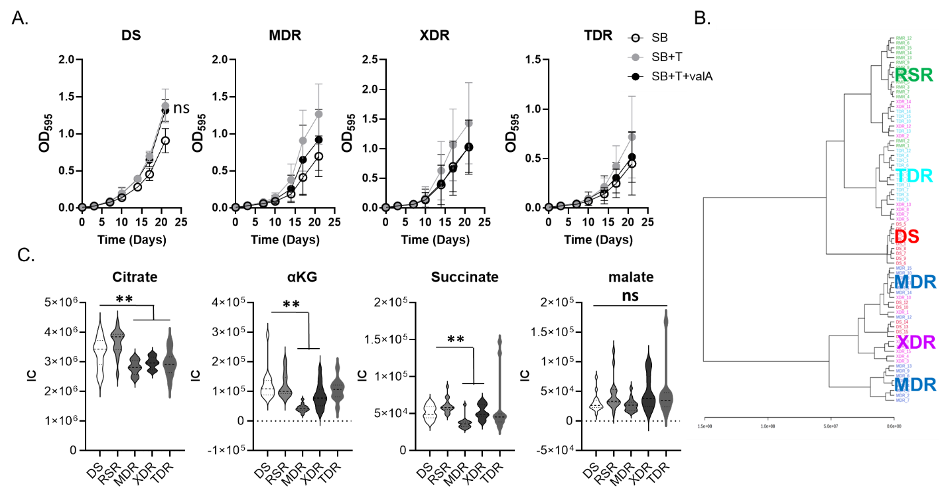
Supplementary Figure 1

Supplementary Fig. 1. Metabolic networks of TB clinical isolates utilized to consume trehalose.
A. Growth kinetics of drug-sensitive (DS)-, RSR-, MDR-, XDR-, and TDR- clinical TB isolates in m7H9 supplemented with 10 mM sodium butyrate (SB) were monitored by measuring OD₅₉₅. The effects of co-treatment with either 20 mM trehalose (T) or a combination of trehalose and 200 µM validamycin A (Val A) on their growth were assessed. Due to the heterogeneity in growth kinetics, there was significant variability in the DR-TB clinical isolates, which hindered appropriate statistical analysis. However, the results clearly indicate that the trehalose-mediated growth enhancement was diminished by co-treatment with ValA only in DR-TB clinical isolates. Values represent the average of biological replicates ± s.e.m. ns, not significant by ANOVA between SB + T and SB + T + Val A.
B. The phylogram generated from metabolomics analysis illustrates the phylogenetic relationships among five categories of TB clinical isolates. Due to metabolic heterogeneity, some strains were identified as outliers. Bootstrap values are based on 100 iterations.
C. Targeted metabolomics revealed the intrabacterial abundance of TCA cycle intermediates detected in the five categories of TB clinical isolates when cultured in m7H9 with 20 mM trehalose. Data points represent the average of 15 biological replicates ± s.e.m. **, P < 0.05 by Student’s t-test.
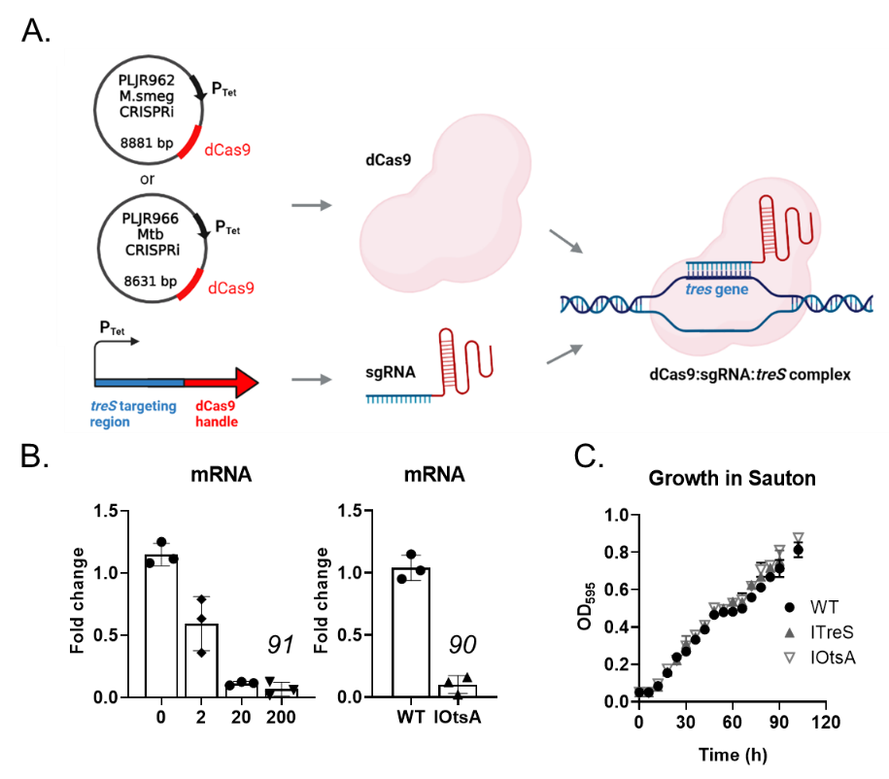

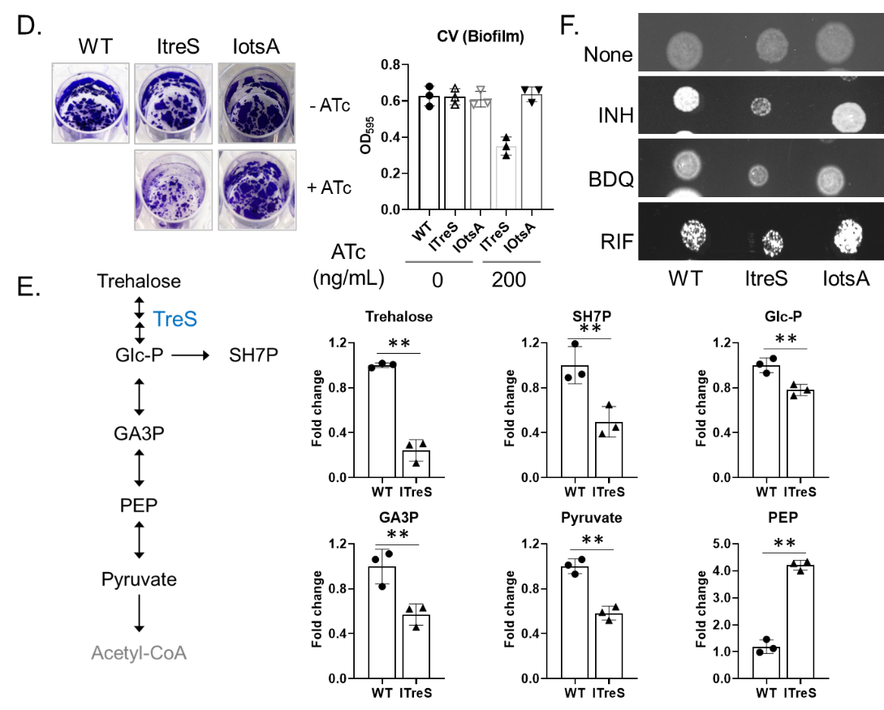

Supplementary Figure 2

Supplementary Fig. 2. M. smegmatis deficient in treS phenocopies Mtb mutants lacking trehalose catalytic shift.
A. A schematic diagram illustrating the generation of CRISPRi knockdown mutants in the genetic backgrounds of M. smegmatis or M. tuberculosis.
B. Left panel: Suppression of treS mRNA expression in ItreSSM (CRISPRi treS KD M. smegmatis mutant) after treatment with 0, 2, 20, and 200 ng/mL Anhydrotetracycline (ATc). Right panel: Suppression of otsA mRNA expression in IotsASM (CRISPRi otsA KD M. smegmatis mutant) after treatment with 200 ng/mL ATc.
C. Growth kinetics of ItreSSM and IotsASM in Sauton media, which promotes the formation of biofilm-persister bacilli. The growth kinetics of wildtype M. smegmatis are included as a control.
D. The level of biofilm-persister formation in ItreSSM and IotsASM, with or without treatment with 200 ng/mL of ATc. The biofilm-persister formation of wildtype M. smegmatis is included as a control. Right panel: Levels of biofilm-persister formation are depicted using the CV staining method.
E. Targeted metabolomics analysis of wildtype M. smegmatis and ItreSSM. The graph shows the fold change when cultured in trehalose-containing m7H9 relative to m7H9 alone. **, P<0.01; n.s., not significant by Student’s t-test.
F. A spot assay using ItreSSM and IotsASM in m7H10 containing various antibiotics, such as INH, RIF, or BDQ. Colony formation was compared with that in antibiotic-free m7H10.

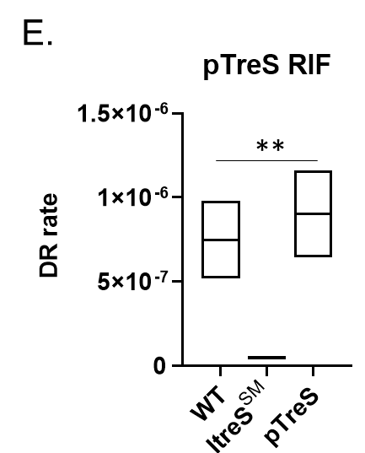
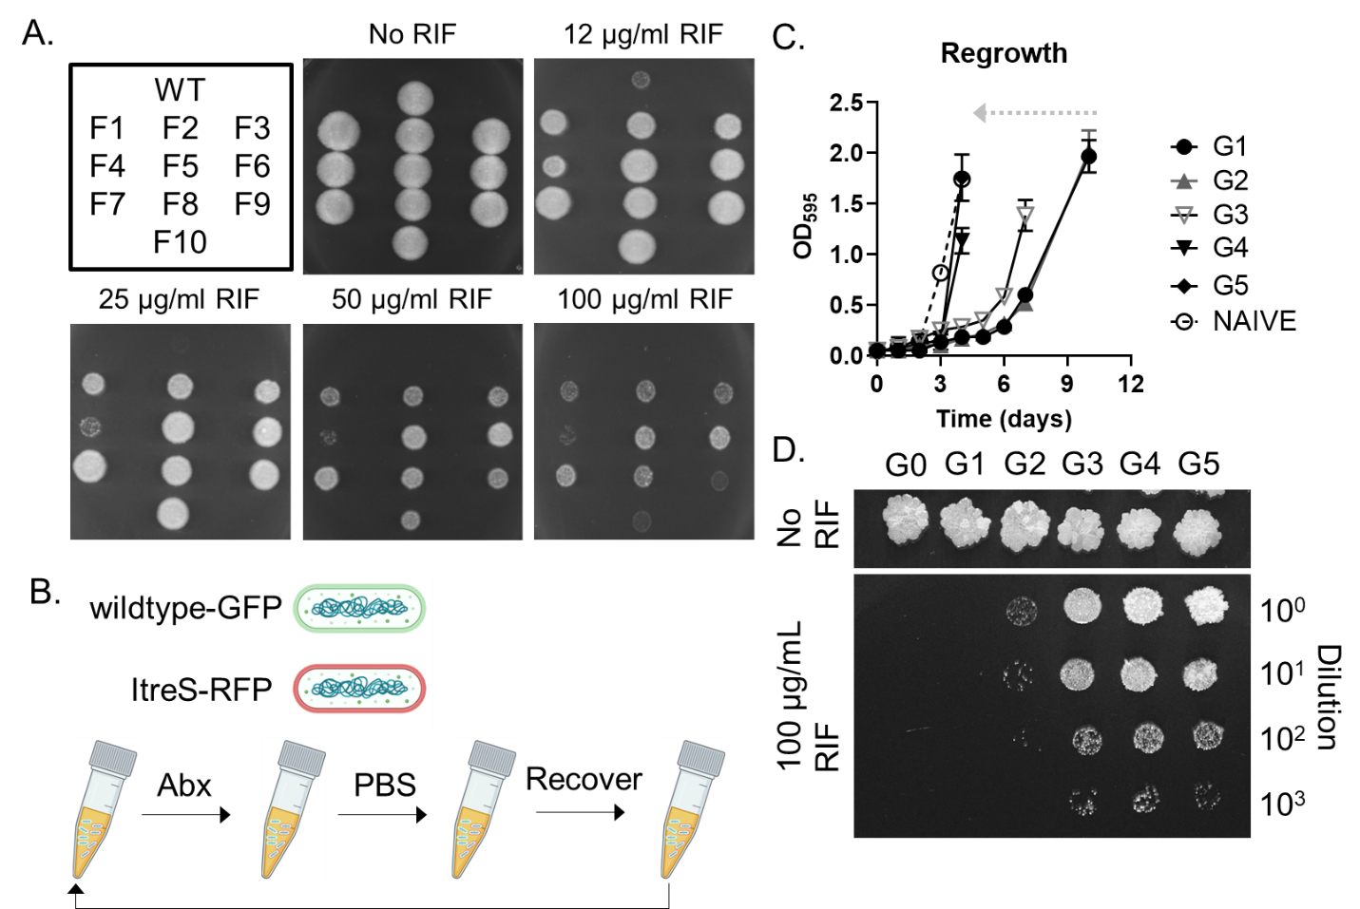

Supplementary Figure 3

Supplementary Fig. 3. The role of trehalose catalytic shift in the emergence of drug resistance.
A. A spot assay using RIF-resistant M. smegmatis bacilli obtained from the classical fluctuation assay on m7H10, with various concentrations of RIF ranging from 0 to100 µg/mL. Naïve M. smegmatis (WT) bacilli were included as a control.
B. A schematic diagram illustrating the method of coculture competition assay using a mixture of wildtype M. smegmatis harboring GFP and ItreSSM harboring RFP. The mixture was intermittently treated with 100 µg/mL RIF or DCS for 1 day, producing G0-G5 cultures.
C. Growth kinetics of G0-G5 cultures in antibiotic-free m7H9 immediately after RIF treatment. Naïve M. smegmatis bacilli were included as a control.
D. A spot assay using G0-G5 cultures on m7H10 containing 100 µg/mL RIF. Colony formation was compared with that in antibiotic-free m7H10.
E. The rates at which wildtype M. smegmatis, ItreSSM, and pTreS acquired spontaneous RIF resistance per generation were measured using the classical fluctuation assay. All values represent the average of 25 biological replicates ± s.e.m. **, P < 0.01 by Student’s t-test.

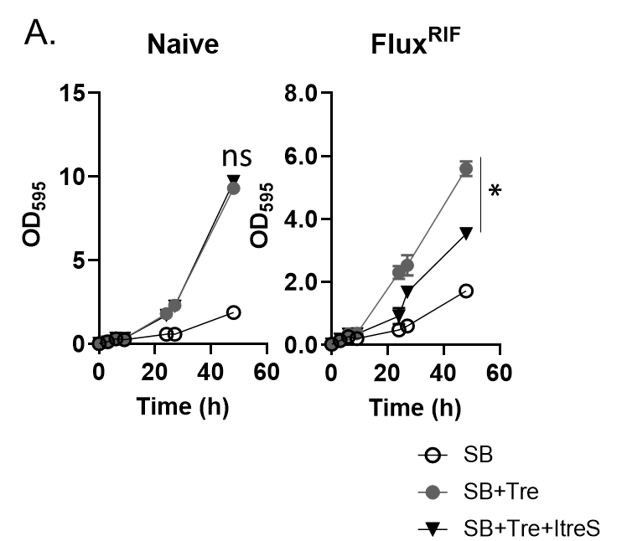

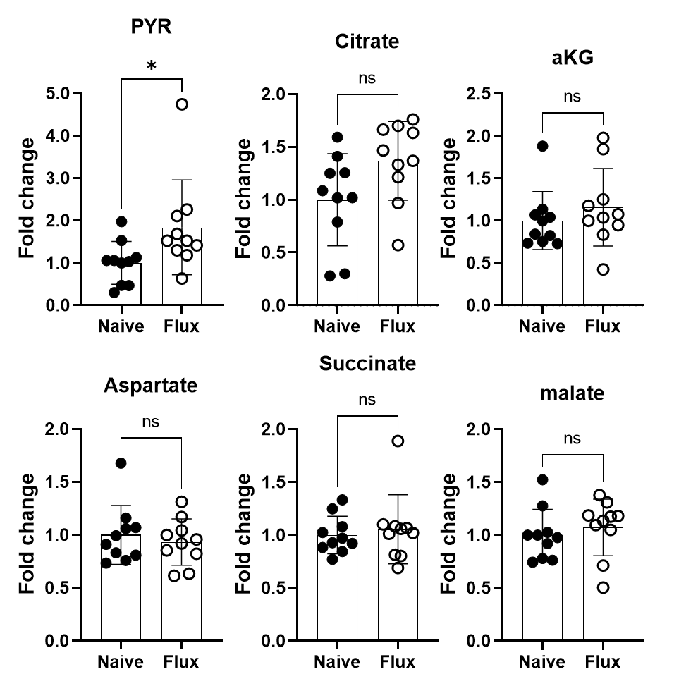
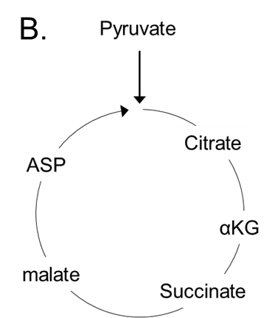

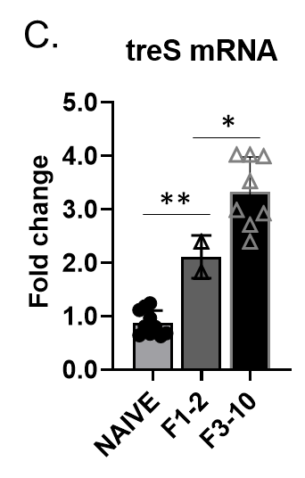

Supplementary Figure 4
Supplementary Fig. 4. Biochemical and metabolic properties of Flux^{RIF} bacilli.
A. Growth kinetics of wildtype M. smegmatis, Flux^{RIF}, and ItreS^{Flux} bacilli in m7H9 containing sodium butyrate (SB) with or without 20 mM trehalose (Tre).
B. Targeted metabolomics analysis of wildtype M. smegmatis and Flux^{RIF} bacilli after culturing in m7H9 with or without 20 mM trehalose. The analysis is represented by the fold changes in TCA cycle metabolite abundance for each strain cultured in m7H9 with trehalose relative to that in m7H9 without trehalose.
C. treS mRNA expression levels in naïve M. smegmatis and Flux^{RIF} #1 and #2 (RRDR-mutation mediated Flux^{RIF}), and Flux^{RIF} #3 - #10 (RRDR mutation-free Flux^{RIF}) bacilli.
All values represent the average of biological replicates ± s.e.m. *, P < 0.05; **, P<0.01 by Student’s t-test.

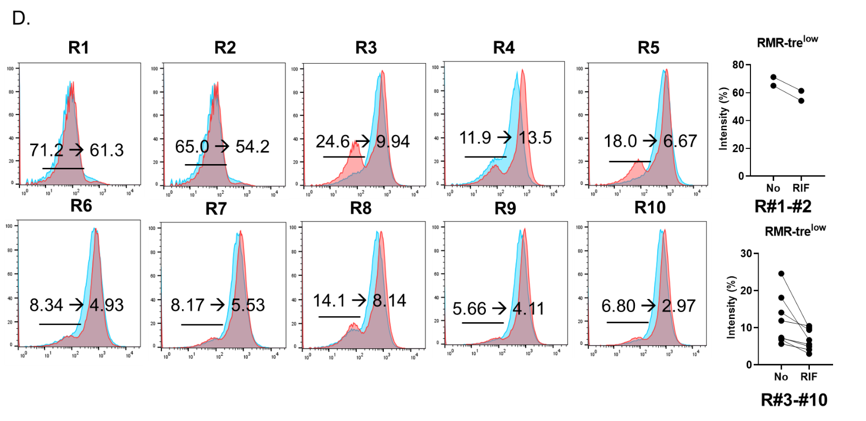
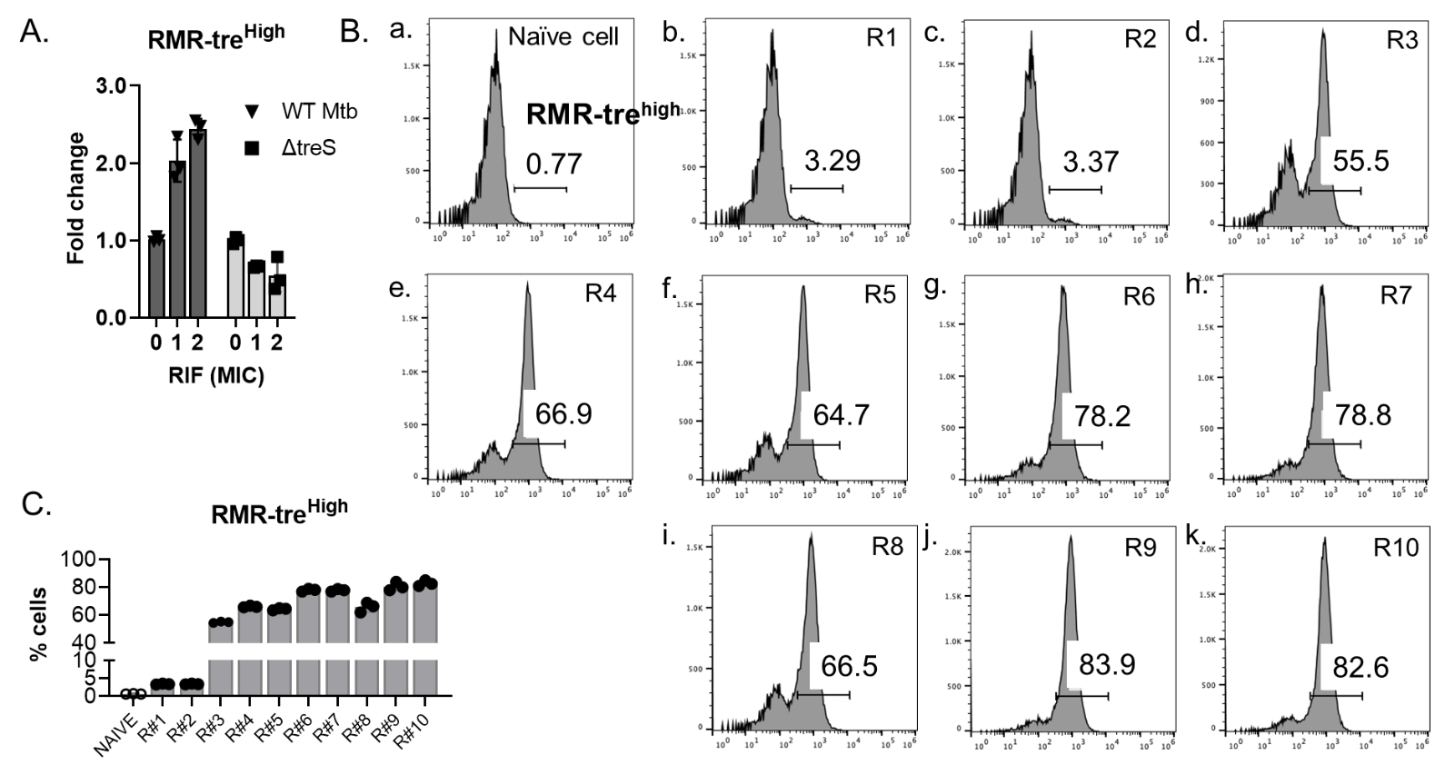
Supplementary Figure 5

Supplementary Fig. 5. Labeling with RMR-trehalose fluorogenic dye (RMR-tre) as a method to monitor trehalose catalytic shift activity.
A. The newly emerged RMR-tre^{high} population in naïve or ΔtreS Mtb was monitored by flow cytometry after treatment with 1X or 2X MIC RIF.
B. Intensity of the RMR-tre^{high} population in naïve M. smegmatis (panel a) and in Flux^{RIF} bacilli #1-#10 (panels b-k).
C. The percentage fraction of the RMR-tre^{high} population in each Flux^{RIF} strain is depicted in a bar graph.
D. An overlay illustrating the change in RMR-tre^{low} population intensity in naïve M. smegmatis and the 10 Flux^{RIF} bacilli before (blue) and after (red) treatment with 100 µg/mL RIF. Inset graphs show the change of RMR-tre^{low} population abundance in Flux^{RIF} #1-#2 (upper panel) and Flux^{RIF}#3-#10 (lower panel) before and after RIF treatment.

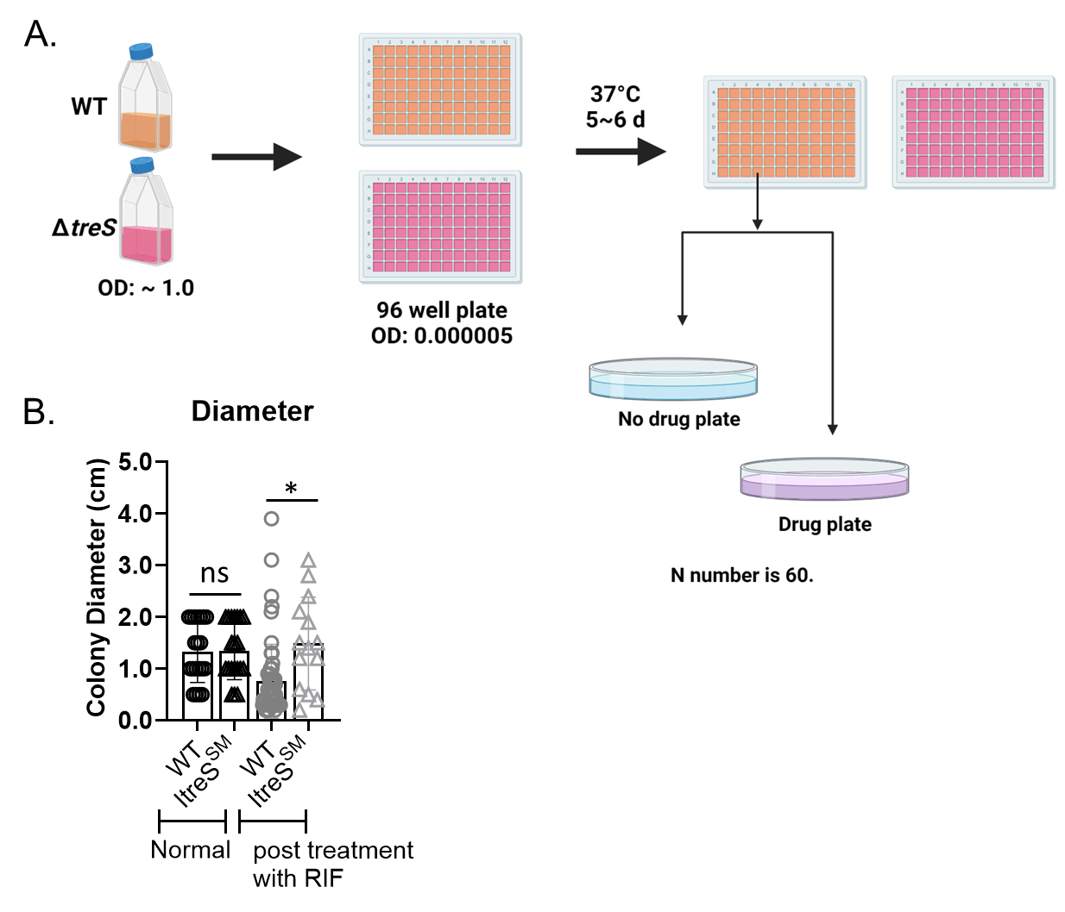

Supplementary Figure 6

Supplementary Fig. 6. Fluctuation assay for mathematical modeling simulation.
A. To generate a single-cell suspension of M. smegmatis wildtype and ItreSSM, cultures were diluted to an OD₅₉₅, 0.000005 in 200 µL of m7H9 in 96-well plates. The cultures were then regrown until they reached an OD₅₉₅ of 0.7-1.0. A total of 100 µL from 60 randomly selected colonies were plated on m7H10 containing 100 µg/mL of RIF. Spontaneous RIF-resistant colonies were counted after incubating for up to 10 days. To determine the total viable input cell number, the remaining 100 µL of the cultures were serially diluted and plated on m7H10 without antibiotics.
B. The diameter of wildtype and ItreSSM colonies forming on antibiotic-free m7H10 after recovery from treatment with 100 µg/mL of RIF for 3 days.

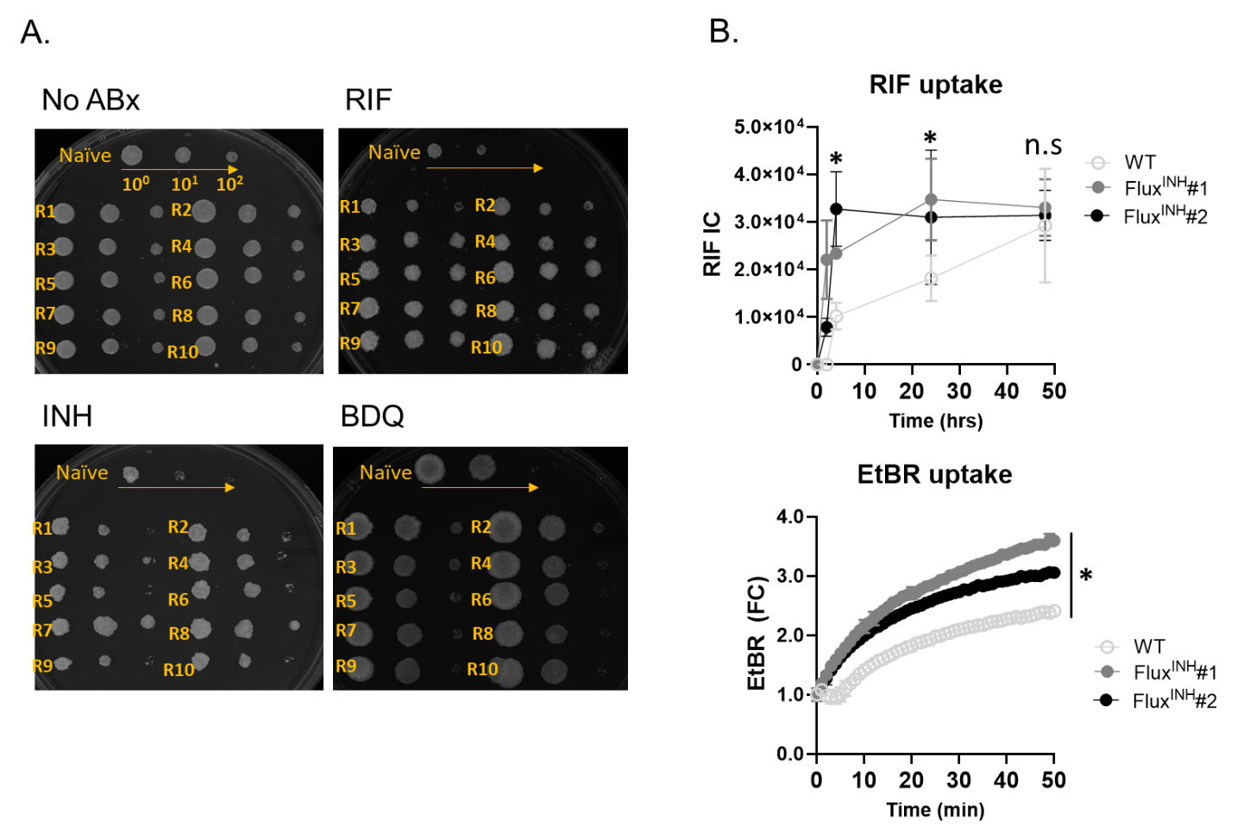
Supplementary Figure 7

Supplementary Fig. 7. The role of trehalose catalytic shift in the emergence of antibiotic cross-resistance.
A. A spot assay was conducted using Flux^{RIF} #1 - #10 on m7H10 containing INH, RIF, or BDQ. Naïve M. smegmatis bacilli were included as a control.
B. RIF uptake kinetics for naïve M. smegmatis and Flux^{INH} #1 and #2 were monitored through LC-MS quantification after a 2 day-incubation. All values represent the average of biological replicates ± s.e.m. *, P < 0.05; n.s, not significant by Student’s t-test.
C. EtBr uptake kinetics for naïve M. smegmatis and Flux^{INH} #1 and #2 were monitored after a 60-min incubation.

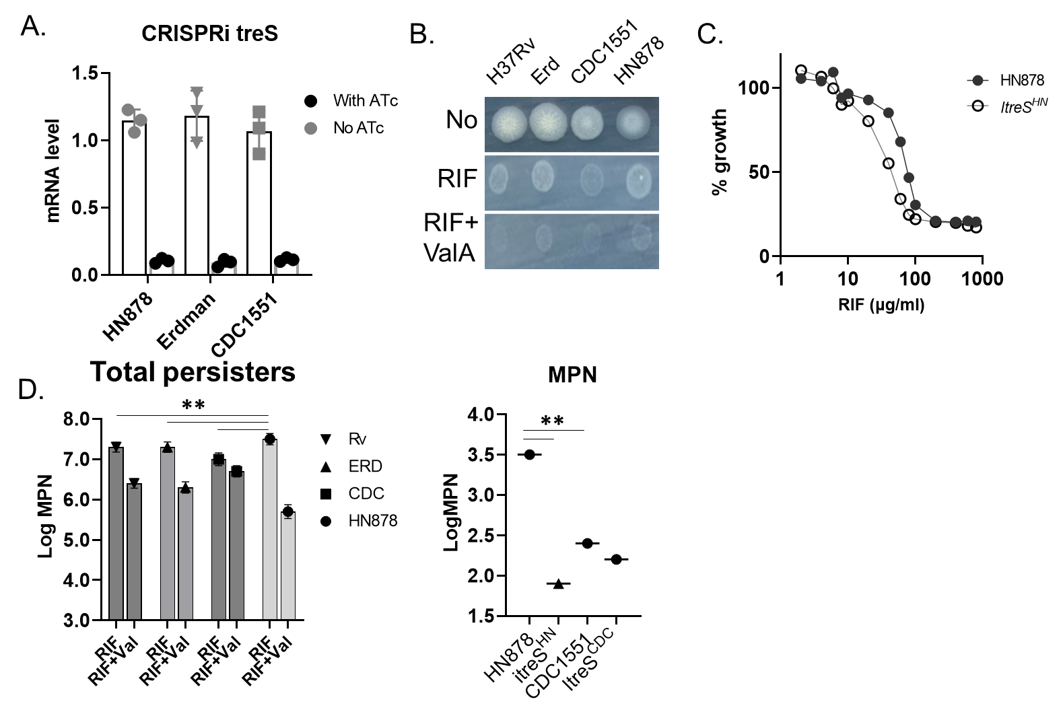
Supplementary Figure 8

S Fig. 8. Characterization of HN878’s trehalose catalytic shift.
A. Suppression of mRNA expression in ItreS (CRISPRi treS knockdown in the genetic background of M. tuberculosis clinical strains such as HN878, Erdman, and CDC1551) after treatment with 0 or 200 ng/mL ATc.
B. A spot assay was performed using H37Rv, Erdman, CDC1551, and HN878 to assess the effect of ValA (TreS specific inhibitor) on their colony formation on m7H10 containing RIF.
C. IC₅₀ values of RIF against HN878 and ItreS^{HN} (CRISPRi treS knockdown in M. tuberculosis HN878).
D. MPN method was performed using H37Rv, Erdman, CDC1551, and HN878 before and after treatment with ValA (TreS specific inhibitor), as well as ItreS^{HN} or ItreS^{CDC} after treatment with ATc.

