Table 6 Nomogram for Predicting the Probability of Dysmenorrhea in AM
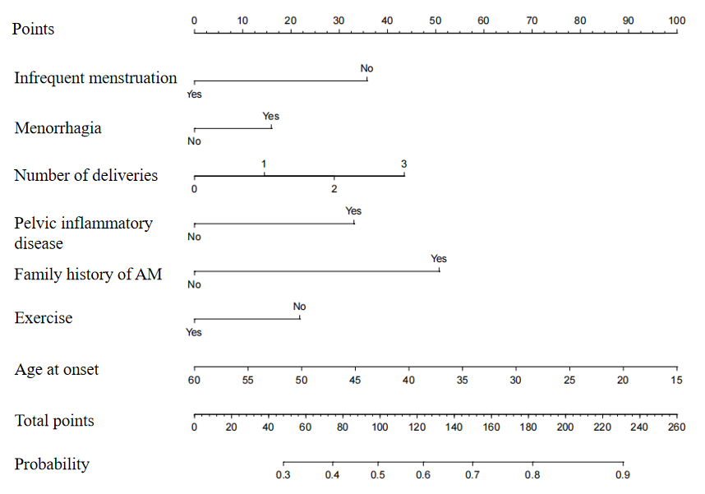
Table 7 ROC Curve
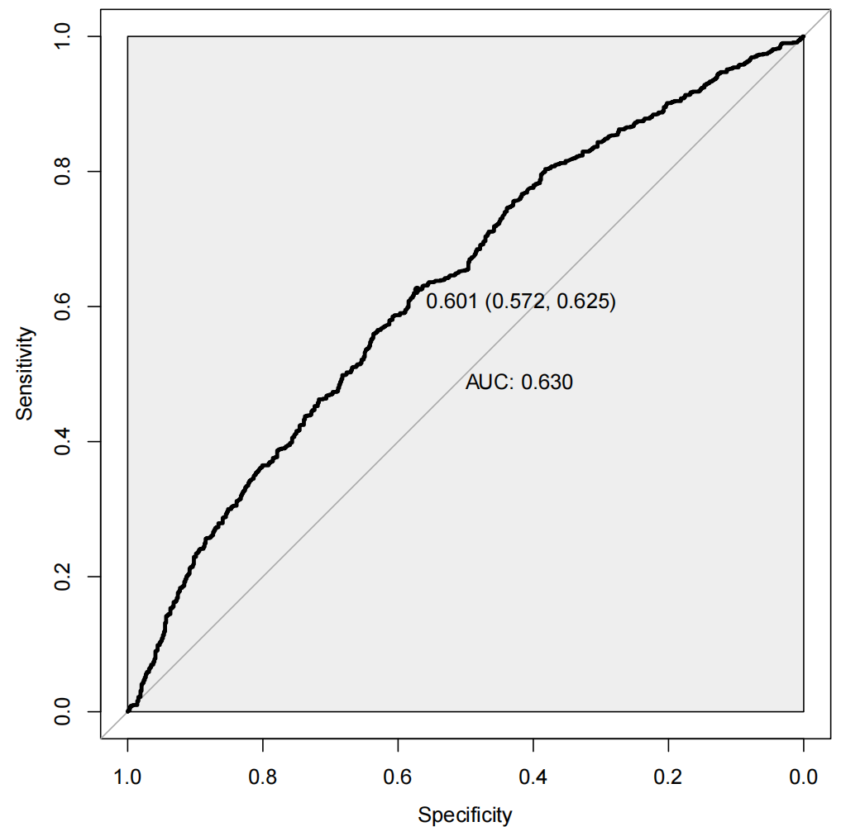
Table 9 Calibration Plot
