Extended Figures and Tables
Extended Figure 1 | Cartographic image of the number of EPDs in the concrete database per U.S. state. The Eastern and Pacific Southwest regions have the most amount of EPDs, with the Pacific Northwest and Southeastern regions also having a large quantity of EPDs. Yet, central U.S., especially the Great Lakes and South Central regions, have significantly less EPD representation, with multiple states without any EPDs.
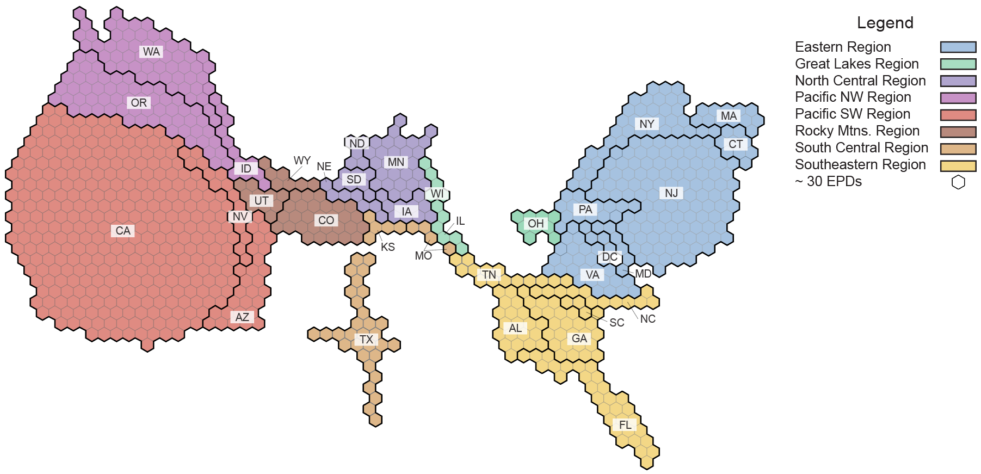
Extended Figure 2 | Percentage breakdown for the four EPD classifications based on the quantity of GWP data available.
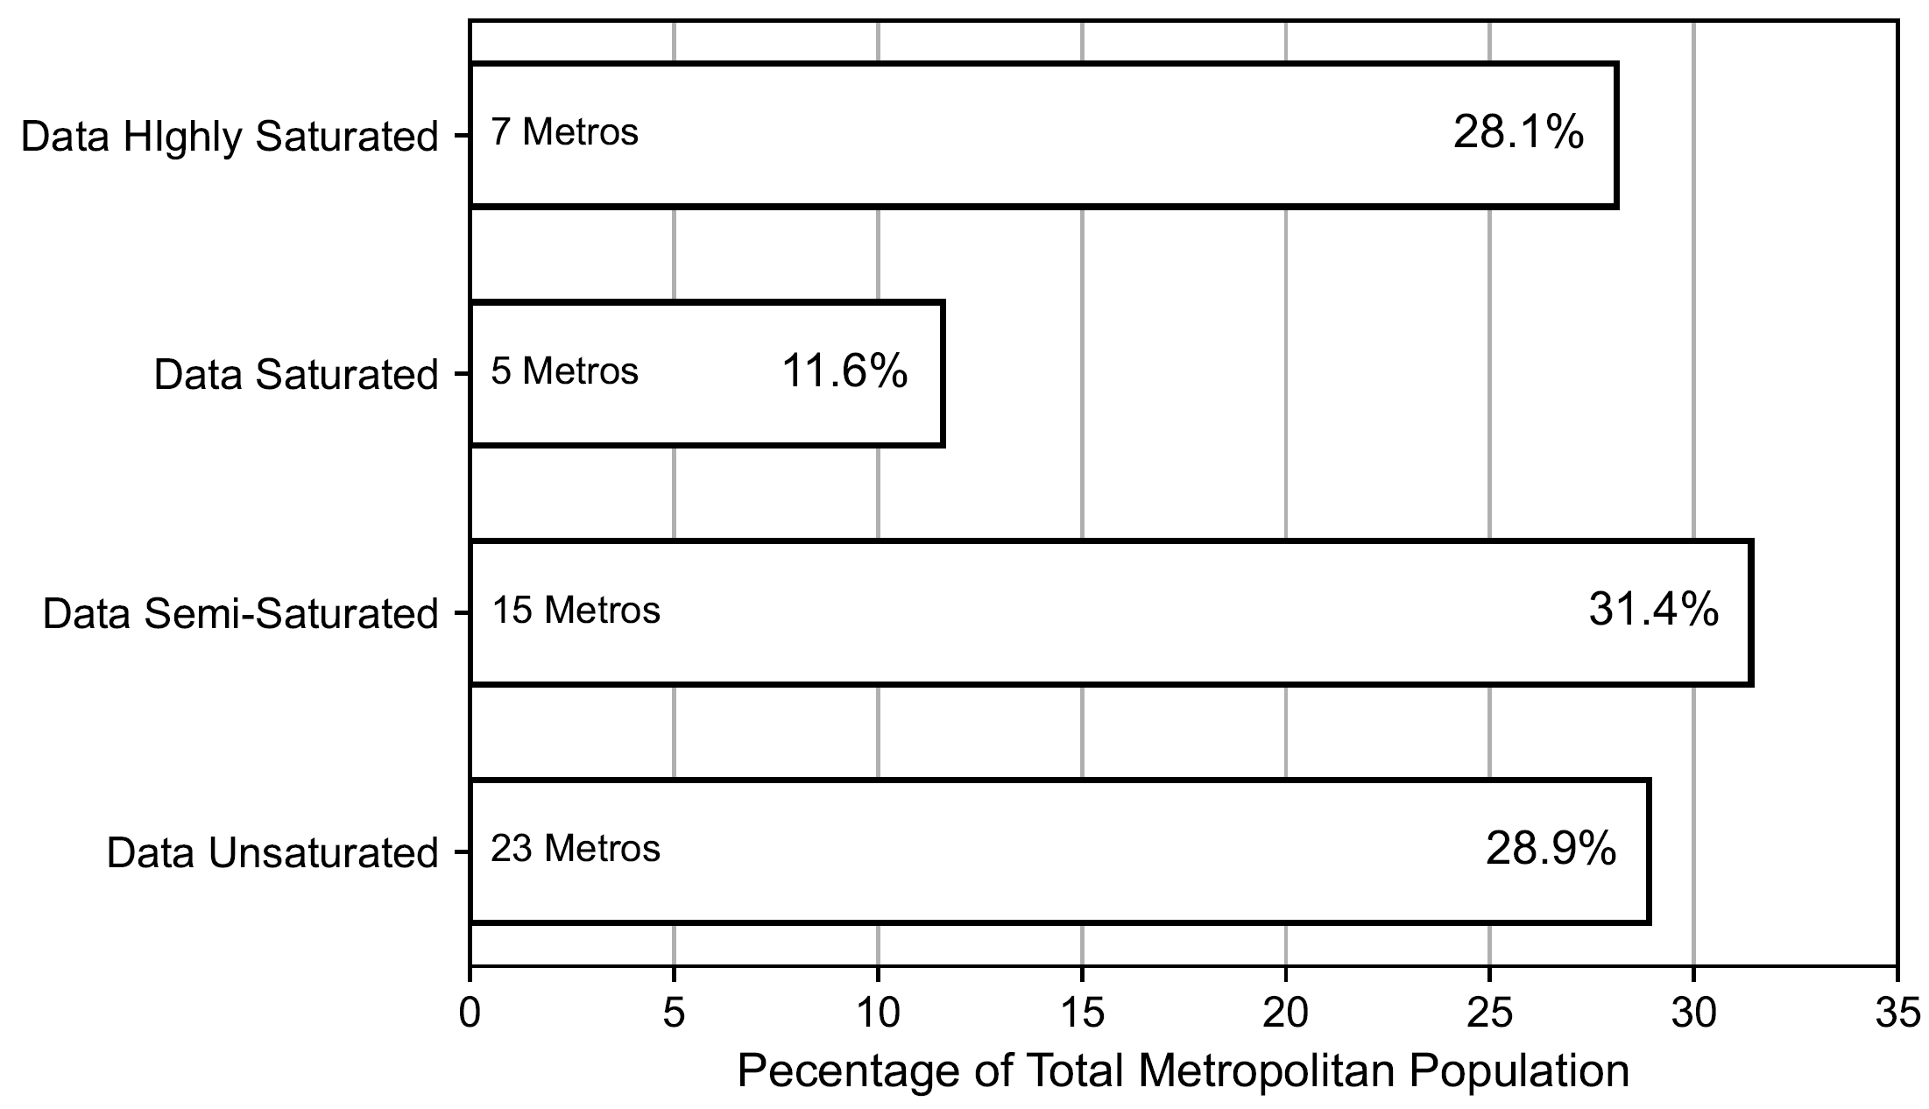

Extended Figure 3 | Average population percent difference against the number of concrete EPDs needed to be classified as data highly saturated (i.e., having at least 1,000 EPDs). The majority of urbanizing metropolitans are data insufficient, as they need approximately 1,000 EPDs, emphasizing that these urban areas currently have data scarcity. Furthermore, many of the metropolitans are in the South Central and Southeastern regions, implying that these are hot spots where more concrete EPDs are needed. Only the metropolitans that have an average population growth above 0% are shown. Metropolitans with a negative EPD count would already be considered highly saturated.
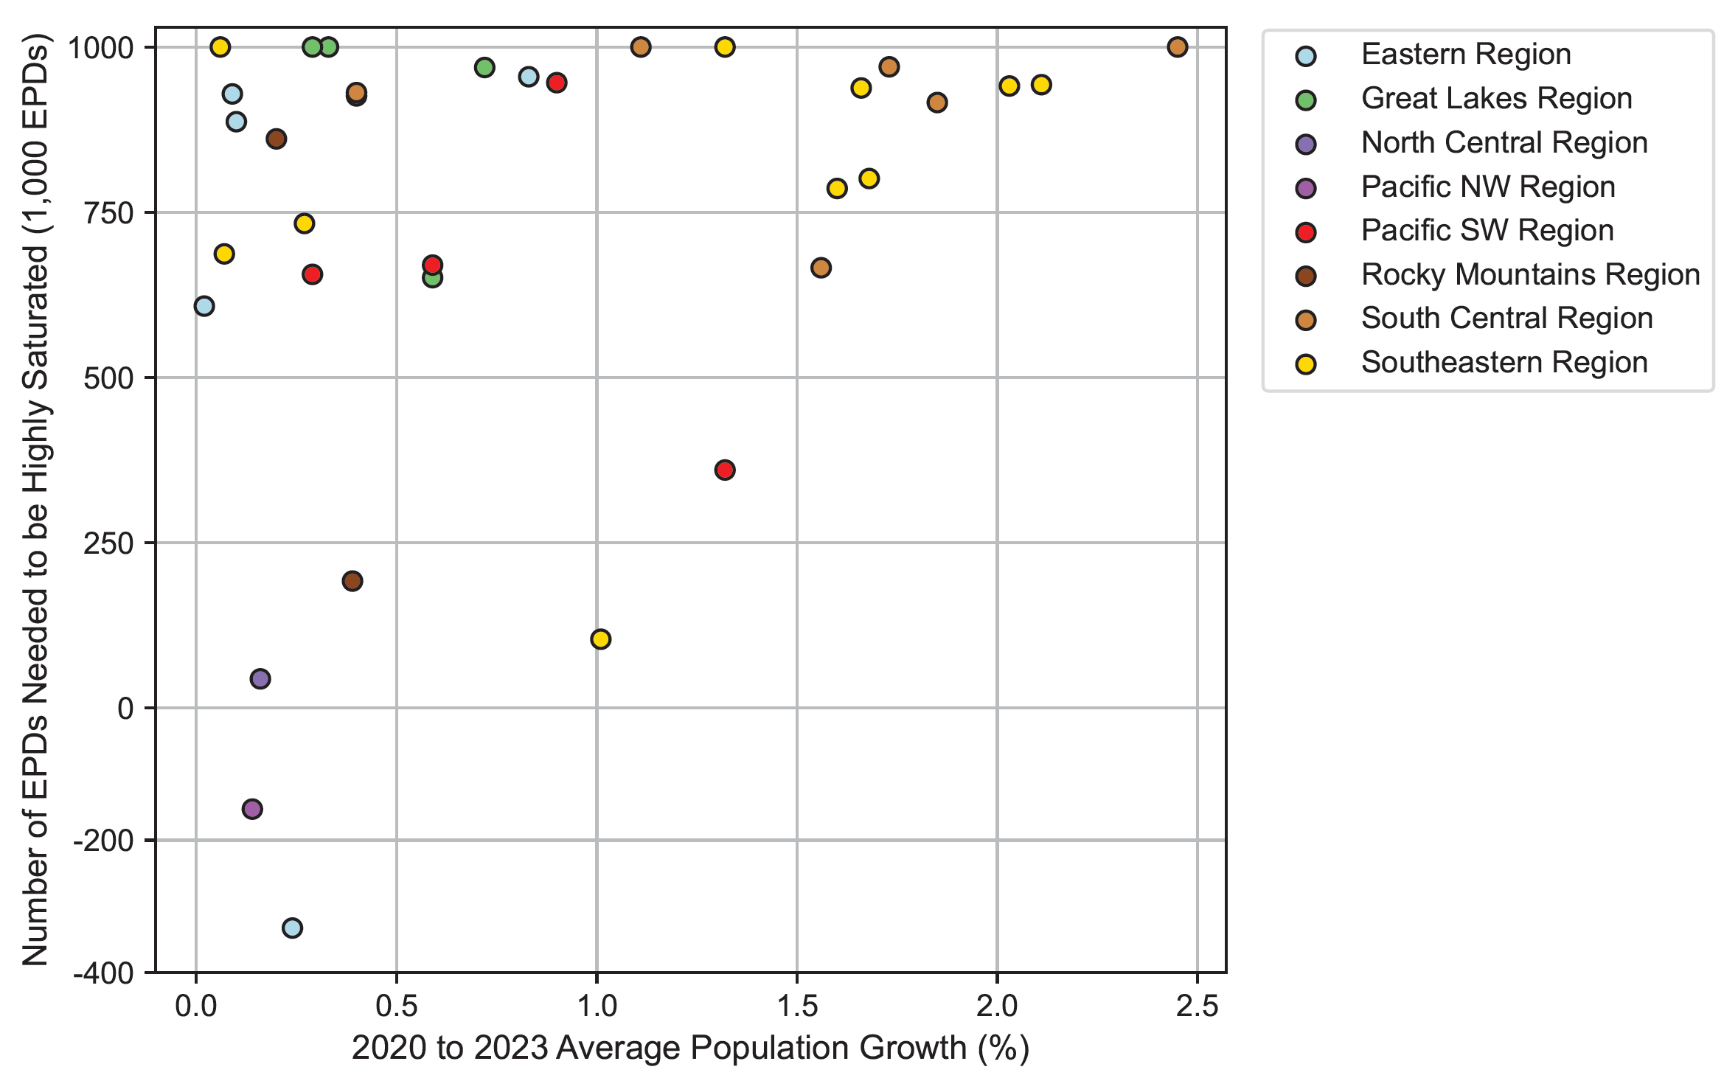
Extended Figure 4 | a. Population growth (by 3,000 people) between 2020 to 2023 in U.S. states with populous metropolitans and b. the number of EPDs needed to be classified as data highly saturated (i.e., having at least 1,000 EPDs).
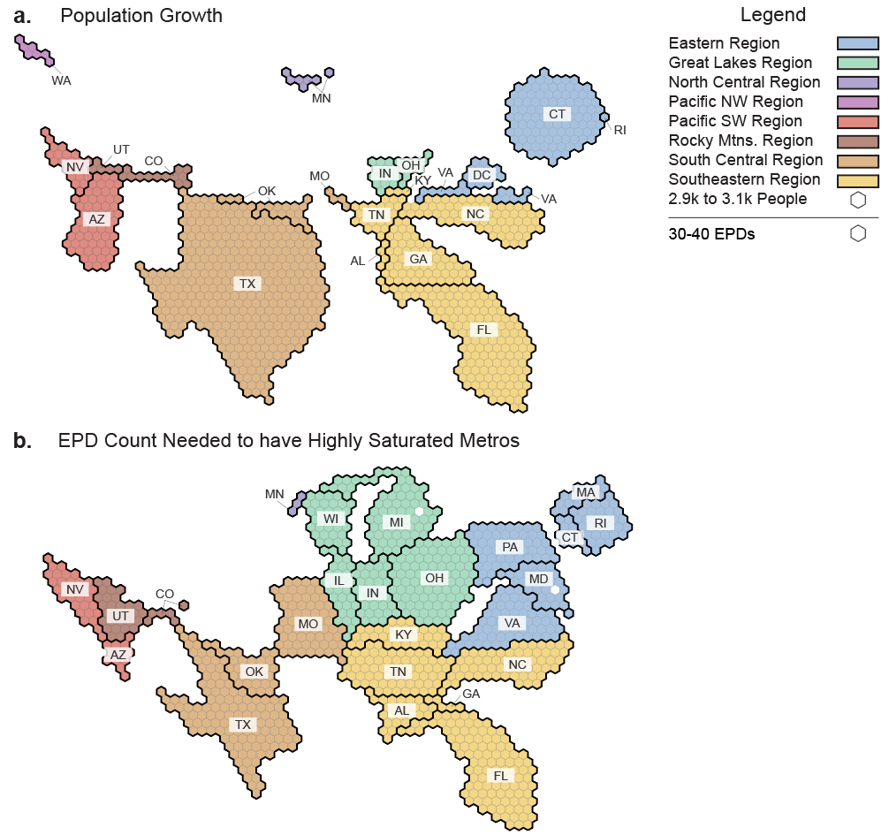

Extended Data Table 1 | Geographical, EPD count, and demographics for the 50 most populous U.S. metropolitans in the 2022 and 2023 U.S. censuses.
Metropolitan Area | Latitude | Longitude | NRMCA-Defined Region | Number of Concrete EPDs
New York City-Newark-Jersey City, NY-NJ-PA | 40.7128 | -74.006 | Eastern Region | 8,746
Los Angeles-Long Beach-Anaheim, CA | 34.0549 | -118.2426 | Pacific Southwest Region | 6,800
Chicago-Naperville-Elgin, IL-IN-WI | 41.8781 | -87.6298 | Great Lakes Region | 108
Dallas-Fort Worth-Arlington, TX | 32.7767 | -96.797 | South Central Region | 84
Houston-The Woodlands-Sugar Land, TX | 29.7604 | -95.3698 | South Central Region | 334
Atlanta-Sandy Springs-Alpharetta, GA | 33.7488 | -84.3877 | Southeastern Region | 896
Washington-Arlington-Alexandria, DC-VA-MD-WV | 38.9072 | -77.0369 | Eastern Region | 1,333
Philadelphia-Camden-Wilmington, PA-NJ-DE-MD | 39.9562 | -75.1652 | Eastern Region | 392
Miami-Fort Lauderdale-Pompano Beach, FL | 25.7617 | -80.1918 | Southeastern Region | 267
Phoenix-Mesa-Chandler, AZ | 33.4484 | -112.074 | Pacific Southwest Region | 640
Boston-Cambridge-Newton, MA-NH | 42.3601 | -71.0589 | Eastern Region | 474
Riverside-San Bernardino-Ontario, CA | 33.9806 | -117.3755 | Pacific Southwest Region | 330
San Francisco-Oakland-Berkeley, CA | 37.7749 | -122.4194 | Pacific Southwest Region | 3,578
Detroit-Warren-Dearborn, MI | 42.3314 | -83.0458 | Great Lakes Region | 0
Seattle-Tacoma-Bellevue, WA | 47.6061 | -122.3328 | Pacific Northwest Region | 1,153
Minneapolis-St. Paul-Bloomington, MN-WI | 44.9778 | -93.265 | North Central Region | 956
Tampa-St. Petersburg-Clearwater, FL | 27.9517 | -82.4588 | Southeastern Region | 214
San Diego-Chula Vista-Carlsbad, CA | 32.7157 | -117.1611 | Pacific Southwest Region | 624
Denver-Aurora-Lakewood, CO | 39.7392 | -104.9903 | Rocky Mountains Region | 808
Baltimore-Columbia-Towson, MD | 39.2904 | -76.6122 | Eastern Region | 135
Orlando-Kissimmee-Sanford, FL | 28.5384 | -81.3789 | Southeastern Region | 199
Charlotte-Concord-Gastonia, NC-SC | 35.2271 | -80.8431 | Southeastern Region | 62
St. Louis, MO-IL | 38.627 | -90.1994 | South Central Region | 0
San Antonio-New Braunfels, TX | 29.4252 | -98.4946 | South Central Region | 30
Portland-Vancouver-Hillsboro, OR-WA | 45.5152 | -122.6784 | Pacific Northwest Region | 2,121
Austin-Round Rock-Georgetown, TX | 30.2672 | -97.7431 | South Central Region | 0
Pittsburgh, PA | 40.4406 | -79.9959 | Eastern Region | 0
Sacramento-Roseville-Folsom, CA | 38.5816 | -121.4944 | Pacific Southwest Region | 344
Las Vegas-Henderson-Paradise, NV | 36.1716 | -115.1391 | Pacific Southwest Region | 54
Cincinnati, OH-KY-IN | 39.1031 | -84.512 | Great Lakes Region | 0
Kansas City, MO-KS | 39.0997 | -94.5786 | South Central Region | 69
Columbus, OH | 39.9612 | -82.9988 | Great Lakes Region | 349
Indianapolis-Carmel-Anderson, IN | 39.7691 | -86.158 | Great Lakes Region | 0
Nashville-Davidson--Murfreesboro-Franklin, TN | 36.1627 | -86.7816 | Southeastern Region | 31
Cleveland-Elyria, OH | 41.4993 | -81.6944 | Great Lakes Region | 0
San Jose-Sunnyvale-Santa Clara, CA | 37.3387 | -121.8853 | Pacific Southwest Region | 5,632
Virginia Beach-Norfolk-Newport News, VA-NC | 36.8516 | -75.9792 | Eastern Region | 113
Jacksonville, FL | 30.3322 | -81.6557 | Southeastern Region | 59
Providence-Warwick, RI-MA | 41.824 | -71.4128 | Eastern Region | 71
Milwaukee-Waukesha, WI | 43.0389 | -87.9065 | Great Lakes Region | 0
Raleigh-Cary, NC | 35.7796 | -78.6382 | Southeastern Region | 57
Oklahoma City, OK | 35.4676 | -97.5164 | South Central Region | 0
Louisville-Jefferson County, KY-IN | 38.2527 | -85.7585 | Southeastern Region | 0
Richmond, VA | 37.5407 | -77.436 | Eastern Region | 45
Memphis, TN-MS-AR | 35.1495 | -90.049 | Southeastern Region | 0
Salt Lake City, UT | 40.7608 | -111.891 | Rocky Mountains Region | 139
Birmingham-Hoover, AL | 33.5186 | -86.8104 | Southeastern Region | 313
Fresno, CA | 36.7468 | -119.7726 | Pacific Southwest Region | 74
Grand Rapids-Wyoming-Kentwood, MI | 42.9634 | -85.6681 | Great Lakes Region | 0
Buffalo-Cheektowaga, NY | 42.8864 | -78.8784 | Eastern Region | 119
Hartford-East Hartford-Middletown, CT | 41.7658 | -72.6734 | Eastern Region | 343
New Orleans-Metairie, LA | 29.9511 | -90.0715 | South Central Region | 0

Extended Data Table 2 | 2020, 2021, 2022, and 2023 demographic data for the 50 most populous U.S. metropolitans in the 2023 U.S. censuses⁴³, with their averaged population percent difference and growth rank.
Population Growth Rank | Metropolitan Area | 2020 Population (in millions) | 2021 Population (in millions) | 2022 Population (in millions) | 2023 Population (in millions) | Average Population Percent Difference (%)
1 | Austin-Round Rock-Georgetown, TX | 2.30 | 2.36 | 2.42 | 2.47 | 2.45
2 | Raleigh-Cary, NC | 1.42 | 1.45 | 1.48 | 1.51 | 2.11
3 | Jacksonville, FL | 1.61 | 1.64 | 1.68 | 1.71 | 2.03
4 | Dallas-Fort Worth-Arlington, TX | 7.67 | 7.77 | 7.95 | 8.10 | 1.85
5 | San Antonio-New Braunfels, TX | 2.57 | 2.61 | 2.66 | 2.70 | 1.73
6 | Orlando-Kissimmee-Sanford, FL | 2.68 | 2.70 | 2.76 | 2.82 | 1.68
7 | Charlotte-Concord-Gastonia, NC-SC | 2.67 | 2.71 | 2.75 | 2.81 | 1.66
8 | Tampa-St. Petersburg-Clearwater, FL | 3.19 | 3.23 | 3.29 | 3.34 | 1.60
9 | Houston-The Woodlands-Sugar Land, TX | 7.17 | 7.25 | 7.37 | 7.51 | 1.56
10 | Nashville-Davidson--Murfreesboro-Franklin, TN | 2.02 | 2.03 | 2.07 | 2.10 | 1.32
11 | Phoenix-Mesa-Chandler, AZ | 4.88 | 4.95 | 5.02 | 5.07 | 1.32
12 | Oklahoma City, OK | 1.43 | 1.44 | 1.46 | 1.48 | 1.11
13 | Atlanta-Sandy Springs-Alpharetta, GA | 6.12 | 6.16 | 6.24 | 6.31 | 1.01
14 | Las Vegas-Henderson-Paradise, NV | 2.27 | 2.30 | 2.32 | 2.34 | 0.90
15 | Richmond, VA | 1.32 | 1.33 | 1.34 | 1.35 | 0.83
16 | Indianapolis-Carmel-Anderson, IN | 2.09 | 2.11 | 2.12 | 2.14 | 0.72
17 | Columbus, OH | 2.14 | 2.15 | 2.16 | 2.18 | 0.59
18 | Riverside-San Bernardino-Ontario, CA | 4.61 | 4.65 | 4.67 | 4.69 | 0.59
19 | Fresno, CA | 1.17 | 1.17 | 1.18 | 1.18 | 0.40
20 | Kansas City, MO-KS | 2.20 | 2.20 | 2.21 | 2.22 | 0.40
21 | Denver-Aurora-Lakewood, CO | 2.97 | 2.98 | 2.99 | 3.01 | 0.39
22 | Grand Rapids-Wyoming-Kentwood, MI | 1.15 | 1.15 | 1.16 | 1.16 | 0.33
23 | Cincinnati, OH-KY-IN | 2.25 | 2.25 | 2.26 | 2.27 | 0.29
24 | Sacramento-Roseville-Folsom, CA | 2.40 | 2.41 | 2.42 | 2.42 | 0.29
25 | Miami-Fort Lauderdale-Pompano Beach, FL | 6.13 | 6.11 | 6.14 | 6.18 | 0.27
26 | Washington-Arlington-Alexandria, DC-VA-MD-WV | 6.26 | 6.26 | 6.27 | 6.30 | 0.24
27 | Salt Lake City, UT | 1.26 | 1.26 | 1.27 | 1.27 | 0.20
28 | Minneapolis-St. Paul-Bloomington, MN-WI | 3.69 | 3.70 | 3.69 | 3.71 | 0.16
29 | Seattle-Tacoma-Bellevue, WA | 4.03 | 4.02 | 4.03 | 4.04 | 0.14
30 | Virginia Beach-Norfolk-Newport News, VA-NC | 1.78 | 1.79 | 1.79 | 1.79 | 0.10
31 | Providence-Warwick, RI-MA | 1.67 | 1.68 | 1.67 | 1.68 | 0.09
32 | Birmingham-Hoover, AL | 1.18 | 1.18 | 1.18 | 1.18 | 0.07
33 | Louisville-Jefferson County, KY-IN | 1.36 | 1.36 | 1.36 | 1.37 | 0.06
34 | Philadelphia-Camden-Wilmington, PA-NJ-DE-MD | 6.24 | 6.25 | 6.24 | 6.25 | 0.02
35 | Boston-Cambridge-Newton, MA-NH | 4.93 | 4.91 | 4.90 | 4.92 | -0.10
36 | Baltimore-Columbia-Towson, MD | 2.84 | 2.84 | 2.83 | 2.83 | -0.10
37 | Portland-Vancouver-Hillsboro, OR-WA | 2.52 | 2.52 | 2.51 | 2.51 | -0.13
38 | Buffalo-Cheektowaga, NY | 1.16 | 1.16 | 1.16 | 1.16 | -0.25
39 | San Diego-Chula Vista-Carlsbad, CA | 3.30 | 3.27 | 3.28 | 3.27 | -0.26
40 | Memphis, TN-MS-AR | 1.35 | 1.34 | 1.34 | 1.34 | -0.26
41 | St. Louis, MO-IL | 2.82 | 2.81 | 2.80 | 2.80 | -0.26
42 | Milwaukee-Waukesha, WI | 1.57 | 1.56 | 1.56 | 1.56 | -0.30
43 | Detroit-Warren-Dearborn, MI | 4.39 | 4.37 | 4.35 | 4.34 | -0.33
44 | Cleveland-Elyria, OH | 2.18 | 2.17 | 2.16 | 2.16 | -0.39
45 | Pittsburgh, PA | 2.46 | 2.45 | 2.43 | 2.42 | -0.44
46 | Chicago-Naperville-Elgin, IL-IN-WI | 9.44 | 9.36 | 9.28 | 9.26 | -0.61
47 | New York City-Newark-Jersey City, NY-NJ-PA | 19.99 | 19.72 | 19.56 | 19.50 | -0.83
48 | San Jose-Sunnyvale-Santa Clara, CA | 2.00 | 1.95 | 1.95 | 1.95 | -0.84
49 | Los Angeles-Long Beach-Anaheim, CA | 13.18 | 12.97 | 12.87 | 12.80 | -0.97
50 | San Francisco-Oakland-Berkeley, CA | 4.74 | 4.62 | 4.58 | 4.57 | -1.23

